  - THE INSIGHT BOARD | BUSINESS INTELLIGENCE

ApnoMart — Executive Insights & Strategic Recommendation
Analyst: Shyam | Tool: Python (Pandas, Matplotlib, Streamlit, Plotly) | October 2026
SCOPE NOTE: The task template requests Q2 2026, but the supplied data covers 01 May 2026–28 Oct 2026. This report uses all 1,200 supplied rows and is not Q2-only.

Executive snapshot
Metric | Result
Total Sales | ₹16,261,998.30
Total Profit | ₹4,419,736.17
Unique Orders | 1,200
Quantity Sold | 6,736
Weighted Profit Margin | 27.18%
Loss-making orders | 61
Loss on negative-profit rows | ₹82,743.74

Insight 1 — Revenue pattern
Pattern: Furniture is the largest sales category, generating ₹3,518,270.00 (21.63% of sales). 2026-07 is the strongest month by sales at ₹2,957,618.40.
So what: Protect the leading category’s availability and use monthly demand patterns to plan inventory and campaign timing instead of applying the same budget every month.

Insight 2 — Profitability pattern
Pattern: Office Supplies generates the highest category profit at ₹1,176,657.32 (weighted margin 34.80%). Electronics has the lowest weighted margin at 18.88%. 61 orders have negative recorded profit, with combined loss of ₹82,743.74.
So what: Review product costs, pricing and discounts in the low-margin category and investigate loss-making order lines. The data does not establish that discounts caused every loss, so test that relationship at order/product level.

Insight 3 — Customer behavior pattern
Pattern: Corporate leads by sales at ₹4,311,027.50 (26.51%). Cash leads payment-method sales at ₹3,574,076.95 (21.98%).
So what: Maintain a strong experience for the largest segment, test targeted repeat-purchase campaigns across other segments, and keep all major payment options reliable.

Strategic recommendation
Run a margin-protection pilot before increasing broad discount spend. Start with Electronics (lowest weighted margin: 18.88%), audit the loss-making orders by product, discount, region and payment method, then test selective discounts and monitor sales, profit and conversion together. Scale only after comparison with a control group. Use the leading category and strongest month to guide inventory and campaign planning.

Dashboard screenshot
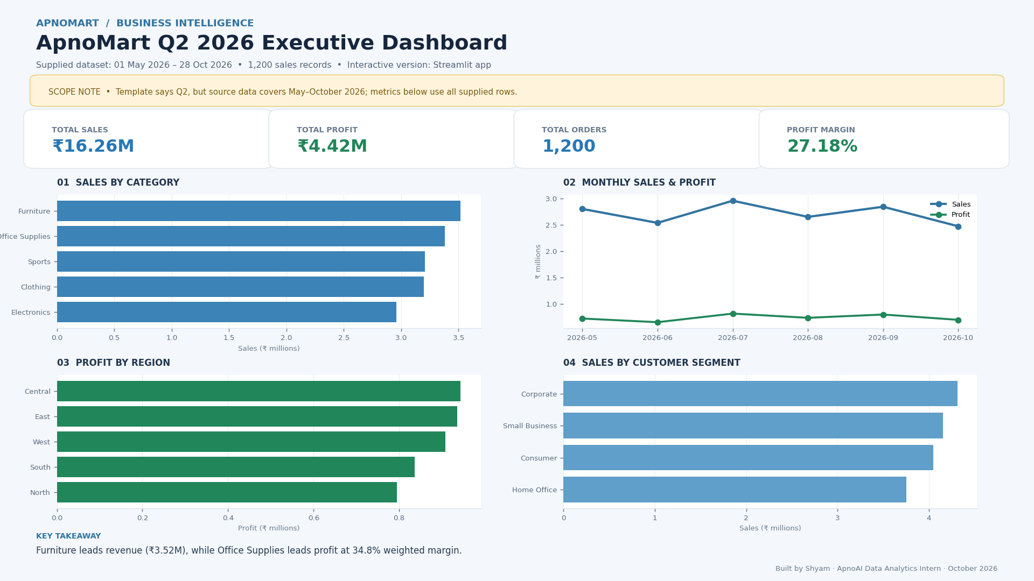
Calculated field: Weighted Profit Margin % = SUM(Profit) / SUM(Sales) × 100.

AI-use disclosure
ChatGPT helped organize the analysis, refine business wording and scaffold the report/dashboard code. Metrics were calculated from the supplied dataset; the reporting-period mismatch is explicitly disclosed.

