
VEDANTA KITCHEN & RETREAT CENTRE
Kitchen Safety Brochure &
Combined Risk Assessment Pack
Equipment · Chemicals (Sylvester Keal) · Step-by-step care guides
with Do / Don’t / Care visuals for staff training
Assessor: Shyam Prasad
Location: The Vedanta Kitchen & Retreat Centre
Document date: 27 July 2026
Review due: 27 July 2027
Chemical supplier reference: Sylvester Keal (SK brochure)
Includes:
TRK70 · Rational Oven · SK Chemicals / COSHH · Thermomix · Caso ·
Ninja · KitchenAid · Waring · Knives / Mandoline ·
Kitchen, Catering, FOH & Generic Assessments

Contents
Use this pack as the master risk assessment file for kitchen and catering operations.
1. Electrolux / Dito Sama TRK70 Combined Cutter & Vegetable Slicer
2. Rational Combi Oven
3. Kitchen Chemicals (COSHH)
4. Thermomix TM6
5. Caso Ice Creamer
6. Ninja Hand Blender
7. KitchenAid Professional Stand Mixer
8. Waring Stick Blender
9. Knives, Mandoline, Slicers & Peelers
10. Mixers & Blenders — Visual Safety Guide
11. Knives & Mandoline — Visual Safety Guide
12. Vedanta Kitchen Risk Assessment
13. Vedanta Catering Services Risk Assessment
14. Vedanta Front of House & Kitchen Risk Assessment
15. Vedanta Generic Kitchen Risk Assessment (June 2024)
16. Document Control & Sign-Off

Electrolux / Dito Sama TRK70 — Combined Cutter & Vegetable Slicer Risk Assessment
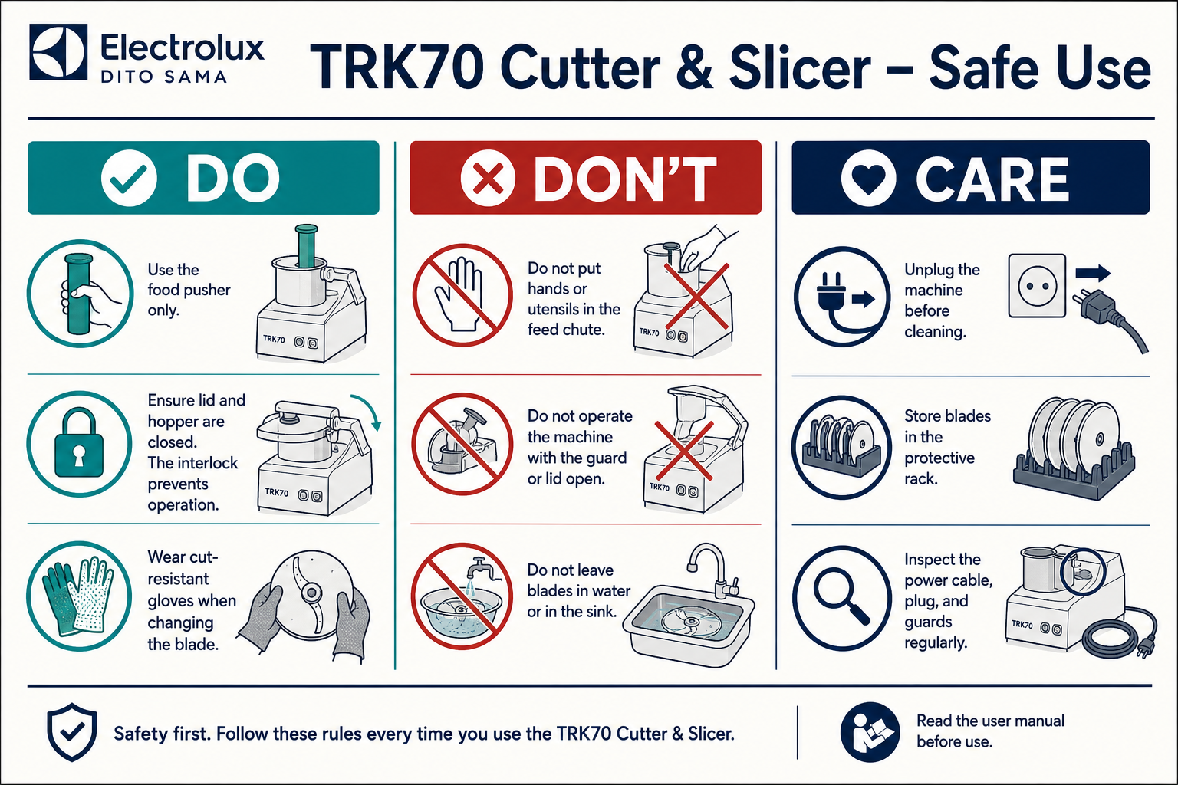
Quick visual guide — Do / Don’t / Care
DO
- Use only the supplied food pusher
- Keep hopper / lid closed and interlocks engaged
- Wear cut-resistant gloves when changing blades
- Unplug before cleaning or clearing blockages
DON’T
- Never put hands or utensils in the feed chute while powered
- Never run the machine with a guard open or bypassed
- Never leave blades in sink water or loose in drawers
- Never allow untrained staff to operate the TRK70
CARE
- Inspect guards, cable and blades before every use
- Store discs in the protective rack
- Clean and sanitise food-contact parts after use
- Label and remove faulty equipment from service
1. Workplace & Equipment Information
Workplace | The Vedanta Kitchen & Retreat Centre
Department | Main Kitchen
Equipment | Electrolux / Dito Sama TRK70 Combined Cutter and Vegetable Slicer
Manufacturer / model | Electrolux Professional / Dito Sama TRK70
Persons completing the task | Trained and authorised kitchen staff
Assessor | Shyam Prasad
Assessment date | 27 July 2026
Review date | 27 July 2027, or sooner after an accident, near miss, equipment change or safety concern
Manager responsible | [Name]

2. Activity Covered
Operating, loading, unloading, changing cutting discs or blades, clearing blockages, dismantling, cleaning, reassembling and maintaining the TRK70.
The TRK70 uses interchangeable rotating blades and discs for cutting, chopping, slicing, grating, shredding and dicing food. The machine incorporates a magnetic safety system and motor brake intended to stop operation when the hopper, vegetable preparation lever or cutter lid is not correctly closed. These safety systems must never be defeated or bypassed.
3. Persons at Risk
- Chefs and kitchen assistants
- Kitchen porters and cleaning staff
- Maintenance contractors
- Employees working close to the machine
- New, inexperienced or young workers
- Consumers, where poor cleaning or allergen controls could contaminate food
4. Risk-Rating System
Likelihood
- 1 – Rare
- 2 – Unlikely
- 3 – Possible
- 4 – Likely
- 5 – Almost certain
Severity
- 1 – Minor injury
- 2 – Injury requiring first aid
- 3 – Injury requiring medical treatment
- 4 – Serious injury
- 5 – Fatality or life-changing injury
Risk score = Likelihood × Severity
- 1–4: Low
- 5–9: Medium
- 10–15: High
- 16–25: Very high
5. Significant Hazards and Control Measures
Hazard | Possible harm | Initial risk | Required control measures | Residual risk
Contact with rotating cutter blade or slicing disc | Deep cuts, amputation or life-changing injury | 15 – High | Only trained and authorised staff may operate. All guards, hopper, lid, pushers and interlocks must be correctly fitted. Hands, knives, spoons and utensils must never enter the feed opening or bowl while connected to power. Feed food only with the supplied pusher. | 5 – Medium
Reaching into the machine while it is running | Severe cuts, crushing or amputation | 15 – High | Never reach beneath the hopper, through the feed chute or into the cutter bowl while operating. Stop and isolate from the electrical supply before inspecting or touching internal components. | 5 – Medium
Unexpected start-up during assembly, cleaning or blockage removal | Contact with moving blades resulting in serious injury | 15 – High | Switch off using the main control, turn off the rear isolation switch and unplug before dismantling, cleaning, changing blades or clearing a blockage. Keep the plug under the operator’s control until the task is complete. | 5 – Medium
Defective, removed or bypassed guard / interlock | Access to dangerous moving parts | 15 – High | Check lid, hopper, pusher, guard and safety interlock before every use. Never bypass, tape down or modify a safety device. If the machine runs with a guard open, stop, unplug, label “DO NOT USE” and report to the manager. | 5 – Medium
Handling, fitting or removing sharp blades and discs | Cuts and puncture wounds to hands and fingers | 12 – High | Switch off and unplug before handling blades. Hold only by hub, handle or non-cutting edge. Wear cut-resistant gloves when changing, transporting or manually cleaning blades. Do not test sharpness with fingers. | 4 – Low
Blades stored incorrectly | Cuts while reaching into drawers or cupboards | 12 – High | Store each blade and disc in a designated rack, protective holder or labelled container. Cutting edges must not be left exposed. Never leave blades submerged in sinks or hidden beneath other equipment. | 4 – Low
Blocked machine or food becoming stuck | Operator may attempt to push food with hands or utensils | 15 – High | Stop and unplug before clearing any blockage. Wait until all movement has stopped. Remove hopper, lid or attachment per manufacturer instructions. Use an appropriate cleaning tool after isolation; never use hands while connected. | 5 – Medium
Food or broken blade components being ejected | Cuts, bruising or eye injury | 12 – High | Inspect blades, discs, bowl, shaft and attachments for cracks, distortion or damage before use. Secure attachments correctly. Do not process bones, frozen-solid food or unsuitable materials. Do not overload. Stand clear when starting. | 4 – Low
Loose clothing, jewellery or long hair becoming caught | Entanglement, pulling or impact injury | 12 – High | Wear close-fitting kitchen clothing. Tie back and secure long hair. Remove loose jewellery, scarves and lanyards. Secure sleeves. Do not distract anyone operating the machine. | 4 – Low
Electrical damage, wet plug or damaged cable | Electric shock, burns or fire | 10 – High | Visually inspect plug, cable, socket and machine before use. Keep connections dry. Do not use with wet hands or pull/lift by the cable. Damaged equipment must be unplugged, labelled and removed from service until repaired by a competent person. | 5 – Medium
Water entering the motor or electrical controls during cleaning | Electric shock, equipment failure or fire | 10 – High | Unplug before cleaning. Never hose down, immerse or pressure-wash the motor base. Clean with a damp cloth using the manufacturer-approved method. Removable food-contact parts may be cleaned separately. Ensure components are dry before reassembly. | 5 – Medium
Cleaning chemicals | Skin irritation, eye damage or breathing difficulty | 6 – Medium | Follow the relevant COSHH assessment and product instructions. Use correct dilution. Wear gloves and eye protection where specified. Never mix chemicals. Store away from food and rinse food-contact components thoroughly. | 3 – Low
Wet or contaminated floor around the machine | Slips, falls, strains or impact injuries | 9 – Medium | Position on a stable work surface. Clean spillages immediately. Display a wet-floor sign where necessary. Keep the power cable away from walkways. Wear slip-resistant safety footwear. | 3 – Low
Machine positioned on an unstable or unsuitable surface | Machine movement, falling equipment or operator injury | 12 – High | Place on a strong, level, dry and stable surface at a comfortable working height. Ensure the base is secure before operation. Do not operate close to the edge of a workbench. | 4 – Low
Lifting or moving the machine and attachments | Back, shoulder, hand or foot injuries | 9 – Medium | Avoid moving the complete machine unnecessarily. Assess weight before lifting. Use a trolley or two-person lift where required. Remove loose attachments before transport. Keep the route clear and use correct manual-handling techniques. | 4 – Low
Repetitive loading, pushing and awkward posture | Musculoskeletal injury or fatigue | 6 – Medium | Position the machine at a suitable height. Keep ingredients close to the operator. Avoid twisting or overreaching. Rotate tasks during prolonged production and take appropriate breaks. | 2 – Low
Excessive machine noise, vibration or overheating | Hearing discomfort, equipment failure or fire | 6 – Medium | Stop if unusual noise, vibration, smell, smoke or overheating occurs. Unplug and report the fault. Do not continue operating damaged equipment. Keep ventilation openings clear. | 2 – Low
Poor cleaning or food remaining inside attachments | Bacterial contamination and food poisoning | 12 – High | Dismantle and clean food-contact parts after every use and between incompatible foods. Inspect hidden areas, shafts, seals, lids and feed components. Sanitise using the approved kitchen procedure and dry before reassembly. | 4 – Low
Allergen cross-contamination | Allergic reaction, potentially severe or fatal | 12 – High | Follow the kitchen allergen-management procedure. Clean and sanitise bowl, blades, discs, hopper, pushers, utensils and surrounding work surface between allergen and non-allergen recipes. Use dedicated equipment where required and verify cleaning before production begins. | 4 – Low
Use by an untrained or unauthorised person | Incorrect assembly, unsafe operation or serious injury | 15 – High | Operators must receive practical training and be assessed as competent. New employees must be directly supervised. Cleaning staff must be trained in isolation and safe blade handling. Operating instructions and this assessment must remain accessible. | 5 – Medium
Maintenance or repairs by an unauthorised person | Electric shock, unexpected movement or defective safety systems | 15 – High | Operators may only perform normal cleaning and user checks. Electrical repairs, motor work, interlock adjustments and internal maintenance must be completed by an authorised competent engineer. | 5 – Medium

6. Safe Operating Procedure
Before use
1. Confirm that the operator is trained and authorised.
2. Check that the machine is clean, dry and correctly positioned.
3. Inspect the plug, cable, controls, bowl, lid, hopper, pusher, blades and discs.
4. Confirm that all guards and safety interlocks are present and undamaged.
5. Select the correct blade, disc and speed for the food being processed.
6. Fit the attachment while the machine is unplugged.
7. Confirm that the blade or disc is properly secured.
8. Secure long hair and remove loose jewellery.
9. Keep the floor and surrounding work area clean and dry.
10. Do not operate the machine if any component is missing, loose or damaged.
During operation
1. Close and secure the bowl lid or vegetable-slicer hopper.
2. Start the machine only after checking that no person is touching the attachments.
3. Use only the supplied pusher to feed food.
4. Never place hands or utensils inside the feed opening or bowl.
5. Do not overload the machine.
6. Remain with the machine while it is operating.
7. Stop immediately if there is unusual noise, vibration, smell, heat or movement.
8. Do not remove any guard until the machine has stopped completely and has been unplugged.
Blade or disc changes
1. Switch the machine off.
2. Turn off the rear isolation switch.
3. Unplug the machine.
4. Wait until all movement has stopped.
5. Wear suitable cut-resistant gloves.
6. Hold the blade or disc by its hub or non-cutting edge.
7. Place the removed blade directly into its protective storage rack.
8. Fit the replacement securely before reconnecting the machine.
Clearing a blockage
1. Press the stop control.
2. Switch off the main isolation switch.
3. Unplug the machine.
4. Keep control of the plug.
5. Wait for the blade or disc to stop completely.
6. Carefully dismantle the appropriate attachment.
7. Remove the blockage without placing fingers against cutting edges.
8. Inspect for blade damage before reassembling.
9. Do not restart the machine until all guards are correctly fitted.
Cleaning
1. Switch off and unplug the machine.
2. Wear cut-resistant gloves when handling blades.
3. Remove the blade or disc first and place it in a safe position.
4. Never leave a blade hidden or submerged in washing-up water.
5. Dismantle removable food-contact components.
6. Wash, rinse, sanitise and dry components according to the kitchen cleaning procedure.
7. Do not immerse or hose down the motor base.
8. Inspect components for cracks, damage or food deposits.
9. Reassemble only when all parts are clean and dry.
10. Store blades and discs in their designated protective rack.
7. Emergency Arrangements
Serious cut or amputation
- Stop and isolate the machine immediately.
- Call 999 for a serious or uncontrolled injury.
- Apply firm pressure using a sterile dressing.
- Do not remove embedded objects.
- Preserve any severed part in a clean sealed bag, place that bag within another bag containing ice, and send it with the injured person.
- Report the accident immediately and secure the machine for investigation.
Electric shock
- Do not touch the injured person until the electrical supply has been safely isolated.
- Switch off the supply or unplug the machine where safe.
- Call 999.
- Begin first aid or CPR if trained and instructed to do so.
Equipment malfunction
- Press stop and disconnect the power.
- Label the machine “DO NOT USE – FAULTY.”
- Inform the kitchen manager.
- Arrange inspection by a competent engineer.
- Do not return the machine to service until formally declared safe.
8. Training Requirements
Operators must be trained in:
- Correct assembly and attachment selection
- Operation of the controls and isolation switch
- Use of guards, hopper and food pushers
- Safe blade and disc handling
- Blockage-clearing procedure
- Cleaning and sanitising
- Allergen cross-contamination controls
- Pre-use inspection and fault reporting
- Emergency procedures
Training must be recorded and refreshed following an accident, near miss, unsafe practice, equipment modification or significant period without using the machine.
9. Inspection and Maintenance
- Carry out a visual pre-use check before every shift.
- Inspect guards, lids, pushers and interlocks before every use.
- Record and report damage immediately.
- Maintain the machine according to the manufacturer’s instructions.
- Arrange electrical inspection and testing based on usage, environment and previous inspection results.
- Only competent authorised persons may repair or adjust the machine.
- Keep servicing, repair and inspection records.
10. Residual Risk Statement
Provided that all listed controls are implemented, operators are trained, guards and interlocks remain functional, and the machine is isolated before blade handling, cleaning or blockage removal, the remaining risk is considered medium to low and tolerable with continued supervision.
The machine must not be used where:
- A guard, lid, hopper or pusher is missing
- A safety interlock is defective
- The blade or disc is damaged
- The machine starts while a guard is open
- The cable, plug or controls are damaged
- There is unusual noise, vibration, heat, smoke or smell
- The operator has not received suitable training
11. Required PPE
- Apron / chef whites
- Non-slip / slip-resistant footwear
- Cut-resistant gloves when changing, transporting or manually cleaning blades and discs
- Eye protection and chemical gloves where specified by COSHH for cleaning chemicals
12. Approval
Assessor’s name | Shyam Prasad
Assessor signature
Assessor date | 27 July 2026
Manager’s name
Manager signature
Manager date

13. Employee Acknowledgement
I confirm that I have read and understood this risk assessment, received suitable instruction and training, and agree to follow the stated control measures and safe operating procedure.
Employee name | Signature | Date

Rational Combi Oven — Equipment Risk Assessment & Operating Procedures
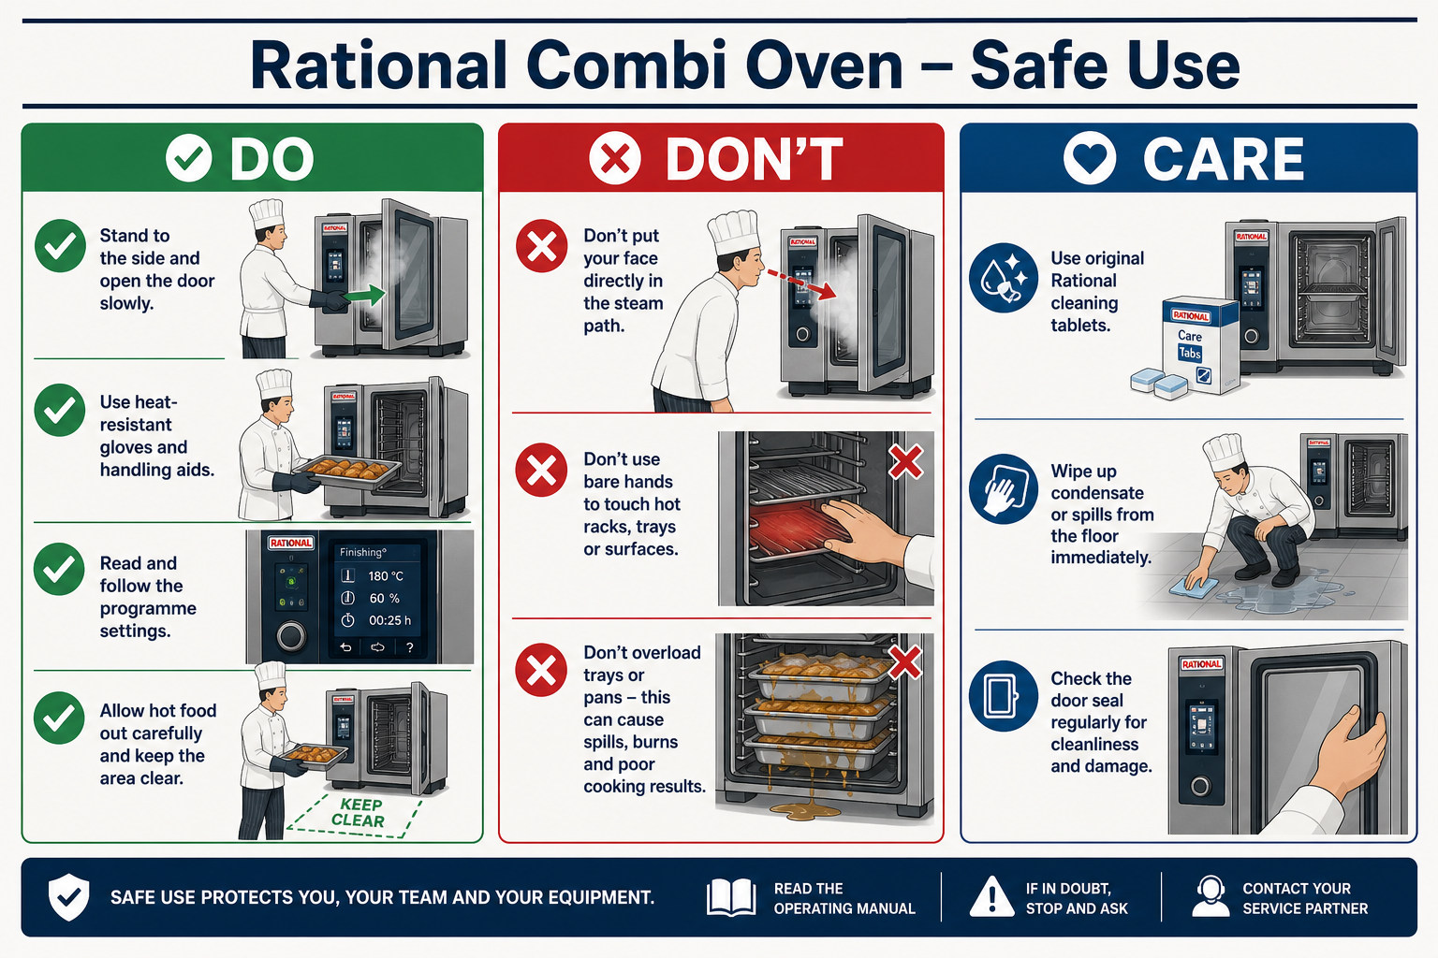
Quick visual guide — Do / Don’t / Care
DO
- Stand to the side and open the door slowly to release steam
- Use heat-resistant gloves / dry cloths for trays and racks
- Select the correct programme and temperature
- Use only approved Rational / SK cleaning tablets as directed
DON’T
- Don’t put your face in the steam path
- Don’t touch hot racks or glass with bare hands
- Don’t overload trays or leave grease fires unattended
- Don’t mix oven cleaners with other chemicals
CARE
- Check door seals and racks before service
- Wipe condensate and keep floors dry
- Run CareControl / cleaning programmes with correct tablets
- Keep SDS for Rational detergent and care tablets with this pack
1. Equipment Information
Workplace | The Vedanta Kitchen & Retreat Centre
Department | Main Kitchen
Equipment | Rational Combi Oven (steam / convection / combi modes)
Manufacturer / model | Rational (model as installed on site)
Persons completing the task | Trained and authorised kitchen staff
Assessor | Shyam Prasad
Assessment date | 27 July 2026
Review date | 27 July 2027, or sooner after an accident, near miss, equipment change or safety concern
Manager responsible | [Name]

2. Description of Equipment
A commercial Rational combi oven used for roasting, baking, steaming, regenerating and combination cooking. The oven can produce high temperatures, steam, hot surfaces, hot liquids and condensate. Self-cleaning / CareControl programmes may use cleaning chemicals under heat and pressure and must only be run by trained staff following manufacturer instructions.
3. Persons at Risk
- Chefs and kitchen assistants
- Kitchen porters and cleaning staff
- Maintenance contractors
- Staff working near the oven during service
- New, inexperienced or young workers
- Consumers, where poor cooking or cleaning controls affect food safety
4. Operating Procedure (How to Use)
Before use
1. Confirm the operator is trained and authorised on the Rational oven.
2. Check the door seal, handle, racks, trays, probes and controls are clean and undamaged.
3. Ensure the oven is stable, vents are clear and the surrounding floor is dry.
4. Confirm water and power connections are correct where relevant.
5. Select the correct mode, temperature and programme for the product.
6. Do not operate if the door, glass, seal, racks or controls are damaged.
During cooking
1. Load trays carefully; do not overload racks or block airflow.
2. Keep face and forearms clear when opening the door — open slowly to release steam away from the body.
3. Announce “hot” / “steam” when opening during busy service.
4. Use dry oven cloths or heat-resistant gloves for trays and racks.
5. Never leave flammable materials on or against the oven.
6. Remain aware of hot condensate and dripping liquids from trays.
7. Stop the programme and seek help if unusual noise, smell, smoke or error codes occur.
After use / cleaning
1. Allow the oven to cool to a safe temperature before manual cleaning where required.
2. Remove food debris from trays, racks and the cavity using approved methods.
3. Run manufacturer cleaning / rinse programmes only with approved Rational cleaning chemicals and correct dosing.
4. Never mix cleaning tablets/liquids with other chemicals.
5. Wear gloves and eye protection when handling oven cleaner.
6. Keep the door closed during automatic cleaning cycles as instructed.
7. Wipe surrounding floors of condensate and leave the area safe for the next service.
5. Risk Assessment
Hazard | Possible harm | Initial risk | Required control measures | Residual risk
Burns from hot surfaces, trays, racks and door glass | Burns to hands, arms or face | 15 – High | Use dry heat-resistant gloves/cloths; warn others; allow cooling where practical; never touch heating elements or hot racks bare-handed. | 5 – Medium
Steam release when opening the door | Scalds to face, neck, arms or chest | 15 – High | Stand to the side; open door slowly; keep face clear of the opening; announce steam release during service. | 5 – Medium
Hot liquid / grease spill from trays | Scalds, slips or secondary burns | 12 – High | Load trays level; do not overfill; use both hands; wipe spills immediately; non-slip footwear. | 4 – Low
Entrapment / impact from door or falling racks | Bruising, crush or impact injury | 9 – Medium | Open and close door under control; seat racks fully on supports; do not overload shelves. | 3 – Low
Fire from grease build-up or unsuitable items | Burns, smoke inhalation or property damage | 12 – High | Clean regularly; never cook with excessive unattended oil; know extinguisher type and shut-off procedure; keep flammables away. | 4 – Low
Electrical fault or damaged cable / controls | Electric shock, burns or fire | 10 – High | Visual checks before use; report faults; isolate and label “DO NOT USE”; repairs by competent engineer only. | 5 – Medium
Contact with oven cleaning chemicals | Skin/eye burns, irritation or breathing difficulty | 12 – High | Use only approved Rational cleaner; follow COSHH and dosing instructions; wear gloves and eye protection; never mix chemicals; rinse as required. | 4 – Low
Slips from condensate / cleaning water around oven | Slips, falls and impact injuries | 9 – Medium | Mop condensate promptly; wet-floor signs; keep walkways clear; slip-resistant footwear. | 3 – Low
Manual handling of loaded trays / trolleys | Back, shoulder or strain injuries | 9 – Medium | Use trolley where available; keep loads manageable; ask for help with heavy pans; good posture. | 4 – Low
Undercooking / temperature abuse of food | Food poisoning risk to guests | 12 – High | Use correct programmes; probe core temperatures where required; follow HACCP and hot-holding rules. | 4 – Low
Use by untrained staff | Burns, scalds, chemical injury or unsafe cooking | 12 – High | Only trained authorised operators; supervise new staff; keep operating instructions accessible. | 4 – Low

6. Required PPE
- Apron / chef whites
- Non-slip footwear
- Heat-resistant gloves or dry oven cloths
- Chemical-resistant gloves and eye protection when handling oven cleaner
7. Emergency Arrangements
- Burns/scalds: cool under lukewarm running water for at least 20 minutes; seek first aid; call 999 for serious burns.
- Fire: shut down if safe, evacuate if needed, use the correct extinguisher only if trained, call 999.
- Chemical contact: rinse skin/eyes as per SDS/COSHH; seek medical help for eye exposure or persistent symptoms.
- Faulty oven: stop programme if safe, isolate power where possible, label “DO NOT USE – FAULTY”, report to manager.
8. Additional Notes
- This section restores the Rational oven risk assessment that was missing from the earlier combined pack.
- Insert the exact Rational model number from the machine rating plate when known.
- Keep the manufacturer manual and cleaning chemical SDS with this assessment.

Kitchen Chemicals (COSHH) — Sylvester Keal Product Risk Assessment
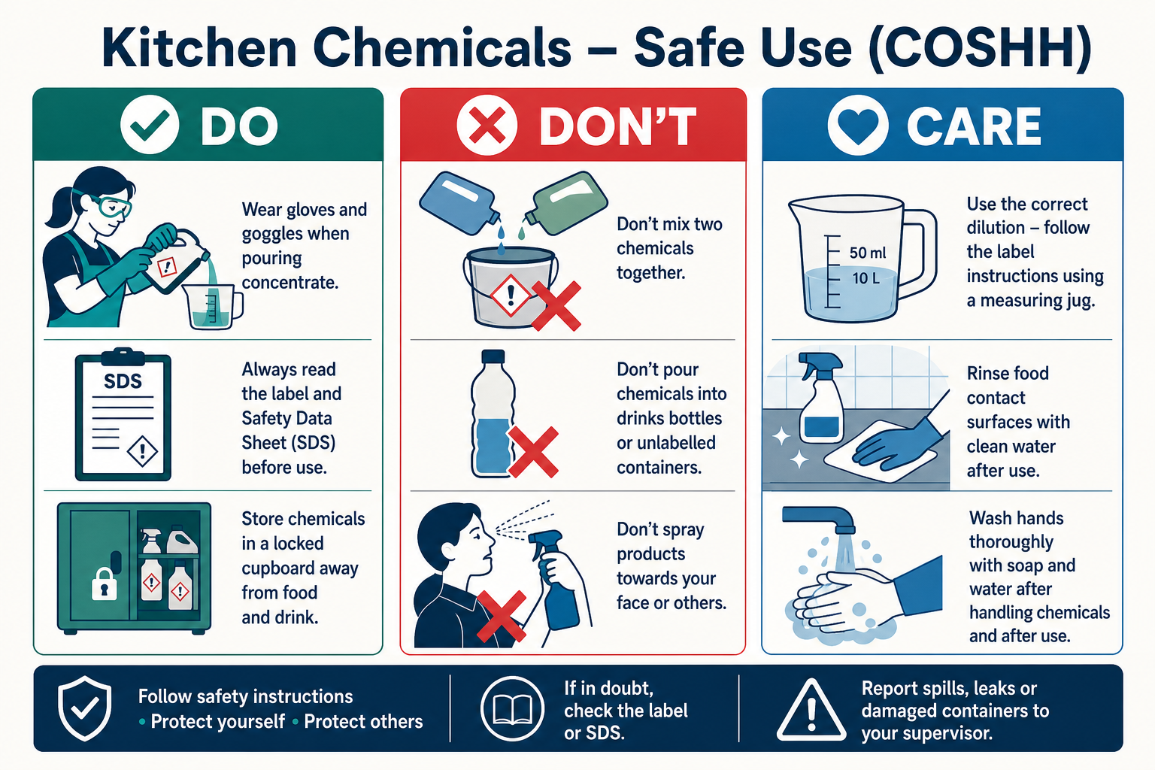
Quick visual guide — Do / Don’t / Care
DO
- Wear gloves (and eye protection for concentrates / oven cleaner)
- Read the label and SDS before use
- Store chemicals locked / labelled, away from food
- Dilute and dose exactly as instructed
DON’T
- Never mix chemicals together
- Never pour chemicals into drinks or food bottles
- Never spray toward your face or other people
- Never use a product with no label or SDS
CARE
- Keep Sylvester Keal SDS sheets with this pack
- Rinse food-contact surfaces after cleaning
- Wipe spills and wash hands before handling food
- Review when a new SK product is introduced
1. Assessment Information
Workplace | The Vedanta Kitchen & Retreat Centre
Department | Main Kitchen / Cleaning
Activity | Storage, dosing, use and disposal of Sylvester Keal kitchen cleaning chemicals
Supplier | Sylvester Keal (SK) — https://sylvesterkeal.co.uk/sk-company-brochure/
Persons completing the task | Chefs, kitchen porters, cleaning staff and authorised users
Assessor | Shyam Prasad
Assessment date | 27 July 2026
Review date | 27 July 2027, or sooner after an incident, product change or SDS update
Manager responsible | [Name]

2. Site Chemical Inventory (Sylvester Keal)
Products in use / available for Vedanta kitchen operations, based on staff knowledge and the Sylvester Keal Machine & Manual Dishwashing / oven-care range. All SK products have COSHH Safety Data Sheets — keep the current SDS for each code with this pack.
Product | Code | Pack size | Intended use
SK Premium Dishwashing Detergent | 1A | 2×5L / 20L | Machine detergent for hard water; tannin & scale control
SK Premium Dishwashing Rinse Aid | 2B | 2×5L / 20L | Machine rinse aid for hygienic, streak-free finish
SK Salt Pebble | PE12705 | 25KG | Water softener salt — limescale prevention
SK Salt Granular (Hydrosoft) | 1270S | 25KG | Granular vacuum salt for granular softeners
SK 1DT Dishwasher Tablets | 1DT | 15×7 tablets | 7-in-1 lemon tablets for machine wash sparkle
SK Super Lemon Sinkwash | 3L | 2×5L / 12×1L | Manual wash-up of crockery, glass, pans; light cleaning
SK Bacti Manual Dishwashing Detergent | 3AB | 2×5L / 20L | Concentrated neutral detergent; cuts grease; streak-free rinse
SK Heavy Duty Degreaser | — | As supplied | Caustic powder for burnt-on oils/fats on trays & equipment
SK Hot Oven Cleaner | — | As supplied | Removes oils, fats, carbon from hot plates, grills, griddles
SK Rational Detergent Tablets | — | As supplied | Red detergent tablets for Rational combi oven cleaning
SK Rational Active Green Care Cleaner Tablets | — | As supplied | For iCombi Pro / Classic — phosphate-free care cleaner
SK Rational Combi Care Control Tablets | — | As supplied | Care/control tablets for Rational (also Lincat SCC)

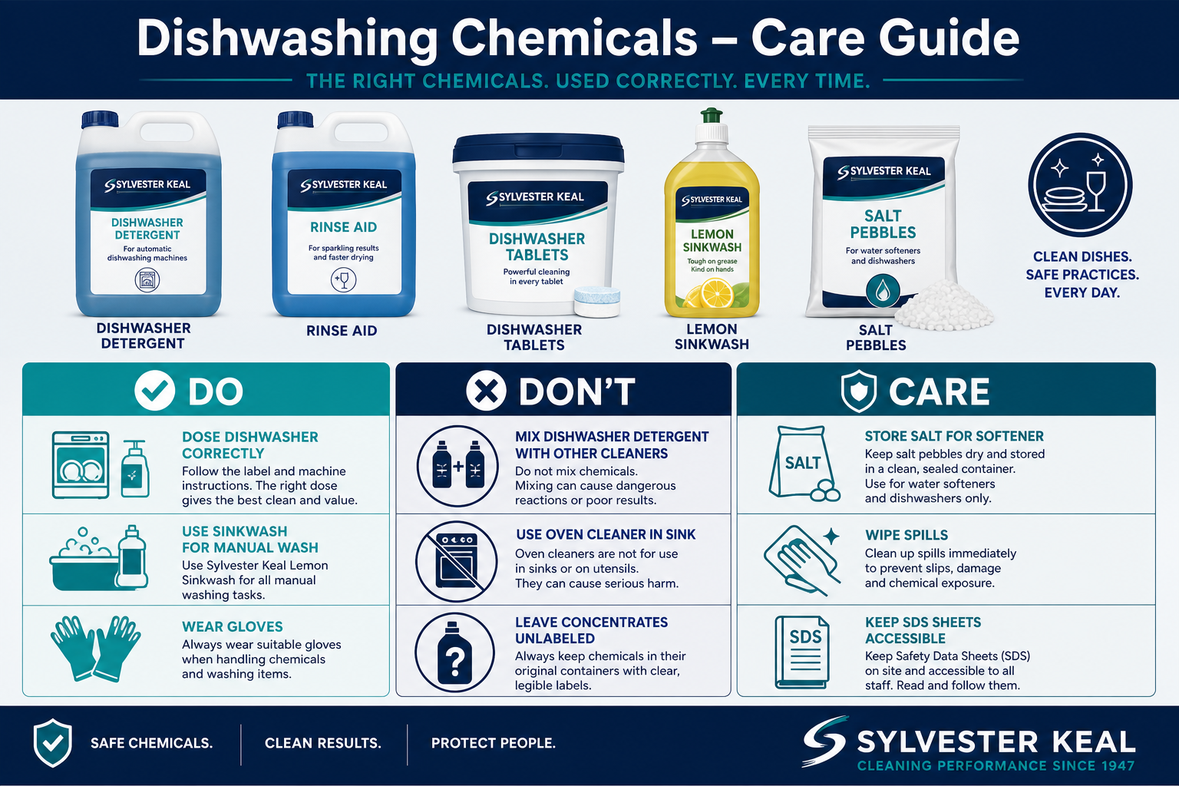
3. Step-by-step — Dishwashing chemicals
Machine dishwashing (1A / 2B / salt / tablets)
1. Check dishwasher is empty of food debris and spray arms are free.
2. Ensure softener salt (pebble or granular) is topped up if the machine requires it.
3. Confirm detergent (1A or tablets 1DT) and rinse aid (2B) are correctly loaded / dosed.
4. Wear gloves when handling concentrates or tablets.
5. Run the cycle; do not open mid-cycle if steam/chemical vapour is present.
6. On empty containers, store upright, labelled, away from food.
Manual dishwashing (Super Lemon Sinkwash / Bacti Manual)
1. Scrape food soil into waste before washing.
2. Dilute sinkwash / Bacti Manual as per label — do not guess a stronger mix.
3. Wash, rinse and sanitise following kitchen procedure.
4. Change water when heavily soiled; wipe spills around the sink.
5. Wash hands after chemical contact and before handling clean service ware.
Oven / heavy degreasing (Rational tablets / Hot Oven Cleaner / Heavy Duty Degreaser)
1. Only trained staff may use oven cleaner, caustic degreaser or Rational cleaning tablets.
2. Wear chemical gloves and eye protection.
3. For Rational: use only the correct tablet type for the oven model; run the manufacturer cleaning programme; keep door closed.
4. For Hot Oven Cleaner / Heavy Duty Degreaser: follow label; do not use on aluminium where the product warns against it.
5. Never mix these products with sinkwash, bleach or other cleaners.
6. Rinse food-contact surfaces thoroughly after use.
4. Persons at Risk
- Kitchen porters and cleaning staff
- Chefs and assistants using chemicals during service or close-down
- Maintenance staff
- Other employees nearby during spraying or mopping
- Guests, if residues remain on food-contact surfaces
- New or inexperienced workers
5. Risk Assessment
Hazard | Possible harm | Initial risk | Required control measures | Residual risk
Skin contact with concentrates (1A, sinkwash, degreaser, oven cleaner) | Irritation, dermatitis or chemical burns | 12 – High | Gloves for concentrates; correct dilution; wash splashes promptly; report skin problems early. | 4 – Low
Eye contact from splash (oven cleaner / caustic degreaser / dosing) | Eye irritation or serious eye damage | 12 – High | Eye protection for aggressive cleaners; pour carefully; know eye-wash location. | 4 – Low
Mixing incompatible SK / other chemicals | Toxic gas, burns or violent reaction | 15 – High | Never mix products; rinse between different cleaners; train and supervise staff. | 4 – Low
Rational tablet / hot oven cleaner misuse | Severe skin/eye burns or inhalation injury | 15 – High | Trained staff only; correct tablet for model; door closed on auto clean; PPE; follow SDS. | 5 – Medium
Chemical in unmarked / food bottle | Accidental ingestion or food contamination | 15 – High | Original SK labelled containers only; separate chemical store; stock checks. | 4 – Low
Residue on crockery or prep surfaces | Chemical contamination of food | 12 – High | Correct rinse aid dosing; rinse food-contact surfaces; follow contact times for sanitisers. | 4 – Low
Spillage of detergent / degreaser | Slips and skin/eye exposure | 9 – Medium | Contain with PPE; wet-floor sign; dispose correctly; report significant spills. | 3 – Low
Untrained person using chemicals | Incorrect use leading to injury or contamination | 12 – High | COSHH induction; product-specific instruction; SDS accessible; supervise until competent. | 4 – Low

6. Required PPE
- Chemical-resistant gloves suitable for the product
- Eye protection for concentrates, Hot Oven Cleaner, Heavy Duty Degreaser and Rational cleaning chemicals
- Apron where specified
- Non-slip footwear
- Additional PPE as stated on the Sylvester Keal product SDS
7. Emergency Arrangements
- Skin contact: remove contaminated clothing; rinse with plenty of water; seek first aid / medical advice if irritation persists.
- Eye contact: rinse immediately with clean water for at least 15 minutes; seek urgent medical attention.
- Inhalation: move to fresh air; seek medical help if breathing is affected.
- Swallowing: do not induce vomiting unless SDS advises; call 999 / poison guidance and take the product label/SDS.
- Large spill or unknown reaction: evacuate immediate area, ventilate if safe, inform manager, do not neutralise by mixing other chemicals.
8. Training & Records
- All users must receive COSHH awareness and product-specific instruction before unsupervised use.
- Keep Sylvester Keal SDS sheets for every chemical code in an accessible folder.
- Record training, product changes and any chemical-related incidents or near misses.
- Review this assessment when a new SK product is introduced or an SDS is updated.
- Brochure reference: https://sylvesterkeal.co.uk/sk-company-brochure/
9. Additional Notes
- This inventory is based on products confirmed by kitchen knowledge and the Sylvester Keal brochure range.
- Where a product SDS sets stricter controls than this sheet, follow the SDS.
- Rational cleaning tablets must only be used in compatible Rational / approved ovens.

Thermomix TM6 — Equipment Risk Assessment & Operating Procedures
1. Equipment Information
Location | The Vedanta Kitchen & Retreat Centre
Assessor | Shyam Prasad
Brand | Thermomix
Model | TM6
Date Completed | 27/07/2026
Review Date | 04/11/2025

2. Description of Equipment
A multi-function cooking appliance used for chopping, blending, cooking, steaming, kneading and precise heating. Used for soups, sauces, doughs, purees and prepared dishes in bakery and catering production.
3. Operating Procedure (How to Use)
1. Place the Thermomix on a stable, dry, level work surface with adequate ventilation around the base.
2. Ensure the mixing bowl is correctly seated and locked before use.
3. Fit the correct blade or accessory for the task and secure the lid and measuring cup as required.
4. Select the appropriate mode, temperature and speed for the recipe; do not exceed recommended fill levels.
5. Keep hands, utensils and cloths away from the blade area while the machine is running.
6. Allow hot contents to settle before opening the lid; open away from the face to avoid steam.
7. Use the spatula only through the lid opening when the manufacturer instructions allow.
8. Switch off and unplug before changing accessories, emptying the bowl or cleaning.
9. Clean food-contact parts thoroughly after each use and follow HACCP hygiene controls.
4. Risk Assessment
Hazard | People at Risk | Risk Before | Control Measures | Risk After
Blade contact / finger injury | Staff | High | Never reach into the bowl while powered; lock lid; unplug before removing blade. | Low
Steam / hot liquid burns | Staff | High | Use correct temperature settings; open lid carefully; use oven cloths for hot bowls. | Low
Electrical shock | Staff | Medium | Inspect cable and base; keep area dry; unplug before cleaning. | Low
Splash / ejection of hot contents | Staff | Medium | Do not overfill; use measuring cup; start at low speed for hot liquids. | Low
Food contamination | Guests / Staff | High | Clean and sanitise bowl, lid and blade; separate raw and ready-to-eat use; follow HACCP. | Low

5. Required PPE
- Apron
- Non-slip footwear
- Heat-resistant gloves or cloths when handling hot bowls / steam

Caso Ice Creamer — Equipment Risk Assessment & Operating Procedures
1. Equipment Information
Location | The Vedanta Kitchen & Retreat Centre
Assessor | Shyam Prasad
Brand | Caso
Model | Ice Creamer
Date Completed | 27/07/2026
Review Date | 04/11/2025

2. Description of Equipment
A countertop ice cream / frozen dessert machine used to churn and freeze ice cream, sorbet and similar products for catering and retreat service.
3. Operating Procedure (How to Use)
1. Position the machine on a stable, ventilated surface away from heat sources.
2. Ensure the freezing bowl / canister is correctly pre-frozen or pre-chilled as per the manual.
3. Assemble the paddle, lid and bowl securely before switching on.
4. Prepare mix to the correct recipe and temperature; do not overfill the bowl.
5. Start the machine and supervise during churning; do not leave unattended for long periods.
6. Do not insert hands or utensils into the bowl while the paddle is moving.
7. Switch off before removing the paddle or scraping the finished product.
8. Transfer product with clean utensils into sanitised containers and store under correct temperature control.
9. Clean all food-contact parts after use and dry thoroughly before storage.
4. Risk Assessment
Hazard | People at Risk | Risk Before | Control Measures | Risk After
Finger entrapment in paddle | Staff | High | Keep hands clear while running; switch off before scraping or removing paddle. | Low
Cold burns / freezer bowl handling | Staff | Medium | Handle frozen canister with dry cloths or gloves; do not touch with wet hands. | Low
Electrical shock | Staff | Medium | Keep cable and controls dry; inspect before use; unplug before cleaning. | Low
Slips from spilled mix | Staff | Medium | Wipe spills immediately; keep floor clear around machine. | Low
Food contamination / temperature abuse | Guests / Staff | High | Use clean utensils; chill finished product promptly; follow shelf-life and HACCP controls. | Low

5. Required PPE
- Apron
- Non-slip footwear
- Protective gloves when handling frozen canisters

Ninja Hand Blender — Equipment Risk Assessment & Operating Procedures
1. Equipment Information
Location | The Vedanta Kitchen & Retreat Centre
Assessor | Shyam Prasad
Brand | Ninja
Model | Hand Blender
Date Completed | 27/07/2026
Review Date | 04/11/2025

2. Description of Equipment
A handheld immersion blender used for pureeing soups, sauces, dressings and soft mixtures directly in pans or containers.
3. Operating Procedure (How to Use)
1. Check the blender shaft, blade guard and cable before use; do not use if damaged.
2. Ensure the pan or jug is stable and only partially filled to avoid splash-over.
3. Fully immerse the blade guard in the food before switching on.
4. Start on a low speed and keep the head submerged while blending.
5. Never blend with the blade above the liquid surface or near the rim of a shallow pan.
6. Do not insert fingers or utensils near the blade while powered.
7. Switch off and unplug before removing the shaft or cleaning the blade.
8. Allow hot liquids to cool slightly where practical to reduce splash risk.
9. Wash detachable parts, sanitise, dry and store with blade guard protected.
4. Risk Assessment
Hazard | People at Risk | Risk Before | Control Measures | Risk After
Blade cuts | Staff | High | Keep hands clear; unplug before cleaning; store with guard / cover. | Low
Hot liquid splash / burns | Staff | High | Immerse fully before starting; blend gently; use tall containers where possible. | Low
Electrical shock | Staff | Medium | Keep motor body dry; never immerse the handle; inspect cable. | Low
Dropped appliance / impact injury | Staff | Medium | Use two hands for deep pans; dry grip; do not stretch cables across walkways. | Low
Food contamination | Guests / Staff | High | Clean and sanitise shaft and blade after each use; avoid cross-contamination. | Low

5. Required PPE
- Apron
- Non-slip footwear
- Cut-resistant glove recommended when washing the blade

Mixers & Blenders — Visual Safety Guide
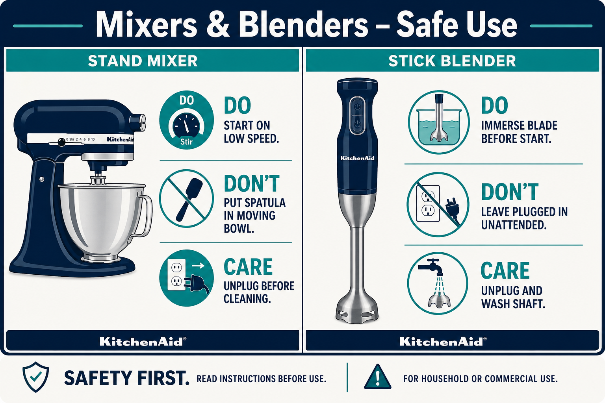
Quick visual guide — Do / Don’t / Care
DO
- Start stand mixers on the lowest speed
- Immerse stick-blender blade fully before switching on
- Unplug before changing tools or washing blades
- Use stable bowls / pans and dry grip
DON’T
- Don’t put spatulas or hands in a moving bowl
- Don’t leave a plugged-in stick blender unattended in a pot
- Don’t wash blades while still connected to power
- Don’t overfill bowls or shallow pans
CARE
- Inspect cables and attachments before use
- Clean and sanitise food-contact parts after each product
- Store blades with guards / covers
- Remove damaged equipment from service

KitchenAid Professional Stand Mixer — Equipment Risk Assessment & Operating Procedures
1. Equipment Information
Location | The Vedanta Kitchen & Retreat Centre
Assessor | Shyam Prasad
Brand | KitchenAid
Model | Professional Stand Mixer
Date Completed | 27/07/2026
Review Date | 04/11/2025

2. Description of Equipment
A heavy-duty stand mixer used for mixing doughs, batters, creams and other food ingredients. Commonly used for bakery and catering production.
3. Operating Procedure (How to Use)
1. Ensure the mixer is placed on a stable, dry surface before use.
2. Attach the correct tool (dough hook, whisk or flat beater) and lock the bowl securely.
3. Add ingredients carefully; do not exceed the recommended bowl capacity.
4. Start the mixer on the lowest speed and increase gradually as needed.
5. Never insert hands, spatulas or utensils into the bowl while the mixer is operating.
6. Stop the mixer completely before scraping the bowl or changing tools.
7. Unplug the mixer before cleaning or removing attachments.
8. Clean all food-contact parts thoroughly after each use.
9. Store attachments safely when not in use.
4. Risk Assessment
Hazard | People at Risk | Risk Before | Control Measures | Risk After
Finger entrapment | Staff | High | Keep hands away from moving parts; ensure mixer is off when changing tools. | Low
Electrical shock | Staff | Medium | Inspect cables; keep hands dry; unplug before cleaning. | Low
Cuts from whisk or hook edges | Staff | Medium | Handle attachments carefully; unplug before removal. | Low
Mixer movement during heavy loads | Staff | Medium | Ensure stable surface; supervise during thick dough mixing. | Low
Food contamination | Guests / Staff | High | Clean thoroughly; sanitise food-contact parts; follow HACCP. | Low

5. Required PPE
- Apron
- Non-slip footwear
- Heat-resistant gloves (when working with warm mixtures)

Waring Stick Blender — Equipment Risk Assessment & Operating Procedures
1. Equipment Information
Location | The Vedanta Kitchen & Retreat Centre
Assessor | Shyam Prasad
Brand | Waring
Model | Stick / Immersion Blender
Date Completed | 27/07/2026
Review Date | 04/11/2025

2. Description of Equipment
A commercial stick blender used for blending soups, sauces and large-batch liquids in pots and deep containers within the kitchen.
3. Operating Procedure (How to Use)
1. Inspect the shaft, blade, switch and power cable before each use.
2. Place the pot on a stable surface; do not overfill.
3. Immerse the blade fully before switching on.
4. Hold the blender with a firm grip; support the pot if needed.
5. Blend at controlled speed to avoid splash-back of hot liquids.
6. Never place hands near the blade while the unit is plugged in.
7. Switch off and unplug before dismantling or washing.
8. Clean immediately after use; sanitise food-contact surfaces.
9. Store hanging or in a designated safe location with blade protected.
4. Risk Assessment
Hazard | People at Risk | Risk Before | Control Measures | Risk After
Severe blade cuts | Staff | High | Unplug before cleaning; never leave plugged-in blender unattended in a pot; use blade cover in storage. | Low
Hot liquid burns / splash | Staff | High | Start submerged; use deep pots; reduce speed for hot liquids. | Low
Electrical shock | Staff | Medium | Keep motor housing dry; check cable integrity; RCD-protected circuits where available. | Low
Musculoskeletal strain | Staff | Medium | Use correct posture; avoid extended one-handed use; take breaks on large batches. | Low
Food contamination | Guests / Staff | High | Clean and sanitise after each product; follow allergen and HACCP controls. | Low

5. Required PPE
- Apron
- Non-slip footwear
- Cut-resistant glove when washing blades
6. Additional Notes
- This section consolidates Risk_Assessment_Waring_Stick_Blender.docx and the duplicate “(1)” file.

Knives & Mandoline — Visual Safety Guide
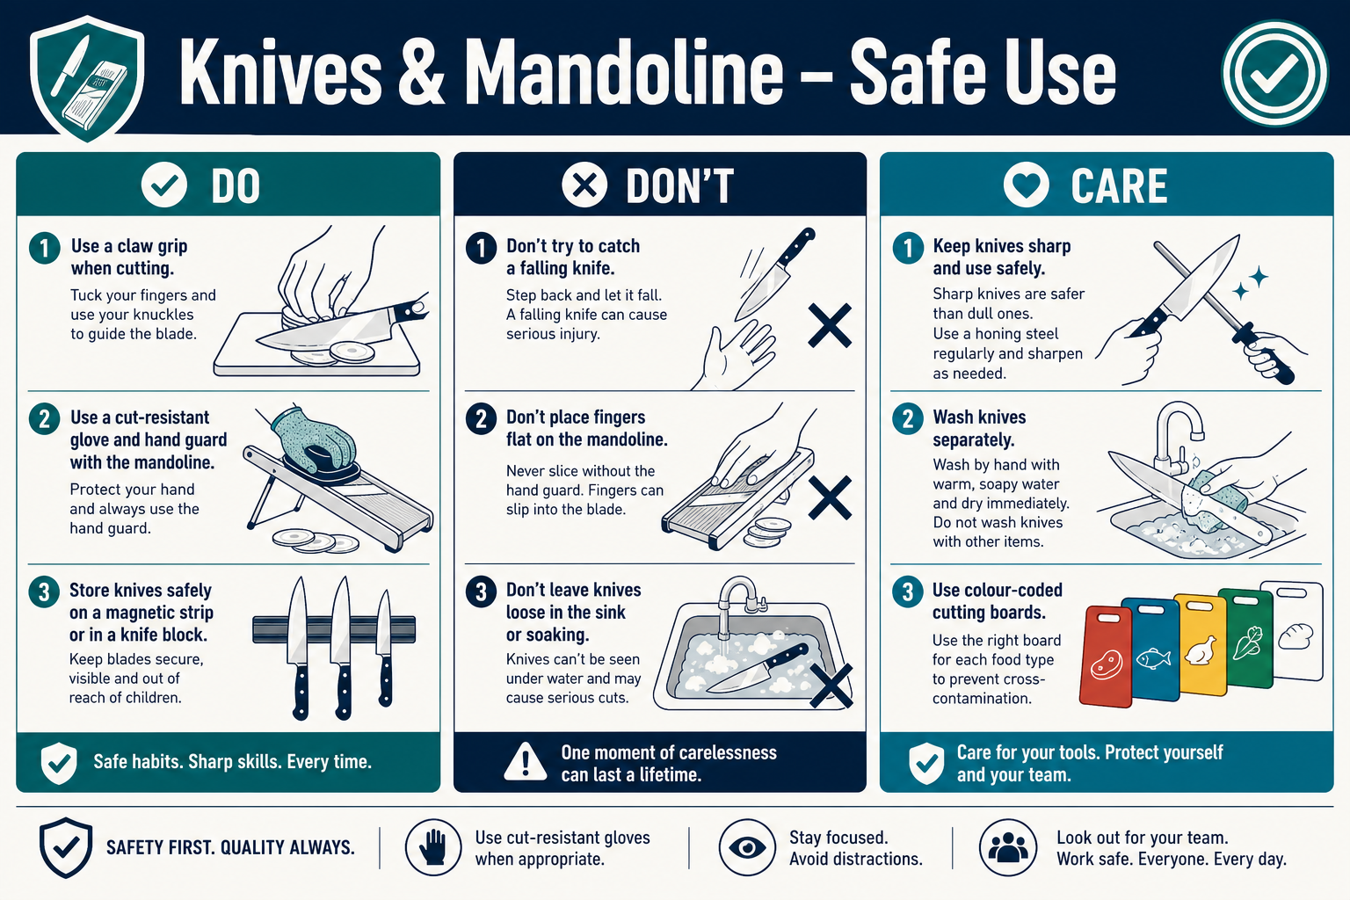
Quick visual guide — Do / Don’t / Care
DO
- Use claw grip and a stable board with non-slip mat
- Use hand guard or cut-resistant glove on mandoline / slicer
- Store knives on a magnetic strip, block or in sheaths
- Wash knives individually and carefully
DON’T
- Don’t catch a falling knife
- Don’t push food on a mandoline with bare fingers
- Don’t leave knives hidden in sink water
- Don’t store loose blades in drawers
CARE
- Keep knives sharp — dull blades slip more easily
- Use colour-coded boards for raw / ready-to-eat / allergens
- Report damaged tools and remove from service
- Train new staff before unsupervised prep work

Knives, Mandoline, Slicers & Peelers — Risk Assessment & Safe Use
1. Equipment Information
Location | The Vedanta Kitchen & Retreat Centre
Assessor | Shyam Prasad
Brand | Various
Model | Chef knives, mandoline, slicers and peelers
Date Completed | 27/07/2026
Review Date | 04/11/2025

2. Description of Equipment
Hand tools and small cutting equipment used for preparation of fruit, vegetables, meat and other ingredients. This section merges the Knives/Mandoline/Peelers and Knives/Slicers/Peelers assessments into one procedure.
3. Operating Procedure (How to Use)
1. Select the correct knife or tool for the task; check blades are clean and undamaged.
2. Use a stable chopping board with a non-slip mat underneath.
3. Keep fingers curled and clear of the blade path (claw grip).
4. For mandoline / slicers: always use the hand guard or cut-resistant glove; never push product by hand.
5. Cut away from the body; do not catch falling knives — let them drop.
6. Wash knives individually; never leave blades loose in sinks under water.
7. Store knives in a knife block, magnetic strip or sheath — not loose in drawers.
8. Sharpen / hone as required; a dull blade increases slip risk.
9. Report damaged tools and remove from service.
4. Risk Assessment
Hazard | People at Risk | Risk Before | Control Measures | Risk After
Cuts / lacerations from knives | Staff | High | Training on safe knife skills; claw grip; cut-resistant gloves for high-risk tasks; safe storage. | Low
Severe cuts from mandoline / slicer | Staff | High | Mandatory use of guard or cut-resistant glove; dismantle carefully for cleaning. | Low
Cross-contamination (raw / allergens) | Guests / Staff | High | Colour-coded boards and knives; wash between products; follow HACCP and allergen matrix. | Low
Slips from peelings / waste on floor | Staff | Medium | Clear waste regularly; wipe floors; use non-slip footwear. | Low
Incorrect tool storage injuries | Staff | Medium | Sheaths / magnetic strip / designated knife area; never leave in sinks. | Low

5. Required PPE
- Apron
- Non-slip footwear
- Cut-resistant gloves for mandoline, slicer and high-volume prep

Vedanta Kitchen Risk Assessment
1. Scope
Covers general kitchen operations including food preparation, cooking, cleaning, storage, waste handling and staff movement within The Vedanta Kitchen.
2. Key Information
Location | The Vedanta Kitchen & Retreat Centre
Assessor | Shyam Prasad
Assessment type | Area / activity risk assessment
Date Completed | 27/07/2026
Review Date | 04/11/2025

3. Risk Assessment
Hazard | People at Risk | Risk Before | Control Measures | Risk After
Slips, trips and falls | Staff / Visitors | High | Clean spills immediately; clear walkways; non-slip mats; suitable footwear. | Low
Burns from ovens, hobs, hot pans | Staff | High | Use dry cloths / gloves; announce “hot”; keep pan handles turned inward. | Low
Fire (oil, electrical, gas) | Staff / Guests | High | Never leave fryers/pans unattended; know extinguisher types; fire training; extract cleaning. | Low
Manual handling injuries | Staff | Medium | Team lifts for heavy stock; use trolleys; training on safe lifting. | Low
Food poisoning / contamination | Guests | High | Temperature control; date labelling; cleaning schedules; allergen controls; HACCP. | Low
Chemical exposure (cleaners) | Staff | Medium | COSHH sheets; correct dilution; PPE; store chemicals away from food. | Low

4. Control Summary
- Maintain daily opening/closing cleaning checklists.
- Record fridge/freezer temperatures at required intervals.
- Keep first-aid kit and burn gel accessible.
- Report all near-misses and incidents.
5. Required PPE
- Apron / chef whites
- Non-slip footwear
- Heat-resistant gloves / cloths as needed
- Gloves for cleaning chemicals

Vedanta Catering Services Risk Assessment
1. Scope
Covers off-site and on-site catering service: transport of food, service set-up, hot holding, buffet/service lines, and breakdown.
2. Key Information
Location | The Vedanta Kitchen & Retreat Centre
Assessor | Shyam Prasad
Assessment type | Area / activity risk assessment
Date Completed | 27/07/2026
Review Date | 04/11/2025

3. Risk Assessment
Hazard | People at Risk | Risk Before | Control Measures | Risk After
Temperature abuse during transport | Guests | High | Use insulated boxes; hot-hold above 63°C or cold below 5°C; temperature logs. | Low
Vehicle loading injuries / traffic risk | Staff | Medium | Use trolleys; secure loads; park safely; two-person lifts for heavy items. | Low
Burns / hot holding equipment | Staff | Medium | Warn guests/staff of hot surfaces; use correct lids and gloves. | Low
Allergen cross-contact at service | Guests | High | Clear allergen labelling; separate utensils; trained service staff; guest enquiry process. | Low
Slips at service points | Staff / Guests | Medium | Manage cable runs; wipe spills; clear guest walkways. | Low

4. Control Summary
- Complete a service checklist before departure and on arrival.
- Keep probe thermometer and sanitising wipes with the catering kit.
- Return leftovers under temperature control or dispose per food safety policy.
5. Required PPE
- Apron / service uniform
- Non-slip footwear
- Heat-resistant gloves for hot equipment
- Disposable gloves for ready-to-eat service where required

Vedanta Front of House & Kitchen Risk Assessment
1. Scope
Covers interaction between front-of-house and kitchen areas: service pass, guest areas, beverage service, and shared walkways during service periods.
2. Key Information
Location | The Vedanta Kitchen & Retreat Centre
Assessor | Shyam Prasad
Assessment type | Area / activity risk assessment
Date Completed | 27/07/2026
Review Date | 04/11/2025

3. Risk Assessment
Hazard | People at Risk | Risk Before | Control Measures | Risk After
Collision in pass / corridor | Staff | Medium | Keep-left / call-outs (“behind”, “hot”); keep floors clear; limit congestion. | Low
Hot plate / spill burns at pass | Staff | Medium | Use dry cloths; communicate plate status; stable stacking. | Low
Guest slips in dining areas | Guests / Staff | Medium | Prompt spill response; suitable mats at entrances; clear trailing cables. | Low
Broken glass / crockery | Staff / Guests | Medium | Clear immediately with dustpan; dispose in glass bin; cordon if needed. | Low
Allergen information failure | Guests | High | Up-to-date allergen matrix; FOH trained to check with kitchen; never guess. | Low

4. Control Summary
- FOH and kitchen brief before busy service.
- Keep emergency exits and fire routes clear at all times.
- Ensure allergen folder / matrix is current for the day’s menu.
5. Required PPE
- Non-slip footwear
- Service apron where required
- Gloves for clearing waste / glass

Vedanta Generic Kitchen Risk Assessment (June 2024)
1. Scope
General kitchen hazards and standard controls for The Vedanta Kitchen & Retreat Centre, based on the June 2024 generic kitchen risk assessment. Use alongside equipment-specific sheets.
2. Key Information
Location | The Vedanta Kitchen & Retreat Centre
Assessor | Shyam Prasad
Assessment type | Area / activity risk assessment
Date Completed | 27/07/2026
Review Date | 04/11/2025

3. Risk Assessment
Hazard | People at Risk | Risk Before | Control Measures | Risk After
General kitchen injury (cuts, burns, strains) | Staff | High | Induction training; supervision of new staff; safe systems of work; PPE. | Low
Electrical equipment faults | Staff | Medium | Visual checks before use; PAT testing schedule; remove defective kit from service. | Low
Poor housekeeping | Staff / Guests | Medium | Clean-as-you-go; end-of-day deep clean; designated storage for tools and stock. | Low
Pest activity | Guests / Staff | Medium | Seal food; waste control; report sightings; pest contractor visits. | Low
Inadequate first aid response | Staff / Guests | Medium | Trained first aiders; stocked kit; incident reporting forms available. | Low

4. Control Summary
- Review this generic assessment whenever menus, staffing or layout change.
- Keep SDS / COSHH information accessible for all cleaning chemicals.
- Link this pack to staff induction and refresher training records.
5. Required PPE
- Apron
- Non-slip footwear
- Task-specific gloves (heat, cut, chemical)
6. Additional Notes
- Source file reference: Vedanta generic kitchen risk assessments June 2024 (AutoRecovered).
- Where an equipment sheet and this generic sheet both apply, follow the stricter control.

Document Control & Sign-Off
This combined pack replaces the separate equipment and area risk assessment files listed on the cover. It should be reviewed after any incident, equipment change, or at least annually.
Document owner | Shyam Prasad
Approved by
Approval date
Next review | 27/07/2027
Version | 2.0 Brochure Pack (visuals + Sylvester Keal chemicals)

Staff acknowledgement
I confirm I have read and understood the relevant sections for equipment and tasks I use.
Name | Role / Area | Date / Signature

