
Kitchen Safety Brochure &
Combined Risk Assessment Pack
Equipment · Sylvester Keal Chemicals (original brochure products) ·
Step-by-step Do / Don’t / Care staff training guides
The Vedanta Kitchen & Retreat Centre
Company: The Vedanta Way Limited
Assessor: Shyam Prasad
Document date: 27 July 2026
Review due: 27 July 2027
Includes:
TRK70 · Rational Oven · SK Chemicals / COSHH · Thermomix · Caso ·
Ninja · KitchenAid · Waring · Knives / Mandoline ·
Lincat Fryer · Dough Mixer · Blast Chiller · Bratt Pan ·
Wrapmaster Cutters · Buffalo Induction · Heavy Tray Storage ·
Kitchen, Catering, FOH & Generic Assessments

Contents
Use this pack as the master risk assessment file for kitchen and catering operations.
1. Electrolux / Dito Sama TRK70 Combined Cutter & Vegetable Slicer
2. Rational Combi Oven
3. Kitchen Chemicals (COSHH) — Sylvester Keal
4. Thermomix TM6
5. Caso Ice Creamer
6. Ninja Hand Blender
7. Mixers & Blenders — Visual Safety Guide
8. KitchenAid Professional Stand Mixer
9. Waring Stick Blender
10. Knives & Mandoline — Visual Safety Guide
11. Knives, Mandoline, Slicers & Peelers
12. Lincat Deep Fat Fryer
13. Floor Dough Mixer / Planetary Mixer
14. Blast Chiller (Safe Methods 18 & 19)
15. Bratt Pan (Tilting Skillet) & Tray Handling
16. Wrapmaster Cling Film & Parchment Cutters
17. Buffalo Induction Hob
18. Heavy Metal Trays, Fryer Shelf & Storage Organisation
19. Vedanta Kitchen Risk Assessment
20. Vedanta Catering Services Risk Assessment
21. Vedanta Front of House & Kitchen Risk Assessment
22. Vedanta Generic Kitchen Risk Assessment (June 2024)
23. Document Control & Sign-Off

Electrolux / Dito Sama TRK70 — Combined Cutter & Vegetable Slicer Risk Assessment
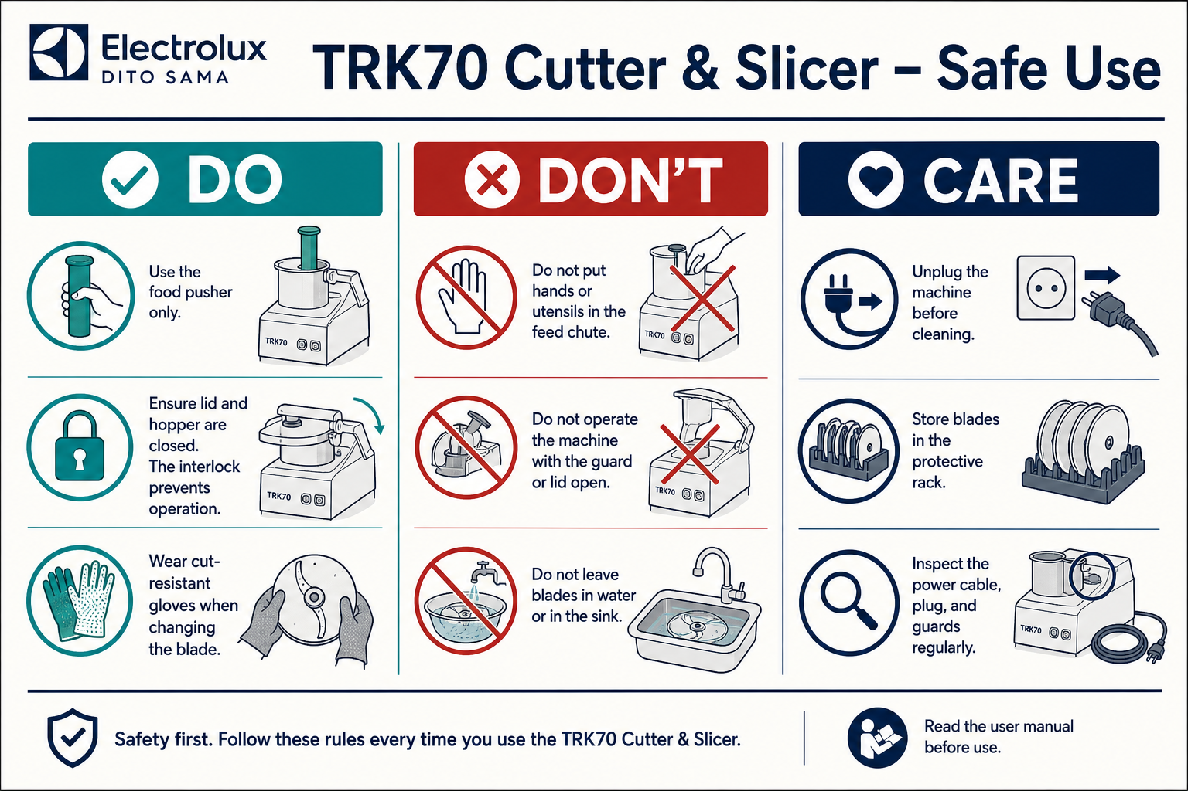
TRK70 — Step-by-step safe use
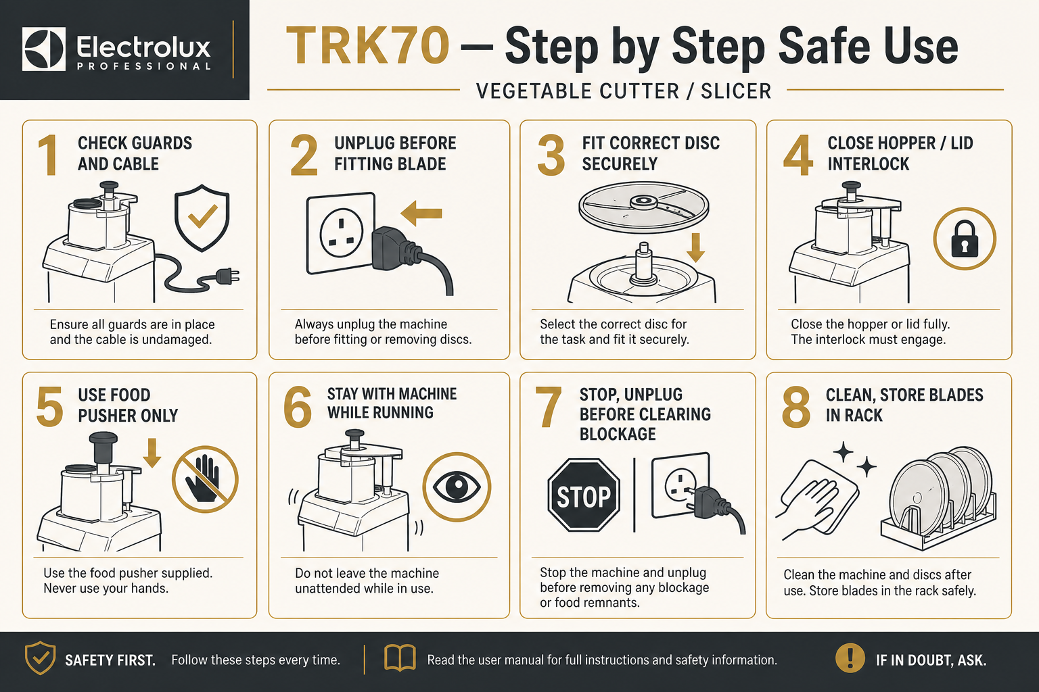
Quick visual guide — Do / Don’t / Care
DO
- Use only the supplied food pusher
- Keep hopper / lid closed and interlocks engaged
- Wear cut-resistant gloves when changing blades
- Unplug before cleaning or clearing blockages
DON’T
- Never put hands or utensils in the feed chute while powered
- Never run the machine with a guard open or bypassed
- Never leave blades in sink water or loose in drawers
- Never allow untrained staff to operate the TRK70
CARE
- Inspect guards, cable and blades before every use
- Store discs in the protective rack
- Clean and sanitise food-contact parts after use
- Label and remove faulty equipment from service
1. Workplace & Equipment Information
Workplace | The Vedanta Kitchen & Retreat Centre
Department | Main Kitchen
Equipment | Electrolux / Dito Sama TRK70 Combined Cutter and Vegetable Slicer
Manufacturer / model | Electrolux Professional / Dito Sama TRK70
Persons completing the task | Trained and authorised kitchen staff
Assessor | Shyam Prasad
Assessment date | 27 July 2026
Review date | 27 July 2027, or sooner after an accident, near miss, equipment change or safety concern
Manager responsible | [Name]

2. Activity Covered
Operating, loading, unloading, changing cutting discs or blades, clearing blockages, dismantling, cleaning, reassembling and maintaining the TRK70.
The TRK70 uses interchangeable rotating blades and discs for cutting, chopping, slicing, grating, shredding and dicing food. The machine incorporates a magnetic safety system and motor brake intended to stop operation when the hopper, vegetable preparation lever or cutter lid is not correctly closed. These safety systems must never be defeated or bypassed.
3. Persons at Risk
- Chefs and kitchen assistants
- Kitchen porters and cleaning staff
- Maintenance contractors
- Employees working close to the machine
- New, inexperienced or young workers
- Consumers, where poor cleaning or allergen controls could contaminate food
4. Risk-Rating System
Likelihood
- 1 – Rare
- 2 – Unlikely
- 3 – Possible
- 4 – Likely
- 5 – Almost certain
Severity
- 1 – Minor injury
- 2 – Injury requiring first aid
- 3 – Injury requiring medical treatment
- 4 – Serious injury
- 5 – Fatality or life-changing injury
Risk score = Likelihood × Severity
- 1–4: Low
- 5–9: Medium
- 10–15: High
- 16–25: Very high
5. Significant Hazards and Control Measures
Hazard | Possible harm | Initial risk | Required control measures | Residual risk
Contact with rotating cutter blade or slicing disc | Deep cuts, amputation or life-changing injury | 15 – High | Only trained and authorised staff may operate. All guards, hopper, lid, pushers and interlocks must be correctly fitted. Hands, knives, spoons and utensils must never enter the feed opening or bowl while connected to power. Feed food only with the supplied pusher. | 5 – Medium
Reaching into the machine while it is running | Severe cuts, crushing or amputation | 15 – High | Never reach beneath the hopper, through the feed chute or into the cutter bowl while operating. Stop and isolate from the electrical supply before inspecting or touching internal components. | 5 – Medium
Unexpected start-up during assembly, cleaning or blockage removal | Contact with moving blades resulting in serious injury | 15 – High | Switch off using the main control, turn off the rear isolation switch and unplug before dismantling, cleaning, changing blades or clearing a blockage. Keep the plug under the operator’s control until the task is complete. | 5 – Medium
Defective, removed or bypassed guard / interlock | Access to dangerous moving parts | 15 – High | Check lid, hopper, pusher, guard and safety interlock before every use. Never bypass, tape down or modify a safety device. If the machine runs with a guard open, stop, unplug, label “DO NOT USE” and report to the manager. | 5 – Medium
Handling, fitting or removing sharp blades and discs | Cuts and puncture wounds to hands and fingers | 12 – High | Switch off and unplug before handling blades. Hold only by hub, handle or non-cutting edge. Wear cut-resistant gloves when changing, transporting or manually cleaning blades. Do not test sharpness with fingers. | 4 – Low
Blades stored incorrectly | Cuts while reaching into drawers or cupboards | 12 – High | Store each blade and disc in a designated rack, protective holder or labelled container. Cutting edges must not be left exposed. Never leave blades submerged in sinks or hidden beneath other equipment. | 4 – Low
Blocked machine or food becoming stuck | Operator may attempt to push food with hands or utensils | 15 – High | Stop and unplug before clearing any blockage. Wait until all movement has stopped. Remove hopper, lid or attachment per manufacturer instructions. Use an appropriate cleaning tool after isolation; never use hands while connected. | 5 – Medium
Food or broken blade components being ejected | Cuts, bruising or eye injury | 12 – High | Inspect blades, discs, bowl, shaft and attachments for cracks, distortion or damage before use. Secure attachments correctly. Do not process bones, frozen-solid food or unsuitable materials. Do not overload. Stand clear when starting. | 4 – Low
Loose clothing, jewellery or long hair becoming caught | Entanglement, pulling or impact injury | 12 – High | Wear close-fitting kitchen clothing. Tie back and secure long hair. Remove loose jewellery, scarves and lanyards. Secure sleeves. Do not distract anyone operating the machine. | 4 – Low
Electrical damage, wet plug or damaged cable | Electric shock, burns or fire | 10 – High | Visually inspect plug, cable, socket and machine before use. Keep connections dry. Do not use with wet hands or pull/lift by the cable. Damaged equipment must be unplugged, labelled and removed from service until repaired by a competent person. | 5 – Medium
Water entering the motor or electrical controls during cleaning | Electric shock, equipment failure or fire | 10 – High | Unplug before cleaning. Never hose down, immerse or pressure-wash the motor base. Clean with a damp cloth using the manufacturer-approved method. Removable food-contact parts may be cleaned separately. Ensure components are dry before reassembly. | 5 – Medium
Cleaning chemicals | Skin irritation, eye damage or breathing difficulty | 6 – Medium | Follow the relevant COSHH assessment and product instructions. Use correct dilution. Wear gloves and eye protection where specified. Never mix chemicals. Store away from food and rinse food-contact components thoroughly. | 3 – Low
Wet or contaminated floor around the machine | Slips, falls, strains or impact injuries | 9 – Medium | Position on a stable work surface. Clean spillages immediately. Display a wet-floor sign where necessary. Keep the power cable away from walkways. Wear slip-resistant safety footwear. | 3 – Low
Machine positioned on an unstable or unsuitable surface | Machine movement, falling equipment or operator injury | 12 – High | Place on a strong, level, dry and stable surface at a comfortable working height. Ensure the base is secure before operation. Do not operate close to the edge of a workbench. | 4 – Low
Lifting or moving the machine and attachments | Back, shoulder, hand or foot injuries | 9 – Medium | Avoid moving the complete machine unnecessarily. Assess weight before lifting. Use a trolley or two-person lift where required. Remove loose attachments before transport. Keep the route clear and use correct manual-handling techniques. | 4 – Low
Repetitive loading, pushing and awkward posture | Musculoskeletal injury or fatigue | 6 – Medium | Position the machine at a suitable height. Keep ingredients close to the operator. Avoid twisting or overreaching. Rotate tasks during prolonged production and take appropriate breaks. | 2 – Low
Excessive machine noise, vibration or overheating | Hearing discomfort, equipment failure or fire | 6 – Medium | Stop if unusual noise, vibration, smell, smoke or overheating occurs. Unplug and report the fault. Do not continue operating damaged equipment. Keep ventilation openings clear. | 2 – Low
Poor cleaning or food remaining inside attachments | Bacterial contamination and food poisoning | 12 – High | Dismantle and clean food-contact parts after every use and between incompatible foods. Inspect hidden areas, shafts, seals, lids and feed components. Sanitise using the approved kitchen procedure and dry before reassembly. | 4 – Low
Allergen cross-contamination | Allergic reaction, potentially severe or fatal | 12 – High | Follow the kitchen allergen-management procedure. Clean and sanitise bowl, blades, discs, hopper, pushers, utensils and surrounding work surface between allergen and non-allergen recipes. Use dedicated equipment where required and verify cleaning before production begins. | 4 – Low
Use by an untrained or unauthorised person | Incorrect assembly, unsafe operation or serious injury | 15 – High | Operators must receive practical training and be assessed as competent. New employees must be directly supervised. Cleaning staff must be trained in isolation and safe blade handling. Operating instructions and this assessment must remain accessible. | 5 – Medium
Maintenance or repairs by an unauthorised person | Electric shock, unexpected movement or defective safety systems | 15 – High | Operators may only perform normal cleaning and user checks. Electrical repairs, motor work, interlock adjustments and internal maintenance must be completed by an authorised competent engineer. | 5 – Medium

6. Safe Operating Procedure
Before use
1. Confirm that the operator is trained and authorised.
2. Check that the machine is clean, dry and correctly positioned.
3. Inspect the plug, cable, controls, bowl, lid, hopper, pusher, blades and discs.
4. Confirm that all guards and safety interlocks are present and undamaged.
5. Select the correct blade, disc and speed for the food being processed.
6. Fit the attachment while the machine is unplugged.
7. Confirm that the blade or disc is properly secured.
8. Secure long hair and remove loose jewellery.
9. Keep the floor and surrounding work area clean and dry.
10. Do not operate the machine if any component is missing, loose or damaged.
During operation
1. Close and secure the bowl lid or vegetable-slicer hopper.
2. Start the machine only after checking that no person is touching the attachments.
3. Use only the supplied pusher to feed food.
4. Never place hands or utensils inside the feed opening or bowl.
5. Do not overload the machine.
6. Remain with the machine while it is operating.
7. Stop immediately if there is unusual noise, vibration, smell, heat or movement.
8. Do not remove any guard until the machine has stopped completely and has been unplugged.
Blade or disc changes
1. Switch the machine off.
2. Turn off the rear isolation switch.
3. Unplug the machine.
4. Wait until all movement has stopped.
5. Wear suitable cut-resistant gloves.
6. Hold the blade or disc by its hub or non-cutting edge.
7. Place the removed blade directly into its protective storage rack.
8. Fit the replacement securely before reconnecting the machine.
Clearing a blockage
1. Press the stop control.
2. Switch off the main isolation switch.
3. Unplug the machine.
4. Keep control of the plug.
5. Wait for the blade or disc to stop completely.
6. Carefully dismantle the appropriate attachment.
7. Remove the blockage without placing fingers against cutting edges.
8. Inspect for blade damage before reassembling.
9. Do not restart the machine until all guards are correctly fitted.
Cleaning
1. Switch off and unplug the machine.
2. Wear cut-resistant gloves when handling blades.
3. Remove the blade or disc first and place it in a safe position.
4. Never leave a blade hidden or submerged in washing-up water.
5. Dismantle removable food-contact components.
6. Wash, rinse, sanitise and dry components according to the kitchen cleaning procedure.
7. Do not immerse or hose down the motor base.
8. Inspect components for cracks, damage or food deposits.
9. Reassemble only when all parts are clean and dry.
10. Store blades and discs in their designated protective rack.
7. Emergency Arrangements
Serious cut or amputation
- Stop and isolate the machine immediately.
- Call 999 for a serious or uncontrolled injury.
- Apply firm pressure using a sterile dressing.
- Do not remove embedded objects.
- Preserve any severed part in a clean sealed bag, place that bag within another bag containing ice, and send it with the injured person.
- Report the accident immediately and secure the machine for investigation.
Electric shock
- Do not touch the injured person until the electrical supply has been safely isolated.
- Switch off the supply or unplug the machine where safe.
- Call 999.
- Begin first aid or CPR if trained and instructed to do so.
Equipment malfunction
- Press stop and disconnect the power.
- Label the machine “DO NOT USE – FAULTY.”
- Inform the kitchen manager.
- Arrange inspection by a competent engineer.
- Do not return the machine to service until formally declared safe.
8. Training Requirements
Operators must be trained in:
- Correct assembly and attachment selection
- Operation of the controls and isolation switch
- Use of guards, hopper and food pushers
- Safe blade and disc handling
- Blockage-clearing procedure
- Cleaning and sanitising
- Allergen cross-contamination controls
- Pre-use inspection and fault reporting
- Emergency procedures
Training must be recorded and refreshed following an accident, near miss, unsafe practice, equipment modification or significant period without using the machine.
9. Inspection and Maintenance
- Carry out a visual pre-use check before every shift.
- Inspect guards, lids, pushers and interlocks before every use.
- Record and report damage immediately.
- Maintain the machine according to the manufacturer’s instructions.
- Arrange electrical inspection and testing based on usage, environment and previous inspection results.
- Only competent authorised persons may repair or adjust the machine.
- Keep servicing, repair and inspection records.
10. Residual Risk Statement
Provided that all listed controls are implemented, operators are trained, guards and interlocks remain functional, and the machine is isolated before blade handling, cleaning or blockage removal, the remaining risk is considered medium to low and tolerable with continued supervision.
The machine must not be used where:
- A guard, lid, hopper or pusher is missing
- A safety interlock is defective
- The blade or disc is damaged
- The machine starts while a guard is open
- The cable, plug or controls are damaged
- There is unusual noise, vibration, heat, smoke or smell
- The operator has not received suitable training
11. Required PPE
- Apron / chef whites
- Non-slip / slip-resistant footwear
- Cut-resistant gloves when changing, transporting or manually cleaning blades and discs
- Eye protection and chemical gloves where specified by COSHH for cleaning chemicals
12. Approval
Assessor’s name | Shyam Prasad
Assessor signature
Assessor date | 27 July 2026
Manager’s name
Manager signature
Manager date

13. Employee Acknowledgement
I confirm that I have read and understood this risk assessment, received suitable instruction and training, and agree to follow the stated control measures and safe operating procedure.
Employee name | Signature | Date

Rational Combi Oven — Equipment Risk Assessment & Operating Procedures
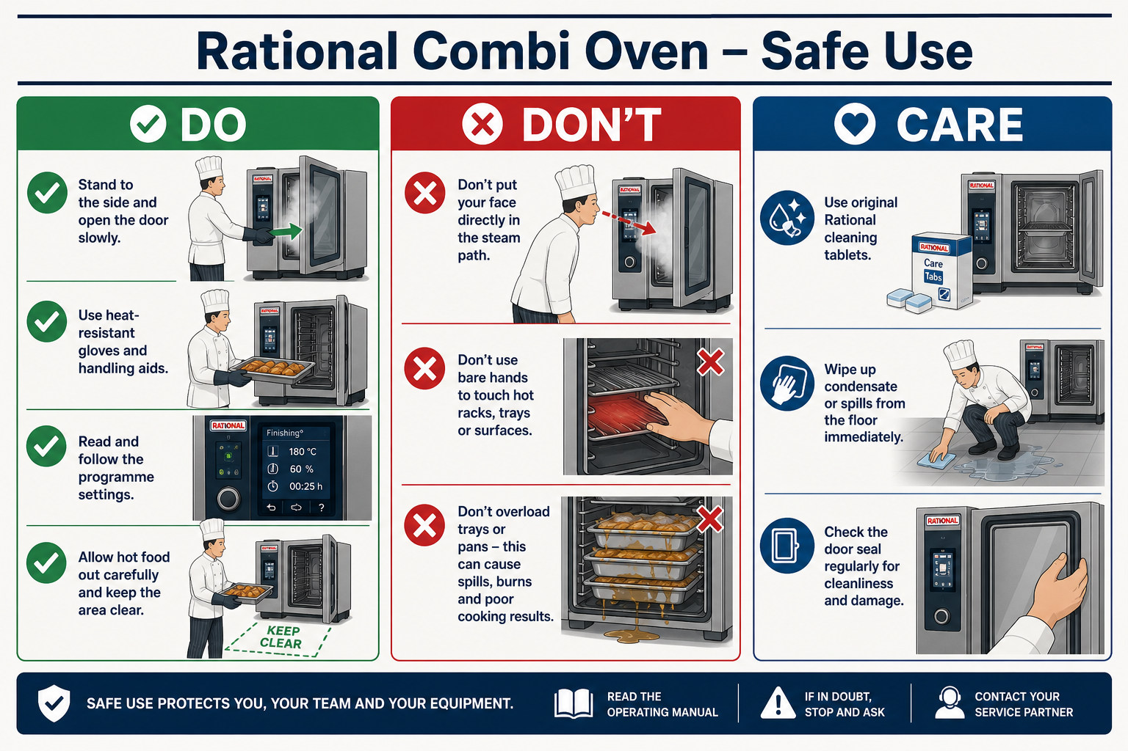
Rational oven — Step-by-step safe use
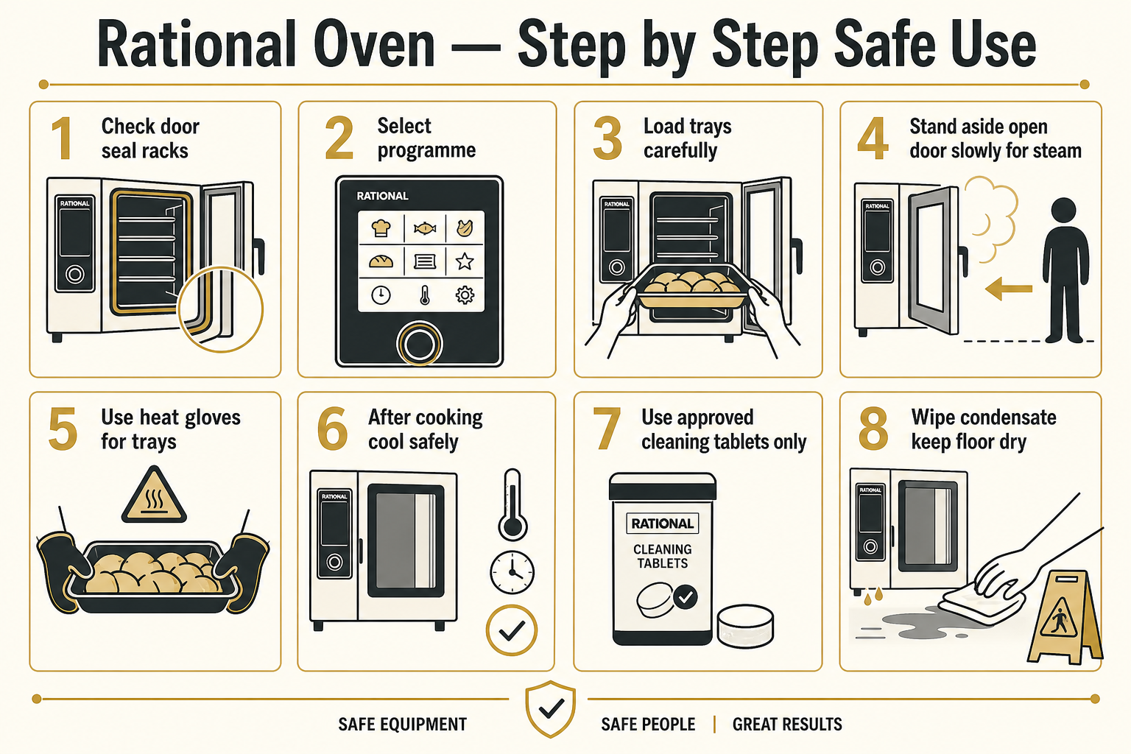
Quick visual guide — Do / Don’t / Care
DO
- Stand to the side and open the door slowly to release steam
- Use heat-resistant gloves / dry cloths for trays and racks
- Select the correct programme and temperature
- Use only approved Rational / SK cleaning tablets as directed
DON’T
- Don’t put your face in the steam path
- Don’t touch hot racks or glass with bare hands
- Don’t overload trays or leave grease fires unattended
- Don’t mix oven cleaners with other chemicals
CARE
- Check door seals and racks before service
- Wipe condensate and keep floors dry
- Run CareControl / cleaning programmes with correct tablets
- Keep SDS for Rational detergent and care tablets with this pack
1. Equipment Information
Workplace | The Vedanta Kitchen & Retreat Centre
Department | Main Kitchen
Equipment | Rational Combi Oven (steam / convection / combi modes)
Manufacturer / model | Rational (model as installed on site)
Persons completing the task | Trained and authorised kitchen staff
Assessor | Shyam Prasad
Assessment date | 27 July 2026
Review date | 27 July 2027, or sooner after an accident, near miss, equipment change or safety concern
Manager responsible | [Name]

2. Description of Equipment
A commercial Rational combi oven used for roasting, baking, steaming, regenerating and combination cooking. The oven can produce high temperatures, steam, hot surfaces, hot liquids and condensate. Self-cleaning / CareControl programmes may use cleaning chemicals under heat and pressure and must only be run by trained staff following manufacturer instructions.
3. Persons at Risk
- Chefs and kitchen assistants
- Kitchen porters and cleaning staff
- Maintenance contractors
- Staff working near the oven during service
- New, inexperienced or young workers
- Consumers, where poor cooking or cleaning controls affect food safety
4. Operating Procedure (How to Use)
Before use
1. Confirm the operator is trained and authorised on the Rational oven.
2. Check the door seal, handle, racks, trays, probes and controls are clean and undamaged.
3. Ensure the oven is stable, vents are clear and the surrounding floor is dry.
4. Confirm water and power connections are correct where relevant.
5. Select the correct mode, temperature and programme for the product.
6. Do not operate if the door, glass, seal, racks or controls are damaged.
During cooking
1. Load trays carefully; do not overload racks or block airflow.
2. Keep face and forearms clear when opening the door — open slowly to release steam away from the body.
3. Announce “hot” / “steam” when opening during busy service.
4. Use dry oven cloths or heat-resistant gloves for trays and racks.
5. Never leave flammable materials on or against the oven.
6. Remain aware of hot condensate and dripping liquids from trays.
7. Stop the programme and seek help if unusual noise, smell, smoke or error codes occur.
After use / cleaning
1. Allow the oven to cool to a safe temperature before manual cleaning where required.
2. Remove food debris from trays, racks and the cavity using approved methods.
3. Run manufacturer cleaning / rinse programmes only with approved Rational cleaning chemicals and correct dosing.
4. Never mix cleaning tablets/liquids with other chemicals.
5. Wear gloves and eye protection when handling oven cleaner.
6. Keep the door closed during automatic cleaning cycles as instructed.
7. Wipe surrounding floors of condensate and leave the area safe for the next service.
5. Risk Assessment
Hazard | Possible harm | Initial risk | Required control measures | Residual risk
Burns from hot surfaces, trays, racks and door glass | Burns to hands, arms or face | 15 – High | Use dry heat-resistant gloves/cloths; warn others; allow cooling where practical; never touch heating elements or hot racks bare-handed. | 5 – Medium
Steam release when opening the door | Scalds to face, neck, arms or chest | 15 – High | Stand to the side; open door slowly; keep face clear of the opening; announce steam release during service. | 5 – Medium
Hot liquid / grease spill from trays | Scalds, slips or secondary burns | 12 – High | Load trays level; do not overfill; use both hands; wipe spills immediately; non-slip footwear. | 4 – Low
Entrapment / impact from door or falling racks | Bruising, crush or impact injury | 9 – Medium | Open and close door under control; seat racks fully on supports; do not overload shelves. | 3 – Low
Fire from grease build-up or unsuitable items | Burns, smoke inhalation or property damage | 12 – High | Clean regularly; never cook with excessive unattended oil; know extinguisher type and shut-off procedure; keep flammables away. | 4 – Low
Electrical fault or damaged cable / controls | Electric shock, burns or fire | 10 – High | Visual checks before use; report faults; isolate and label “DO NOT USE”; repairs by competent engineer only. | 5 – Medium
Contact with oven cleaning chemicals | Skin/eye burns, irritation or breathing difficulty | 12 – High | Use only approved Rational cleaner; follow COSHH and dosing instructions; wear gloves and eye protection; never mix chemicals; rinse as required. | 4 – Low
Slips from condensate / cleaning water around oven | Slips, falls and impact injuries | 9 – Medium | Mop condensate promptly; wet-floor signs; keep walkways clear; slip-resistant footwear. | 3 – Low
Manual handling of loaded trays / trolleys | Back, shoulder or strain injuries | 9 – Medium | Use trolley where available; keep loads manageable; ask for help with heavy pans; good posture. | 4 – Low
Undercooking / temperature abuse of food | Food poisoning risk to guests | 12 – High | Use correct programmes; probe core temperatures where required; follow HACCP and hot-holding rules. | 4 – Low
Use by untrained staff | Burns, scalds, chemical injury or unsafe cooking | 12 – High | Only trained authorised operators; supervise new staff; keep operating instructions accessible. | 4 – Low

6. Required PPE
- Apron / chef whites
- Non-slip footwear
- Heat-resistant gloves or dry oven cloths
- Chemical-resistant gloves and eye protection when handling oven cleaner
7. Emergency Arrangements
- Burns/scalds: cool under lukewarm running water for at least 20 minutes; seek first aid; call 999 for serious burns.
- Fire: shut down if safe, evacuate if needed, use the correct extinguisher only if trained, call 999.
- Chemical contact: rinse skin/eyes as per SDS/COSHH; seek medical help for eye exposure or persistent symptoms.
- Faulty oven: stop programme if safe, isolate power where possible, label “DO NOT USE – FAULTY”, report to manager.
8. Additional Notes
- This section restores the Rational oven risk assessment that was missing from the earlier combined pack.
- Insert the exact Rational model number from the machine rating plate when known.
- Keep the manufacturer manual and cleaning chemical SDS with this assessment.

Kitchen Chemicals (COSHH) — Sylvester Keal Product Risk Assessment
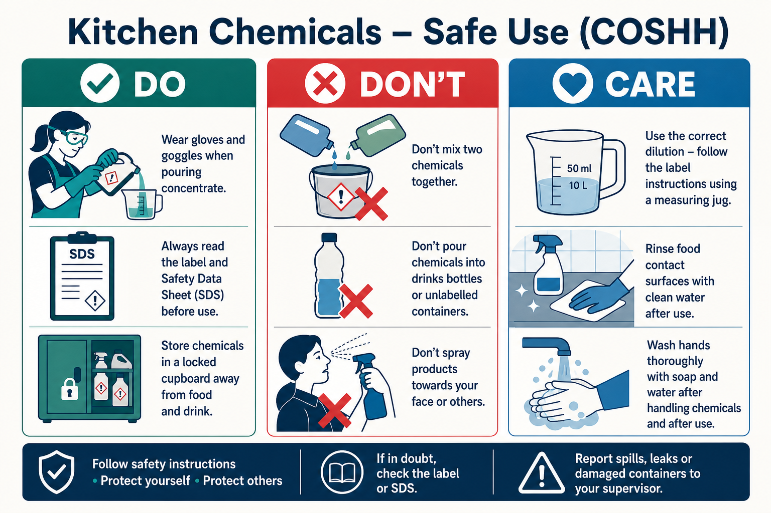
Kitchen chemicals — Step-by-step safe use
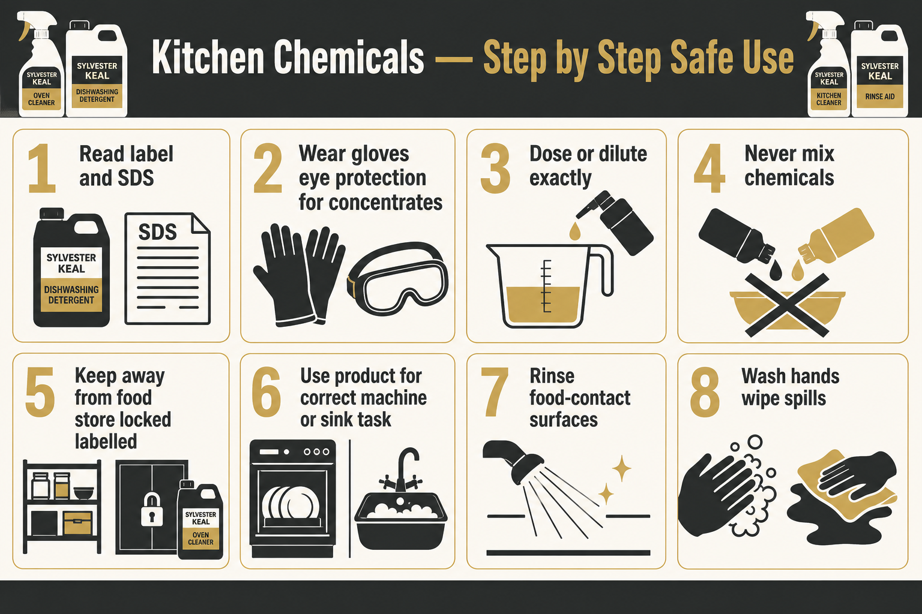
Quick visual guide — Do / Don’t / Care
DO
- Wear gloves (and eye protection for concentrates / oven cleaner)
- Read the label and SDS before use
- Store chemicals locked / labelled, away from food
- Dilute and dose exactly as instructed
DON’T
- Never mix chemicals together
- Never pour chemicals into drinks or food bottles
- Never spray toward your face or other people
- Never use a product with no label or SDS
CARE
- Keep Sylvester Keal SDS sheets with this pack
- Rinse food-contact surfaces after cleaning
- Wipe spills and wash hands before handling food
- Review when a new SK product is introduced
1. Assessment Information
Workplace | The Vedanta Kitchen & Retreat Centre — Branston Hall, Lincoln LN4 1PD
Company | The Vedanta Way Limited
Department | Main Kitchen / Cleaning
Activity | Storage, dosing, use and disposal of Sylvester Keal kitchen cleaning chemicals
Supplier | Sylvester Keal (SK) — https://sylvesterkeal.co.uk/sk-company-brochure/
Website | https://thevedanta.org/
Persons completing the task | Chefs, kitchen porters, cleaning staff and authorised users
Assessor | Shyam Prasad
Assessment date | 27 July 2026
Review date | 27 July 2027, or sooner after an incident, product change or SDS update
Manager responsible | [Name]

2. Site Chemical Inventory (Sylvester Keal brochure)
Products taken from the official Sylvester Keal Product Guide (Machine & Manual Dishwashing Products and Oven Cleaning Products pages). Original brochure product photography is included below. All SK products have COSHH Safety Data Sheets — keep the current SDS for each code with this pack. Brochure: https://sylvesterkeal.co.uk/sk-company-brochure/
Original brochure — Machine & Manual Dishwashing Products
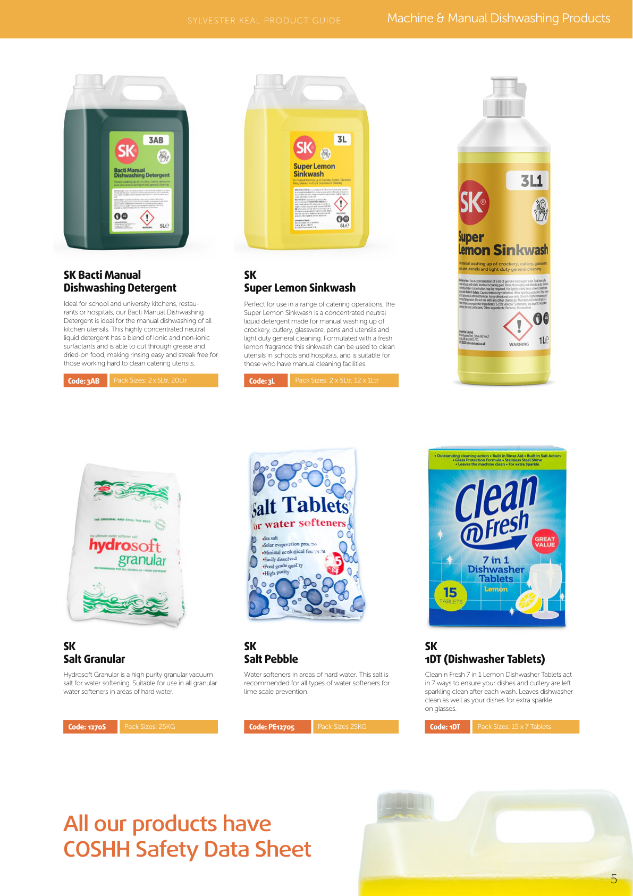
Product (brochure) | Code | Pack size | Intended use
SK Premium Dishwashing Detergent | 1A | 2×5L / 20L | Hard-water machine detergent; tannin & scale control
SK Premium Dishwashing Rinse Aid | 2B | 2×5L / 20L | Machine rinse aid for hygienic streak-free finish
SK Machine Destainer | 2HX | 2×5L / 3×5L / 20L | Tea/coffee destainer with sanitiser for machines
SK Bacti Manual Dishwashing Detergent | 3AB | 2×5L / 20L | Manual dishwashing; cuts grease; streak-free rinse
SK Super Lemon Sinkwash | 3L | 2×5L / 12×1L | Manual wash-up & light duty general cleaning
SK Super Lemon Sinkwash (1L) | 3L1 | 12×1L | 1L sinkwash bottle for manual washing
SK Salt Granular (Hydrosoft) | 12705 | 25KG | Granular vacuum salt for water softeners
SK Salt Pebble | PE12705 | 25KG | Salt tablets for water softeners / limescale prevention
SK 1DT Dishwasher Tablets | 1DT | 15×7 tablets | Clean n Fresh 7-in-1 lemon dishwasher tablets

Original brochure — Oven Cleaning Products
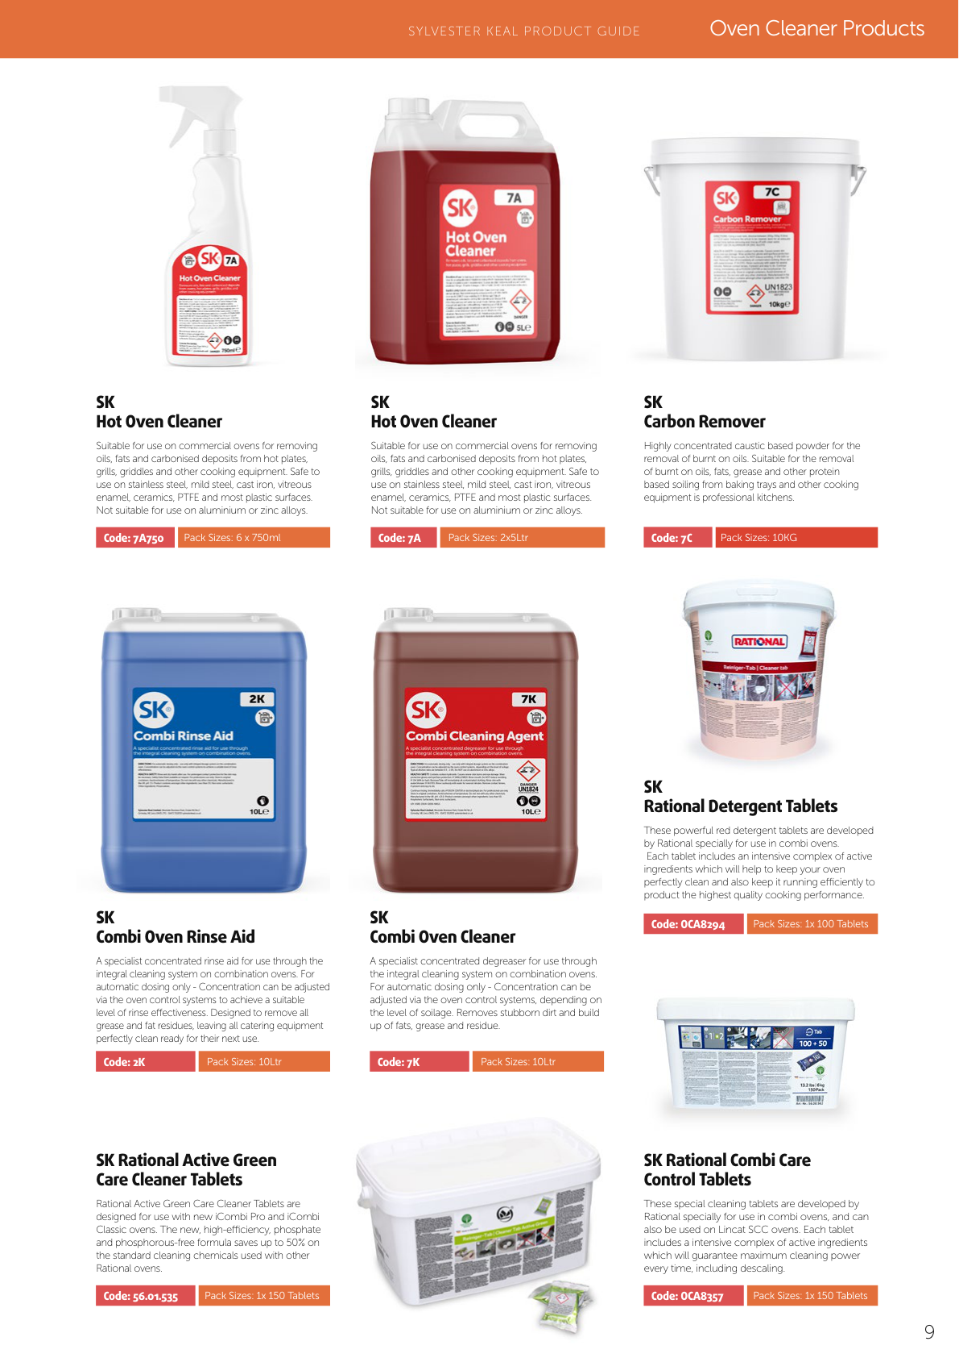
Product (brochure) | Code | Pack size | Intended use
SK Hot Oven Cleaner | 7A750 | 6×750ml | Trigger spray for ovens, hot plates, grills, griddles
SK Hot Oven Cleaner | 7A | 2×5L | 5L hot oven cleaner for commercial cooking equipment
SK Carbon Remover | 7C | 10KG | Caustic powder for burnt-on oils/fats on trays & equipment
SK Combi Oven Rinse Aid | 2K | 10L | Integral combi-oven rinse system (auto dosing)
SK Combi Oven Cleaner | 7K | 10L | Integral combi-oven cleaner / degreaser (auto dosing)
SK Rational Detergent Tablets | OCA8294 | 1×100 | Red Rational combi oven detergent tablets
SK Rational Active Green Care Cleaner Tablets | 56.01.535 | 1×150 | iCombi Pro / Classic phosphate-free care cleaner
SK Rational Combi Care Control Tablets | OCA8357 | 1×150 | Care/control tablets for Rational & Lincat SCC

Source images: Sylvester Keal Company Brochure 2025 — Machine & Manual Dishwashing Products and Oven Cleaning Products pages (original product photography).
3. Step-by-step — Dishwashing chemicals
Machine dishwashing (1A / 2B / salt / tablets)
1. Check dishwasher is empty of food debris and spray arms are free.
2. Ensure softener salt (pebble or granular) is topped up if the machine requires it.
3. Confirm detergent (1A or tablets 1DT) and rinse aid (2B) are correctly loaded / dosed.
4. Wear gloves when handling concentrates or tablets.
5. Run the cycle; do not open mid-cycle if steam/chemical vapour is present.
6. On empty containers, store upright, labelled, away from food.
Manual dishwashing (Super Lemon Sinkwash / Bacti Manual)
1. Scrape food soil into waste before washing.
2. Dilute sinkwash / Bacti Manual as per label — do not guess a stronger mix.
3. Wash, rinse and sanitise following kitchen procedure.
4. Change water when heavily soiled; wipe spills around the sink.
5. Wash hands after chemical contact and before handling clean service ware.
Oven / heavy degreasing (Hot Oven Cleaner / Carbon Remover / Rational tablets / Combi 7K & 2K)
1. Only trained staff may use Hot Oven Cleaner (7A/7A750), Carbon Remover (7C), Combi Oven Cleaner/Rinse (7K/2K) or Rational tablets.
2. Wear chemical gloves and eye protection.
3. For Rational: use only the correct tablet type for the oven model (OCA8294 / 56.01.535 / OCA8357); run the manufacturer cleaning programme; keep door closed.
4. For Hot Oven Cleaner: follow label; do not use on aluminium or zinc alloys where the product warns against it.
5. Never mix these products with sinkwash, bleach or other cleaners.
6. Rinse food-contact surfaces thoroughly after use.
4. Persons at Risk
- Kitchen porters and cleaning staff
- Chefs and assistants using chemicals during service or close-down
- Maintenance staff
- Other employees nearby during spraying or mopping
- Guests, if residues remain on food-contact surfaces
- New or inexperienced workers
5. Risk Assessment
Hazard | Possible harm | Initial risk | Required control measures | Residual risk
Skin contact with concentrates (1A, sinkwash, degreaser, oven cleaner) | Irritation, dermatitis or chemical burns | 12 – High | Gloves for concentrates; correct dilution; wash splashes promptly; report skin problems early. | 4 – Low
Eye contact from splash (oven cleaner / caustic degreaser / dosing) | Eye irritation or serious eye damage | 12 – High | Eye protection for aggressive cleaners; pour carefully; know eye-wash location. | 4 – Low
Mixing incompatible SK / other chemicals | Toxic gas, burns or violent reaction | 15 – High | Never mix products; rinse between different cleaners; train and supervise staff. | 4 – Low
Rational tablet / hot oven cleaner misuse | Severe skin/eye burns or inhalation injury | 15 – High | Trained staff only; correct tablet for model; door closed on auto clean; PPE; follow SDS. | 5 – Medium
Chemical in unmarked / food bottle | Accidental ingestion or food contamination | 15 – High | Original SK labelled containers only; separate chemical store; stock checks. | 4 – Low
Residue on crockery or prep surfaces | Chemical contamination of food | 12 – High | Correct rinse aid dosing; rinse food-contact surfaces; follow contact times for sanitisers. | 4 – Low
Spillage of detergent / degreaser | Slips and skin/eye exposure | 9 – Medium | Contain with PPE; wet-floor sign; dispose correctly; report significant spills. | 3 – Low
Untrained person using chemicals | Incorrect use leading to injury or contamination | 12 – High | COSHH induction; product-specific instruction; SDS accessible; supervise until competent. | 4 – Low

6. Required PPE
- Chemical-resistant gloves suitable for the product
- Eye protection for concentrates, Hot Oven Cleaner, Heavy Duty Degreaser and Rational cleaning chemicals
- Apron where specified
- Non-slip footwear
- Additional PPE as stated on the Sylvester Keal product SDS
7. Emergency Arrangements
- Skin contact: remove contaminated clothing; rinse with plenty of water; seek first aid / medical advice if irritation persists.
- Eye contact: rinse immediately with clean water for at least 15 minutes; seek urgent medical attention.
- Inhalation: move to fresh air; seek medical help if breathing is affected.
- Swallowing: do not induce vomiting unless SDS advises; call 999 / poison guidance and take the product label/SDS.
- Large spill or unknown reaction: evacuate immediate area, ventilate if safe, inform manager, do not neutralise by mixing other chemicals.
8. Training & Records
- All users must receive COSHH awareness and product-specific instruction before unsupervised use.
- Keep Sylvester Keal SDS sheets for every chemical code in an accessible folder.
- Record training, product changes and any chemical-related incidents or near misses.
- Review this assessment when a new SK product is introduced or an SDS is updated.
- Brochure reference: https://sylvesterkeal.co.uk/sk-company-brochure/
9. Additional Notes
- This inventory is based on products confirmed by kitchen knowledge and the Sylvester Keal brochure range.
- Where a product SDS sets stricter controls than this sheet, follow the SDS.
- Rational cleaning tablets must only be used in compatible Rational / approved ovens.

Thermomix TM6 — Equipment Risk Assessment & Operating Procedures
Step-by-step safe use
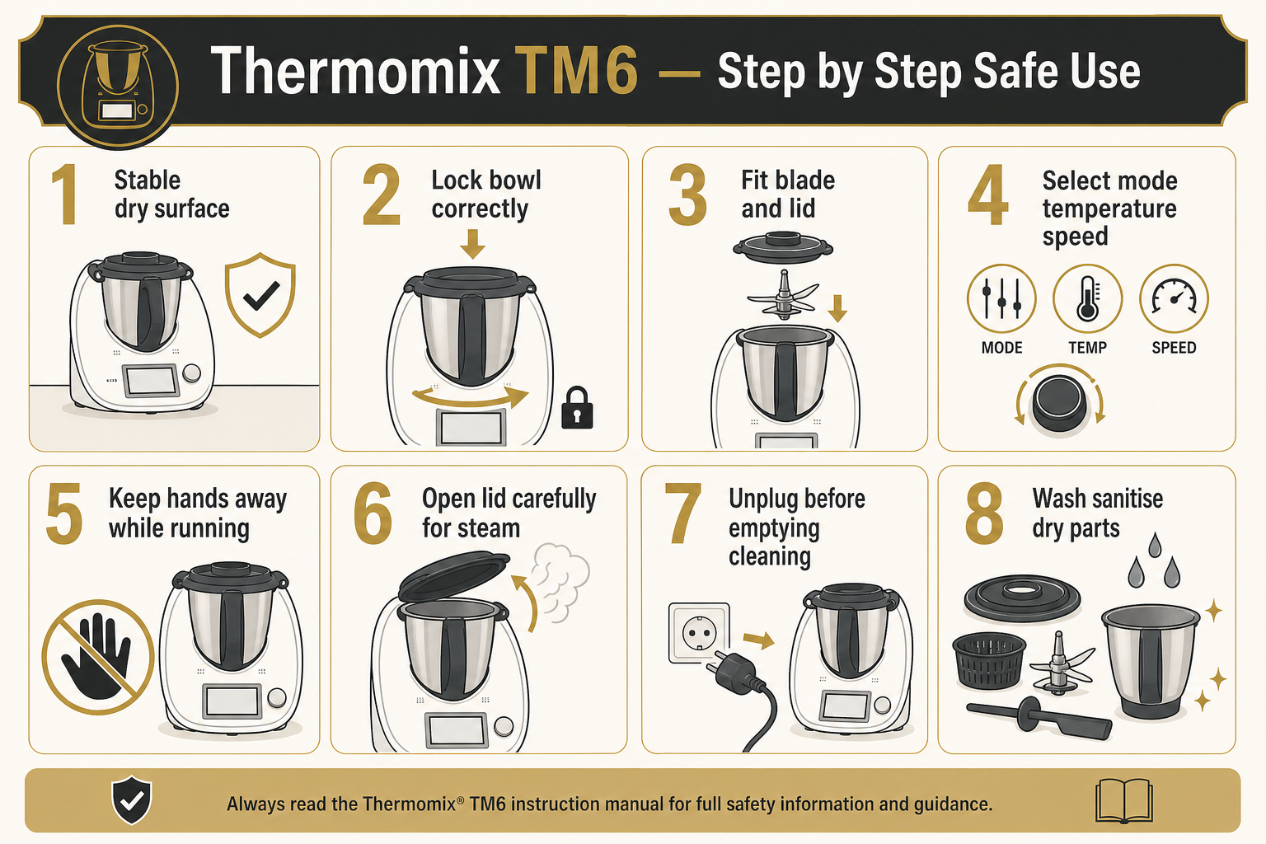
1. Equipment Information
Location | The Vedanta Kitchen & Retreat Centre
Assessor | Shyam Prasad
Brand | Thermomix
Model | TM6
Date Completed | 27/07/2026
Review Date | 04/11/2025

2. Description of Equipment
A multi-function cooking appliance used for chopping, blending, cooking, steaming, kneading and precise heating. Used for soups, sauces, doughs, purees and prepared dishes in bakery and catering production.
3. Operating Procedure (How to Use)
1. Place the Thermomix on a stable, dry, level work surface with adequate ventilation around the base.
2. Ensure the mixing bowl is correctly seated and locked before use.
3. Fit the correct blade or accessory for the task and secure the lid and measuring cup as required.
4. Select the appropriate mode, temperature and speed for the recipe; do not exceed recommended fill levels.
5. Keep hands, utensils and cloths away from the blade area while the machine is running.
6. Allow hot contents to settle before opening the lid; open away from the face to avoid steam.
7. Use the spatula only through the lid opening when the manufacturer instructions allow.
8. Switch off and unplug before changing accessories, emptying the bowl or cleaning.
9. Clean food-contact parts thoroughly after each use and follow HACCP hygiene controls.
4. Risk Assessment
Hazard | People at Risk | Risk Before | Control Measures | Risk After
Blade contact / finger injury | Staff | High | Never reach into the bowl while powered; lock lid; unplug before removing blade. | Low
Steam / hot liquid burns | Staff | High | Use correct temperature settings; open lid carefully; use oven cloths for hot bowls. | Low
Electrical shock | Staff | Medium | Inspect cable and base; keep area dry; unplug before cleaning. | Low
Splash / ejection of hot contents | Staff | Medium | Do not overfill; use measuring cup; start at low speed for hot liquids. | Low
Food contamination | Guests / Staff | High | Clean and sanitise bowl, lid and blade; separate raw and ready-to-eat use; follow HACCP. | Low

5. Required PPE
- Apron
- Non-slip footwear
- Heat-resistant gloves or cloths when handling hot bowls / steam

Caso Ice Creamer — Equipment Risk Assessment & Operating Procedures
Step-by-step safe use
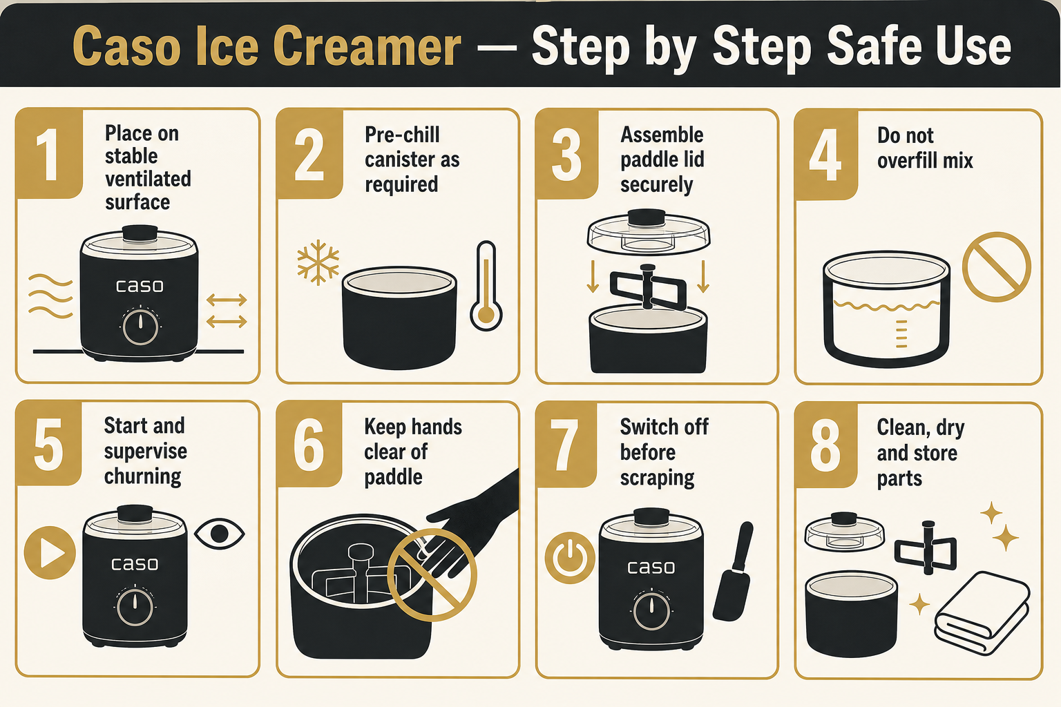
1. Equipment Information
Location | The Vedanta Kitchen & Retreat Centre
Assessor | Shyam Prasad
Brand | Caso
Model | Ice Creamer
Date Completed | 27/07/2026
Review Date | 04/11/2025

2. Description of Equipment
A countertop ice cream / frozen dessert machine used to churn and freeze ice cream, sorbet and similar products for catering and retreat service.
3. Operating Procedure (How to Use)
1. Position the machine on a stable, ventilated surface away from heat sources.
2. Ensure the freezing bowl / canister is correctly pre-frozen or pre-chilled as per the manual.
3. Assemble the paddle, lid and bowl securely before switching on.
4. Prepare mix to the correct recipe and temperature; do not overfill the bowl.
5. Start the machine and supervise during churning; do not leave unattended for long periods.
6. Do not insert hands or utensils into the bowl while the paddle is moving.
7. Switch off before removing the paddle or scraping the finished product.
8. Transfer product with clean utensils into sanitised containers and store under correct temperature control.
9. Clean all food-contact parts after use and dry thoroughly before storage.
4. Risk Assessment
Hazard | People at Risk | Risk Before | Control Measures | Risk After
Finger entrapment in paddle | Staff | High | Keep hands clear while running; switch off before scraping or removing paddle. | Low
Cold burns / freezer bowl handling | Staff | Medium | Handle frozen canister with dry cloths or gloves; do not touch with wet hands. | Low
Electrical shock | Staff | Medium | Keep cable and controls dry; inspect before use; unplug before cleaning. | Low
Slips from spilled mix | Staff | Medium | Wipe spills immediately; keep floor clear around machine. | Low
Food contamination / temperature abuse | Guests / Staff | High | Use clean utensils; chill finished product promptly; follow shelf-life and HACCP controls. | Low

5. Required PPE
- Apron
- Non-slip footwear
- Protective gloves when handling frozen canisters

Ninja Hand Blender — Equipment Risk Assessment & Operating Procedures
Step-by-step safe use
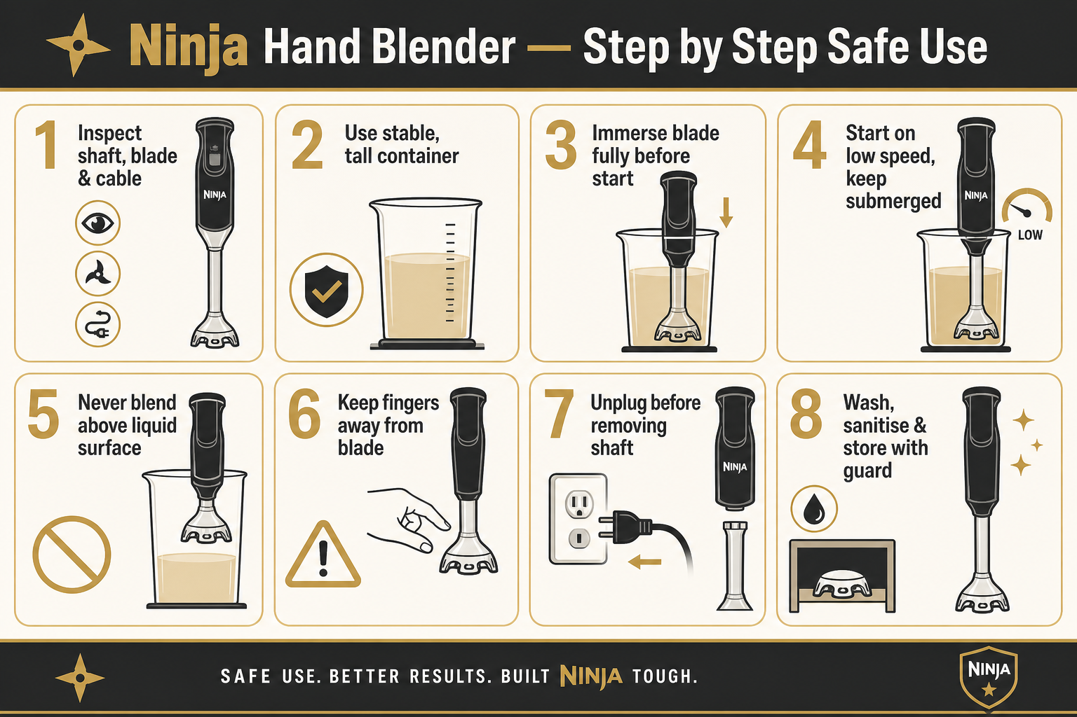
1. Equipment Information
Location | The Vedanta Kitchen & Retreat Centre
Assessor | Shyam Prasad
Brand | Ninja
Model | Hand Blender
Date Completed | 27/07/2026
Review Date | 04/11/2025

2. Description of Equipment
A handheld immersion blender used for pureeing soups, sauces, dressings and soft mixtures directly in pans or containers.
3. Operating Procedure (How to Use)
1. Check the blender shaft, blade guard and cable before use; do not use if damaged.
2. Ensure the pan or jug is stable and only partially filled to avoid splash-over.
3. Fully immerse the blade guard in the food before switching on.
4. Start on a low speed and keep the head submerged while blending.
5. Never blend with the blade above the liquid surface or near the rim of a shallow pan.
6. Do not insert fingers or utensils near the blade while powered.
7. Switch off and unplug before removing the shaft or cleaning the blade.
8. Allow hot liquids to cool slightly where practical to reduce splash risk.
9. Wash detachable parts, sanitise, dry and store with blade guard protected.
4. Risk Assessment
Hazard | People at Risk | Risk Before | Control Measures | Risk After
Blade cuts | Staff | High | Keep hands clear; unplug before cleaning; store with guard / cover. | Low
Hot liquid splash / burns | Staff | High | Immerse fully before starting; blend gently; use tall containers where possible. | Low
Electrical shock | Staff | Medium | Keep motor body dry; never immerse the handle; inspect cable. | Low
Dropped appliance / impact injury | Staff | Medium | Use two hands for deep pans; dry grip; do not stretch cables across walkways. | Low
Food contamination | Guests / Staff | High | Clean and sanitise shaft and blade after each use; avoid cross-contamination. | Low

5. Required PPE
- Apron
- Non-slip footwear
- Cut-resistant glove recommended when washing the blade

Mixers & Blenders — Visual Safety Guide
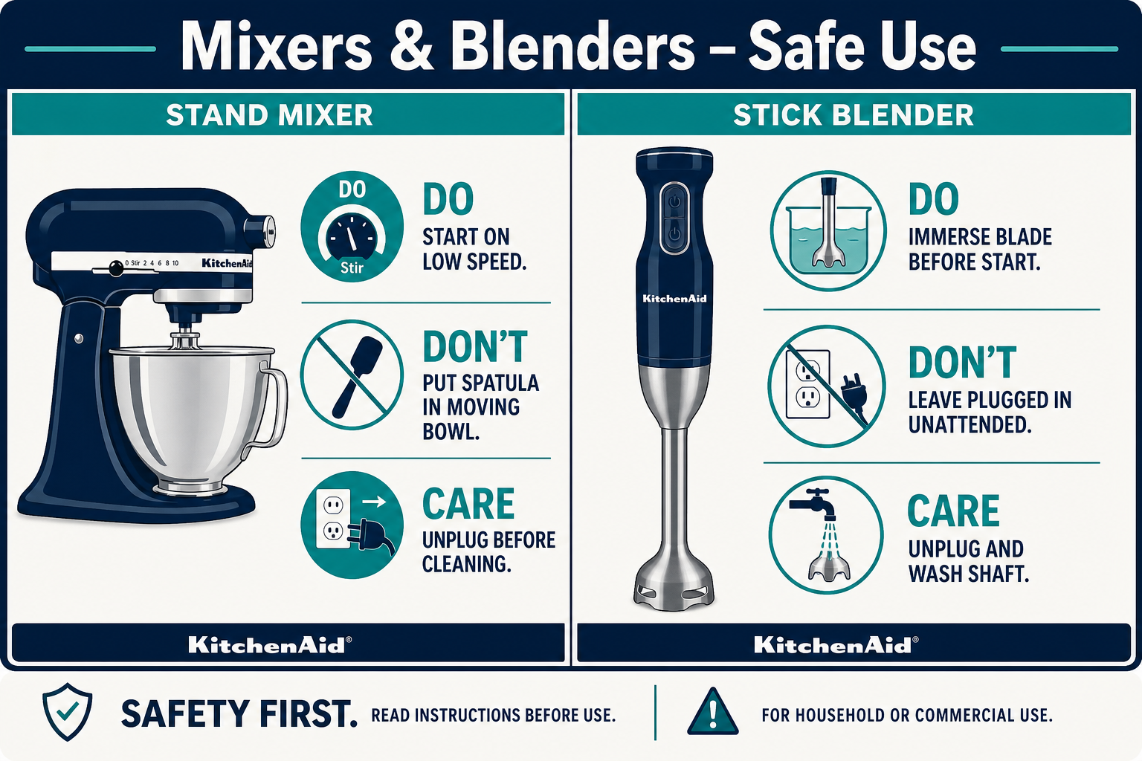
Quick visual guide — Do / Don’t / Care
DO
- Start stand mixers on the lowest speed
- Immerse stick-blender blade fully before switching on
- Unplug before changing tools or washing blades
- Use stable bowls / pans and dry grip
DON’T
- Don’t put spatulas or hands in a moving bowl
- Don’t leave a plugged-in stick blender unattended in a pot
- Don’t wash blades while still connected to power
- Don’t overfill bowls or shallow pans
CARE
- Inspect cables and attachments before use
- Clean and sanitise food-contact parts after each product
- Store blades with guards / covers
- Remove damaged equipment from service

KitchenAid Professional Stand Mixer — Equipment Risk Assessment & Operating Procedures
Step-by-step safe use
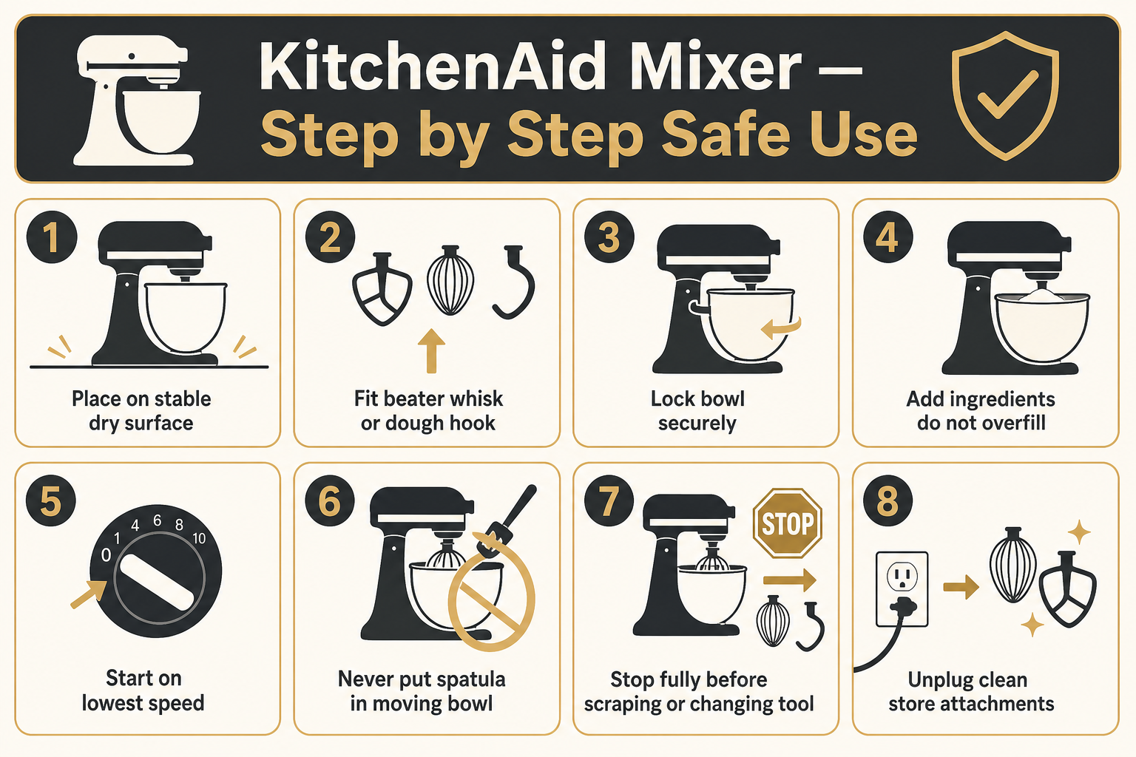
1. Equipment Information
Location | The Vedanta Kitchen & Retreat Centre
Assessor | Shyam Prasad
Brand | KitchenAid
Model | Professional Stand Mixer
Date Completed | 27/07/2026
Review Date | 04/11/2025

2. Description of Equipment
A heavy-duty stand mixer used for mixing doughs, batters, creams and other food ingredients. Commonly used for bakery and catering production.
3. Operating Procedure (How to Use)
1. Ensure the mixer is placed on a stable, dry surface before use.
2. Attach the correct tool (dough hook, whisk or flat beater) and lock the bowl securely.
3. Add ingredients carefully; do not exceed the recommended bowl capacity.
4. Start the mixer on the lowest speed and increase gradually as needed.
5. Never insert hands, spatulas or utensils into the bowl while the mixer is operating.
6. Stop the mixer completely before scraping the bowl or changing tools.
7. Unplug the mixer before cleaning or removing attachments.
8. Clean all food-contact parts thoroughly after each use.
9. Store attachments safely when not in use.
4. Risk Assessment
Hazard | People at Risk | Risk Before | Control Measures | Risk After
Finger entrapment | Staff | High | Keep hands away from moving parts; ensure mixer is off when changing tools. | Low
Electrical shock | Staff | Medium | Inspect cables; keep hands dry; unplug before cleaning. | Low
Cuts from whisk or hook edges | Staff | Medium | Handle attachments carefully; unplug before removal. | Low
Mixer movement during heavy loads | Staff | Medium | Ensure stable surface; supervise during thick dough mixing. | Low
Food contamination | Guests / Staff | High | Clean thoroughly; sanitise food-contact parts; follow HACCP. | Low

5. Required PPE
- Apron
- Non-slip footwear
- Heat-resistant gloves (when working with warm mixtures)

Waring Stick Blender — Equipment Risk Assessment & Operating Procedures
Step-by-step safe use
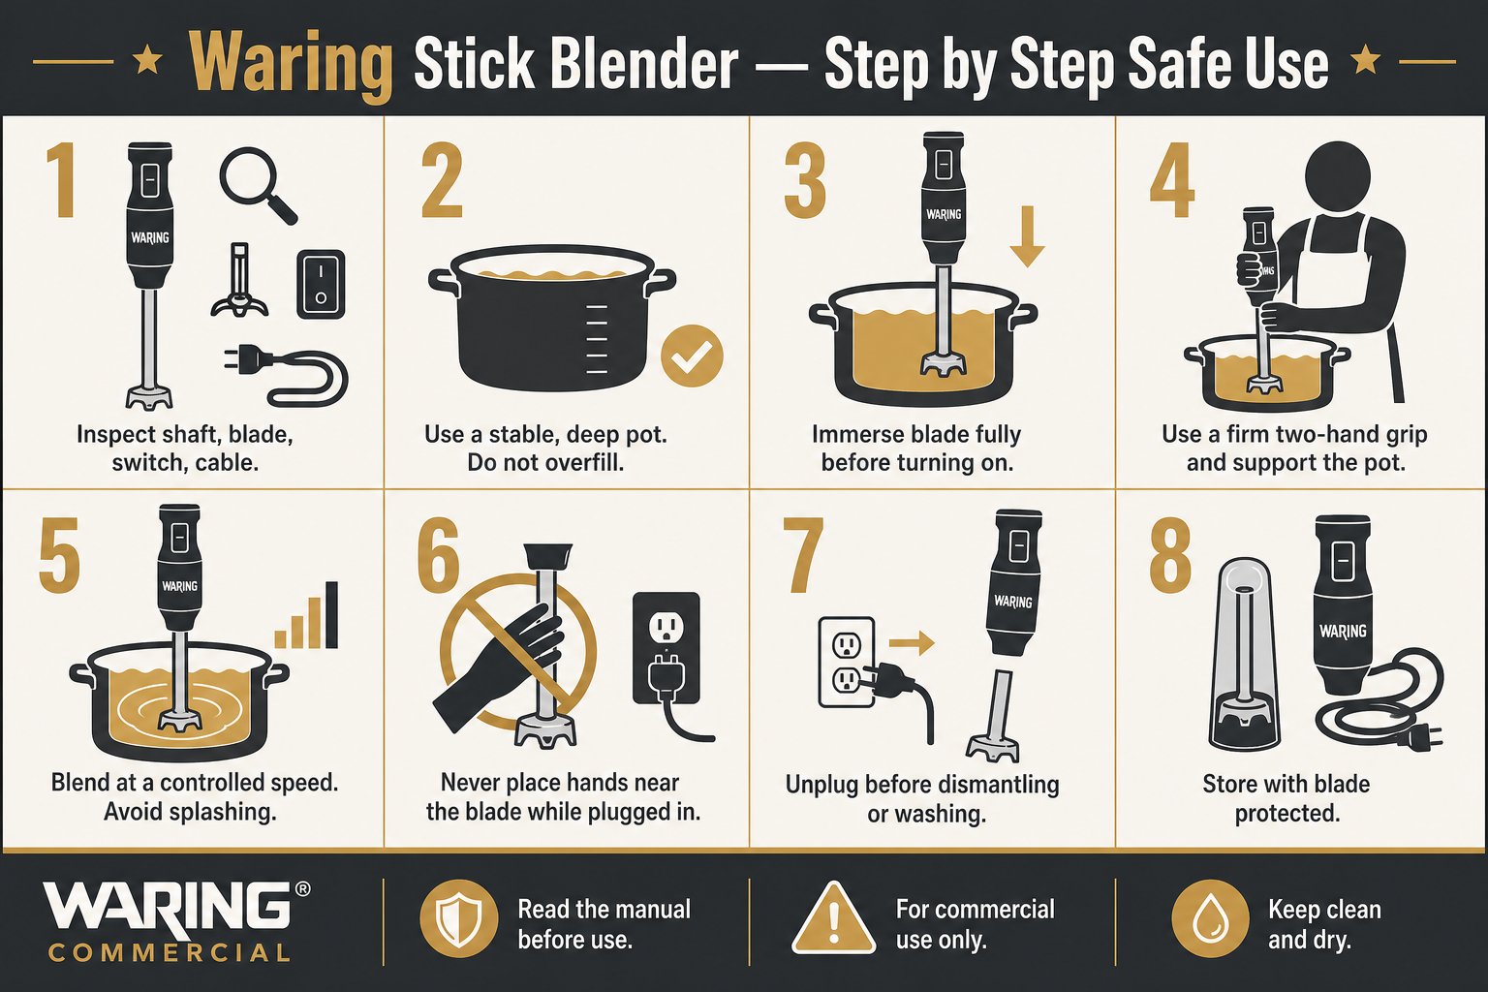
1. Equipment Information
Location | The Vedanta Kitchen & Retreat Centre
Assessor | Shyam Prasad
Brand | Waring
Model | Stick / Immersion Blender
Date Completed | 27/07/2026
Review Date | 04/11/2025

2. Description of Equipment
A commercial stick blender used for blending soups, sauces and large-batch liquids in pots and deep containers within the kitchen.
3. Operating Procedure (How to Use)
1. Inspect the shaft, blade, switch and power cable before each use.
2. Place the pot on a stable surface; do not overfill.
3. Immerse the blade fully before switching on.
4. Hold the blender with a firm grip; support the pot if needed.
5. Blend at controlled speed to avoid splash-back of hot liquids.
6. Never place hands near the blade while the unit is plugged in.
7. Switch off and unplug before dismantling or washing.
8. Clean immediately after use; sanitise food-contact surfaces.
9. Store hanging or in a designated safe location with blade protected.
4. Risk Assessment
Hazard | People at Risk | Risk Before | Control Measures | Risk After
Severe blade cuts | Staff | High | Unplug before cleaning; never leave plugged-in blender unattended in a pot; use blade cover in storage. | Low
Hot liquid burns / splash | Staff | High | Start submerged; use deep pots; reduce speed for hot liquids. | Low
Electrical shock | Staff | Medium | Keep motor housing dry; check cable integrity; RCD-protected circuits where available. | Low
Musculoskeletal strain | Staff | Medium | Use correct posture; avoid extended one-handed use; take breaks on large batches. | Low
Food contamination | Guests / Staff | High | Clean and sanitise after each product; follow allergen and HACCP controls. | Low

5. Required PPE
- Apron
- Non-slip footwear
- Cut-resistant glove when washing blades
6. Additional Notes
- This section consolidates Risk_Assessment_Waring_Stick_Blender.docx and the duplicate “(1)” file.

Knives & Mandoline — Visual Safety Guide
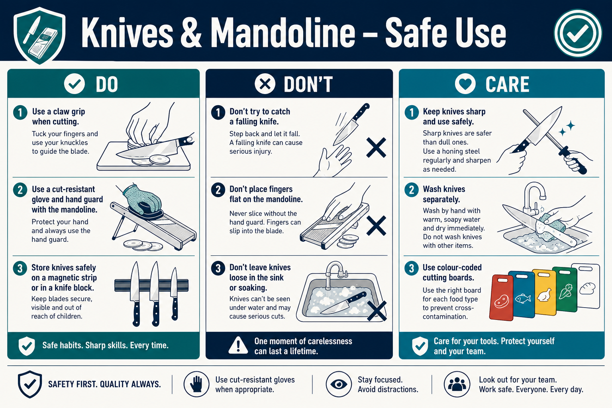
Knives & peelers — Step-by-step safe use
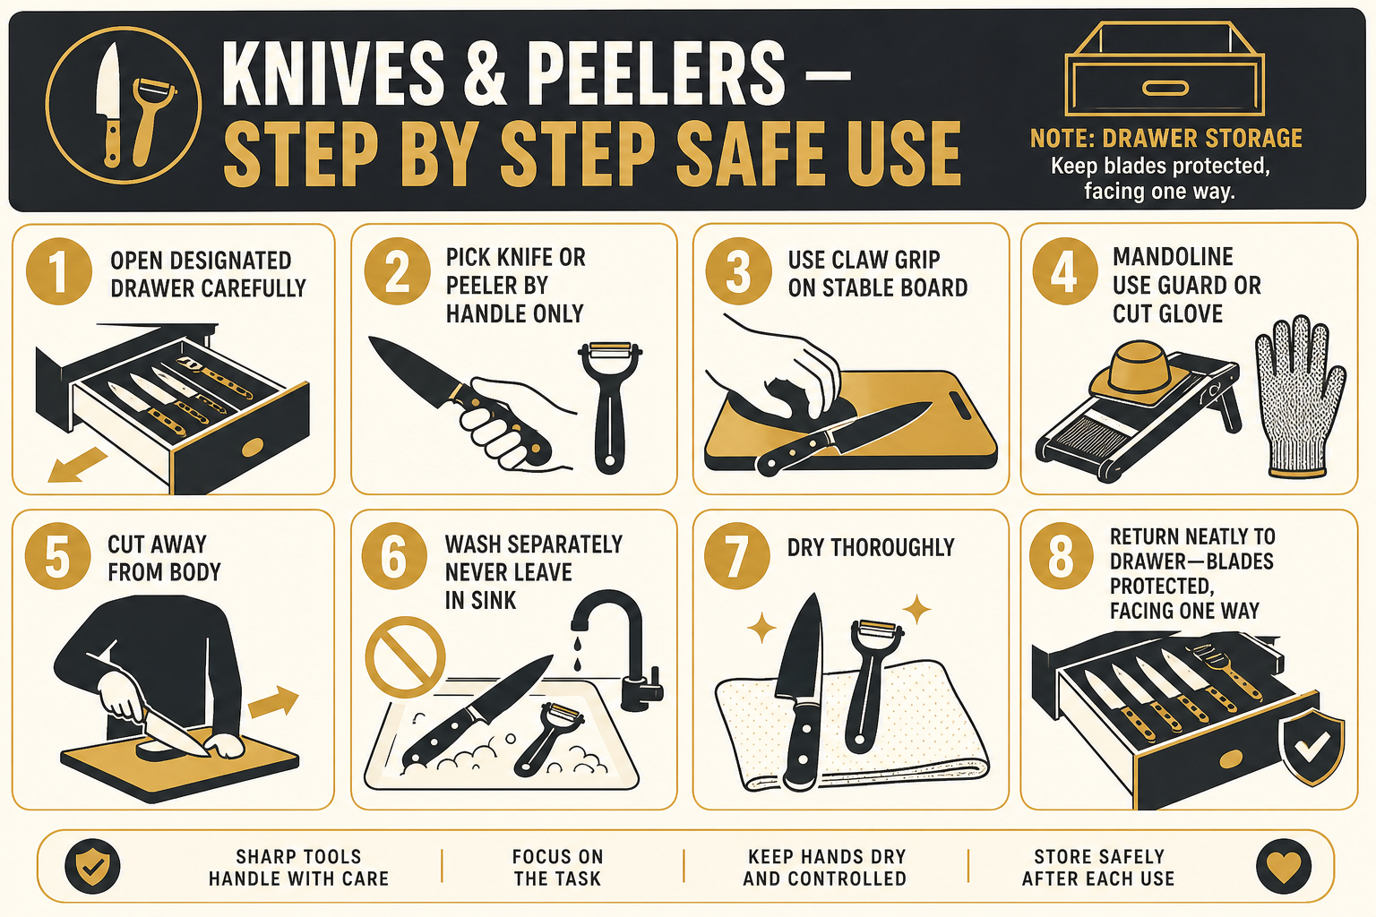
Quick visual guide — Do / Don’t / Care
DO
- Use claw grip and a stable board with non-slip mat
- Use hand guard or cut-resistant glove on mandoline / slicer
- Keep knives and peelers in the designated kitchen drawer only
- Wash knives and peelers individually and carefully
DON’T
- Don’t catch a falling knife
- Don’t push food on a mandoline with bare fingers
- Don’t leave knives or peelers hidden in sink water
- Don’t rummage blindly in the knife/peeler drawer
CARE
- Store knives and peelers neatly in the drawer with blades protected / facing one way
- Open the drawer carefully and pick up tools by the handle
- Use colour-coded boards for raw / ready-to-eat / allergens
- Report damaged tools and remove from service

Knives, Mandoline, Slicers & Peelers — Risk Assessment & Safe Use
1. Equipment Information
Location | The Vedanta Kitchen & Retreat Centre
Assessor | Shyam Prasad
Brand | Various
Model | Chef knives, mandoline, slicers and peelers
Date Completed | 27/07/2026
Review Date | 04/11/2025

2. Description of Equipment
Hand tools and small cutting equipment used for preparation of fruit, vegetables, meat and other ingredients. At The Vedanta Kitchen, kitchen knives and peelers are kept in the designated drawer. This section merges the Knives/Mandoline/Peelers and Knives/Slicers/Peelers assessments into one procedure.
3. Operating Procedure (How to Use)
1. Select the correct knife or peeler for the task; check blades are clean and undamaged.
2. Use a stable chopping board with a non-slip mat underneath.
3. Keep fingers curled and clear of the blade path (claw grip).
4. For mandoline / slicers: always use the hand guard or cut-resistant glove; never push product by hand.
5. Cut away from the body; do not catch falling knives — let them drop.
6. Wash knives and peelers individually; never leave blades loose in sinks under water.
7. Return knives and peelers to the designated kitchen drawer after cleaning and drying.
8. In the drawer: store neatly with handles accessible, blades protected or facing one direction — do not leave blades exposed and jumbled.
9. Open the drawer carefully; pick tools up by the handle only — never rummage with fingers among blades.
10. Sharpen / hone as required; a dull blade increases slip risk.
11. Report damaged tools and remove from service.
4. Risk Assessment
Hazard | People at Risk | Risk Before | Control Measures | Risk After
Cuts / lacerations from knives | Staff | High | Training on safe knife skills; claw grip; cut-resistant gloves for high-risk tasks; careful drawer handling. | Low
Severe cuts from mandoline / slicer | Staff | High | Mandatory use of guard or cut-resistant glove; dismantle carefully for cleaning. | Low
Cuts when taking knives or peelers from the drawer | Staff | High | Designated knife/peeler drawer only; store neatly with handles out / blades protected; open carefully; pick up by handle; no blind rummaging. | Low
Cross-contamination (raw / allergens) | Guests / Staff | High | Colour-coded boards and knives; wash between products; follow HACCP and allergen matrix. | Low
Slips from peelings / waste on floor | Staff | Medium | Clear waste regularly; wipe floors; use non-slip footwear. | Low
Incorrect tool storage injuries | Staff | Medium | Keep knives and peelers only in the designated drawer; never leave in sinks or on open worktops after use. | Low

5. Required PPE
- Apron
- Non-slip footwear
- Cut-resistant gloves for mandoline, slicer and high-volume prep
6. Additional Notes
- Site practice: kitchen knives and peelers are stored in the designated drawer.
- If blade guards/sheaths are available, fit them before returning knives to the drawer.

Lincat Deep Fat Fryer — Equipment Risk Assessment & Operating Procedures
Step-by-step safe use
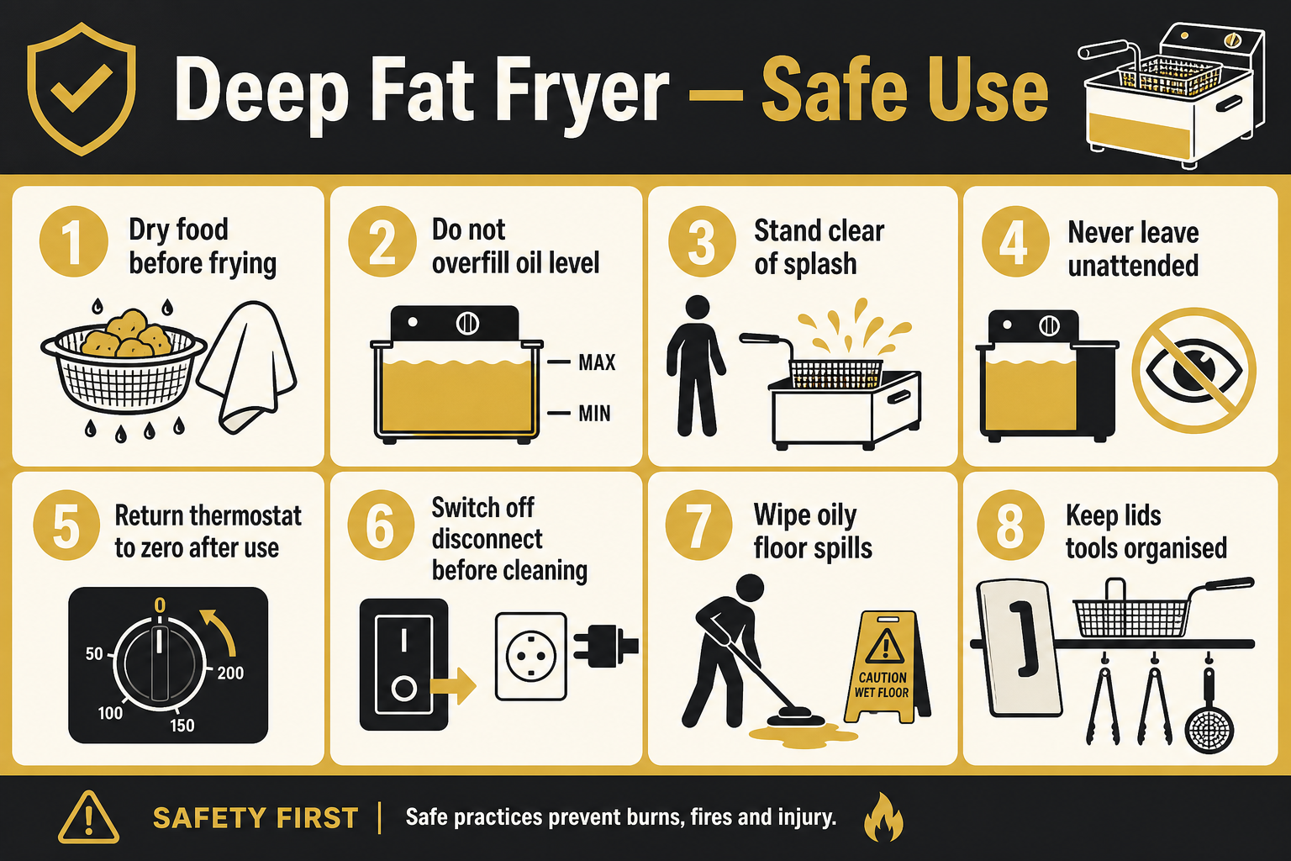
1. Equipment Information
Location | The Vedanta Kitchen & Retreat Centre
Assessor | Shyam Prasad
Brand | Lincat
Model | Deep Fat Fryer (asset approx. 25278)
Date Completed | 27/07/2026
Review Date | 04/11/2025

2. Description of Equipment
Commercial deep fat fryer used for frying foods in hot oil. The unit has a stainless-steel fryer section over a two-door base cabinet. A manufacturer safety label on the front warns about oil fill level, drying food before immersion, isolating power before cleaning, and returning the thermostat to zero after use.
3. Operating Procedure (How to Use)
1. Check oil level before heating — never fill beyond the recommended fill mark.
2. Ensure baskets and pans are dry and food is thoroughly drained/dried before immersing to prevent frothing and boil-over.
3. Heat oil gradually; do not leave the fryer unattended while heating or in use.
4. Lower baskets slowly into hot oil; stand to the side to avoid splash.
5. Do not overload baskets — overcrowding causes oil surge, uneven cooking and spill risk.
6. When finished, return thermostat control to zero and allow oil to cool before covering, filtering or cleaning.
7. Switch off / disconnect power at the mains before cleaning or draining oil.
8. Keep the floor around the fryer dry and clear; wipe any oil spills immediately and use wet-floor signage.
9. Store empty GN trays and baskets on the designated shelf — do not stack heavy trays unstably on or beside the fryer.
4. Risk Assessment
Hazard | People at Risk | Risk Before | Control Measures | Risk After
Hot oil splash / burns | Staff | High | Dry food before frying; lower baskets slowly; correct fill level; heat-resistant gloves/apron; never leave unattended. | Low
Oil boil-over / fire | Staff / Kitchen | High | Do not overfill oil; do not overload baskets; keep water away from hot oil; know fire blanket / Class F extinguisher location; isolate power if safe. | Low
Overloading / underloading baskets | Staff | Medium | Follow batch sizes set by chef; never force oversized loads; underloading is acceptable for quality/safety — overcrowding is not. | Low
Slips from oil on floor | Staff | High | Clean as you go; absorbent mats if used must be secured; non-slip footwear; spill kit available. | Low
Electric shock during cleaning | Staff | Medium | Isolate mains before cleaning; never hose live electrics; follow Lincat label instructions. | Low
Manual handling of hot baskets / trays | Staff | Medium | Use dry heat-resistant gloves; two-person lift for heavy loads; cool trays before stacking for storage. | Low

5. Required PPE
- Heat-resistant gloves / oven gloves
- Apron (preferably heat-resistant front)
- Non-slip footwear
- Hair net / suitable hair restraint
6. Additional Notes
- Follow the on-unit Lincat Deep Fat Fryer safety label at all times.
- Damaged or peeling safety labels must be reported so replacements can be fitted.
- Oil changes and filtering only by trained staff using cool oil and correct PPE.

Floor Dough Mixer / Planetary Mixer — Equipment Risk Assessment & Operating Procedures
Step-by-step safe use
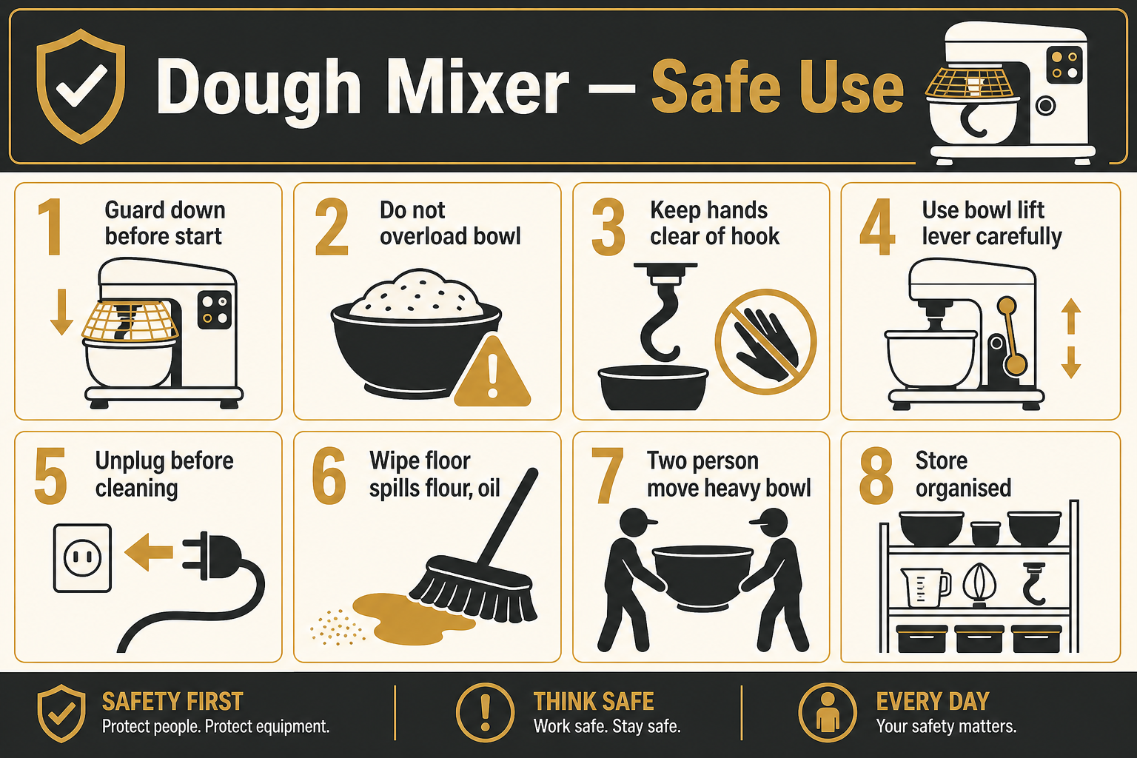
1. Equipment Information
Location | The Vedanta Kitchen & Retreat Centre
Assessor | Shyam Prasad
Brand | Commercial dough mixer
Model | Floor-standing planetary / dough mixer
Date Completed | 27/07/2026
Review Date | 04/11/2025

2. Description of Equipment
Large floor-standing mixer used for dough and heavy mixing. Fitted with a wire safety guard, bowl-lift lever, stainless mixing bowl with side handles, and control panel. Positioned near walk-in cold-store access — keep clear of door swing and traffic routes.
3. Operating Procedure (How to Use)
1. Visually check the mixer, bowl seating, guard and power lead before use.
2. Load ingredients within the bowl capacity — do not overload with dough that strains the motor or climbs the bowl.
3. Fit the correct attachment; lower the bowl and close the wire safety guard before starting.
4. Never reach into the bowl while the machine is running or while attachments are still moving.
5. Use the bowl-lift lever only when the machine is stopped; keep hands clear of pinch points.
6. Stop the machine before scraping down, adding late ingredients near the beater, or removing the bowl.
7. Two-person lift for a full dough bowl where weight requires it; use correct posture.
8. Switch off and isolate before cleaning; clean spillages around the base to prevent slips.
9. Keep the power cord tidy and off the floor walkway.
4. Risk Assessment
Hazard | People at Risk | Risk Before | Control Measures | Risk After
Entanglement / crushing in rotating bowl or attachment | Staff | High | Safety guard closed during operation; never bypass interlocks; stop before clearing dough; loose clothing and jewellery removed. | Low
Overloading mixer / motor strain | Staff / Equipment | Medium | Follow max dough batch size; do not force under-mixed overloads; report unusual noise/smell. | Low
Manual handling of heavy bowl / dough | Staff | High | Team lift when needed; use bowl handles; clear path before moving bowl. | Low
Pinch points on bowl-lift lever | Staff | Medium | Hands clear of mechanism when raising/lowering; operate lever smoothly. | Low
Slips / trips around mixer base | Staff | Medium | Clean flour/dough spills immediately; cord management; keep area organised. | Low
Collision with walk-in door traffic | Staff | Medium | Do not block door swing; park mixer in designated corner; announce when moving bowl across route. | Low

5. Required PPE
- Apron
- Non-slip footwear
- Hair net
- Gloves only when cleaning (machine stopped/isolated)
6. Additional Notes
- If the safety guard is damaged or will not close, take the mixer out of service.
- Only trained staff may operate the dough mixer.

Blast Chiller — Equipment Risk Assessment & Safe Chilling Methods
Commercial blast chiller used to rapidly cool cooked foods (e.g. pie fillings, rice, salad items). Site posters on the unit cover Safe Method 18 (Blast Chilling) and Safe Method 19 (Manual Chilling). Staff must follow both posters and this assessment.
Step-by-step safe blast chilling
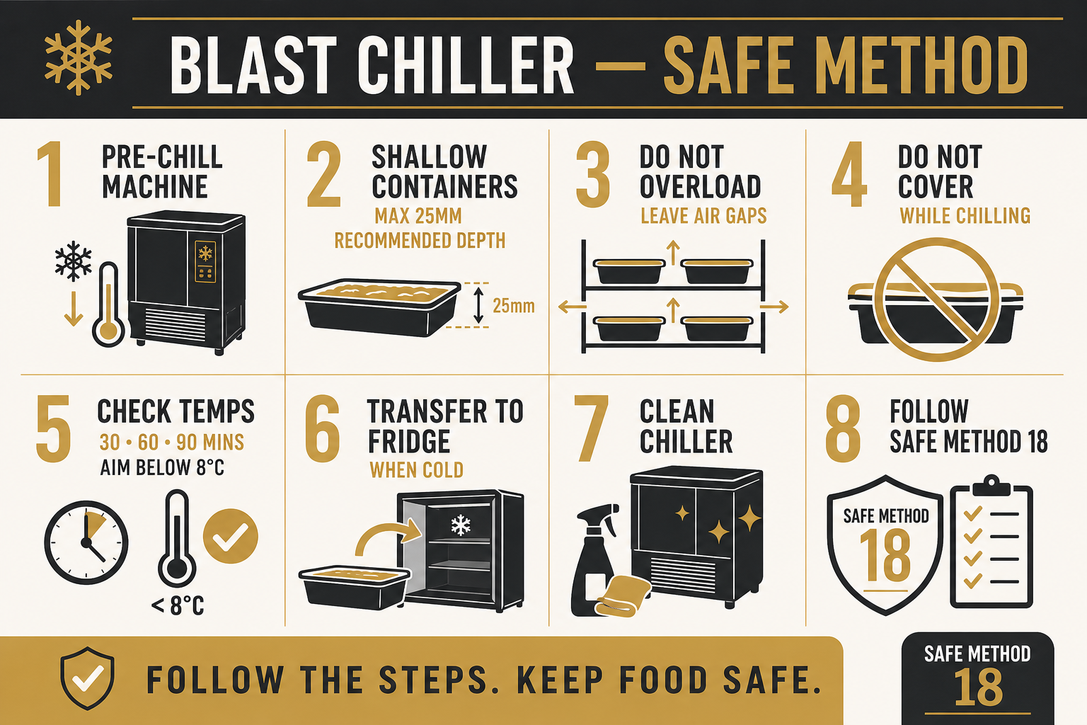
1. Equipment Information
Location | The Vedanta Kitchen & Retreat Centre
Assessor | Shyam Prasad
Equipment | Blast chiller
Reference posters | Safe Method 18 (Blast) & 19 (Manual)
Date Completed | 27/07/2026
Review Date | 27/07/2027

2. Safe Method 18 — Blast Chilling (summary)
1. Read and follow the manufacturer’s instructions.
2. Pre-chill the blast chiller to speed up cooling.
3. Do not overfill containers — about 25 mm depth is recommended; shallow dishes chill faster.
4. Do not overload the blast chiller — leave space for air to circulate between dishes.
5. Do not cover food while blast chilling (unless manufacturer/site method requires otherwise) so heat can escape; keep the chiller clean.
6. Discard high-risk food that takes too long to chill.
7. Remove food as soon as it is below 8°C and transfer to the fridge or use immediately.
3. Checking (blast chill)
1. Leave food out for about 15 minutes so fierce heat can escape; decant from the cooking vessel where possible.
2. Record time and temperature when food goes into the chiller.
3. Check temperature again at 30, 60 and 90 minutes; record when below 8°C.
4. Report to supervisor if not chilled within 90 minutes — refer to Manual Chilling (Safe Method 19).
4. Safe Method 19 — Manual Chilling (backup)
Use when blast chilling is unavailable or if food has not reached target in time under Method 18 (as directed by supervisor). Aim to chill to below 8°C within 90 minutes.
1. Avoid cooking oversized batches solely for chilling.
2. Transfer food to shallow containers.
3. Move to a cool part of the kitchen (larder/cellar); avoid unscreened open windows/doors.
4. Where suitable (e.g. rice/pasta), chill under running cold water.
5. Stand containers in cold water or on ice beds; stir liquids while chilling.
6. Discard high-risk food that takes too long to chill.
5. Risk Assessment
Hazard | People at Risk | Risk Before | Control Measures | Risk After
Bacterial growth / spore regermination from slow cooling | Guests / Staff | High | Follow Safe Method 18/19; chill to below 8°C within 90 mins; record checks; discard if out of time. | Low
Overloading blast chiller / containers | Guests / Staff | High | Max ~25 mm fill depth; space between trays for airflow; never jam unit full. | Low
Underloading / inefficient use causing delays | Operations | Low | Plan batches; still prioritise food safety over filling capacity. | Low
Burns from hot pans into chiller | Staff | Medium | Allow fierce heat to drop ~15 mins; use gloves; do not rush with uncovered hot pans near others. | Low
Cross-contamination | Guests | Medium | Clean chiller and containers; separate raw/ready-to-eat; good personal hygiene. | Low
Manual handling of heavy GN trays | Staff | Medium | Do not overfill trays; team lift; store trays properly after use — no unstable stacks. | Low

6. Required PPE
- Heat-resistant gloves when handling hot pans
- Apron
- Non-slip footwear
- Hair net
Quick visual guide — Do / Don’t / Care
DO
- Pre-chill the unit
- Use shallow containers (~25 mm)
- Leave space for air flow
- Record temperatures at 30/60/90 mins
- Transfer to fridge once below 8°C
DON’T
- Overfill containers or overload shelves
- Cover food so heat is trapped (during blast chill)
- Leave high-risk food that failed the 90-minute target in service
- Ignore the Safe Method posters on the unit
CARE
- Keep posters visible and readable
- Clean the chiller regularly
- Report faults or failed chill times to supervisor
- Train new staff on Methods 18 and 19

Bratt Pan (Tilting Skillet) — Equipment Risk Assessment & Operating Procedures
Step-by-step safe use
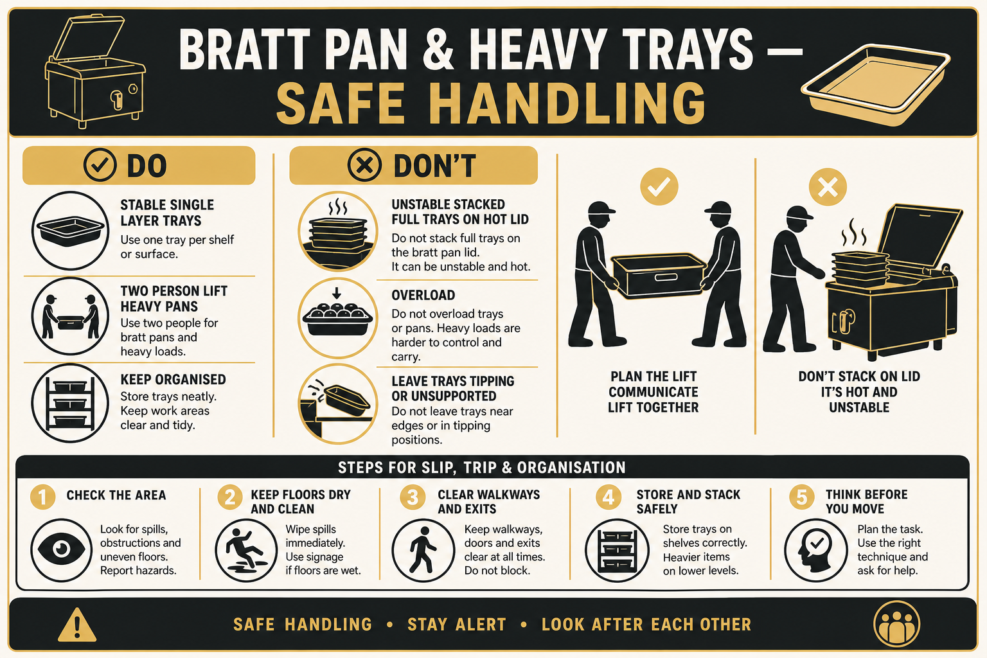
1. Equipment Information
Location | The Vedanta Kitchen & Retreat Centre
Assessor | Shyam Prasad
Brand | Commercial bratt pan
Model | Tilting skillet / bratt pan (asset approx. 25277)
Date Completed | 27/07/2026
Review Date | 04/11/2025

2. Description of Equipment
Large stainless-steel bratt pan with temperature dial (up to ~300°C), indicator lights and a tilting handwheel. The flat lid is sometimes used as a temporary holding surface for GN trays of cooked product. Incorrect stacking of heavy metal trays on the lid creates fall, burn and slip hazards.
3. Operating Procedure (How to Use)
1. Confirm the pan is clear, clean and dry before heating; set temperature for the task only.
2. Do not leave the bratt pan unattended while heating or cooking.
3. Keep clear of steam and hot surfaces; open the lid away from the face.
4. When tilting to empty, clear the pour path, warn colleagues, and use the handwheel steadily.
5. Never stand in the pour path of hot liquids or food.
6. Do not use the closed lid as long-term storage for heavy GN trays.
7. If trays must rest briefly on the lid: one layer only, trays fully supported on the rim, not resting on food below, and never stacked crosswise or unevenly.
8. Move trays to designated racking as soon as practicable; cool before deep stacking for storage.
9. Isolate power and allow the pan to cool before cleaning; follow manufacturer guidance.
4. Risk Assessment
Hazard | People at Risk | Risk Before | Control Measures | Risk After
Burns from hot pan, lid or contents | Staff | High | Heat-resistant PPE; controlled temperature; never leave unattended; cool before deep clean. | Low
Spill / scald when tilting | Staff | High | Clear pour area; slow handwheel use; warn others; correct fill level — do not overfill. | Low
Unstable heavy metal trays stacked on lid | Staff | High | No irregular/crosswise stacks; no tray resting on food surface; move to proper racking; team lift heavy trays. | Low
Slip from spilled product if trays fall | Staff | High | Stable placement only; clean spills immediately; non-slip footwear; keep walkways clear. | Low
Overloading pan with product | Staff | Medium | Follow chef batch sizes; leave headspace; do not force oversized loads. | Low
Manual handling of full GN trays | Staff | High | Do not overfill trays; two-person lifts; keep trays at waist height on racks, not high unstable piles. | Low

5. Required PPE
- Heat-resistant gloves
- Apron
- Non-slip footwear
- Hair net
6. Additional Notes
- Site observation: trays stacked unevenly on the bratt pan lid are not acceptable — correct immediately.
- Report asset/service needs using the unit identification label.

Wrapmaster Cling Film & Parchment Cutters — Equipment Risk Assessment
Step-by-step safe use
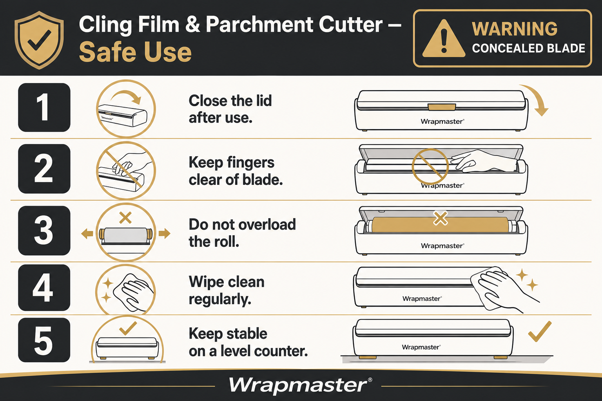
1. Equipment Information
Location | The Vedanta Kitchen & Retreat Centre
Assessor | Shyam Prasad
Brand | Wrapmaster
Model | Cling film / parchment dispenser with concealed blade
Date Completed | 27/07/2026
Review Date | 04/11/2025

2. Description of Equipment
White/grey Wrapmaster table-top dispensers for cling film and parchment. Each unit has a hinged lid and a concealed cutting blade. Front warning: CAUTION: CONCEALED BLADE. Units sit on stainless prep tables and must stay stable and organised.
3. Operating Procedure (How to Use)
1. Place the dispenser on a clear, dry, stable stainless worktop — do not leave it where it can be knocked.
2. Open the lid carefully; load the correct roll so film/paper feeds square to the cutter.
3. Pull film/paper evenly; cut using the designed cutting action — never force fingers toward the blade track.
4. Keep hands clear of the concealed blade at all times; never remove or defeat blade guards.
5. Close the lid when not in use.
6. Replace empty cores promptly; do not leave loose rolls free on the bench.
7. Wipe the housing regularly; do not immerse the unit or blade assembly in water.
8. Report damaged lids, latches or blades and take the unit out of service if unsafe.
4. Risk Assessment
Hazard | People at Risk | Risk Before | Control Measures | Risk After
Cuts / lacerations from concealed blade | Staff | High | Heed CAUTION: CONCEALED BLADE; keep fingers away from cutter; close lid after use; train new staff. | Low
Dispenser sliding on worktop | Staff | Medium | Stable placement; clear bench; do not pull film with excessive force that drags the unit. | Low
Trip / slip from film/paper on floor | Staff | Medium | Pick up discarded film immediately; keep walkways clear; organise spare rolls on shelves. | Low
Hygiene / contamination of film contact surfaces | Guests | Medium | Clean housing; wash hands; keep food debris out of roll compartment. | Low

5. Required PPE
- Apron
- Non-slip footwear
- Hair net
6. Additional Notes
- Applies to both cling film and parchment Wrapmaster cutters on site.
- Do not attempt blade repairs unless competent and authorised.

Buffalo Induction Hob — Equipment Risk Assessment & Operating Procedures
Step-by-step safe use
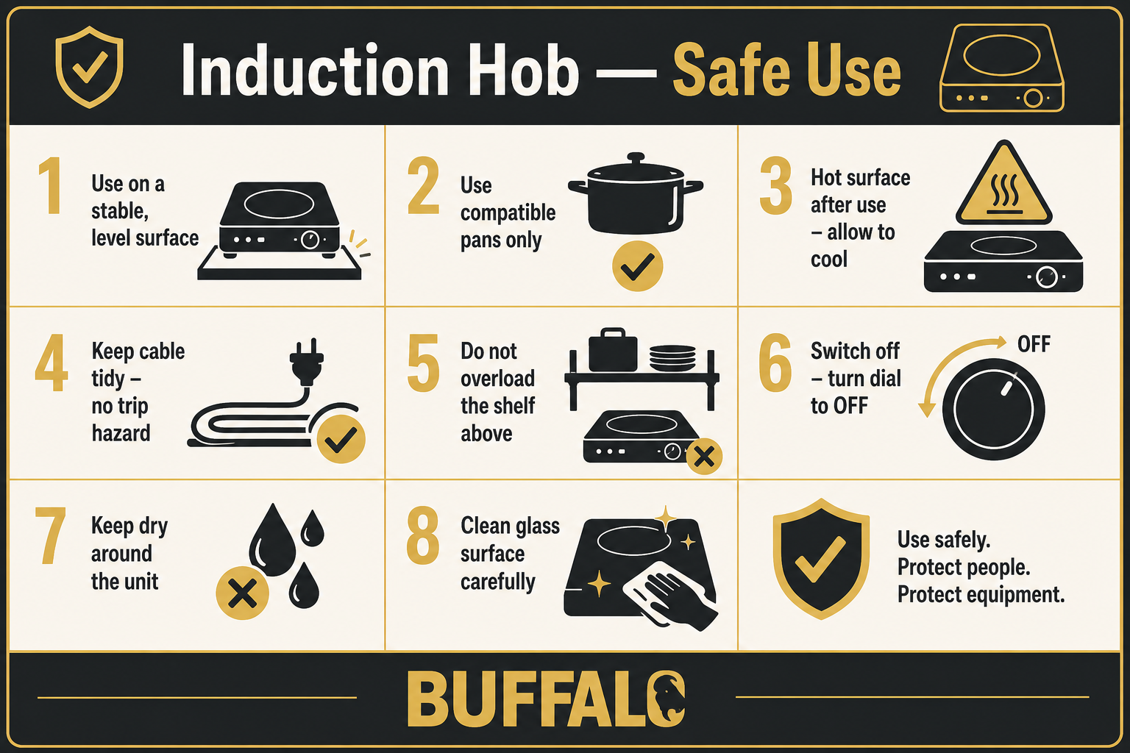
1. Equipment Information
Location | The Vedanta Kitchen & Retreat Centre
Assessor | Shyam Prasad
Brand | Buffalo
Model | Portable single-zone induction hob
Date Completed | 27/07/2026
Review Date | 04/11/2025

2. Description of Equipment
Countertop Buffalo induction hob with ceramic glass cooking zone, MIN–MAX rotary control, POWER indicator and hot-surface warning symbol. Used on stainless prep tables; power cord must be managed to avoid trips and contact with water.
3. Operating Procedure (How to Use)
1. Place the hob on a stable, level, dry stainless surface with ventilation around the unit.
2. Use only induction-compatible cookware, correctly centred on the marked zone.
3. Keep the glass clean and dry; do not place empty pans on high power for long periods.
4. Set power with the dial between MIN and MAX as needed; return to OFF when finished.
5. Never touch the ceramic zone during or shortly after use — observe the hot-surface warning.
6. Keep liquids, cloths and plastic containers clear of the cooking zone.
7. Route the power cord behind the unit — not across walkways or sinks.
8. Do not overload a single socket circuit with multiple high-draw appliances.
9. Switch off, unplug and allow to cool before cleaning; wipe with a damp cloth — do not immerse.
4. Risk Assessment
Hazard | People at Risk | Risk Before | Control Measures | Risk After
Burns from hot glass / cookware | Staff | High | Hot-surface awareness; use pan handles; allow cool-down; keep zone clear when idle. | Low
Electric shock / damaged flex | Staff | Medium | Visual check of cord/plug; keep dry; PAT as scheduled; remove if damaged. | Low
Trip hazard from power cord | Staff | Medium | Cord tidy behind unit; do not stretch across aisles. | Low
Fire / overheating from unsuitable use | Staff / Kitchen | Medium | Correct cookware; do not leave unattended on high; clear combustibles (boxes, parchment) from beside the hob. | Low
Overloading electrical circuit | Staff / Building | Medium | Do not share overloaded multi-way adapters; use designated outlet. | Low

5. Required PPE
- Apron
- Non-slip footwear
- Heat-resistant gloves when moving hot pans
6. Additional Notes
- Scratched control panels still need cleaning — report if markings become unreadable.
- Keep parchment/cling dispensers and cardboard clear of the hot zone.

Heavy Metal Trays, Fryer Shelf & Kitchen Storage — Organisation Risk Assessment
1. Scope
Covers stainless GN pans, baking trays and metal bowls stored on fryer-area shelving, Craven-style racking, bratt-pan tops and general kitchen shelves. Focus: prevent overload, under-support, unstable stacks, manual handling injury, and slip/trip from fallen items or spilled food. Storage must be properly organised.
2. Key Information
Location | The Vedanta Kitchen & Retreat Centre
Assessor | Shyam Prasad
Assessment type | Area / activity risk assessment
Date Completed | 27/07/2026
Review Date | 04/11/2025

3. Risk Assessment
Hazard | People at Risk | Risk Before | Control Measures | Risk After
Unstable / overloaded stacks of heavy metal trays | Staff | High | Stack like with like; keep stacks vertical and within shelf capacity; no crosswise or teetering piles; limit height so top tray can be taken safely. | Low
Manual handling injury from full GN pans | Staff | High | Do not overfill pans; team lift heavy loads; store heavy items between knuckle and shoulder height where practicable; avoid retrieving from bottom of tall stacks. | Low
Trays falling from high shelves | Staff | High | Do not stack beyond safe reach; use step stool if authorised; never climb racking; keep top-shelf stacks modest. | Low
Slip / trip from spilled food or fallen trays | Staff | High | Immediate clean-up; wet-floor signs; clear floor of bins/utensils protruding into walkways; non-slip footwear. | Low
Protruding utensils on rack sides (snag hazard) | Staff | Medium | Hang tools inward or in designated hooks that do not obstruct aisles. | Low
Cluttered shelves blocking cleaning / hygiene | Staff / Guests | Medium | Properly organise by type/size; leave access for cleaning; remove broken or unused items. | Low
Using equipment lids (fryer/bratt) as permanent tray storage | Staff | High | Use designated shelves/racks only; temporary rests must be single-layer and supervised, then cleared. | Low

4. Control Summary
- Store empty trays nested neatly on designated Craven / fryer-area shelves — not on hot equipment.
- Do not overload shelves or individual stacks; if a stack feels unstable, rebuild it immediately.
- Do not under-support trays (e.g. resting a full pan on food in the pan below).
- Keep walkways clear of bins, hanging tools and stray film/paper.
- Clean as you go; report damaged racking.
- Supervisors to check organisation at open/close.
5. Required PPE
- Non-slip footwear
- Apron
- Gloves when handling dirty/hot trays as appropriate
6. Additional Notes
- Visual reference: steps-heavy-tray-storage.png in the steps guide folder.
- Applies together with fryer, bratt pan and blast-chiller assessments when trays are in use.

Heavy tray organisation — visual guide
Step-by-step tray storage & organisation
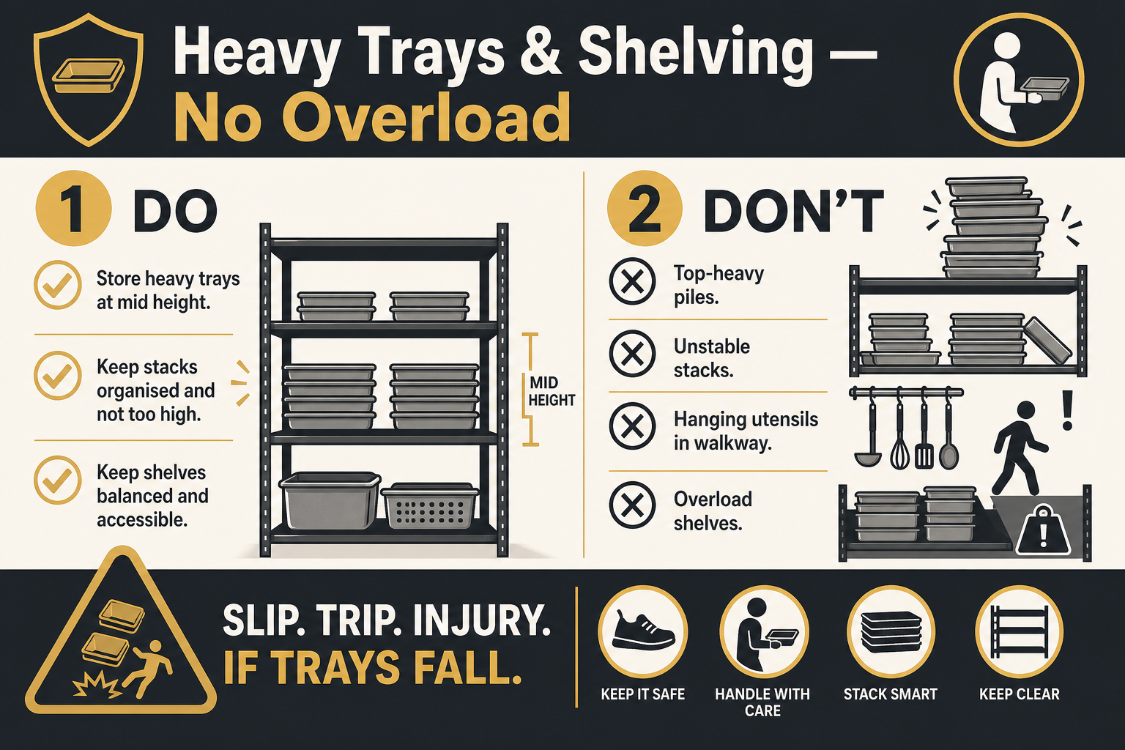
Quick visual guide — Do / Don’t / Care
DO
- Stack trays of the same size, neatly nested
- Keep heavy items at safe height
- Clear spills and fallen film immediately
- Use designated racking only
DON’T
- Overload shelves or build towering unstable stacks
- Rest full pans crosswise or on food below
- Store trays permanently on fryer/bratt lids
- Leave utensils sticking into walkways
CARE
- Check shelves at start and end of service
- Team-lift heavy full pans
- Keep floors dry and organised
- Train agency/new staff on storage rules

Vedanta Kitchen Risk Assessment
1. Scope
Covers general kitchen operations including food preparation, cooking, cleaning, storage, waste handling and staff movement within The Vedanta Kitchen.
2. Key Information
Location | The Vedanta Kitchen & Retreat Centre
Assessor | Shyam Prasad
Assessment type | Area / activity risk assessment
Date Completed | 27/07/2026
Review Date | 04/11/2025

3. Risk Assessment
Hazard | People at Risk | Risk Before | Control Measures | Risk After
Slips, trips and falls | Staff / Visitors | High | Clean spills immediately; clear walkways; non-slip mats; suitable footwear. | Low
Burns from ovens, hobs, hot pans | Staff | High | Use dry cloths / gloves; announce “hot”; keep pan handles turned inward. | Low
Fire (oil, electrical, gas) | Staff / Guests | High | Never leave fryers/pans unattended; know extinguisher types; fire training; extract cleaning. | Low
Manual handling injuries | Staff | Medium | Team lifts for heavy stock; use trolleys; training on safe lifting. | Low
Food poisoning / contamination | Guests | High | Temperature control; date labelling; cleaning schedules; allergen controls; HACCP. | Low
Chemical exposure (cleaners) | Staff | Medium | COSHH sheets; correct dilution; PPE; store chemicals away from food. | Low

4. Control Summary
- Maintain daily opening/closing cleaning checklists.
- Record fridge/freezer temperatures at required intervals.
- Keep first-aid kit and burn gel accessible.
- Report all near-misses and incidents.
5. Required PPE
- Apron / chef whites
- Non-slip footwear
- Heat-resistant gloves / cloths as needed
- Gloves for cleaning chemicals

Vedanta Catering Services Risk Assessment
1. Scope
Covers off-site and on-site catering service: transport of food, service set-up, hot holding, buffet/service lines, and breakdown.
2. Key Information
Location | The Vedanta Kitchen & Retreat Centre
Assessor | Shyam Prasad
Assessment type | Area / activity risk assessment
Date Completed | 27/07/2026
Review Date | 04/11/2025

3. Risk Assessment
Hazard | People at Risk | Risk Before | Control Measures | Risk After
Temperature abuse during transport | Guests | High | Use insulated boxes; hot-hold above 63°C or cold below 5°C; temperature logs. | Low
Vehicle loading injuries / traffic risk | Staff | Medium | Use trolleys; secure loads; park safely; two-person lifts for heavy items. | Low
Burns / hot holding equipment | Staff | Medium | Warn guests/staff of hot surfaces; use correct lids and gloves. | Low
Allergen cross-contact at service | Guests | High | Clear allergen labelling; separate utensils; trained service staff; guest enquiry process. | Low
Slips at service points | Staff / Guests | Medium | Manage cable runs; wipe spills; clear guest walkways. | Low

4. Control Summary
- Complete a service checklist before departure and on arrival.
- Keep probe thermometer and sanitising wipes with the catering kit.
- Return leftovers under temperature control or dispose per food safety policy.
5. Required PPE
- Apron / service uniform
- Non-slip footwear
- Heat-resistant gloves for hot equipment
- Disposable gloves for ready-to-eat service where required

Vedanta Front of House & Kitchen Risk Assessment
1. Scope
Covers interaction between front-of-house and kitchen areas: service pass, guest areas, beverage service, and shared walkways during service periods.
2. Key Information
Location | The Vedanta Kitchen & Retreat Centre
Assessor | Shyam Prasad
Assessment type | Area / activity risk assessment
Date Completed | 27/07/2026
Review Date | 04/11/2025

3. Risk Assessment
Hazard | People at Risk | Risk Before | Control Measures | Risk After
Collision in pass / corridor | Staff | Medium | Keep-left / call-outs (“behind”, “hot”); keep floors clear; limit congestion. | Low
Hot plate / spill burns at pass | Staff | Medium | Use dry cloths; communicate plate status; stable stacking. | Low
Guest slips in dining areas | Guests / Staff | Medium | Prompt spill response; suitable mats at entrances; clear trailing cables. | Low
Broken glass / crockery | Staff / Guests | Medium | Clear immediately with dustpan; dispose in glass bin; cordon if needed. | Low
Allergen information failure | Guests | High | Up-to-date allergen matrix; FOH trained to check with kitchen; never guess. | Low

4. Control Summary
- FOH and kitchen brief before busy service.
- Keep emergency exits and fire routes clear at all times.
- Ensure allergen folder / matrix is current for the day’s menu.
5. Required PPE
- Non-slip footwear
- Service apron where required
- Gloves for clearing waste / glass

Vedanta Generic Kitchen Risk Assessment (June 2024)
1. Scope
General kitchen hazards and standard controls for The Vedanta Kitchen & Retreat Centre, based on the June 2024 generic kitchen risk assessment. Use alongside equipment-specific sheets.
2. Key Information
Location | The Vedanta Kitchen & Retreat Centre
Assessor | Shyam Prasad
Assessment type | Area / activity risk assessment
Date Completed | 27/07/2026
Review Date | 04/11/2025

3. Risk Assessment
Hazard | People at Risk | Risk Before | Control Measures | Risk After
General kitchen injury (cuts, burns, strains) | Staff | High | Induction training; supervision of new staff; safe systems of work; PPE. | Low
Electrical equipment faults | Staff | Medium | Visual checks before use; PAT testing schedule; remove defective kit from service. | Low
Poor housekeeping | Staff / Guests | Medium | Clean-as-you-go; end-of-day deep clean; designated storage for tools and stock. | Low
Pest activity | Guests / Staff | Medium | Seal food; waste control; report sightings; pest contractor visits. | Low
Inadequate first aid response | Staff / Guests | Medium | Trained first aiders; stocked kit; incident reporting forms available. | Low

4. Control Summary
- Review this generic assessment whenever menus, staffing or layout change.
- Keep SDS / COSHH information accessible for all cleaning chemicals.
- Link this pack to staff induction and refresher training records.
5. Required PPE
- Apron
- Non-slip footwear
- Task-specific gloves (heat, cut, chemical)
6. Additional Notes
- Source file reference: Vedanta generic kitchen risk assessments June 2024 (AutoRecovered).
- Where an equipment sheet and this generic sheet both apply, follow the stricter control.

Document Control & Sign-Off
This combined pack replaces the separate equipment and area risk assessment files listed on the cover. It should be reviewed after any incident, equipment change, or at least annually.
Document owner | Shyam Prasad
Approved by
Approval date
Next review | 27/07/2027
Version | 2.3 Added fryer, dough mixer, blast chiller, bratt pan, Wrapmaster, induction & tray storage

Staff acknowledgement
I confirm I have read and understood the relevant sections for equipment and tasks I use.
Name | Role / Area | Date / Signature

