**Office ERP System – Internship Project Report**

**An Internship Report Submitted**

**In Partial Fulfillment**

**for award of Master of Computer Applications**

**by**

**Shyam Sundar**

**(Roll No. 2400290140205)**

**Under the Mentorship of**

**Ms. Shruti Aggarwal**

**Assistant Professor**

**Department of Computer Applications**





**Department of Computer Applications**

**(An Autonomous Institute)**

**Affiliated to**

**DR. A.P.J. ABDUL KALAM TECHNICAL UNIVERSITY, LUCKNOW**

**Table of Contents**

| **S. No.** | **Content** | **Page No.** |
| --- | --- | --- |
|  | **Declaration** | 4 |
|  | **Internship Certificate** | 5 |
|  | **Acknowledgements** | 6 |
| 1 | **Introduction** | 7 |
| 1.1 | Overview of the Internship / Experience | 7 |
| 1.2 | Organization Profile (Brief) | 8 |
| 1.3 | Internship Objectives | 9 |
| 2 | **Project / Task Details** | 10 |
| 2.1 | Project Title and Scope | 10 |
| 2.2 | Project Modules or Task Breakdown | 11-12 |
| 2.3 | Methodology / Tools & Technologies Used | 12-14 |
| 2.4 | Challenges Faced | 14-15 |
| 3 | **Conclusion** | 16 |
| 3.1 | Summary of Learning, Key Takeaways & Achievements | 16-17 |
| 4 | **References / Bibliography** *(Books, Research Articles, Tools, Websites, APIs etc. referred during internship* | 18 |
| 5 | **Annexures** | 19 |
| 5.1 | SNAPSHOTS | 19-22 |
| 5.2 | GITHUB REPOSITORY LINK | 22 |

**List of Figures**

| **S. No.** | **Content** | **Page No.** |
| --- | --- | --- |
| 5.1.1 | ADMIN VIEW | 18 |
| 5.1.2 | HR VIEW | 18 |
| 5.1.3 | EMPLOYEE VIEW | 19 |
| 5.1.4 | MANAGE EMPLOYEES PAGE | 19 |
| 5.1.5 | MANAGE DEPARTMENT PAGE | 20 |
| 5.1.6 | NOTIFICATIONS PAGE | 20 |
| 5.1.7 | ATTENDANCE PAGE | 21 |

## DECLARATION

I hereby declare that the work presented in this report entitled **“Office ERP System– Internship Project Report”** is my original contribution and was carried out by me as part of the requirements for the **MCA program**. This report has not been submitted, either fully or partially, for the award of any other degree, diploma, or certification at any other university or institute.

I have given due credit and acknowledgment to all sources from which ideas, data, diagrams, graphics, computer programs, or experimental results have been taken. Any content reproduced verbatim has been appropriately quoted and cited.

I affirm that the report upholds the values of **academic integrity**, and no part of this work is plagiarized or fabricated. The experiments and results documented herein are genuine and have not been manipulated. I understand that any instance of plagiarism or data manipulation will be treated as a serious academic offense, and I shall be solely responsible and answerable for any such misconduct.

Name: Shyam Sundar

Roll Number: 2400290140205

***(Candidate Signature)***

### **INTERNSHIP CERTIFICATE**

### **ACKNOWLEDGEMENT**

I would like to express my sincere gratitude to my **Project Mentor- CA Mohit Aggarwal Sir,**  at the TAC Services for providing the opportunity, resources, and mentorship necessary to complete this project successfully.

My heartfelt thanks to the  **Ms. Shruti Aggarwal , Assistant Professor at KIET**, for their constant motivation, encouragement, and support throughout this learning journey. I extend my appreciation to all those who directly or indirectly contributed to this enriching experience.

Shyam Sundar

Roll No.: 2400290140205

1. **Introduction**
   1. **Overview of the Internship**

I had the opportunity to pursue a 6-week internship at **Tavishi Advisory & Consultancy Services Private Limited (TAC Services)** from **2nd June 2025** to **16th July 2025**. The internship was focused on gaining hands-on experience in full-stack software development and working on a real-world **Office ERP System.**

During this period, I was exposed to professional tools, coding standards, collaborative workflows, and industry practices that are followed in software consultancy and product development. The experience was structured and guided under the mentorship of professionals from TAC Services, which allowed me to enhance both my technical skills and professional discipline.

The internship was divided into weekly milestones, starting with orientation and environmentsetup, followed by learning modern frontend technologies, and then progressing to a **team-based project – Office ERP System**. My primary responsibility was to design and implement the userinterface of different ERP modules using **React.js** and **Tailwind CSS**, ensuring a responsive, interactive, and user-friendly experience.

This systematic approach not only strengthened my technical expertise in **React.js, Tailwind CSS, component-based design, and API integration**, but also improved my understanding of **UI/UX design principles, collaborative teamwork, version control, and software documentation**.

* 1. **Organization Profile :**

**Tavishi Advisory & Consultancy Services Private Limited (TAC Services)** is a private company incorporated in **January 2025**, headquartered in **Ghaziabad, Uttar Pradesh (India)**.

The company is primarily engaged in:

* Software consultancy and advisory services
* Custom web and mobile application development
* Technology transformation for startups and SMEs

As a **technology-driven consultancy**, TAC Services aims to bridge the gap between businesses and digital solutions by delivering **scalable**, **reliable**, and **client-focused** software products.

The company’s approach is strongly rooted in innovation and practical implementation, which was clearly reflected in the internship program. Interns were treated as contributors to actual projects, ensuring that the work carried out added real business value while giving interns the confidence to handle industry-level challenges.

* 1. **Internship Objectives:**

The objectives of my internship at **Tavishi Advisory & Consultancy Services Pvt. Ltd. (TAC Services)** were carefully designed to align with both organizational goals and my personal learning aspirations. The internship primarily focused on frontend development for the Office ERP System, aiming to provide me with industry-level exposure and hands-on experience.

The key objectives were as follows:

1. **Enhance Technical Proficiency**
   * To strengthen my knowledge and practical skills in modern frontend technologies, specifically React.js and Tailwind CSS, while following best coding practices and industry standards.
2. **Design and Development of User Interfaces**
   * To design and implement responsive, interactive, and user-friendly interfaces for different modules of the Office ERP System, ensuring an intuitive experience for end-users.
3. **Integration with Backend Services**
   * To understand and implement API integration for dynamic data handling, enabling seamless communication between the frontend and backend of the ERP system.
4. **Adoption of Component-Based Architecture**
   * To apply modular and reusable component-based design principles in React.js, ensuring scalability and maintainability of the software.
5. **Focus on UI/UX Best Practices**
   * To improve my understanding of user experience (UX) and user interface (UI) design, making the ERP application visually appealing, accessible, and easy to navigate.
6. **Team Collaboration and Workflow Management**
   * To gain experience in collaborative development environments using Git/GitHub, participate in team discussions, and adapt to professional workflows followed in software consultancy.
7. **Documentation and Professional Development**
   * To develop the ability to create structured documentation for the modules I worked on, and to cultivate discipline, problem-solving skills, and professional communication.

1. **Project Details**
   1. **Project Title and Scope**

**Project Title: Office ERP System**

**Scope of the Project:**

The **Office ERP System** was designed as a **modular enterprise application** to simplify and automate daily organizational processes such as **employee management, leave approvals, task tracking, payroll, reporting, and communication**. The scope of the project extended beyond simple automation and focused on building a **centralized digital platform** that improves efficiency, transparency, and collaboration within an organization.

From a **frontend perspective**, the scope of the project included:

* Designing and implementing **user-friendly interfaces** for different ERP modules using **React.js** and **Tailwind CSS**.
* Ensuring the ERP system is **responsive** and can be accessed seamlessly across desktops, laptops, and tablets.
* Building **reusable UI components** (forms, modals, tables, dashboards, etc.) to maintain consistency and scalability across modules.
* Integrating the frontend with **RESTful APIs** to fetch and display real-time organizational data.
* Applying **UI/UX design principles** to create an intuitive navigation system, making it easy for both administrators and employees to use the system effectively.
  1. **Project Modules or Task Breakdown**

The **Office ERP System** was divided into several modules, each focusing on a specific aspect of office management. As a **Frontend Developer Intern**, my contribution was to design and implement the user interface for these modules using **React.js** and **Tailwind CSS**, ensuring responsiveness, interactivity, and API integration.

**1. Dashboard Module**

**Objective:** To provide an overview of organizational activities and quick access to important features.  
**Tasks Performed:**

* Designed a **responsive admin/HR dashboard layout**.
* Implemented **statistical cards** (e.g., total employees, tasks in progress, pending leaves).
* Added **charts/graphs integration** placeholders for data visualization.

**2. Employee Directory Module**

**Objective:** To maintain records of all employees in the organization.  
**Tasks Performed:**

* Created **listing tables** with pagination and search functionality.
* Designed **employee profile cards**.
* Integrated API calls to fetch employee data dynamically.
* Added action buttons like **View, Edit, Delete** for managing employee records.

**3. Leave Management Module**

**Objective:** To manage employee leave requests and approvals.  
**Tasks Performed:**

* Built **leave application forms** with form validation.
* Designed an **HR leave approval panel** with filtering and sorting options.
* Integrated **leave balance display** and approval/rejection actions.
* Added **modals** for leave history and rejection reasons.

**4. Task/Project Management Module**

**Objective:** To assign, monitor, and track office tasks and projects.  
**Tasks Performed:**

* Implemented a **task list view** with filters (status, priority, deadline).
* Created a **Kanban board view** for visual task tracking (To Do, In Progress, Review, Completed).
* Added **task creation modals** with form fields for deadlines, priority, and team members.
* Integrated **progress tracking** using progress bars and status updates.

**5. Reports and Analytics Module**

**Objective:** To generate and visualize organizational reports.  
**Tasks Performed:**

* Designed **report cards** (Completion Rate, Avg. Task Duration, Overdue Tasks).
* Integrated **charts (pie, line, bar)** for tasks by status, priority, and team performance.
* Ensured **responsive layouts** for analytics dashboards.

**6. Notices & Announcements Module**

**Objective:** To communicate important updates and announcements across the organization.  
**Tasks Performed:**

* Developed a **notice board UI** with listing and filtering features.
* Designed **create notice forms** with validation.
* Implemented **announcement display cards** for better readability.

**Summary of My Contributions**

Throughout the project, I was responsible for:

* Designing **responsive layouts** using React.js and Tailwind CSS.
* Developing **reusable frontend components** (forms, modals, tables, dashboards).
* Integrating APIs for **dynamic data rendering**.
* Ensuring **cross-browser compatibility** and optimizing UI performance.
* Following **collaborative workflows** with Git/GitHub for version control
  1. **Methodology / Tools & Technologies Used**

The internship project followed a **modular and milestone-based development methodology** inspired by **Agile practices**. The work was divided into **weekly sprints**, starting from tool setup and individual learning tasks to team collaboration and final integration.

As a **frontend developer**, my workflow involved the following steps:

1. **Requirement Analysis:**
   * Understanding the business requirements of each ERP module (Employee, Leave, Task, Reports, Notices).
   * Identifying required UI components and user interactions.
2. **UI/UX Planning:**
   * Creating wireframe sketches for forms, dashboards, modals, and lists.
   * Ensuring user-centric design and accessibility.
3. **Component-based Development:**
   * Breaking the frontend into reusable and modular React components.
   * Structuring code using clean folder hierarchy and best practices.
4. **API Integration:**
   * Consuming RESTful APIs to fetch, display, and update dynamic data.
   * Handling loading states, error handling, and conditional rendering.
5. **Testing & Debugging:**
   * Testing responsiveness, cross-browser compatibility, and data accuracy.
   * Debugging UI issues using browser dev tools and React Developer Tools.
6. **Version Control & Collaboration:**
   * Using **Git** and **GitHub** for version control and pull request workflow.
   * Collaborating with teammates through branches and code reviews.

**🧰 Technologies Used**

| **Category** | **Tools / Technologies** | **Purpose / Use-Case** |
| --- | --- | --- |
| **Frontend Framework** | React.js | Building modular and dynamic UI components |
| **Styling & UI Design** | Tailwind CSS | Utility-first styling, responsive layouts |
| **State Management** | React useState, useEffect | Managing component state and lifecycle |
| **Routing** | React Router DOM | Navigating between different pages/modules |
| **Form Handling** | React forms + validation hooks | Input validation, controlled form fields |
| **API Communication** | Fetch / Axios | Consuming REST APIs for dynamic data rendering |
| **Version Control** | Git & GitHub | Code versioning, branching, collaboration |
| **Browser Developer Tools** | Chrome DevTools, React DevTools | Debugging, inspecting elements, performance check |
| **Code Editor** | Visual Studio Code | Main IDE for development |
| **Operating System** | Windows 11 | Local development environment |

* 1. **Challenges Faced**

During my internship, I encountered several challenges that helped me grow as a **software tester** and improve my **problem-solving and automation skills**. Some of the key challenges were:

**1. Understanding a Large-Scale ERP Project**

* **Challenge:** Initially, it was difficult to understand the workflows of a large ERP system (Attendance, Leave, Tasks, etc.) and identify what areas needed thorough testing.
* **Solution:** I carefully studied each module, mapped test cases to real workflows, and interacted with my mentor to clarify functional requirements. This helped me design accurate test cases.

**2. Automating Test Cases with Selenium**

* **Challenge:** Writing automation scripts to handle dynamic elements (like dropdowns, modals, and date pickers) was difficult.
* **Solution:** I used different Selenium locators (XPath, CSS, ID), applied explicit waits, and broke scripts into reusable functions for better efficiency.

**3. Handling Browser Compatibility**

* **Challenge:** Some ERP features behaved differently across browsers (e.g., form submissions or button actions).
* **Solution:** I executed test scripts on multiple browsers (Chrome, Firefox, Edge) and adjusted scripts using proper waits and validations.

**4. Validating API Data with UI**

* **Challenge:** At times, the UI displayed incorrect or delayed data fetched from backend APIs.
* **Solution:** I cross-checked API responses with UI data, reported mismatches as bugs, and added validations in test scripts to verify data consistency.

**5. Debugging and Script Failures**

* **Challenge**: Test scripts failed frequently due to changes in element locators or page load delays.
* **Solution:** I used Selenium’s WebDriverWait, added exception handling, and continuously updated test scripts when the application UI changed.

1. **Conclusion**

This 6-week internship at Tavishi Advisory & Consultancy Services Pvt. Ltd. (TAC Services) was a highly enriching experience that provided me with hands-on exposure to **software testing using Selenium with Python** in a professional setting.

**Key Learnings:**

* Gained practical experience in **automated testing** using Selenium with Python for web applications.
* Learned to work with different **locators** (ID, Name, XPath, CSS Selector) to identify and interact with web elements.
* Understood the importance of **test case design, execution, and validation** in ensuring software quality.
* Improved skills in handling **dynamic elements, waits (implicit/explicit), and form submissions** during testing.
* Learned to integrate Selenium scripts with **Python unittest/PyTest frameworks** for structured test automation.
* Strengthened knowledge of **bug reporting and documentation**, ensuring clear communication with the development team.
* Understood ERP workflows, especially in modules like **Attendance, Leave Management, and Task Tracking**, and validated their functionality through automation.

**Key Takeaways:**

* Understood how **automation testing speeds up validation** in enterprise-level ERP systems.
* Realized the importance of **accuracy and reliability in test scripts** for maintaining software quality.
* Learned how to translate **business requirements into test cases** and verify real-world scenarios effectively.
* Gained confidence in using **Selenium with Python** for automating repetitive test tasks.
* Improved collaboration and communication skills by working with developers and reporting test results.
* Learned the importance of **debugging and refining test scripts** to handle different environments and browsers.
* Understood that **continuous testing and feedback** are critical for scalable and maintainable systems.

**Achievements:**

* Successfully automated test cases for key ERP modules including **My Attendance, Manage Users, and Leave Requests**.
* Designed and executed automated scripts to **verify login, data validation, and report generation** processes.
* Implemented test automation for **form submissions, task creation, and approval workflows**, reducing manual testing efforts.
* Improved testing efficiency by applying **modular and reusable script design**.
* Demonstrated ability to work independently as well as collaboratively in a team, meeting project deadlines.
* Received positive feedback from mentors for the **accuracy of test cases, detailed bug reports, and quality of automation scripts**.

**4. References**

* <https://react.dev/>
* <https://tailwindcss.com/docs>
* <https://nodejs.org/en/docs>
* <https://expressjs.com/>
* <https://mongoosejs.com/docs/>
* <https://jwt.io/introduction>
* <https://developer.mozilla.org/en-US/docs/Glossary/REST>
* <https://learning.postman.com/docs>
* <https://docs.github.com/en/get-started>

* 1. **ANNEXURES**

**5.1 SNAPSHOTS**

**ADMIN VIEW:**

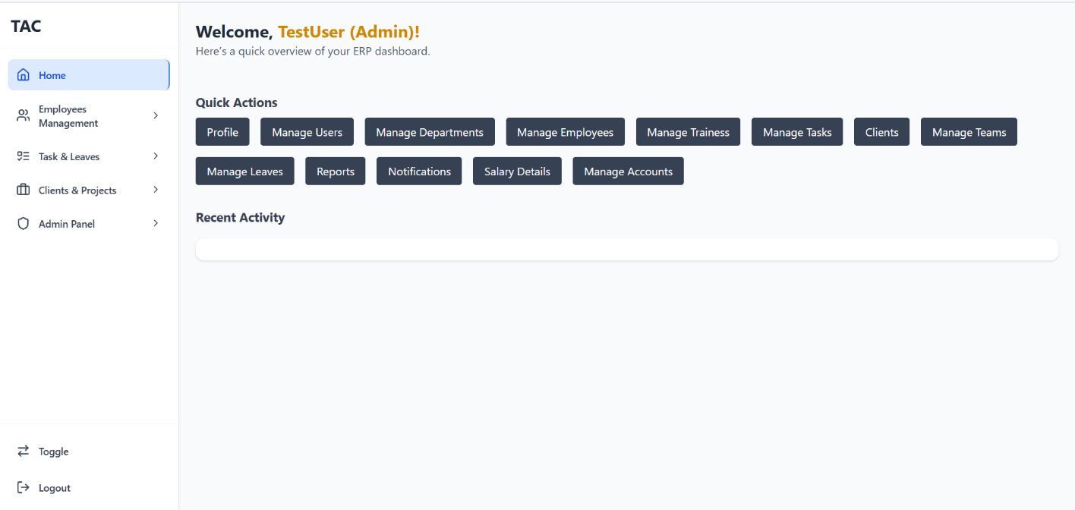

**FIG 5.1.1**

**HR VIEW:**

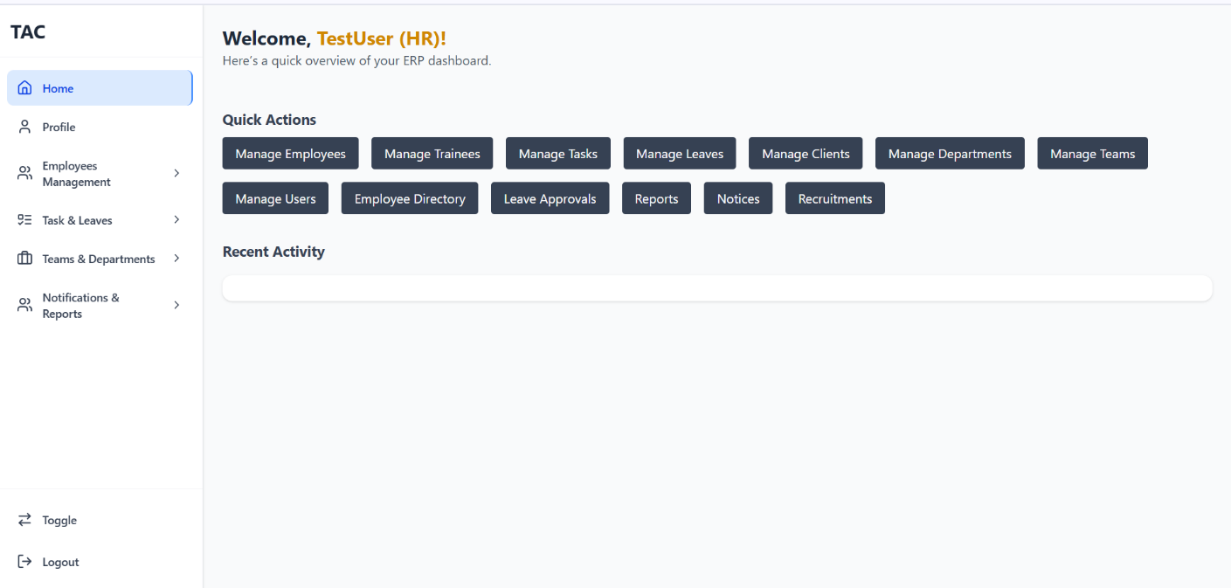

**FIG 5.1.2**

**EMPLOYEE VIEW:**

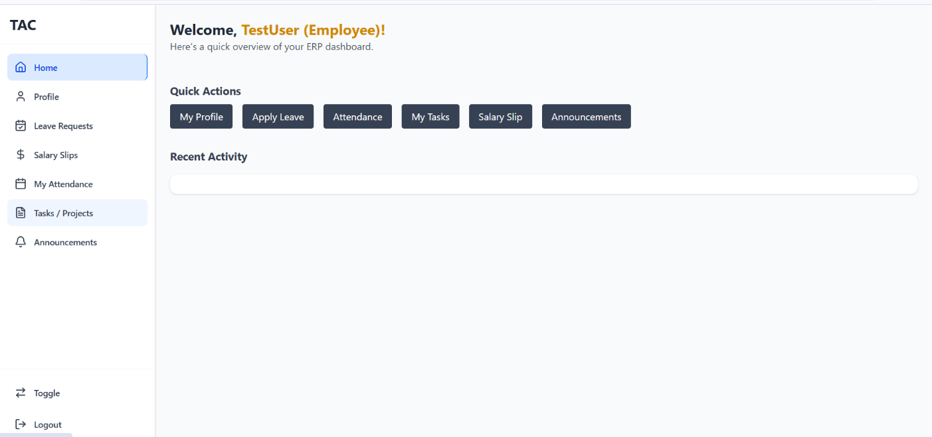

**FIG 5.1.3**

**MANAGE EMPLOYEES:**

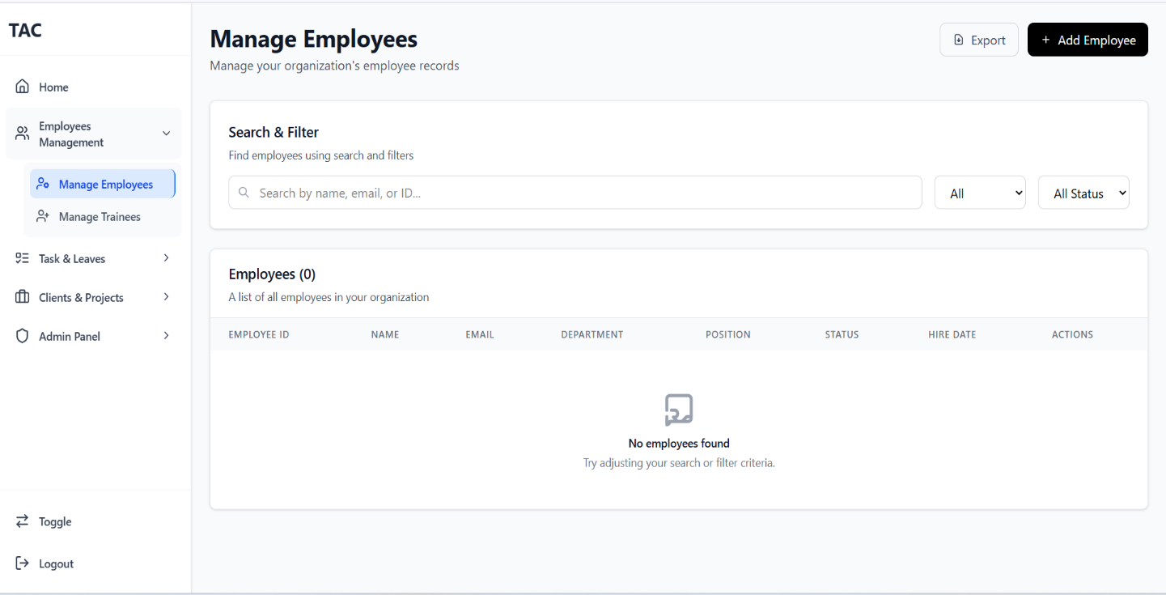

**FIG 5.1.4**

**MANAGE DEPARTMENTS:**

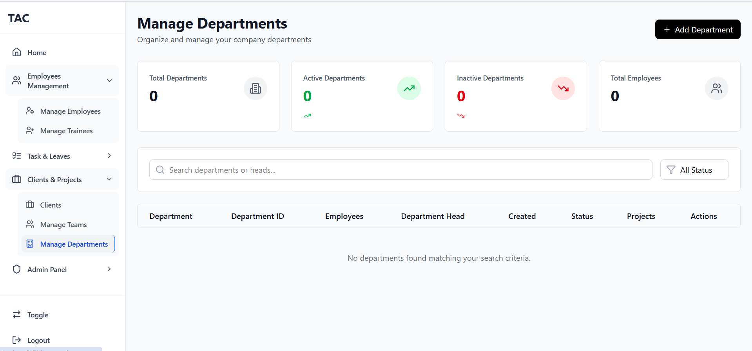

**FIG 5.1.5**

**NOTIFICATIONS:**

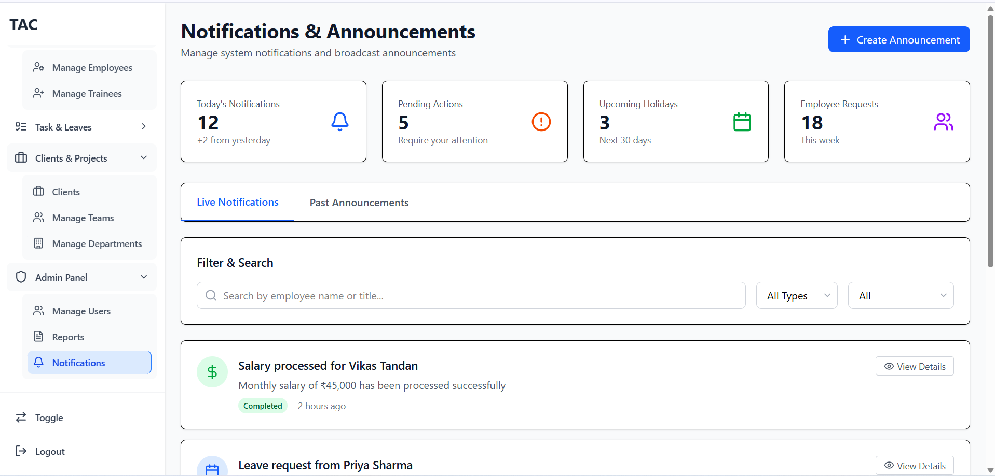

**FIG 5.1.6**

**ATTENDANCE VIEW:**

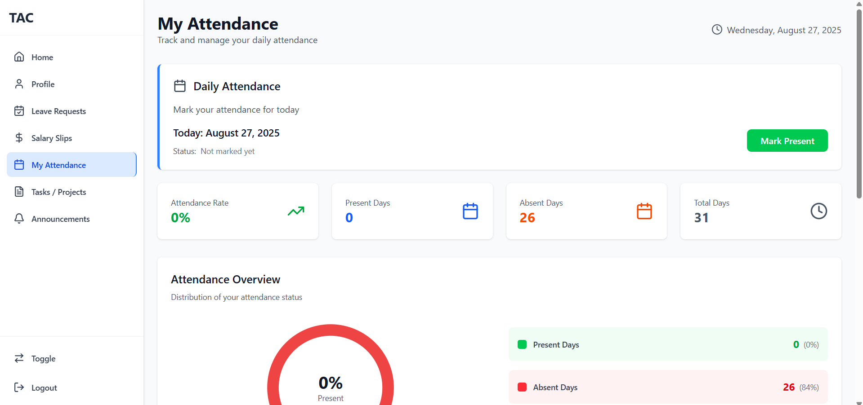

**FIG 5.1.7**

**5.2 GITHUB REPOSITORY LINK**

[**https://github.com/shivam-chaturvedi/OFFICE-ERP-SYSTEM**](https://github.com/shivam-chaturvedi/OFFICE-ERP-SYSTEM)