CS23532 – COMPUTER NETWORKS
EX 1: Study of Various Network Commands used in Linux and Windows
AIM :
To study and execute the various network commands used in Linux and Windows and to understand their purpose through hands-on practice.
PROCEDURE :
Windows commands (Command Prompt / PowerShell)
1. arp -a : Address Resolution Protocol. Shows the IP address and MAC address of the devices (such as the router) known to your computer.
2. hostname : The simplest TCP/IP command. Displays the name of your computer.
3. ipconfig /all : Displays detailed configuration information about the TCP/IP connection, including gateway, DNS, DHCP and the type of Ethernet adapter.
4. nbtstat -a : Helps solve problems with NetBIOS name resolution (NBT stands for NetBIOS over TCP/IP).
5. netstat : Network statistics. Displays the active TCP/IP connections of the computer and is used to monitor incoming and outgoing connections, routing tables and interface statistics (e.g. netstat -r).
6. nslookup : Name server lookup. Performs DNS lookups to display the IP address of a computer, the MX records or the name servers of a domain (e.g. nslookup www.google.com).
7. pathping : Unique to Windows; a combination of ping and tracert. It traces the route to the destination and then tests each router along the way to gather statistics on packet loss at each hop.
8. ping : Packet INternet Groper. Tests connectivity between two nodes using ICMP. It can be used with a hostname (ping localhost), an IP address (ping 4.2.2.2) or a domain name (ping www.facebook.com).
9. route print : Shows and manipulates the IP routing table; mainly used to set up static routes to specific hosts or networks.
Linux commands
1. ip : Shows address information, manipulates routing and displays network devices, interfaces and tunnels.
ip address show
ip address add 192.168.1.254/24 dev enps03
ip link set eth0 up
ip route add default via 192.168.1.254 dev eth0
ip route get 10.10.1.4

2. ifconfig : Configures and troubleshoots network interfaces; it has since been replaced by the ip command.
ifconfig

3. mtr : Matt's traceroute. Combines the functions of ping and traceroute and shows statistics such as response time and packet loss for every hop.
mtr google.com
mtr -c 10 google.com

4. tcpdump : Captures and displays network packets.
tcpdump -D
tcpdump -i eth0 -c 10
tcpdump -i eth0 host 8.8.8.8
tcpdump -i eth0 port 53

5. ping : Verifies IP-level connectivity to another TCP/IP computer by sending ICMP Echo Request messages and showing the round-trip times.
ping google.com
ping -c 10 google.com

6. nmcli : Manages the network connection settings of an Ethernet connection from the command line.
nmcli connection show
nmcli connection modify "Wired connection 1" ipv4.method auto

Steps
- Open Command Prompt or PowerShell on the Windows system.
- Type each of the Windows commands listed above and press Enter.
- Observe and record the output of each command.
- Open a terminal on a Linux system and execute the Linux commands listed above.

OUTPUT:
arp -a, hostname and ipconfig /all
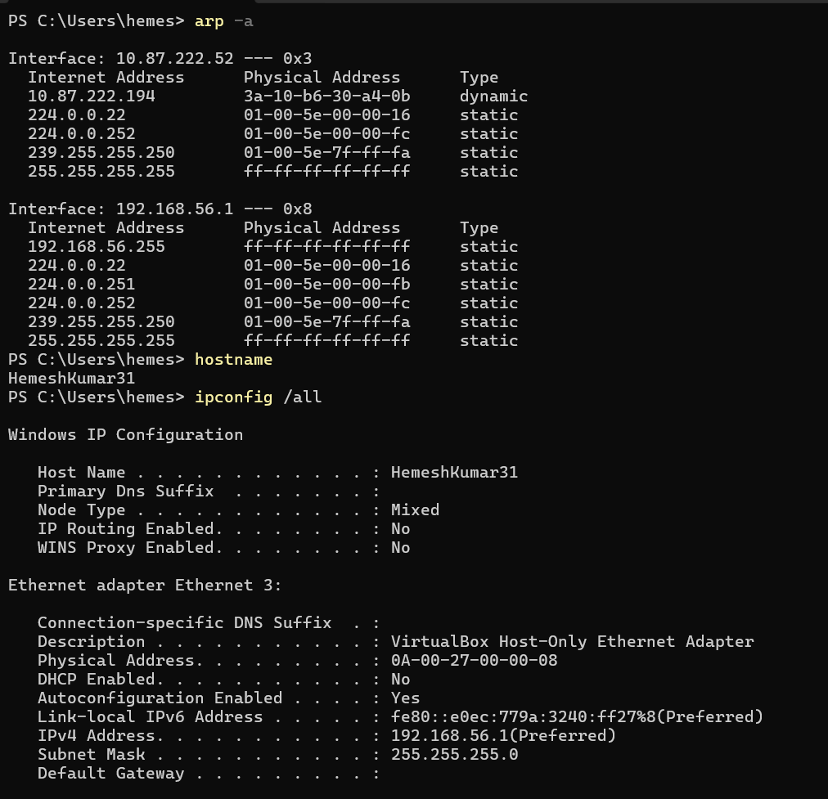
nbtstat -a, netstat and nslookup
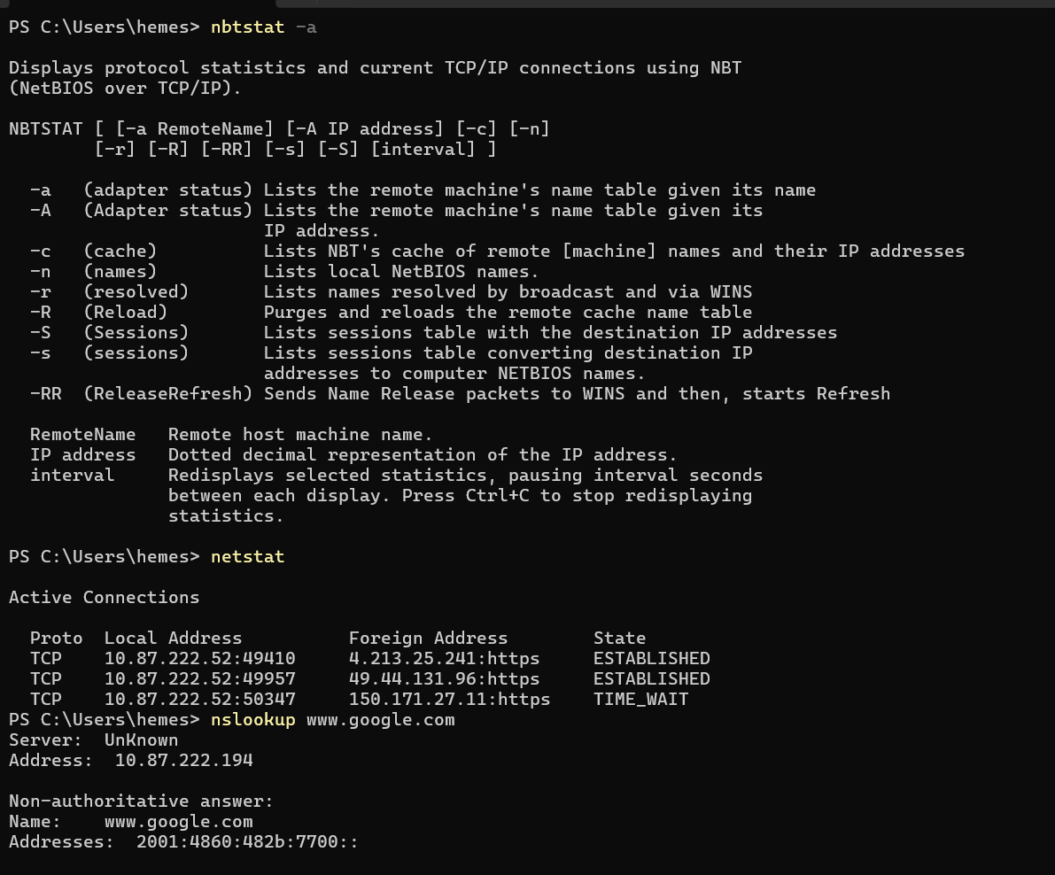
nslookup, pathping and ping
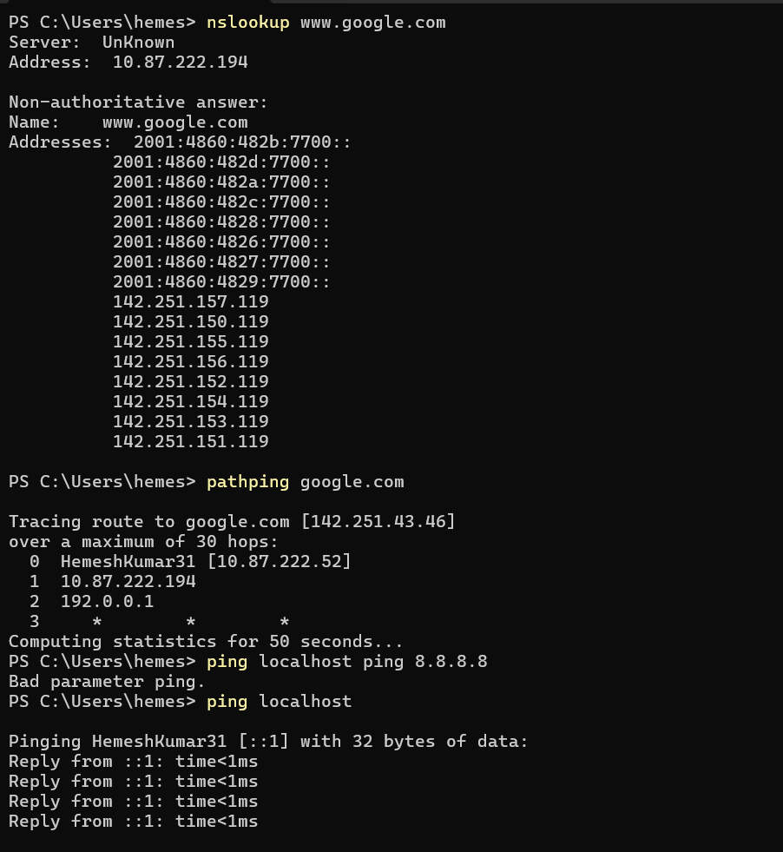
ping and route print
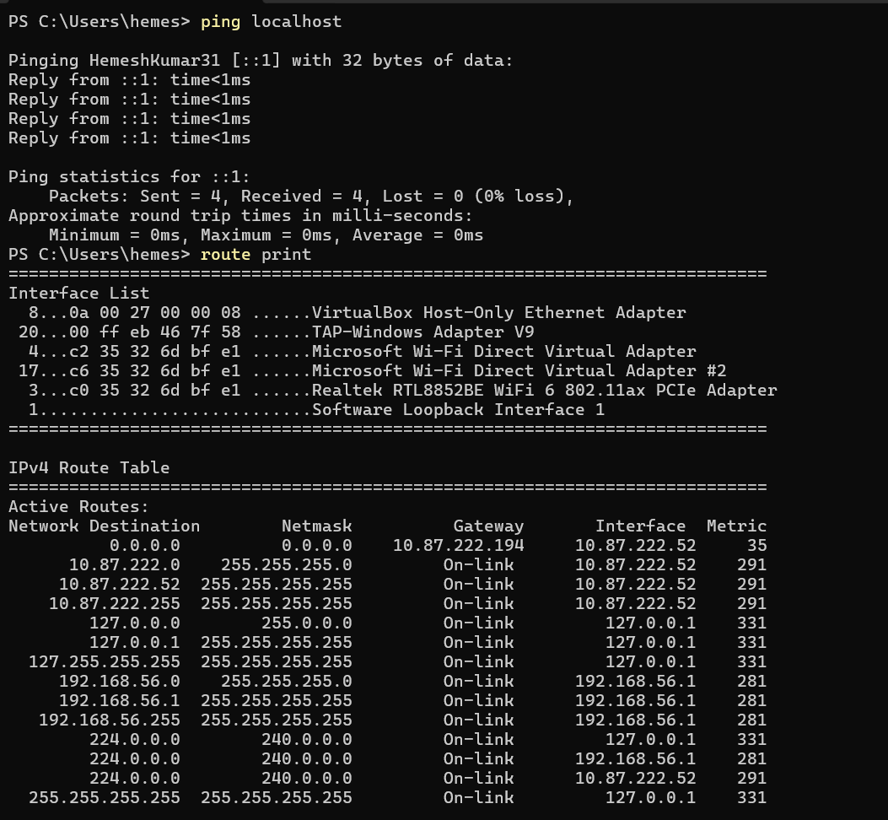
RESULT:
Thus, the various network commands used in Linux and Windows were studied and executed successfully, and their outputs were observed.

