CS23532 – COMPUTER NETWORKS
EX 2: Study of Different Types of Network Cables
AIM :
To study and understand the different types of network cables, and to make an Ethernet cross-over cable and a straight-through cable.
PROCEDURE :
a) Understand different types of network cables
The different types of cables used in networking are:
- Unshielded Twisted Pair (UTP) Cable
- Shielded Twisted Pair (STP) Cable
- Coaxial Cable
- Fibre Optic Cable
Cable type | Category | Maximum Data Rate | Advantages / Disadvantages | Application / Use | Image
UTP | Category 3 | 10 Mbps | Advantages  • Cheaper in cost  • Easy to install as they have a smaller overall diameter  Disadvantages  • More prone to EMI (Electromagnetic Interference) and noise | 10Base-T Ethernet | 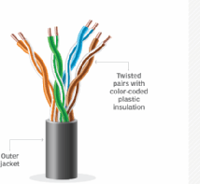
UTP | Category 5 | Up to 100 Mbps |  | Fast Ethernet, Gigabit Ethernet
UTP | Category 5e | 1 Gbps |  | Fast Ethernet, Gigabit Ethernet
STP | Category 6, 6a | 10 Gbps | Advantages  • Shielded  • Faster than UTP  • Less susceptible to noise and interference  Disadvantages  • Expensive  • Greater installation effort | Gigabit Ethernet, 10G Ethernet (55 m). Widely used in data centres | 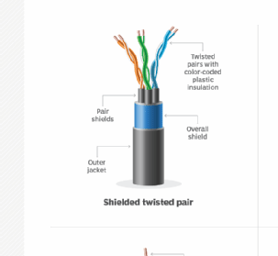  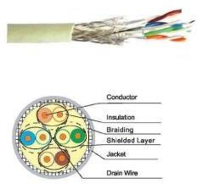
SSTP | Category 7 | 10 Gbps |  | Gigabit Ethernet, 10G Ethernet (100 m)
Coaxial cable | RG-6, RG-59, RG-11 | 10–100 Mbps | Advantages  • High bandwidth  • Immune to interference  • Low loss bandwidth  • Versatile  Disadvantages  • Limited distance  • Cost  • Size is bulky | Speed of signal is 500 m. Television network, high speed internet connections | 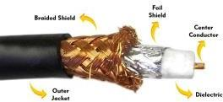
Fibre optic cable | Single mode, Multi mode | 100 Gbps | Advantages  • High speed  • High bandwidth  • High security  • Long distance  Disadvantages  • Expensive  • Requires skilled installers | Maximum distance of fibre optic cable is around 100 meters | 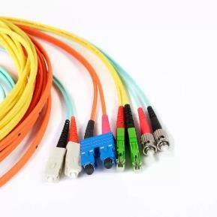
b) Make your own Ethernet cross-over cable / straight cable
Tools and parts needed:
• Ethernet cabling. CAT5e is certified for gigabit support, but CAT5 cabling works as well, just over shorter distances.
• A crimping tool. This is an all-in-one networking tool shaped to push down the pins in the plug and strip and cut the shielding off the cables.
• Two RJ45 plugs.
• Optional two plug shields.
Difference between crossover cable and straight cable: In a straight-through cable both ends are wired in arrangement A. In a crossover cable one end is wired in arrangement A and the other end in arrangement B.
Step 1: To start construction of the cable, begin by threading shields onto the cable.
Step 2: Next, strip approximately 1.5 cm of cable shielding from both ends. The crimping tool has a round area to complete this task.
Step 3: Untangle the wires; there should be four “twisted pairs”. Referring to the sheet, arrange them from top to bottom. One end should be in arrangement A and the other in B.
Step 4: Once the order is correct, bunch the wires together in a line and snip any that stick out farther than others to create an even level. To place them in the RJ45 plug without messing up the order, hold the plug with the clip side facing away from you and the gold pins facing toward you.
Step 5: Push the cable right in. The notch at the end of the plug needs to be just over the cable shielding; if it is not, too much shielding has been stripped off, so snip the wires back a little more.
Step 6: After the wires are securely sitting inside the plug, insert it into the crimping tool and push down. Pushing too hard can crack the fragile plastic plug.
Step 7: Repeat for the other end using diagram B (to make a crossover cable) or diagram A (to make a straight-through cable). To test it, plug it in and connect two devices directly.

OUTPUT:
Straight-through and crossover cable pinouts
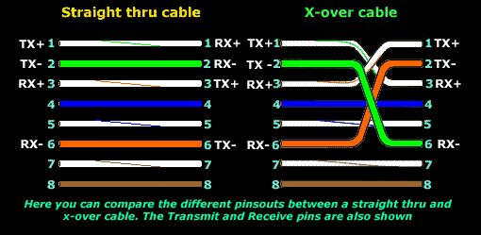
Wire arrangement A and B
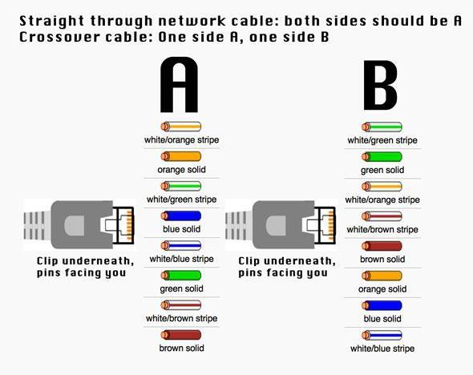
Step 1: Threading the shields onto the cable
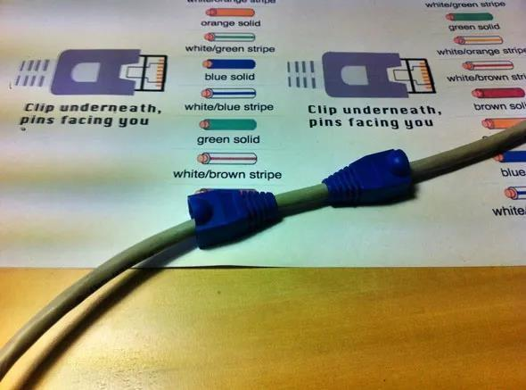
Step 2: Stripping the cable shielding using the crimping tool
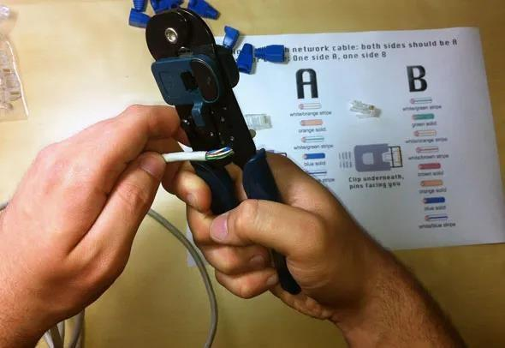
Step 3: Arranging the twisted pairs as per arrangement A / B
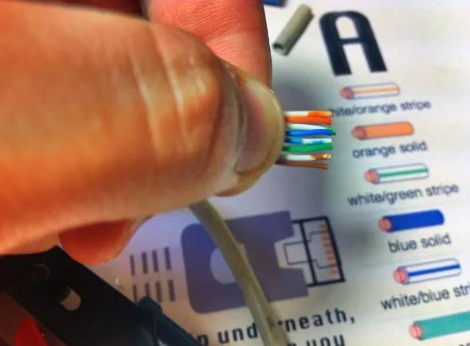
Step 4: Holding the RJ45 plug with the gold pins facing you
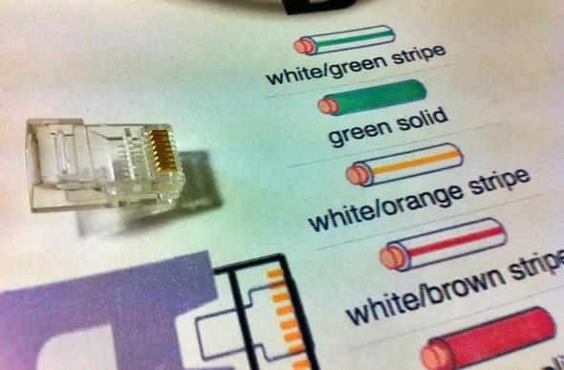
Step 5: Pushing the wires into the RJ45 plug
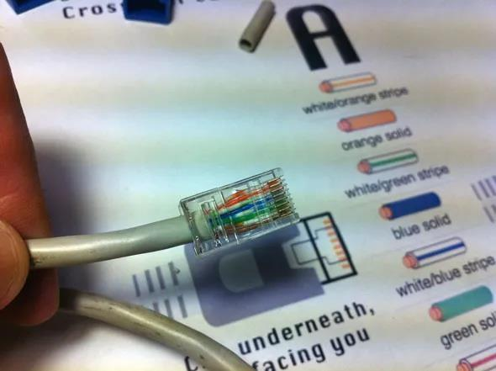
RESULT:
Thus, the different types of network cables were studied successfully, and the Straight Through and Cross Over Ethernet cables were prepared and tested successfully.

