CS23532 – COMPUTER NETWORKS
EX 3: Cisco Packet Tracer
AIM :
To study the installation and user interface of the Cisco Packet Tracer simulation tool, and to design a simple network with a hub and a switch and analyse the behaviour of these network devices.
PROCEDURE :
Introduction
A simulator simulates network devices and their environment. Packet Tracer is a network design, simulation and modelling tool.
• It allows you to model complex systems without the need for dedicated equipment.
• It helps you practise network configuration and troubleshooting skills on a computer or an Android or iOS mobile device.
• It is available for both Linux and Windows desktop environments.
• Protocols in Packet Tracer are coded to work and behave in the same way as they would on real hardware.
Installing Packet Tracer
Go to https://www.netacad.com, log in with your Cisco Networking Academy credentials, click on the Packet Tracer graphic and download the package for your operating system.
Windows: Open the setup file (Packettracer_Setup6.0.1.exe) to begin the setup wizard, accept the license agreement, choose a location and start the installation.
Linux: Download the file for Ubuntu/Debian or for Fedora/Redhat/CentOS, grant executable permission using chmod and execute it to begin the installation.
chmod +x PacketTracer601_i386_installer-rpm.bin
./PacketTracer601_i386_installer-rpm.bin

User interface overview
1. Menu bar – A common menu used to open, save, print, change preferences, and so on.
2. Main toolbar – Shortcut icons to commonly used menu options such as open, save, zoom, undo and redo; on the right-hand side is an icon for entering network information for the current network.
3. Logical/Physical workspace tabs – Used to toggle between the Logical and Physical work areas.
4. Workspace – The area where topologies are created and simulations are displayed.
5. Common tools bar – Controls for manipulating topologies, such as select, move layout, place note, delete, inspect, resize shape and add simple/complex PDU.
6. Real-time/Simulation tabs – Used to toggle between the real-time and simulation modes. Buttons are also provided to control the time and to capture the packets.
7. Network component box – Contains all the network and end devices available in Packet Tracer. It is divided into the device-type selection box (7a), which contains the device categories, and the device-specific selection box (7b), which displays the device models of the selected category.
8. User-created packet box – Users can create customised packets to test their topology from this area, and the results are displayed as a list.
Analyse the behaviour of network devices
- From the network component box, drag and drop 4 generic PCs and one hub, and 4 generic PCs and one switch.
- Click on Connections and select the Copper Straight-Through cable. Connect each PC to the hub; the link LED glows green when the link is up. Similarly, connect the 4 PCs to the switch.
- Click on a PC, go to the Desktop tab, click on IP Configuration and enter an IP address and subnet mask. The default gateway and DNS server are not needed in this network.
- Click on the PDU (message icon) in the common tools bar and drag and drop it on the source PC and then on the destination PC connected to the hub.
- Observe the flow of the PDU from the source PC to the destination PC using the Realtime mode of the simulation.
- Repeat the same steps for the PCs connected to the switch.
- Observe how the hub and the switch forward the PDU and note the behaviour of each device.

OUTPUT:
Packet Tracer user interface
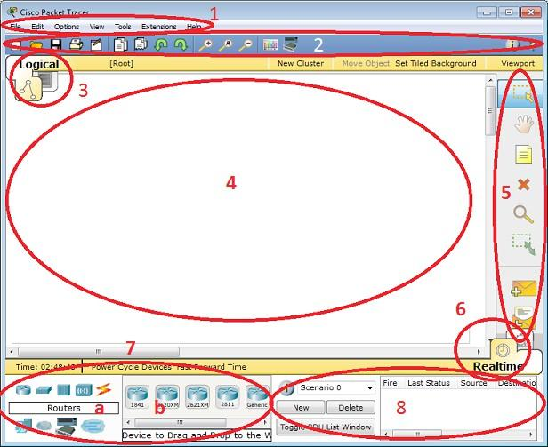
Network topology with a hub and a switch (Cisco Packet Tracer)
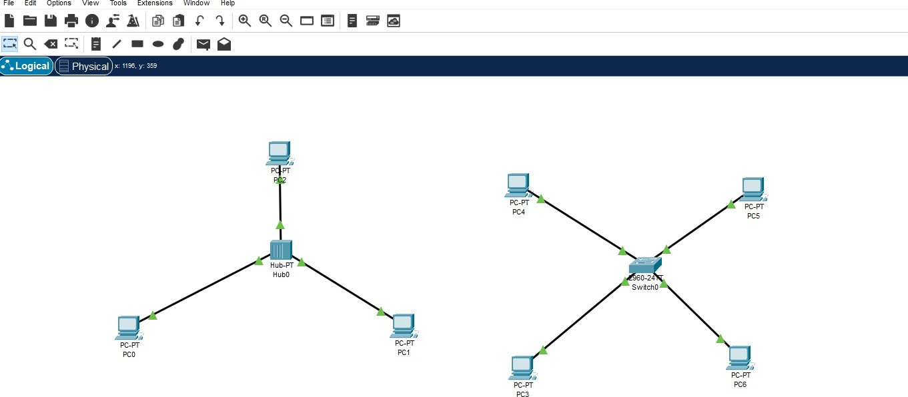
IP configuration of the PCs
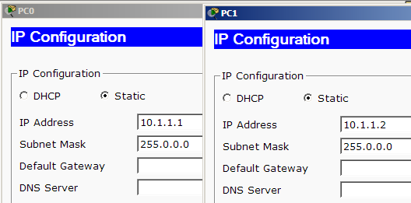
RESULT:
Thus, the Cisco Packet Tracer environment was studied, and a simple network using a hub and a switch was designed and simulated successfully.

