CS23532 – COMPUTER NETWORKS
EX 4: LAN Setup using a Switch
AIM :
To set up and configure a Local Area Network (LAN) using a switch and Ethernet cables in the lab.
PROCEDURE :
What is a LAN?
A Local Area Network (LAN) is a network that connects devices within a limited area, such as an office building, school or home. It enables users to share resources including data, printers and internet access. A LAN switch is the primary connecting device; it manages and directs communication within the local network, allowing each connected device to communicate directly with the others for fast and secure data transfer.
How to set up a LAN
Step 1: Plan and design an appropriate network topology, taking into account the network requirements and the equipment location.
Step 2: Take 4 computers, a switch with 8, 16 or 24 ports (sufficient for networks of this size) and 4 Ethernet cables.
Step 3: Connect each computer to the network switch with an Ethernet cable by plugging one end into the computer and the other end into the switch.
Step 4: Assign IP addresses to the PCs: log on to the client computer as Administrator or Owner, open Network and Internet Connections, right-click Local Area Connection / Ethernet, go to Properties, select Internet Protocol (TCP/IPv4), click Properties, choose “Use the following IP address” and enter the address. Assign the addresses as given in the table below.
Step 5: Configure the network switch: connect a computer to the switch, open a web browser and enter the IP address of the switch, log in with the username and password, configure the basic settings and assign the IP address 10.1.1.5 with subnet mask 255.0.0.0.
Step 6: Check the connectivity between the switch and the other machines using the ping command in the command prompt.
Step 7: Select a folder, go to Properties, click the Sharing tab and share it with everyone on the same LAN.
Step 8: Try to access the shared folder from the other computers of the network.

IP addressing
Device | IP address | Subnet mask
PC1 | 10.1.1.1 | 255.0.0.0
PC2 | 10.1.1.2 | 255.0.0.0
PC3 | 10.1.1.3 | 255.0.0.0
PC4 | 10.1.1.4 | 255.0.0.0
Switch | 10.1.1.5 | 255.0.0.0
OUTPUT:
LAN topology
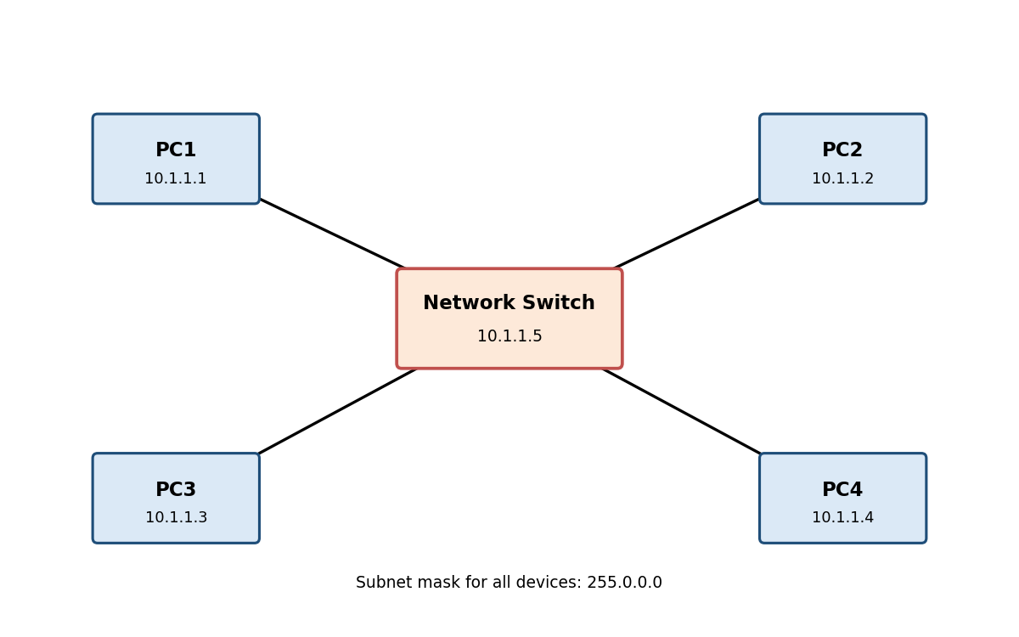
IP configuration of the PCs
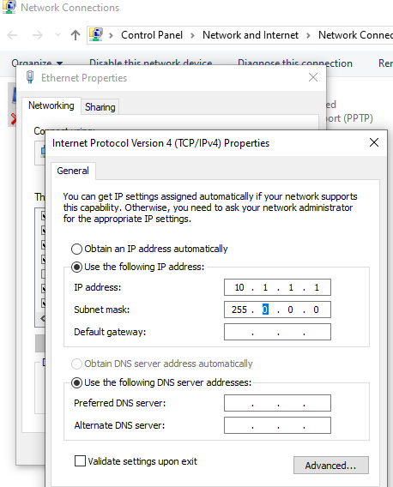
Connectivity check using ping
C:\Users\PC1>ping 10.1.1.2

Pinging 10.1.1.2 with 32 bytes of data:
Reply from 10.1.1.2: bytes=32 time<1ms TTL=128
Reply from 10.1.1.2: bytes=32 time<1ms TTL=128
Reply from 10.1.1.2: bytes=32 time<1ms TTL=128
Reply from 10.1.1.2: bytes=32 time<1ms TTL=128

Ping statistics for 10.1.1.2:
Packets: Sent = 4, Received = 4, Lost = 0 (0% loss),
Approximate round trip times in milli-seconds:
Minimum = 0ms, Maximum = 0ms, Average = 0ms

C:\Users\PC1>ping 10.1.1.5

Pinging 10.1.1.5 with 32 bytes of data:
Reply from 10.1.1.5: bytes=32 time=1ms TTL=64
Reply from 10.1.1.5: bytes=32 time<1ms TTL=64
Reply from 10.1.1.5: bytes=32 time<1ms TTL=64
Reply from 10.1.1.5: bytes=32 time<1ms TTL=64

Ping statistics for 10.1.1.5:
Packets: Sent = 4, Received = 4, Lost = 0 (0% loss),
Approximate round trip times in milli-seconds:
Minimum = 0ms, Maximum = 1ms, Average = 0ms
Access to the shared folder
[Paste the shared folder screenshot here]
RESULT:
Thus, a LAN was set up and configured using a switch and Ethernet cables, and the connectivity between the devices was verified.

