CS23532 – COMPUTER NETWORKS
EX 5: Packet Capture using Wireshark
AIM :
To understand the features of Wireshark as a packet capture tool, and to capture, filter and analyse packets in order to understand the encapsulation of information at the various layers of a protocol stack.
PROCEDURE :
Introduction
A packet sniffer sniffs the messages sent and received by a computer and stores and displays the contents of the various protocol fields in those messages.
• It is a passive program: it never sends packets itself and no packets are addressed to it.
• It receives a copy of all packets sent and received by the host.
• Wireshark, formerly known as Ethereal, captures packets in real time and displays them in a human-readable format.
• It provides filters, colour coding and statistics that help in inspecting individual packets in depth.
Uses of Wireshark
• Network administrators use it to troubleshoot network problems.
• Network security engineers use it to examine security problems.
• Developers use it to debug protocol implementations.
• Students use it to learn network protocol internals.
Installing Wireshark
Wireshark can be downloaded for Windows or macOS from https://www.wireshark.org. On Linux or other UNIX-like systems it is available in the package repositories (for Ubuntu, through the Ubuntu Software Center or apt).
Wireshark user interface
1. Packet List pane -- Displays all packets in the current capture; each line is one packet.
2. Packet Details pane -- Shows the protocols and fields of the selected packet as an expandable tree.
3. Packet Bytes pane -- Shows the data of the selected packet in hexdump style.
4. Colour coding -- By default light purple is TCP, light blue is UDP and black marks packets with errors. View > Coloring Rules shows the full list.
5. Filter box -- A display filter such as tcp, arp, dns, http, icmp or dhcp is typed here to show only the matching packets.
Capturing packets
1. Launch Wireshark and select the Local Area Connection (Ethernet, IEEE 802.3) interface under Capture.
2. Go to Capture > Options and select "Stop capture automatically after 100 packets". Promiscuous mode is enabled by default, so packets of other hosts on the network are also seen.
3. Click Start capture; packets appear in real time.
4. Save the captured packets using File > Save.
Applying display filters
1. TCP/UDP: type tcp or udp in the filter box, inspect the packets and open Statistics > Flow Graph.
2. ARP: type arp in the filter box and inspect the packets.
3. DNS: type dns in the filter box, inspect the packets and open Statistics > Flow Graph.
4. HTTP: type http in the filter box and inspect the packets.
5. IP/ICMP: type icmp (or ip) in the filter box and inspect the packets.
6. DHCP: type dhcp in the filter box and inspect the packets.

OUTPUT:
Capture of 100 packets from the Ethernet (IEEE 802.3) interface
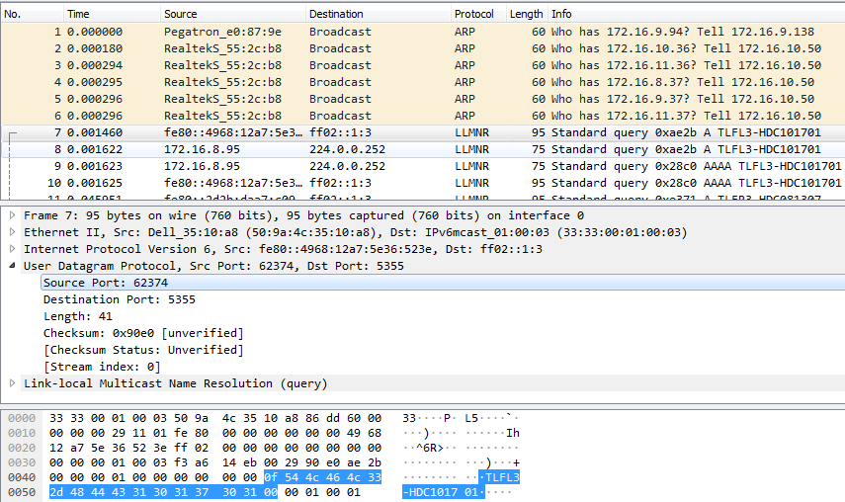
TCP/UDP filter – packet list
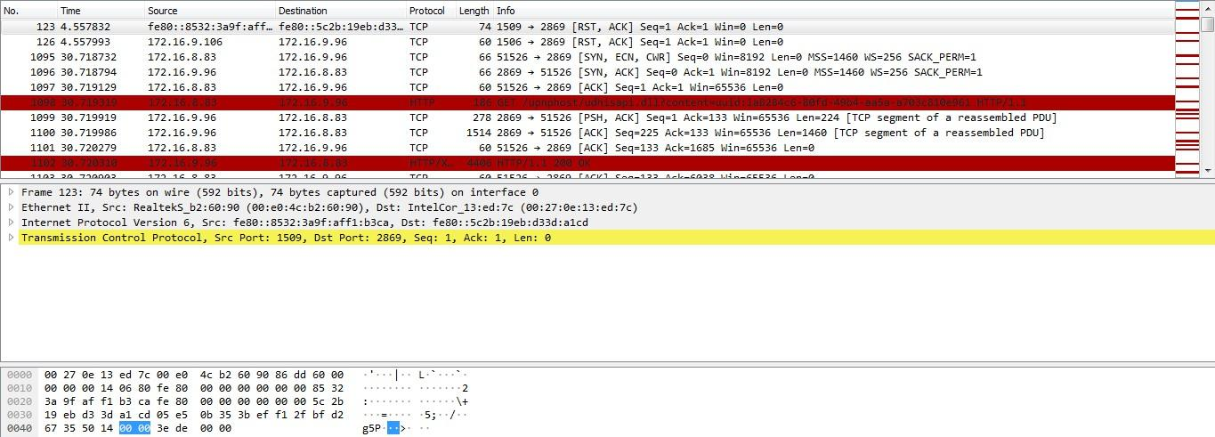
TCP/UDP flow graph
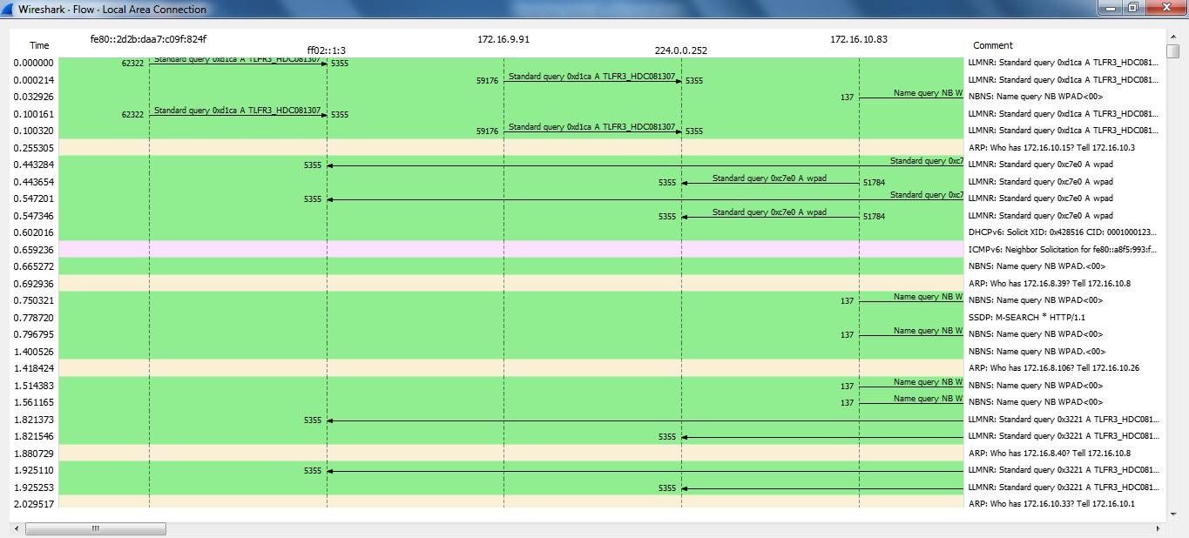
ARP filter
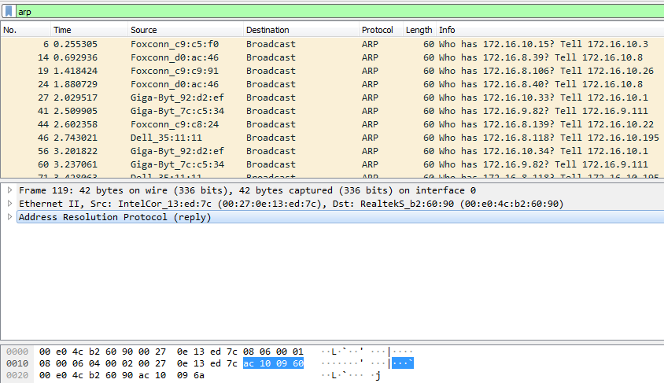
DNS filter
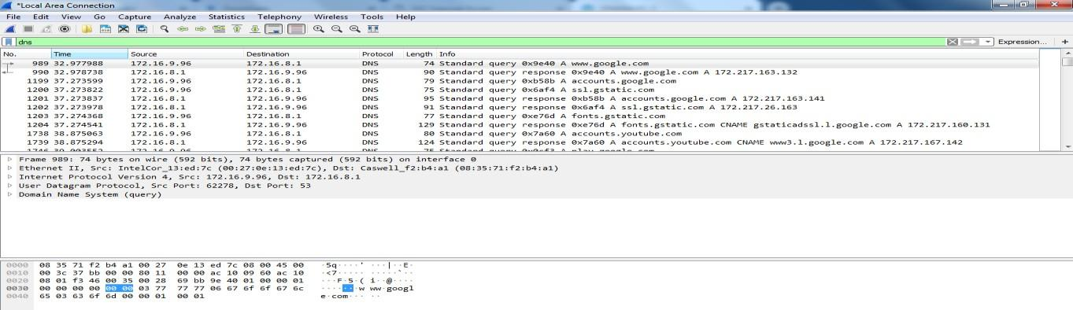
DNS flow graph
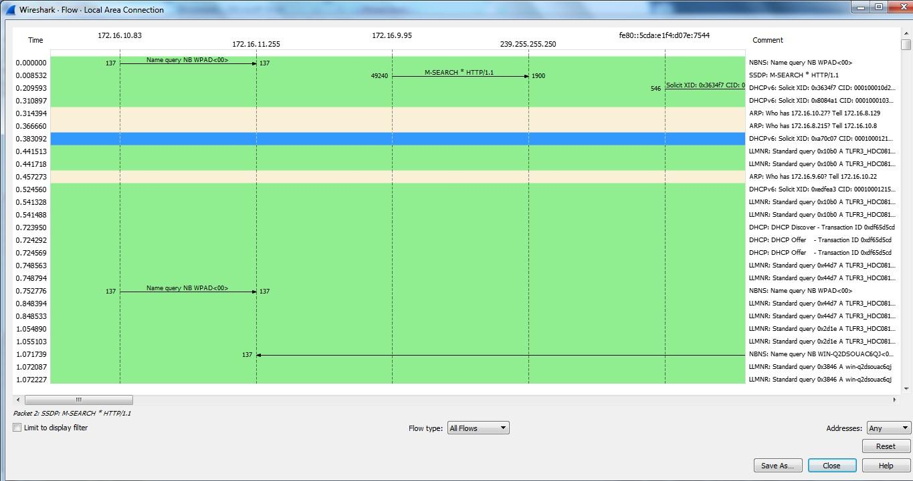
HTTP filter
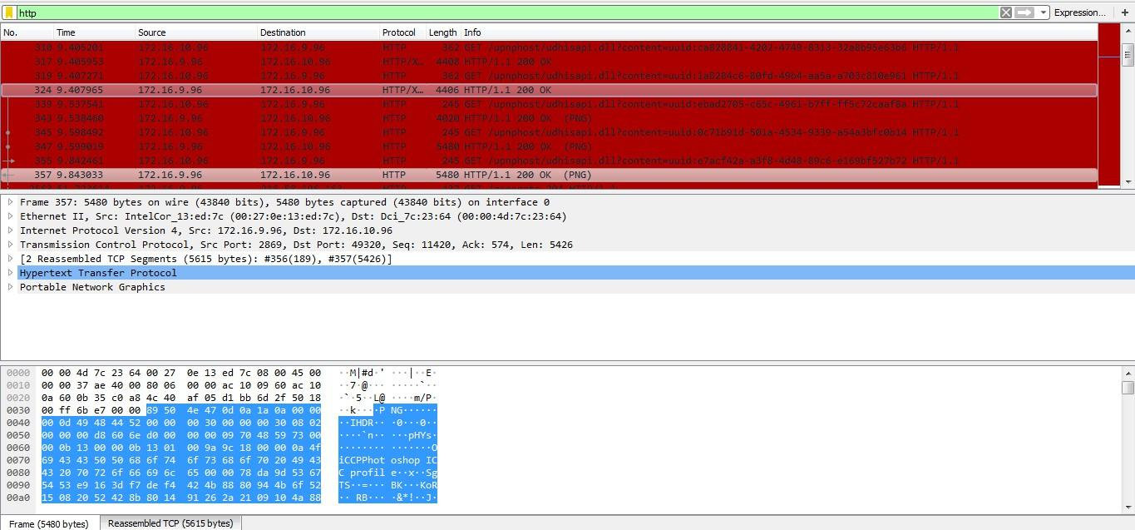
IP/ICMP filter
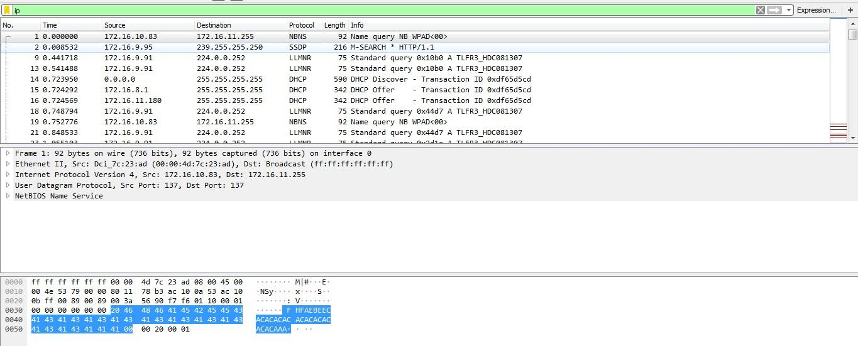
DHCP filter
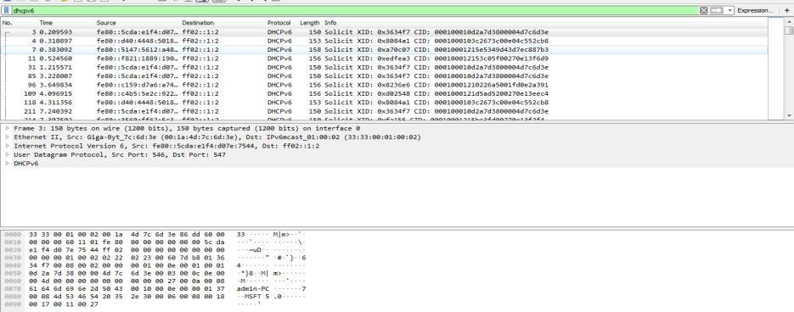
RESULT:
Thus, the features of Wireshark were studied, and packets were captured and analysed using TCP/UDP, ARP, DNS, HTTP, ICMP and DHCP display filters to understand the encapsulation of information at the various layers of the protocol stack.

