CS23532 – COMPUTER NETWORKS
EX 8: Nmap – Discovering Live Hosts (ARP, ICMP, TCP/UDP) on TryHackMe
AIM :
To discover live hosts on a network using the Nmap scans based on ARP, ICMP and TCP/UDP on the TryHackMe platform (Room: Nmap Live Host Discovery, https://tryhackme.com/room/nmap01).
PROCEDURE :
Introduction
Nmap (Network Mapper) is a free, open-source network scanner released under the GPL licence. It was created by Gordon Lyon (Fyodor) and first released in 1997. It is an industry-standard tool for mapping networks, identifying live hosts and discovering the services running on them.
Before port scanning, Nmap first finds out which systems are online. This stage is important because port-scanning offline systems only wastes time and creates unnecessary noise on the network. A typical Nmap scan goes through the following stages, many of which are optional and depend on the command-line options used: enumerate targets, discover live hosts, reverse-DNS lookup, scan ports, detect versions, detect OS, traceroute, scripts and write output.
The following host-discovery approaches are covered in this experiment:
• ARP scan: uses ARP requests to discover live hosts on the same subnet.
• ICMP scan: uses ICMP echo, timestamp and address-mask requests to identify live hosts.
• TCP/UDP ping scan: sends packets to TCP and UDP ports to find live hosts when ICMP is blocked.
Subnetworks and ARP
A network segment is a group of computers linked through a shared medium such as a switch or a Wi-Fi access point, while a subnetwork is a logical grouping that shares the same IP range and router. A /16 subnet (mask 255.255.0.0) can hold about 65 thousand hosts and a /24 subnet (mask 255.255.255.0) about 250 hosts.
ARP is a link-layer protocol used to find the MAC address of a host from its IP address. An ARP request is broadcast, so it can reach only devices in the same subnet and cannot cross a router. A reply to an ARP request therefore shows that the host is online.
Enumerating targets
Targets can be given to Nmap in three ways: as a list (e.g. MACHINE_IP, scanme.nmap.org, example.com), as a range (e.g. 10.11.12.15-20 scans 6 addresses) or as a subnet (e.g. MACHINE_IP/30 scans 4 addresses). A list can also be read from a file with the -iL option, and -sL previews the targets without scanning them. The -n option disables reverse-DNS lookups.
Steps performed on TryHackMe
1. Log in to TryHackMe and open the room “Nmap Live Host Discovery” (nmap01). Start the AttackBox and the target machine.
2. In the network simulator of the room, send an ARP request from computer1 (To: computer1, i.e. broadcast, Packet Type: ARP Request, Data: computer6) and note how many devices see the request and whether computer6 replies. Repeat from computer4.
3. Send a Ping Request from computer1 to computer3 and from computer2 to computer5; observe the ARP request/response that precedes the ping and whether a repeated ping needs new ARP requests.
4. Use the ARP broadcast from computer1 with each of the other devices as data to find how many devices can be discovered.
5. Enumerate targets for given subnet and range expressions (10.10.12.13/29 and 10.10.0-255.101-125) and answer the questions of the room.
6. Run the Nmap host-discovery scans listed in the table below from the AttackBox and study the packets exchanged for each of them.
7. Answer the questions of the room on the TCP SYN ping, TCP ACK ping, UDP ping and reverse-DNS options and verify the room as completed.
Nmap host-discovery commands
Scan | Command / Option | Working
Ping scan (no port scan) | nmap -sn TARGETS | Finds online hosts without scanning their ports
ARP scan | nmap -PR -sn TARGETS | ARP request; an ARP reply means host is up (same subnet only)
ICMP echo | nmap -PE -sn TARGETS | ICMP Type 8 request, Type 0 reply
ICMP timestamp | nmap -PP -sn TARGETS | ICMP Type 13 request, Type 14 reply
ICMP address mask | nmap -PM -sn TARGETS | ICMP Type 17 request, Type 18 reply
TCP SYN ping | nmap -PS22 -sn TARGETS | SYN sent; SYN/ACK or RST shows host is up (no root needed)
TCP ACK ping | sudo nmap -PA80 -sn TARGETS | ACK sent; RST reply shows host is up (needs root)
UDP ping | nmap -PU -sn TARGETS | UDP to a closed port gives ICMP “port unreachable” (Type 3, Code 3)
Reverse-DNS | -n / -R | -n skips DNS lookup; -R looks up all hosts, even offline ones

By default, a privileged user scanning the local Ethernet uses ARP requests. For targets outside the local network a privileged user’s scan uses ICMP echo, TCP ACK to port 80, TCP SYN to port 443 and ICMP timestamp; an unprivileged user’s scan sends TCP SYN packets to ports 80 and 443.
OUTPUT:
Stages of an Nmap scan
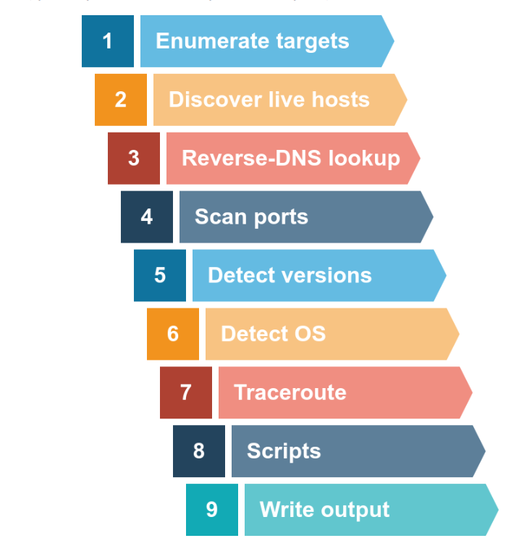
Network segments (subnets) used in the room
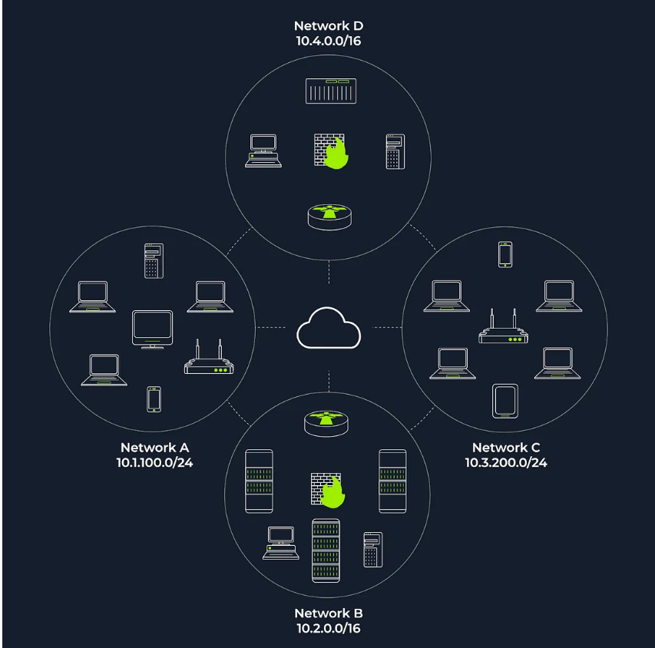
ARP request sent from computer1 and its network
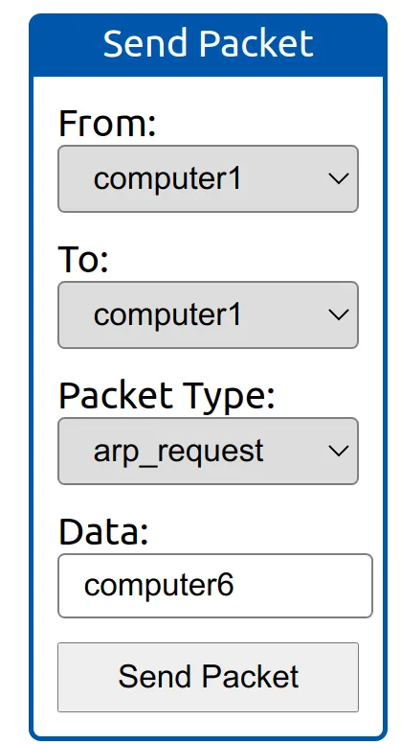
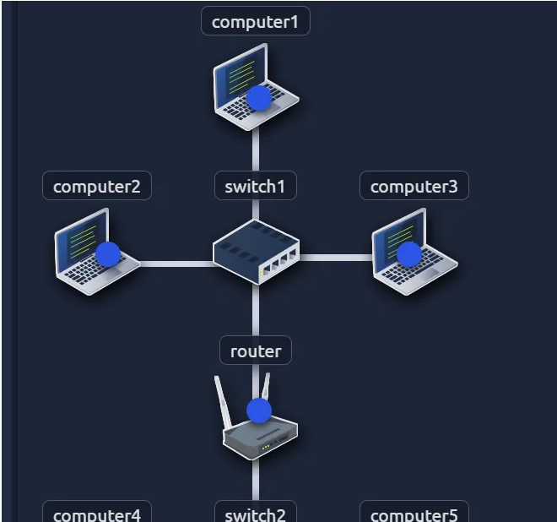
Devices that saw the ARP request: 4. Did computer6 receive the request? N (it is in a different subnet).
ARP request sent from computer4
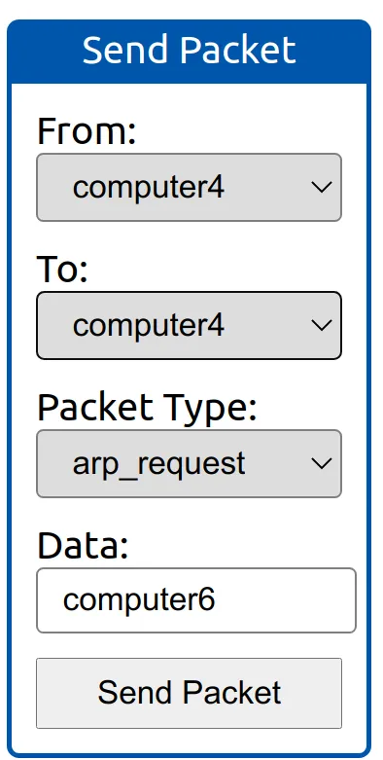
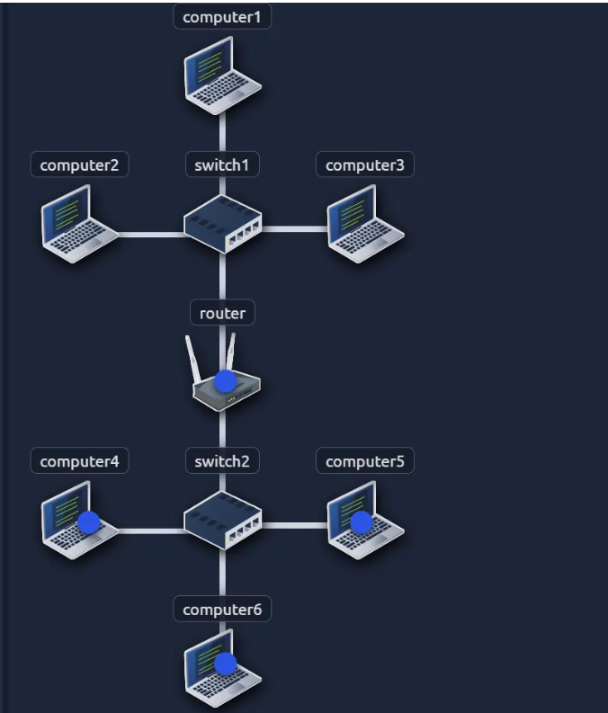
Devices that saw the ARP request: 4. Did computer6 reply? Y (it is in the same subnet).
ISO/OSI and TCP/IP layers used by the discovery protocols
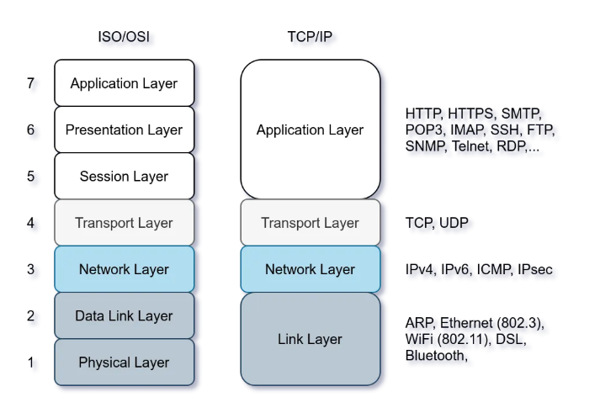
ARP works at the Link layer, ICMP at the Network layer, and TCP and UDP at the Transport layer.
Ping request – ARP and ICMP behaviour
Question | Answer
Packet type sent by computer1 before the ping | ARP Request
Packet type received by computer1 before it could ping | ARP Response
Computers that responded to the ping request | 1
First device to respond to the first ARP request (computer2 → computer5) | router
First device to respond to the second ARP request | computer5
Does a repeated ping need new ARP requests? | N (the ARP result is cached)
Devices discovered using ARP requests from computer1 | 3

Enumerating targets
Question | Working | Answer
First IP address scanned for 10.10.12.13/29 | /29 = 8 addresses, block 10.10.12.8–15 | 10.10.12.8
Number of IPs for 10.10.0-255.101-125 | 256 × 25 | 6400

ARP scan: nmap -PR -sn
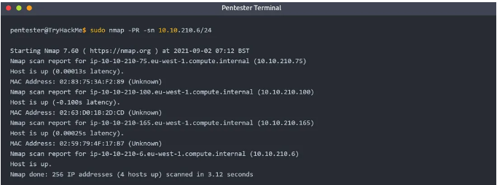
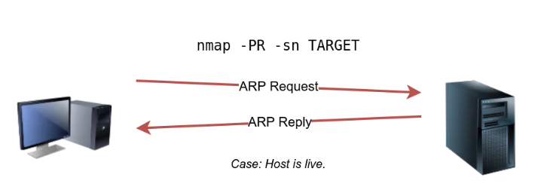
The AttackBox (10.10.210.6) found 4 hosts up among 256 addresses in 3.12 seconds.
ICMP echo scan: -PE
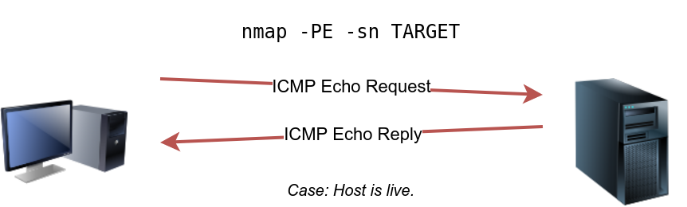
ICMP timestamp scan: -PP
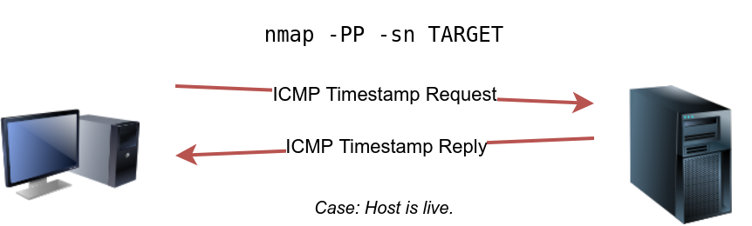
ICMP address mask scan: -PM
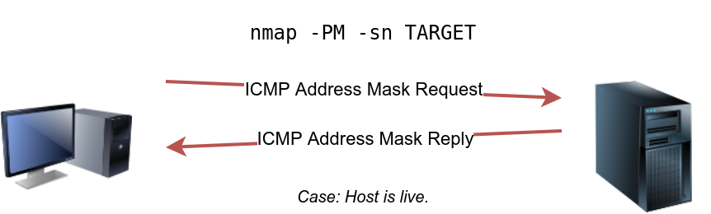
TCP SYN ping: -PS (open port)
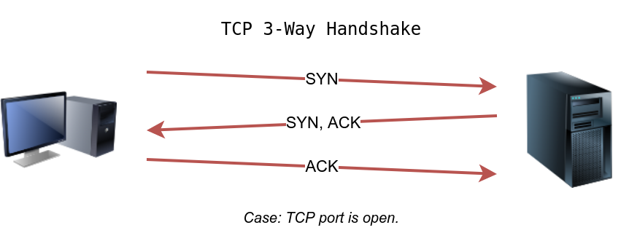
TCP SYN ping: -PS (closed port)
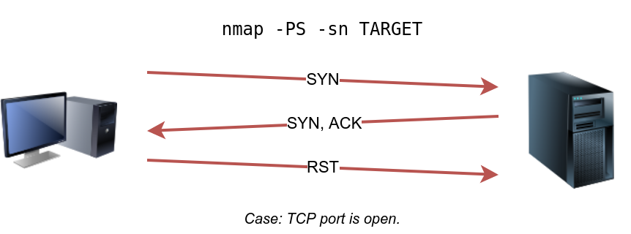
TCP ACK ping: -PA
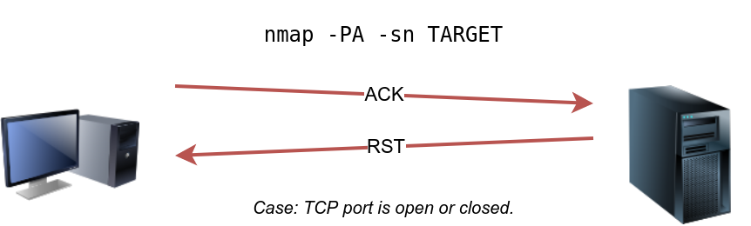
UDP ping: -PU (open port – no reply)
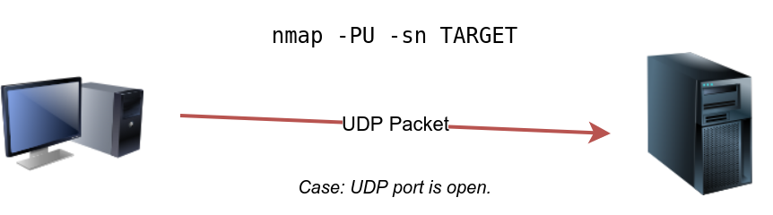
UDP ping: -PU (closed port – ICMP port unreachable)
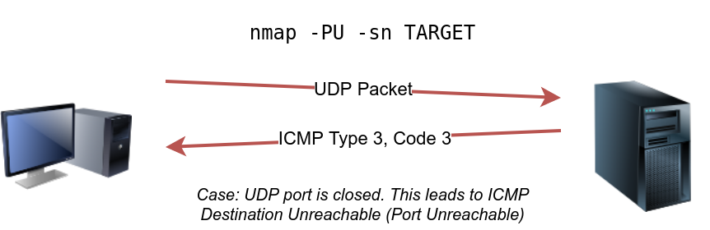
Answers to the room questions
Question | Answer
Option to use ICMP timestamp for host discovery | -PP
Option to use ICMP address mask for host discovery | -PM
Option to use ICMP echo for host discovery | -PE
TCP ping scan that does not need a privileged account | TCP SYN ping
TCP ping scan that needs a privileged account | TCP ACK ping
Option for a TCP SYN ping scan on the telnet port | -PS23
Option for reverse-DNS lookup of all possible hosts | -R

RESULT:
Thus, live hosts were discovered using the Nmap ARP, ICMP and TCP/UDP ping scans on the TryHackMe platform, and the working of each host-discovery technique was studied and verified.

