CS23532 – COMPUTER NETWORKS
EX 9: Subnetting in Cisco Packet Tracer
AIM :
To implement subnetting in the Cisco Packet Tracer simulator by dividing a network into multiple subnets, connecting them through routers and testing the connectivity.
PROCEDURE :
Introduction
Classless IP subnetting is a technique that allows more efficient use of IP addresses by using subnet masks that are not just the default masks of each IP class. It allows the IP address space to be divided into smaller subnets, which is useful when only a limited number of IP addresses are available but several networks are needed.
Creating a network topology
Select the “New” button in the top left corner of Packet Tracer, then select “Network” and “Generic”. This creates a blank network topology to which devices can be added.
Adding the devices
Routers, switches and PCs are added to the topology. To add a device, select it from the device box at the bottom left corner and drag it onto the workspace. Then connect the devices by dragging a cable from one device’s port to another device’s port.
Subnetting
To subnet the network address 192.168.1.0/24 so that there is enough space for at least 5 addresses for the end devices, the switch and the router, a /27 subnet mask (255.255.255.224) is used. This gives 8 subnets with 30 host addresses each.
The IP addressing for the network shown in the topology is as follows:
Device | Interface / Subnet | IP address
Router R1 | GigabitEthernet0/0 | 192.168.1.1
 | GigabitEthernet0/1 | 192.168.2.1
Switch S1 | FastEthernet0/1 – 192.168.1.0/27 | PC1 – PC5: 192.168.1.11 – 192.168.1.15
 | FastEthernet0/2 – 192.168.2.0/27 | PC1 – PC5: 192.168.2.11 – 192.168.2.15
Router R2 | FastEthernet0/0 | 192.168.3.1
 | FastEthernet0/1 | 192.168.4.1
Switch S2 | FastEthernet0/1 – 192.168.3.0/27 | PC1 – PC5: 192.168.3.11 – 192.168.3.15
 | FastEthernet0/2 – 192.168.4.0/27 | PC1 – PC5: 192.168.4.11 – 192.168.4.15

Configuring the devices
Router: Right-click on the router and select “CLI”. In the CLI, enter the following commands. Replace {IP address} and {subnet mask} with the required values. FastEthernet0/0 is connected to the switch and FastEthernet0/1 to the next network.
enable
configure terminal
interface FastEthernet0/0
ip address {IP address} {subnet mask}
no shutdown
exit
interface FastEthernet0/1
ip address {IP address} {subnet mask}
no shutdown
exit
Switch: Right-click on the switch and select “CLI”. In the CLI, enter the following commands. They configure the two switch ports in access mode.
enable
configure terminal
interface FastEthernet0/1
switchport mode access
exit
interface FastEthernet0/2
switchport mode access
exit
PCs: Right-click on each PC and select “Config”. Enter the IP address, subnet mask, default gateway and DNS server. The IP address and subnet mask must be in the same subnet as the router interface the PC is connected to.
GigabitEthernet interface of the router: Right-click on the router, select “CLI” and enter the following commands. They configure the interface with an IP address and subnet mask and enable it.
enable
configure terminal
interface GigabitEthernet0/0
ip address {IP address} {subnet mask}
no shutdown
exit
Testing the network
Open the command prompt on each PC and ping the other PCs. If the ping is successful, the network is functioning properly. The ping command can also be used to test the connectivity between the router and the PCs.
OUTPUT:
Network topology with four subnets connected through routers
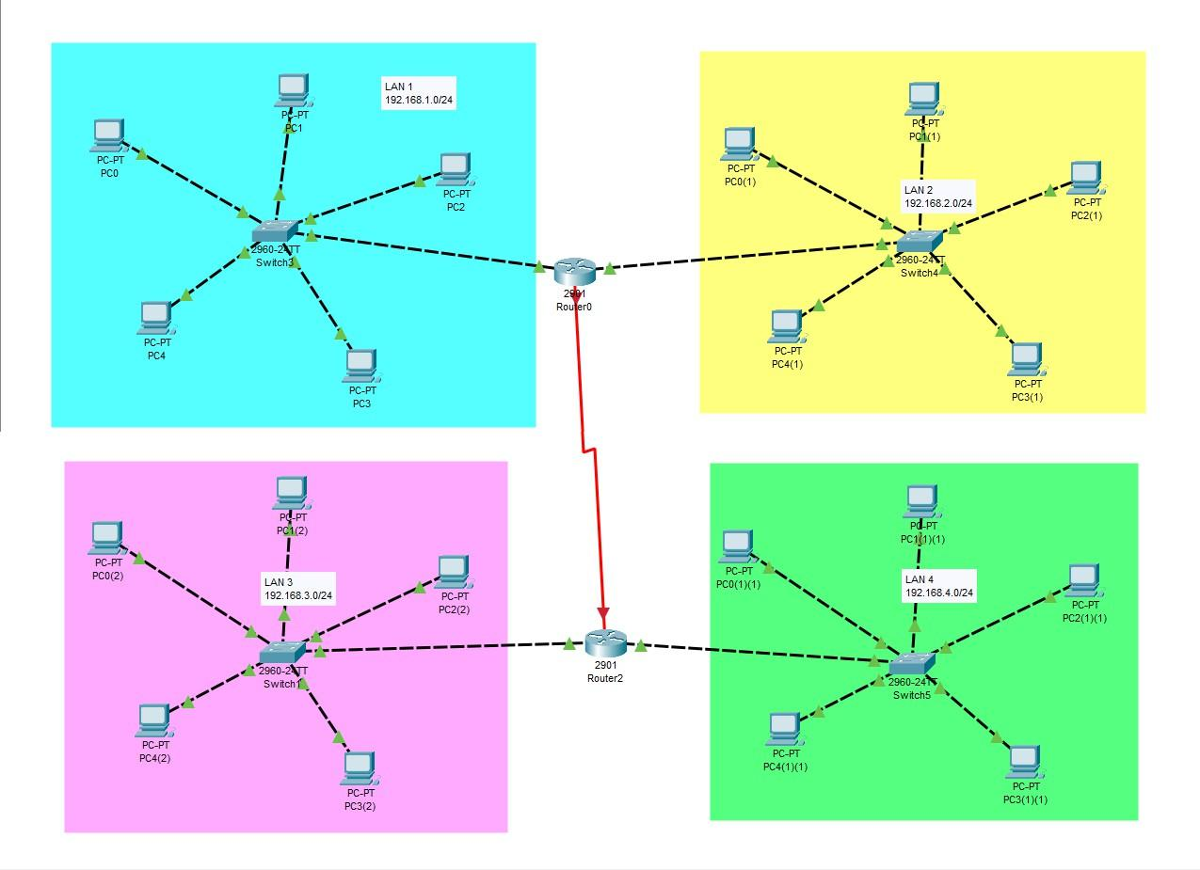
Simulation – packets transmitted across the subnets
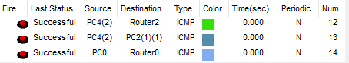
The ICMP packets sent from PC4(2) to Router2, from PC4(2) to PC2(1)(1) and from PC0 to Router0 were all successful.
Student observation
a) Understanding of subnetting: Subnetting is the process of dividing a large network into smaller logical networks (subnets) by borrowing bits from the host part of the IP address and extending the subnet mask. Each subnet has its own network address and range of host addresses, and devices in different subnets communicate through a router.
b) Advantages of subnetting: It makes efficient use of IP addresses, reduces broadcast traffic and network congestion, improves security by isolating the subnets, and makes the network easier to manage and troubleshoot.
RESULT:
Thus, subnetting was implemented in the Cisco Packet Tracer simulator by dividing the network 192.168.1.0/24 into /27 subnets, assigning static IP addresses, connecting the subnets through routers, and the packet transmission across the subnets was verified successfully.

