CS23532 – COMPUTER NETWORKS
EX 10: Internetworking with Routers in Cisco Packet Tracer
AIM :
To design and configure internetworks in the Cisco Packet Tracer simulator: (a) a simple internetwork using a router, (b) an internetwork using a wireless router, a DHCP server and an Internet cloud, and (c) an internetwork using a switch, a router and Ethernet cables, and to trace how packets are routed between the networks.
PROCEDURE :
a) Design and configure a simple internetwork using a router
In this network, a router and 2 PCs are used. The computers are connected to the router using copper straight-through cables. After forming the network, a simple PDU is transferred from PC0 to PC1 to check the network connectivity.
Step 1 – Configuring Router1
- Select the router and open the CLI.
- Press ENTER to start configuring Router1.
- Type enable to activate the privileged mode.
Router1 Command Line Interface:
Router>enable
Router#config t
Enter configuration commands, one per line. End with CNTL/Z.
Router(config)#interface FastEthernet0/0
Router(config-if)#ip address 192.168.10.1 255.255.255.0
Router(config-if)#no shutdown
Router(config-if)#interface FastEthernet0/1
Router(config-if)#ip address 192.168.20.1 255.255.255.0
Router(config-if)#no shutdown

Step 2 – Configuring the PCs
- Assign an IP address to every PC in the network.
- Select the PC, go to the Desktop tab, open IP Configuration and enter the IP address, subnet mask and default gateway.
- Assign the default gateway of PC0 as 192.168.10.1.
- Assign the default gateway of PC1 as 192.168.20.1.
Step 3 – Connecting the PCs with the Router
- Connect the FastEthernet0 port of PC0 with the FastEthernet0/0 port of Router1 using a copper straight-through cable.
- Connect the FastEthernet0 port of PC1 with the FastEthernet0/1 port of Router1 using a copper straight-through cable.
Step 4 – Testing the connectivity
- Click the Add Simple PDU icon in the common tools bar, then click on PC0 (source) and PC1 (destination).
- Switch to Simulation mode and observe the PDU travelling PC0 → Router1 → PC1, and the acknowledgement returning PC1 → Router1 → PC0.
Router Configuration Table:
Device Name | IP Address FastEthernet0/0 | Subnet Mask | IP Address FastEthernet0/1 | Subnet Mask
Router1 | 192.168.10.1 | 255.255.255.0 | 192.168.20.1 | 255.255.255.0
PC Configuration Table:
Device Name | IP Address | Subnet Mask | Gateway
PC 0 | 192.168.10.2 | 255.255.255.0 | 192.168.10.1
PC 1 | 192.168.20.2 | 255.255.255.0 | 192.168.20.1
b) Design and configure an internetwork using a wireless router, DHCP server and Internet cloud
Addressing Table
Device | Interface | IP Address | Subnet Mask | Default Gateway
PC | Ethernet0 | DHCP |  | 192.168.0.1
Wireless Router | LAN | 192.168.0.1 | 255.255.255.0
Wireless Router | Internet | DHCP
Cisco.com Server | Ethernet0 | 208.67.220.220 | 255.255.255.0
Laptop | Wireless0 | DHCP
Objectives
- Part 1: Build a simple network in the Logical topology workspace.
- Part 2: Configure the network devices.
- Part 3: Test connectivity between the network devices.
- Part 4: Save the file and close Packet Tracer.
Part 1 – Build the network in the Logical workspace
Step 1: Launch Packet Tracer.
Step 2: Build the topology.
- Add network devices. Choose a device type in the Device-Type Selection box, click the required model in the Device-Specific Selection box, and click on the workspace to place it (or drag and drop it).
- Change display names. Click the device, open the Config tab and type the new name in the Display Name box.
- Add the cabling. Use the following connections:
From | To | Cable
PC – FastEthernet0 | Wireless Router – Ethernet 1 | Copper straight-through
Wireless Router – Internet | Cable Modem – Port 1 | Copper straight-through
Cable Modem – Port 0 | Internet Cloud – Coaxial | Coaxial
Internet Cloud – Ethernet | Cisco.com Server – FastEthernet0 | Copper straight-through
Part 2 – Configure the network devices
Step 1: Configure the wireless router
- Click the Wireless Router, open the GUI tab and then the Wireless tab. The only setting changed from the defaults is the Network Name (SSID); type “HomeNetwork”.
- Click the Setup tab. In the DHCP Server settings verify that Enabled is selected and set the static DNS server address to 208.67.220.220.
- Click Save Settings.
Step 2: Configure the laptop
- Click the Laptop and open the Physical tab. Power the laptop off, drag out the Ethernet copper module into the MODULES pane, install the Wireless WPC300N module in the empty slot, and power the laptop on again.
- Open the Desktop tab and select PC Wireless. In the Connect tab select the “HomeNetwork” wireless network and click Connect.
Step 3: Configure the PC
- Click the PC, open Desktop → IP Configuration and select the DHCP radio button so that the PC obtains its IPv4 address from the wireless router.
- Open the Command Prompt and issue ipconfig /all. The PC should receive an address in the 192.168.0.x range.
Step 4: Configure the Internet cloud
- Open the Physical tab of the cloud. If they are not already installed, power the cloud off and add the PT-CLOUD-NM-1CX (cable modem connection) and PT-CLOUD-NM-1CFE (copper Ethernet connection) modules, then power it on.
- In the Config tab, select Cable under CONNECTIONS, choose Coaxial in the first drop-down and Ethernet in the second, and click Add.
- Select Ethernet under INTERFACE and set Cable as the Provider Network.
Step 5: Configure the Cisco.com server
- DHCP service: open the Services tab → DHCP and use the settings below, then click Add.
Setting | Value
DHCP service | On
Pool name | DHCPpool
Default Gateway | 208.67.220.220
DNS Server | 208.67.220.220
Starting IP Address | 208.67.220.1
Subnet Mask | 255.255.255.0
Maximum number of Users | 50

- DNS service: Services → DNS: turn the service On, Name = Cisco.com, Type = A Record, Address = 208.67.220.220, then click Add.
- Global settings: Config → Settings: select Static, Gateway = 208.67.220.1, DNS Server = 208.67.220.220.
- FastEthernet0 interface: Config → FastEthernet: select Static, IP Address = 208.67.220.220, Subnet Mask = 255.255.255.0.
Part 3 – Verify connectivity
Step 1: Refresh the IPv4 settings on the PC.
- In the PC Command Prompt issue ipconfig /release followed by ipconfig /renew. The output should show an IP address in the 192.168.0.x range, a subnet mask, a default gateway and the DNS server address.
Step 2: Test connectivity to the Cisco.com server.
- From the Command Prompt issue ping Cisco.com. It may take a few seconds to return; four replies should be received.
Part 4 – Save the file
- Save the Packet Tracer file (File → Save) and close Packet Tracer.
c) Design and configure an internetwork using a switch, router and Ethernet cables
Two LANs are built, each with one switch and three PCs. The two switches are joined by a router, and every device is connected with a copper straight-through cable. Each PC uses the router interface of its own LAN as the default gateway.
Step 1 – Build the topology
- Place one router, two switches and six generic PCs on the workspace and rename them as shown in the topology.
- Connect PC0, PC1 and PC2 to Switch1, and PC3, PC4 and PC5 to Switch2 (FastEthernet0 of each PC to a free switch port).
- Connect Switch1 to FastEthernet0/0 of Router1 and Switch2 to FastEthernet0/1 of Router1.
Step 2 – Configure Router1
Router>enable
Router#config t
Router(config)#interface FastEthernet0/0
Router(config-if)#ip address 192.168.10.1 255.255.255.0
Router(config-if)#no shutdown
Router(config-if)#interface FastEthernet0/1
Router(config-if)#ip address 192.168.20.1 255.255.255.0
Router(config-if)#no shutdown
Router(config-if)#end
Router#show ip route

Step 3 – Configure the PCs
- On each PC open Desktop → IP Configuration and enter the address, subnet mask and default gateway from the table below. The switches need no configuration.
Device Name | IP Address | Subnet Mask | Default Gateway
PC0 | 192.168.10.2 | 255.255.255.0 | 192.168.10.1
PC1 | 192.168.10.3 | 255.255.255.0 | 192.168.10.1
PC2 | 192.168.10.4 | 255.255.255.0 | 192.168.10.1
PC3 | 192.168.20.2 | 255.255.255.0 | 192.168.20.1
PC4 | 192.168.20.3 | 255.255.255.0 | 192.168.20.1
PC5 | 192.168.20.4 | 255.255.255.0 | 192.168.20.1

Step 4 – Test and trace routing
- From PC0 send a Simple PDU to PC1 (same LAN) – the switch alone forwards it.
- From PC0 send a Simple PDU to PC5 (different LAN) – in Simulation mode observe it go PC0 → Switch1 → Router1 → Switch2 → PC5, with the router forwarding it between the two networks.
- Use ping 192.168.20.4 from the Command Prompt of PC0 to confirm the reply.

OUTPUT:
a) Simple internetwork using a router
Designed network topology
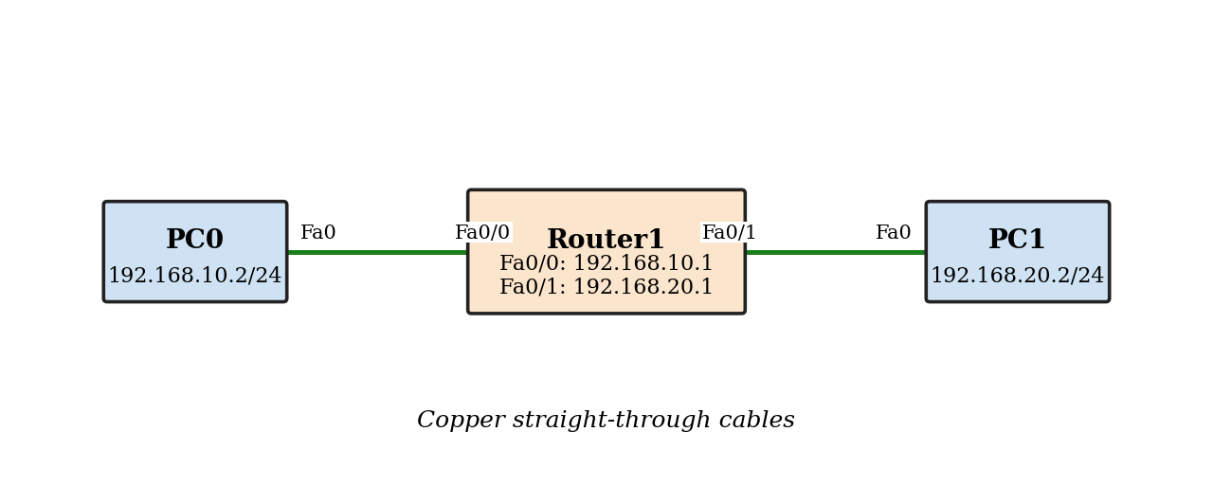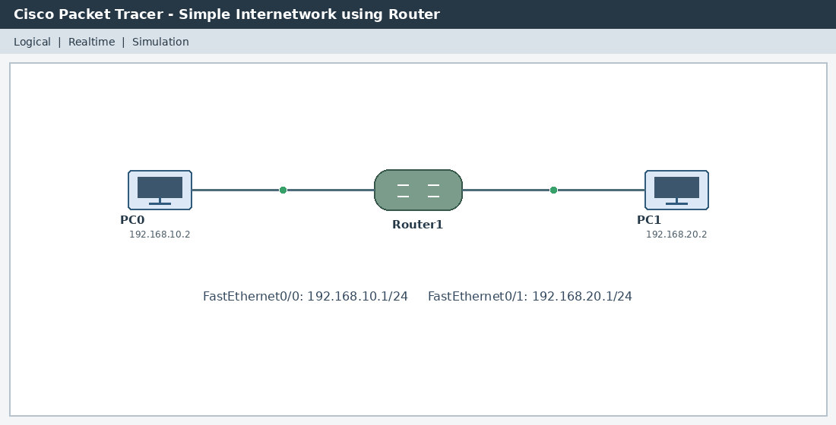
Sending a PDU from PC0 to PC1
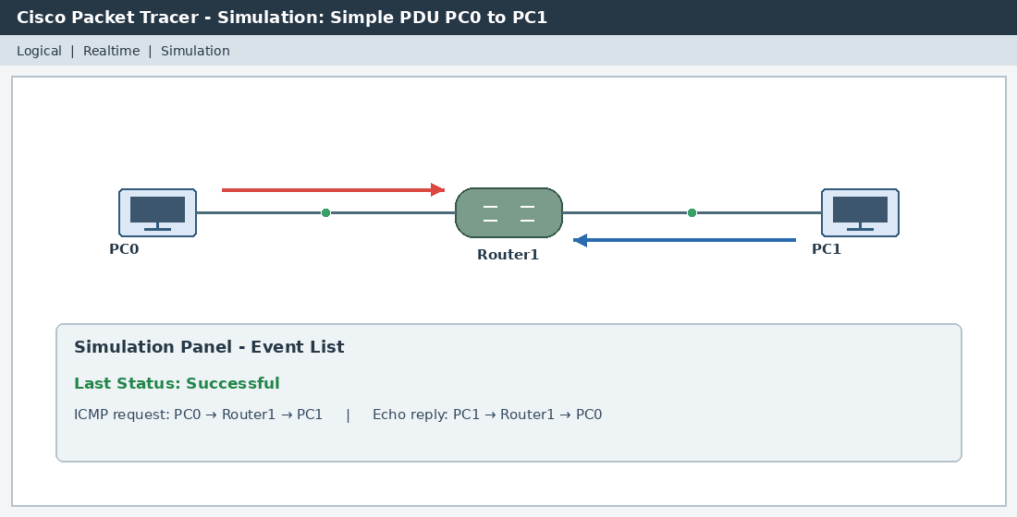

Acknowledgement from PC1 to PC0

b) Internetwork using wireless router, DHCP server and Internet cloud
Designed network topology
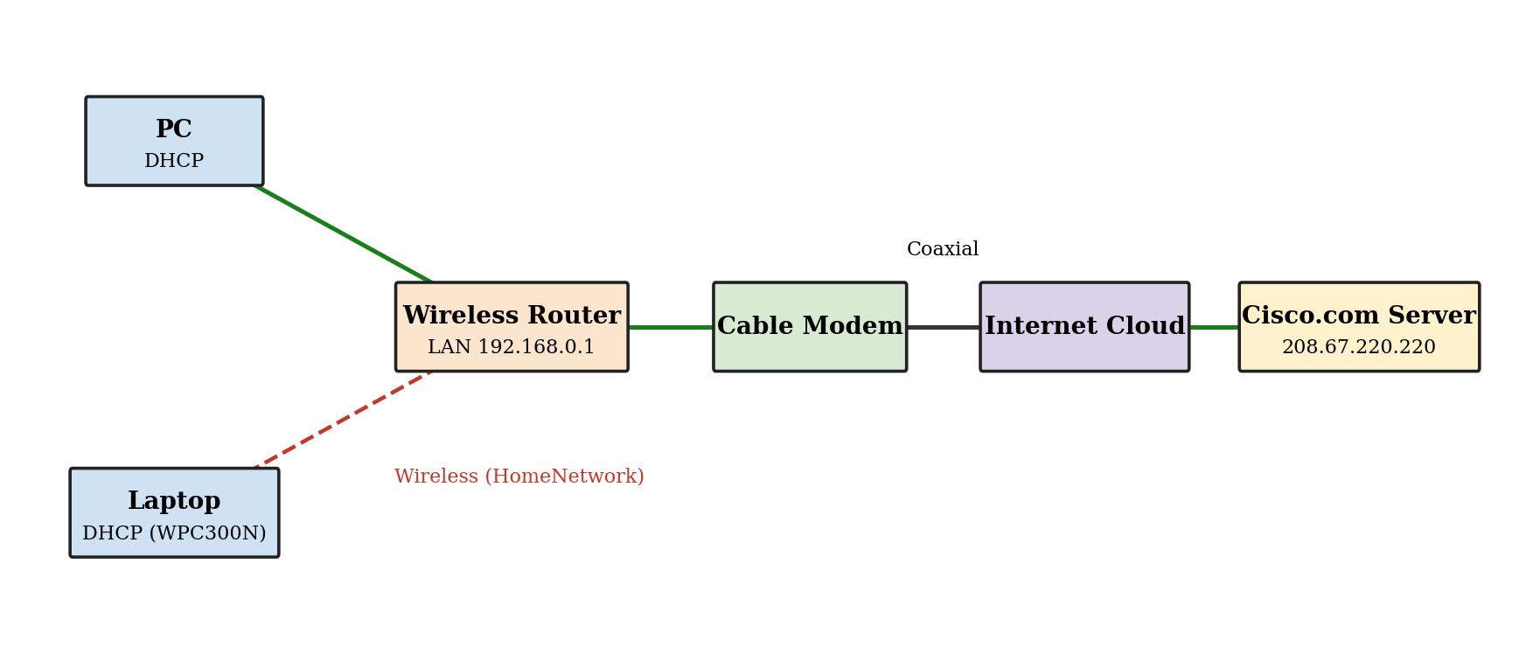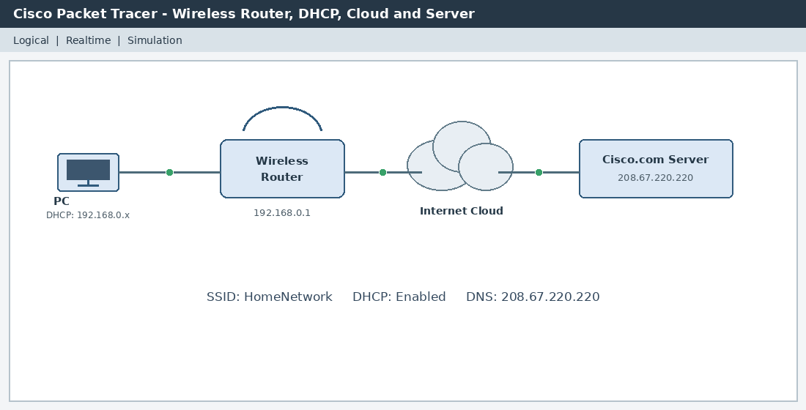
IP configuration of the PC using DHCP (ipconfig /all)
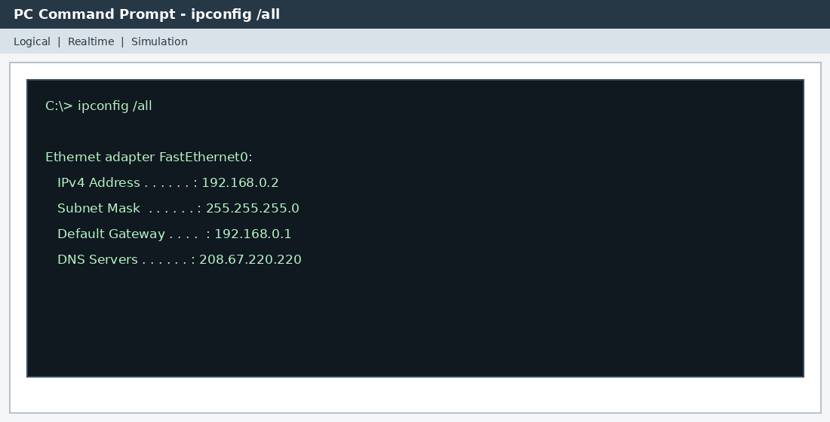

Connectivity test (ping Cisco.com)
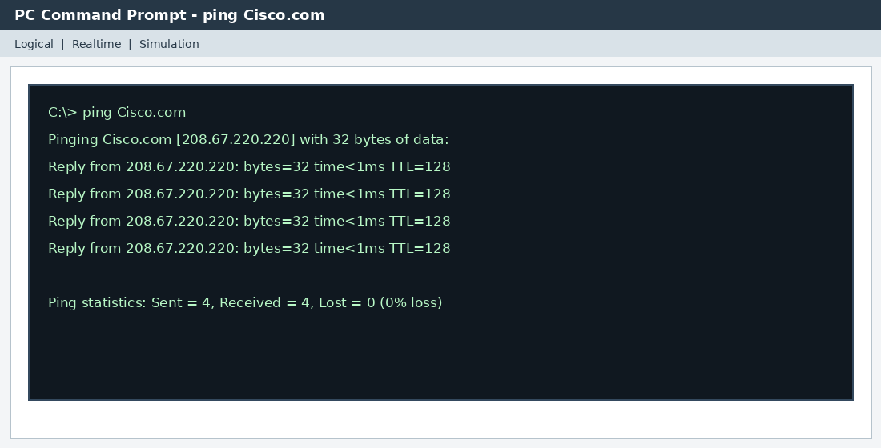

c) Internetwork using switch, router and Ethernet cables
Designed network topology
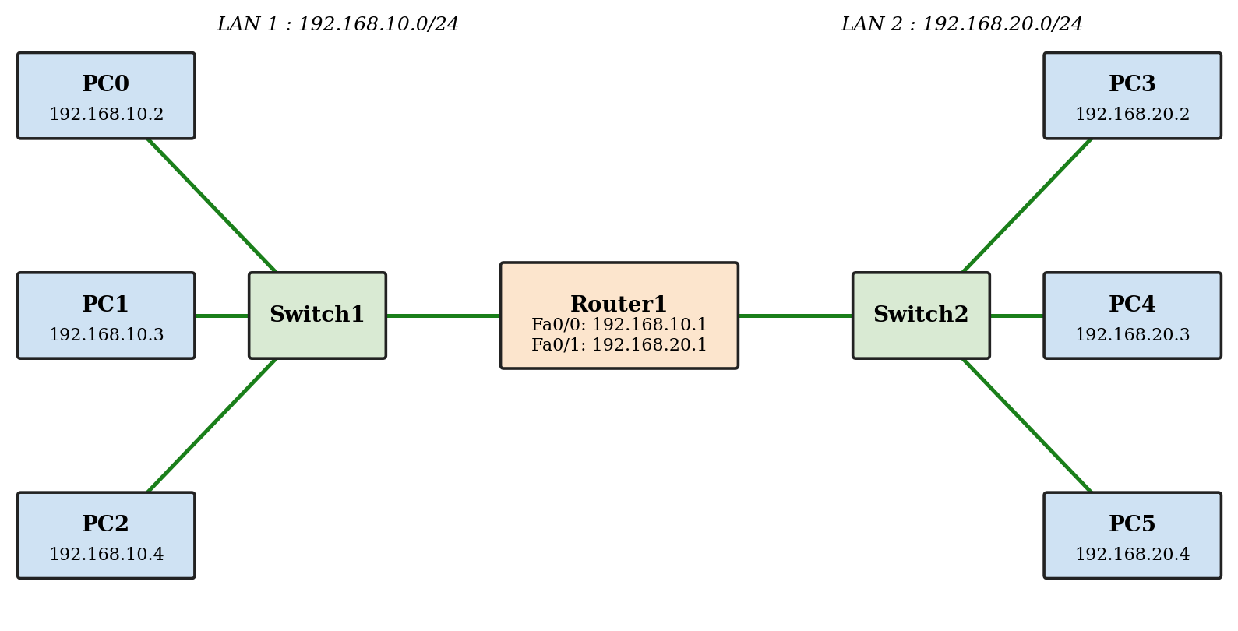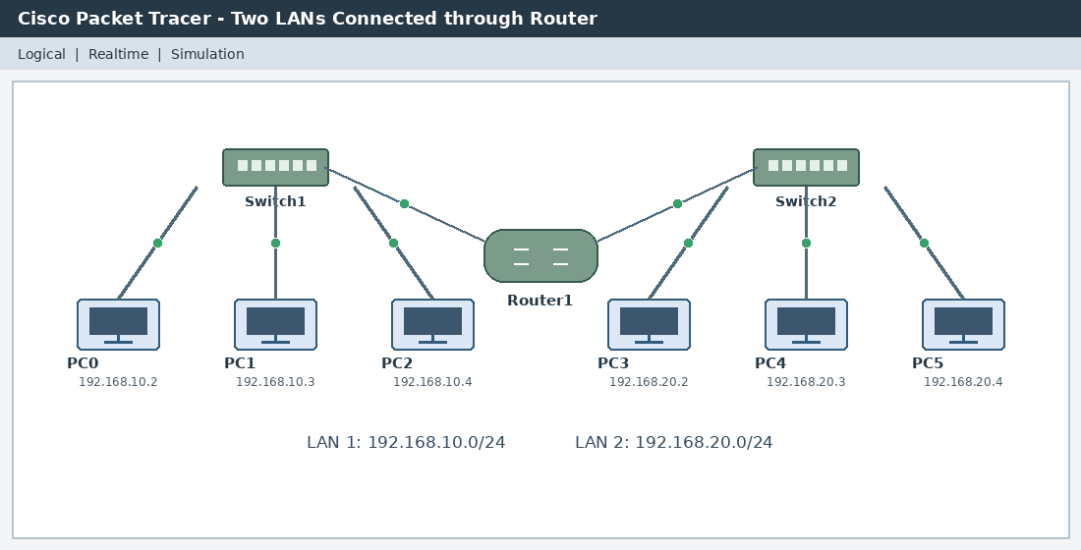
Packet transmission across the router (PC0 to PC5)
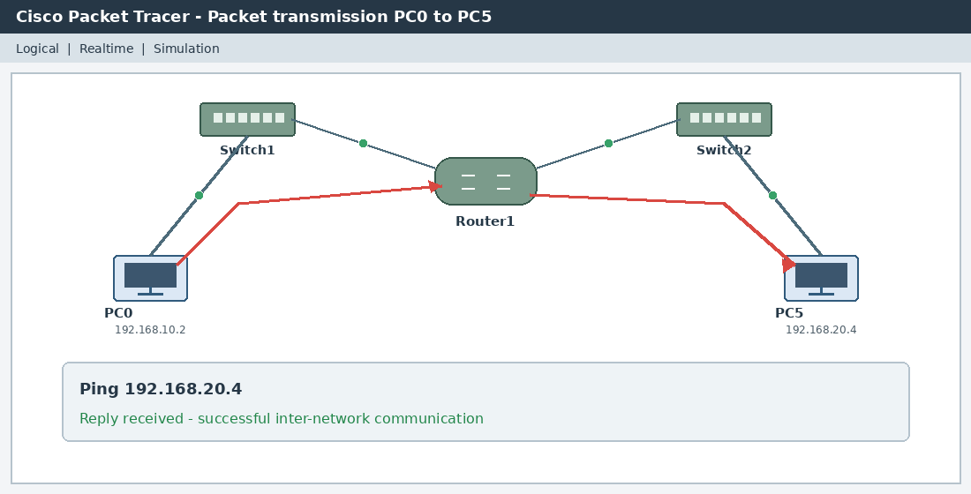

RESULT:
Thus, internetworks were designed and configured in Cisco Packet Tracer using a router, using a wireless router with a DHCP server and Internet cloud, and using switches with a router, and packet routing between the networks was verified successfully.

