CS23532 – COMPUTER NETWORKS
EX 11: Static Routing and RIP
AIM :
a) To simulate static routing configuration using Cisco Packet Tracer.
b) To simulate the Routing Information Protocol (RIP) using Cisco Packet Tracer.
PROCEDURE :
a) Static routing
Static routes are the routes that are manually added to the router’s routing table; the process of adding them is known as static routing. In the lab, each network has two routes to reach. One route is configured as the main route and the other as the backup route. If the link bandwidth of all the routes is the same, the route with the least number of routers is used as the main route. If two routes are given for the same destination, the router automatically selects the best route; to select a route manually, the Administrative Distance (AD) value of that route is set lower than that of the other route. If the main route fails, the router automatically adds the backup route to the routing table.
Routers automatically learn their connected networks, so routes are required only for the networks that are not available on the router’s interfaces.
Router | Available networks on local interfaces | Networks available on other routers’ interfaces
Router0 | 10.0.0.0/8, 20.0.0.0/8, 40.0.0.0/8 | 30.0.0.0/8, 50.0.0.0/8
Router1 | 20.0.0.0/8, 30.0.0.0/8, 50.0.0.0/8 | 10.0.0.0/8, 40.0.0.0/8
Router2 | 40.0.0.0/8, 50.0.0.0/8 | 10.0.0.0/8, 20.0.0.0/8, 30.0.0.0/8

Step 1: Create the Packet Tracer lab with three routers, switches and PCs as shown in the topology, and assign the initial IP configuration.
Step 2: Open the CLI of Router0 and create two routes for network 30.0.0.0/8 (main route via Router1, backup via Router2), two routes for the host 30.0.0.100 (main route via Router2, backup via Router1) and two routes for network 50.0.0.0/8 (main route via Router2, backup via Router1). Verify that only the main routes are added to the routing table.
Router>enable
Router#configure terminal
Router(config)#ip route 30.0.0.0 255.0.0.0 20.0.0.2 10
Router(config)#ip route 30.0.0.0 255.0.0.0 40.0.0.2 20
Router(config)#ip route 30.0.0.100 255.255.255.255 40.0.0.2 10
Router(config)#ip route 30.0.0.100 255.255.255.255 20.0.0.2 20
Router(config)#ip route 50.0.0.0 255.0.0.0 40.0.0.2 10
Router(config)#ip route 50.0.0.0 255.0.0.0 20.0.0.2 20
Router(config)#exit
Router#show ip route static

Step 3: Configure Router1 with the main and backup routes for networks 10.0.0.0/8 and 40.0.0.0/8, and verify the routing table.
Router>enable
Router#configure terminal
Router(config)#ip route 10.0.0.0 255.0.0.0 20.0.0.1 10
Router(config)#ip route 10.0.0.0 255.0.0.0 50.0.0.1 20
Router(config)#ip route 40.0.0.0 255.0.0.0 20.0.0.1 10
Router(config)#ip route 40.0.0.0 255.0.0.0 50.0.0.1 20
Router(config)#exit
Router#show ip route static

Step 4: Configure Router2 with static routes for networks 10.0.0.0/8 and 30.0.0.0/8 and verify that both routes are added to the routing table.
Router>enable
Router#configure terminal
Router(config)#ip route 10.0.0.0 255.0.0.0 40.0.0.1
Router(config)#ip route 30.0.0.0 255.0.0.0 50.0.0.2
Router(config)#exit
Router#show ip route static

Step 5: Verify the main route by sending ping requests from a PC of network 10.0.0.0/8 to a PC of network 30.0.0.0/8 and tracing the path using the tracert command, and by listing the routing table entries of Router0.
C:\>tracert 30.0.0.20
C:\>tracert 30.0.0.100

Step 6: Simulate the failure of the main route by deleting the link between Router0 and Router1, and repeat the test to verify that the backup route is used.
Step 7: To delete a static route, list the static routes with show ip route static, note down the route to be deleted and remove it with the no ip route command. When the main route is deleted, the backup route becomes the main route.
Router#show ip route static
Router#configure terminal
Router(config)#no ip route 30.0.0.100 255.255.255.255 40.0.0.2
Router(config)#exit

b) Routing Information Protocol (RIP)
RIP is a dynamic routing protocol in which the routers share the networks connected to them with each other, and the best route is selected automatically based on the hop count.
Initial IP configuration:
Device | Interface | IP configuration | Connected with
PC0 | Fast Ethernet | 10.0.0.2/8 | Router0’s Fa0/1
Router0 | Fa0/1 | 10.0.0.1/8 | PC0’s Fast Ethernet
Router0 | S0/0/1 | 192.168.1.254/30 | Router2’s S0/0/1
Router0 | S0/0/0 | 192.168.1.249/30 | Router1’s S0/0/0
Router1 | S0/0/0 | 192.168.1.250/30 | Router0’s S0/0/0
Router1 | S0/0/1 | 192.168.1.246/30 | Router2’s S0/0/0
Router2 | S0/0/0 | 192.168.1.245/30 | Router1’s S0/0/1
Router2 | S0/0/1 | 192.168.1.253/30 | Router0’s S0/0/1
Router2 | Fa0/1 | 20.0.0.1/30 | PC1’s Fast Ethernet
PC1 | Fast Ethernet | 20.0.0.2/30 | Router2’s Fa0/1

Step 1: Assign the IP addresses to the PCs: double click the PC, open the Desktop tab, click IP Configuration and enter the address from the table.
Step 2: Assign the IP addresses to the router interfaces: open the CLI of the router, enter the global configuration mode, then the interface mode, assign the IP address and bring the interface up. A serial interface also needs the clock rate and bandwidth, which are configured only at the DCE end of the cable (checked using show controllers).
Router>enable
Router#configure terminal
Router(config)#interface fastEthernet 0/1
Router(config-if)#ip address 10.0.0.1 255.0.0.0
Router(config-if)#no shutdown
Router(config-if)#exit
Router(config)#interface serial 0/0/0
Router(config-if)#ip address 192.168.1.249 255.255.255.252
Router(config-if)#clock rate 64000
Router(config-if)#bandwidth 64
Router(config-if)#no shutdown
Router(config-if)#exit

Step 3: Configure the RIP routing protocol on every router: enable RIP from the global configuration mode using the router rip command and advertise the networks that are directly connected to the router using the network command. For Router0:
Router(config)#router rip
Router(config-router)#network 10.0.0.0
Router(config-router)#network 192.168.1.248
Router(config-router)#network 192.168.1.252
Router(config-router)#exit

Step 4: Repeat the same steps on Router1 and Router2, advertising their own directly connected networks.
Step 5: Verify the setup by using the ping command from PC1 to PC0.
Step 6: There are two routes between PC0 and PC1. Route 1 passes through Router0 and Router2 and Route 2 passes through Router0, Router1 and Router2. RIP uses the route with the lower hop count (Route 1); verify it using the tracert command. Simulate the failure of Route 1 by removing the cable between Router0 [S0/0/1] and Router2 [S0/0/1], and use the tracert command again to see that RIP automatically reroutes the traffic.
OUTPUT:
a) Static routing
Network topology used for static routing
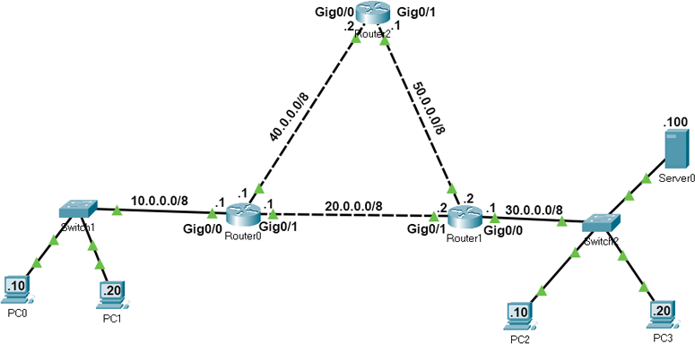
Router0 configuration
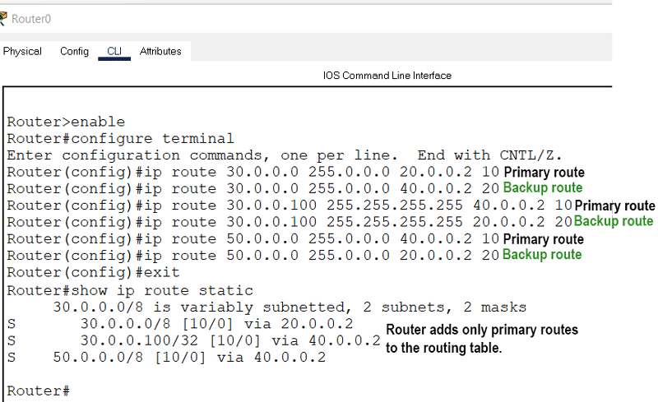
Router1 configuration
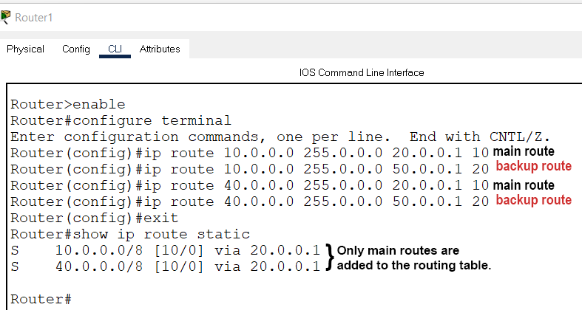
Router2 configuration
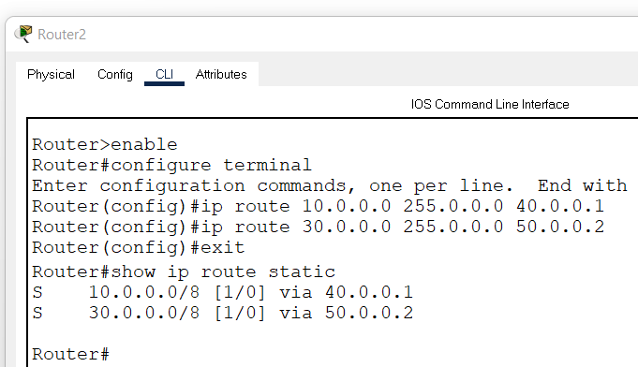
Verifying the main static route
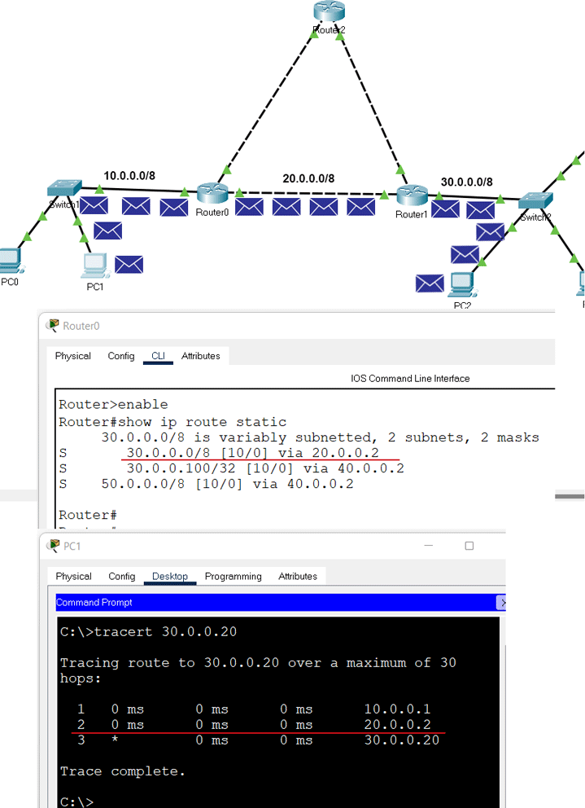
Verifying the host route (30.0.0.100)
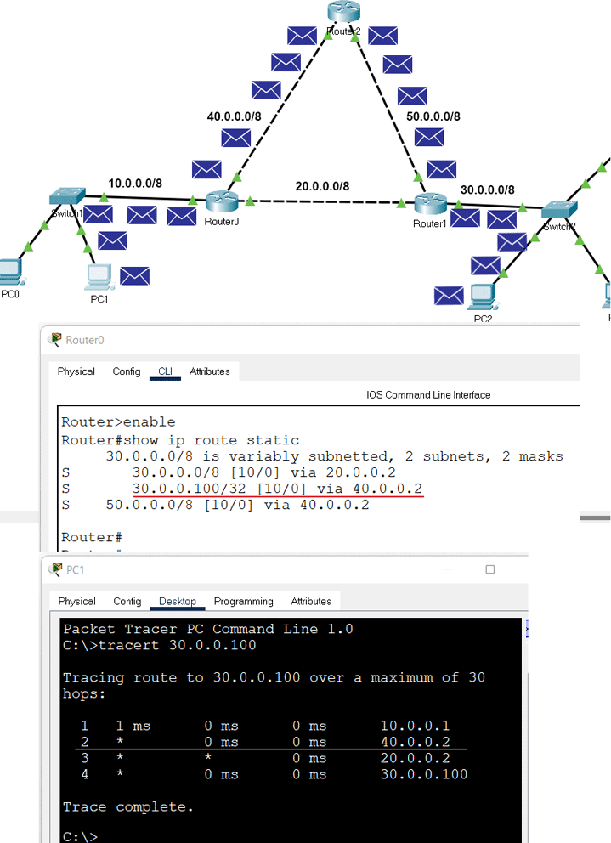
Verifying the backup route when the main route fails
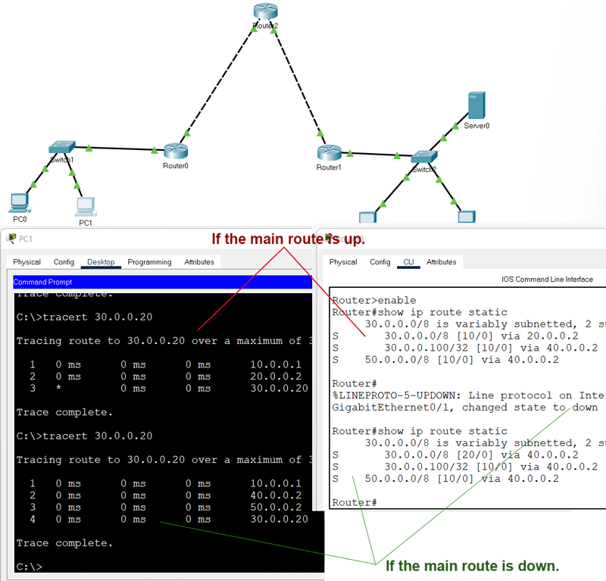
Deleting the static routes
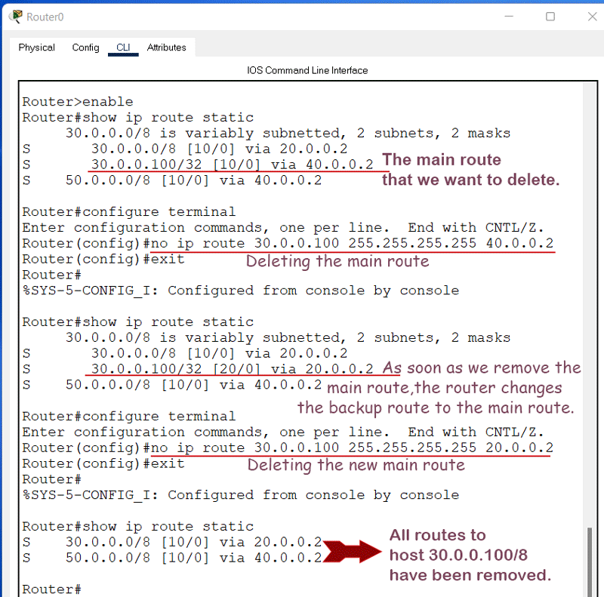
b) RIP
Network topology used for RIP
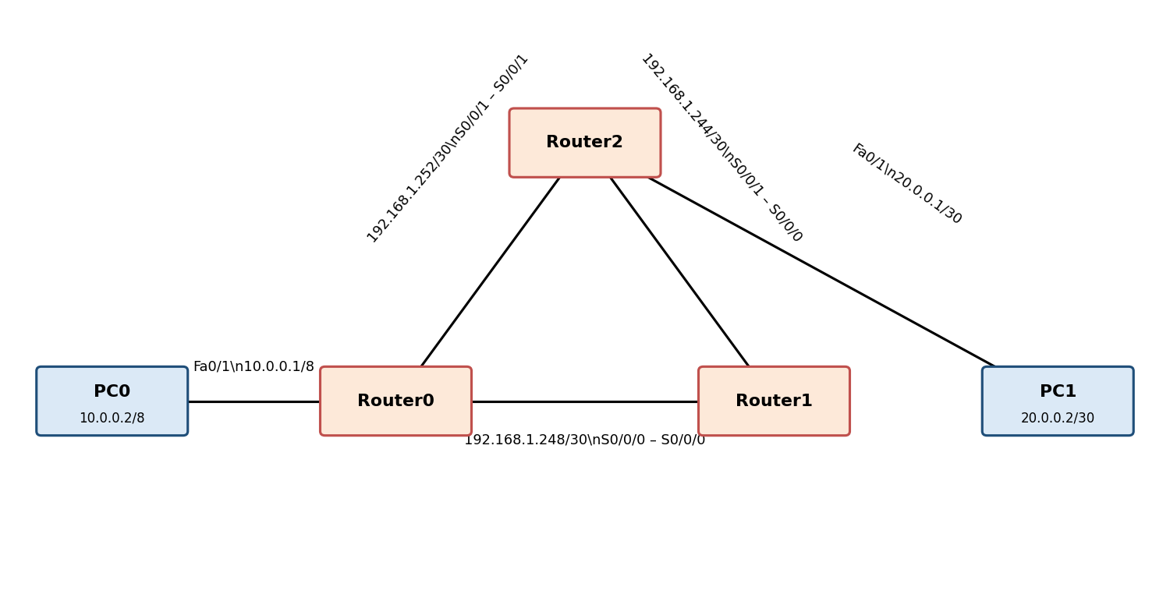
Ping test from PC1 to PC0
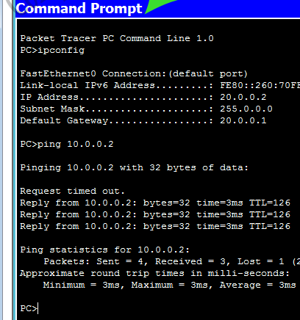
RESULT:
Thus, static routing and the Routing Information Protocol (RIP) were configured and simulated successfully using Cisco Packet Tracer, and the routes were verified using the ping and tracert commands.

