CS23532 – COMPUTER NETWORKS
EX 15: Analysis of Web Logs using Webalizer
AIM :
To analyze the different types of web logs using the Webalizer tool.
PROCEDURE :
1. Run the Webalizer (Windows version).
2. Input the web log file (downloaded from the web).
3. Press Run Webalizer.
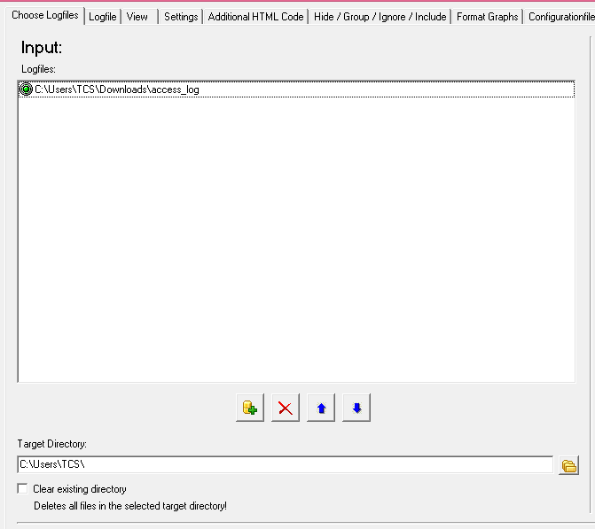
OUTPUT:
Monthly statistics
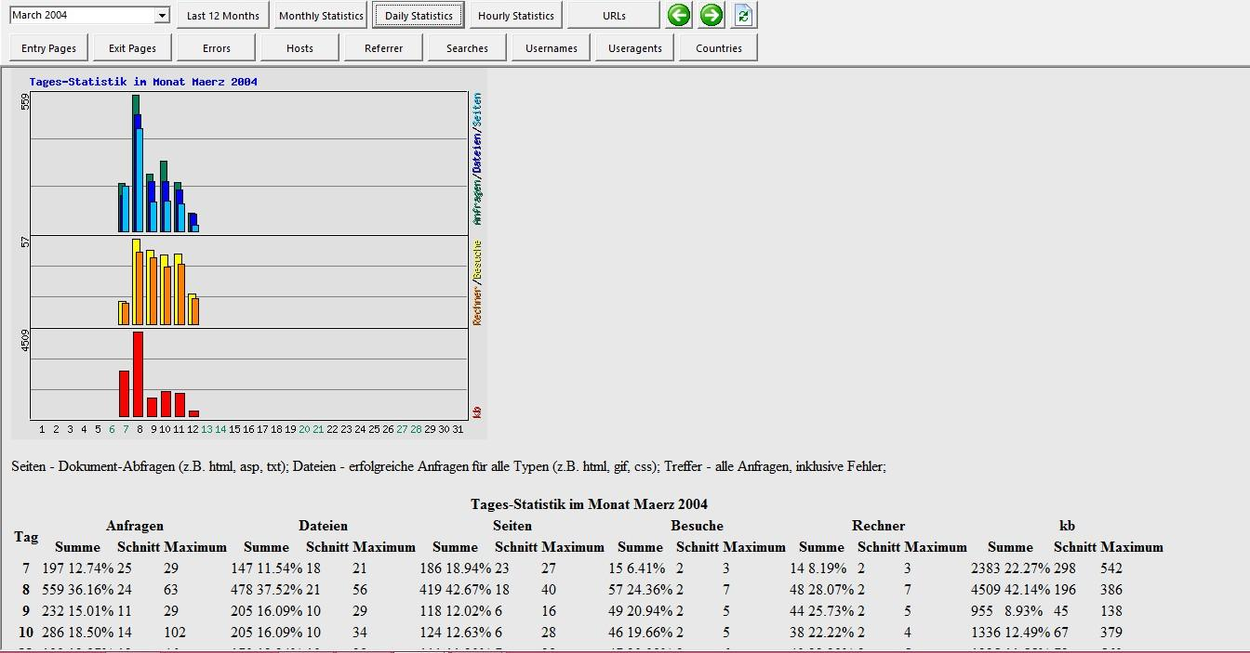
Hosts
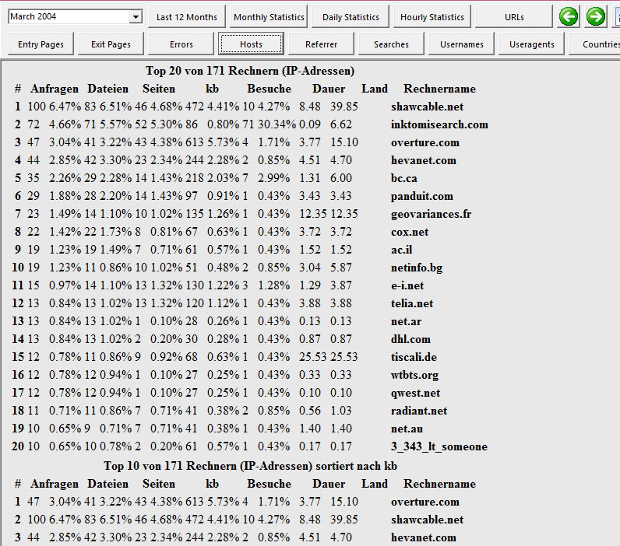
User-agents
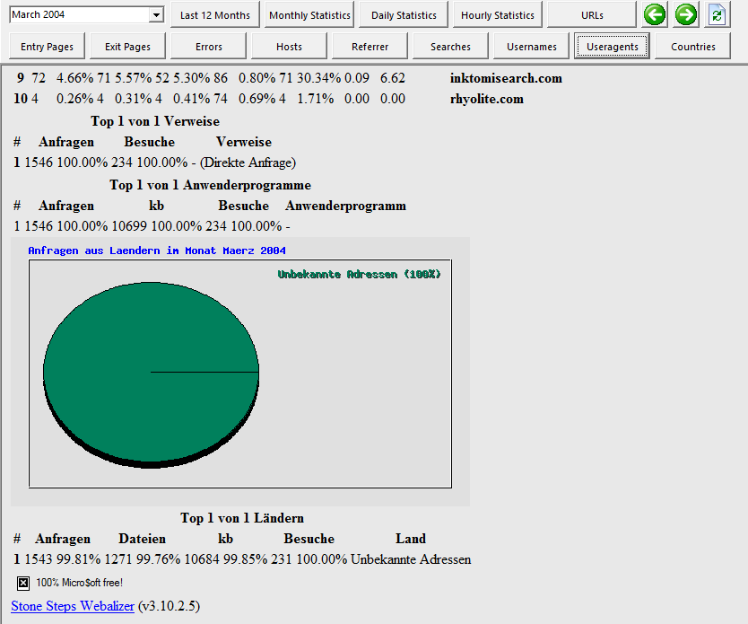
RESULT:
Thus, the different types of web logs were analyzed using the Webalizer tool, and the monthly statistics, hosts and user-agents reports were generated from the input web log file.

