LayerCAM vs. Transformer Attribution
Comparing how ResNet-50 and a Vision Transformer explain their predictions
Shyam Patel | (Advanced) Models of Deep Learning — Midterm Project | Dr. Kokalj-Filipovic | Fall 2026

1. Introduction
Explainable AI (XAI) helps me understand how an AI model makes predictions by showing which parts of an image may be important. In my project, I compare ResNet-50 using LayerCAM with Vision Transformer (ViT) using Chefer's Transformer Attribution. I chose these methods because ResNet-50 uses convolutional layers, while ViT uses self-attention, and I wanted to see how their heatmaps differ. Before running the experiment, I expected LayerCAM to focus on smaller details, like the animal's eyes, ears, and nose, while ViT would highlight larger areas, including the body and background.

2. Architectures

2.1 ResNet-50
ResNet-50 takes an image and passes it through multiple convolutional layers to identify features like edges, shapes, and textures. It uses skip connections to help gradients flow through the network, making deep models easier to train and reducing the vanishing gradient problem. The final convolutional block produces a 7×7 feature map, which is averaged into a vector using global average pooling before the model predicts a class. Because LayerCAM uses this small 7×7 grid, its heatmaps can look blurry and blob-like when enlarged to the original image size.

2.2 Vision Transformer (ViT-B/16)
The Vision Transformer (ViT) divides a 224×224 image into 196 patches, each measuring 16×16 pixels. It adds a special CLS token that collects information from the patches to help predict the image class. Unlike convolutional layers, which mainly focus on nearby features, self-attention allows the ViT to connect information from different parts of the image. Since the 196 patches form a 14×14 grid, the ViT heatmaps can look more patchy or block-like when enlarged to the original image size.

3. Explanation Methods

3.1 LayerCAM
LayerCAM combines the feature activations from a convolutional layer with the positive gradients of the predicted class to create a heatmap. Unlike Grad-CAM, which uses one average gradient weight for each feature map, LayerCAM uses gradients at individual spatial locations. This helps it identify which regions of the image contribute to the prediction.

3.2 Transformer Attribution (Chefer's Method)
Raw attention shows how image patches interact, but it does not necessarily explain which patches contributed most to the final prediction. Chefer's Transformer Attribution combines attention information with gradients and relevance propagation across transformer layers. This produces a class-specific heatmap showing which image regions the method considers important for the prediction.

4. Data, Preprocessing, and Loss

4.1 Dataset and Loss Function
Both ResNet-50 and ViT were pretrained on ImageNet, which contains images from 1,000 different categories. Classifiers like these are commonly trained using cross-entropy loss, which measures how different the predicted probabilities are from the correct labels. In my project, I used pretrained models, so I did not train them or calculate a training loss.

4.2 Image Preprocessing
Before passing an image into either model, I converted it to RGB, resized it directly to 224×224 pixels without cropping, converted it into a tensor, and normalized its pixel values. This makes the image compatible with the models' expected inputs.

4.3 Different Normalization and Original Notebook Issue
The two models need different normalization because their pretrained weights expect different input preprocessing. ResNet-50 uses ImageNet mean and standard deviation values, while the Chefer ViT implementation uses normalization with a mean and standard deviation of 0.5 for each RGB channel. In my original notebook, I used the same ImageNet normalization for both models, which was incorrect for the ViT. This issue was found during a code review, not through an error message, because incorrect normalization can run without producing an error. I then used separate preprocessing pipelines so each model receives the expected input format.

5. Results
Table 1 lists each model’s top prediction and confidence for the four test images, as recorded by the notebook.
Image | ResNet-50 prediction | ViT prediction | Same class?
Dog (PyTorch Hub) | Samoyed (49.0%) | Samoyed (65.9%) | Yes
Cow | ox (59.7%) | ox (76.2%) | Yes
Cat | tiger cat (37.0%) | tabby (71.5%) | No
Parrot | lorikeet (53.2%) | lorikeet (40.8%) | Yes
Table 1. Predictions and confidence for each image.

5.1 Dog (Samoyed)
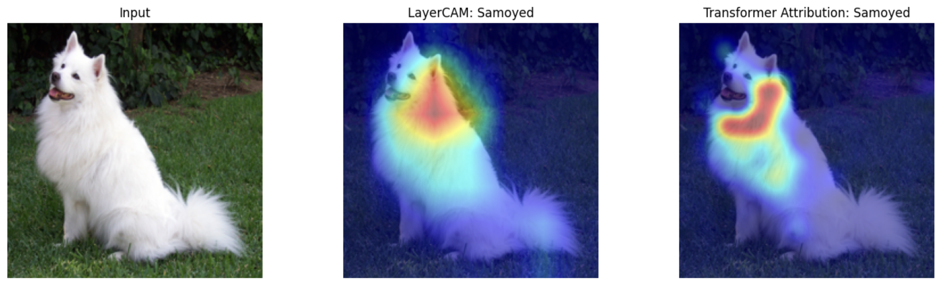
Figure 1. Dog: input, ResNet-50 LayerCAM, and ViT Transformer Attribution.
In the dog image, both models correctly predicted the Samoyed breed. ResNet-50 had a confidence of 49.0%, while ViT had a confidence of 65.9%. I originally expected LayerCAM to highlight the dog's face, especially its eyes, ears, and nose. However, neither heatmap showed much attention on the face. Both mainly highlighted the neck and upper chest, but LayerCAM produced a broad, blob-like heatmap, while Transformer Attribution showed a narrower, L-shaped band along the neck. This surprised me because I expected ViT to highlight a larger area than LayerCAM.

5.2 Cow (Ox)
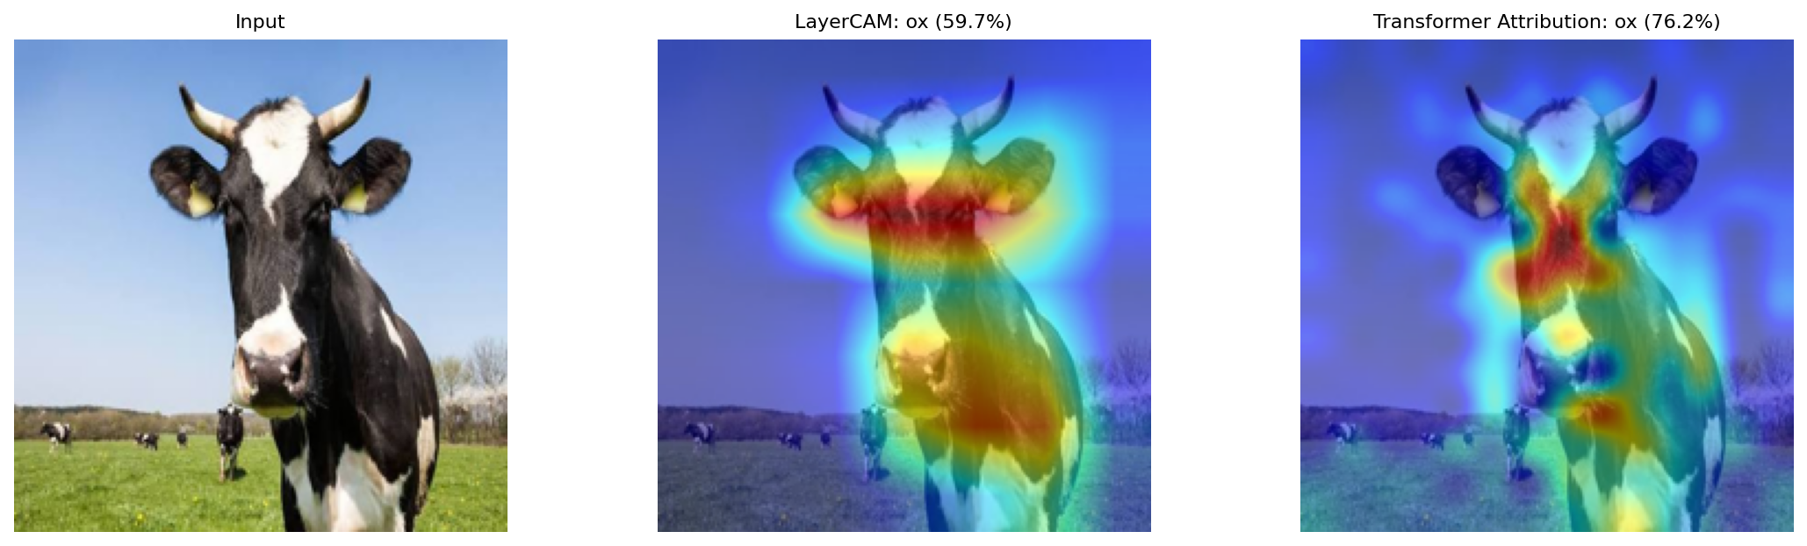
Figure 2. Cow: input, ResNet-50 LayerCAM, and ViT Transformer Attribution.
In the cow image, both models predicted the ox class, which ImageNet uses for cattle. ResNet-50 had a confidence of 59.7%, while ViT had a confidence of 76.2%. LayerCAM showed a broad band across the cow's forehead and eyes, along with some highlighting on its chest. Transformer Attribution produced four smaller, circle-like regions around the face, with additional spots on the chest. Neither heatmap showed noticeable attention on the background. I noticed that LayerCAM highlighted larger, more continuous regions, while ViT produced smaller, separated regions. This difference may be partly related to ResNet-50's 7×7 feature grid compared with ViT's finer 14×14 patch grid.

5.3 Cat
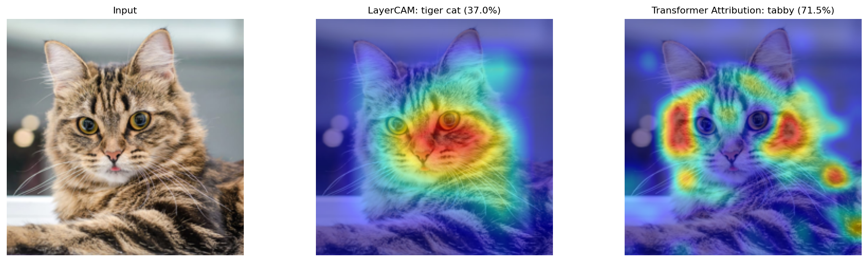
Figure 3. Cat: input, ResNet-50 LayerCAM, and ViT Transformer Attribution.
In the cat image, the two models predicted different ImageNet classes. ResNet-50 predicted tiger cat with 37.0% confidence, while ViT predicted tabby with 71.5% confidence. LayerCAM mainly highlighted the cat's face, especially the right side. Transformer Attribution focused on the cheeks and the area between the eyes, with some smaller highlighted regions on the body. Both models recognized the animal as a cat, but they selected different classes. Since tiger cat and tabby are visually similar categories, this disagreement may reflect ambiguity between the labels rather than a major classification error.

5.4 Parrot (Lorikeet)
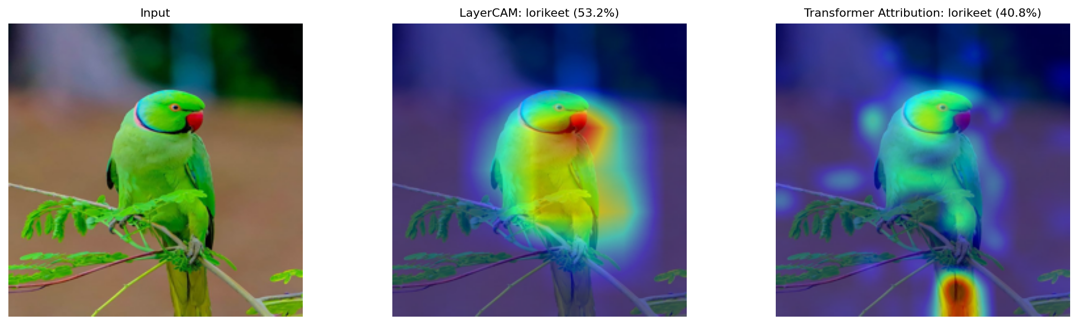
Figure 4. Parrot: input, ResNet-50 LayerCAM, and ViT Transformer Attribution.
In the parrot image, both models predicted lorikeet. ResNet-50 had a confidence of 53.2%, while ViT had a confidence of 40.8%. This was the only image where ViT had lower confidence than ResNet-50. LayerCAM showed very little red, with the strongest highlighting around the bird's beak, but it also showed a broad yellow glow across much of the bird's body. In contrast, Transformer Attribution highlighted an area near the tail, rather than mainly focusing on the head. The bird looks like a parakeet, so lorikeet may be the closest available ImageNet category rather than an exact species match; this could be one reason for the relatively low confidence scores. I found this surprising because I expected the models to focus more on the bird's face and colorful feathers. The tail hotspot also reminded me that a heatmap cannot prove which features actually caused a prediction. Covering the tail and checking whether the prediction changes would help test its importance.

6. Discussion

6.1 How the heatmaps compared
LayerCAM usually showed larger, smoother highlighted areas, while ViT's Transformer Attribution showed smaller, more separated, and sometimes scattered spots. LayerCAM often covered more of the animal's body, while ViT's highlighted regions varied across the images.

6.2 What surprised me most
I was most surprised by the dog image because I expected LayerCAM to focus on the face, but both methods mainly highlighted the neck. I was also surprised that ViT highlighted the parrot's tail instead of its head.

6.3 Confidence and heatmap quality
Higher prediction confidence does not necessarily mean a better heatmap. Confidence shows how strongly a model favors a prediction, while a heatmap estimates which image regions contributed to that prediction. Confidence values from different models are also not directly comparable as measures of explanation quality.

6.4 Next test
I would run an occlusion test by covering different parts of the images, especially the parrot's tail and the dog's neck, and comparing the predictions before and after. This would help me test whether the highlighted regions actually influence the models' decisions.

7. Conclusion
Overall, I found that LayerCAM usually produced broader and smoother heatmaps, while Transformer Attribution showed smaller and more separated highlighted regions. I was surprised that both methods focused on the dog's neck instead of its face and that ViT highlighted the parrot's tail. I learned that heatmaps can help me understand model predictions, but they cannot prove exactly why a model made a decision.

References
- He, K., Zhang, X., Ren, S., and Sun, J. "Deep Residual Learning for Image Recognition." CVPR, 2016.
- Dosovitskiy, A., et al. "An Image is Worth 16x16 Words: Transformers for Image Recognition at Scale." ICLR, 2021.
- Jiang, P.-T., et al. "LayerCAM: Exploring Hierarchical Class Activation Maps for Localization." IEEE Transactions on Image Processing, 2021.
- Chefer, H., Gur, S., and Wolf, L. "Transformer Interpretability Beyond Attention Visualization." CVPR, 2021.

