1. I need to be this button will open registration page



1. On Blog page I do not need those section



1. This section have problem after RTL on pc view but in mobile view doesn't have problem

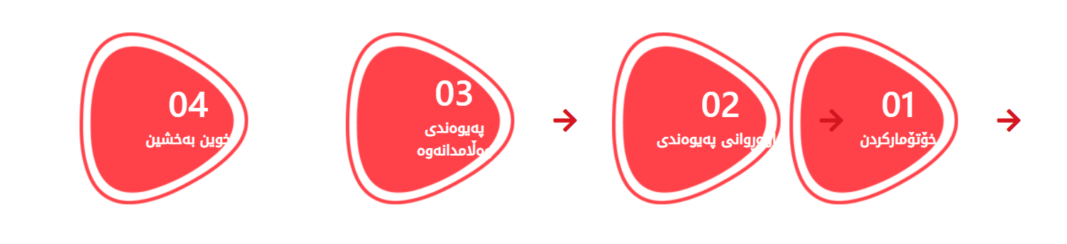

1. The important thing I do not need on registration page

I do not need the email , that’s big problem because not everybody have email and they do not know confirmation so if you can delete those field (Email) its better.

1. Some time when I add blog on Blog page will sort posts like this

<https://xwenbexshin.com/blog>

