AWS Overview
Agenda:
Introduction to Cloud?
Cloud features: pay as you use and Horizontal/Vertical scalability
Cloud Models: Public, Private, Hybrid, Community
Cloud Services: IAAS PAAS SAAS
Cloud providers
AWS introduction
AWS Services:
EC2 – Elastic Cloud Compute
EBS – Elastic Block Store
Auto scaling
ELB – Elastic Load Balancer
S3 – Simple Storage service
IAM – Identity and Access Management
VPC – Virtual Private Cloud
DNS Route 53 - DNS
RDS – Relational Database Service

Cloud Overview:
Definition:
Cloud computing refers to the on-demand delivery of IT resources and applications via the internet with pay as you go.
If we need we can get it right away
If we don’t we can give it away.
These services are available over internet, we just need web browser and internet connection, we can request computing or storage infrastructure
Pay as you go: psostpaid mobile bill or electricity bill
SAAS – Software as service
Cloud Computing: The practice of using a network of remote servers hosted on the Internet to store, manage, and process data, rather than a local server or a personal computer

Features:
On demand provisioning
Scalability in minutes: we can scale out, or scale in
Horizonal scalability: can scale from 1 instance to several instances
Or can scale down from several instances to 1
Vertical Scalability: can go from 1GB RAM to 100GB RAM – for a single machine
Cloud Models:
Public
Private
Hybrid
Community
Clouse services:
IAAS – Infrastructure as service
PAAS – Platform as service
IAAS:
Creating infrastructure as the service
Create VMs, attach storage, assign network to it
Creating infrastructure ourselves in IAAS
Pay per hour basis
PAAS:
Developers may need a java/.net platform.
They create all the infrastructure and put your code on it and run it

SAAS:
Software as a service:
In SAAS everything is managed by the cloud providers, h/w, servers, network, storage, virtualization, OS, middleware, data, run time, applications etc
Examples:

osoft azzure google cloud rackspace, ibm softlayer
PAAS: elastic beanstalk google app engine
SAAS: HRMS Human Resource Management system

When you are a simple client who want to make use of a software but you have nothing in hand then you use SaaS.

When you have a software developed by you, but you want to deploy and run on a publicly available platform then you use PaaS.
When you have the software and the platform ready but you want the hardware to run then you use IaaS.

EC2 (Elastic Cloud Computing):
Amazon Elastic Compute Cloud (Amazon EC2) is a web service that provides secure, resizable compute capacity in the cloud. It is designed to allow you to obtain and configure capacity with minimal friction and to make web-scale cloud computing easier for developers.
Amazon is elastic/flexible, supports lot of OS flavours

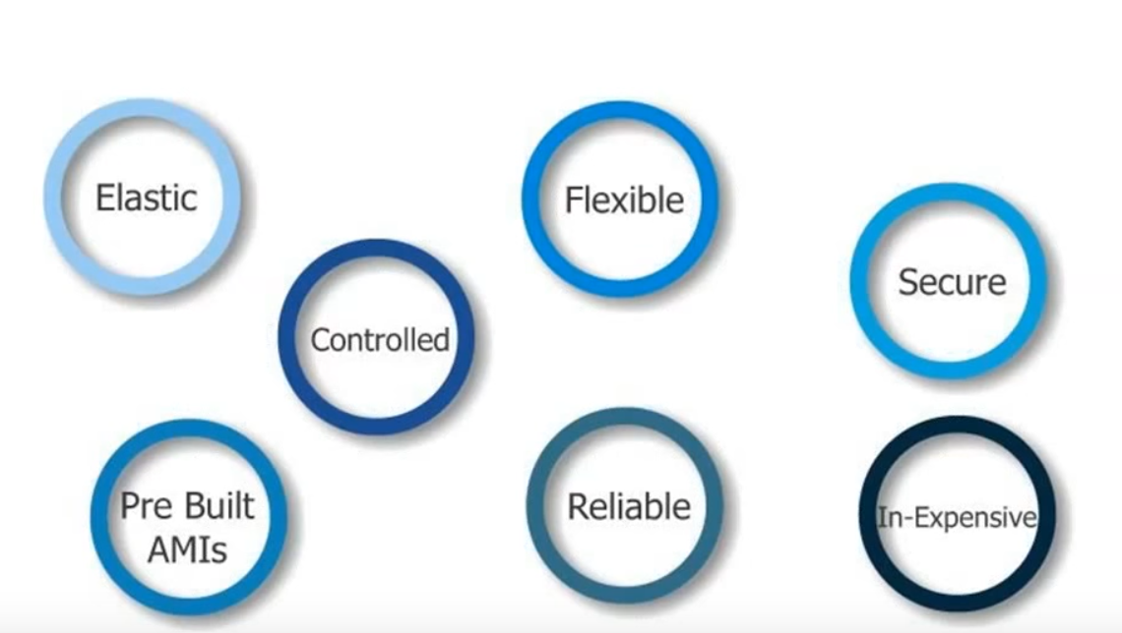

EC2 Flow:
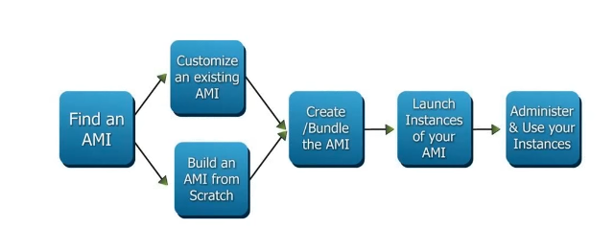

EC2 Life Cycle:

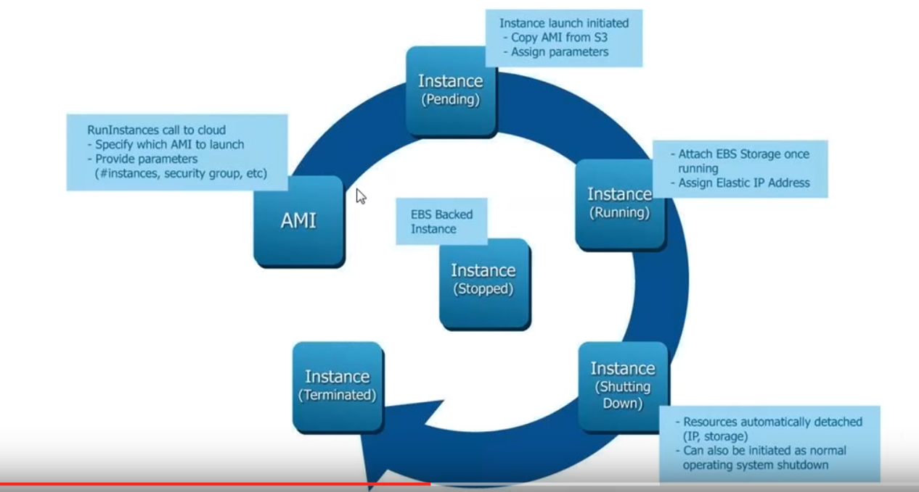

Default users to login to ec2:
ec2-user
ubuntu
centos
root
admin

To configure password less authentication between 2 ec2 instances:
- Login to ec2 instance and change ssh configuration file /etc/ssh/sshd_config as below
PermitRootLogin prohibit-password to PermitRootLogin yes
PasswordAuthentication no to PasswordAuthentication yes
Then restart ssh
RHEL → service sshd restart
Ubuntu → service ssh restart
To have password less authentication between 2 instances, master and slave:
- Generate the keys using ssh-keygen on master
- Copy the keys using from master to slave using
ssh-copy id -I ~/.ssh/id_rsa.pub root@slave

ec2 instances:

When you launch an EC2 instance, you receive a Public IP address by which that instance is reachable.
Once you stop that instance and restart the you get a new Public IP for the same instances.

So, Public IP gets changed every time for an instance after stop/start.

To overcome with this problem, we attach an Elastic IP to an Instance which doesn't change after you stop / start the instance as many times.

Advantage of Having Elastic IP
-> It is kind of static IP for your Instance.
-> Doesn't change after stop/start.

Note: If you have Elastic IP in your account and it’s not in use, then you will be charged for it.

EC2 Load balancer - Elastic Load Balancing
It Is simply a software to manage the load of application.
For ex: if there are 10 web servers, we have public ip for one webservers, the traffic flow to one webserver will be balanced across the 10 webservers using load balancer.
To automatically distribute incoming web traffic across multiple ec2 instances.
Add and remove ec2 instances without changing the inflow
If one of the instance fails, AWS ELB will automatically redirect the traffic to another running instance.
If the failed instance is restored, ELB restores the traffic to that instance.
ELB is like a traffic manager, it minimizes the risk of overloading one single instance and provides continuous monitoring of the health of AWS instances.
ELB can be setup to load balance incoming application traffic across Amazon ec2 instances in a single Availability zone or multiple AZs – AZ is a data center.

The AWS Classic Load Balancer (CLB) operates at Layer 4 of the OSI model. What this means is that the load balancer routes traffic between clients and backend servers based on IP address and TCP port.

AWS Application Load Balancer (ALB) operates at Layer 7 of the OSI model. At Layer 7, the ELB has the ability to inspect application-level content, not just IP and port. This lets it route based on more complex rules than with the Classic Load Balancer.

Internal load balancer -> internal, not external, not internet facing
Response timeout – 5 sec – time out value
Health check interval – how often it pings
Unhealth threshold – 2 consecutive time outs, it tries to access page twice
Healthy threshold - 3 ping the LB and report it as healthy as 3 times. – 3 successful pings
Exercise:
- Create 2 ec2 instances
- Install apache server on both and configure
- On one of the machine in /var/www/html/index.html add server1
- On the other machine in /var/www/html/index.html add server2
- Create load balancer with 2 ec2 instances
- Open the load balancer using the url provided, by default it points to server1, so in the web browser output we can see server1
- Bring down the server1, and after some time try to access the same load balancer,
it should display server2
- If ec2 instance is brought up again, it should show server1 in the web browser output

EC2 Auto Scaling:
Auto scaling helps to have correct number of EC2 instances available to handle the load of application.
Create collection of EC2 instances called auto scaling groups
While creating the group, we need to specify the desired capacity.

Example:
There is website to download video games.
And 2 servers are serving the requests from the users.
There is increase in the demand, and the servers are scaled to 4 servers.
Same thing is done by Auto scaling group automatically.
Minimum - 2
Maximum – 10
Desired – 4
If desired no. of servers is changed to 6, 2 instances will be spinned up.
Launch configuration:
Tells the auto configuration service what exactly it must launch.

EC2 instance type and size
AMI
Security groups/ssh keys/IAM instance profile
User data

Launch configuration → which instances you want to launch/ OS/Config etc – defined here
Create auto scaling group → minimum max desired instances are defined here.

Elastic Block Storage:
EBS is a virtual hard drive that can be used with ec2 instances.
Can attach it to ec2 instance.
Can place file system on it
If EBS is used to store your data, if any ec2 instance fails, we can still get the data as data is not stored on the instance, but on EBS volume.
1GB to 1TB in size, created in a particular AZ – availability zone/data center
It appears as a mounted device.
1 volume can be attached to 1 instance only
Great performance for read/write in case of heavy load – iops
To create to go EC2 dash board → ebs volume → create volume
Attach volume to instance,
And run lsblk/fdisk -l to check the volume on the ec2 instance.
We can remove the volume by force detach
We can create snapshots to replicate the data
Go to snapshots to check snapshot created.
To create high performance drive, we can create volume from snapshot.
S3 vs EBS vs EFS
Simple storage service
Elastic Block Storage
Elastic File System.
S3 can be used when the requirement is for WORM – write once and read many times
EBS works best as server disks – high performance in terms of read and write.
EFS – to share the file system across different servers.

Cloud watch – monitoring service
Monitoring can be enabled while creating instance.
Detailed monitoring – happens every 1 min
Standard monitoring happens every 5 min
We can create alarms using cloud watch
Like: if cpu utilization goes > 90% for 2 min, send me a email/text message

RDS – Relational Data base Service:
Allows to create mysql, mariadb, oracle sql,postgresql, Aurora db (Amazon’s database)
Easy administration
RDS db instances are preconfigured with appropriate settings

- Fully Managed Relational database – does not allow access to underlying OS
- Can connect to data base using mysql
- RDS runs on instance types ex: t2.mcro, m4.large etc
Enable multi AZ deployments for HA, backups

Main benefits:
- AWS takes care of underlying platform, so automatic updates
- Automatic backups
- Automatic recovery in case of failures

For production env – multi AZ failover has to be enabled
Read replicas – copies of the primary data base
Can scale up read replicas to increase the data base
We can enable HA/elasticity/fail over using multi AZ / read replicas
We can take backup/snapshots manually
Exercise:
Go to RDS Service
Launch a new db instance
Select mysql
Select Dev/Test environment – as it is free tier eligible
Select same VPC and Subnet for the DB so that ec2 instances can access it
Create a subnet group
Select vpc
Select the availability zone – us-east-1c
DB Instance type: t2.micro
Multi AZ deployment – na for free tier

DNS/ Route 53:
Domain Management service
Key features:
- Domain Registration
- DNS – Domain Name System Service
- Health Checking
Which resource should have dns
ELB?
EC2?

Hosted Zones:
- Can register a domain with AWS
Public hosted zone/ Private hosted zone
Resource Record sets:
Instructions that match domain names to IP
They are comprised of
Record type
Standard/alias
Routing policy
Evaluate target health

Common record types:
A – to point to a domain on IPV4 address
AAAA – to point to a domain in IPV6 address
CNAME - to point to hostname to another hostname
MX - used to route email

Alias Record sets:
Alias record set contains a pointer to an AWS specific resource for ex:
Elb
Ec2 instance

Routing policy:
Simple: Route all traffic to one end point
Weighted: Route all traffic to multiple end points
Latency: Route traffic to end point based on the users latency to various end points
Failover: Route traffic to a secondary end point if the primary is not available
GeoLocation: Route traffic to and end point based on the geo graphical location of the user

Amazon Aurora – data base engine
Amazon glacier – to store the archives , huge data bases

Design your own website: http://www.opendesigns.org/design/blue-skies/
Development; dropbox – application to upload docs /pdfs/videos

Amazon VPC:
Amazon Virtual Private Cloud (Amazon VPC) lets you provision a logically isolated section of the Amazon Web Services (AWS) cloud where you can launch AWS resources in a virtual network that you define. You have complete control over your virtual networking environment, including selection of your own IP address range, creation of subnets, and configuration of route tables and network gateways. You can use both IPv4 and IPv6 in your VPC for secure and easy access to resources and applications.
Using VPC:
Launch instances into a subnet of our choice
Assign custom ip address ranges in each subnet
Configure route tables between subnets
Create internet gateways and attach them to subnets
Better security control.

Create custom VPC:

1. create custom vpc
give cidr block: 10.0.0.0/16
2. create subnet -
cidr 10.0.1.0/24

3. create internet gateway

4. after creating vpc, it creates route table by default

5. attach internet gateway to vpc

6. go to route table add a route to internet

7. make sure that subnet has internet gateway. which has route to internet

launch ec2 instance in the custom vpc
try to access using private ip --> cannot be accessed

create elastic ip
associate with ec2

How to access instances in private n/w:

1. Create nat server - n/w address translation - pubic instances to communicate out to internet

outside world should be able to access using 80 port

create 3 subnets
10.0.1.0/24
10.0.2.0/24 private subnet
10.0.3.0/24 private subnet

create a new security group:
nat security group
select custom vpc

edit the security group
add inbound
http / and https from 10.0.2.0/24
https/ and https from 10.0.3.0/24

add outbound

http and https from 0.0.0.0/0

3. provision network address translation server
create ec2 instance

amzn-ami-vpc-nat

4. while creating instance select custom vpc , select internet facing subnet

security group - select as nat security group

5. allocate new address and associate to nat server instance

6. go to ec2 dashboard
actions--> network --> change source destination check --> disable it

7. enable a route out to using nat
copy instance id

select second route table
edit
add another subnet 10.0.2.0/24
this rt is associated with 2 private subnets

add route to access internet
0.0.0.0/0 target is instance . paste the instance

Creating VPC:

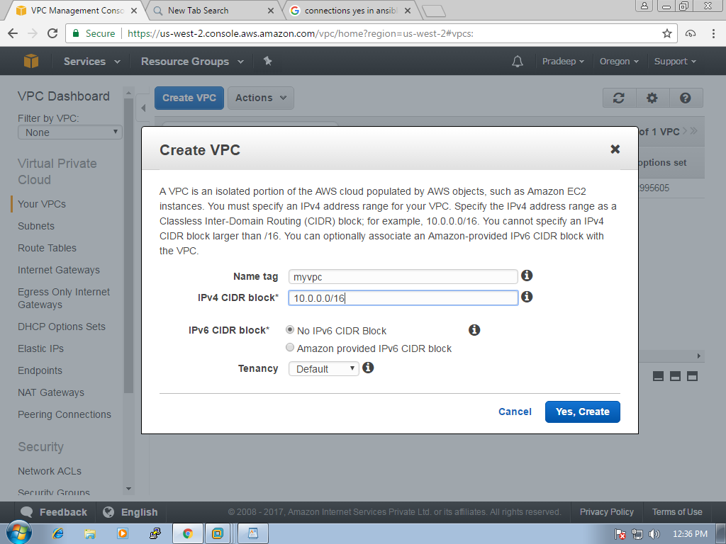

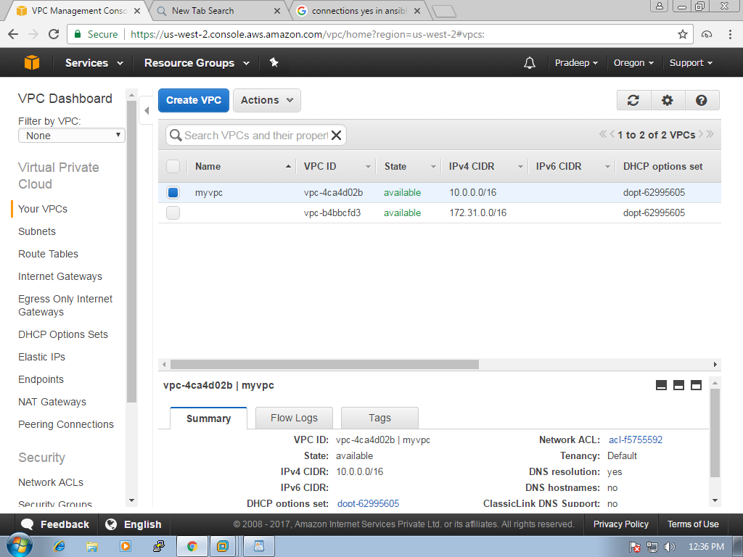

create subnets
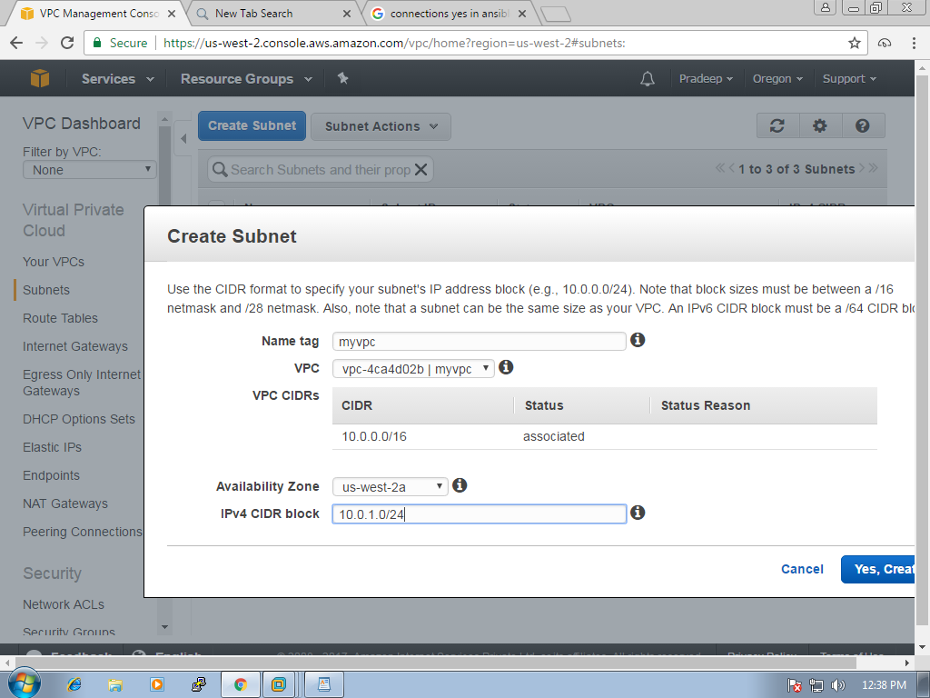
another subnet
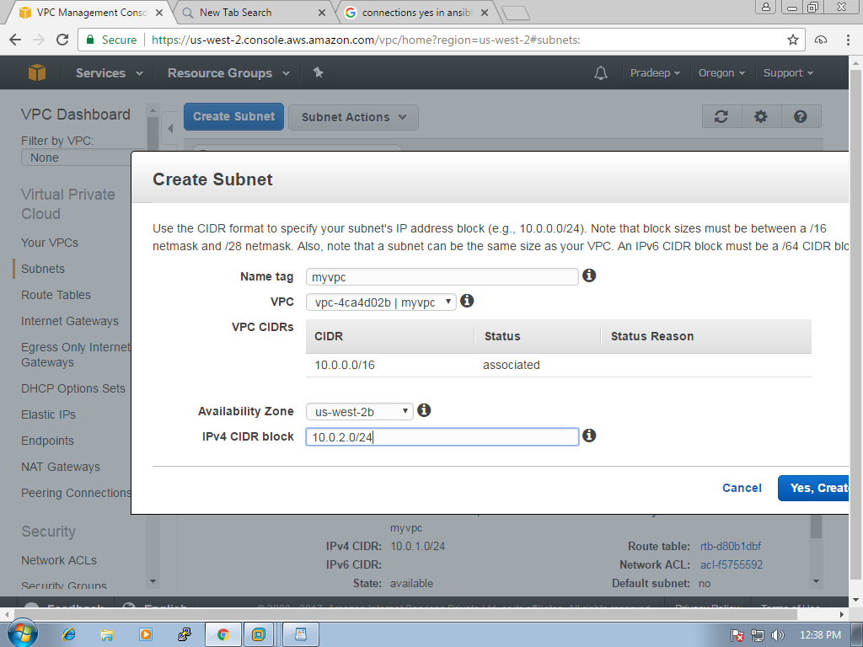
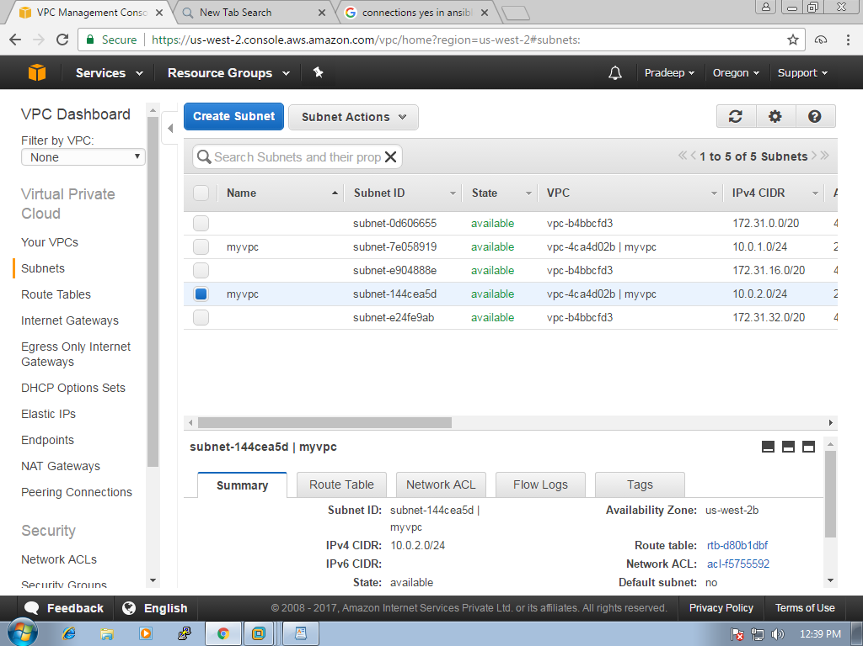

route tables:
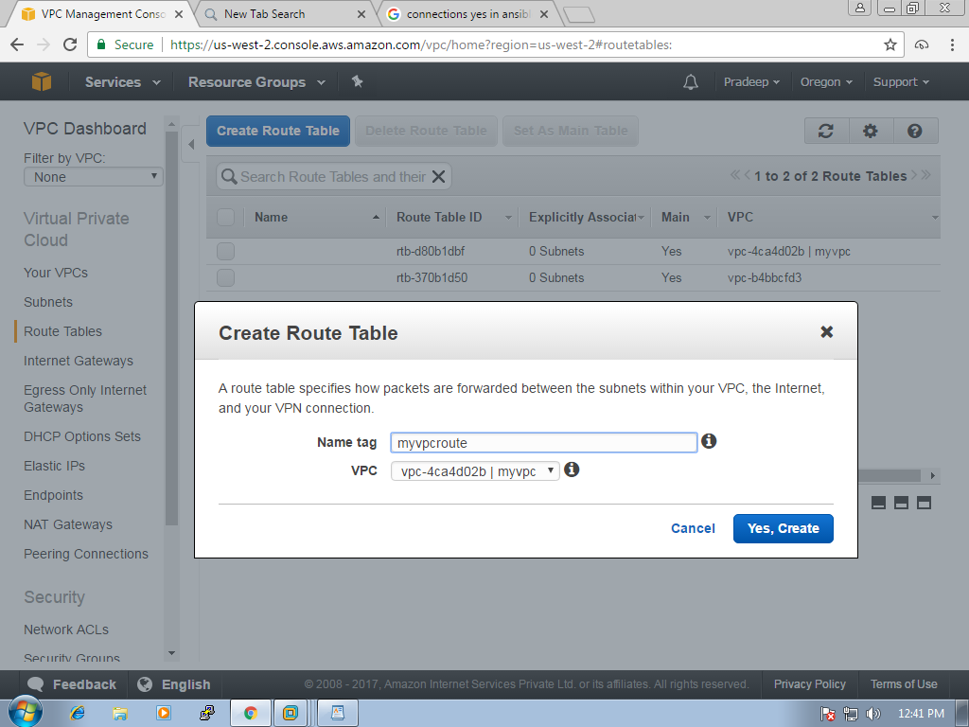
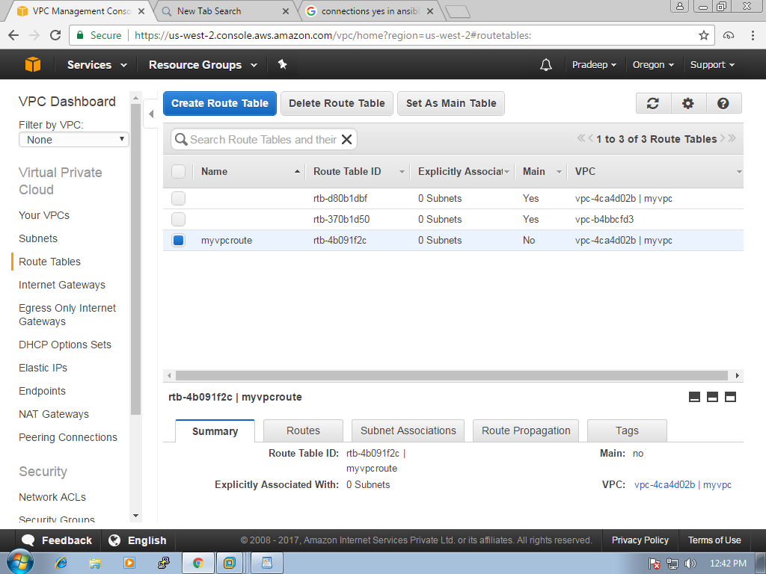

edit in subnet association
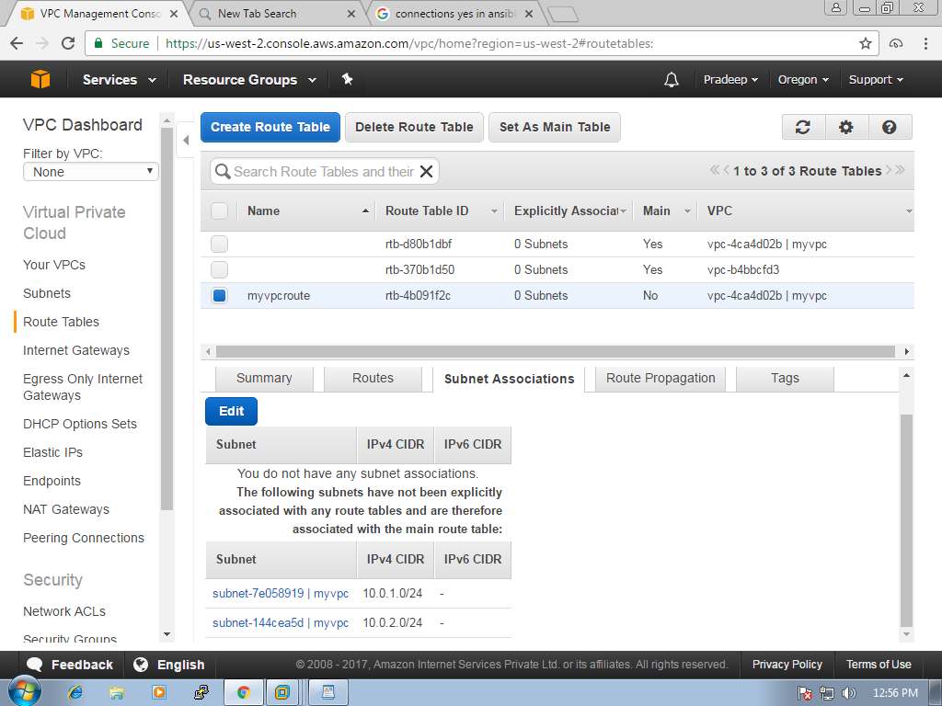

check the check box of 1st subnet

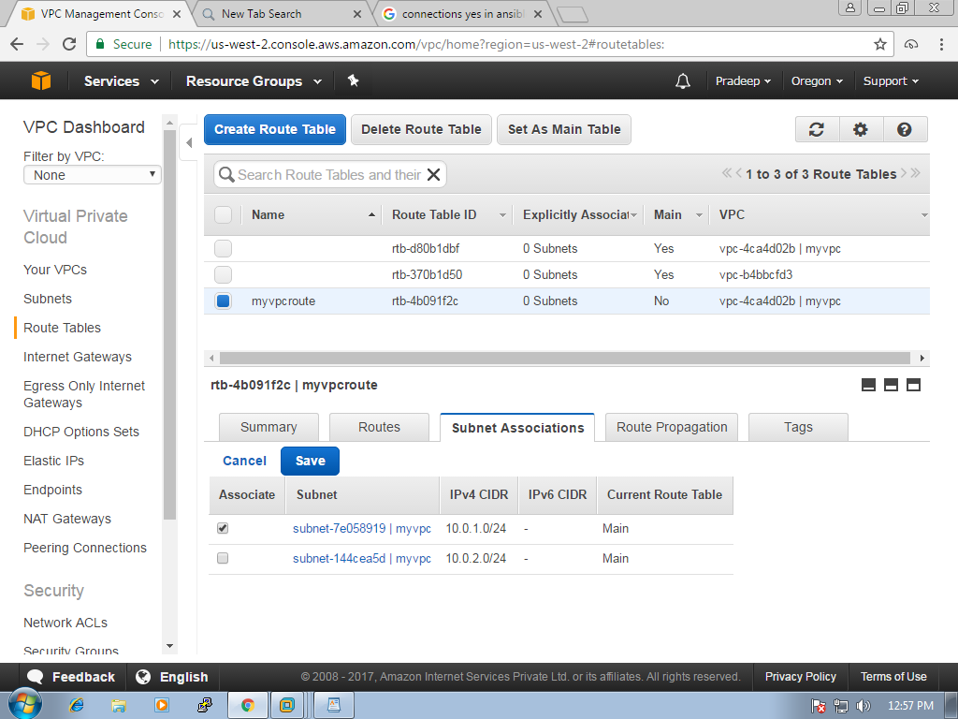

and click on "Save", output is
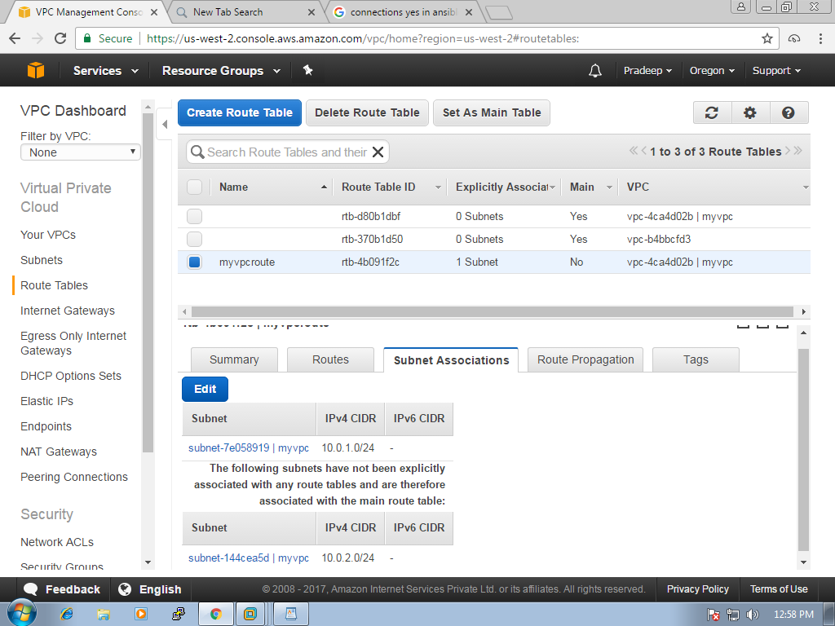

Network ACLs:
where we can give access to inbound and out bound. as of now we are left with default
you can edit by clicking "edit button"
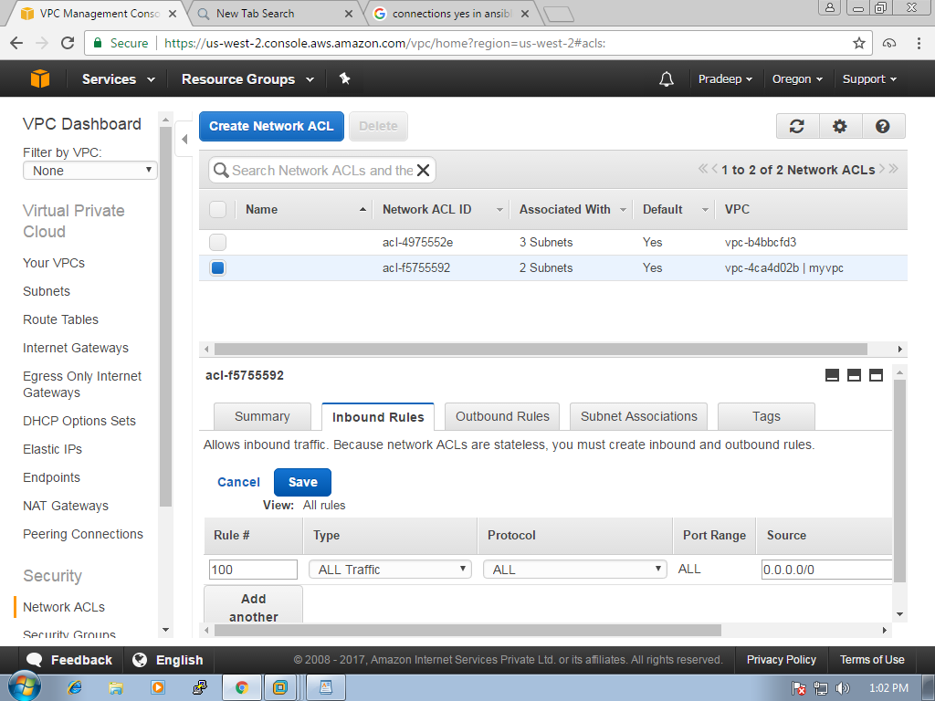

Now navigate to NAT Gateways in the left pane and click on "create a NAT Gateway"
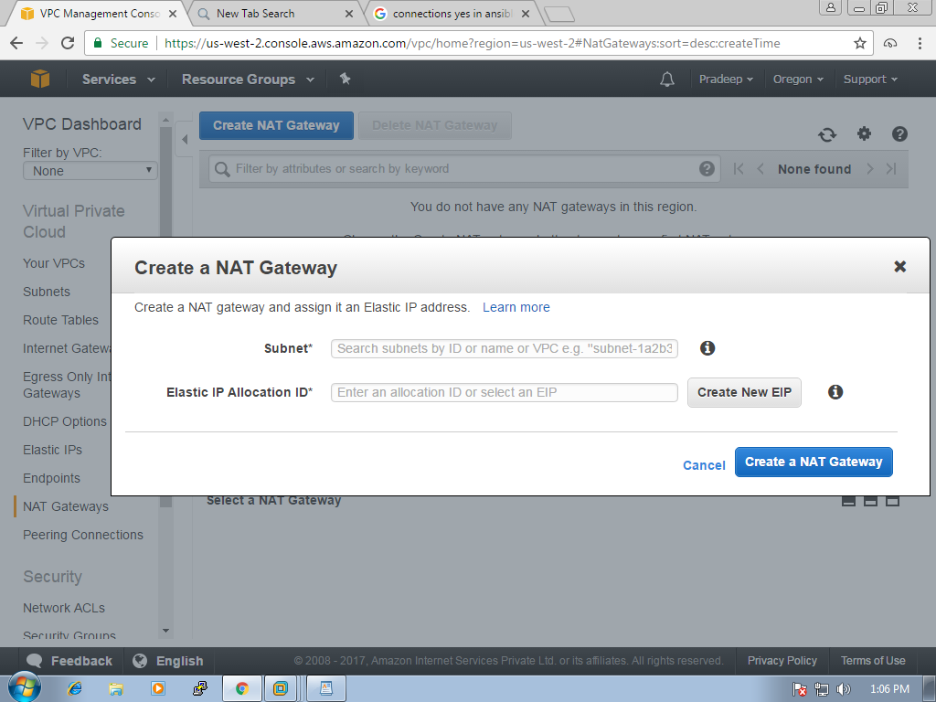
click on create New EIP button, where elastic IP address is created.
if we need fixed public IP , we need to create elastic IP address which chargeable.
if you have created the elastic Ip address, delete the ip address in the NATgatways.
and also remove in the Elastic IP's as follow in the screen shot
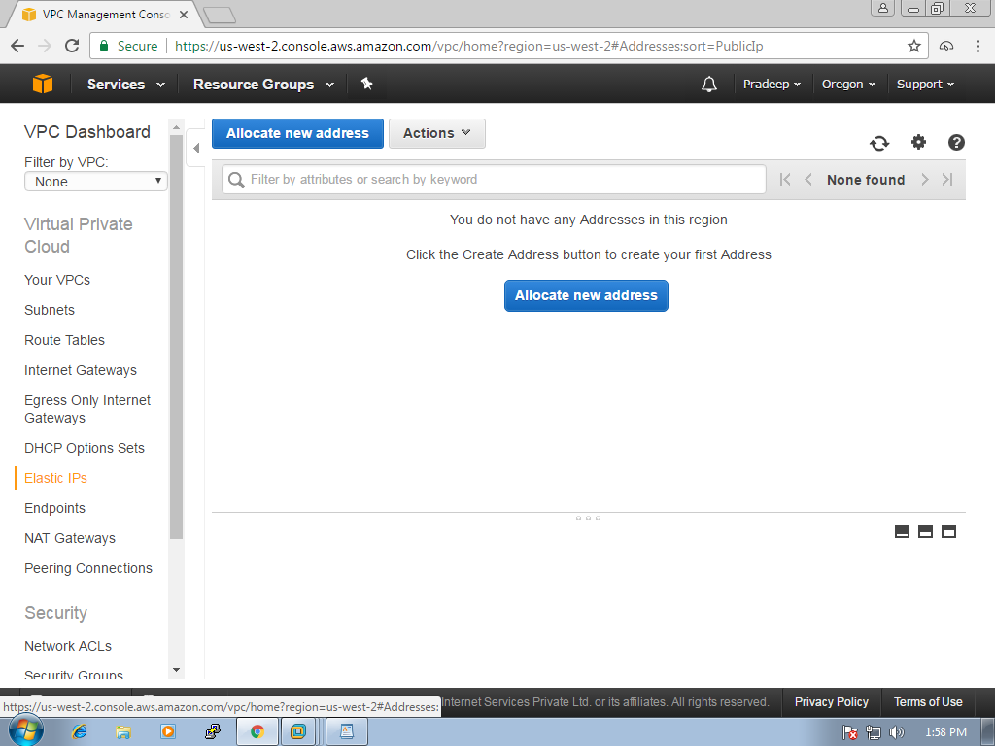
select the ip address and click on release address's in the actions drop down
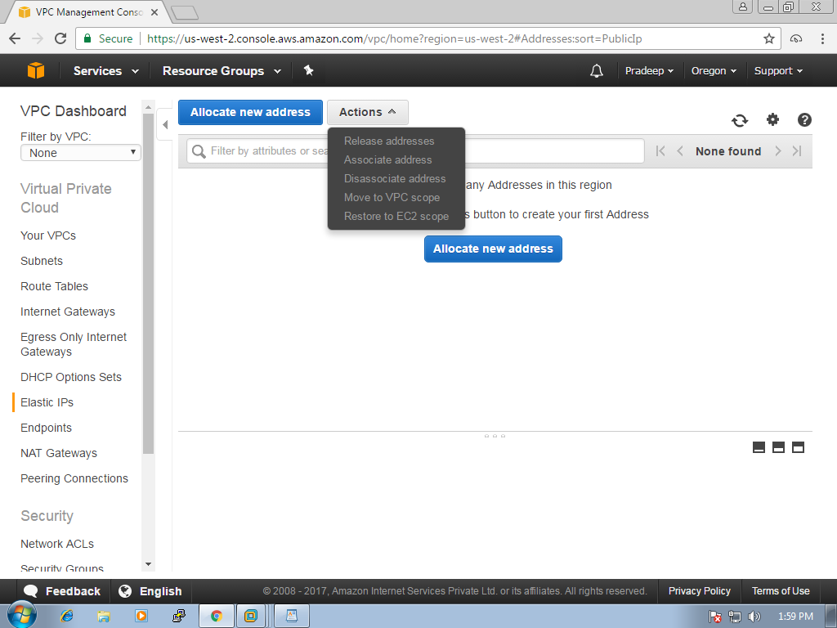

Creating and restoring from backup/snapshot:

lsblk
partprobe
fdisk -l
fdisk /dev/xvdf
create a partition number 2
mkdir /data
mount /dev/sdfx2 /data

cd /data
mkdir test1 test2

create snapshot

remove files

unmount old volume

detach old volume

attach new volume

mount it

files will be restored

resize:

unmount
delete partition
recreate with new size
mount

resizefs /dev/xvdf2

e2fsck

mount

ls

AWS CLI:

apt-get install awscli
aws configure
aws ec2 create-key-pair --key-name test-key --query 'KeyMaterial' --output text > key.pem
aws ec2 create-security-group --group-name group1 --description "group1"
aws ec2 authorize-security-group-ingress --group-name group1 --protocol tcp --port 22 --cidr 0.0.0.0/0
aws ec2 run-instances --image-id ami-6e1a0117 --count 1 --instance-type t2.micro --key-name test-key --security-groups group

aws ec2 terminate-instances --instance-ids i-0c47113d770259890

Cloud Formation:
- Cloud formation is the pure definition of infrastructure as code
- We can convert the application’s architecture into JSON formatted template, so our architecture is literally code
- We can use that JSON template to deploy updated copies of that architecture to multiple regions
Benefits:
Saves time – we don’t have to manually create duplicate architecture in additional regions.
We can version control out infrastructure
Allows backup of infrastructure
Great solution for disaster recovery

Sample cloudf ormation template to create s3 bucket:
Cat cf1.template
{
“AWSTemplateFormatVersion” : “2017-07-02”,
“Description” : “ this is a s3 bucket created from CF”,
“Resources” : {
“S3Bucket” : {
“Type” : “AWS::S3::Bucket”,
“Properties” : {
“AccessControl” : “PublicRead”,
“BucketName” : “bucket-cf-1234”
}
}
}
}

AWS Levels of Certifications:
Associate level:
Solution Architect Associate
Developer Associate
Sysops Associate
Professional level:
Solution Architect Professional
Devops Professional
Special Certifications:
bigdata certification
network certification

