**Tableau Training – Project**

**Comparison of Region Based on Sales**

**SCREENSHOTS:**

1. **Average sales per order**

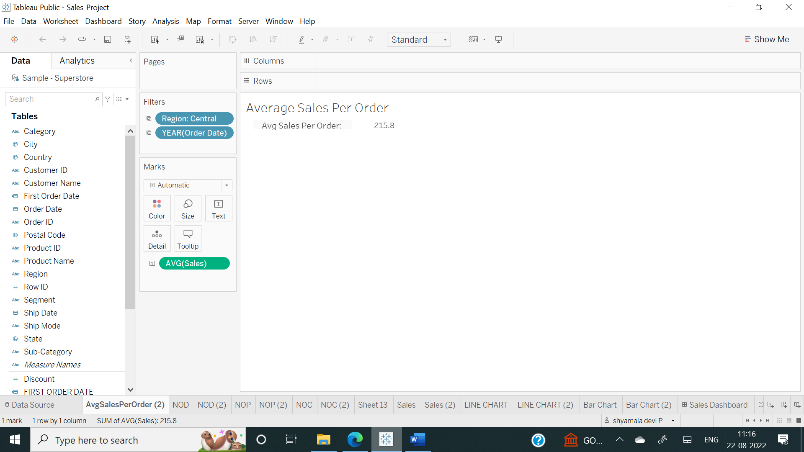

1. **Number of orders:**

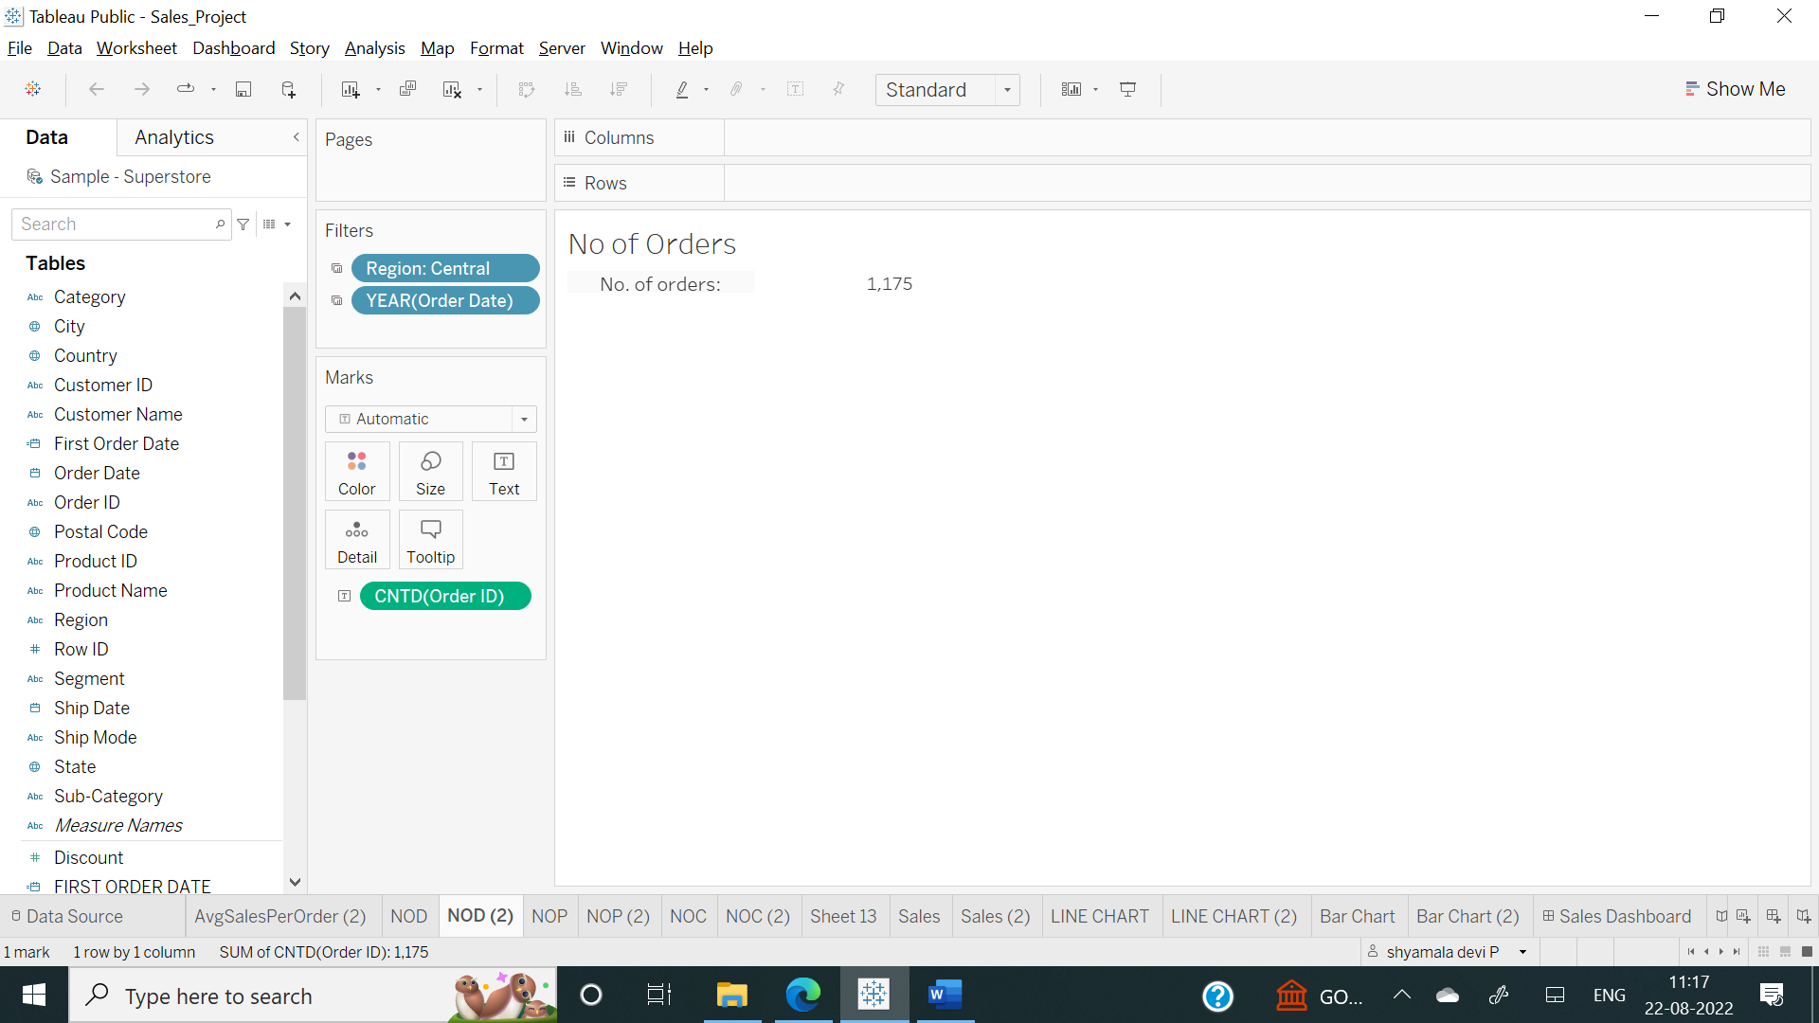

1. **Number of customers:**

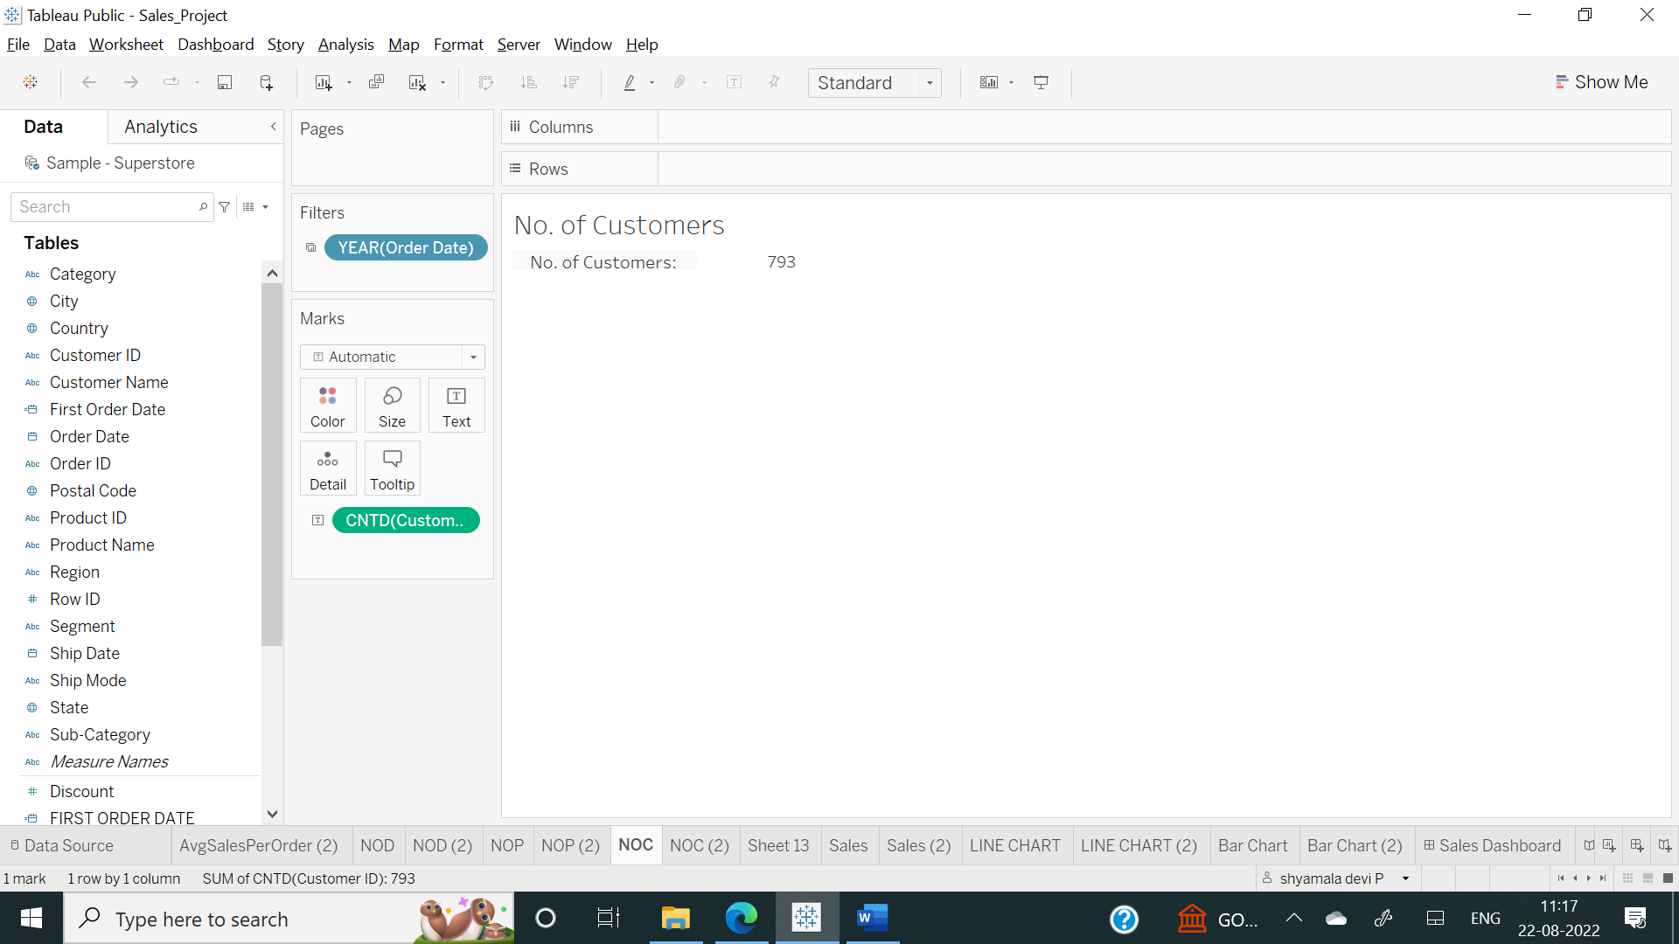

1. **Sales across each sub-category:**

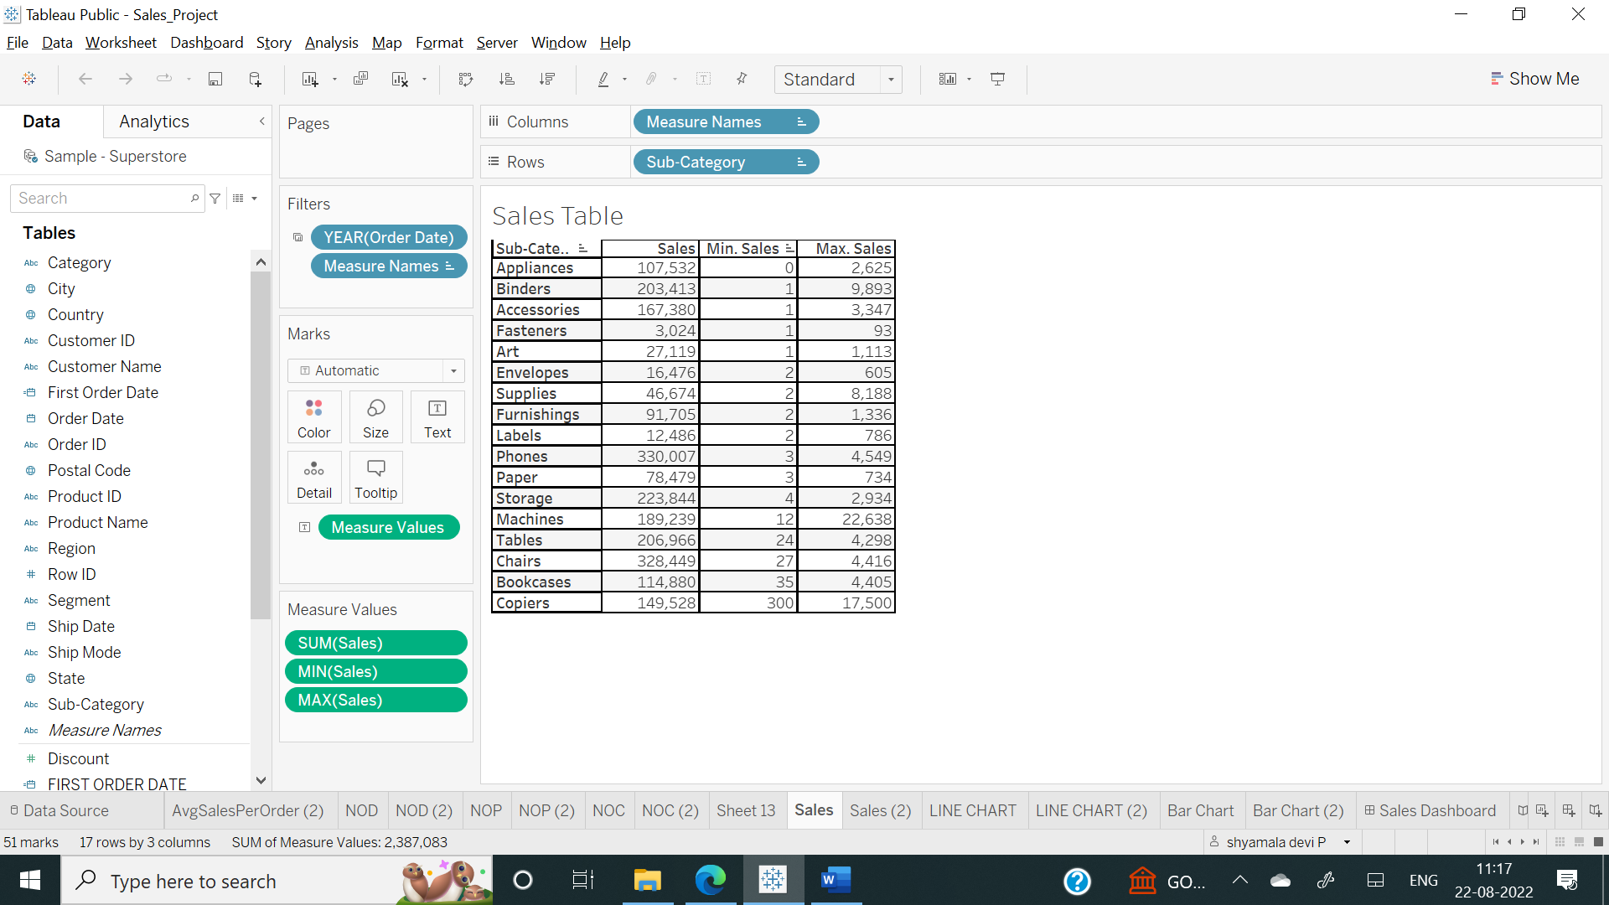

1. **Line chart - sales**

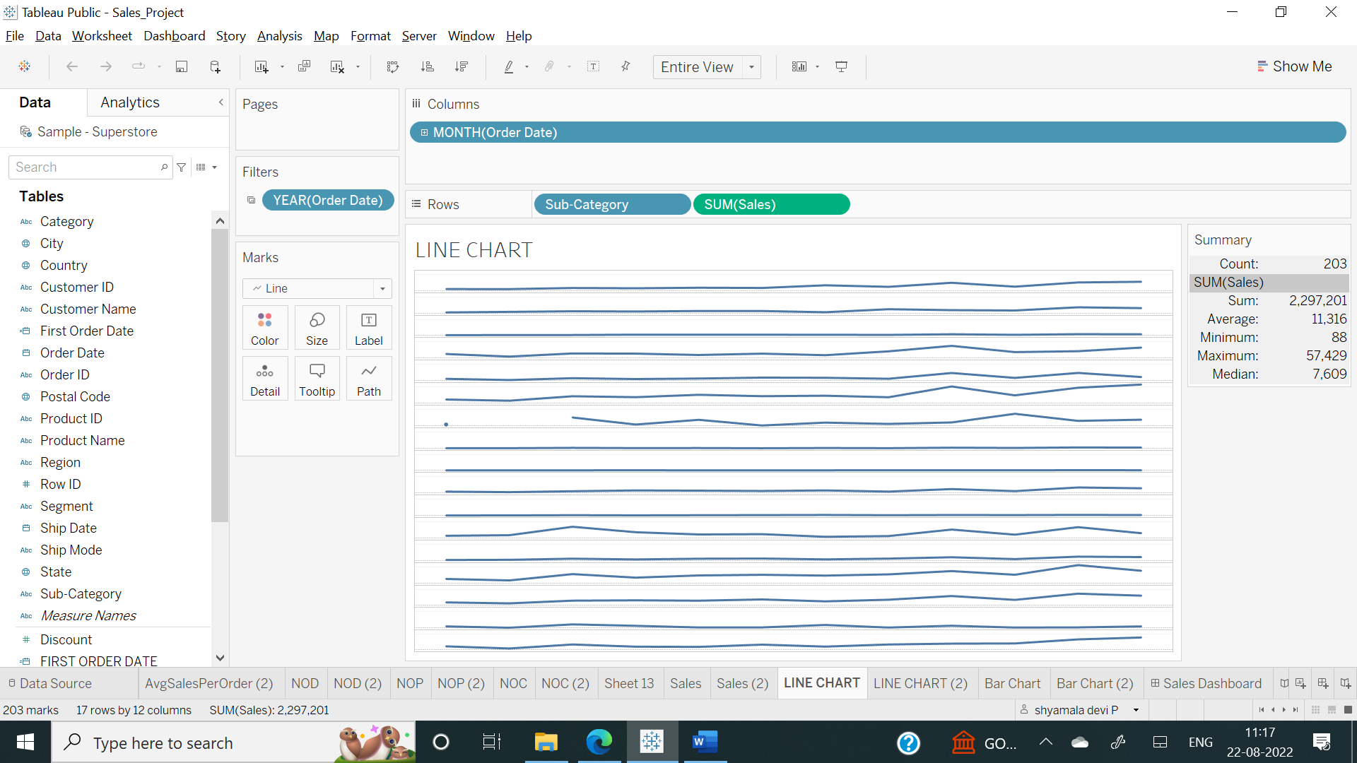

1. **Bar chart – Sales:**

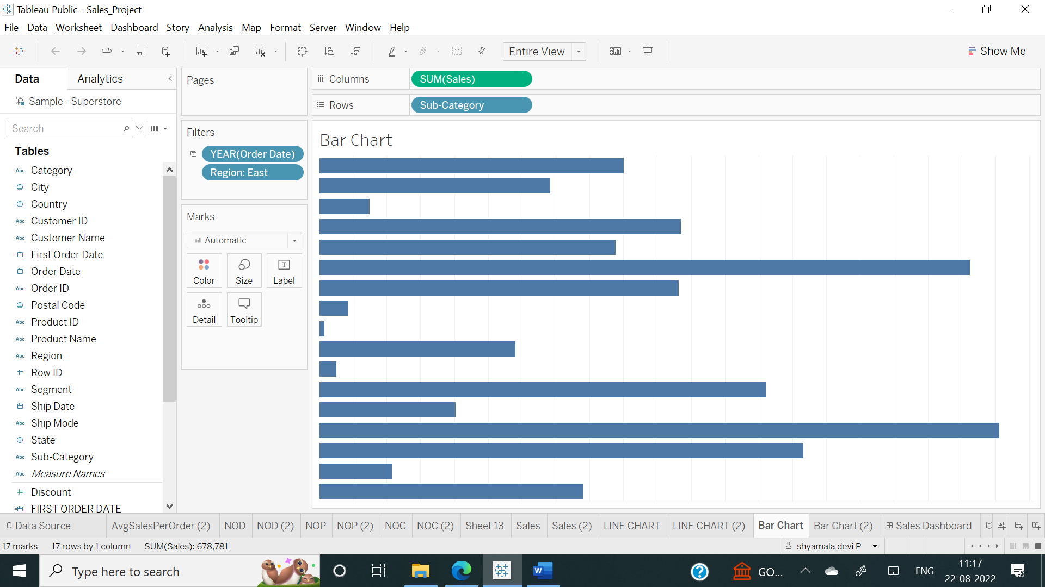

**Dasboard Screenshot:**

