Tagrem Test Results:

1.When browser is resized the website gracefully degrades from desktop down to mobile. I used media queries to implement this.

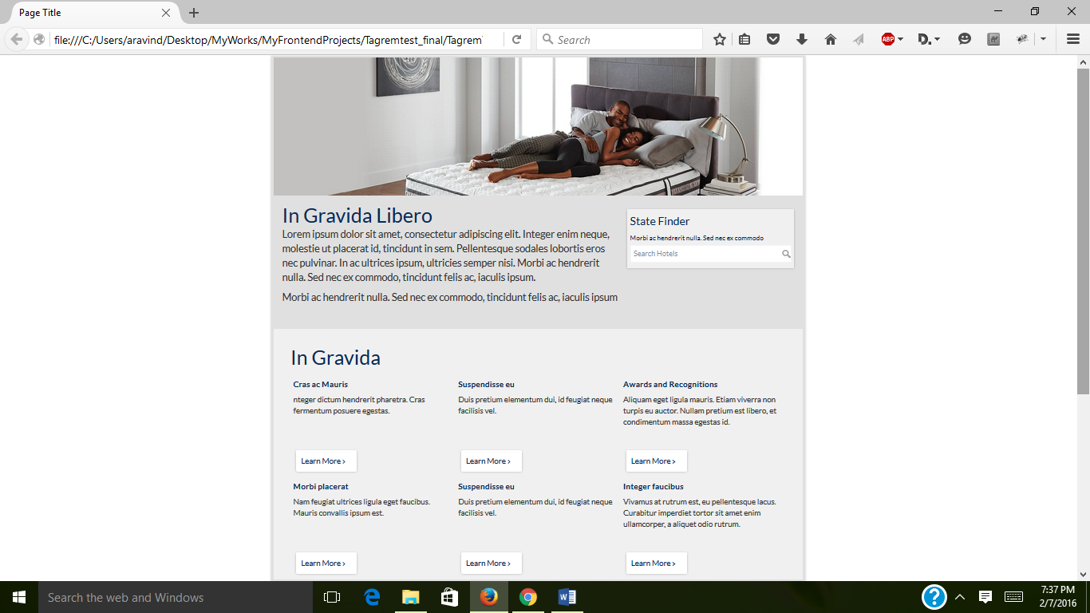

2. For filtering the products based on price I used json objects.

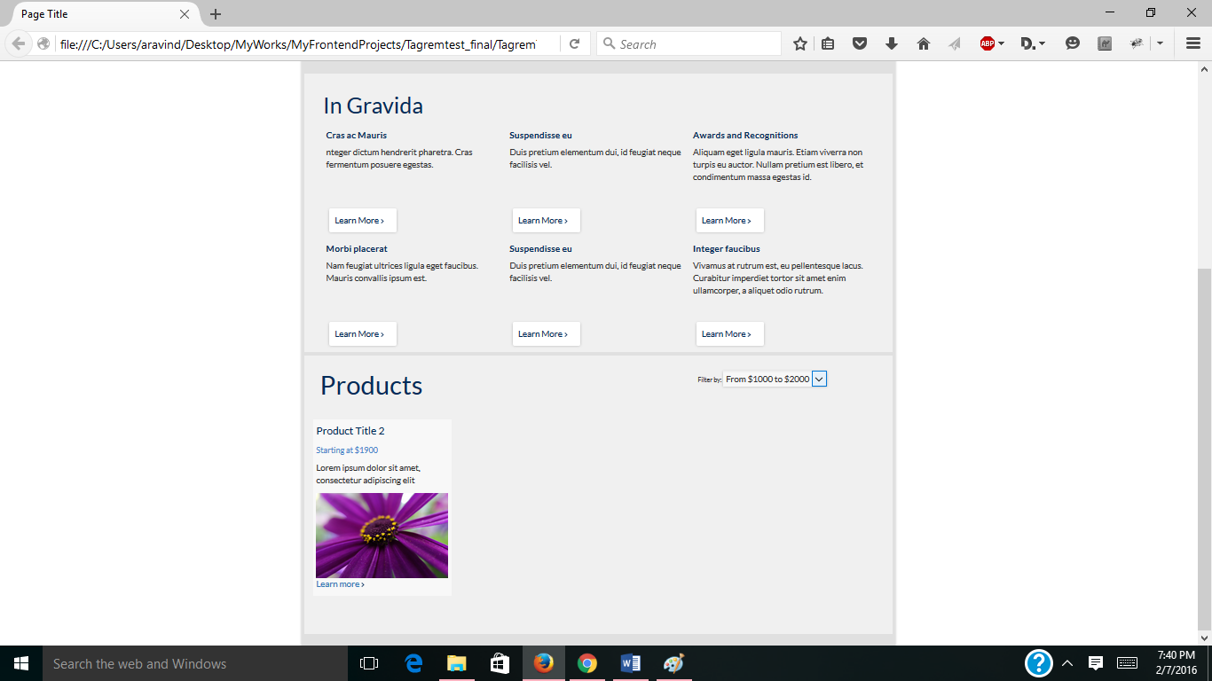

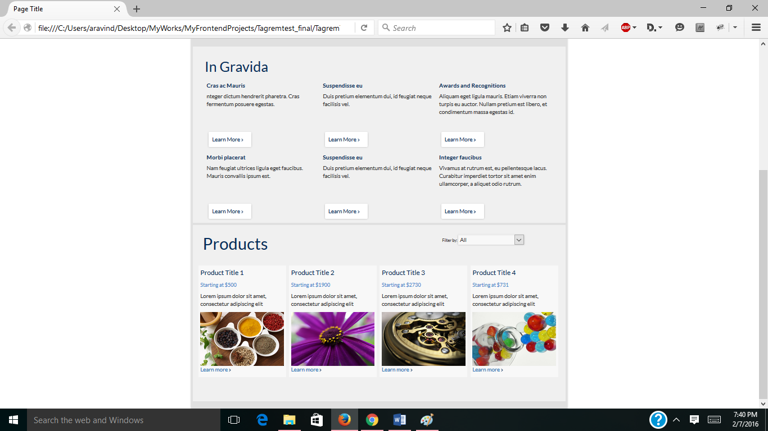

3. when I click on the product title or image it shows the respective product details. I used json objects to implement this.

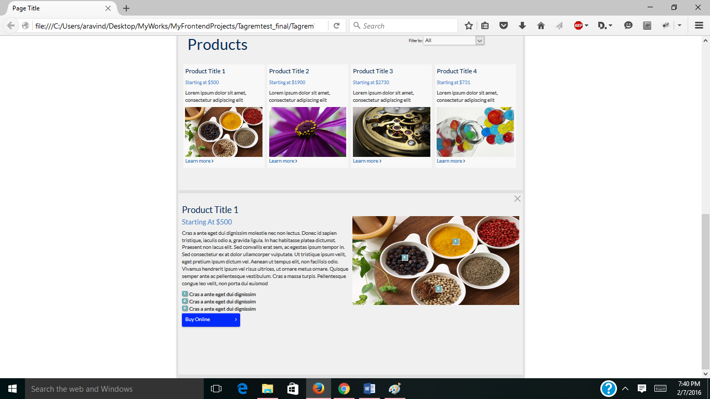

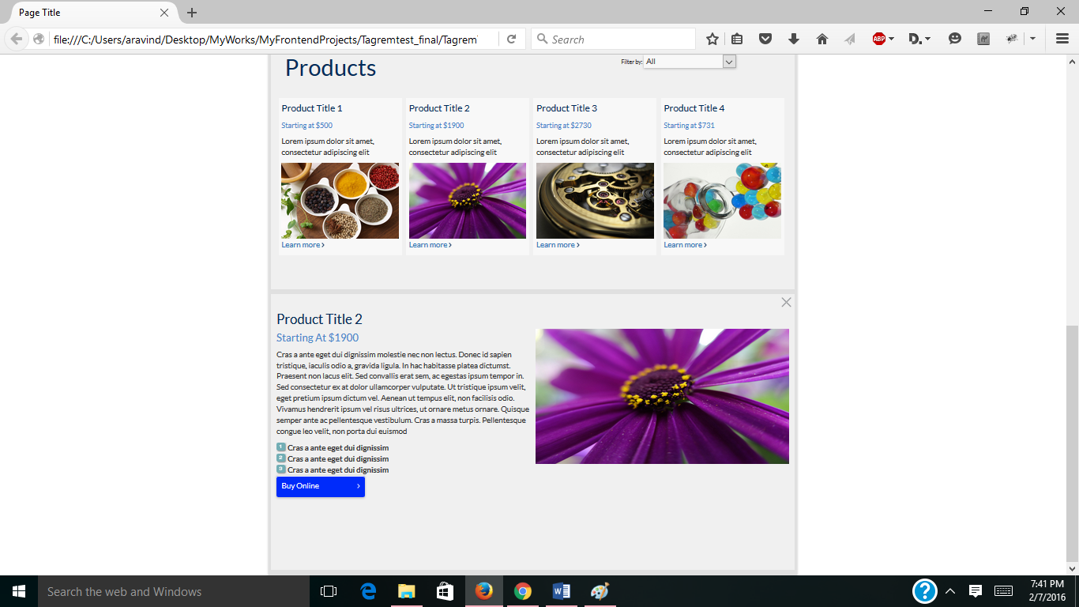

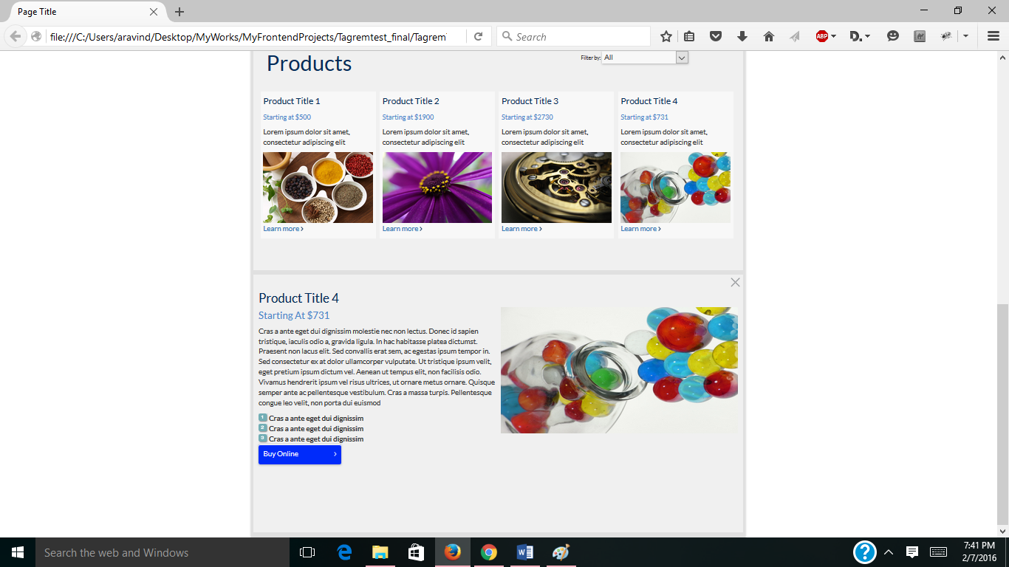

4.Landscape style responsive website:

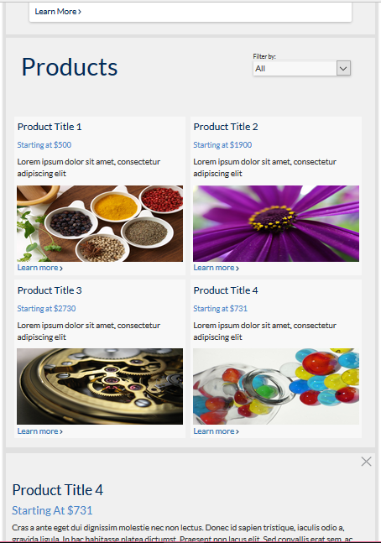

5.Mobile Portrait style

