Hotel Booking Analysis Dashboard
Project documentation
Prepared by : Shyamala Devi N
Tool : Microsoft Power BI Desktop
Dataset : hotel_bookings.csv
Source : Kaggle
1. Project overview
This project analyses hotel booking data for a City Hotel and a Resort Hotel in Power BI. It turns 119,390 booking records (87,389 after cleaning) into an interactive four-page dashboard called HotelStay, showing bookings, cancellations, revenue, booking channels and guest behaviour, and into a set of insights and recommendations for reducing cancellations and growing direct bookings.
2. Objectives
This project demonstrates end to end data cleaning, data modeling, DAX measure creation and dashboard design to analyze hotel booking and cancellation behaviour.
3. Dataset overview
Property | Detail
Dataset name | hotel_bookings.csv
Source | Kaggle
Hotels | City Hotel and Resort Hotel
Arrival period | July 2015 to August 2017
Total rows (raw) | 119,390
Total columns | 32
Rows after cleaning | 87,389
Key columns: hotel, is_canceled, lead_time, arrival date columns (year, month, week, day), stays_in_weekend_nights, stays_in_week_nights, adults, children, babies, meal, country, market_segment, distribution_channel, is_repeated_guest, deposit_type, customer_type, adr, reserved_room_type, assigned_room_type, total_of_special_requests and reservation_status.
Data type of each column:
Whole number (integer): is_canceled, lead_time, arrival_date_year, arrival_date_week_number, arrival_date_day_of_month, stays_in_weekend_nights, stays_in_week_nights, adults, children, babies, is_repeated_guest, previous_cancellations, previous_bookings_not_canceled, booking_changes, days_in_waiting_list, required_car_parking_spaces, total_of_special_requests
Decimal number: adr
Date: reservation_status_date
Text: hotel, arrival_date_month, meal, country, market_segment, distribution_channel, reserved_room_type, assigned_room_type, deposit_type, agent, company, customer_type, reservation_status
The dataset has 32 columns: 17 whole-number, 1 decimal, 1 date and 13 text columns.
4. Data cleaning and preparation (in Power Query)
Step | Action
Null check | Found missing values in company, agent, country and children. They were stored as the text NULL or NA in the file.
Removed columns | Removed unused columns such as company (94% empty).
Missing values | Replaced agent NULL with 0, country NULL with Unknown and children NA with 0, before changing data types.
Blank rows and duplicates | Removed blank rows and exact duplicate rows. This reduced the data from 119,390 to 87,389 rows.
Text cleaning | Trimmed and cleaned the text columns.
Data types | Set count columns to Whole Number, adr to a decimal type and reservation_status_date to Date.
Custom columns | Added TotalNights, TotalGuests, Revenue, Room Changed and Month Number.
Data observation | Undefined values in market_segment, distribution_channel and meal were kept as their own category.
After cleaning, the data was loaded into Power BI, DAX measures were written, and the four report pages were built and formatted.
5. Data model
The model has one table:
- Hotel bookings: a single flat table with one row per booking.
No separate calendar table was used, because the dataset already has arrival year and month columns. Month is sorted by Month Number so months appear in calendar order.
6. DAX measures
Core measures
Total Bookings = COUNTROWS(hotel_bookings)
Confirmed Bookings = CALCULATE([Total Bookings], hotel_bookings[is_canceled] = 0)
Cancelled Bookings = CALCULATE([Total Bookings], hotel_bookings[is_canceled] = 1)
Cancellation Rate = DIVIDE([Cancelled Bookings], [Total Bookings])
Total Revenue = SUM(hotel_bookings[Revenue])
Avg Lead Time = AVERAGE(hotel_bookings[lead_time])
ADR NIGHT = DIVIDE([Total Revenue], [Room Nights Sold])
Avg Special Requests = AVERAGE(hotel_bookings[total_of_special_requests])
Revenue per Booking = DIVIDE([Total Revenue], [Confirmed Bookings])

Guest and stay measures
Total Guests = CALCULATE(SUM(hotel_bookings[TotalGuests]), hotel_bookings[is_canceled] = 0)
Avg Stay = CALCULATE(AVERAGE(hotel_bookings[TotalNights]), hotel_bookings[is_canceled] = 0)
Avg ADR = CALCULATE(AVERAGE(hotel_bookings[adr]), hotel_bookings[is_canceled] = 0)
Repeat Guests = CALCULATE([Total Bookings], hotel_bookings[is_repeated_guest] = 1)
Repeat Guest % = DIVIDE(CALCULATE([Total Bookings], hotel_bookings[is_repeated_guest] = 1), [Total Bookings])
Room Change % = DIVIDE(CALCULATE ([Total Bookings], hotel_bookings[Room Changed] = "Yes" ), [Total Bookings])
Room Nights Sold = CALCULATE(SUM (hotel_bookings[TotalNights]),
hotel_bookings[is_canceled] = 0)

Calculated columns (Power Query custom columns)
TotalNights = [stays_in_weekend_nights] + [stays_in_week_nights]
TotalGuests = [adults] + [children] + [babies]
Revenue = if [is_canceled] = 1 then 0 else [adr] * [TotalNights]
Room Changed = if [reserved_room_type] <> [assigned_room_type] then "Yes" else "No"
Month Number = List.PositionOf({"January","February","March","April","May","June","July","August","September","October",
"November","December"}, [arrival_date_month]) + 1
Revenue is an estimate (price per night multiplied by nights stayed, for bookings that were not cancelled), not actual payments.

7. Dashboard structure
Visual types used: KPI cards, clustered column and bar charts, a column and line combo chart, line chart, donut charts, table, slicers and page navigation buttons.
Page | Focus | Main visuals
Page 1 | Overview | Five KPI cards (Bookings, Revenue, Avg ADR, Cancellation rate, Avg stay), bookings by month, hotel shares donut, revenue by year, top 10 countries
Page 2 | Booking Analysis | Three KPI cards (Bookings, Guests, confirmed bookings), booking by hotel trend, bookings by market segment, hotel summary table
Page 3 | Cancellation Analysis | Cancellation rate and cancelled bookings cards, cancellation rate by deposit, customer type, market segment and hotel
Page 4 | Guest Analysis | Three KPI cards (Guests, Repeat guest, Avg stay), bookings by distribution channel, room allocation donut, bookings by meal
Slicers: Hotel and Year on every page.
Every page has the HotelStay name, the same left navigation panel, KPI cards and slicers, but each page uses its own colour theme: green and cream for Overview, rose for Booking Analysis, navy and cyan for Cancellation Analysis, and orange and brown for Guest Analysis.

8. Dashboard report
The four report pages are shown below with a short reading of each one. The figures come from the dashboard as built.
8.1 Page 1 - Overview
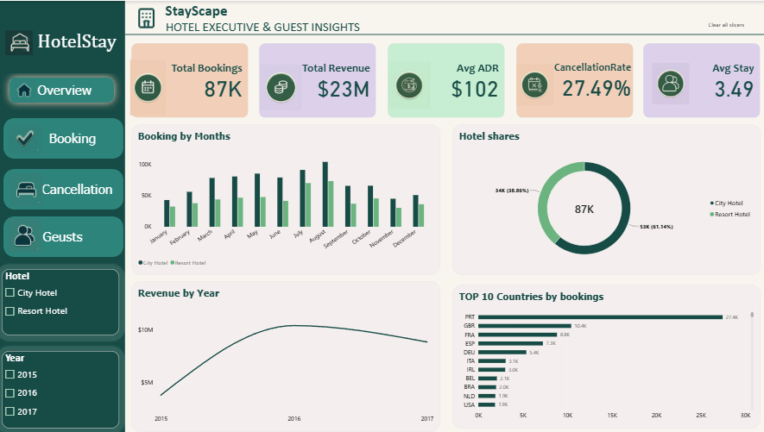
- KPIs: 87K bookings, $23M revenue, $102 average daily rate, 27.49% cancellation rate and an average stay of 3.49 nights.
- Hotel shares: City Hotel has 53K bookings (61.14%) and Resort Hotel has 34K (38.86%).
- Bookings by month: bookings peak in August at both hotels, with City Hotel higher than Resort Hotel every month.
- Revenue by year: revenue rises from 2015 to 2016 and dips slightly in 2017. 2015 and 2017 are partial years, so the yearly comparison is not like for like.
- Top 10 countries: Portugal (PRT) leads with 27.4K bookings, followed by the UK (10.4K), France (8.8K), Spain (7.3K) and Germany (5.4K).
8.2 Page 2 - Booking Analysis
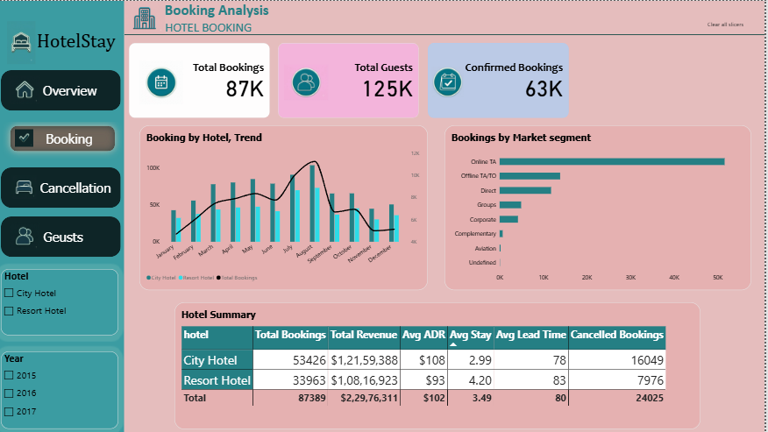
- KPIs: 87K total bookings, 125K guests and 63K confirmed bookings.
- Booking by hotel trend: columns show each hotel by month and the line shows total bookings, peaking in August.
- Market segment: Online TA is by far the largest segment (about 52K bookings), followed by Offline TA/TO (about 14K) and Direct (about 12K).
- Hotel summary: the table below compares the two hotels.
Hotel | Total Bookings | Total Revenue | Avg ADR | Avg Stay | Avg Lead Time | Cancelled Bookings
City Hotel | 53,426 | $12,159,388 | $108 | 2.99 | 78 | 16,049
Resort Hotel | 33,963 | $10,816,923 | $93 | 4.20 | 83 | 7,976
Total | 87,389 | $22,976,311 | $102 | 3.49 | 80 | 24,025
8.3 Page 3 - Cancellation Analysis
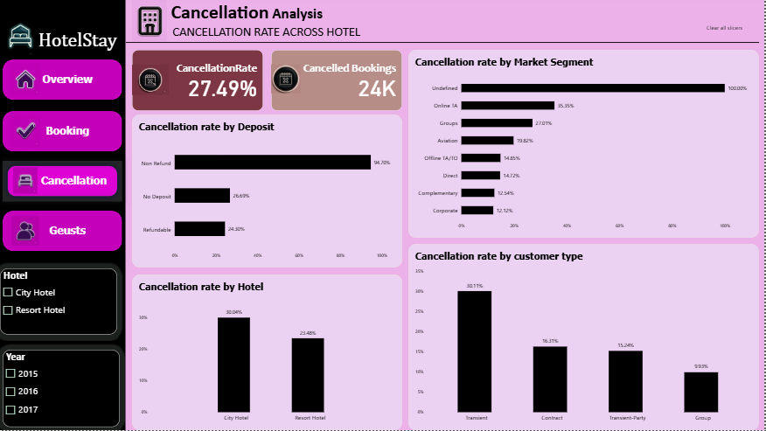
- KPIs: a 27.49% cancellation rate, with about 24K cancelled bookings.
- By deposit type: Non Refund shows 94.70%, No Deposit 26.69% and Refundable 24.30%. The Non Refund figure is unusually high and needs checking before any conclusion is drawn.
- By customer type: Transient guests cancel most (30.11%), then Contract (16.31%), Transient-Party (15.24%) and Group (9.93%).
- By hotel: City Hotel cancels 30.04% of bookings against 23.48% for Resort Hotel.
- By market segment: Online TA is highest among the large segments (35.35%), then Groups (27.81%), Aviation (19.82%), Offline TA/TO (14.85%), Direct (14.72%), Complementary (12.54%) and Corporate (12.12%). The Undefined segment shows 100% but covers only a tiny number of bookings.
8.4 Page 4 - Guest Analysis
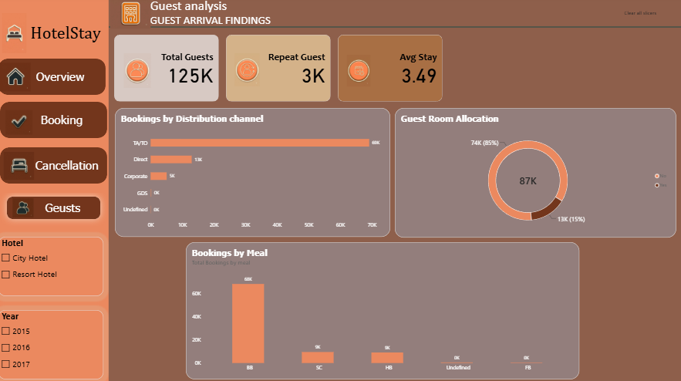
- KPIs: 125K guests, about 3K repeat guest bookings and an average stay of 3.49 nights.
- Distribution channel: TA/TO dominates with about 69K bookings, followed by Direct (about 13K) and Corporate (about 5K).
- Room Allocation: 85% of bookings (74K) kept the reserved room, while 15% (13K) were given a different room.
- Meal plan: BB is by far the most common, at about 67K bookings, followed by SC and HB at roughly 10K each. FB is rare.
9. Key findings and insights
Summary of insights
- After cleaning there are 87,389 bookings, and 27.49% of them (24,025) were cancelled. About 63K bookings were confirmed, with estimated revenue of about $22.98M.
- City Hotel receives 61.14% of bookings and earns the higher ADR ($108 against $93), but it cancels more (30.04%) than Resort Hotel (23.48%). Resort guests stay longer, 4.20 nights against 2.99.
- Bookings peak in August at both hotels.
- Online TA is the largest booking segment (about 52K) and cancels 35.35% of its bookings, while Direct bookings cancel only 14.72%. By distribution channel, TA/TO brings about 69K of the bookings.
- Non-Refund deposits show a 94.70% cancellation rate. This is unusual and comes from a small group of bookings, so it needs checking.
- Transient guests cancel most (30.11%), and Group bookings cancel least (9.93%).
- Repeat guests are only about 3K bookings, a very small share of the total.
- Portugal is the largest source market with 27.4K bookings, followed by the UK, France, Spain and Germany. About 15% of bookings are given a different room from the one reserved, and BB is the most common meal plan.
10. Recommendations
- Grow direct bookings with member rates or a booking-website discount, since they cancel far less than agent bookings.
- Reduce cancellation risk on Online TA bookings with reminders and clear deposit terms, especially for bookings made far in advance.
- Check the non-refundable deposit data before acting on it, because its very high cancellation rate comes from a small group of bookings.
- Create a loyalty offer for returning guests, who are rare in the data.
- Promote longer-stay packages at City Hotel, where the average stay is shorter.
- Plan staffing and stock for the summer peak, especially August.
- Review room assignments, because about 1 in 7 bookings gets a different room from the one reserved.
11. Tools used
- Microsoft Power BI Desktop (Power Query, DAX, data modeling, report design)
- Kaggle (data source)
12. Conclusion and future scope
This project demonstrates a complete Power BI workflow, from raw data validation and cleaning to DAX-driven KPIs and an interactive, filterable dashboard.
The dashboard shows two hotels with different guest patterns, where cancellations are driven by booking channel and guest type rather than by volume. Reducing agent-driven cancellations and encouraging direct and repeat bookings has more upside than adding more bookings.

