**MongoDB**

**For the following question write the corresponding MongoDB queries:**

* Find all the information about each products
* Find the product price which are between 400 to 800
* Find the product price which are not between 400 to 600
* List the four product which are greater than 500 in price
* Find the product name and product material of each products
* Find the product with a row id of 10
* Find only the product name and product material
* Find all products which contain the value of soft in product material
* Find products which contain product color indigo  and product price 492.00
* Delete the products which product price value are 28

**Queries:**

* db.product.find()
* db.product.find({product_price:{$gte:400,$lte:800}})
* db.product.find({product_price:{$not:{$gte:400,$lte:600}}})
* db.product.aggregate([{$match:{product_price:{$gt:400}}}

,{$limit:4}])

* db.product.find({$and:[{id:"10"}]})
* db.product.find({$and:[{product_material:"Soft"}]})
* db.product.find({$and:[{product_color:"indigo"},{product_price:492.

00}]})

**sample output:**

* db.product.find()



* db.product.find({product_price:{$gte:400,$lte:800}})



* db.product.find({product_price:{$not:{$gte:400,$lte:600}}})



* db.product.aggregate([{$match:{product_price:{$gt:400}}} ,{$limit:4}])

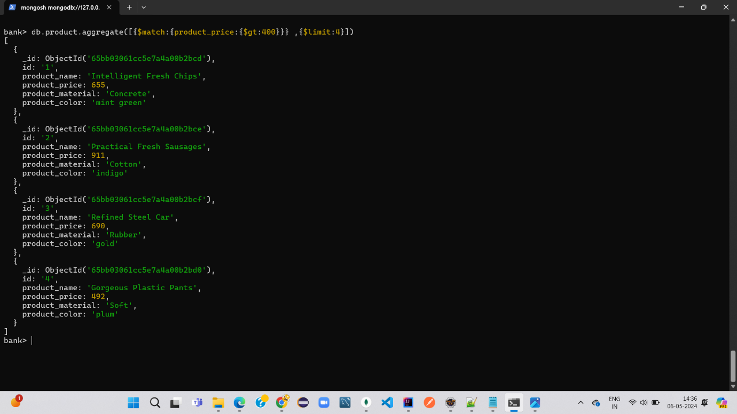

* db.product.find({$and:[{id:"10"}]})



* db.product.find({$and:[{product_material:"Soft"}]})



* db.product.find({$and:[{product_color:"indigo"},{product_price:492.00}]})

