

**Department of Computer Engineering**

**Course: DWMM**

**Mini-Project - Phase 2 Report**

**Guidance By - Kumavat Mam**

**Topic: Design Multidimensional Model for Dairy Management System**

**By**

|  |  |  |
| --- | --- | --- |
| **Roll No** | **SRN** | **Name of Student** |
| 38 | 202200930 | Shyamal S. Patil |
| 39 | 202200931 | M. Asad Shaikh |

**Index**

|  |  |  |
| --- | --- | --- |
| **SNO** | **Topic** | **Page No** |
| **1** | **Multidimensional Modal** | **3** |
| **2** | **Objective** | **5** |
| **3** | **Model Description** | **6** |
| **4** | **Outcome** | **6** |

**Design MD Model:**

In our Dairy Management System project, the multidimensional model is primarily represented by a star schema, consisting of a central fact table (e.g., Sales_Dim) and multiple dimension tables (e.g., Customer_Dim, Product_Dim, Time_Dim, Location_Dim, and Supplier_Dim).

The central fact table, Sales_Dim, serves as the core repository for sales transactions, capturing information related to product sales. This fact table is surrounded by dimension tables, including Customer_Dim, Product_Dim, Time_Dim, Location_Dim, and Supplier_Dim, which provide additional context and details for in-depth analysis and reporting. These dimension tables facilitate a comprehensive view of customer behavior, product performance, time-based trends, geographical aspects, and supplier information within the dairy management system. This star schema design enhances our ability to derive meaningful insights and make informed decisions regarding dairy product sales, distribution, and customer engagement.

**PTO**

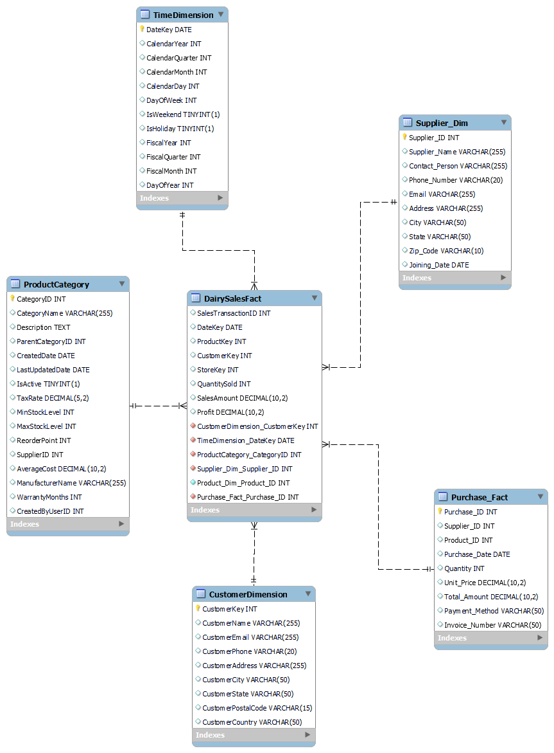

**Objective:**

**1. Structure and Organization:**

The multidimensional model, specifically the star schema, organizes data in a well-structured manner. The fact table (Sales_Dim) is positioned at the core of the structure, with dimension tables (Customer_Dim, Product_Dim, Time_Dim, Location_Dim, and Supplier_Dim) providing essential context. This structured organization enhances the clarity and accessibility of the data within our Dairy Management System.

**2. Optimized Storage:**

Our model optimizes data storage by eliminating redundancy. Dimension tables store common attributes, preventing repetitive data storage. This optimized structure not only conserves storage space but also ensures data integrity and consistency.

**3. Efficient Retrieval:**

The star schema's design significantly improves data retrieval efficiency. It minimizes the need for complex joins, allowing for swift and efficient data access. This streamlined approach enhances the speed of query execution.

**4. Data Processing:**

The multidimensional model simplifies data processing by reducing query complexity. It accommodates aggregation, transformations, and advanced analytical operations, facilitating effective data processing for various dairy management tasks.

**5. Meaningful Insights:**

Our model is tailored to extract meaningful insights from dairy-related data. By structuring information around key dimensions and the central Sales_Dim table, it enables the analysis of sales trends, customer preferences, product performance, supplier relationships, and other critical factors within our Dairy Management System.

**6. Decision-Making:**

The structured data provided by the multidimensional model empowers data-driven decision-making within our Dairy Management System. It supports the generation of comprehensive reports and visualizations, aiding in informed decision-making regarding inventory management, sales strategies, and overall system optimization.

**Model Description:**

**1. Appropriate Data Model:**

The multidimensional model, specifically the star schema in your project, represents an appropriate data model for analytical purposes. It is designed to efficiently store and organize data by separating facts (Sales_Fact) from dimensions (Customer_Dim, Product_Dim, Time_Dim, Location_Dim, and Product_Category_Dim). This structure is ideal for handling complex analytical queries.

**2. Relationships:**

The relationships between the central fact table and dimension tables are well-defined in the star schema. The fact table is linked to dimension tables through foreign keys, establishing relationships that allow for data integration. These relationships facilitate data analysis from multiple perspectives, supporting a wide range of queries.

**Outcome:**

**1. Understanding Database Modeling:**

The multidimensional model within our Dairy Management System serves as a real-world illustration of database modeling. It effectively embodies the concept of structuring data for analytical purposes through the utilization of a star schema. This model prominently features a central fact table (Sales_Dim) intricately linked to dimension tables (Customer_Dim, Product_Dim, Time_Dim, Location_Dim, and Supplier_Dim). The structure exemplifies a prevalent approach to database modeling tailored for analytical and business intelligence requirements, reinforcing the fundamental principles of data organization.

**2. Practical Exposure to Optimizing Database Performance:**

Our Dairy Management System project's multidimensional model offers hands-on experience in optimizing database performance. By engaging with this model, you gain practical insights into the techniques for enhancing query performance. This encompasses the utilization of appropriate indexing, partitioning strategies, and other optimization practices aimed at improving the efficiency of analytical queries, data aggregation, and data transformation operations. This experience not only enriches your understanding of database performance but equips you with valuable skills for enhancing the operational efficiency of data-driven dairy management.