AIRNOVA
An industrial mini project report submitted in partial fulfillment of the requirements for the award of the degree of
Bachelor of Technology
In
Computer Science and Engineering

By
SHYAMA VASA (23011P0529)
SHRAVYA VASA (23011P0526)
V.SANDHYA (23011P0516)

Under The Guidance of
Dr. I.LAKSHMI MANIKYAMBA
Professor

Department of Computer Science and Engineering,
JNTUH University College of Engineering, Science &Technology Hyderabad
Kukatpally, Hyderabad - 500 085.
2025-26
Department of Computer Science and Engineering,
JNTUH University College of Engineering, Science &Technology Hyderabad
Kukatpally, Hyderabad - 500 085
2025-26

DECLARATION BY THE CANDIDATE
We, Shyama Vasa (23011P0529) ,Shravya Vasa (23011P0526), V.Sandhya(23011P0516), hereby declare that the Industrial mini project report entitled "AIRNOVA", carried out by us under the guidance of Dr. I.Lakshmi Manikyamba, is submitted in partial fulfillment of the requirements for the award of the degree of Bachelor of Technology in Computer Science and Engineering. This is a record of bonafide work carried out by us and the results embodied in this project have not been reproduced/copied from any source. Whenever we have used materials (data, theoretical analysis, figures, and text) from other sources, we have given due credit to them by citing them in the text of the report and giving their details in the references. The results embodied in the project have not been submitted to any other University or Institute for the award of any other Degree or Diploma.
SHYAMA VASA
Roll No. :23011P0529
SHRAVYA VASA
Roll No. :23011P0526
V.SANDHYA
Roll No. : 23011P0516
Date:

Department of Computer Science and Engineering,
JNTUH University College of Engineering, Science &Technology Hyderabad
Kukatpally, Hyderabad - 500 085.


CERTIFICATE BY THE SUPERVISOR
This is to certify that the project report entitled "AIRNOVA", being submitted by Shyama Vasa (23011P0529) ,Shravya Vasa (23011P0526), V.Sandhya(23011P0516), in partial fulfillment of the requirements for the award of the degree of Bachelor of Technology in Computer Science and Engineering, is a record of bonafide work carried out by them.
The results of investigation enclosed in this report have been verified and found satisfactory.
The results embodied in the project have not been submitted to any other University or Institute for the award of any other Degree or Diploma.
Dr. I. LAKSHMI MANIKYAMBA
Professor

Date:

Department of Computer Science and Engineering,
JNTUH University College of Engineering, Science &Technology Hyderabad
Kukatpally, Hyderabad - 500 085.


CERTIFICATE BY THE HEAD OF THE DEPARTMENT
This is to certify that the project report entitled "AIRNOVA", being submitted by Shyama Vasa (23011P0529) ,Shravya Vasa (23011P0526), V.Sandhya(23011P0516), in partial fulfillment of the requirements for the award of the degree of Bachelor of Technology in Computer Science and Engineering is a record of bonafide work carried out by them.

Dr. K.SANTHI SREE
Professor and Head of the Department
CSE

Date:

ACKNOWLEDGEMENT
We wish to extend our sincere gratitude to our supervisor, Dr. I.Lakshmi Manikyamba , Professor, Department of Computer Science and Engineering, for being a driving force all through the way. This project would not be so smooth and so interesting without her encouragement.
We wish to express our gratitude to Dr. K.SANTHI SREE, Professor and Head of the Department of Computer Science and Engineering for providing necessary computing facilities.
We are indebted to the Department of Computer Science and Engineering, JNTUH for providing us with all the required facilities to carry our work in a congenial environment. We also extend our gratitude to the department staff for providing necessary support from time to time whenever requested.
Above all, we are grateful to our parents and friends for their patience and continuous supply of inspirations and suggestions for our ever-growing performance.
SHYAMA VASA
Roll No. :23011P0529
SHRAVYA VASA
Roll No. :23011P0526
V.SANDHYA
Roll No. : 23011P0516

ABSTRACT
Rapid urbanization, industrial growth, and increased vehicular emissions have significantly degraded air quality in major cities, posing serious health risks. Most existing air quality monitoring systems focus on real-time Air Quality Index (AQI) reporting and lack reliable mechanisms to forecast sudden pollution spikes. This project proposes a machine learning–based air quality forecasting system to predict AQI levels 24–48 hours in advance using historical pollutant data. The system uses city-wise historical data for key pollutants such as PM2.5, PM10, NO₂, SO₂, CO, and O₃, along with time-based features including day, month, season, and weekend indicators. Lag features and rolling statistics are incorporated to capture temporal dependencies. Time series models such as ARIMA and SARIMA are applied to analyze long-term and seasonal trends, serving as baseline predictors. A Random Forest regression model is then trained on enriched time-series data to improve forecasting accuracy. The proposed system enables early identification of pollution spikes and potential hotspots. Interactive dashboards visualize AQI trends, pollutant contributions, and short-term forecasts, supporting proactive decision-making for pollution control and public health management.

INDEX
Chapter No. | Title | Page No.
1 | INTRODUCTION | 1
1.1 | Motivation | 2
1.2 | Problem Definition | 3
1.3 | Report Organization | 4
2 | LITERATURE SURVEY
2.1 | Air Quality Monitoring Systems | 5
2.2 | Time Series Forecasting Techniques | 5
2.3 | Machine Learning Approaches for AQI Prediction | 5
2.4 | Visualisation and Decision Support Systems | 6
3 | RELATED WORK | 7
4 | DESIGN
4.1 | Overall Structure | 8
4.2 | System Architecture | 12
4.3 | Data Collection and Preprocessing | 13
4.4 | AQI Forecasting Module | 15
4.5 | Visualization Dashboard | 16
5. | IMPLEMENTATION | 18
5.1 | Development Environment | 18
5.2 | Dataset Preparation | 19
5.3 | Feature Engineering Implementation | 20
5.4 | Model Training and Forecasting | 22
5.5 | Visualization Dashboard Implementation | 25
5.6 | System Output | 26
6 | PERFORMANCE ANALYSIS
6.1 | Model Evaluation | 27
6.2 | Evaluation metrics | 27
6.3 | Comparative Analysis | 29
6.4 | Result Analysis | 29
7 | RESULTS
7.1 | Model Accuracy | 30
7.2 | User Dashboard | 31
7.3 | Admin Dashboard | 33
8 | CONCLUSION
8.1 | Work Carried Out | 34
8.2 | Future Scope | 35

LIST OF FIGURES
S.No | Figure No. | Caption | Page No.
1 | 4.1 | System Architecture | 12
2 | 7.1 | Random Forest | 30
3 | 7.2 | Arima | 30
4 | 7.3 | Sarima | 31
5 | 7.4 | Airnova User Dashboard | 31
6 | 7.5 | Live Pollutant Snapshot | 32
7 | 7.6 | AQI Forecast and City Comparison Dashboard | 32
8 | 7.7 | Admin Dashboard- Real Time Monitoring | 33
9 | 7.8 | Admin Dashboard- Forecast and Controls | 33

1. INTRODUCTION
Air pollution has emerged as one of the most critical environmental and public health challenges in modern urban societies. Rapid industrialization, population growth, urban expansion, and the increasing number of vehicles have contributed significantly to the deterioration of air quality across major cities. Pollutants such as particulate matter (PM2.5 and PM10), nitrogen dioxide (NO₂), sulfur dioxide (SO₂), carbon monoxide (CO), and ozone (O₃) are continuously released into the atmosphere from industrial activities, transportation systems, construction work, and fossil fuel combustion. Prolonged exposure to these pollutants can lead to severe respiratory diseases, cardiovascular disorders, reduced lung function, and other long-term health complications.
To monitor pollution levels, many cities rely on the Air Quality Index (AQI), which provides a simplified representation of air quality conditions based on pollutant concentrations. Although existing monitoring systems effectively display current AQI values, most of them are limited to real-time reporting and fail to provide accurate early warnings about upcoming pollution spikes. Since air quality is influenced by temporal, seasonal, and environmental factors, forecasting future AQI levels has become essential for effective pollution management and public safety.
Advancements in Machine Learning (ML) and Time Series Analysis have created new opportunities for developing intelligent air quality forecasting systems. By analyzing historical pollutant patterns and temporal trends, predictive models can estimate future AQI levels with improved accuracy. Forecasting enables government agencies, environmental authorities, healthcare organizations, and the public to take preventive actions before pollution reaches hazardous levels.
The proposed project, Airnova, is a machine learning–based air quality forecasting system designed to predict AQI levels 24–48 hours in advance. The system utilizes historical city-wise pollutant data including PM2.5, PM10, NO₂, SO₂, CO, and O₃ along with time-related features such as day, month, season, and weekend indicators. To capture temporal dependencies and seasonal variations, lag features and rolling statistical measures are incorporated into the dataset.
The project applies traditional time series forecasting techniques such as ARIMA and SARIMA to analyze trends and seasonal behavior in AQI data. These models act as baseline forecasting approaches. To further improve prediction performance, a Random Forest Regression model is trained on enriched time-series features, enabling the system to identify complex nonlinear relationships between pollutants and AQI levels.
In addition to forecasting, the system provides interactive dashboards for visualizing AQI trends, pollutant distributions, and short-term predictions. These visual analytics assist users in understanding pollution patterns and identifying high-risk periods or potential hotspots. By enabling early detection of pollution spikes, Airnova aims to support proactive environmental management, improve public awareness, and contribute to healthier and smarter urban living.
1.1 Motivation
The increasing deterioration of air quality in urban and industrial regions has become a major global concern. Rapid urbanization, industrial emissions, vehicular pollution, and excessive use of fossil fuels have led to a significant rise in harmful air pollutants. As pollution levels continue to increase, people are facing severe health issues such as asthma, respiratory infections, lung diseases, cardiovascular problems, and reduced overall quality of life. According to environmental and health studies, prolonged exposure to polluted air is one of the leading causes of premature deaths worldwide.
Although many cities have implemented air quality monitoring systems, most existing systems mainly provide real-time AQI information without offering reliable future predictions. Real-time monitoring alone is not sufficient because pollution levels can change rapidly due to traffic congestion, industrial activities, weather conditions, and seasonal variations. Without early warning mechanisms, authorities and citizens often fail to take preventive measures before pollution reaches hazardous levels.
The motivation behind developing Airnova is to create an intelligent forecasting system capable of predicting future AQI levels in advance. Predictive analysis allows environmental agencies, healthcare organizations, and the public to prepare for upcoming pollution spikes and reduce their impact. Early AQI forecasting can help governments implement traffic restrictions, regulate industrial emissions, and issue public health advisories before air quality becomes dangerous.
Another major motivation for this project is the growing availability of environmental data and advancements in Machine Learning and Time Series Analysis. Modern predictive algorithms can analyze historical pollutant trends, seasonal variations, and temporal dependencies to generate more accurate forecasts than traditional monitoring approaches. Integrating machine learning techniques with air quality analysis can improve forecasting efficiency and support data-driven environmental management.
The project is also motivated by the need for accessible and user-friendly visualization tools. Interactive dashboards and graphical representations of AQI trends can help users better understand pollution patterns and pollutant contributions. Such visual insights are valuable for researchers, policymakers, healthcare professionals, and ordinary citizens who need timely and understandable air quality information.
Overall, the motivation of Airnova is to contribute toward smarter environmental monitoring, proactive pollution control, and improved public health by transforming historical pollution data into actionable future predictions.
1.2 Problem Definition
Air pollution has become a serious environmental and public health issue in many urban and industrial areas due to increasing vehicular emissions, industrial activities, construction work, and rapid urbanization. Harmful pollutants such as PM2.5, PM10, NO₂, SO₂, CO, and O₃ continuously affect air quality and pose significant risks to human health and the environment. Poor air quality can lead to respiratory diseases, cardiovascular disorders, reduced visibility, environmental degradation, and a decline in overall living conditions.
Existing air quality monitoring systems primarily focus on displaying current AQI values and pollutant concentrations in real time. While these systems provide awareness about present air conditions, they often fail to predict future pollution levels accurately. Sudden increases in pollution levels caused by traffic density, industrial emissions, weather conditions, or seasonal changes are difficult to identify in advance using traditional monitoring approaches. As a result, authorities and citizens may not receive sufficient time to take preventive actions before pollution reaches hazardous levels.
Another challenge is that air quality data contains complex temporal and seasonal patterns. Pollution levels vary depending on factors such as time of day, day of the week, climatic conditions, and seasonal trends. Conventional statistical methods alone may not effectively capture these nonlinear relationships and hidden dependencies within the data, leading to lower forecasting accuracy.
Therefore, there is a need for an intelligent and efficient air quality forecasting system that can analyze historical pollutant data, identify trends and temporal dependencies, and predict AQI levels for the upcoming 24–48 hours. Such a system should provide accurate forecasting, early warning capabilities, and clear visual insights to support proactive environmental management and public health protection.
The proposed system, Airnova, addresses this problem by integrating Time Series Analysis and Machine Learning techniques to forecast AQI levels using historical pollutant data and temporal features. The system also provides interactive dashboards for visualizing trends, pollutant contributions, and future air quality conditions, enabling better decision-making and pollution control strategies.
1.3 Report Organization
Chapter 2 reviews existing air quality monitoring systems, forecasting techniques, machine learning approaches, and visualization methods used for AQI prediction.
Chapter 3 discusses previous research works and existing systems related to AQI forecasting using statistical and machine learning models.
Chapter 4 explains the overall design, architecture, modules, and workflow of the proposed Airnova air quality forecasting system.
Chapter 5 describes the technologies, dataset preparation, feature engineering, model training, forecasting methods, and dashboard implementation used in the system.
Chapter 6 evaluates the performance of forecasting models using various evaluation metrics and comparative analysis techniques.
Chapter 7 presents the forecasting results, model accuracy, dashboard outputs, and visualization screenshots generated by the Airnova system.
Chapter 8 summarizes the work carried out, major outcomes of the project, and future enhancements for the Airnova system.

2. LITERATURE SURVEY
2.1 Air Quality Monitoring Systems
Air pollution has become a major environmental issue due to rapid urbanization, industrialization, and increasing vehicular emissions. These systems help environmental agencies and governments track pollution levels and issue health advisories when pollution becomes hazardous. Rapid urbanization, industrial emissions, and traffic congestion have increased the demand for efficient air quality monitoring and forecasting solutions. Traditional air quality monitoring systems are designed to collect pollutant data from sensors and display real-time Air Quality Index (AQI) values. These systems mainly monitor pollutants such as PM2.5, PM10, NO₂, SO₂, CO, and O₃. Although real-time monitoring creates awareness about current pollution conditions, most systems do not provide accurate future predictions or early warnings for sudden pollution spikes. Because of these limitations, researchers started exploring forecasting models capable of predicting air quality levels in advance.
2.2 Time Series Forecasting Techniques
Time series forecasting methods are widely used for predicting future AQI levels based on historical pollution data. One of the most commonly used techniques is the ARIMA (AutoRegressive Integrated Moving Average) model, which analyzes temporal dependencies and long-term trends in time-series data. Main features of ARIMA include using historical observations for prediction, effective for short-term forecasting, handling trend-based time-series data, Simple and widely adopted forecasting model. ARIMA performs effectively for stationary datasets but has limitations in handling seasonal variations.
To overcome this issue, the SARIMA (Seasonal ARIMA) model was introduced. SARIMA extends ARIMA by incorporating seasonal patterns into forecasting. It is useful for predicting air pollution trends that vary according to seasons, months, or climatic conditions. However, both ARIMA and SARIMA mainly focus on linear relationships and may not accurately model complex nonlinear pollution behavior.
2.3 Machine Learning Approaches for AQI Prediction
Machine Learning techniques have significantly improved air quality forecasting accuracy. Models such as Linear Regression, Decision Trees, Support Vector Machines (SVM), Random Forest, and XGBoost are commonly used for AQI prediction. Among these, Random Forest Regression is widely preferred because it can handle large datasets, reduce overfitting, and capture nonlinear relationships between pollutants and AQI levels.
Researchers have found that machine learning models provide better forecasting performance when combined with enriched features such as lag values, rolling averages, seasonal indicators, and pollutant interactions. These models are capable of identifying hidden patterns in historical pollution data and generating more reliable short-term AQI forecasts.
2.4 Visualization and Decision Support Systems
Modern air quality systems also include visualization dashboards to improve data understanding and decision-making. Graphs and interactive charts help users analyze AQI trends and pollutant behavior more effectively.
Visualization systems mainly provide:
- AQI trend analysis
- Pollutant contribution graphs
- Forecast visualization
- Early warning indications
From the literature survey, it is observed that combining Time Series Analysis with Machine Learning techniques improves forecasting accuracy and supports proactive pollution management. Therefore, the proposed Airnova system integrates ARIMA, SARIMA, and Random Forest models along with interactive dashboards for effective AQI forecasting and visualization.

3. RELATED WORK
Several researchers have developed air quality monitoring and forecasting systems using statistical and machine learning techniques. Existing studies mainly focus on predicting AQI levels using historical pollutant data and environmental parameters.
Many research works have applied ARIMA and SARIMA models for short-term air quality forecasting. These models effectively analyze temporal and seasonal patterns in pollution data and provide reliable baseline predictions. However, their performance decreases when handling nonlinear relationships and rapidly changing pollution conditions.
Researchers have also explored machine learning techniques such as Linear Regression, Support Vector Machines (SVM), Decision Trees, Random Forest, and XGBoost for AQI prediction. Among these, Random Forest models showed improved prediction accuracy due to their ability to handle large datasets and nonlinear pollutant interactions.
Recent studies introduced deep learning models such as LSTM and GRU networks for forecasting air pollution levels. These models achieved high accuracy in sequential data prediction but required large training datasets, high computational resources, and longer training time.
Some existing systems also include visualization dashboards that display AQI trends, pollutant distributions, and forecast results through graphs and charts. Although these systems improve user understanding, many of them focus only on monitoring and lack efficient short-term forecasting capabilities.
Based on the observations from existing research works, the proposed Airnova system combines Time Series Analysis and Machine Learning techniques to improve AQI forecasting accuracy and provide better visualization support for proactive pollution management.

4. DESIGN
The design of the proposed Airnova Air Quality Forecasting System focuses on providing an efficient, scalable, and user-friendly platform for analyzing historical air pollution data and forecasting future Air Quality Index (AQI) levels. The system integrates Machine Learning, Time Series Analysis, and Data Visualization techniques to support intelligent air quality monitoring and prediction.
The primary objective of the system design is to enable users to:
- Analyze historical pollution trends
- Forecast AQI values for the next 24–48 hours
- Detect possible pollution spikes
- Visualize pollutant behavior through interactive dashboards
The overall design mainly consists of two major components:
- AQI Forecasting Engine
- Visualization Dashboard
The forecasting engine processes historical pollution data and generates AQI predictions using advanced forecasting models, while the dashboard provides graphical representation and analysis of current and predicted air quality conditions.
The system is designed to support proactive environmental monitoring and assist environmental agencies, researchers, and public authorities in taking preventive measures against rising pollution levels.
4.1 Overall Structure
The Airnova system follows a structured workflow consisting of multiple functional modules and two primary user roles.
User Roles
1. Admin / Environmental Analysts
Administrators and environmental analysts are responsible for:
- Collecting historical air quality datasets
- Managing pollutant information
- Updating and validating datasets
- Monitoring forecasting performance
The collected dataset contains pollutant concentrations such as:
- PM2.5
- PM10
- NO₂
- SO₂
- CO
- O₃
Additional temporal and environmental information such as:
- Date
- Month
- Season
- Weather-related indicators
is also maintained for accurate forecasting analysis.
2. Public Users / Authorities
Public users and government authorities interact with the system through the visualization dashboard. They can:
- Monitor AQI trends
- Analyze pollutant contributions
- View future AQI forecasts
- Identify possible pollution hotspots
- Take preventive actions during high pollution periods
Functional Workflow
The system processes the collected data through multiple stages:
Data Collection
Historical pollutant and AQI data are collected from available datasets and monitoring stations.
Data Preprocessing
The collected data is cleaned and prepared by:
- Handling missing values
- Removing duplicate records
- Eliminating inconsistencies
- Formatting date and time attributes
Feature Engineering
Additional forecasting features are generated, including:
- Lag values
- Rolling averages
- Seasonal indicators
- Day and month features
These features help the system understand temporal pollution patterns more effectively.
Forecasting
Forecasting models such as:
- ARIMA
- SARIMA
- Random Forest Regression
are applied to analyze pollution behavior and predict future AQI values.
Visualization
The generated forecast results are displayed through an interactive dashboard for easy interpretation and analysis.
Major System Modules
The Airnova system is organized into four major modules:
1. Data Collection Module
Collects and stores historical pollutant and AQI data from datasets and monitoring sources.
2. Data Preprocessing & Feature Engineering Module
Cleans the collected data and generates forecasting features required for model training.
3. Forecasting Module
Implements ARIMA, SARIMA, and Random Forest Regression models for AQI prediction.
4. Visualization Dashboard Module
Displays AQI trends, pollutant analysis, and forecast results using graphs and charts.
The overall structure of the system supports:
- Intelligent pollution monitoring
- Early warning generation
- Accurate AQI forecasting
- Better environmental decision-making

4.2 System Architecture

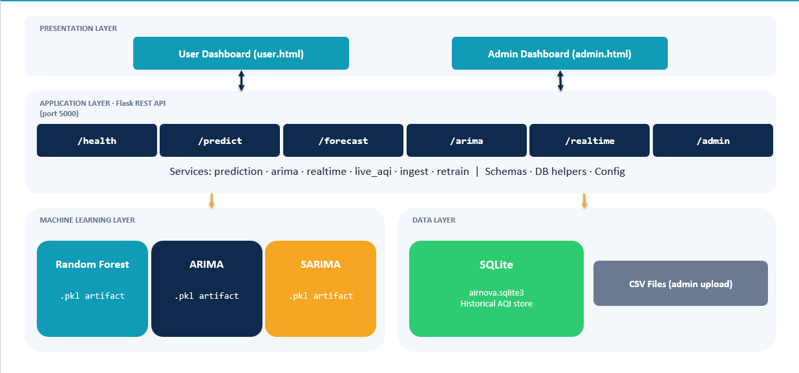
Fig 4.1: System Architecture
The architecture of the Airnova system defines the complete workflow involved in AQI forecasting and visualization.
The process begins with the collection of historical pollutant data from AQI datasets and monitoring stations. The collected data is stored in a centralized database for further processing.
The stored data then passes through the preprocessing stage where:
- Missing values are handled
- Duplicate records are removed
- Pollutant values are normalized
- Date and time information is formatted
After preprocessing, feature engineering techniques are applied to generate additional forecasting features such as lag values, rolling statistics, and seasonal indicators.
The processed data is then provided to forecasting models including:
- ARIMA
- SARIMA
- Random Forest Regression
These models analyze temporal pollution patterns and generate AQI forecasts for the next 24–48 hours.
Finally, the predicted AQI values and pollutant trends are displayed through an interactive dashboard that allows users to monitor and analyze air quality conditions effectively.
The architecture ensures:
- Efficient data flow
- Accurate forecasting
- Scalable processing
- User-friendly visualization
4.3 Data Collection and Preprocessing
The Airnova system relies on historical air pollution datasets for AQI forecasting. The collected data includes pollutant concentrations and date-time information required for time-series analysis.
Data Collection
The dataset contains important air pollutants such as:
- PM2.5
- PM10
- NO₂
- SO₂
- CO
- O₃
along with:
- Date and time information
- Seasonal information
- Environmental indicators
The collected data forms the foundation for training forecasting models.
Data Preprocessing
Raw environmental datasets often contain missing values, inconsistencies, and noisy information. Therefore, preprocessing is necessary to improve forecasting accuracy.
The preprocessing stage performs the following operations:
- Handling Missing Values
- Missing pollutant values are identified and replaced using suitable techniques.
- Removing Duplicate Records
- Duplicate entries are removed to avoid redundancy and incorrect forecasting results.
- Data Cleaning and Normalization
- Pollutant values are normalized and cleaned to maintain consistency across the dataset.
- Date-Time Conversion
- Date and time fields are converted into structured formats suitable for time-series forecasting.
- Dataset Preparation
The cleaned data is organized into structured datasets for machine learning model training.
Feature Engineering
Feature engineering improves forecasting accuracy by generating additional temporal and statistical features.
The generated features include:
- Lag values
- Rolling averages
- Seasonal indicators
- Day features
- Month features
These features help the forecasting models capture:
- Temporal dependencies
- Seasonal pollution behavior
- Trend variations
- Short-term AQI fluctuations
4.4 AQI Forecasting Module
The AQI Forecasting Module is the core component of the Airnova system. It uses Time Series Analysis and Machine Learning techniques to predict future AQI levels.
The forecasting process involves:
- Historical trend analysis
- Seasonal pattern detection
- Machine learning-based prediction
- AQI forecast generation
Forecasting Workflow
ARIMA and SARIMA Models
ARIMA and SARIMA models are used to analyze:
- Long-term trends
- Seasonal pollution patterns
- Temporal dependencies in AQI data
These models are effective for time-series forecasting where AQI values depend on historical observations.
Random Forest Regression
Random Forest Regression is implemented using enriched pollutant and temporal features.
The model:
- Handles nonlinear relationships
- Reduces overfitting
- Improves forecasting stability
- Enhances prediction accuracy
Forecasting Process
The forecasting module performs the following steps:
- Training ARIMA and SARIMA models
- Training the Random Forest Regression model
- Evaluating forecasting performance
- Predicting AQI values for the next 24–48 hours
The generated forecasts help identify possible pollution spikes before they occur.
4.5 Visualisation Dashboard
The Visualisation Dashboard provides an interactive interface for analysing AQI forecasts and pollution trends.
The dashboard is designed using visualisation libraries and web technologies to ensure:
- Simplicity
- Responsiveness
- User-friendly interaction
The dashboard converts complex forecasting results into easy-to-understand graphical representations.
Dashboard Features
- 📊 AQI Trend Graphs - Displays historical and predicted AQI values over time.
- 🌫️ Pollutant Contribution Analysis - Shows the contribution of individual pollutants toward AQI levels.
- 📅 Daily and Seasonal AQI Patterns - Analyzes pollution behavior across different days and seasons.
- ⚠️ Predicted Pollution Spikes - Highlights periods where AQI is expected to increase significantly.
- 📈 Short-Term AQI Forecasts - Displays AQI predictions for the next 24–48 hours.
Benefits of the Dashboard
The dashboard helps:
- Public users understand air quality conditions
- Environmental agencies monitor pollution behaviour
- Authorities take preventive actions during high pollution periods
The visualization module improves decision-making by presenting AQI information in a clear and interactive manner.

5. IMPLEMENTATION
The implementation of the proposed Airnova Air Quality Forecasting System is carried out using Machine Learning, Time Series Analysis, and Data Visualization techniques. The system is developed to process historical air pollution data, train forecasting models, predict future AQI levels, and display the generated results through an interactive dashboard.
The implementation phase focuses on transforming the designed architecture into a working forecasting system capable of:
- Processing large-scale AQI datasets
- Identifying pollution trends
- Forecasting AQI values for the next 24–48 hours
- Visualizing pollution behavior in graphical form
The implementation integrates statistical forecasting models such as ARIMA and SARIMA with machine learning techniques like Random Forest Regression to improve prediction accuracy and forecasting reliability.
5.1 Development Environment
The Airnova system is implemented using various programming tools, libraries, and web technologies that support data analysis, forecasting, and visualization.
Tools and Technologies Used
Technology / Tool | Purpose
Python | Core programming language used for implementation
Jupyter Notebook / VS Code | Development and experimentation environment
Pandas | Data preprocessing and manipulation
NumPy | Numerical computations
Matplotlib & Seaborn | Data visualization and graph plotting
Scikit-learn | Machine learning model implementation
Statsmodels | ARIMA and SARIMA forecasting models
Flask | Backend integration and API handling
HTML, CSS, JavaScript | Frontend dashboard development
These technologies provide an efficient environment for:
- Data preprocessing
- Forecasting model training
- AQI prediction
- Interactive visualization
The use of Python libraries simplifies machine learning implementation and improves computational efficiency during forecasting analysis.
5.2 Dataset Preparation
The forecasting system uses historical AQI and pollutant datasets collected from air quality monitoring sources. The dataset is stored in CSV format and contains pollutant concentration values recorded over different time intervals.
Dataset Attributes
The dataset includes major air pollutants such as:
PM2.5, PM10, NO₂, SO₂, CO, O₃
along with:
- Date and time information
- AQI values
- Seasonal indicators
- Environmental parameters
These attributes are required for analyzing pollution trends and training forecasting models.

Data Preprocessing
Raw environmental datasets often contain incomplete or inconsistent information. Therefore, preprocessing is performed before model training.
The preprocessing operations include:
- Handling Missing Values - Missing pollutant values are identified and replaced using suitable techniques to avoid inaccurate predictions.
- Removing Duplicate Records - Duplicate entries are removed to maintain dataset consistency and reduce redundancy.
- Date-Time Conversion - Date and time values are converted into structured formats suitable for time-series analysis.
- Data Cleaning and Normalization - Pollutant values are normalized and cleaned to improve forecasting performance and maintain uniformity across the dataset.
After preprocessing, the cleaned dataset becomes suitable for feature engineering and model training.
5.3 Feature Engineering Implementation
Feature engineering is implemented to improve the learning capability of forecasting models. Additional temporal and statistical features are generated from historical AQI data to help the models capture pollution patterns more effectively.
The generated features include:
- Lag values
- Rolling mean
- Rolling standard deviation
- Day extraction
- Month extraction
- Seasonal indicators
- Weekend indicators
Lag Features
Lag values represent previous AQI or pollutant readings. These features help forecasting models understand temporal dependencies between past and future pollution levels.
Example:
- AQI value at time ( t-1 )
- AQI value at time ( t-2 )
Lag features are important in time-series forecasting because future AQI values are strongly influenced by previous pollution conditions.
Rolling Statistics
Rolling mean and rolling standard deviation are generated to capture short-term pollution fluctuations and local trends.
- Rolling Mean - Represents the average AQI value over a specific time window.
- Rolling Standard Deviation - Measures the variation in AQI values within a selected time interval.
These features help forecasting models identify:
- Sudden pollution spikes
- Stable pollution periods
- Short-term AQI variations
Temporal Features
Temporal features such as:
- Day
- Month
- Season
- Weekend indicators
help the system understand seasonal pollution behavior and recurring environmental patterns.
These features improve forecasting accuracy by enabling the models to learn:
- Seasonal pollution changes
- Weekly pollution patterns
- Environmental trends across months
5.4 Model Training and Forecasting
The forecasting module is implemented using both Time Series Forecasting and Machine Learning techniques.
The implementation process includes:
- Model training
- Forecast generation
- Performance evaluation
- AQI prediction
The models are trained using historical AQI data and generated forecasting features.
5.4.1 ARIMA and SARIMA Implementation
ARIMA and SARIMA models are implemented using the Statsmodels library for time-series forecasting.
These models are mainly used for:
- Trend analysis
- Seasonal pattern detection
- Forecasting future AQI values

ARIMA Model Implementation
The ARIMA model analyzes relationships between current and previous AQI observations.
Implementation Steps
- Performing stationarity checking using the ADF test
- Selecting suitable ARIMA parameters
- Training the ARIMA model using historical AQI data
- Generating AQI forecasts for future intervals
The ARIMA forecasting equation is represented as:
$$y_{t}=c+ϕ_{1}y_{t-1}+ϕ_{2}y_{t-2}+⋯+ϕ_{p}y_{t-p}+θ_{1}ϵ_{t-1}+θ_{2}ϵ_{t-2}+⋯+θ_{q}ϵ_{t-q}+ϵ_{t}$$
Where:
- (${ y}_{t}$ ) = Current AQI value
- ( $ϕ$ ) = Autoregressive coefficients
- ( $θ_{}$) = Moving average coefficients
- ( $ϵ_{t}$) = Error term
The ARIMA model effectively captures linear trends and temporal dependencies in AQI data.
SARIMA Model Implementation
The SARIMA model extends ARIMA by incorporating seasonal components into forecasting.
It is represented as:
$$SARIMA(p,d,q)(P,D,Q)_{s}$$
Where:
- ( p,d,q ) = Non-seasonal parameters
- ( P,D,Q ) = Seasonal parameters
- ( s ) = Seasonal period
SARIMA is useful for identifying:
- Seasonal pollution behavior
- Repeating AQI patterns
- Long-term environmental cycles
The inclusion of seasonal components improves forecasting accuracy when AQI values show periodic variations.
5.4.2 Random Forest Regression Implementation
The Random Forest Regression model is implemented using the Scikit-learn library for AQI prediction and forecasting.
Random Forest is an ensemble machine learning technique that combines multiple decision trees to improve prediction accuracy and reduce overfitting.
The model is trained using:
- Pollutant concentration values
- Temporal features
- Lag features
- Rolling statistical features
Implementation Steps
The implementation of Random Forest Regression involves the following steps:
- Splitting the dataset into training and testing datasets
- Training the Random Forest Regression model
- Evaluating forecasting performance using MAE, RMSE, and R² Score
- Generating AQI forecasts for future intervals

Random Forest Prediction Formula
The final AQI prediction is obtained by averaging the predictions generated by multiple decision trees.
$$\hat{y}=\frac{1}{N}\sum_{i=1}^{N}{T_{i}}(x)$$
Where:
- ( $\hat{y}$) = Predicted AQI value
- ( N ) = Total number of decision trees
- ( $T_{i}\left(x\right)$) = Prediction generated by the ( $i^{th}$) decision tree
- ( x ) = Input feature vector containing pollutant and environmental parameters
Random Forest improves forecasting accuracy by:
- Handling nonlinear relationships
- Reducing overfitting
- Improving prediction stability
- Capturing complex pollutant interactions
The ensemble approach helps generate more reliable AQI forecasts compared to individual decision trees.
5.5 Visualization Dashboard Implementation
An interactive visualization dashboard is developed to display AQI trends and forecasting results in graphical form.
The dashboard is implemented using:
- Matplotlib
- Seaborn
- HTML, CSS
- JavaScript
The interface is designed to be:
- Simple
- Interactive
- Responsive
- User-friendly

Dashboard Components
The dashboard displays:
- AQI trend graphs
- Pollutant comparison charts
- Seasonal AQI analysis
- Forecast visualization
- Predicted pollution spikes
These visualizations help users better understand:
- Pollution trends
- Pollutant behavior
- Future AQI conditions
The dashboard improves decision-making by converting complex forecasting results into easy-to-understand graphical representations.
5.6 System Output
The implemented Airnova system successfully predicts AQI levels for the next 24–48 hours using historical pollution data and machine learning techniques.
The generated forecasts and visualizations help:
- Monitor environmental conditions
- Detect possible pollution spikes
- Analyze pollutant behavior
- Support proactive environmental management
The implementation demonstrates the successful integration of:
- Time Series Analysis
- Machine Learning
- Data Visualization
6. PERFORMANCE ANALYSIS
Performance analysis is carried out to evaluate the accuracy and efficiency of the proposed Airnova Air Quality Forecasting System. Different forecasting models such as ARIMA, SARIMA, and Random Forest Regression are analyzed using standard evaluation metrics. The performance evaluation helps determine how accurately the system predicts future AQI levels using historical pollution data.
6.1 Model Evaluation
The trained forecasting models are tested using historical AQI datasets. The predicted AQI values are compared with actual AQI values to measure forecasting accuracy and error rates.
The evaluation process includes:
- Training and testing dataset separation
- Forecast generation using trained models
- Comparison between actual and predicted AQI values
- Calculation of forecasting error metrics
The performance of Random Forest Regression is compared with baseline models such as ARIMA and SARIMA.
6.2 Evaluation Metrics
To evaluate forecasting performance, the following statistical metrics are used.
Mean Absolute Error (MAE)
MAE measures the average absolute difference between actual and predicted AQI values.
$$MAE=\frac{1}{n}\sum_{i=1}^{n}{∣}y_{i}-{\overset{^}{y}}_{i}∣$$
Where:
- $y_{i}$= Actual AQI value
- ${\overset{^}{y}}_{i}$= Predicted AQI value
Lower MAE values indicate better prediction accuracy.
Root Mean Square Error (RMSE)
Root Mean Square Error (RMSE) measures the square root of the average squared difference between actual and predicted AQI values. It is widely used to evaluate the accuracy of forecasting models because it gives higher importance to larger prediction errors.
$$RMSE=\sqrt{\frac{1}{n}\sum_{i=1}^{n}{(}y_{i}-{\hat{y}}_{i})^{2}}$$
Where:
- $y_{i}$= Actual AQI value
- ${\hat{y}}_{i}$= Predicted AQI value
- $n$= Total number of observations
Lower RMSE values indicate smaller prediction errors and better forecasting performance. A lower RMSE means the predicted AQI values are closer to the actual AQI values, showing higher model accuracy and reliability.
Coefficient of Determination (R² Score)
R² Score measures how well the forecasting model explains the variations in AQI values. It indicates the proportion of variance in the actual AQI data that is captured by the prediction model.
$$R^{2}=1-\frac{∑(y_{i}-{\hat{y}}_{i})^{2}}{∑(y_{i}-\overset{ˉ}{y})^{2}}$$
Where:
- $y_{i}$= Actual AQI value
- ${\hat{y}}_{i}$= Predicted AQI value
- $\overset{ˉ}{y}$= Mean AQI value of the dataset
The R² Score ranges from 0 to 1. Higher R² values indicate better model performance and stronger prediction capability. An R² value closer to 1 means the model can explain most of the variation in AQI levels, resulting in more accurate forecasting.
6.3 Comparative Analysis
The forecasting models are compared based on prediction accuracy and error metrics. ARIMA and SARIMA effectively analyze trend and seasonal patterns but show limitations when handling nonlinear relationships between pollutants and AQI values.
Random Forest Regression provides improved forecasting accuracy because it:
- Handles nonlinear data efficiently
- Reduces overfitting
- Captures complex pollutant interactions
- Works effectively with engineered features
Experimental results show that the Random Forest model achieves lower MAE and RMSE values and higher R² scores compared to baseline forecasting models.
6.4 Result Analysis
The predicted AQI values closely follow actual AQI trends, demonstrating the effectiveness of the proposed forecasting system. The system successfully identifies short-term pollution spikes and seasonal pollution variations.
The visualization dashboard further improves analysis by displaying:
- AQI trend graphs
- Forecast comparison charts
- Pollutant contribution analysis
- Seasonal AQI patterns
The overall performance analysis indicates that the proposed Airnova system provides accurate and reliable AQI forecasting suitable for proactive pollution monitoring and environmental management.
7.RESULTS
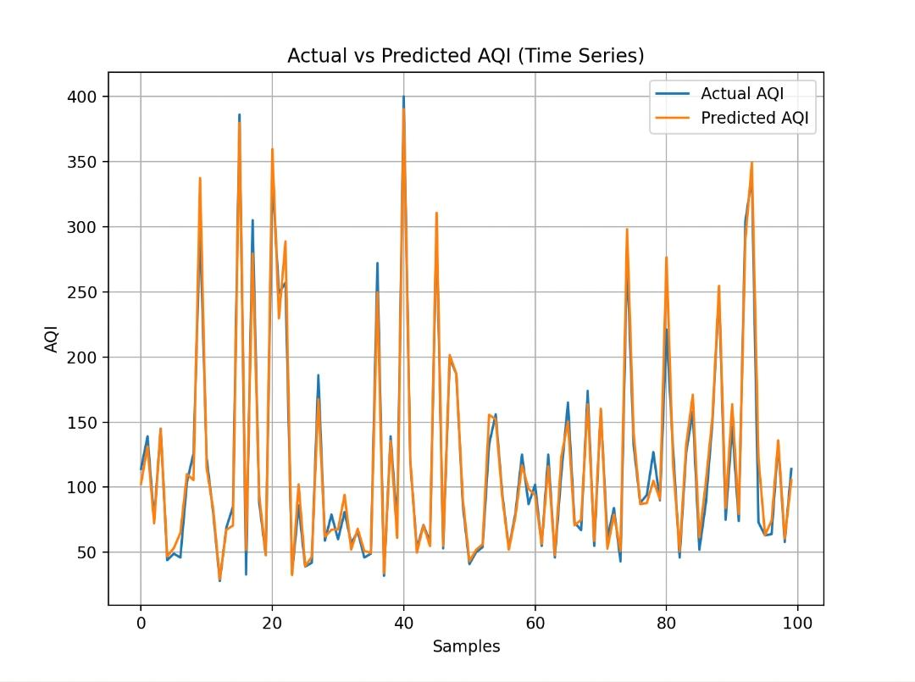
7.1 Model Accuracy
Fig 7.1 : Random Forest
This figure compares the actual AQI values with the AQI values predicted using the Random Forest model. The predicted values closely follow the actual AQI trend, showing that the model effectively captures variations in air quality data.

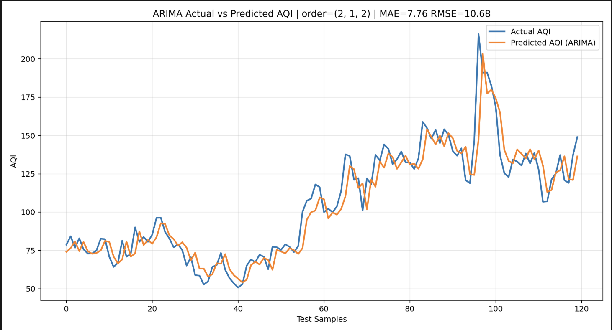

Fig7.2:ARIMA

This figure shows the AQI prediction results of the ARIMA model with order (2,1,2). The predicted AQI values closely match the actual values, achieving an MAE of 7.76 and RMSE of 10.68, indicating good forecasting accuracy.

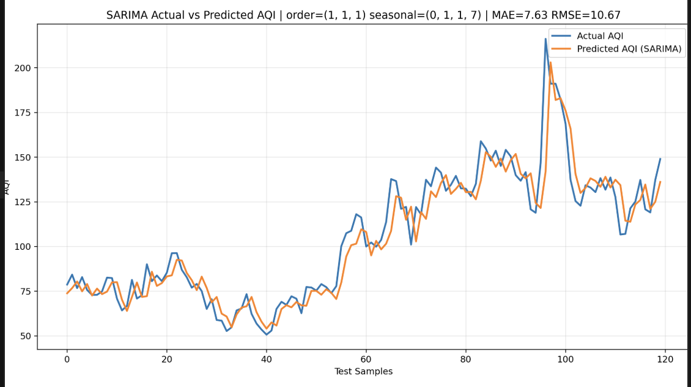

Fig 7.3:SARIMA
This figure presents the AQI prediction performance of the SARIMA model with order (1,1,1) and seasonal order (0,1,1,7). The model captures both trend and seasonal variations effectively, with an MAE of 7.63 and RMSE of 10.67.
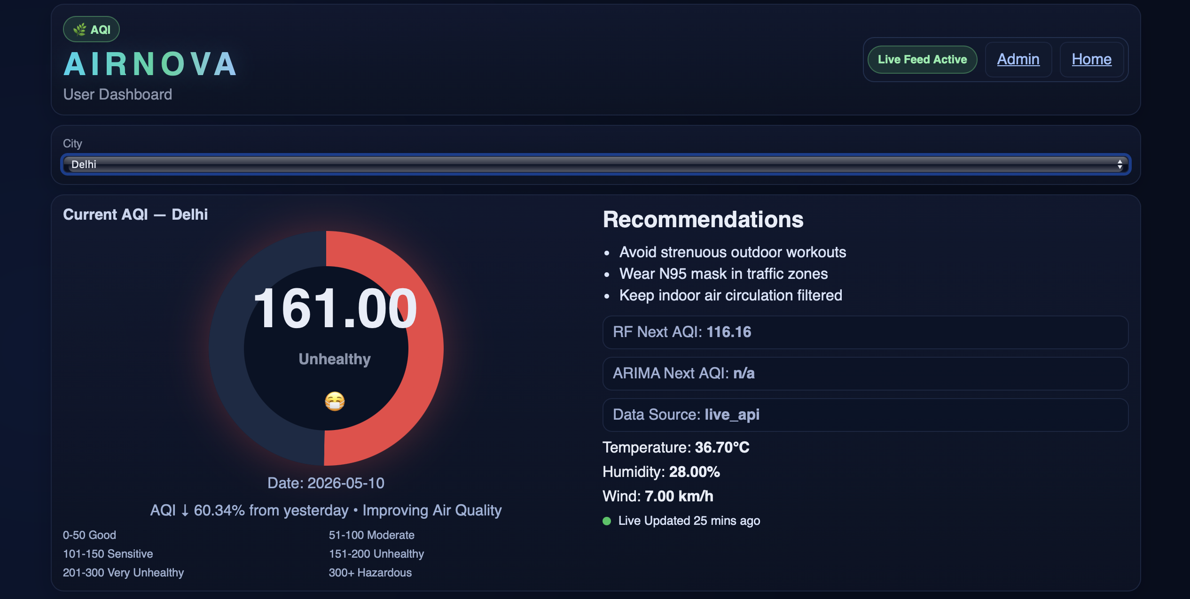
7.2 USER DASHBOARD

Fig 7.4: AIRNOVA User Dashboard
This figure shows the AIRNOVA user dashboard displaying the current AQI status of Hyderabad. It provides live AQI values, environmental parameters such as temperature, humidity, and wind speed, along with health recommendations and predicted AQI values generated using machine learning models.
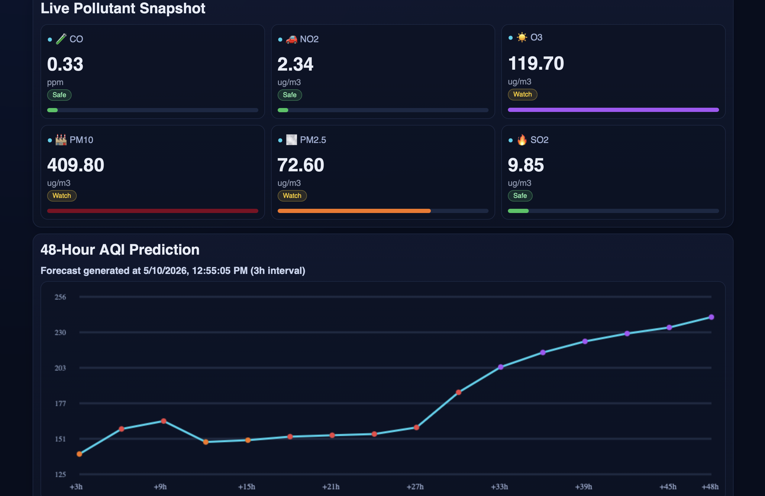

Fig 7.5: Live Pollutant Snapshot
This figure presents the live pollutant monitoring section of the AIRNOVA system, displaying pollutant levels such as CO, NO₂, O₃, PM10, PM2.5, and SO₂.
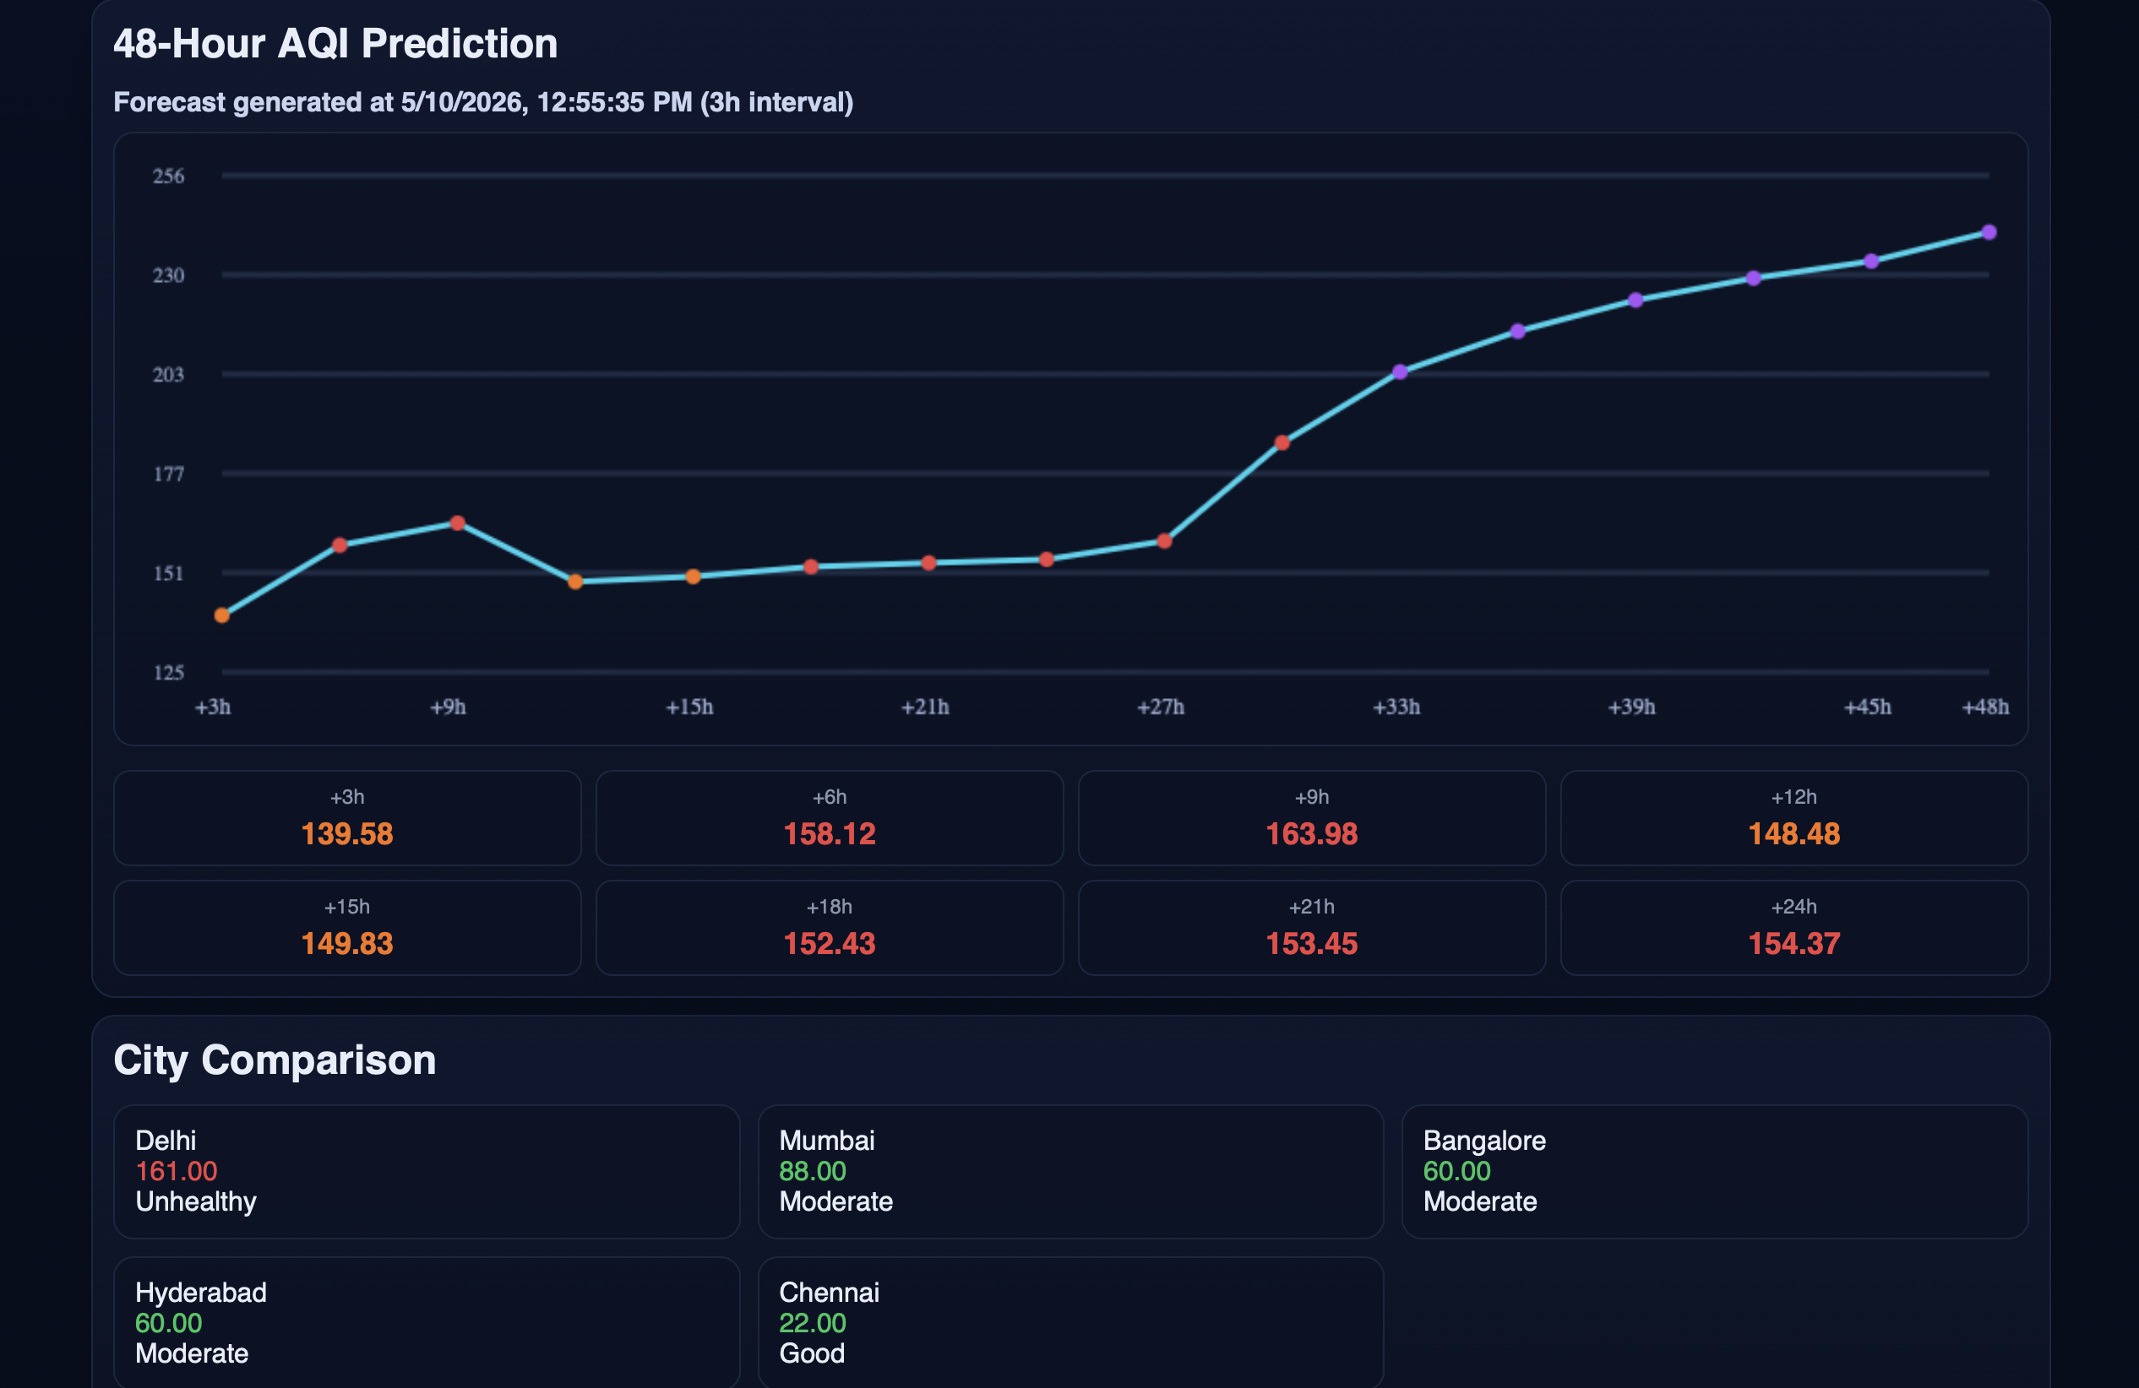

Fig 7.6: AQI Forecast and City Comparison Dashboard.
Displays a 48-hour AQI forecast using a line graph with 3-hour intervals. It also includes forecast values and a City Comparison section showing AQI levels of cities like Delhi, Mumbai, Hyderabad, Bangalore, and Chennai with their air quality status.

7.3 ADMIN DASHBOARD
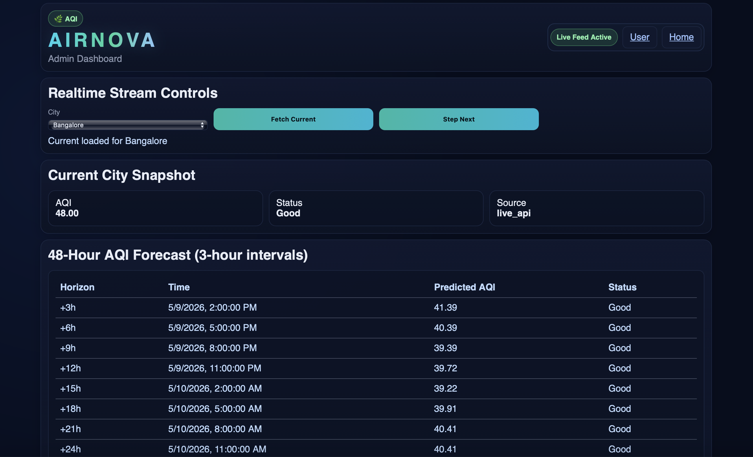

Fig 7.7:Admin Dashboard – Real-Time Monitoring
Shows the Admin Dashboard with realtime stream controls to select cities, fetch current AQI data, and step through records. It also provides a Current City Snapshot and a 48-hour AQI forecast table for the selected city.
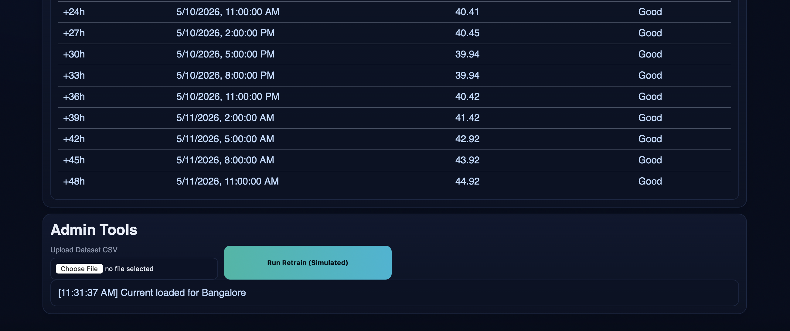

Fig 7.8: Admin Dashboard – Forecast and Controls
Displays AQI forecast data with timestamps, predicted values, and status. It also includes Admin Tools for uploading CSV datasets, retraining the model, and viewing recent system activity logs.
8.CONCLUSION
8.1 Work Carried Out
The AIRNOVA system was developed as an interactive Air Quality Monitoring and Prediction Dashboard with both user-facing and admin functionalities. The following key tasks were completed:
1. Data Integration & Processing
- Integrated real-time air quality data using a live API source.
- Processed pollutant parameters including: PM2.5, PM10, CO, NO₂, SO₂, O₃
- Standardized data into AQI values using predefined environmental thresholds.
2. User Dashboard Development
- Designed a responsive UI displaying Current AQI value with health category (e.g., Unhealthy, Moderate, Good)
- City-based selection (e.g., Delhi, Mumbai, Bangalore)
- Environmental conditions (temperature, humidity, wind)
- Included visual indicators like circular AQI gauge and color-coded pollutant bars.
- Provided health recommendations based on AQI levels.
3. Pollutant Visualization
Implemented real-time pollutant tracking cards showing:
- Concentration levels
- Safety status (Safe / Watch / Hazard)
- Used intuitive color coding for quick interpretation.
4. AQI Prediction Module
- Developed a 48-hour AQI forecasting system
- Time interval: 3 hours
- Implemented machine learning approaches : Random Forest (RF) for prediction and ARIMA model (partially implemented / fallback)
- Displayed predictions through: Line graphs and Time-based numeric breakdown
5. City Comparison Feature
- Enabled comparison of AQI across multiple cities: Delhi, Mumbai, Bangalore, Hyderabad, Chennai
- Provided quick classification (Good / Moderate / Unhealthy)
6. Admin Dashboard
- Built a separate admin interface with:
- Real-time stream control (Fetch Current / Step Next)
- Dataset upload (CSV)
- Simulated model retraining functionality
- Displayed structured forecast tables with timestamps and AQI predictions.
7. Real-Time System Behavior
- Live feed updates
- Timestamp tracking
- Dynamic UI refresh
- Ensured smooth interaction between backend predictions and frontend display.
8.2 Future Scope
The AIRNOVA system has strong potential for expansion. Key future improvements include:
1. Advanced Machine Learning Models
- LSTM (Long Short-Term Memory)
- GRU networks
- Improve prediction accuracy using seasonal and temporal patterns.
2. IoT Sensor Integration
- Connect with real-time IoT air quality sensors
- Enable hyperlocal AQI monitoring (street-level accuracy)
3. Mobile Application Development
- Develop Android/iOS app for:
- Push notifications on hazardous AQI
- Personalized exposure tracking
4. Health Impact Analysis
- User-specific health alerts (asthma, elderly)
- Exposure history and risk scoring
5. Geographic Visualization
- Integrate maps (GIS-based):
- Heatmaps for AQI distribution
- Zone-wise pollution tracking

REFERENCES
- Hands-On Machine Learning with Scikit-Learn, Keras, and TensorFlow, Aurélien Géron, O’Reilly Media, 2019.
- Python for Data Analysis, Wes McKinney, O’Reilly Media, 2022.
- Introduction to Time Series and Forecasting, Peter J. Brockwell and Richard A. Davis, Springer, 2016.
- Applied Predictive Modeling, Max Kuhn and Kjell Johnson, Springer, 2013.
- Central Pollution Control Board, National Air Quality Monitoring Programme (NAMP), Government of India.
- World Health Organization, Air Quality Guidelines and Environmental Health Reports.
- Research papers and journal articles related to:
- Air Quality Forecasting
- Time Series Analysis
- Machine Learning for Environmental Monitoring
- AQI Prediction Systems
- Smart Environmental Monitoring Systems

