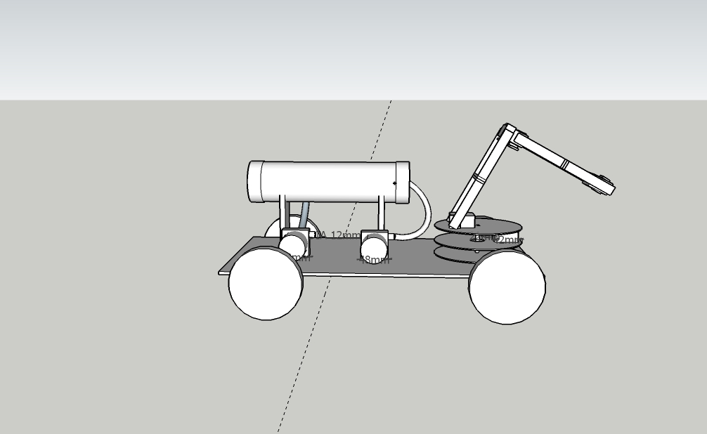**Our Approach to the problem :**

I have divided the problems into four parts:

1. Navigating under the water
2. Picking up the nodules
3. Locating the nodules
4. Sending the control signals to the bot

*For the navigation :*

We are using a ballast tank and two submersible pump one will push the water into the tank and other will take the water out, leaving the tank empty with air.

For navigation at the bottom we have used wheels and waterproof dc motors.

*For picking the nodules :*

we have used a grabbing mechanism which is operated by a servo motor and this grabbing mechanism is itself attached to a robotic arm.

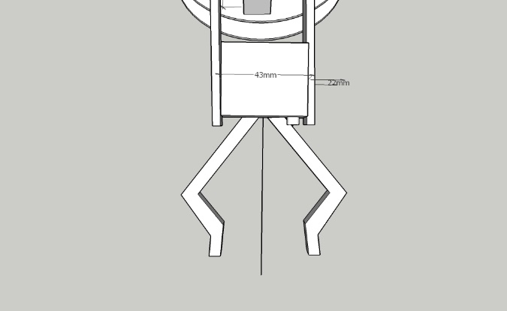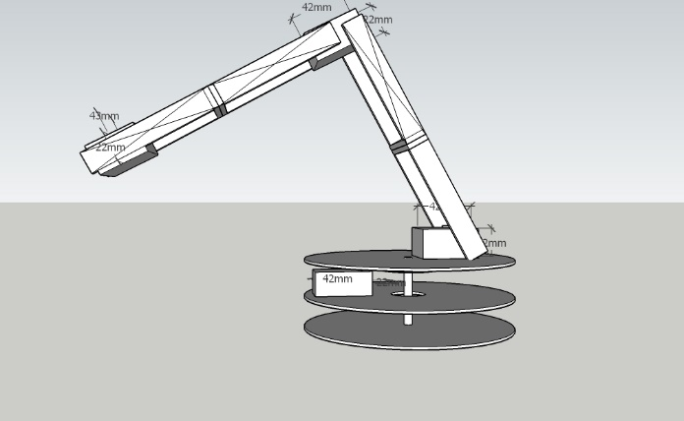

*Locating the nodules :*

To locate the nodules at the sea bottom we have attached wheels on the bot. We will attach a wireless waterproof camera on our bot to get the live feed form the bot, then through remote we will move our bot to a specific point.

*Sending the control signal to the bot :*

We have used low frequency radio modules to control our bot wirelessly.