Create a new page, pStrategy – we will use the delta exchange APIs for this. We particularly trade gold using this for now. As in the screen shot

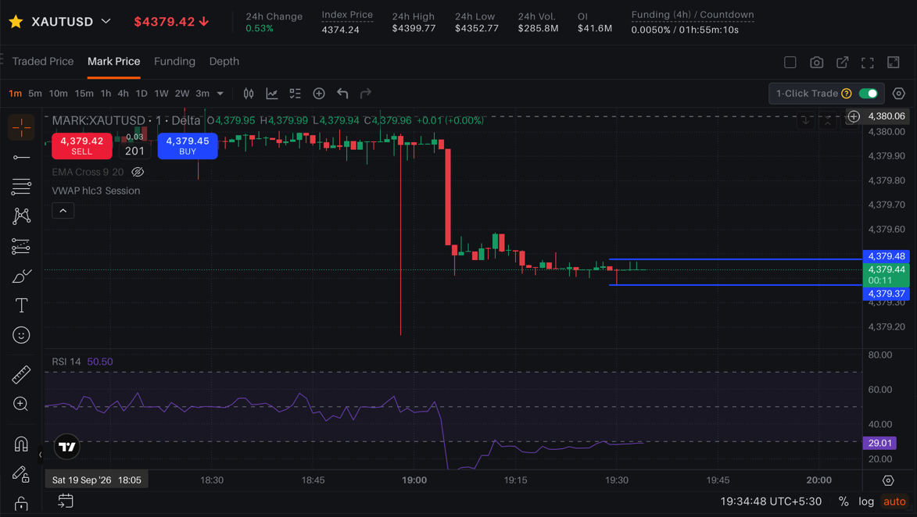

Lets build the similar UI using trading view charts public API.

Core Concept:
Step 1: Find consolidation, in any time frame (get data for 1m, 5m and 15m time frame) look at the last 3 or 4 candles, check if they are within range. Hint: the high and low of the candles should be within the range or use any other logic, refer to public internet for the same.
Step 2: Mark the support and resistance, like I have done in the chart above. Also provide options to draw the line where required. I have drawn the line as a ray. Please draw line only for those 3 or 4 candles.

Lets do these 2 steps for now.

