Delhi Technical Campus
Knowledge park-3, Greater Noida



CSE Department
MOBILE COMPUTING
LAB FILE

Submitted To:-
Ms. Megha Kumar
(Assistant Professor)
(Department of CSE)

Submitted By:-
Shyamendra

41418002716

B.Tech(CSE 4th yr.)

Index

S.NO | Date | Title | Sign
 |  | Study of WML and J2ME simulators
1
2 |  | Design of simple Calculator having +,,,* and /
2 |  | using WML/J2ME
 |  | Design of Calendar for any given month and year
3 |  | using WML/J2ME
4 |  | Design a Timer to System Time using
 |  | WML/J2ME
5 |  | Design of simple game using WML/J2ME
6 |  | Animate an image using WML/J2ME
7 |  | Design a personal phone book containing the
7 |  | name, phone no., address, e-mail,etc.
 |  | Simulation of Authentication and encryption
8 |  | technique used in GSM
9 |  | Browsing the Internet using Mobile phone
9 |  | simulator
10 |  | Study of GlomoSim Simulator

Study of WML and J2ME simulators

Aim:

To study about WML and J2ME simulator.

Java 2 Platform, Micro Edition (J2ME)

Introduction:

Traditional computing devices use fairly standard hardware configurations such as display, keyboard,large amount of memory and permanent storage. However, a new breed of computing devices lacks hardware configuration. J2ME is specially designed for
developing applications for small computing devices such as cell phones, PDA etc.

J2ME Configurations:

Configuration defines the JVM for a particular small computing device.

Types:

Two types of configuration haves been defined.

1) CLDC (Connected limited Device configuration)

CLDC is used for the devices with the limited resources. CLDC devices use stripped version of JVM called KVM. CLDC devices are mobile phones,PDA etc. 2) CDC ( Connected device configuration)

CDC devices use complete JVM. CDC devices are set-top box, Home appliances such as Air conditioner etc..

J2ME Profiles:

Profile consists of classes that enable developers to implement features found in a related group of small computing devices.

Many profile are available . Here we use MIDP ( Mobile Information Device Profile) MIDP is used with CLDC configuration that provides classes for local storage, a user interface and networking capabilities. Other profiles are Game profile, Foundation profile, RMI profile and many more..

Java Virtual Machine layer:

This layer is an implementation of a Java Virtual Machine that is customized for a particular device's host operating system and supports a particular J2ME configuration.

Configuration layer:

The configuration layer defines the minimum set of Java Virtual Machine features and Java class libraries available on a particular category of devices. In a way, a configuration
defines the commonality of the Java platform features and libraries that developers can assume to be available on all devices

belonging to a particular category. This layer is less visible to users, but is very important to profile implementers.

Profile layer:

The profile layer defines the minimum set of application programming interfaces (APIs) available on a particular family of devices.

Profiles are implemented upon a particular configuration. Applications are written

for a particular profile and are thus portable to any device that supports that profile. A device can support multiple profiles. This is the layer that is most visible to users and application providers.

MIDP layer:

The Mobile Information Device Profile (MIDP) is a set of Java APIs that addresses issues such as user interface, persistence storage, and networking.

MIDlet Programming:

A MIDlet is a class , which is controlled by the application manager. A MIDlet class must contain three abstract methods that are called by the application manager.

public class class-name extends MIDlet

{

public void startApp(){ }

public void pauseApp() { }

public void destroyApp( unconditional boolean) { } }

Steps for creating a MIDlet suite:

- Select a file system where you want to create a MIDlet suite. Right click on it, a pop the menu appears. From the pop up menu, select New -> MIDlet Suite.

- Enter the Name of MIDlet suite. Click on Next.

- It gives you two options.

Allows you to create a new Midlet :

Enter the package and class name . This is the name of a MIDlet that is to be created.

Allows you to add existing MIDlet :

To add existing MIDlet ,click on brows , select the MIDlet to be added.

J2ME It also allows you to select icon for the given MIDlet.

4) Click Finish.

ADDING MIDlet to a MIDlet suite:

1) Select a MIDlet suite , to which you want to add Midlet. Right click on it, a pop up
menu appears. Select Edit suite from the popup menu.

- Click on ADD button to add a new MIDlet.

- Enter name of package and class name.

- Click on OK.

New MIDlet is added to your MIDlet suite.

An example J2ME application using Radio buttons :

Description:

Item class is a base class for a number of derived classes that can be contained within a form class. These derived classes are ChoiceGroup , DateField, ImageItem, StringItem and TextField.

The ChoiceGroup class is used to create check boxes or radio buttons on a form. The state of an instance of a class derived from the Item class changes whenever user enters data into the instance ,such as radio button is selected. An ItemListener monitors the events during a life of the MIDlet and traps events that changes in the state of any Item class contained on a form.

An instance of a ChoiceGroup class can be of two types: Exclusive or multiple. An exclusive instance appears as a set of radio buttons and a multiple instance contains set of check boxes.

Classes used:

Form Class: It is a container for the other displayable objects that appear on the screen.

Any derived class instance of the Item class can be placed on the instance of Form class.

ChoiceGroup class :

J2ME classifies check boxes and radio buttons as the instance of ChoiceGroup class. We set the type of choiceGroup instance to EXCLUSIVE to create radio buttons.

ItemStateListener:

Any MIDlet that utilizes instances of the Item class withon a form must implement ItemStateListener and must have an itemStateChanged() method.

Creating a Radio buttons :

private ChoiceGroup gender;

gender = new ChioceGroup (“Enter gender”, Choice.EXCLUSIVE) ; gender.append(“Female”,null);

gender.append(“Male”,null);

J2ME program to insert an image in a Canvas.
Description:

There are two types of images that can be displayed.

- Immutable

- Mutable

An immutable images are loaded from a file or other resources and cannot be modified once the image is displayed. Examples. Icon s associated with MIDlets are immutable.

A mutable image is drawn on the Canvas using methods available in Graphics

class.

An immutable image can be drawn on the screen as well as on Canvas.

where as mutable image is drawn only on the canvas.

The Canvas Class:

Each MIDlet has a one instance of the Display class, and the Display class has a one derived class called 'displayable'. Everything a MIDlet displays on the Screen is created by an instance of a Displayable class. The Display class hierarchy is shown below:

public class Displayable

public abstract class Displayable

public abstract class Screen extends Displayable public abstract class Canvas extends Displayable public class Graphics

The screen class is used to create high-level components. the Canvas class is used to gain low-level access to display.

Creating an Image using Image class:

Create an instance of an Image class by calling the createImage() method of the Image

class.

private Image img;

img = Image.createImage(path);

Displaying an Image on a Canvas

Once the image is created , it can be drawn on the Canvvs using drawImage() method of the Graphics class.

Graphics.drawImage()

drawImage() method takes four parameters.

First parameter is the reference to the image that you want to display.

second and third parameters indicate position of the image on Canvas.

Fourth parameter specifies the portion of the image bounding box that is placed

at the

specified co-ordinate position.
Example:

graphics.drawImage(img,5,20,Graphics.HCENTER | Graphics.VCENTER)

palces the center of the image at co-ordinate position (5,20).

Wireless Markup Language (WML)

Introduction:

The Wireless Markup Language (WML) is the HTML of WAP browsers and is transmitted via the HTTP protocol.

WML is a markup language built specifically for communicating across WAP-based networks, and is based upon XML (eXtensible Markup Language). Like HDML, it is at first glance similar to HTML, but is also a much more strictly written language.

To make it possible for web pages to be read from a WAP-enabled device, WML must be used. The WML coder determines within the code what parts of the web page are viewable to the device, and what is not. For example, it would not be too advantageous for a 468x60 pixel banner to be loaded into the small screen of a WAP device, due to size, color and bandwidth restraints. However, certain parts of the text may be made available to the device.

The advantage of the WML language is the fact that, since it is a subset of XML, developer's can easily kill two birds with one stone by building both the web page and wireless device page simultaneously. While this is still possible with HDML code, it is certainly not as obvious and workarounds must be introduced

Why Should we use WML

Although you might not have any plans immediately for creating a WAP version of your site, it is always a good idea to get involved in new technology. All you need to do is make a small site (even one page) which tells people a bit about your website. In the future you can develop the site further with things like e-mail and information for people to get directly off their phones.

Over the past few months new WAP (Wireless Applications Protocol) phones have become extremely popular and many large websites have created special 'mobile' versions of their site. Many people predict that, over the next few years, WAP sites will become extremely popular and e-commerce over mobile phones will be widely available

The main sites which will benefit from WAP are ones providing a service like e-mail, live sports scores or a calendar service etc. but there are many other uses. For example, a site giving music reviews could put their reviews on a WAP site. People could then read the reviews on their mobile phone while browsing through the CDs in a shop.

WML Decks and Cards

WML pages are called DECKS. They are constructed as a set of CARDS, related to each other with links. When a WML page is accessed from a mobile phone, all the cards in the page are downloaded from the WAP server. Navigation between the cards is done by the phone computer - inside the phone - without any extra access trips to the server.

<?xml version="1.0"?>

!DOCTYPE wml PUBLIC "-//WAPFORUM//DTD WML 1.1//EN" "http://www.techiwarehouse.com/DTD/wml_1.1.xml"> <wml>

<card id="HTML" title="HTML Tutorial">

- p> You can learn WML in 30 Days </p>

</card>

- card id="XML" title="XML Tutorial">

- p> You can also learn how to make an WAP based Page

- /p>

</card>

</wml>

As you can see from the example, the WML document is an XML document. The DOCTYPE is defined to be wml, and the DTD is accessed at www.techiwarehouse.org/DTD/wml_1.1.xml.

<?xml version="1.0"?>

<!DOCTYPE wml PUBLIC "-//WAP/DTD WML 1.1//EN"

"http://www.wap.org/DTD/wml_1.1.xml">

<wml>

<card id="no1" title="Card 1">

<p>Hello World!</p>

</card>

<card id="no2" title="Card 2">

<p>Welcome to our WAP Tutorial!</p>

</card>

</wml>

WML TAGS

WAP homepages are not very different from HTML homepages. The markup language used for WAP is WML (Wireless Markup Language). WML uses tags - just like HTML - but the syntax is stricter and conforms to the XML 1.0 standard. WML pages have the extension *.WML, just like HTML pages have the extension *.HTML

WML is mostly about text. Tags that would slow down the communication with handheld devices are not a part of the WML standard. The use of tables and images is strongly restricted.
Since WML is an XML application, all tags are case sensitive (<wml> is not the same as </WML>), and all tags must be properly closed.

CONCLUSION

Wap's designed is flexible for client's minimal resources such as computing power and memory storage.WAP is programmed in wireless markup language WML (application of XML) and WMLScript (WAP's version JavaScript) which is embedded in client's mobile. WML provides a simple event mechanism that allows different content to be displayed. User actions, such as pressing a key, can be tied to scripts that cause changes in content. The WML browser

also has this timer function that can load a different page or trigger the change of variables when the time is up. This provide great flexibility than the static content that HTML can deliver.
Design of simple Calculator having +,,,* and / using WML/J2ME

Aim:

To write the program for implementing the calculator entry using J2ME Algorithm:

- The midlet class have been imported the class calc is declared

- Required data fields are initialized.

- The arithmetic operations are declared in different module to do their process

- The command listener have been used to invoke the command

- The command action have been used perform the operation

Program:

import javax.microedition.lcdui.*;

import javax.microedition.midlet.*;

public class Calc extends MIDlet implements CommandListener {

TextField inp;

Display display;

Command add,OK,Exit,sub,div,mul,History;

int result;

Ticker tk;

public Calc()

{

tk=new Ticker("Start");

History=new Command("History", Command.OK, 6); inp = new TextField("Input", "", 10, TextField.NUMERIC); add = new Command("ADD", Command.OK, 1); div=new Command("Divide", Command.OK, 3); mul=new Command("Multiply", Command.OK, 5); sub=new Command("Subtract", Command.OK, 2);

OK = new Command("OK", Command.STOP, 4); Exit=new Command("EXIT", Command.EXIT, 7);
}

public void startApp()

{

display =Display.getDisplay(this);

Form f1=new Form("CALCULATOR BY VSB");

f1.setTicker(tk);

f1.append(inp);

f1.addCommand(History);

f1.addCommand(add);

f1.addCommand(OK);

f1.addCommand(Exit);

f1.addCommand(sub);

f1.addCommand(div);

f1.addCommand(mul);

f1.setCommandListener(this);

display.setCurrent(f1);

}

public void pauseApp() {

}

public void destroyApp(boolean unconditional)

{

notifyDestroyed();

}

int kpress=0;

void ad()

{

kpress=0;

if(inp.size()!=0)

{

tk.setString(tk.getString()+"+"+inp.getString());

String input=inp.getString();

result+=Integer.parseInt(input);

}

}

void sb()

{

kpress=1;

if(inp.size()!=0)

{

tk.setString(tk.getString()+"-"+inp.getString());

String input=inp.getString();

if(result==0)

result=Integer.parseInt(input);
else

result-=Integer.parseInt(input);

}

}

void ml()

{

kpress=2;

if(inp.size()!=0)

{

tk.setString(tk.getString()+"x"+inp.getString());

String input=inp.getString();

if(result==0)

result=Integer.parseInt(input);

else

result*=Integer.parseInt(input);

}

}

void dv()

{

try

{

kpress=3;

if(inp.size()!=0)

{

tk.setString(tk.getString()+"/"+inp.getString());

String input=inp.getString();

if(result==0)

result=Integer.parseInt(input);

else

result/=Integer.parseInt(input);

}

}

catch(Exception ex)

{

result=0;

}

}

public void commandAction(Command c,Displayable d)

{

if(c==add)

ad();

if(c==sub)

sb();
if(c==mul)

ml();

if(c==div)

dv();

if(c==History)

{

Alert nalt=new Alert("History",tk.getString(),null,AlertType.INFO); nalt.setTimeout(Alert.FOREVER); display.setCurrent(nalt);

}

if(c==OK)

{

try

{

if(kpress==0)

ad();

else if(kpress==1)

sb();

else if(kpress==2)

ml();

else if(kpress==3)

dv();

else{}

}

catch(Exception ex)

{}

finally

{

tk.setString(tk.getString()+"="+result);

Alert res=new Alert("Result","RESULT = "+result, null, AlertType.INFO); res.setTimeout(5000);

display.setCurrent(res);

}

}

if(c==Exit)

destroyApp(true);

inp.setString("");

}

}
OUTPUT :
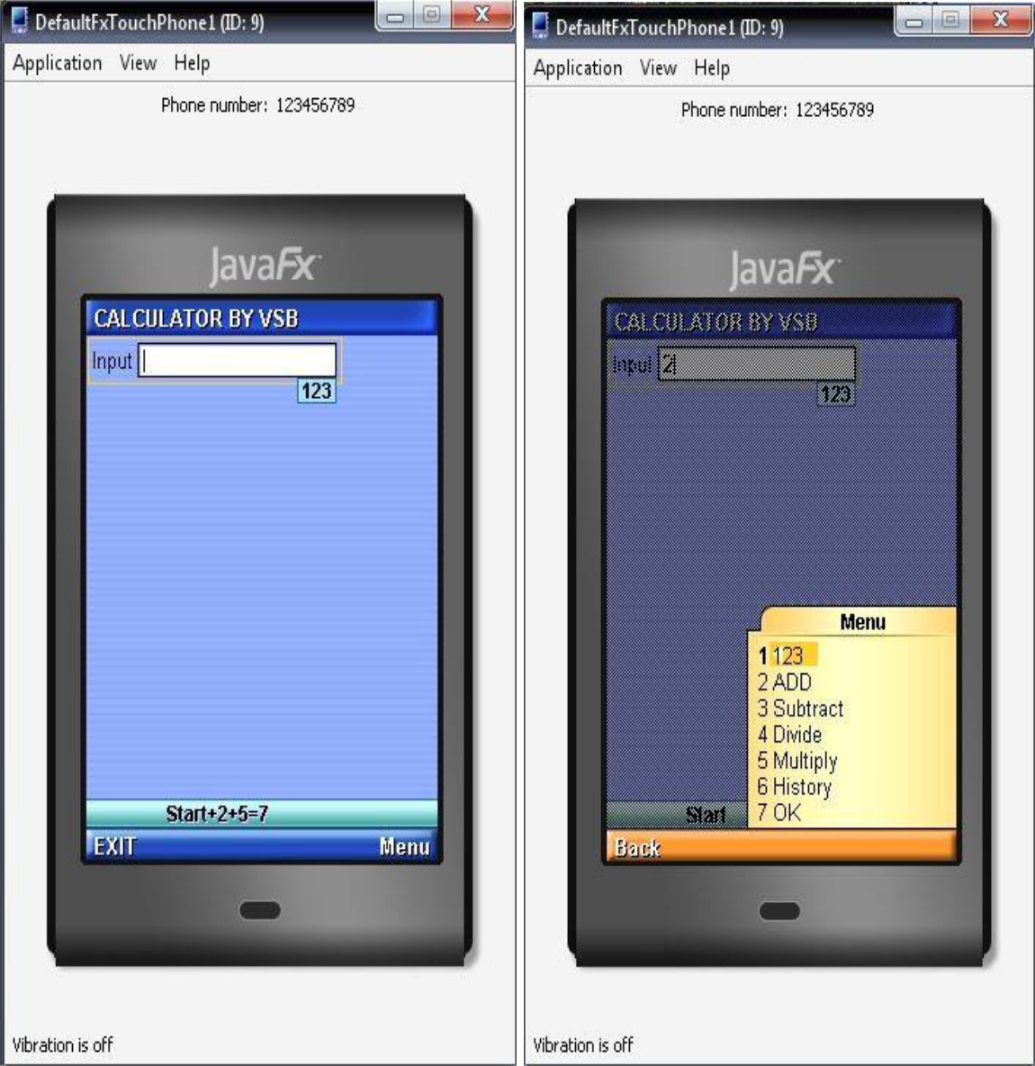
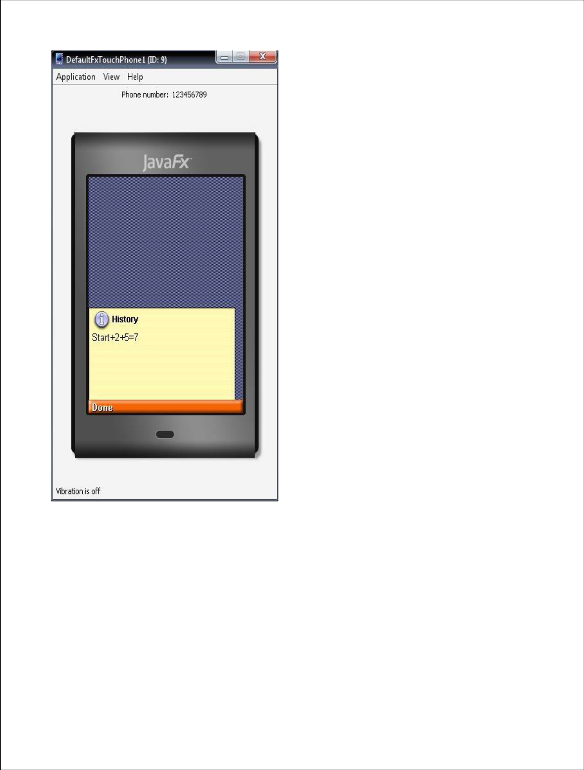

Result:

Thus the program for implementing the calculator in mobile was successfully executed and verified.
Design of Calendar for any given month and year using WML/J2ME

Aim:

To write the program for implementing the calendar in mobile

Algorithm:

- Import the packages for the execution of the program

- In class phone calendar extends the class MIDLETs

- The class implements the interface command listener

- The private data member are initialized

- Initialize and design data to the field we need to display

- Using phone calendar as constructor the required functions are called.

- The start application is called to append the data and display the form.

- Destroy appends is also called allocate and reallocate and notify the destroyed function.

Program:

import javax.microedition.midlet.*;

import javax.microedition.lcdui.*;

public class PhoneCalendar extends MIDlet implements CommandListener,ItemStateListener {

private Command exitCommand;

private Display display;

Form displayForm;

DateField date;

public PhoneCalendar()

{

display = Display.getDisplay(this);

exitCommand = new Command("exit",Command.SCREEN,1); date = new DateField("select to date",DateField.DATE);

}

public void startApp()

{

displayForm = new Form("quick calendar");

displayForm.append(date);

displayForm.addCommand(exitCommand);

displayForm.setCommandListener(this);

displayForm.setItemStateListener(this);

display.setCurrent(displayForm);

}

public void itemStateChanged(Item item)

{
}

public void pauseApp(){}

public void destroyApp(boolean unconditional){}

public void commandAction(Command c,Displayable s)

{

if(c==exitCommand)

{

destroyApp(false);

notifyDestroyed();

}

}

}
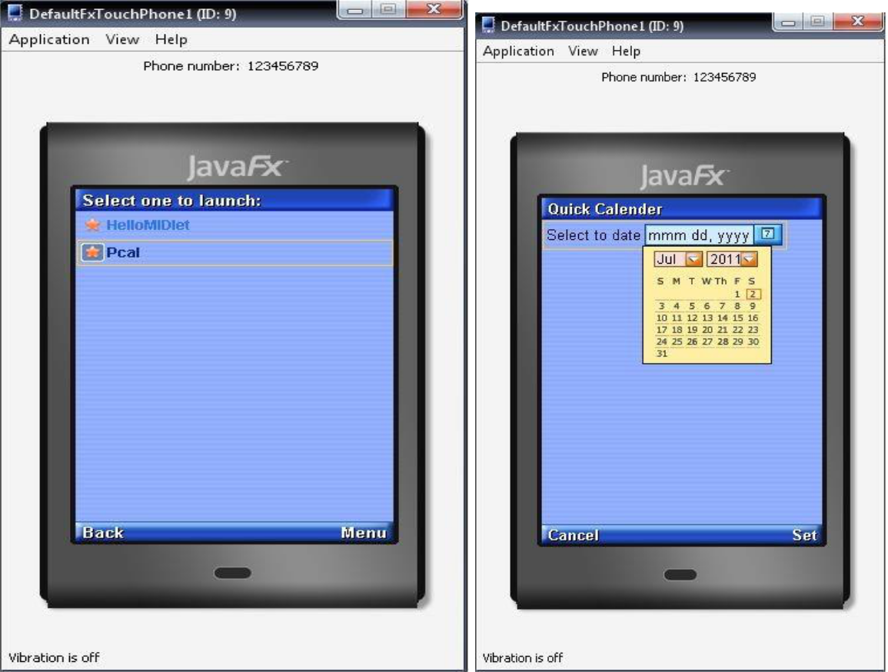

Result :

Thus the program for implementing the calendar in mobile was successfully executed and verified.
Design a Timer to System Time using WML/J2ME

Aim:

To write the program for implementing the system timer entry using J2ME Algorithm:

- Import the package word for the application

- Apply the variables used which are applicable to the program development

- In the snooze function set the date field and commands are assigned for snooze, reset and exit

- Add the commands for these functions and call the command action set the alert time for alarm

- Set the snooze timer and schedule the snooze timer for alarm

- Remove the command snooze

PROGRAM:

import java.util.*;

import javax.microedition.midlet.*;

import javax.microedition.lcdui.*;

import java.util.Timer;

import java.util.TimerTask;

public class PHALARM extends MIDlet implements ItemStateListener,CommandListener

{

private Display display;

private Form fmmain;

private Command cmsnooze;

private Command cmreset;

private Command cmexit;

private DateField dfsnoozetime;

private int dateindex;

private Date currenttime;

private Timer tmsnooze;

private SnoozeTimer ttsnooze;
private boolean dateOK = false;

public PHALARM()

{

display=Display.getDisplay(this);

fmmain = new Form("When to sound the alarm:"); currenttime = new Date();

dfsnoozetime=new DateField("",DateField.DATE_TIME); dfsnoozetime.setDate(currenttime);

cmsnooze = new Command("Snooze",Command.SCREEN,1); cmreset =new Command("Reset",Command.SCREEN,1); cmexit =new Command("Exit",Command.EXIT,1); dateindex=fmmain.append(dfsnoozetime); fmmain.addCommand(cmsnooze); fmmain.addCommand(cmreset); fmmain.addCommand(cmexit); fmmain.setCommandListener(this); fmmain.setItemStateListener(this);

}

public void startApp()

{

display.setCurrent(fmmain);

}

public void pauseApp()

{}

public void destroyApp(boolean unconditional)

{

}

public void ItemStateChanged(Item item)

{
if(item == dfsnoozetime)

{

if(dfsnoozetime.getDate().getTime()<currenttime.getTime())

dateOK= false;

else

dateOK = true;

}

}

public void commandAction(Command c,Displayable s)

{

if(c==cmsnooze)

{

if(dateOK == false)

{

Alert al = new Alert("Unable to set alarm","Please choose another date and time",null,null);

al.setTimeout(Alert.FOREVER);

al.setType(AlertType.ERROR);

display.setCurrent(al);

}

else

{

tmsnooze = new Timer();

ttsnooze = new SnoozeTimer();

long amount = dfsnoozetime.getDate().getTime()-currenttime.getTime();

tmsnooze.schedule(ttsnooze, amount);

fmmain.removeCommand(cmsnooze);

fmmain.removeCommand(cmreset);

fmmain.delete(dateindex);
fmmain.setTitle("Snoozing. .. ");

}

}

else if(c==cmreset)

{

dfsnoozetime.setDate(currenttime=new Date());

}

else if(c==cmexit)

{

destroyApp(false);

notifyDestroyed();

}

}

public void itemStateChanged(Item item) {

throw new UnsupportedOperationException("Not supported yet.");

}

private class SnoozeTimer extends TimerTask

{

public final void run()

{

Alert al = new Alert("Time to weakeup");

al.setTimeout(Alert.FOREVER);

al.setType(AlertType.ALARM);

AlertType.ERROR.playSound(display);

display.setCurrent(al);
cancel();

}

}

}

OUTPUT:
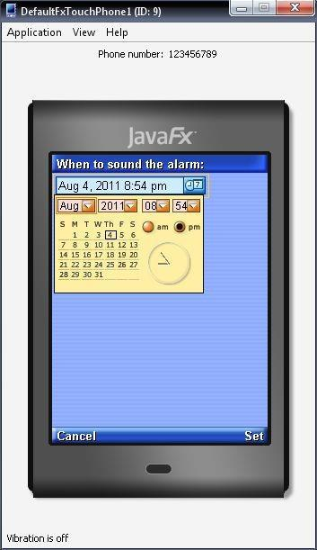

Result:

Thus the program for implementing the system timer in mobile was successfully executed and verified.
Design of simple game using WML/J2ME

Aim:

To write the program for implementing the games using J2ME Algorithm:

- Create the class with name bouncing ball

- In constructor can display the bouncing ball object

- In start application by using graphics function return the value of graphics

- By using paint method check the maximum value is equal to or less then the value of x4 radius

- In try function wait() method with parameter 2

- Otherwise throw the exception

- In class Bounce, call the paint()

PROGRAM:

import javax.microedition.midlet.*;

import javax.microedition.lcdui.*;

import java.util.Timer;

import java.util.TimerTask;

public class Bouncing extends MIDlet

{

Ball b1,b2;

BallCanvas bc;

Display display;

public Bouncing()

{

System.out.println("Boucing ball");

}

public void destroyApp(boolean a)

{}
public void startApp()

{ try {

bc = new BallCanvas();

display = Display.getDisplay(this);

Ball b1 = new

Ball(90,30,5,5,1,10,250,255,255,bc.getGraphics(),bc.getWidth(),bc.getHeight(),bc);

Ball b2 = new

Ball(100,20,15,1,3,20,150,150,250,bc.getGraphics(),bc.getWidth(),bc.getHeight(),bc);

Ball b3 = new

Ball(10,10,30,2,1,25,250,100,250,bc.getGraphics(),bc.getWidth(),bc.getHeight(),bc);

display.setCurrent(bc);

}

catch(Exception e){System.out.println(e);}

}

public void pauseApp()

{}

public class BallCanvas extends Canvas

{Graphics g1;

public void paint(Graphics g)

{ g1=g;

}

Graphics getGraphics()

{ return(g1); } }

public class Ball

{private int ox,oy,radius,speed; private int incx,incy; private int red,green,blue;

private int maxx,maxy;

private boolean xb,yb,flag;

TimerTask t;

Timer timer;

Graphics g;

BallCanvas bc;

private int prev1,prev2;

public Ball(int x,int y,int r,int ix,int iy,int s,int rd,int gr,int b,Graphics g1,int mx,int my,BallCanvas bc1)

{System.out.println("Ball"); maxx=mx;

maxy=my;

incx=ix;

incy=iy;

red=rd; green = gr; blue = b; xb=false; yb=false; radius = r; ox=x; oy=y; flag = false; bc = bc1; g1 = g;

timer = new Timer();
timer.schedule(new Bounce(),(long)0,(long)s);

}

public void paint()

{if((ox+radius)>=maxx) xb=true;

if(ox<=0)

xb=false;

if((oy+radius)>=maxy)

yb=true;

if(oy<=0)

yb=false;

if(xb==false)

{prev1=ox;ox+=incx;}

else

{prev1=ox;ox-=incx;} if(yb==false)

{prev2=oy;oy+=incy;}

else

{prev2=oy;oy-=incy;} bc.repaint(); if(flag==false)

{

bc.getGraphics().setColor(0,0,0);

bc.getGraphics().fillRect(0,0,bc.getWidth(),bc.getHeight()); flag = true;
}
bc.getGraphics().setColor(0,0,0);

bc.getGraphics().fillArc(prev1,prev2,radius,radius,0,360); bc.getGraphics().setColor(red,green,blue); bc.getGraphics().fillArc(ox,oy,radius,radius,0,360); try{

wait(20);

}catch(Exception e){}

}

public class Bounce extends TimerTask

{public void run()

{ paint(); }

} } }

OUTPUT:
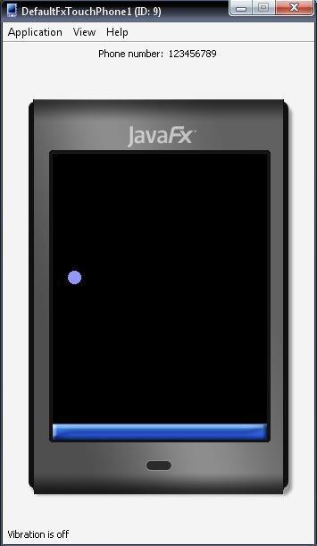
Animate an image using WML/J2ME

Aim:

To write the program for implementing the animation using J2ME Algorithm:

- Import the required packages for display starfield declared

- Object for display starfield are declared as constructor

- Function for displaying time are called timer is scheduled on per application

- Height and width are assigned

- Destroy the object created

PROGRAM:

import javax.microedition.lcdui.*;

import javax.microedition.midlet.*;

public class anim extends MIDlet

{

public void startApp()

{

final SweepCanvas sweeper = new SweepCanvas(); sweeper.start();

sweeper.addCommand(new Command("Exit", Command.EXIT, 0)); sweeper.setCommandListener(new CommandListener()

{

public void commandAction(Command c, Displayable s)

{

sweeper.stop();

notifyDestroyed();

}
});

Display.getDisplay(this).setCurrent(sweeper);

}

public void pauseApp() {}

public void destroyApp(boolean unconditional) {}

}

class SweepCanvas extends Canvas implements Runnable { private boolean mTrucking;

private int mTheta;

private int mBorder;

private int mDelay;

public SweepCanvas()

{

mTheta = 100;

mBorder = 10;

mDelay = 50;

}

public void start()

{

mTrucking = true;

Thread t = new Thread(this);

t.start();

}

public void stop()

{

mTrucking = false;
}

public void paint(Graphics g) {

int width = getWidth();

int height = getHeight();

g.setGrayScale(255);

g.fillRect(0, 0, width - 1, height - 1);

int x = mBorder;

int y = mBorder;

int w = width - mBorder * 2;

int h = height - mBorder * 2;

for (int i = 0; i < 8; i++) {

g.setGrayScale((8 - i) * 32 - 16);

g.fillArc(x, y, w, h, mTheta + i * 20, 10);

g.fillArc(x, y, w, h, (mTheta + 180) % 360 + i * 20, 10);

}

}

public void run()

{

while (mTrucking)

{

mTheta = (mTheta + 1) % 360;

repaint();

try { Thread.sleep(mDelay); }

catch (InterruptedException ie) {}

}
}

}

OUTPUT :
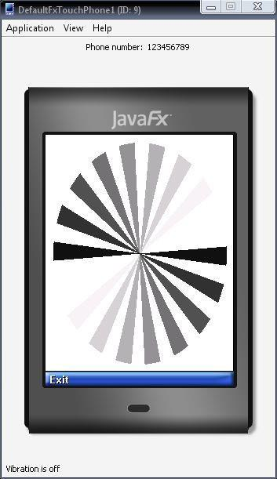

Result :

Thus the program for implementing the animation in mobile was successfully executed and verified.
Design a personal phone book containing the name, phone no., address, e-mail

Aim:

To write the program for implementing the phonebook entry using J2ME Algorithm:

- Import the package which are all used for the application

- Initialize the variables for data types using modifiers

- Inside the start app() function , for searching of contact different functions are called

- On any error in the try hello, the exception in carryout.

- The pause application and destroy application is using MIDlet class

- Command action function is called to handle the command

- Local contact function is called to lead the contact information

Program:

import javax.microedition.lcdui.Alert;

import javax.microedition.lcdui.Choice;

import javax.microedition.lcdui.ChoiceGroup;

import javax.microedition.lcdui.Command;

import javax.microedition.lcdui.CommandListener;

import javax.microedition.lcdui.Display;

import javax.microedition.lcdui.Displayable;

import javax.microedition.lcdui.Form;

import javax.microedition.lcdui.TextField;

import javax.microedition.midlet.MIDlet;

import javax.microedition.rms.RecordEnumeration; import javax.microedition.rms.RecordStore;

import javax.microedition.rms.RecordStoreException;

import javax.microedition.rms.RecordStoreNotOpenException;

public class SearchContact extends MIDlet implements CommandListener { private Display display;

private ChoiceGroup searchChoice;

private Form searchForm;

private TextField searchTxtField;

private Command exitCmd;

private Command addContactCmd;

private Form addContactForm;

private TextField nameTxtField;

private TextField numberTxtField;

private Command backCmd;

private Command saveCmd;
private String nameStr;

private String numberStr;

private Alert addAlert;

private RecordStore openRecStore;

public void startApp() {

display = Display.getDisplay(this);

searchForm = new Form("Search Contact");

searchTxtField = new TextField("Search Here", "", 30, TextField.ANY); searchForm.append(searchTxtField);

searchChoice = new ChoiceGroup("", Choice.EXCLUSIVE); searchForm.append(searchChoice);

exitCmd = new Command("Exit", Command.EXIT, 7); searchForm.addCommand(exitCmd);

addContactCmd = new Command("Add", Command.OK, 4); searchForm.addCommand(addContactCmd); searchForm.setCommandListener(this); display.setCurrent(searchForm); addContactForm = new Form("Add Contacts");

nameTxtField = new TextField("Name", "", 80, TextField.ANY); addContactForm.append(nameTxtField);

numberTxtField = new TextField("Number", "", 20, TextField.PHONENUMBER); addContactForm.append(numberTxtField);

backCmd = new Command("Back", Command.BACK, 2); addContactForm.addCommand(backCmd);

saveCmd = new Command("Save", Command.OK, 4); addContactForm.addCommand(saveCmd); addContactForm.setCommandListener(this);
try {

openRecStore = RecordStore.openRecordStore("Contacts", true); } catch (RecordStoreException ex) {

ex.printStackTrace();

}

loadContacts();

}

public void pauseApp() {

}

public void destroyApp(boolean unconditional) {

}

public void commandAction(Command c, Displayable d) { if (c == exitCmd) {

notifyDestroyed();

} else if (c == addContactCmd) { nameTxtField.setString(""); numberTxtField.setString(""); display.setCurrent(addContactForm);

} else if (c == backCmd) { searchTxtField.setString(""); display.setCurrent(searchForm);
} else if (c == saveCmd) {

nameStr = nameTxtField.getString();

numberStr = numberTxtField.getString();

String fullDetails = nameStr + "*" + numberStr;

addAlert = new Alert("Added to the Contacts");

loadContacts();

display.setCurrent(addAlert, searchForm);

searchTxtField.setString("");

byte[] byteArray = fullDetails.getBytes(); // String class try {

openRecStore.addRecord(byteArray, 0, fullDetails.length()); // RecordStore class } catch (RecordStoreException ex) {

ex.printStackTrace();

}

loadContacts();

}

}

private void loadContacts() {

searchChoice.deleteAll();

try {

RecordEnumeration enuRec = openRecStore.enumerateRecords(null, null, true);

while (enuRec.hasNextElement()) {

try {

byte[] nextRec = enuRec.nextRecord();

String nextRecStr = new String(nextRec);

String takeName = nextRecStr.substring(0, nextRecStr.indexOf("*")); String takeNumber = nextRecStr.substring(nextRecStr.indexOf("*") + 1,

nextRecStr.length());

searchChoice.append(takeName, null);

} catch (RecordStoreException ex) {

ex.printStackTrace();

}

}

} catch (RecordStoreNotOpenException ex) { ex.printStackTrace();

}

}

}

OUTPUT:
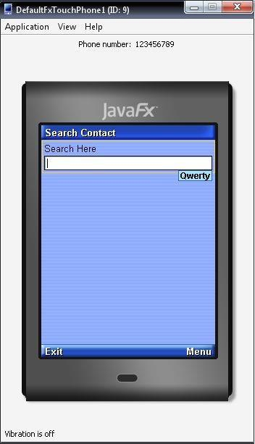
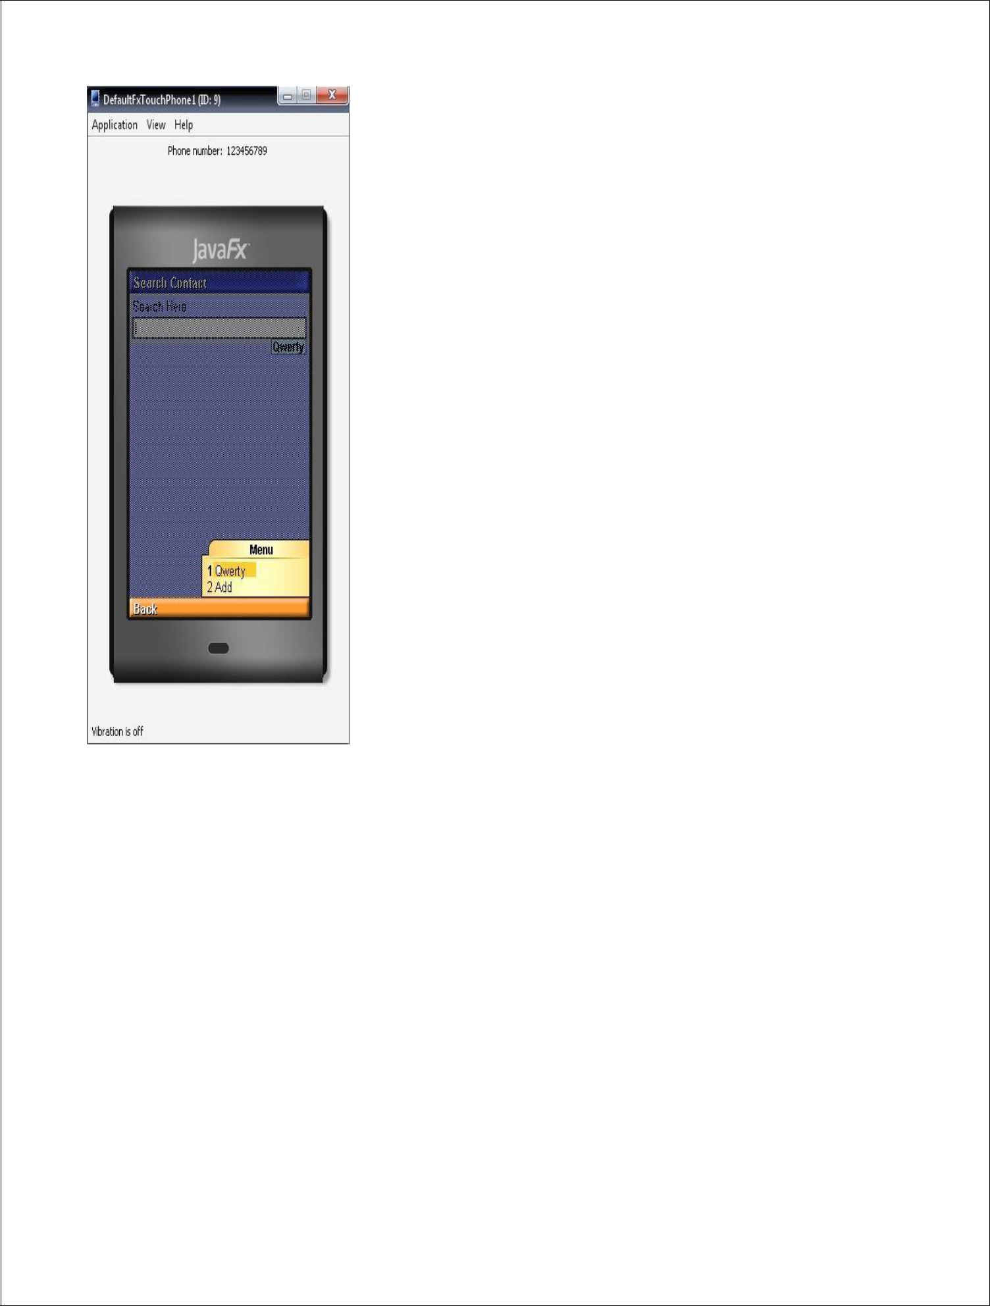
Simulation of Authentication and encryption technique used in GSM

AIM:

To study the simulation of authentication and encryption technique used in GSM

Introduction

Authentication - Whenever a MS requests access to a network, the network must authenticate the MS. Authentication verifies the identity and validity of the SIM card to the network and ensures that the subscriber is authorized access to the network.

Encryption - In GSM, encryption refers to the process of creating authentication and ciphering crypto-variables using a special key and an encryption algorithm.

Ciphering - Ciphering refers to the process of changing plaintext data into encrypted data using a special key and a special encryption algorithm. Transmissions between the MS and the BTS on the Um link are enciphered.

Ki - The Ki is the individual subscriber authentication key. It is a 128-bit number that is paired with an IMSI when the SIM card is created. The Ki is only stored on the SIM card and at the Authentication Center (AuC). The Ki will never be transmitted across the network on any link.

RAND - The RAND is a random 128-bit number that is generated by the AuC when the network requests to authenticate a subscriber. The RAND is used to generate the Signed Response (SRES) and Kc crypto-variables.

Signed Response - The SRES is a 32-bit crypto-variable used in the authentication process. The MS is challenged by being given the RAND by the network, the SRES is the expected correct response. The MS receives the RAND as a challenge and uses it to calculate the SRES. The SRES is passed up to the network to as a response to the challenge.

A3 Algorithm - The A3 algorithm computes a 32-bit Signed Response (SRES). The Ki and RAND are inputted into the A3 algorithm and the result is the 32-bit SRES. The A3 algorithm resides on the SIM card and at the AuC.

A8 Algorithm - The A8 algorithm computes a 64-bit ciphering key (Kc). The Ki and the RAND are inputted into the A8 algorithm and the result is the 64-bit Kc. The A8 algorithm resides on the ISM card and at the AuC.

COMP128 - A keyed hash function that combines the A3 and A8 algorithms into a single function. The 128-bit Ki and 128-bit RAND are input into the COMP128 which generates a 32-bit SRES and a 54-bit Kc in a single function. COMP128 is weak because it can give away information about the Ki.

Kc - The Kc is the 64-bit ciphering key that is used in the A5 encryption algorithm to encipher
and decipher the data that is being transmitted on the Um interface.

A5 - The A5 encryption algorithm is used to encipher and decipher the data that is being transmitted on the Um interface. The Kc and the plaintext data are inputted into the A5 algorithm and the output is enciphered data. The A5 algorithm is a function of the Mobile Equipment (ME) and not a function of the SIM card. The BTS also makes use of the A5 algorithm.

There are three versions of the A5 algorithm:

A5/1 - The current standard for U.S. and European networks. A5/1 is a stream cipher.

A5/2 - The deliberately weakened version of A5/1 that is intended for export to non-western countries. A5/2 is a stream cipher.

A5/3 - A newly developed algorithm not yet in full use. A5/3 is a block cipher.

Triplets - The RAND, SRES, and Kc together are known as the Triplets. The AuC will send these three crypto-variables to the requesting MSC/VLR so it can authenticate and encipher.

Authentication Procedures

When a MS requests access to the network, the MSC/VLR will normally require the MS to authenticate. The MSC will forward the IMSI to the HLR and request authentication Triplets.

The network can have the MS authenticate whenever it wants and this can vary from network to network. The network can require the MS to authenticate every time an event is initiated (location update, mobile-originated call, mobile-terminated call, etc.), every so many events, or even after a certain time period has elapsed. The network will almost always require authentication whenever the MS moves into a new Location Area and does a Location update.
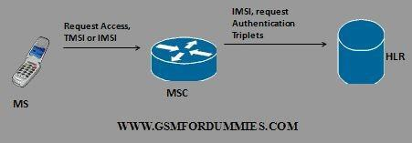

When the HLR receives the IMSI and the authentication request, it first checks its database to make sure the IMSI is valid and belongs to the network. Once it has accomplished this, it will forward the IMSI and authentication request to the Authentication Center (AuC).
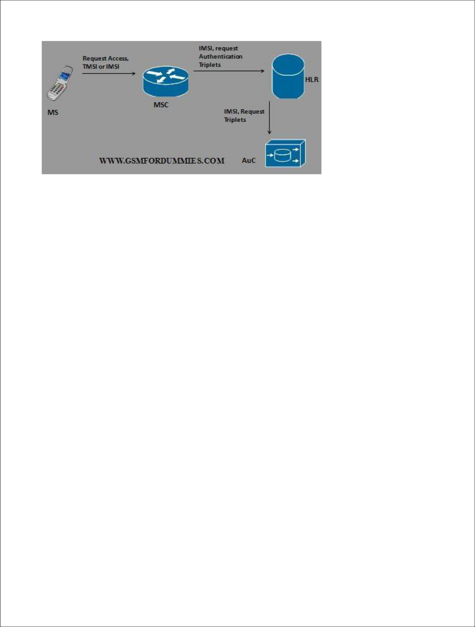

The AuC will use the IMSI to look up the Ki associated with that IMSI. The Ki is the individual subscriber authentication key. It is a 128-bit number that is paired with an IMSI when the SIM card is created. The Ki is only stored on the SIM card and at the AuC. The Auc will also generate a 128-bit random number called the RAND.
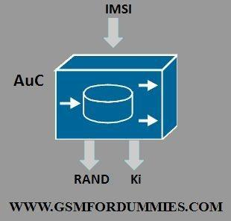

The RAND and the Ki are inputted into the A3 encryption algorithm. The output is the 32-bit Signed Response (SRES). The SRES is essentially the "challenge" sent to the MS when authentication is requested.
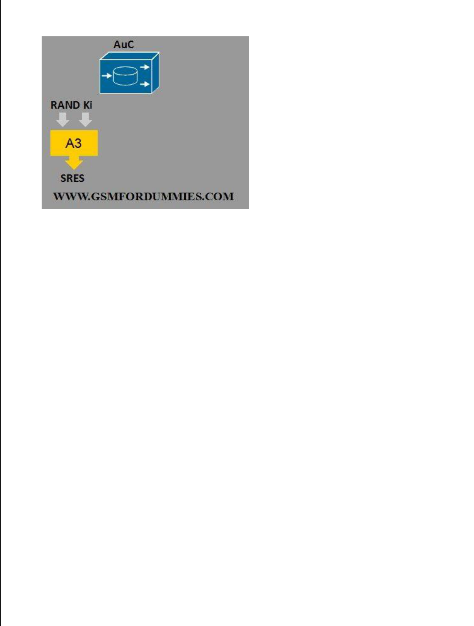

The RAND, SRES, and Kc are collectively known as the Triplets. The AuC may generate many sets of Triplets and send them to the requesting MSC/VLR. This is in order to reduce the signaling overhead that would result if the MSC/VLR requested one set of triplets every time it wanted to authenticate the MS. It should be noted that a set of triplets is unique to one IMSI, it can not be used with any other IMSI.
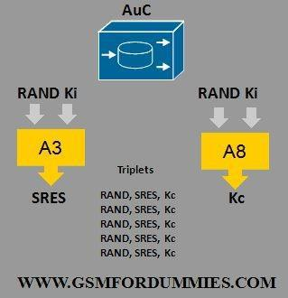

The MS has the Ki stored on the SIM card. The A3 and A8 algorithms also reside on the SIM card. The RAND and Ki are inputted into the A3 and A8 encryption algorithms to generate the SRES and the Kc respectively.
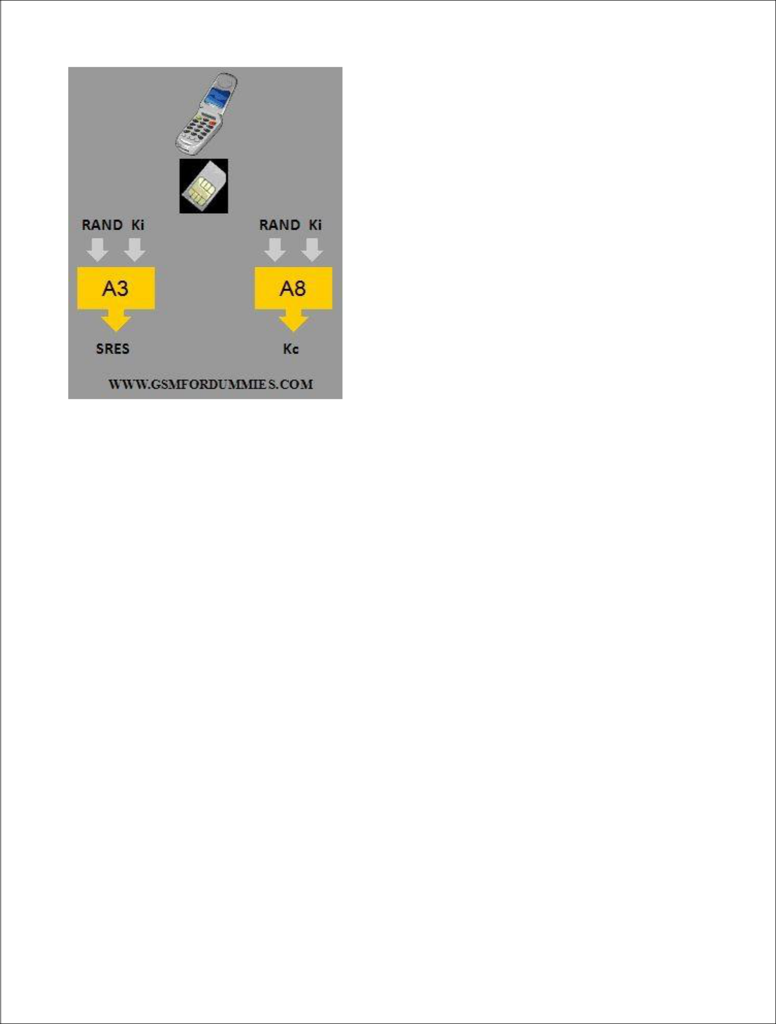

Ciphering Procedure

The MS stores the Kc on the SIM card and sends the generated SRES back to the network. The MSC receives the MS generated SRES and compares it to the SRES generated by the AuC. If they match, then the MS is authenticated.
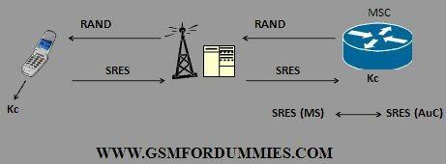

Once the MS is authenticated, the MSC passes the Kc to the BSS (the BTS to be specific), and orders the BTS and MS to switch to Cipher Mode. The Kc will never be passed on the Air Interface (Um), it will be stored at the BTS.
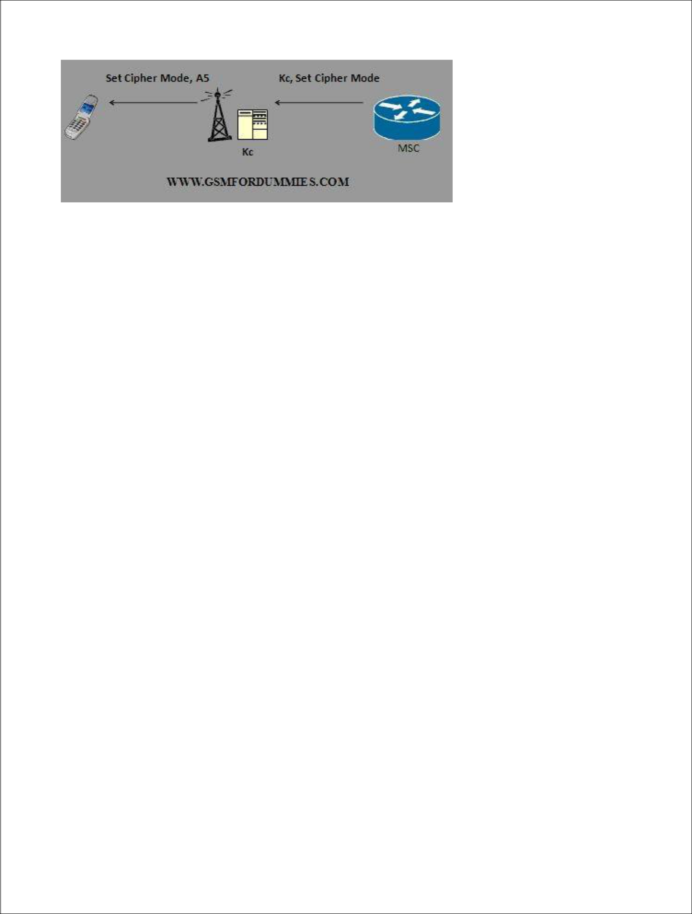

The BTS inputs the Kc and the data payload into the A5 encryption algorithm resulting in an enciphered data stream. The MS also inputs the Kc and the data payload into the A5 encryption algorithm resulting in an enciphered data stream. It should be noted that the A5 algorithm is a function of the Mobile Equipment (ME) and not the SIM card.
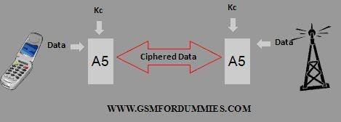

COMP128

COMP128 is a single keyed hash function that takes the place of the A3 and A8 algorithms and generates the SRES and Kc in a single function. The Ki and RAND are fed into the COMP128 hash and the result is a 32-bit SRES and a 54-bit Kc. Note that the A8 algorithm generates a 64-bit Kc. So it is obvious that the COMP128 hash generates a much weaker Kc.

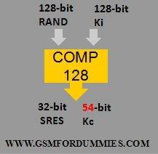
Browsing the Internet using Mobile phone simulator

Aim

To study the browsing of internet using mobile phone simulator.

Introduction

The rapid growth of Web services has led to a situation where companies and individuals rely more and more on material that is available on the Internet and intranets. Internet access is no longer limited to personal computers and powerful workstations in the office, but is reaching into the home, as well as on the road. A new class of electronics devices with Internet access capability called "Information Appliances" was recently born. This Internet access capability is embedded in devices such as televisions, set top boxes, home game machines, telephone-based terminals, PDAs, car navigation systems and cellular phones. As mobile phones become available for everyone as commodities, successful telephone based access to internet is becoming more and more important to improve individual productivity. However, hardware restriction, narrow bandwidth restriction and accessibility requirements are serious obstacle to the success of telephone based access to internet. The following sections analyze the requirement for telephone based access to internet, discussed existing and possible strategies for dealing with these limitations.
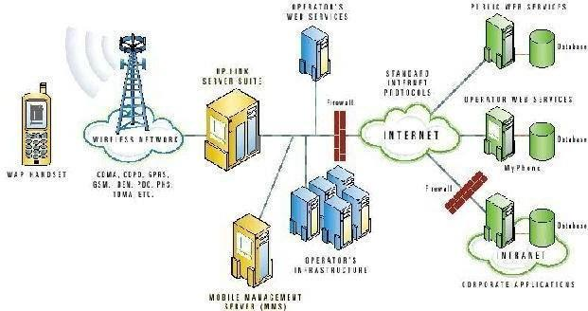

Phone.com's solution for telephone based access to Internet
Recommendations

Today, as the Internet and mobile phones are becoming part of people’s daily life, many commentators hope that the mobile Internet will be much easier to use. However, it’s probably not surprising to learn that people who use cell phones to gain access to the Web find the experience less than gratifying. The studies[6] conducted in this area found that phones themselves were not difficult to use, the fault lay with the wireless services.

One reason for the poor results is that designers have carried over too many designs from the Web rather than rethinking the interface specifically for the mobile medium. Actually, according to[3], there are many characteristics made mobile phone based access to Internet different from access to Internet from PC.

  - The hardware restrictions

    - small memory capacity

    - small display space

    - less powerful CPU

    - limited input method

    - no or small data storage

    - limited power consumption

  - The network bandwidth

    - slow speed

    - unstable

    - expensive

    - non-IP connection

- The Accessibility requirement

Simple and easy operations of information appliances are also very important. Unlike PC user interface, keyboard and mouse are not suitable for mobile devices. Rather, intuitive operation like a four-button interface (cursor forward, cursor back, select, and back buttons) is required. In this sense, some kind of accessibility considerations, should be taken into account.

All of these characteristics have to be taken into account in designing the user agent functionality for telephone based access to Internet. So the goal for the successful web page design is to:

- consider the characteristic of mobile environment, avoid copying web page design for PC, rewrite the content when necessary
- quickly provide personal and locally relevant information to users on the move

- make the site easy to mine and present information clearly

- make the users trust the source of information

- provide error prevention/error handling and help function to ease users’ anxiety in face of connection error or operation failure

Guidelines

It is not that difficult to learn how to use telephone to access Internet and remember those mobile phones' key functions. But, users usually encountered many lost connections and poor signposts when using the system. So to make telephone based access to Internet more successful, designers may consider the restrictions summarized above and the following principles from [3] and [5].

1. Small screen related design

(1) Use short openings to sum up everything that lies beyond

Displaying data on a small screen is never going to be easy. But the users made the basic principles clear. Most users, most of the time, are only online for a handful of minutes. Given this:

- The data must be easy to scan at a cursory level or quick to drill through.

- In terms of depth, designers should also let the users go deeper if they want (in which case, tell them how many pages they are letting themselves in for).

- Lastly, do not simply lift your information from a different media. The small screen makes it impossible for users to scroll or scan with any comfort.

  - Example: for news, this means

    - Clear one- or two-line headlines, a brief extract

    - And the option to click through to increasingly longer versions.

    - Also, these pages should be numbered so that users know what they are getting into (for example, "2 of 16")..

- Keep the content that appears above select and input fields to 1 or 2 lines max.

According to [6], content exceeding two lines may be truncated on smaller devices when used in conjunction with input and select fields (choice and entry cards). This may result in the loss of important information. Test your application on small-screen devices to make sure menu titles and input field can fit in the small screen of those devices.

(3) Avoid using style sheets

Usual mobile devices have small size of screens, and limited display capabilities, thus in many cases style sheets are not supported, or its support is limited. So, [3] gives the following principles,

  - Contents should be readable without style sheets so that devices which don't support style sheets can still render contents reasonably.

  - When style sheets are used, external style sheets are recommended from the viewpoint of content size and separation of structure and style. In this way, user agents which don't support style sheets don't have to load unnecessary style sheets.

- Avoid using tables, consider lists as alternative

  - points out that most mobile phones have small screens. If contents have table descriptions, it will be very difficult to browse them in mobile phones. In addition, though it would be possible to restructure tables in accessible way, it will be difficult for mobile devices to process complex tables due to the hardware restrictions. It would be, therefore, safe to avoid using tables whenever possible. Consider alternative structures, e.g. lists, whenever appropriate.

- Avoid using Frames

Usual mobile phones have small size of screens, and most of them support only textual information. According to [3], frames strongly depend on screen interface, therefore, should not be used.

If there is compelling reason to use frames, make sure that those contents have the descriptions below:

  - Provide a fallback content for contents that contain frames using NOFRAMES at the end of each FRAMESET.

  - Name each frame via the "title" attribute on FRAME elements so that users can keep track of frames by name.

- Avoid using images

On mobile phones, it cannot be generally assumed that images are always rendered, nor can be pointed by pointing devices like mouse. Therefore, [3] pointed out that server-side image maps should not be used. On the other hand, client-side image maps can be used even if images are not rendered nor can be pointed, so authors may include client-side image maps into their contents. But in many cases images are not rendered on mobile phones.

2. Design for better Navigation

(1) Design the Menus with small number of options

The networks and content providers often offer long lists of sites and services and try to provide everything a mobile phone user might want. But to the users, the long menus require much scrolling.

However, there are clear points as to how to better offer users data to read.

- One way is to make the menus hold only a small number of options. And keep the frequently used options appear first.

- Much more importantly, let the users customize their own menu so that their favorite sites or interests come up automatically.

- At the same time offer the users' clickable options that go deeper into areas that users want to know about, reduce the number of paths and present information clearly.
- Another method is to presents the list with numbers that act as accelerator shortcut keys, allowing users to select an option by pressing the corresponding number on the keypad rather than scrolling to it.

This means thinking ahead for the users. Create search paths that make sense to the users.

- Example: for weather forecast, this means:

  - Main menus could be more direct, offering options such as regional, national, or international weather

  - Submenus could show options for now, later, or long-range forecasts

  - Maps are a nice idea, but the screen size does not really allow for accurate detail information, such information must be designed to be delivered in text form.

Here is an example from WeatherOnline.co.uk (mobile phone simulator provided by www.wap.com)
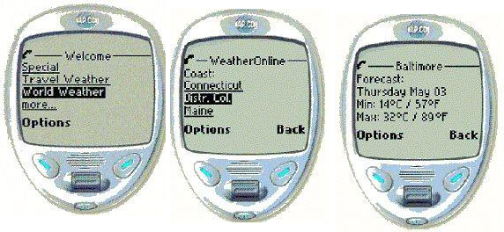

Main | Submenu for regions of | Weather information for Baltimore
Main | US | Weather information for Baltimore
menu | US

(2) Use simple and familiar phrases for labeling

Telling people what will happen before they click through to a new screen is a basic, long-established principle of Internet design[4]. It should also be applied to the design for mobile phones, where the screen real estate is particularly restricted. Simple descriptions should always be used instead of more enigmatic phrases. Thus users can simply find the information that they are looking for.

(3) Use the <prev> or <exit> tasks whenever navigating in the backward direction.

According to [5], The back button has become a fundamental part of the Internet. Users accept that they might find themselves on the wrong track and have to go back a few steps to choose a different path. If you link to a page the user has already visited (e.g., the application's main menu), be sure to navigate to the page by popping pages from the history stack instead of adding a redundant page to the history stack. This minimizes the risk of history stack overflow on memory-constrained devices, which can result in the user being unexpectedly returned to the subscriber homepage. Use the <prev> or <exit> tasks whenever navigating in the backward direction. Don't use the <go> task to navigate to a page that is already on the history stack.

[3][5] also provide the following design principles for Telephone based access to Internet.

3. Design to reduce the operation/waiting time

(1) Assign the most commonly chosen action or most intuitive task to the accept soft key.

Make it easy for users to select the most common action by pressing a single key -- the accept (OK) key. Don't force users to move the cursor before pressing the accept key (e.g., by making them navigate to some text anchor first).

(2) Ensure all decks are smaller than 500 bytes.

The download latency for very large decks (1500-2000 bytes) can be over 10 seconds. Wireless phone users perceive network latencies to be longer than they actually are, because consumer-grade devices are typically single-tasking devices (prohibiting users from performing other tasks on the device while waiting for content to load). To minimize network latencies, keep each deck as small as possible. The recommended guideline is 500 bytes or less per deck (encoded WML).

(3) Don't set a deck's expiration to a low value unless the content is highly volatile.

Setting a short expiration time for non-volatile deck (e.g., static application menus) may force users to reload the deck from the server even though the deck is already in the browser cache. Applications that optimize deck caching are perceived by users to be more efficient and less costly, since they minimize connection times over the wireless network. Short deck expiration values should only be set for highly volatile content (e.g., stock quotes).
4. Design to avoid Storage Limitation

(1) Avoid using Scripts, Event Handlers

Usual mobile devices have limitation of memory storage, CPU power and so on, thus in many cases scripting are not supported. It should not be assumed that scripts will always be executed. Contents should be readable even if scripts are not executed.

(2) Avoid using Forms

Usual mobile devices support basic forms, but they don't have keyboards like desktop PCs. Content authors should keep in mind that it will be hard for users of mobile devices to input many characters. Since mobile phones don't have local file systems, some features, which depend on local file system, such as file upload, should not be used.

5. Others for convenient usage and error prevention

(1) Keep soft key labels to 5 characters or less.

Many devices cannot display soft key labels that exceed 5 characters, and will truncate or abbreviate any labels that are longer.

(2) Use Wizards instead of forms.

By using a single card for each input of information, the user can follow a natural process of entering information. User studies show that wizards make for a better user experience than forms. Finally, avoid having a separate 'submit' card. The last 'ok' of the wizard should in fact be the 'submit' option. This avoids an unnecessary additional click.

- Use the format attribute to constrain text input fields to only allow valid character types

In some applications, text entry fields can employ character format constraints. These guide users to enter the required information. For example, if users must enter a credit card number of 16 digits, the entry field can be formatted to accept 16 characters exactly. Other formatting is also possible; for example, the browser can be limited to accept only numeric entries. Use format="NNNNN" for US zip code fields.

(4) Assigning access keys via "accesskey" attribute

In general, it cannot be assumed that input methods which consist of a (full) keyboard and a pointing device such as mouse are available in mobile phones. It is desirable that description for efficient use of input methods on mobile devices are provided in contents. From this viewpoint, assigning access keys via "accesskey" attribute (for A, AREA, BUTTON, INPUT, LABEL, LEGEND and TEXTAREA elements) will be effective when it is available. This may improve
accessibility of links or form related operations.

But the use of "accesskey" attribute needs careful consideration.

- In many mobile devices, available keys are limited. It cannot be assumed that all keys in "full" keyboards are available.

- Available keys differ among mobile devices. For example, cell phones will usually have "0"-"9", "*" and "#" keys, but the same assumption cannot be applied for most pagers or mobile game machines.

- There may be some mobile devices that cannot use "accesskey" attribute at all. For example, devices only for voice browsing will not use access "keys". Content authors should not rely on access keys for navigation.

Websites

According to Dr. Jakob Nielsen, a former researcher at Bell Communications Research (Bellcore) and at Sun Microsystems: No WAP web site is well designed. "The only wireless service that I think is fairly good is not a WAP service: the Vindigo restaurant guide for the Palm Pilot. It makes great use of the touch screen, to really make it pretty easy to navigate and find the restaurant reviews. It's good because it solves a mobile problem: I'm out at a meeting or trade show or whatever and I've got to find a good Chinese restaurant within three blocks of where I am."

Wireless may be getting off to a slow start, but that's not stopping the wireless world from

gearing up for the revolution. Mobilehomer.com (www.mobilehomer.com) has pioneered a site

for WAP devices based on the Global Positioning System (GPS). Cinema Electric

(www.cinemaelectric.com) is developing a site for wireless devices that will beam short,

personalized films to users. Phone.com is a company dedicated to wireless service and it can

provide a better designed web page for mobile device. Its produce Openwave™ Mobile Browser

is a microbrowser optimized for mobile phones and other mobile information appliances that use

mobile communication networks for information access. The following are two example displays

by Mobile Browser.

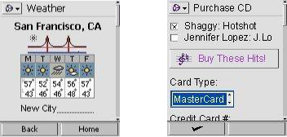

example for | example for m-commerce
weather forecast

Another example is yell.com. It is a site for UK Yellow Pages and has a large section devoted to the WAP service. (mobile phone simulator provided by

www.wap.com)

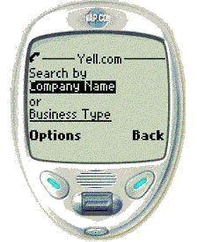

The advantages of its WAP version are:

- It uses the short openings to sum up everything that lies beyond, the first main page gives only the option to search by either company name or business type

- The system is quick and accurate in returning results. If there are several places with the same or similar name, users are given the options to choose from

- It shunned the option as on its web site to narrow down by successive sub-categories

- It reduces the number of clicks needed but guessing from what users enter, what sort of categories the users are interested in. Users can then select from the shortlist returned
- Back links at the bottom of every page are sensibly included

- The design of the site is not so sophisticated that it works well with all browsers, especially that the logo is optimized to fit neatly onto the screen of every phone.
- The combination of text entry and then scrollable selections is one of the best listings service so far.

Conclusions and future work

According to the studies conducted in the area of telephone based access to Internet, in terms of the five attributes of usability—learnability, efficiency, memorability, errors, and satisfaction—mobile phones did not perform very well. WAP-enabled phones are not that difficult to learn to use. The proper design strategies are the keys to improve the mobile phone service quantity.

Site designers should not simply copy the content, they should better take the restrictions of mobile phones into account, redesign the content for small screen devices and select the proper mobile phone based application to make the mobile phones quickly provide personal and locally relevant information to a user on the move. They should also test the results before unleashing their sites on unsuspecting users.
Study of GlomoSim Simulator

Aim:

To study the concept of Glomo sim Simulator.

- Introduction to GloMoSim.

- Introduction

With GloMoSim we are building a scalable simulation environment for wireless network systems. It is being designed using the parallel discrete-event simulation capability provided by Parsec.

Most network systems are currently built using a layered approach that is similar to the OSI seven layer network architecture. The plan is to build GloMoSim using a similar layered approach. Standard APIs will be used between the different simulation layers. This will allow the rapid integration of models developed at different layers by different people. The goal is to build a library of parallelized models that can be used for the evaluation of a variety of wireless network protocols. The proposed protocol stack will include models for the channel, radio, MAC, network, transport, and higher layers.

1.1 Network Gridding

The simple approach to designing a network simulation would be to initialize each network node in the simulation as a Parsec entity. We can view different entity initializations as being separate logical processes in the system. Hence each entity initialization requires its own stack space in the runtime. In GloMoSim, we are trying to build a simulation that will scale to thousands of nodes. If we have to instantiate an entity for each node in the runtime, the memory requirements would increase dramatically. The performance of the system would also degrade rapidly. Since there are so many entities in the simulation, the runtime would need to constantly context switch among the different entities in the system. This will cause significant degradation in the performance of the simulation. Hence initializing each node as a separate entity will inherently limit the scalability and performance of the simulation.

To circumvent these problems network gridding was introduced into the simulation. With network gridding, a single entity can simulate several network nodes in the system. A separate data structure representing the complete state of each node is maintained within the entity. Similarly we need to maintain the right level of abstraction. When the simulation code of a particular node is being executed it should not have access to the data structures of the other nodes in the simulation. The network gridding technique means that we can increase the number of nodes in the system while maintaining the same number of entities in the simulation. In fact, the only requirement is that we need only as many entities as the number of processors
on which the simulation is being run. Hence if we are running a sequential simulation we need to initialize only one entity in the system. We also don't meet the memory or context switching problems that limit the simulation.

In GloMoSim, each entity represents a geographical area of the simulation. Hence the network nodes which a particular entity represents are determined by the physical position of the nodes.

Suppose we specify the following in the input file:

#

SIMULATION-RANGE-X 100

SIMULATION-RANGE-Y 100

#

- Number of partitions in x and y range.

PARTITION-NUM-X 2 PARTITION-NUM-Y 2

We would now have a simulation are of size (100 * 100). We would also have 4 partitions (each partition is represented by a single entity) in the simulation. So one partition would encompass the square area represented by the coordinates (0, 0), (49, 0), (0, 49), and (49, 49).

1.2 Layered Structure

Since we are building GloMoSim using a layered approach, we would like to have the ability to rapidly integrate models developed at different layers by different people. Hence the simple approach here would seem to be that each layer in the simulation would be represented by a different Parsec entity. We would still have the same problem that we had previously. As the number of layers in the simulation increases, the number of entities in the simulation would also increase. This would lead to scalability and performance problems in the simulation. But this is not as dramatic since there are only a few layers in the simulation. But there are other reasons why we need to aggregate the layers into a single entity.

Often times, different layers of the simulation need to access certain common variables. For example, the upper layers of the simulation need to use the CPU when they are executing any instructions. But CPU is a shared resource among these layers. Hence, before executing any instructions a layer has to make sure that the CPU is free. Hence the upper layers need to have access to common variables which will provide information about the state of the CPU. If these layers are kept as different entities in the simulation we don't have a way of accessing shared variables. Besides we don't want to use any global variables as they can create problems for parallel execution.

If the layers are kept as different entities, each layer also has to explicitly keep track of the "ename" value for the upper and lower layers. These "ename" values are needed for message passing among the various layers. For parallel conservative runtime, each entity also has to specify the source and destination set as well as the lookahead values for the entity. Specifying
lookahead for an entity can become very complicated. All this creates additional work for the developer who is basically interested in modeling a particular network protocol.

For these reasons, we decided to integrate the various GloMoSim layers into a single entity. Each entity now encompasses all the layers of a simulation. Instead each layer is now implemented as functions in the new design. We provide an initialization function that will be called for each layer of each node at the beginning of the simulation. We provide functions that can be used to send messages between the layers. When a layer receives a particular message, it will automatically invoke a function that is provided by the developer of that particular layer. And based on the contents of the message, the function can then execute the appropriate instructions. At the end of the simulation, a function is also called for each layer of each node. A layer can use this function to collect any relevant statistics. An actual implementation of a particular layer will be shown shortly.

- Directory Structure of GloMoSim.

After downloading and upzipping GloMoSim, it should contain the following directories:

/applicaiton contains code for the application layer /bin for executable and input/output files

/doc contains the documentation /include contains common include files /mac contains the code for the mac layer /main contains the basic framework design /network contains the code for the network layer /radio contains the code for the physical layer /transport contains the code for the transport layer

You have to compile the files from the main/ directory.

- Run "make depend" to create list of depndencies in the Makefile.

- Make sure that the right path for the Parsec compiler is specified in the Makefile

for the "PAR" variable.

- Run "make" to create the executable

You can also use Makent.bat for compiling in batch mode (for NT).

To run the simulation you have to go to the bin/ directory. The executable is called "Sim". It taked only one command line paramter, which is an input file. An example input file is CONFIG.IN in bin/ directory. Run "Sim CONFIG.IN" to run the program. A file called "GLOMO.STAT" is produced at the end of the simulation and contains all the statistics generated by the simulation. Make modifications to CONFIG.IN to vary the parameters for running the simulation.

3. Description of input file.

This section explains the various parameters which are part of the input file supplied to the GloMoSim executable. In the input file anything following a "#" is treated as a comment. Note that some parameters presented in this section may not be valid in the latest GloMoSim library
as we keep updating the library to be configured easily. The "config.in" file included in the distribution should be the most up-to-date configuration file and used as a template file.

The following two parameters stand for the physical terrain in which the nodes are being simulated. For example, the following represents an area of size 100 meters by 100 meters. All range parameters are in terms of meters.

#

- Terrain Area we are simulating. TERRAIN-RANGE-X 100 TERRAIN-RANGE-Y 100

The following parameter represents the power range of wireless nodes in the simulation. For example, a node can reach any other node within 50 meters of its position.

#

POWER-RANGE 50

#

The following is a random number seed used to initialize part of the seed of various randomly generated numbers in the simulation. This can be used to vary the seed of the simulation to see the consistency of the results of the simulation.

#

SEED 1

#

The following parameter represents the maximum simulation time. The numbered portion can be followed by optional letters to modify the simulation time.

For example:

100NS - 100 nano-seconds

100MS - 100 milli-seconds

100S - 100 seconds

100 - 100 seconds (default case)

100M - 100 minutes

100H - 100 hours

100D - 100 days

#

SIMULATION-TIME 100M

#

The following parameter represents the number of nodes being simulated.
#

NUMBER-OF-NODES 12

#

Conclusion:

Here the glomo simulator has been evaluated with the range of small time manipulation.

So every part of delivery standards can be modified easily,.

