1Q.which architecture do you have in your project(2-Tier or 3-Tier)

3-Tier architecture.

2Q.Difference between 2-Tier and 3-tier architecture.

# Two-Tier Architecture:

The two-tier is based on Client Server architecture. The two-tier architecture is like client server application. The direct communication takes place between client and server. There is no intermediate between client and server. Because of tight coupling a 2 tiered application will run faster.

[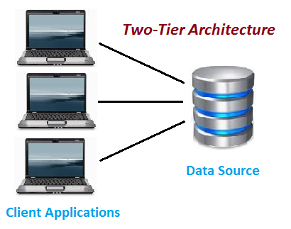](http://www.softwaretestingclass.com/what-is-difference-between-two-tier-and-three-tier-architecture/two-tier-architecture/)

Two-Tier Architecture

The above figure shows the architecture of two-tier. Here the direct communication between client and server, there is no intermediate between client and server.

The Two-tier architecture is divided into two parts:

**1) Client Application (Client Tier)  
2) Database (Data Tier)**

On client application side the code is written for saving the data in the SQL server database. Client sends the request to server and it process the request & send back with data. **The main problem of two tier architecture is the server cannot respond multiple request same time, as a result it cause a data integrity issue**.

**Advantages:**

1. Easy to maintain and modification is bit easy
2. Communication is faster

**Disadvantages**:

1. In two tier architecture application performance will be degrade upon increasing the users.
2. Cost-ineffective

**Three-Tier Architecture:**

**Three-tier architecture** typically comprise a presentation tier, a business or data access tier, and a data tier. Three layers in the three tier architecture are as follows:

**1) Client layer**  
**2) Business layer**  
**3) Data layer**

**1) Client layer:**

It is also called as *Presentation layer* which contains UI part of our application. This layer is used for the design purpose where data is presented to the user or input is taken from the user. For example designing registration form which contains text box, label, button etc.

**2) Business layer:**

In this layer all business logic written like validation of data, calculations, data insertion etc. This acts as a interface between Client layer and Data Access Layer. This layer is also called the intermediary layer helps to make communication faster between client and data layer.

**3) Data layer:**

In this layer actual database is comes in the picture. Data Access Layer contains methods to connect with database and to perform insert, update, delete, get data from database based on our input data.

[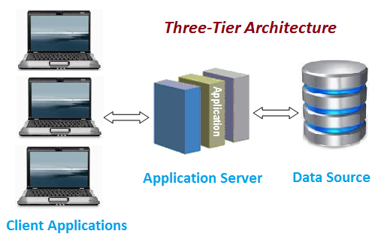](http://www.softwaretestingclass.com/what-is-difference-between-two-tier-and-three-tier-architecture/three-tier-architecture/)

Three-tier Architecture

**Advantages**

1. High performance, lightweight persistent objects
2. Scalability – Each tier can scale horizontally
3. Performance – Because the Presentation tier can cache requests, network utilization is minimized, and the load is reduced on the Application and Data tiers.
4. High degree of flexibility in deployment platform and configuration
5. Better Re-use
6. Improve Data Integrity
7. Improved Security – Client is not direct access to database.
8. Easy to maintain and modification is bit easy, won’t affect other modules
9. In three tier architecture application performance is good.

**Disadvantages**

1. Increase Complexity/Effort

This is the common Question asked in the Interview. Hope this article helped you understanding Two-Tier and Three-Tier

3Q.In JMS if messages are not delivered from source to destination in such case where jms stores those messages?

A: JMS –SERVER

4Q. if ssl certificate fails does application run or not?

A:application will run but the crucial original data won’t be encrypted [ the account details(username password) so the hackers may hack the details.]

5Q.how to troubleshoot after patching if application won’t work. Is there any reason?

A: if application won’t work first we need to clear the cache and then we need to do the patching.it will work if not we need to check the file extentions .

6Q. how global transaction will work?

Global transaction involve multiple databases

If data is saved in all data bases then only data will be **commited**

If data is not saved even in any one of the databases then the data will be **rollback**ed(removed) from the dbs in which it has saved.

7Q.how do we configure and run multiple servers in jboss?

A: using **offset** parameter we can configure multiple servers in jboss

8Q.what is the use of prefork and worker use in jboss.

A: it’s role is to distribute the requests among the jboss servers.

9Q.if request comes to webserver and if we change the port of app server then is the request goes to webserver or not.

A: there is no impact on webserver bcoz first request will comes to webserver then only it will goes to app serve r

10Q. Sed command

11Q . how to replace a word in multiple files at a time?

A: using sed sed –i “s/old-word/new-word/g” file1 file2 file3 …….

12Q. what is the difference between # and $

A: when we login to the root user # will come

If we login with normal user we will get $ symbol

13. how to copy a file to remote system with out change the date and time stamp.

Scp –p file-name username@ip:path (in local we can use cp -pr)

14.how to know how many cpu’s are there in the system

A: **cpu cores** option will give that information(cat /proc/cpuinfo command we need to use that will give cpucores information)