Program No: 1 | Date: 29/06/2026
Program Title: Create an app that displays name and email id.
MainActivity.java:
package com.example.labcycle;
import android.annotation.SuppressLint;
import android.os.Bundle;
import androidx.activity.EdgeToEdge;
import androidx.appcompat.app.AppCompatActivity;
import androidx.core.graphics.Insets;
import androidx.core.view.ViewCompat;
import androidx.core.view.WindowInsetsCompat;
import android.view.View;
import android.widget.EditText;
import android.widget.Button;
import android.widget.TextView;
public class MainActivity extends AppCompatActivity {
EditText name,email;
Button btn;
TextView t1,t2;
@SuppressLint("MissingInflatedId")
@Override
protected void onCreate(Bundle savedInstanceState) {
super.onCreate(savedInstanceState);
EdgeToEdge.enable(this);
setContentView(R.layout.activity_main);
name = findViewById(R.id.nametxt);
email = findViewById(R.id.emailTxt);
btn = findViewById(R.id.btnclick);
t1 = findViewById(R.id.txtView1);
t2 = findViewById(R.id.txtView2);
btn.setOnClickListener(new View.OnClickListener(){
@Override
public void onClick(View view) {
String n1 = name.getText().toString();
String n2 = email.getText().toString();
t1.setText(n1);
t2.setText(n2);
}
});
}
}
activity_main.xml:
<?xml version="1.0" encoding="utf-8"?>
<androidx.constraintlayout.widget.ConstraintLayout
xmlns:android="http://schemas.android.com/apk/res/android"
xmlns:app="http://schemas.android.com/apk/res-auto"
android:layout_width="match_parent"
android:layout_height="match_parent">
<EditText
android:id="@+id/nametxt"
android:layout_width="250dp"
android:layout_height="wrap_content"
android:hint="Name"
app:layout_constraintTop_toTopOf="parent"
app:layout_constraintStart_toStartOf="parent"
app:layout_constraintEnd_toEndOf="parent"
android:layout_marginTop="150dp"/>
<EditText
android:id="@+id/emailTxt"
android:layout_width="250dp"
android:layout_height="wrap_content"
android:hint="Email"
app:layout_constraintTop_toBottomOf="@id/nametxt"
app:layout_constraintStart_toStartOf="parent"
app:layout_constraintEnd_toEndOf="parent"
android:layout_marginTop="16dp"/>
<Button
android:id="@+id/btnclick"
android:layout_width="wrap_content"
android:layout_height="wrap_content"
android:text="Click"
app:layout_constraintTop_toBottomOf="@id/emailTxt"
app:layout_constraintStart_toStartOf="parent"
app:layout_constraintEnd_toEndOf="parent"
android:layout_marginTop="20dp"/>
<TextView
android:id="@+id/txtView1"
android:layout_width="wrap_content"
android:layout_height="wrap_content"
android:text="Name"
app:layout_constraintTop_toBottomOf="@id/btnclick"
app:layout_constraintStart_toStartOf="parent"
app:layout_constraintEnd_toEndOf="parent"
android:layout_marginTop="30dp"/>
<TextView
android:id="@+id/txtView2"
android:layout_width="wrap_content"
android:layout_height="wrap_content"
android:text="Email"
app:layout_constraintTop_toBottomOf="@id/txtView1"
app:layout_constraintStart_toStartOf="parent"
app:layout_constraintEnd_toEndOf="parent"
android:layout_marginTop="10dp"/>
</androidx.constraintlayout.widget.ConstraintLayout>
Output:
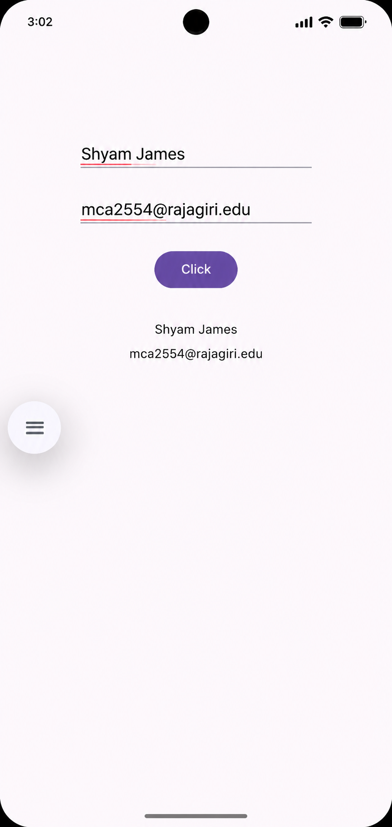

Program No: 2 | Date: 29/06/2026
Program Title: Create an app that takes marks of any three subjects from the user and displays its sum and average.
MainActivity.java:
package com.example.labcycle;
import android.annotation.SuppressLint;
import android.os.Bundle;
import androidx.activity.EdgeToEdge;
import androidx.appcompat.app.AppCompatActivity;
import androidx.core.graphics.Insets;
import androidx.core.view.ViewCompat;
import androidx.core.view.WindowInsetsCompat;
import android.view.View;
import android.widget.EditText;
import android.widget.Button;
import android.widget.TextView;
public class MainActivity extends AppCompatActivity {
EditText m1, m2, m3;
Button btn;
TextView t1, t2;
@SuppressLint("MissingInflatedId")
@Override
protected void onCreate(Bundle savedInstanceState) {
super.onCreate(savedInstanceState);
EdgeToEdge.enable(this);
setContentView(R.layout.activity_main);
m1 = findViewById(R.id.mark1);
m2 = findViewById(R.id.mark2);
m3 = findViewById(R.id.mark3);
btn = findViewById(R.id.btncal);
t1 = findViewById(R.id.textView4);
t2 = findViewById(R.id.textView5);
btn.setOnClickListener(new View.OnClickListener() {
@Override
public void onClick(View view) {
int n1 = Integer.parseInt(m1.getText().toString());
int n2 = Integer.parseInt(m2.getText().toString());
int n3 = Integer.parseInt(m3.getText().toString());
int sums = n1 + n2 + n3;
int avg = sums / 3;
t1.setText("Sum is " + sums);
t2.setText("Average is " + avg);
}
});
}
}
activity_main.xml:
<?xml version="1.0" encoding="utf-8"?>
<androidx.constraintlayout.widget.ConstraintLayout
xmlns:android="http://schemas.android.com/apk/res/android"
xmlns:app="http://schemas.android.com/apk/res-auto"
xmlns:tools="http://schemas.android.com/tools"
android:layout_width="match_parent"
android:layout_height="match_parent">
<EditText
android:id="@+id/mark1"
android:layout_width="wrap_content"
android:layout_height="wrap_content"
android:layout_marginEnd="92dp"
android:layout_marginBottom="43dp"
android:ems="10"
android:inputType="number"
android:text="mark1"
app:layout_constraintBottom_toTopOf="@+id/mark2"
app:layout_constraintEnd_toEndOf="parent" />
<EditText
android:id="@+id/mark2"
android:layout_width="wrap_content"
android:layout_height="wrap_content"
android:layout_marginEnd="91dp"
android:layout_marginBottom="40dp"
android:ems="10"
android:inputType="number"
android:text="mark2"
app:layout_constraintBottom_toTopOf="@+id/mark3"
app:layout_constraintEnd_toEndOf="parent" />
<EditText
android:id="@+id/mark3"
android:layout_width="wrap_content"
android:layout_height="wrap_content"
android:layout_marginEnd="85dp"
android:layout_marginBottom="48dp"
android:ems="10"
android:inputType="numberSigned"
android:text="mark3"
app:layout_constraintBottom_toTopOf="@+id/btncal"
app:layout_constraintEnd_toEndOf="parent" />
<Button
android:id="@+id/btncal"
android:layout_width="wrap_content"
android:layout_height="wrap_content"
android:layout_marginEnd="182dp"
android:layout_marginBottom="49dp"
android:text="Button"
app:layout_constraintBottom_toTopOf="@+id/textView4"
app:layout_constraintEnd_toEndOf="parent" />
<TextView
android:id="@+id/textView4"
android:layout_width="wrap_content"
android:layout_height="wrap_content"
android:layout_marginEnd="202dp"
android:layout_marginBottom="160dp"
android:text="TextView"
app:layout_constraintBottom_toBottomOf="parent"
app:layout_constraintEnd_toEndOf="parent" />
<TextView
android:id="@+id/textView5"
android:layout_width="wrap_content"
android:layout_height="wrap_content"
android:layout_marginEnd="200dp"
android:layout_marginBottom="120dp"
android:text="TextView"
app:layout_constraintBottom_toBottomOf="parent"
app:layout_constraintEnd_toEndOf="parent" />
</androidx.constraintlayout.widget.ConstraintLayout>
Output:
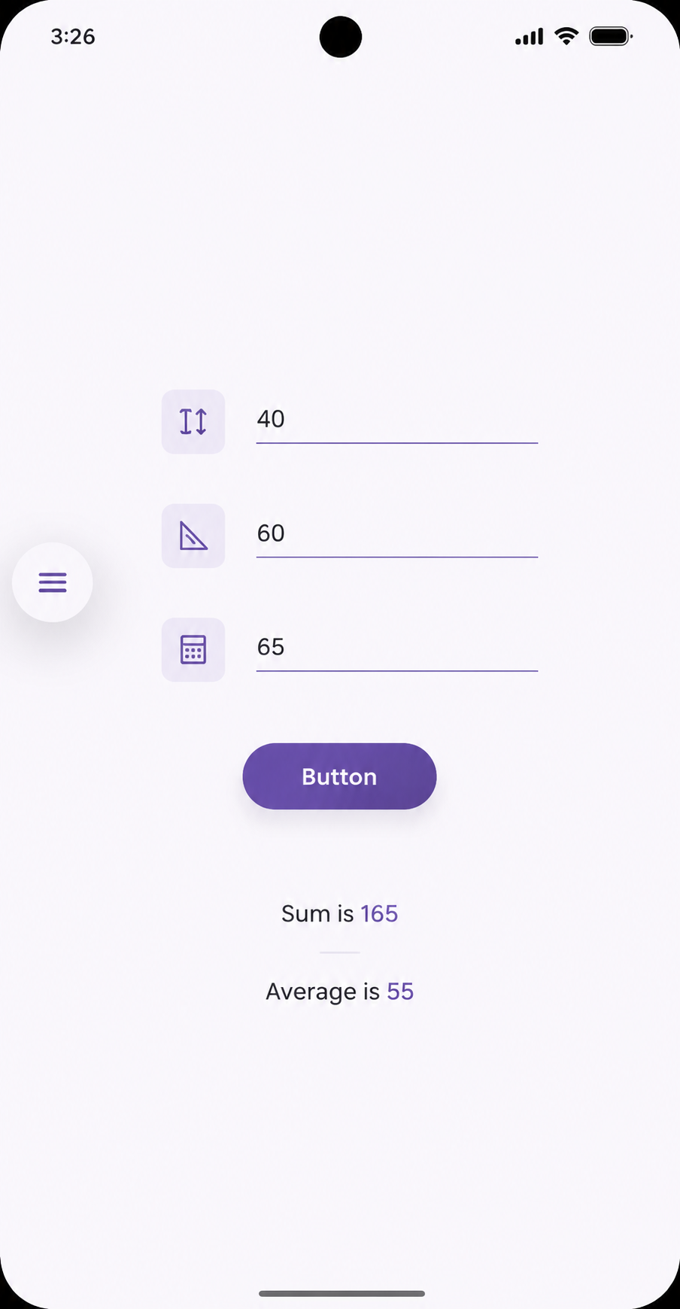

Program No: 3 | Date: 29/06/2026
Program Title: Create suitable apps to design the different layouts of the androidstudio.
MainActivity.java:
package com.example.labcycle;
import android.os.Bundle;
import android.widget.Button;
import android.widget.Toast;
import androidx.appcompat.app.AppCompatActivity;
public class MainActivity extends AppCompatActivity {
Button button1, button2, button3;
@Override
protected void onCreate(Bundle savedInstanceState) {
super.onCreate(savedInstanceState);
setContentView(R.layout.activity_main);
button1 = findViewById(R.id.button1);
button2 = findViewById(R.id.button2);
button3 = findViewById(R.id.button3);
button1.setOnClickListener(v ->
Toast.makeText(this, "LinearLayout Button 1", Toast.LENGTH_SHORT).show());
button2.setOnClickListener(v ->
Toast.makeText(this, "LinearLayout Button 2", Toast.LENGTH_SHORT).show());
button3.setOnClickListener(v ->
Toast.makeText(this, "RelativeLayout Button", Toast.LENGTH_SHORT).show());
}
}
activity_main.xml:
<?xml version="1.0" encoding="utf-8"?>
<ScrollView xmlns:android="http://schemas.android.com/apk/res/android"
android:layout_width="match_parent"
android:layout_height="match_parent">
<LinearLayout
android:layout_width="match_parent"
android:layout_height="wrap_content"
android:orientation="vertical"
android:padding="16dp">
<!-- LinearLayout -->
<TextView
android:layout_width="wrap_content"
android:layout_height="wrap_content"
android:text="Linear Layout"
android:textStyle="bold"
android:textSize="18sp"/>
<LinearLayout
android:layout_width="match_parent"
android:layout_height="wrap_content"
android:orientation="horizontal"
android:layout_marginBottom="20dp">
<Button
android:id="@+id/button1"
android:layout_width="0dp"
android:layout_height="wrap_content"
android:layout_weight="1"
android:text="Button 1"/>
<Button
android:id="@+id/button2"
android:layout_width="0dp"
android:layout_height="wrap_content"
android:layout_weight="1"
android:text="Button 2"/>
</LinearLayout>
<!-- RelativeLayout -->
<TextView
android:layout_width="wrap_content"
android:layout_height="wrap_content"
android:text="Relative Layout"
android:textStyle="bold"
android:textSize="18sp"/>
<RelativeLayout
android:layout_width="match_parent"
android:layout_height="120dp"
android:background="#DDDDDD"
android:layout_marginBottom="20dp">
<TextView
android:id="@+id/text1"
android:layout_width="wrap_content"
android:layout_height="wrap_content"
android:text="Top Left"/>
<Button
android:id="@+id/button3"
android:layout_width="wrap_content"
android:layout_height="wrap_content"
android:text="Bottom Right"
android:layout_alignParentBottom="true"
android:layout_alignParentEnd="true"/>
</RelativeLayout>
<!-- FrameLayout -->
<TextView
android:layout_width="wrap_content"
android:layout_height="wrap_content"
android:text="Frame Layout"
android:textStyle="bold"
android:textSize="18sp"/>
<FrameLayout
android:layout_width="match_parent"
android:layout_height="150dp"
android:background="#2196F3">
<TextView
android:layout_width="wrap_content"
android:layout_height="wrap_content"
android:text="FrameLayout Example"
android:textColor="#FFFFFF"
android:layout_gravity="center"/>
</FrameLayout>
</LinearLayout>
</ScrollView>
Output:
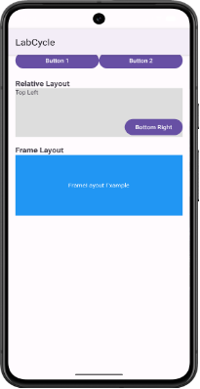

Program No: 4 | Date: 29/06/2026
Program Title: Develop a simple calculator app.
MainActivity.java:
package com.example.pg04_calculator;
import android.os.Bundle;
import androidx.activity.EdgeToEdge;
import androidx.appcompat.app.AppCompatActivity;
import androidx.core.graphics.Insets;
import androidx.core.view.ViewCompat;
import androidx.core.view.WindowInsetsCompat;
import android.widget.TextView;
import android.widget.Button;
import android.widget.EditText;
public class MainActivity extends AppCompatActivity {
TextView result;
Button ad, sub, div, mult;
EditText no1, no2;
@Override
protected void onCreate(Bundle savedInstanceState) {
super.onCreate(savedInstanceState);
EdgeToEdge.enable(this);
setContentView(R.layout.activity_main);
result = findViewById(R.id.result);
ad = findViewById(R.id.ad);
sub = findViewById(R.id.sub);
div = findViewById(R.id.div);
mult =findViewById(R.id.mult);
no1 = findViewById(R.id.no1);
no2 = findViewById(R.id.no2);
ad.setOnClickListener(v -> {
int a = Integer.parseInt(no1.getText().toString());
int b = Integer.parseInt(no2.getText().toString());
int res = a + b;
result.setText(res+"");
});
sub.setOnClickListener(v -> {
int a = Integer.parseInt(no1.getText().toString());
int b = Integer.parseInt(no2.getText().toString());
int res = a - b;
result.setText(res+"");
});
mult.setOnClickListener(v -> {
int a = Integer.parseInt(no1.getText().toString());
int b = Integer.parseInt(no2.getText().toString());
int res = a * b;
result.setText(res+"");
});
div.setOnClickListener(v -> {
int a = Integer.parseInt(no1.getText().toString());
int b = Integer.parseInt(no2.getText().toString());
if(b!=0) {
int res = a / b;
result.setText(res+"");
}
else
result.setText("Error: Divsion / 0");
});
}
}
activity_main.xml:
<?xml version="1.0" encoding="utf-8"?>
<androidx.constraintlayout.widget.ConstraintLayout xmlns:android="http://schemas.android.com/apk/res/android"
xmlns:app="http://schemas.android.com/apk/res-auto"
xmlns:tools="http://schemas.android.com/tools"
android:id="@+id/main"
android:layout_width="match_parent"
android:layout_height="match_parent"
tools:context=".MainActivity">
<TextView
android:layout_width="wrap_content"
android:layout_height="wrap_content"
android:text="Result: "
android:textSize="18sp"
app:layout_constraintBottom_toBottomOf="parent"
app:layout_constraintEnd_toEndOf="parent"
app:layout_constraintHorizontal_bias="0.252"
app:layout_constraintStart_toStartOf="parent"
app:layout_constraintTop_toTopOf="parent" />
<TextView
android:id="@+id/result"
android:layout_width="wrap_content"
android:layout_height="wrap_content"
android:textSize="18sp"
app:layout_constraintBottom_toBottomOf="parent"
app:layout_constraintEnd_toEndOf="parent"
app:layout_constraintHorizontal_bias="0.52"
app:layout_constraintStart_toStartOf="parent"
app:layout_constraintTop_toTopOf="parent" />
<EditText
android:id="@+id/no1"
android:layout_width="wrap_content"
android:layout_height="wrap_content"
android:ems="10"
android:hint="Enter First Number"
android:inputType="text"
app:layout_constraintBottom_toBottomOf="parent"
app:layout_constraintEnd_toEndOf="parent"
app:layout_constraintHorizontal_bias="0.437"
app:layout_constraintStart_toStartOf="parent"
app:layout_constraintTop_toTopOf="parent"
app:layout_constraintVertical_bias="0.228" />
<EditText
android:id="@+id/no2"
android:layout_width="wrap_content"
android:layout_height="wrap_content"
android:ems="10"
android:hint="Enter Second Number"
android:inputType="text"
app:layout_constraintBottom_toBottomOf="parent"
app:layout_constraintEnd_toEndOf="parent"
app:layout_constraintHorizontal_bias="0.437"
app:layout_constraintStart_toStartOf="parent"
app:layout_constraintTop_toTopOf="parent"
app:layout_constraintVertical_bias="0.355" />
<Button
android:id="@+id/ad"
android:layout_width="wrap_content"
android:layout_height="wrap_content"
android:text="Add"
app:layout_constraintBottom_toBottomOf="parent"
app:layout_constraintEnd_toEndOf="parent"
app:layout_constraintHorizontal_bias="0.275"
app:layout_constraintStart_toStartOf="parent"
app:layout_constraintTop_toTopOf="parent"
app:layout_constraintVertical_bias="0.655" />
<Button
android:id="@+id/sub"
android:layout_width="wrap_content"
android:layout_height="wrap_content"
android:text="Subtract"
app:layout_constraintBottom_toBottomOf="parent"
app:layout_constraintEnd_toEndOf="parent"
app:layout_constraintHorizontal_bias="0.64"
app:layout_constraintStart_toStartOf="parent"
app:layout_constraintTop_toTopOf="parent"
app:layout_constraintVertical_bias="0.655" />
<Button
android:id="@+id/mult"
android:layout_width="wrap_content"
android:layout_height="wrap_content"
android:text="Multiply"
app:layout_constraintBottom_toBottomOf="parent"
app:layout_constraintEnd_toEndOf="parent"
app:layout_constraintHorizontal_bias="0.275"
app:layout_constraintStart_toStartOf="parent"
app:layout_constraintTop_toTopOf="parent"
app:layout_constraintVertical_bias="0.78" />
<Button
android:id="@+id/div"
android:layout_width="wrap_content"
android:layout_height="wrap_content"
android:text="Division"
app:layout_constraintBottom_toBottomOf="parent"
app:layout_constraintEnd_toEndOf="parent"
app:layout_constraintHorizontal_bias="0.646"
app:layout_constraintStart_toStartOf="parent"
app:layout_constraintTop_toTopOf="parent"
app:layout_constraintVertical_bias="0.78" />
</androidx.constraintlayout.widget.ConstraintLayout>
Output:
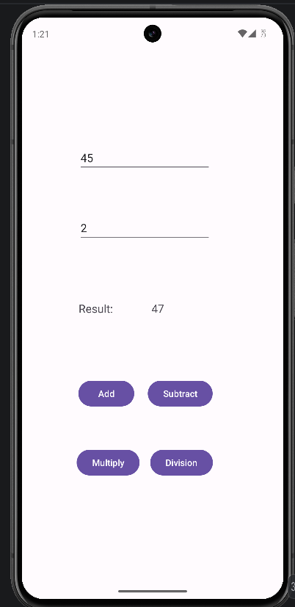 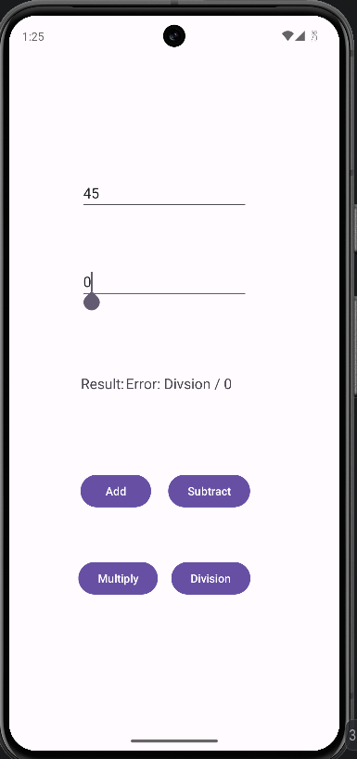

Program No: 5 | Date: 29/06/2026
Program Title: Create an app that changes text color when a button is clicked.
MainActivity.java:
package com.example.pg05_textcolor;
import android.graphics.Color;
import android.os.Bundle;
import androidx.activity.EdgeToEdge;
import androidx.appcompat.app.AppCompatActivity;
import androidx.core.graphics.Insets;
import androidx.core.view.ViewCompat;
import androidx.core.view.WindowInsetsCompat;
import android.widget.TextView;
import android.widget.Button;
public class MainActivity extends AppCompatActivity {
TextView name;
Button color;
@Override
protected void onCreate(Bundle savedInstanceState) {
super.onCreate(savedInstanceState);
EdgeToEdge.enable(this);
setContentView(R.layout.activity_main);
color = findViewById(R.id.color);
name = findViewById(R.id.name);
color.setOnClickListener(v -> {
name.setTextColor(Color.RED);
});
}
}
activity_main.xml:
<?xml version="1.0" encoding="utf-8"?>
<androidx.constraintlayout.widget.ConstraintLayout xmlns:android="http://schemas.android.com/apk/res/android"
xmlns:app="http://schemas.android.com/apk/res-auto"
xmlns:tools="http://schemas.android.com/tools"
android:id="@+id/main"
android:layout_width="match_parent"
android:layout_height="match_parent"
tools:context=".MainActivity">
<TextView
android:id="@+id/name"
android:layout_width="wrap_content"
android:layout_height="wrap_content"
android:text="Shyam"
android:textSize="24sp"
app:layout_constraintBottom_toBottomOf="parent"
app:layout_constraintEnd_toEndOf="parent"
app:layout_constraintHorizontal_bias="0.498"
app:layout_constraintStart_toStartOf="parent"
app:layout_constraintTop_toTopOf="parent"
app:layout_constraintVertical_bias="0.421" />
<Button
android:id="@+id/color"
android:layout_width="wrap_content"
android:layout_height="wrap_content"
android:text="Change Color"
app:layout_constraintBottom_toBottomOf="parent"
app:layout_constraintEnd_toEndOf="parent"
app:layout_constraintStart_toStartOf="parent"
app:layout_constraintTop_toTopOf="parent"
app:layout_constraintVertical_bias="0.613" />
</androidx.constraintlayout.widget.ConstraintLayout>
Output:
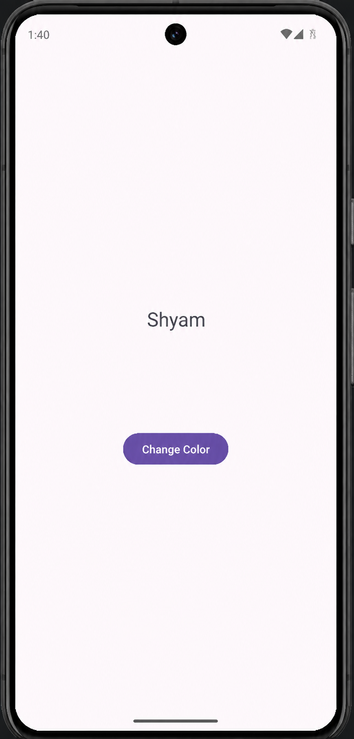 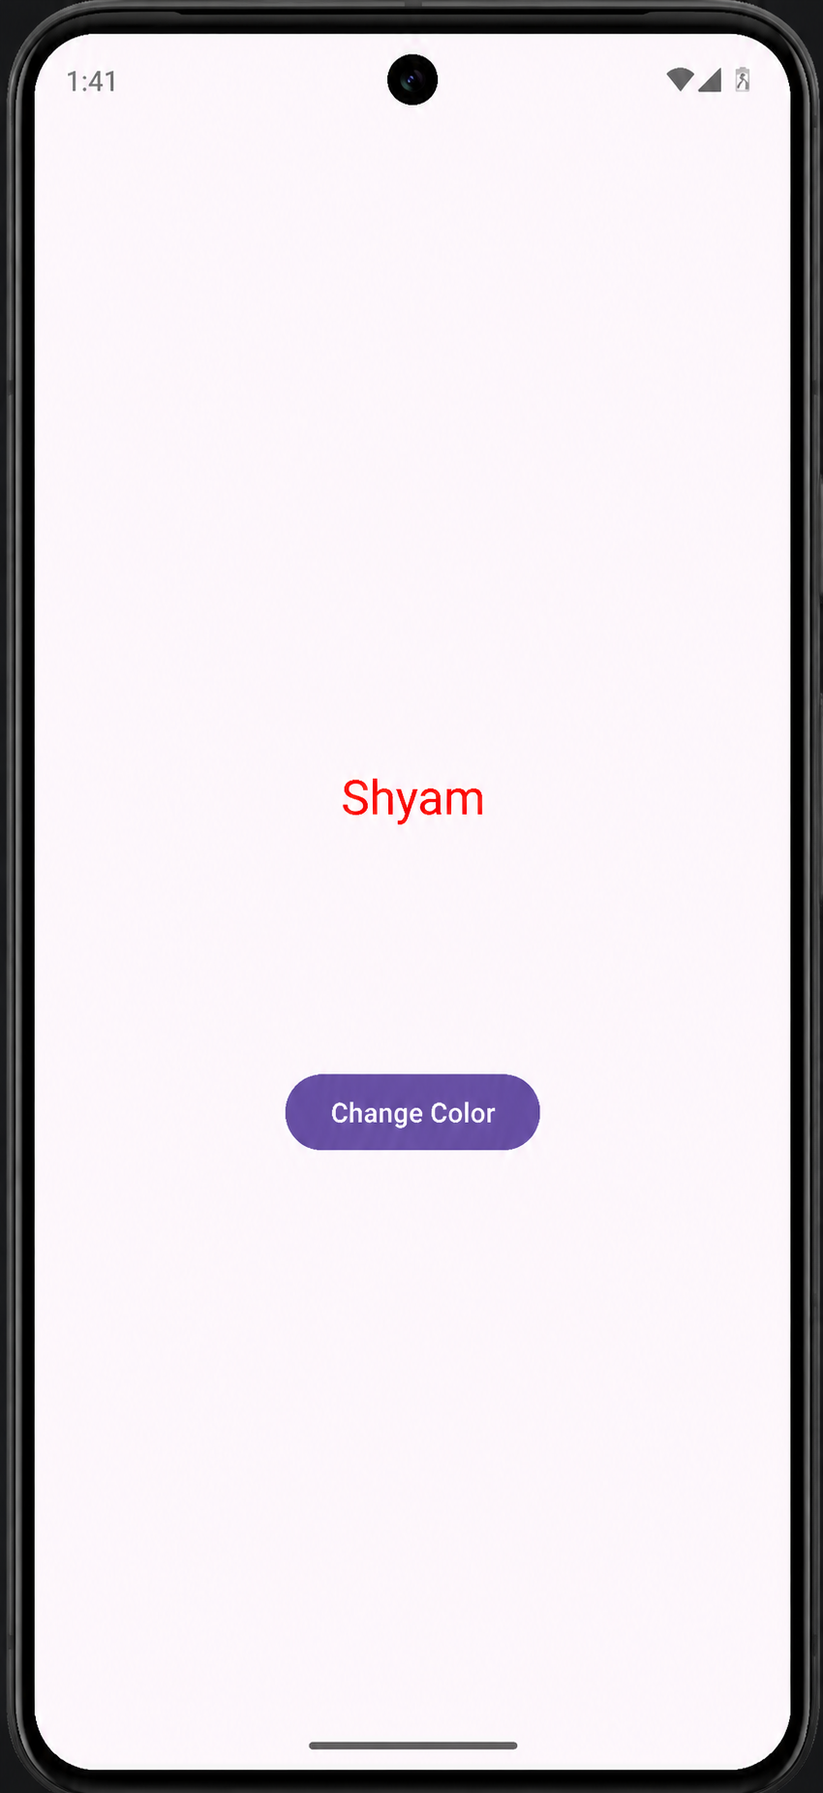

Program No: 6 | Date: 29/06/2026
Program Title: Create an app that displays Date and Time in different formats using Linear Layout.
MainActivity.java:
package com.example.pg06_datetime;
import android.os.Bundle;
import android.view.View;
import android.widget.Button;
import android.widget.TextView;
import androidx.appcompat.app.AppCompatActivity;
import java.text.SimpleDateFormat;
import java.util.Date;
import java.util.Locale;
public class MainActivity extends AppCompatActivity {
@Override
protected void onCreate(Bundle savedInstanceState) {
super.onCreate(savedInstanceState);
setContentView(R.layout.activity_main);
final TextView textView1 = findViewById(R.id.textView1);
final TextView textView2 = findViewById(R.id.textView2);
final TextView textView3 = findViewById(R.id.textView3);
final TextView textView4 = findViewById(R.id.textView4);
Button button1 = findViewById(R.id.button1);
button1.setOnClickListener(new View.OnClickListener() {
@Override
public void onClick(View v) {
Date currentDateTime = new Date();
SimpleDateFormat format1 = new SimpleDateFormat("EEEE, dd MMM yyyy", Locale.getDefault());
SimpleDateFormat format2 = new SimpleDateFormat("MM/dd/yyyy", Locale.getDefault());
SimpleDateFormat format3 = new SimpleDateFormat("HH:mm:ss z", Locale.getDefault());
SimpleDateFormat format4 = new SimpleDateFormat("hh:mm a", Locale.getDefault());
textView1.setText(format1.format(currentDateTime));
textView2.setText(format2.format(currentDateTime));
textView3.setText(format3.format(currentDateTime));
textView4.setText(format4.format(currentDateTime));
}
});
}
}
activity_main.xml:
<?xml version="1.0" encoding="utf-8"?>
<LinearLayout xmlns:android="http://schemas.android.com/apk/res/android"
xmlns:app="http://schemas.android.com/apk/res-auto"
xmlns:tools="http://schemas.android.com/tools"
android:id="@+id/main"
android:layout_width="match_parent"
android:layout_height="match_parent"
android:orientation="vertical"
android:gravity="center"
tools:context=".MainActivity">
<TextView
android:id="@+id/textView1"
android:layout_width="wrap_content"
android:layout_height="wrap_content"
android:textSize="20sp" />
<TextView
android:id="@+id/textView2"
android:layout_width="wrap_content"
android:layout_height="wrap_content"
android:textSize="20sp" />
<TextView
android:id="@+id/textView3"
android:layout_width="wrap_content"
android:layout_height="wrap_content"
android:textSize="20sp" />
<TextView
android:id="@+id/textView4"
android:layout_width="wrap_content"
android:layout_height="wrap_content"
android:textSize="20sp" />
<Button
android:id="@+id/button1"
android:layout_width="wrap_content"
android:layout_height="wrap_content"
android:text="Button" />
</LinearLayout>
Output:
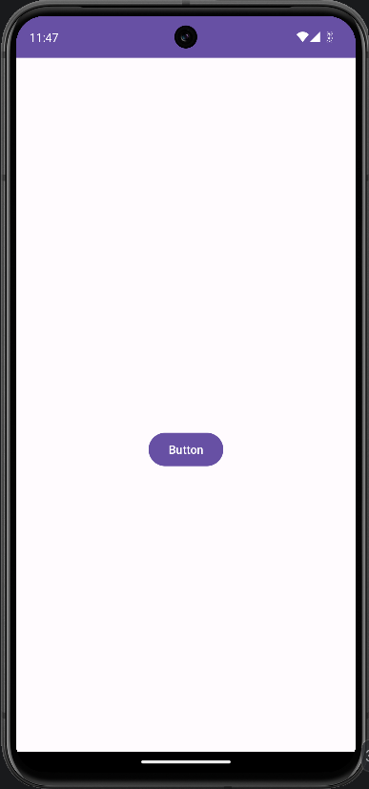 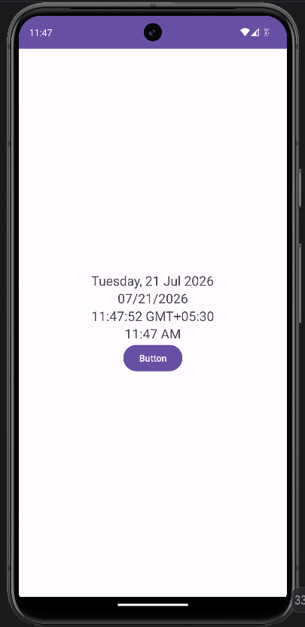

Program No: 7 | Date: 29/06/2026
Program Title: Create an app that displays a Toast on the launch of an activity.
MainActivity.java:
package com.example.pg07_launchtoast;
import android.os.Bundle;
import android.widget.Toast;
import androidx.activity.EdgeToEdge;
import androidx.appcompat.app.AppCompatActivity;
import androidx.core.graphics.Insets;
import androidx.core.view.ViewCompat;
import androidx.core.view.WindowInsetsCompat;
public class MainActivity extends AppCompatActivity {
@Override
protected void onCreate(Bundle savedInstanceState) {
super.onCreate(savedInstanceState);
EdgeToEdge.enable(this);
setContentView(R.layout.activity_main);
Toast.makeText(this, "Welcome Shyam", Toast.LENGTH_SHORT).show();
}
}
activity_main.xml:
<?xml version="1.0" encoding="utf-8"?>
<androidx.constraintlayout.widget.ConstraintLayout xmlns:android="http://schemas.android.com/apk/res/android"
xmlns:app="http://schemas.android.com/apk/res-auto"
xmlns:tools="http://schemas.android.com/tools"
android:id="@+id/main"
android:layout_width="match_parent"
android:layout_height="match_parent"
tools:context=".MainActivity">
<TextView
android:layout_width="wrap_content"
android:layout_height="wrap_content"
android:text="Hello ^_^"
android:textSize="24sp"
app:layout_constraintBottom_toBottomOf="parent"
app:layout_constraintEnd_toEndOf="parent"
app:layout_constraintStart_toStartOf="parent"
app:layout_constraintTop_toTopOf="parent" />
</androidx.constraintlayout.widget.ConstraintLayout>
Output:
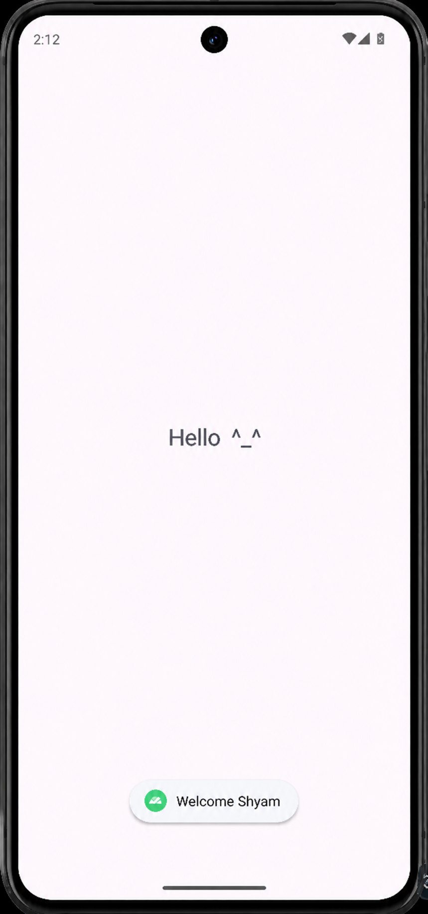

Program No: 8 | Date: 29/06/2026
Program Title: Create an app that creates an Alert Dialog Box.
MainActivity.java:
package com.example.pg08_alertbox;
import android.os.Bundle;
import androidx.appcompat.app.AppCompatActivity;
import androidx.appcompat.app.AlertDialog;
import android.widget.Button;
import android.widget.Toast;
public class MainActivity extends AppCompatActivity {
@Override
protected void onCreate(Bundle savedInstanceState) {
super.onCreate(savedInstanceState);
setContentView(R.layout.activity_main);
Button btn = findViewById(R.id.btn);
btn.setOnClickListener(v -> {
AlertDialog.Builder builder = new AlertDialog.Builder(MainActivity.this);
builder.setTitle("Alert");
builder.setMessage("What do you want to click?");
builder.setPositiveButton("Yes", (dialog, which) -> {
Toast.makeText(MainActivity.this, "You clicked Yes",
Toast.LENGTH_SHORT).show();
});
builder.setNegativeButton("No", (dialog, which) -> {
Toast.makeText(MainActivity.this, "You clicked No",
Toast.LENGTH_SHORT).show();
});
builder.setNeutralButton("Cancel", (dialog, which) -> {
dialog.dismiss();
});
builder.show();
});
}
}
activity_main.xml:
<?xml version="1.0" encoding="utf-8"?>
<androidx.constraintlayout.widget.ConstraintLayout xmlns:android="http://schemas.android.com/apk/res/android"
xmlns:app="http://schemas.android.com/apk/res-auto"
xmlns:tools="http://schemas.android.com/tools"
android:id="@+id/main"
android:layout_width="match_parent"
android:layout_height="match_parent"
tools:context=".MainActivity">
<Button
android:id="@+id/btn"
android:layout_width="wrap_content"
android:layout_height="wrap_content"
android:text="Click Here"
app:layout_constraintBottom_toBottomOf="parent"
app:layout_constraintEnd_toEndOf="parent"
app:layout_constraintStart_toStartOf="parent"
app:layout_constraintTop_toTopOf="parent"
app:layout_constraintVertical_bias="0.566" />
</androidx.constraintlayout.widget.ConstraintLayout>
Output:
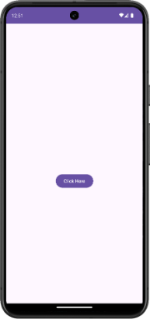 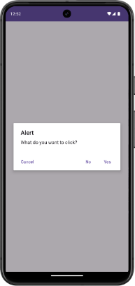 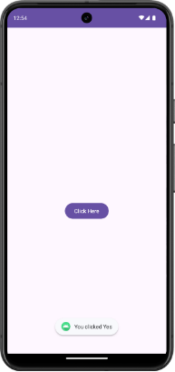

Program No: 9 | Date: 29/06/2026
Program Title: Create a Greeting card app that displays an image.
MainActivity.java:
package com.example.pg09_greetingcard;
import android.os.Bundle;
import androidx.appcompat.app.AppCompatActivity;
public class MainActivity extends AppCompatActivity {
@Override
protected void onCreate(Bundle savedInstanceState) {
super.onCreate(savedInstanceState);
setContentView(R.layout.activity_main);
}
}
activity_main.xml:
<?xml version="1.0" encoding="utf-8"?>
<androidx.constraintlayout.widget.ConstraintLayout xmlns:android="http://schemas.android.com/apk/res/android"
xmlns:app="http://schemas.android.com/apk/res-auto"
xmlns:tools="http://schemas.android.com/tools"
android:id="@+id/main"
android:layout_width="match_parent"
android:layout_height="match_parent"
tools:context=".MainActivity">
<ImageView
android:id="@+id/imageView"
android:layout_width="288dp"
android:layout_height="393dp"
app:layout_constraintBottom_toBottomOf="parent"
app:layout_constraintEnd_toEndOf="parent"
app:layout_constraintHorizontal_bias="0.495"
app:layout_constraintStart_toStartOf="parent"
app:layout_constraintTop_toTopOf="parent"
app:layout_constraintVertical_bias="0.328"
app:srcCompat="@drawable/greetings" />
<TextView
android:id="@+id/textView2"
android:layout_width="wrap_content"
android:layout_height="wrap_content"
android:text="Happy Birthday!"
android:textColor="#2196F3"
android:textSize="24sp"
app:layout_constraintBottom_toBottomOf="parent"
app:layout_constraintEnd_toEndOf="parent"
app:layout_constraintStart_toStartOf="parent"
app:layout_constraintTop_toTopOf="parent"
app:layout_constraintVertical_bias="0.739" />
<TextView
android:id="@+id/textView"
android:layout_width="258dp"
android:layout_height="59dp"
android:text="Wishing you a joyful day and an amazing year ahead!"
android:textAlignment="center"
android:textColor="#020202"
android:textSize="18sp"
app:layout_constraintBottom_toBottomOf="parent"
app:layout_constraintEnd_toEndOf="parent"
app:layout_constraintHorizontal_bias="0.496"
app:layout_constraintStart_toStartOf="parent"
app:layout_constraintTop_toTopOf="parent"
app:layout_constraintVertical_bias="0.833" />
</androidx.constraintlayout.widget.ConstraintLayout>
Output:
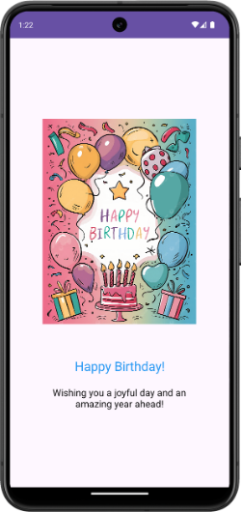

Program No: 10 | Date: 29/06/2026
Program Title: Create an app that plays audio when we click on the button ``Play Music" and plays video when we click on the button ``Play Video".
MainActivity.java:
package com.example.pg10_videomusic;
import android.os.Bundle;
import androidx.appcompat.app.AppCompatActivity;
import android.widget.Button;
import android.widget.VideoView;
import android.net.Uri;
import android.media.MediaPlayer;
import android.widget.MediaController;
public class MainActivity extends AppCompatActivity {
MediaPlayer mediaPlayer;
VideoView videoView;
@Override
protected void onCreate(Bundle savedInstanceState) {
super.onCreate(savedInstanceState);
setContentView(R.layout.activity_main);
Button btnMusic = findViewById(R.id.music);
Button btnVideo = findViewById(R.id.video);
videoView = findViewById(R.id.videoView);
videoView.setZOrderOnTop(true);
mediaPlayer = MediaPlayer.create(this, R.raw.song);
btnMusic.setOnClickListener(v -> {
if (!mediaPlayer.isPlaying()) {
mediaPlayer.start();
}
});
btnVideo.setOnClickListener(v -> {
Uri uri = Uri.parse("android.resource://" + getPackageName()
+ "/" + R.raw.video);
videoView.setVideoURI(uri);
MediaController controller =
new MediaController(MainActivity.this);
videoView.setMediaController(controller);
controller.setAnchorView(videoView);
videoView.start();
});
}
@Override
protected void onDestroy() {
super.onDestroy();
if (mediaPlayer != null) {
mediaPlayer.release();
mediaPlayer = null;
}
}
}
activity_main.xml:
<?xml version="1.0" encoding="utf-8"?>
<androidx.constraintlayout.widget.ConstraintLayout xmlns:android="http://schemas.android.com/apk/res/android"
xmlns:app="http://schemas.android.com/apk/res-auto"
xmlns:tools="http://schemas.android.com/tools"
android:id="@+id/main"
android:layout_width="match_parent"
android:layout_height="match_parent"
tools:context=".MainActivity">
<VideoView
android:id="@+id/videoView"
android:layout_width="348dp"
android:layout_height="231dp"
android:background="#000000"
app:layout_constraintBottom_toBottomOf="parent"
app:layout_constraintEnd_toEndOf="parent"
app:layout_constraintHorizontal_bias="0.492"
app:layout_constraintStart_toStartOf="parent"
app:layout_constraintTop_toTopOf="parent"
app:layout_constraintVertical_bias="0.23" />
<Button
android:id="@+id/music"
android:layout_width="wrap_content"
android:layout_height="wrap_content"
android:text="Play Music"
app:layout_constraintBottom_toBottomOf="parent"
app:layout_constraintEnd_toEndOf="parent"
app:layout_constraintHorizontal_bias="0.237"
app:layout_constraintStart_toStartOf="parent"
app:layout_constraintTop_toTopOf="parent"
app:layout_constraintVertical_bias="0.632" />
<Button
android:id="@+id/video"
android:layout_width="wrap_content"
android:layout_height="wrap_content"
android:layout_marginStart="8dp"
android:text="Play Video"
app:layout_constraintBottom_toBottomOf="parent"
app:layout_constraintEnd_toEndOf="parent"
app:layout_constraintHorizontal_bias="0.777"
app:layout_constraintStart_toStartOf="parent"
app:layout_constraintTop_toTopOf="parent"
app:layout_constraintVertical_bias="0.632" />
</androidx.constraintlayout.widget.ConstraintLayout>
Output:
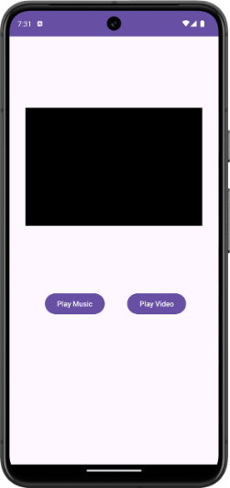 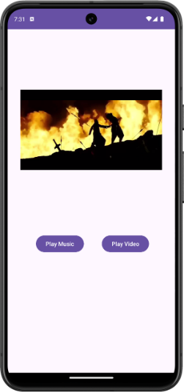

Program No: 11 | Date: 29/06/2026
Program Title: Create an app that plays video from the internet.
MainActivity.java:
package com.example.pg11_internetvideo;
import android.os.Bundle;
import androidx.appcompat.app.AppCompatActivity;
import android.widget.Button;
import android.widget.VideoView;
import android.net.Uri;
import android.widget.MediaController;
public class MainActivity extends AppCompatActivity {
VideoView videoView;
@Override
protected void onCreate(Bundle savedInstanceState) {
super.onCreate(savedInstanceState);
setContentView(R.layout.activity_main);
Button btnVideo = findViewById(R.id.play);
videoView = findViewById(R.id.videoView);
videoView.setZOrderOnTop(true);
btnVideo.setOnClickListener(v -> {
Uri uri = Uri.parse("https://www.learningcontainer.com/"
+ "wp-content/uploads/2020/05/"
+ "sample-mp4-file.mp4");
videoView.setVideoURI(uri);
MediaController controller =
new MediaController(MainActivity.this);
videoView.setMediaController(controller);
controller.setAnchorView(videoView);
videoView.start();
});
}
}
activity_main.xml:
<?xml version="1.0" encoding="utf-8"?>
<androidx.constraintlayout.widget.ConstraintLayout xmlns:android="http://schemas.android.com/apk/res/android"
xmlns:app="http://schemas.android.com/apk/res-auto"
xmlns:tools="http://schemas.android.com/tools"
android:id="@+id/main"
android:layout_width="match_parent"
android:layout_height="match_parent"
tools:context=".MainActivity">
<VideoView
android:id="@+id/videoView"
android:layout_width="365dp"
android:layout_height="211dp"
app:layout_constraintBottom_toBottomOf="parent"
app:layout_constraintEnd_toEndOf="parent"
app:layout_constraintHorizontal_bias="0.493"
app:layout_constraintStart_toStartOf="parent"
app:layout_constraintTop_toTopOf="parent"
app:layout_constraintVertical_bias="0.141" />
<Button
android:id="@+id/play"
android:layout_width="wrap_content"
android:layout_height="wrap_content"
android:text="Play Video"
app:layout_constraintBottom_toBottomOf="parent"
app:layout_constraintEnd_toEndOf="parent"
app:layout_constraintStart_toStartOf="parent"
app:layout_constraintTop_toTopOf="parent"
app:layout_constraintVertical_bias="0.537" />
</androidx.constraintlayout.widget.ConstraintLayout>
Output:
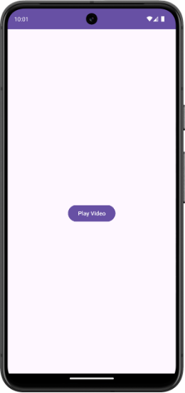 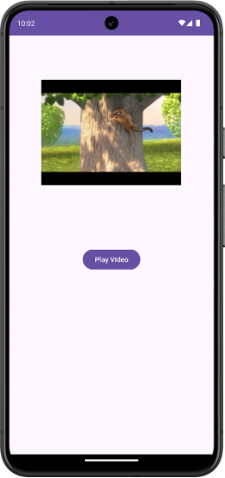

Program No: 12 | Date: 29/06/2026
Program Title: Create an app to demonstrate Options Menu.
MainActivity.java:
package com.example.pg12_optionsmenu;
import android.os.Bundle;
import androidx.appcompat.app.AppCompatActivity;
import android.view.Menu;
import android.view.MenuItem;
import android.widget.Toast;
public class MainActivity extends AppCompatActivity {
@Override
protected void onCreate(Bundle savedInstanceState) {
super.onCreate(savedInstanceState);
setContentView(R.layout.activity_main);
}
@Override
public boolean onCreateOptionsMenu(Menu menu) {
getMenuInflater().inflate(R.menu.menu, menu);
return true;
}
@Override
public boolean onOptionsItemSelected(MenuItem item) {
int id = item.getItemId();
if (id == R.id.settings) {
Toast.makeText(this, "Settings Selected",
Toast.LENGTH_SHORT).show();
}
else if (id == R.id.about) {
Toast.makeText(this, "About Selected",
Toast.LENGTH_SHORT).show();
}
else if (id == R.id.exit) {
finish();
}
return true;
}
}
activity_main.xml:
<?xml version="1.0" encoding="utf-8"?>
<androidx.constraintlayout.widget.ConstraintLayout xmlns:android="http://schemas.android.com/apk/res/android"
xmlns:app="http://schemas.android.com/apk/res-auto"
xmlns:tools="http://schemas.android.com/tools"
android:id="@+id/main"
android:layout_width="match_parent"
android:layout_height="match_parent"
tools:context=".MainActivity"/>
menu.xml:
<?xml version="1.0" encoding="utf-8"?>
<menu xmlns:app="http://schemas.android.com/apk/res-auto"
xmlns:android="http://schemas.android.com/apk/res/android">
<item
android:id="@+id/settings"
android:title="Settings" />
<item
android:id="@+id/about"
android:title="About" />
<item
android:id="@+id/exit"
android:title="Exit" />
</menu>
Output:
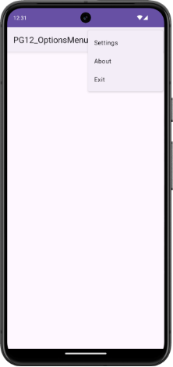 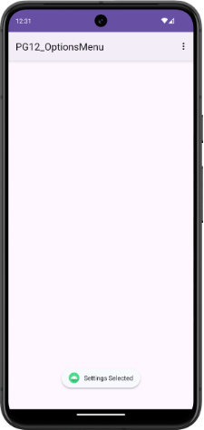

Program No: 13 | Date: 29/06/2026
Program Title: Create an app that changes the background color of an activity using Context Menu.
MainActivity.java:
package com.example.context_menu;
import android.graphics.Color;
import android.os.Bundle;
import androidx.appcompat.app.AppCompatActivity;
import android.view.ContextMenu;
import android.view.MenuInflater;
import android.view.MenuItem;
import android.view.View;
import android.widget.TextView;
public class MainActivity extends AppCompatActivity {
View layout;
TextView tx1;
@Override
protected void onCreate(Bundle savedInstanceState) {
super.onCreate(savedInstanceState);
setContentView(R.layout.activity_main);
layout = findViewById(R.id.main);
tx1 = findViewById(R.id.tx1);
registerForContextMenu(tx1);
}
@Override
public void onCreateContextMenu(ContextMenu menu, View v,
ContextMenu.ContextMenuInfo menuinfo){
super.onCreateContextMenu(menu, v, menuinfo);
MenuInflater inflater = getMenuInflater();
inflater.inflate(R.menu.menu_main, menu);
}
public boolean onContextItemSelected(MenuItem item) {
if (item.getItemId() == R.id.red){
layout.setBackgroundColor(Color.RED);
}
if (item.getItemId() == R.id.blue) {
layout.setBackgroundColor(Color.BLUE);
}
if (item.getItemId() == R.id.green) {
layout.setBackgroundColor(Color.GREEN);
}
if (item.getItemId() == R.id.yellow) {
layout.setBackgroundColor(Color.YELLOW);
}
return false;
}
}
activity_main.xml:
<?xml version="1.0" encoding="utf-8"?>
<androidx.constraintlayout.widget.ConstraintLayout xmlns:android="http://schemas.android.com/apk/res/android"
xmlns:app="http://schemas.android.com/apk/res-auto"
xmlns:tools="http://schemas.android.com/tools"
android:id="@+id/main"
android:layout_width="match_parent"
android:layout_height="match_parent"
tools:context=".MainActivity">
<TextView
android:id="@+id/tx1"
android:layout_width="90dp"
android:layout_height="30dp"
android:text="Hello World!"
app:layout_constraintBottom_toBottomOf="parent"
app:layout_constraintEnd_toEndOf="parent"
app:layout_constraintHorizontal_bias="0.454"
app:layout_constraintStart_toStartOf="parent"
app:layout_constraintTop_toTopOf="parent"
app:layout_constraintVertical_bias="0.499" />
</androidx.constraintlayout.widget.ConstraintLayout>
menu_main.xml:
<?xml version="1.0" encoding="utf-8"?>
<menu xmlns:app="http://schemas.android.com/apk/res-auto"
xmlns:android="http://schemas.android.com/apk/res/android">
<item
android:id="@+id/red"
android:title="RED" />
<item
android:id="@+id/blue"
android:title="BLUE" />
<item
android:id="@+id/green"
android:title="GREEN" />
<item
android:id="@+id/yellow"
android:title="YELLOW" />
</menu>
Output:
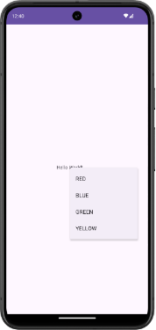 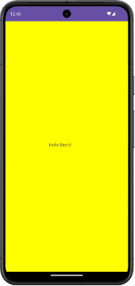

Program No: 14 | Date: 29/06/2026
Program Title: Create an app to demonstrate how radiobuttons and checkboxes can be used in android.
MainActivity.java:
package com.example.radiocheckbox;
import android.os.Bundle;
import androidx.appcompat.app.AppCompatActivity;
import android.widget.Button;
import android.widget.RadioGroup;
import android.widget.RadioButton;
import android.widget.CheckBox;
import android.widget.Toast;
public class MainActivity extends AppCompatActivity {
RadioGroup gender;
CheckBox ten, twelve, UG, PG;
Button submit;
@Override
protected void onCreate(Bundle savedInstanceState) {
super.onCreate(savedInstanceState);
setContentView(R.layout.activity_main);
gender = findViewById(R.id.gender);
ten = findViewById(R.id.ten);
twelve = findViewById(R.id.twelve);
UG = findViewById(R.id.UG);
PG = findViewById(R.id.PG);
submit = findViewById(R.id.submit);
submit.setOnClickListener(v ->{
int selectedId = gender.getCheckedRadioButtonId();
RadioButton rb = findViewById(selectedId);
String gen = rb.getText().toString();
StringBuilder education = new StringBuilder();
if (ten.isChecked()) education.append("Tenth ");
if (twelve.isChecked()) education.append("Plus Two ");
if (UG.isChecked()) education.append("Undergraduate ");
if (PG.isChecked()) education.append("Postgraduate ");
Toast.makeText(this, gen + " | " + education,
Toast.LENGTH_LONG).show();
});
}
}
activity_main.xml:
<?xml version="1.0" encoding="utf-8"?>
<androidx.constraintlayout.widget.ConstraintLayout xmlns:android="http://schemas.android.com/apk/res/android"
xmlns:app="http://schemas.android.com/apk/res-auto"
xmlns:tools="http://schemas.android.com/tools"
android:id="@+id/main"
android:layout_width="match_parent"
android:layout_height="match_parent"
android:background="#FB9E9E"
tools:context=".MainActivity">
<TextView
android:id="@+id/textView4"
android:layout_width="82dp"
android:layout_height="23dp"
android:text="Gender: "
app:layout_constraintBottom_toBottomOf="parent"
app:layout_constraintEnd_toEndOf="parent"
app:layout_constraintHorizontal_bias="0.124"
app:layout_constraintStart_toStartOf="parent"
app:layout_constraintTop_toTopOf="parent"
app:layout_constraintVertical_bias="0.114" />
<RadioGroup
android:id="@+id/gender"
android:layout_width="247dp"
android:layout_height="143dp"
app:layout_constraintBottom_toBottomOf="parent"
app:layout_constraintEnd_toEndOf="parent"
app:layout_constraintHorizontal_bias="0.25"
app:layout_constraintStart_toStartOf="parent"
app:layout_constraintTop_toTopOf="parent"
app:layout_constraintVertical_bias="0.205">
<RadioButton
android:id="@+id/male"
android:layout_width="match_parent"
android:layout_height="wrap_content"
android:text="Male" />
<RadioButton
android:id="@+id/female"
android:layout_width="match_parent"
android:layout_height="wrap_content"
android:text="Female" />
<RadioButton
android:id="@+id/tg"
android:layout_width="match_parent"
android:layout_height="wrap_content"
android:text="TG" />
</RadioGroup>
<CheckBox
android:id="@+id/ten"
android:layout_width="134dp"
android:layout_height="43dp"
android:text="X"
app:layout_constraintBottom_toBottomOf="parent"
app:layout_constraintEnd_toEndOf="parent"
app:layout_constraintHorizontal_bias="0.155"
app:layout_constraintStart_toStartOf="parent"
app:layout_constraintTop_toTopOf="parent"
app:layout_constraintVertical_bias="0.527" />
<CheckBox
android:id="@+id/UG"
android:layout_width="133dp"
android:layout_height="48dp"
android:text="UG"
app:layout_constraintBottom_toBottomOf="parent"
app:layout_constraintEnd_toEndOf="parent"
app:layout_constraintHorizontal_bias="0.154"
app:layout_constraintStart_toStartOf="parent"
app:layout_constraintTop_toTopOf="parent"
app:layout_constraintVertical_bias="0.71" />
<CheckBox
android:id="@+id/twelve"
android:layout_width="134dp"
android:layout_height="48dp"
android:text="XII"
app:layout_constraintBottom_toBottomOf="parent"
app:layout_constraintEnd_toEndOf="parent"
app:layout_constraintHorizontal_bias="0.158"
app:layout_constraintStart_toStartOf="parent"
app:layout_constraintTop_toTopOf="parent"
app:layout_constraintVertical_bias="0.619" />
<Button
android:id="@+id/submit"
android:layout_width="wrap_content"
android:layout_height="wrap_content"
android:text="Submit"
app:layout_constraintBottom_toBottomOf="parent"
app:layout_constraintEnd_toEndOf="parent"
app:layout_constraintHorizontal_bias="0.468"
app:layout_constraintStart_toStartOf="parent"
app:layout_constraintTop_toTopOf="parent"
app:layout_constraintVertical_bias="0.915" />
<TextView
android:id="@+id/textView"
android:layout_width="90dp"
android:layout_height="22dp"
android:text="Qualification"
app:layout_constraintBottom_toBottomOf="parent"
app:layout_constraintEnd_toEndOf="parent"
app:layout_constraintHorizontal_bias="0.13"
app:layout_constraintStart_toStartOf="parent"
app:layout_constraintTop_toTopOf="parent"
app:layout_constraintVertical_bias="0.452" />
<CheckBox
android:id="@+id/PG"
android:layout_width="133dp"
android:layout_height="48dp"
android:text="PG"
app:layout_constraintBottom_toBottomOf="parent"
app:layout_constraintEnd_toEndOf="parent"
app:layout_constraintHorizontal_bias="0.154"
app:layout_constraintStart_toStartOf="parent"
app:layout_constraintTop_toTopOf="parent"
app:layout_constraintVertical_bias="0.808" />
</androidx.constraintlayout.widget.ConstraintLayout>
Output:
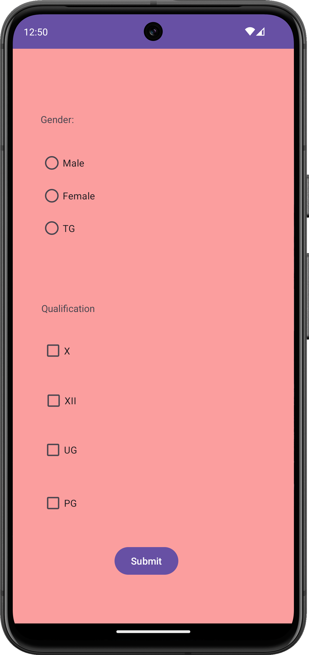 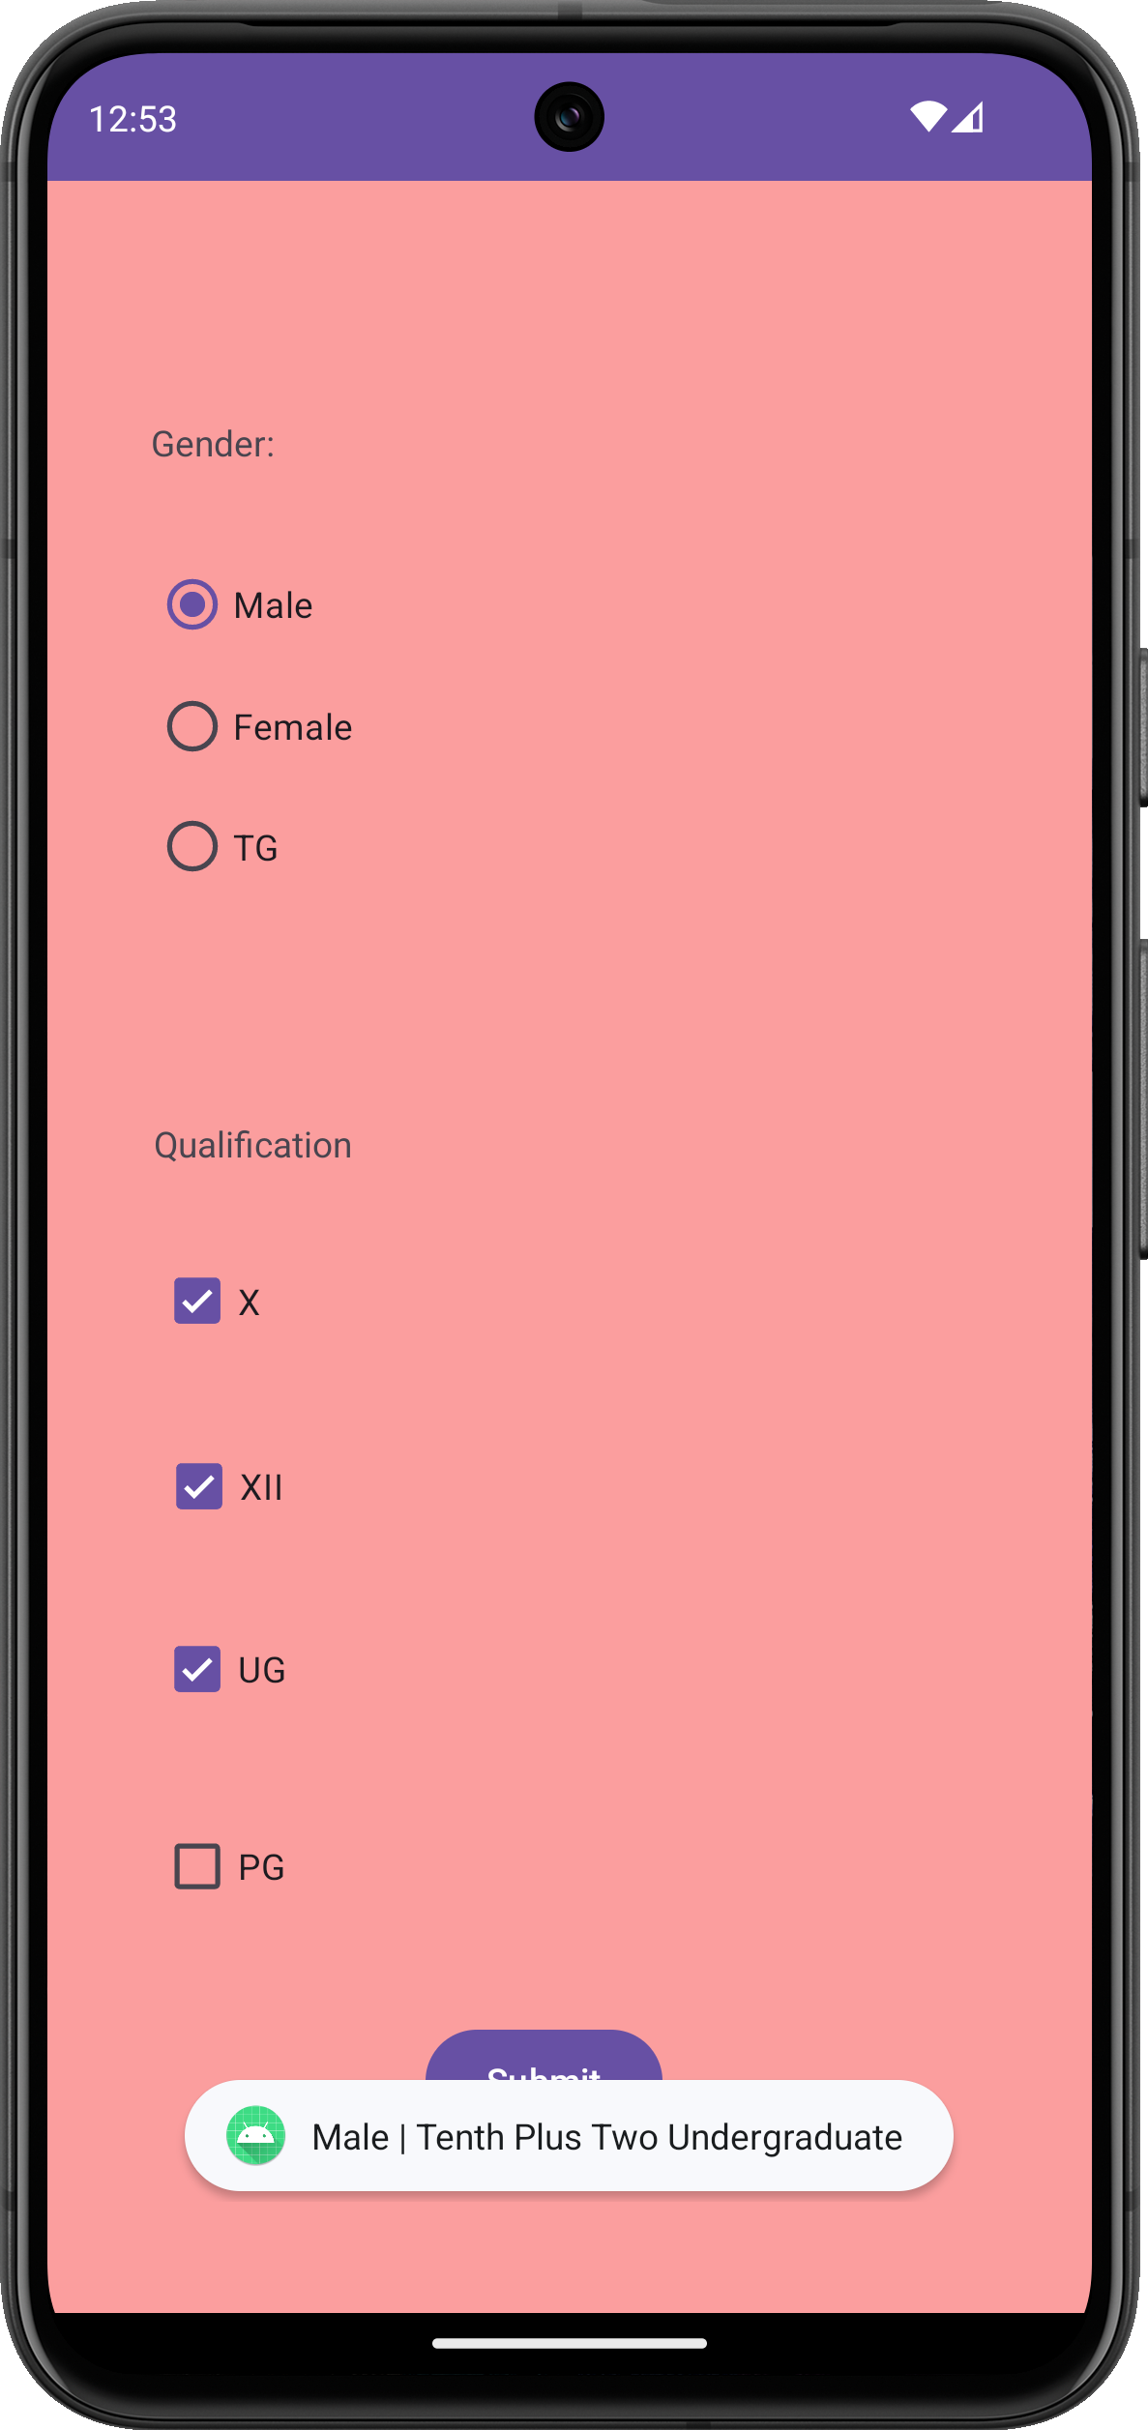

Program No: 15 | Date: 29/06/2026
Program Title: Create an app that launches a new activity on a button click
MainActivity.java:
package com.example.a2screen_welcome;
import android.content.Intent;
import android.os.Bundle;
import androidx.appcompat.app.AppCompatActivity;
import android.widget.Button;
public class MainActivity extends AppCompatActivity {
@Override
protected void onCreate(Bundle savedInstanceState) {
super.onCreate(savedInstanceState);
setContentView(R.layout.activity_main);
Button btn = findViewById(R.id.button);
btn.setOnClickListener(v-> {
Intent intent = new Intent(MainActivity.this,
SecondaryActivity.class);
startActivity(intent);
});
}
}
SecondaryActivity.java:
package com.example.a2screen_welcome;
import android.os.Bundle;
import androidx.appcompat.app.AppCompatActivity;
public class SecondaryActivity extends AppCompatActivity {
@Override
protected void onCreate(Bundle savedInstanceState) {
super.onCreate(savedInstanceState);
setContentView(R.layout.activity_secondary);
}
}
activity_main.xml:
<?xml version="1.0" encoding="utf-8"?>
<androidx.constraintlayout.widget.ConstraintLayout xmlns:android="http://schemas.android.com/apk/res/android"
xmlns:app="http://schemas.android.com/apk/res-auto"
xmlns:tools="http://schemas.android.com/tools"
android:id="@+id/main"
android:layout_width="match_parent"
android:layout_height="match_parent"
tools:context=".MainActivity">
<Button
android:id="@+id/button"
android:layout_width="172dp"
android:layout_height="74dp"
android:text="Go to Next Page"
app:layout_constraintBottom_toBottomOf="parent"
app:layout_constraintEnd_toEndOf="parent"
app:layout_constraintHorizontal_bias="0.498"
app:layout_constraintStart_toStartOf="parent"
app:layout_constraintTop_toTopOf="parent"
app:layout_constraintVertical_bias="0.558" />
</androidx.constraintlayout.widget.ConstraintLayout>
activity_secondary.xml:
<?xml version="1.0" encoding="utf-8"?>
<androidx.constraintlayout.widget.ConstraintLayout xmlns:android="http://schemas.android.com/apk/res/android"
xmlns:app="http://schemas.android.com/apk/res-auto"
xmlns:tools="http://schemas.android.com/tools"
android:id="@+id/main"
android:layout_width="match_parent"
android:layout_height="match_parent"
android:background="#EF9696"
tools:context=".SecondaryActivity">
<TextView
android:id="@+id/textView"
android:layout_width="66dp"
android:layout_height="28dp"
android:text="Welcome"
app:layout_constraintBottom_toBottomOf="parent"
app:layout_constraintEnd_toEndOf="parent"
app:layout_constraintStart_toStartOf="parent"
app:layout_constraintTop_toTopOf="parent" />
</androidx.constraintlayout.widget.ConstraintLayout>
Output:
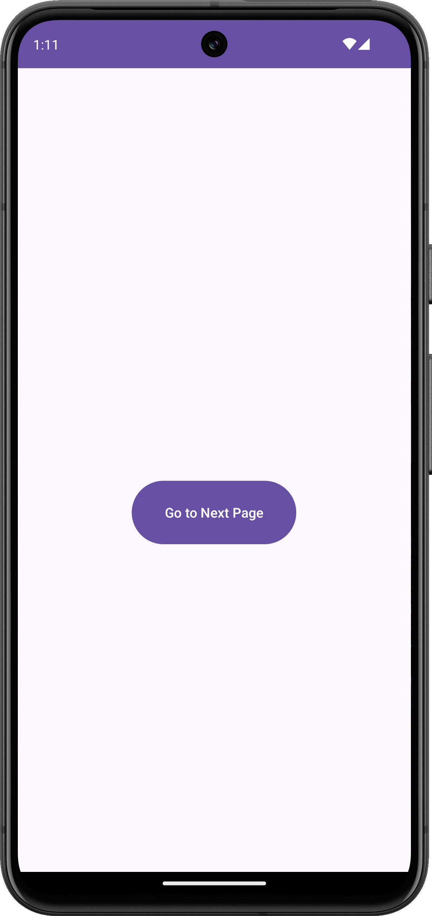 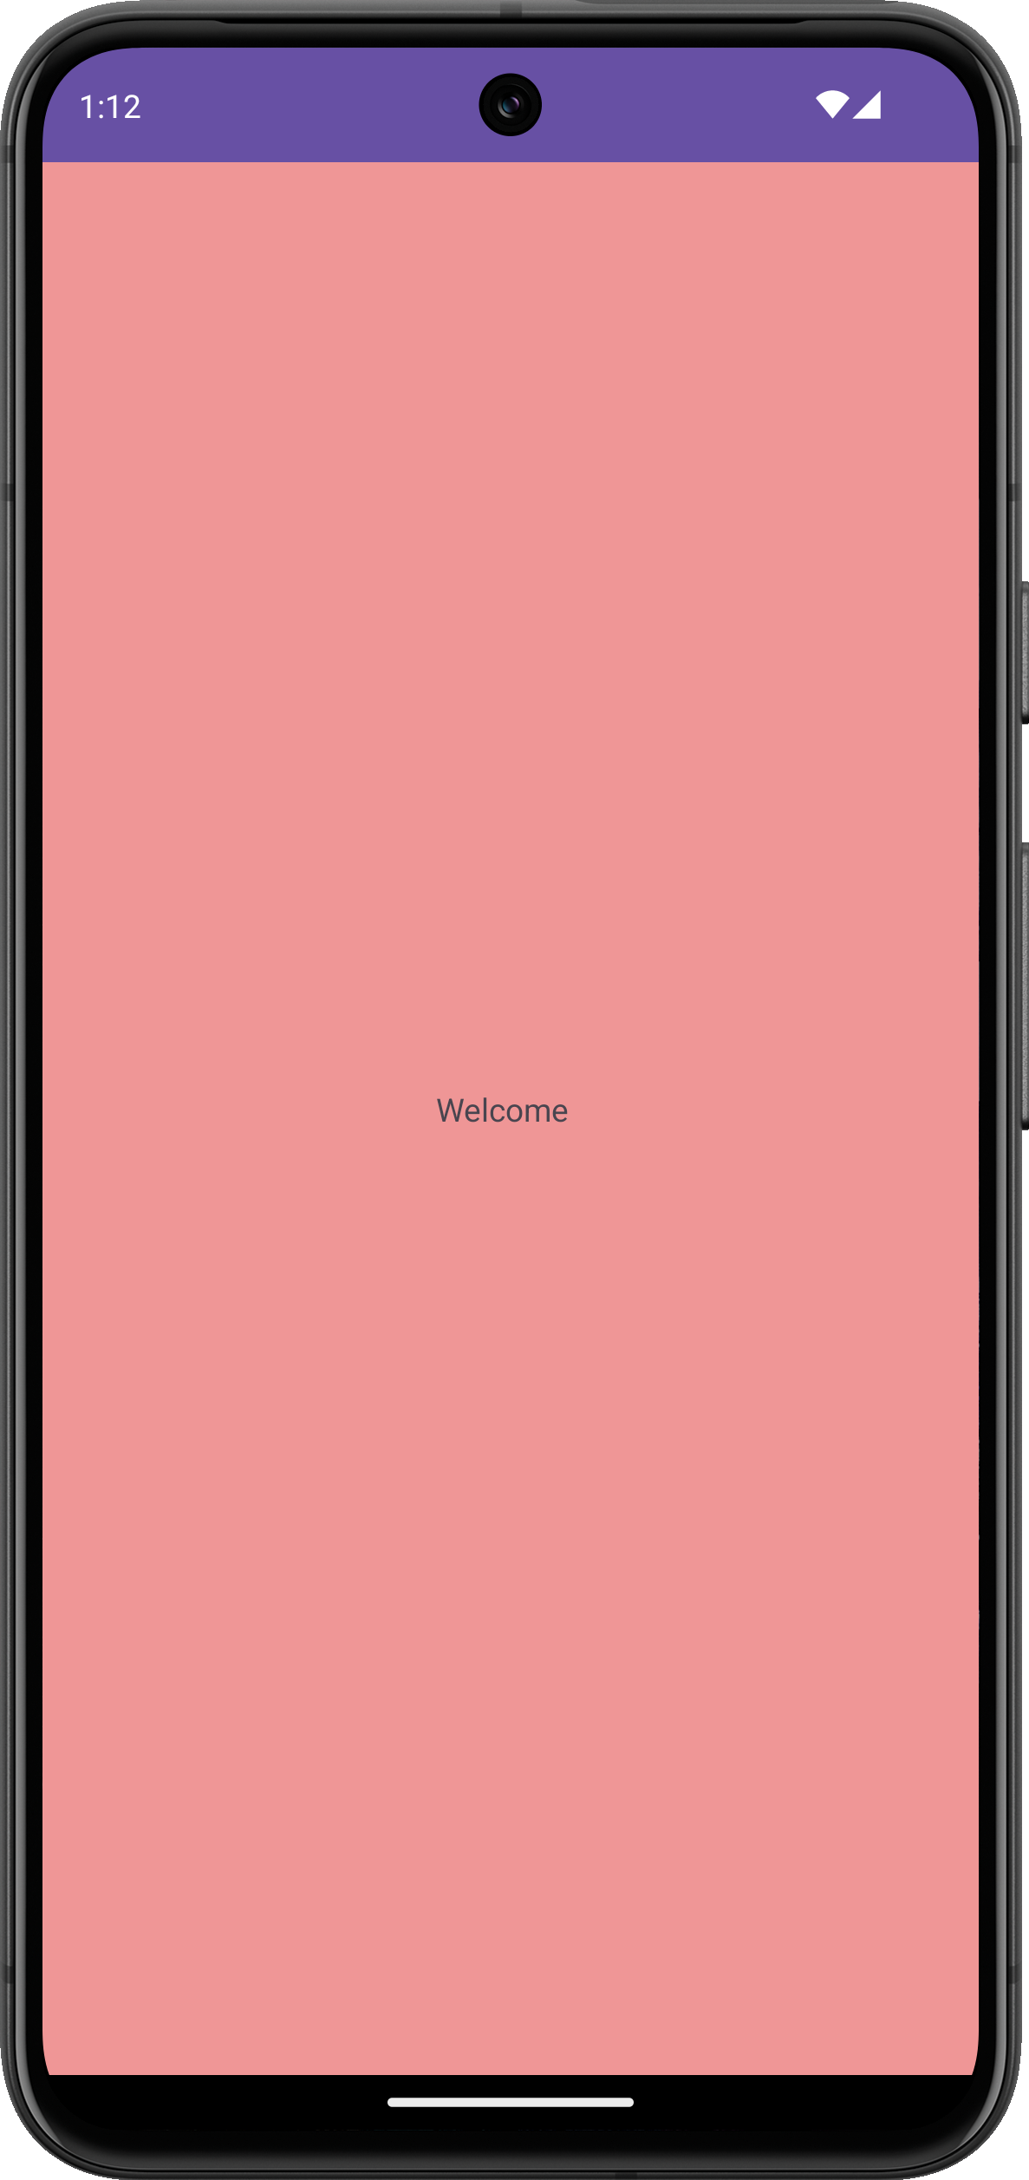

Program No: 16 | Date: 29/06/2026
Program Title: Create an app that launches a new activity on a button click to display student details with checkbox and radio buttons.
MainActivity.java:
package com.example.pg16_studentdetails;
import android.content.Intent;
import android.os.Bundle;
import androidx.appcompat.app.AppCompatActivity;
import android.widget.Button;
import android.widget.CheckBox;
import android.widget.EditText;
import android.widget.RadioButton;
import android.widget.RadioGroup;
public class MainActivity extends AppCompatActivity {
@Override
protected void onCreate(Bundle savedInstanceState) {
super.onCreate(savedInstanceState);
setContentView(R.layout.activity_main);
Button submit = findViewById(R.id.submit);
EditText name = findViewById(R.id.name);
EditText mobile = findViewById(R.id.mobile);
RadioGroup department = findViewById(R.id.department);
RadioGroup gender = findViewById(R.id.gender);
CheckBox ai = findViewById(R.id.ai);
CheckBox cloud = findViewById(R.id.cloud);
CheckBox auto = findViewById(R.id.autocad);
CheckBox ship = findViewById(R.id.ship);
submit.setOnClickListener(v -> {
int depId = department.getCheckedRadioButtonId();
RadioButton rdep = findViewById(depId);
int genId = gender.getCheckedRadioButtonId();
RadioButton rgen = findViewById(genId);
StringBuilder sb = new StringBuilder();
if (ai.isChecked())
sb.append("AI/ML\n");
if (cloud.isChecked())
sb.append("Cloud Computing\n");
if (auto.isChecked())
sb.append("AutoCAD\n");
if (ship.isChecked())
sb.append("Ship Technology\n");
Intent intent = new Intent(MainActivity.this, Details.class);
intent.putExtra("name", name.getText().toString());
intent.putExtra("mobile", mobile.getText().toString());
intent.putExtra("courses", sb.toString());
intent.putExtra("department", rdep.getText().toString());
intent.putExtra("gender", rgen.getText().toString());
startActivity(intent);
});
}
}
Details.java:
package com.example.pg16_studentdetails;
import android.os.Bundle;
import androidx.appcompat.app.AppCompatActivity;
import android.widget.TextView;
public class Details extends AppCompatActivity {
@Override
protected void onCreate(Bundle savedInstanceState) {
super.onCreate(savedInstanceState);
setContentView(R.layout.activity_details);
String name = getIntent().getStringExtra("name");
String mobile = getIntent().getStringExtra("mobile");
String department = getIntent().getStringExtra("department");
String gender = getIntent().getStringExtra("gender");
String courses = getIntent().getStringExtra("courses");
TextView details = findViewById(R.id.details);
details.setText("Name: " + name +
"\nMobile: " + mobile +
"\nDepartment: " + department +
"\nGender: " + gender +
"\nCourses:\n" + courses);
}
}
activity_main.xml:
<?xml version="1.0" encoding="utf-8"?>
<androidx.constraintlayout.widget.ConstraintLayout xmlns:android="http://schemas.android.com/apk/res/android"
xmlns:app="http://schemas.android.com/apk/res-auto"
xmlns:tools="http://schemas.android.com/tools"
android:id="@+id/main"
android:layout_width="match_parent"
android:layout_height="match_parent"
tools:context=".MainActivity">
<TextView
android:layout_width="68dp"
android:layout_height="24dp"
android:text="Name: "
android:textSize="16sp"
app:layout_constraintBottom_toBottomOf="parent"
app:layout_constraintEnd_toEndOf="parent"
app:layout_constraintHorizontal_bias="0.11"
app:layout_constraintStart_toStartOf="parent"
app:layout_constraintTop_toTopOf="parent"
app:layout_constraintVertical_bias="0.077" />
<TextView
android:id="@+id/textView"
android:layout_width="wrap_content"
android:layout_height="wrap_content"
android:text="Department: "
android:textSize="16sp"
app:layout_constraintBottom_toBottomOf="parent"
app:layout_constraintEnd_toEndOf="parent"
app:layout_constraintHorizontal_bias="0.119"
app:layout_constraintStart_toStartOf="parent"
app:layout_constraintTop_toTopOf="parent"
app:layout_constraintVertical_bias="0.131" />
<RadioGroup
android:id="@+id/department"
android:layout_width="314dp"
android:layout_height="134dp"
app:layout_constraintBottom_toBottomOf="parent"
app:layout_constraintEnd_toEndOf="parent"
app:layout_constraintHorizontal_bias="0.391"
app:layout_constraintStart_toStartOf="parent"
app:layout_constraintTop_toTopOf="parent"
app:layout_constraintVertical_bias="0.207">
<RadioButton
android:id="@+id/cs"
android:layout_width="match_parent"
android:layout_height="wrap_content"
android:text="Computer Science"
android:textSize="16sp" />
<RadioButton
android:id="@+id/civil"
android:layout_width="match_parent"
android:layout_height="wrap_content"
android:text="Civil Engineering"
android:textSize="16sp" />
<RadioButton
android:id="@+id/mech"
android:layout_width="match_parent"
android:layout_height="wrap_content"
android:text="Mechanical Enginneering"
android:textSize="16sp" />
</RadioGroup>
<EditText
android:id="@+id/name"
android:layout_width="wrap_content"
android:layout_height="wrap_content"
android:ems="10"
android:hint="Name"
android:inputType="text"
android:textSize="16sp"
app:layout_constraintBottom_toBottomOf="parent"
app:layout_constraintEnd_toEndOf="parent"
app:layout_constraintHorizontal_bias="0.719"
app:layout_constraintStart_toStartOf="parent"
app:layout_constraintTop_toTopOf="parent"
app:layout_constraintVertical_bias="0.076" />
<TextView
android:id="@+id/textView2"
android:layout_width="wrap_content"
android:layout_height="wrap_content"
android:text="Preferred Course: "
android:textSize="16sp"
app:layout_constraintBottom_toBottomOf="parent"
app:layout_constraintEnd_toEndOf="parent"
app:layout_constraintHorizontal_bias="0.123"
app:layout_constraintStart_toStartOf="parent"
app:layout_constraintTop_toTopOf="parent"
app:layout_constraintVertical_bias="0.385" />
<CheckBox
android:id="@+id/ai"
android:layout_width="wrap_content"
android:layout_height="wrap_content"
android:text="AI/ML"
android:textSize="16sp"
app:layout_constraintBottom_toBottomOf="parent"
app:layout_constraintEnd_toEndOf="parent"
app:layout_constraintHorizontal_bias="0.133"
app:layout_constraintStart_toStartOf="parent"
app:layout_constraintTop_toTopOf="parent"
app:layout_constraintVertical_bias="0.44" />
<CheckBox
android:id="@+id/ship"
android:layout_width="127dp"
android:layout_height="41dp"
android:text="Ship Technology"
android:textSize="16sp"
app:layout_constraintBottom_toBottomOf="parent"
app:layout_constraintEnd_toEndOf="parent"
app:layout_constraintHorizontal_bias="0.133"
app:layout_constraintStart_toStartOf="parent"
app:layout_constraintTop_toTopOf="parent"
app:layout_constraintVertical_bias="0.517" />
<CheckBox
android:id="@+id/cloud"
android:layout_width="127dp"
android:layout_height="41dp"
android:text="Cloud Computing"
android:textSize="16sp"
app:layout_constraintBottom_toBottomOf="parent"
app:layout_constraintEnd_toEndOf="parent"
app:layout_constraintHorizontal_bias="0.693"
app:layout_constraintStart_toStartOf="parent"
app:layout_constraintTop_toTopOf="parent"
app:layout_constraintVertical_bias="0.44" />
<CheckBox
android:id="@+id/autocad"
android:layout_width="127dp"
android:layout_height="41dp"
android:text="Autocad"
android:textSize="16sp"
app:layout_constraintBottom_toBottomOf="parent"
app:layout_constraintEnd_toEndOf="parent"
app:layout_constraintHorizontal_bias="0.693"
app:layout_constraintStart_toStartOf="parent"
app:layout_constraintTop_toTopOf="parent"
app:layout_constraintVertical_bias="0.517" />
<TextView
android:id="@+id/textView3"
android:layout_width="wrap_content"
android:layout_height="wrap_content"
android:text="Gender: "
android:textSize="16sp"
app:layout_constraintBottom_toBottomOf="parent"
app:layout_constraintEnd_toEndOf="parent"
app:layout_constraintHorizontal_bias="0.107"
app:layout_constraintStart_toStartOf="parent"
app:layout_constraintTop_toTopOf="parent"
app:layout_constraintVertical_bias="0.585" />
<RadioGroup
android:id="@+id/gender"
android:layout_width="318dp"
android:layout_height="162dp"
app:layout_constraintBottom_toBottomOf="parent"
app:layout_constraintEnd_toEndOf="parent"
app:layout_constraintHorizontal_bias="0.408"
app:layout_constraintStart_toStartOf="parent"
app:layout_constraintTop_toTopOf="parent"
app:layout_constraintVertical_bias="0.775">
<RadioButton
android:id="@+id/male"
android:layout_width="match_parent"
android:layout_height="wrap_content"
android:text="Male"
android:textSize="16sp" />
<RadioButton
android:id="@+id/female"
android:layout_width="match_parent"
android:layout_height="wrap_content"
android:text="Female"
android:textSize="16sp" />
<RadioButton
android:id="@+id/tg"
android:layout_width="match_parent"
android:layout_height="wrap_content"
android:text="TG"
android:textSize="16sp" />
</RadioGroup>
<TextView
android:id="@+id/textView5"
android:layout_width="wrap_content"
android:layout_height="wrap_content"
android:text="Mobile No: "
android:textSize="16sp"
app:layout_constraintBottom_toBottomOf="parent"
app:layout_constraintEnd_toEndOf="parent"
app:layout_constraintHorizontal_bias="0.105"
app:layout_constraintStart_toStartOf="parent"
app:layout_constraintTop_toTopOf="parent"
app:layout_constraintVertical_bias="0.861" />
<EditText
android:id="@+id/mobile"
android:layout_width="wrap_content"
android:layout_height="wrap_content"
android:ems="10"
android:hint="Mobile No."
android:inputType="number"
android:textSize="16sp"
app:layout_constraintBottom_toBottomOf="parent"
app:layout_constraintEnd_toEndOf="parent"
app:layout_constraintHorizontal_bias="0.674"
app:layout_constraintStart_toStartOf="parent"
app:layout_constraintTop_toTopOf="parent"
app:layout_constraintVertical_bias="0.876" />
<Button
android:id="@+id/submit"
android:layout_width="wrap_content"
android:layout_height="wrap_content"
android:text="Submit"
app:layout_constraintBottom_toBottomOf="parent"
app:layout_constraintEnd_toEndOf="parent"
app:layout_constraintStart_toStartOf="parent"
app:layout_constraintTop_toTopOf="parent"
app:layout_constraintVertical_bias="0.976" />
</androidx.constraintlayout.widget.ConstraintLayout>
activity_details.xml:
<?xml version="1.0" encoding="utf-8"?>
<androidx.constraintlayout.widget.ConstraintLayout xmlns:android="http://schemas.android.com/apk/res/android"
xmlns:app="http://schemas.android.com/apk/res-auto"
xmlns:tools="http://schemas.android.com/tools"
android:id="@+id/main"
android:layout_width="match_parent"
android:layout_height="match_parent"
tools:context=".Details">
<TextView
android:id="@+id/details"
android:layout_width="wrap_content"
android:layout_height="wrap_content"
android:textSize="20sp"
app:layout_constraintBottom_toBottomOf="parent"
app:layout_constraintEnd_toEndOf="parent"
app:layout_constraintStart_toStartOf="parent"
app:layout_constraintTop_toTopOf="parent"
app:layout_constraintVertical_bias="0.381" />
</androidx.constraintlayout.widget.ConstraintLayout>
Output:
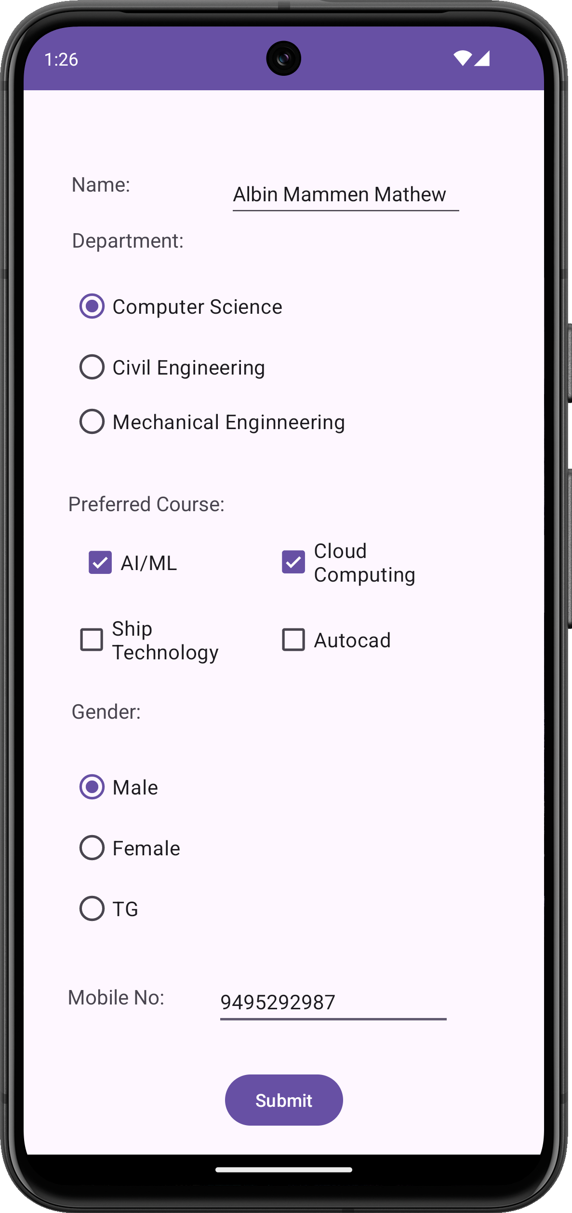 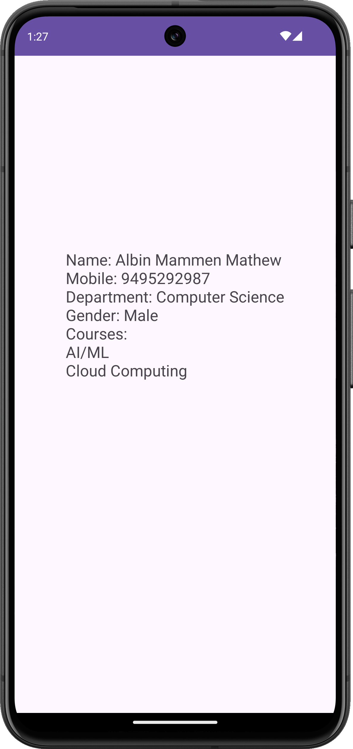

Program No: 17 | Date: 29/06/2026
Program Title: Create an app that launches a new activity on a button click to calculate and display employee details and salary.
MainActivity.java:
package com.example.pg17_employeedetails;
import android.content.Intent;
import android.os.Bundle;
import android.view.View;
import android.widget.Button;
import android.widget.EditText;
import androidx.appcompat.app.AppCompatActivity;
public class MainActivity extends AppCompatActivity {
EditText name, id, sal;
Button btnNext;
@Override
protected void onCreate(Bundle savedInstanceState) {
super.onCreate(savedInstanceState);
setContentView(R.layout.activity_main);
name = findViewById(R.id.name);
id = findViewById(R.id.id);
sal = findViewById(R.id.sal);
btnNext = findViewById(R.id.btnNext);
btnNext.setOnClickListener(new View.OnClickListener() {
@Override
public void onClick(View view) {
Intent intent = new Intent(MainActivity.this,
SecondaryActivity.class);
intent.putExtra("name", name.getText().toString());
intent.putExtra("id", id.getText().toString());
intent.putExtra("salary", sal.getText().toString());
startActivity(intent);
}
});
}
}
SecondaryActivity.java:
package com.example.pg17_employeedetails;
import android.content.Intent;
import android.os.Bundle;
import android.widget.TextView;
import androidx.appcompat.app.AppCompatActivity;
public class SecondaryActivity extends AppCompatActivity {
TextView result;
@Override
protected void onCreate(Bundle savedInstanceState) {
super.onCreate(savedInstanceState);
setContentView(R.layout.activity_secondary);
result = findViewById(R.id.result);
Intent intent = getIntent();
if (intent != null) {
String name = intent.getStringExtra("name");
String id = intent.getStringExtra("id");
String salaryStr = intent.getStringExtra("salary");
double basic = 0;
try {
if (salaryStr != null) {
basic = Double.parseDouble(salaryStr);
}
} catch (Exception e) {
// handle parsing error
}
double hra = basic * 0.15;
double da = basic * 0.10;
double gross = basic + hra + da;
result.setText(
"Employee Details\n\n" +
"Name : " + name +
"\nEmployee ID : " + id +
"\n\nBasic Salary : " + basic +
"\nHRA (15%) : " + hra +
"\nDA (10%) : " + da +
"\nGross Salary : " + gross
);
}
}
}
activity_main.xml:
<?xml version="1.0" encoding="utf-8"?>
<androidx.constraintlayout.widget.ConstraintLayout xmlns:android="http://schemas.android.com/apk/res/android"
xmlns:app="http://schemas.android.com/apk/res-auto"
android:layout_width="match_parent"
android:layout_height="match_parent">
<TextView
android:id="@+id/tvTitle"
android:layout_width="wrap_content"
android:layout_height="wrap_content"
android:text="Employee Details"
android:textSize="22sp"
android:textStyle="bold"
app:layout_constraintBottom_toBottomOf="parent"
app:layout_constraintEnd_toEndOf="parent"
app:layout_constraintHorizontal_bias="0.587"
app:layout_constraintStart_toStartOf="parent"
app:layout_constraintTop_toTopOf="parent"
app:layout_constraintVertical_bias="0.067" />
<TextView
android:id="@+id/tvName"
android:layout_width="wrap_content"
android:layout_height="wrap_content"
android:layout_marginStart="20dp"
android:layout_marginTop="20dp"
android:text="Employee Name"
app:layout_constraintStart_toStartOf="parent"
app:layout_constraintTop_toBottomOf="@id/tvTitle" />
<EditText
android:id="@+id/name"
android:layout_width="250dp"
android:layout_height="wrap_content"
android:hint="Enter Name"
app:layout_constraintStart_toStartOf="@id/tvName"
app:layout_constraintTop_toBottomOf="@id/tvName" />
<TextView
android:id="@+id/tvId"
android:layout_width="wrap_content"
android:layout_height="wrap_content"
android:layout_marginTop="15dp"
android:text="Employee ID"
app:layout_constraintStart_toStartOf="@id/tvName"
app:layout_constraintTop_toBottomOf="@id/name" />
<EditText
android:id="@+id/id"
android:layout_width="250dp"
android:layout_height="wrap_content"
android:hint="Enter ID"
app:layout_constraintStart_toStartOf="@id/tvName"
app:layout_constraintTop_toBottomOf="@id/tvId" />
<TextView
android:id="@+id/tvSalary"
android:layout_width="wrap_content"
android:layout_height="wrap_content"
android:layout_marginTop="15dp"
android:text="Basic Salary"
app:layout_constraintStart_toStartOf="@id/tvName"
app:layout_constraintTop_toBottomOf="@id/id" />
<EditText
android:id="@+id/sal"
android:layout_width="250dp"
android:layout_height="wrap_content"
android:hint="Enter Salary"
android:inputType="numberDecimal"
app:layout_constraintStart_toStartOf="@id/tvName"
app:layout_constraintTop_toBottomOf="@id/tvSalary" />
<Button
android:id="@+id/btnNext"
android:layout_width="wrap_content"
android:layout_height="wrap_content"
android:layout_marginTop="25dp"
android:text="Show Details"
app:layout_constraintEnd_toEndOf="parent"
app:layout_constraintStart_toStartOf="parent"
app:layout_constraintTop_toBottomOf="@id/sal" />
</androidx.constraintlayout.widget.ConstraintLayout>
activity_secondary.xml:
<?xml version="1.0" encoding="utf-8"?>
<androidx.constraintlayout.widget.ConstraintLayout xmlns:android="http://schemas.android.com/apk/res/android"
xmlns:app="http://schemas.android.com/apk/res-auto"
android:layout_width="match_parent"
android:layout_height="match_parent">
<TextView
android:id="@+id/result"
android:layout_width="300dp"
android:layout_height="wrap_content"
android:gravity="center"
android:textSize="18sp"
android:textStyle="bold"
app:layout_constraintBottom_toBottomOf="parent"
app:layout_constraintEnd_toEndOf="parent"
app:layout_constraintStart_toStartOf="parent"
app:layout_constraintTop_toTopOf="parent" />
</androidx.constraintlayout.widget.ConstraintLayout>
Output:
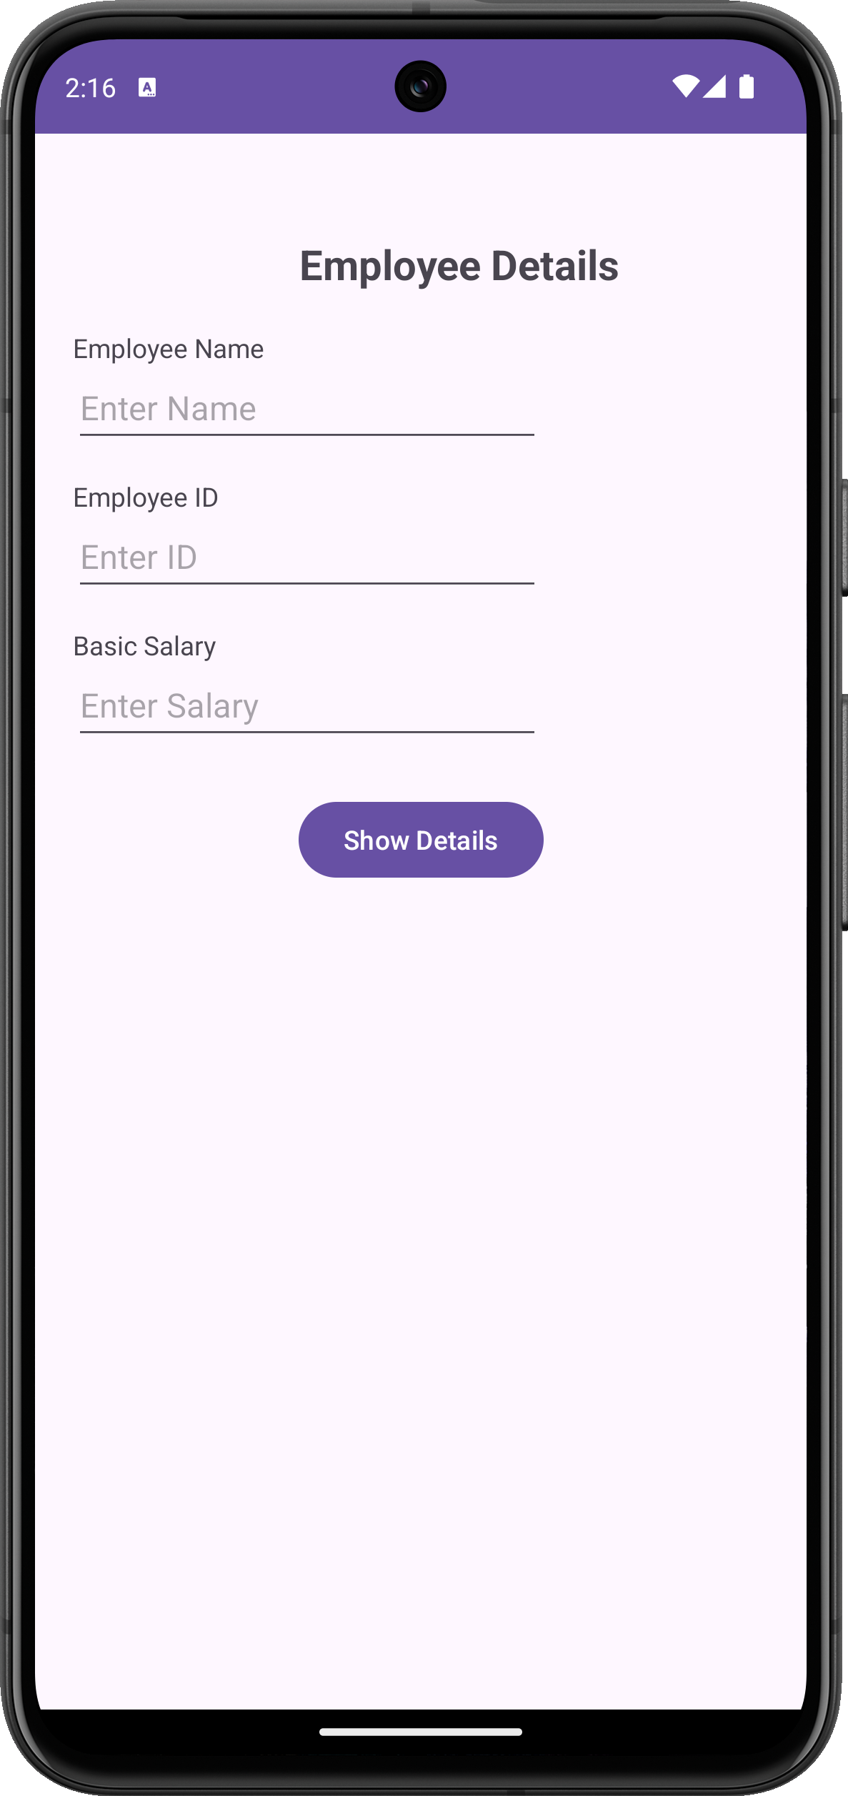 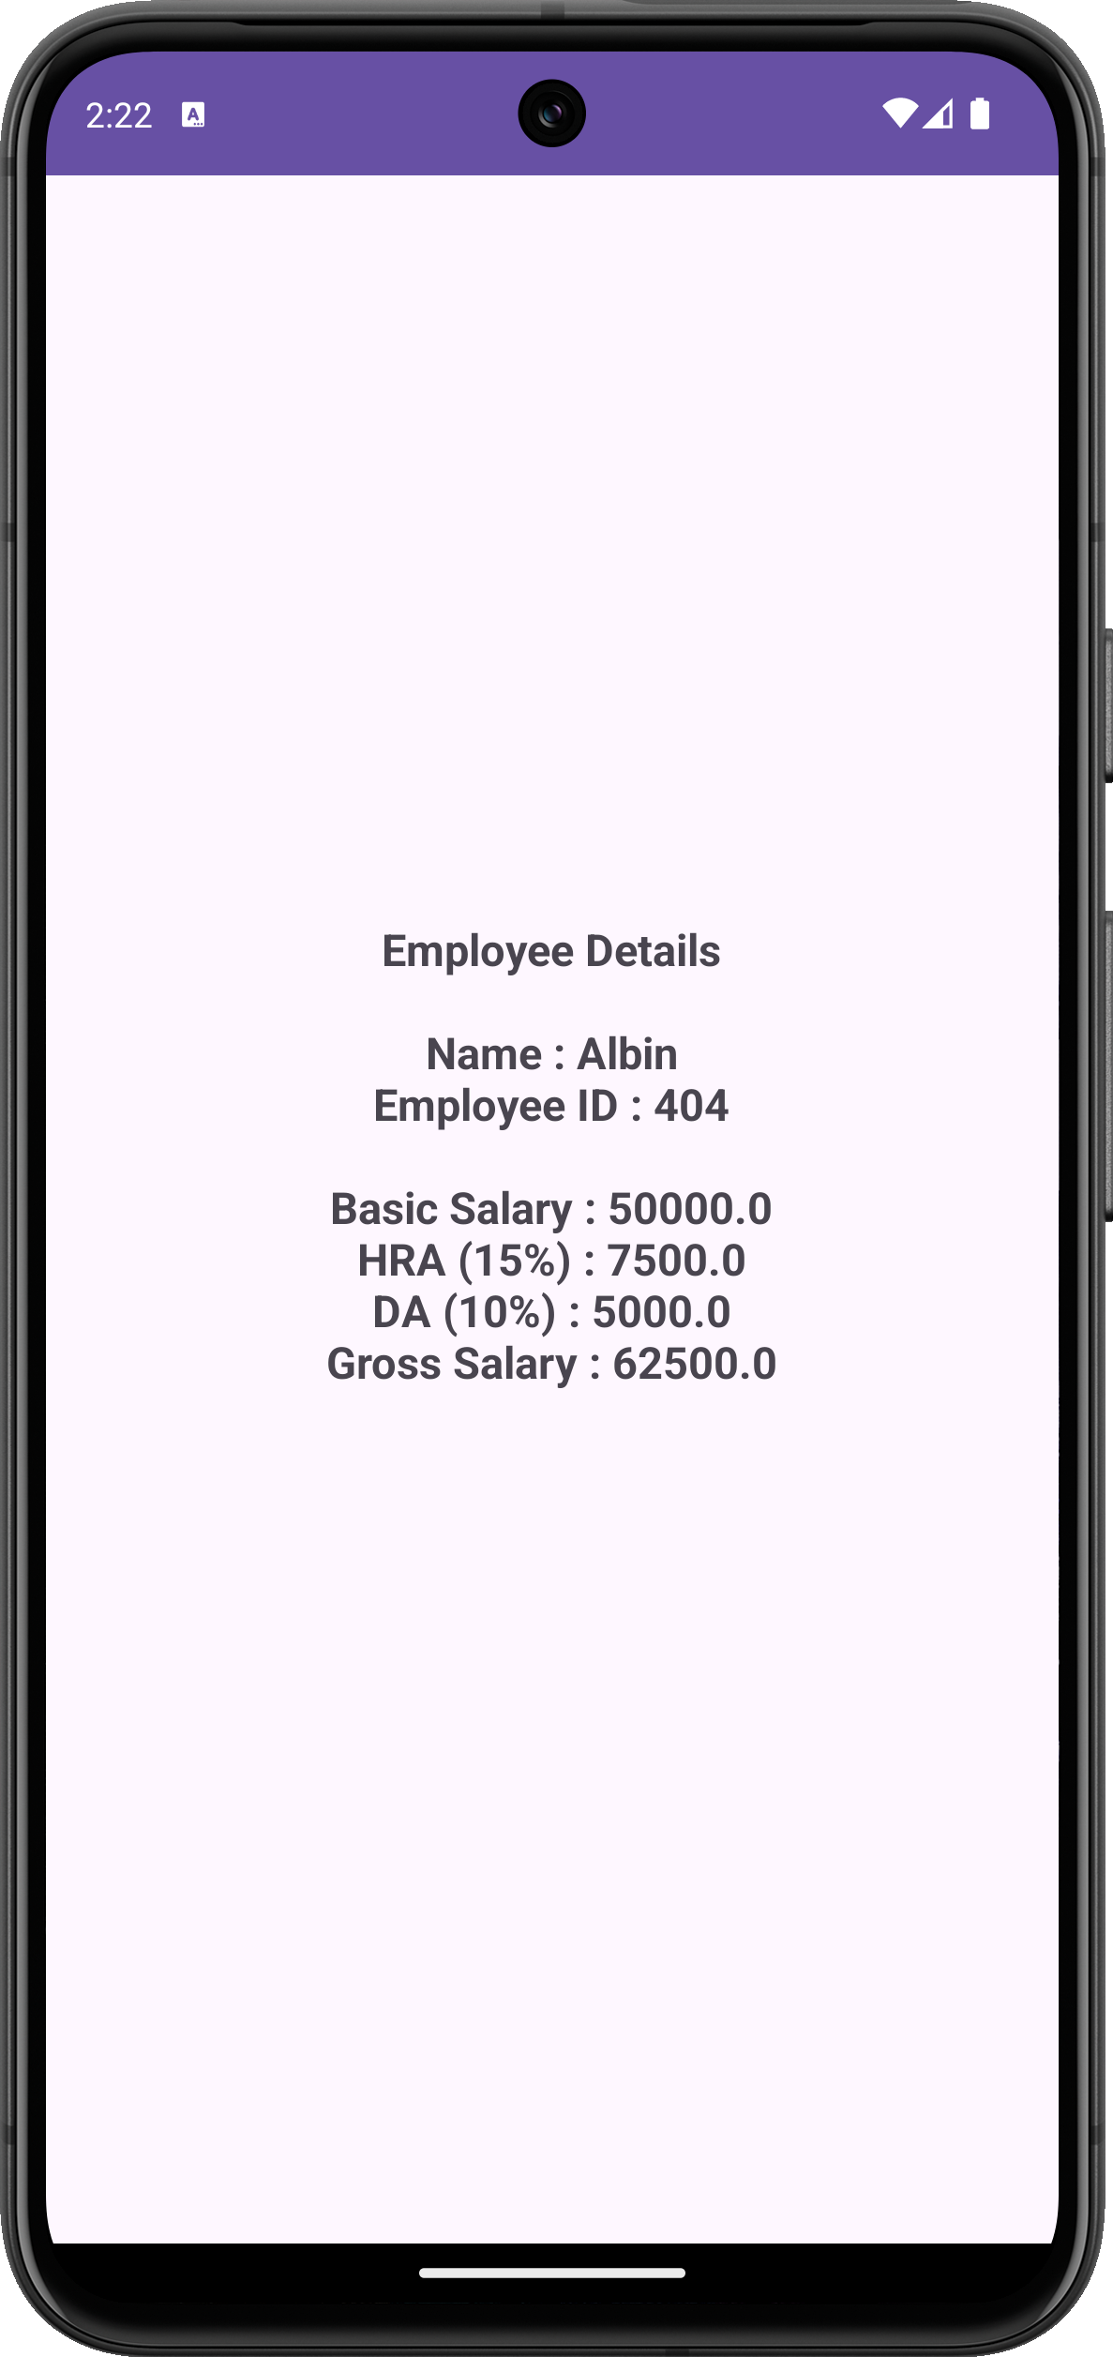

Program No: 18 | Date: 29/06/2026
Program Title: Create an app to broadcast a custom intent.
MainActivity.java:
package com.example.broadcast;
import android.content.Intent;
import android.os.Bundle;
import androidx.appcompat.app.AppCompatActivity;
import android.widget.Button;
public class MainActivity extends AppCompatActivity {
public static final String MY_ACTION =
"com.example.broadcast.MY_ACTION";
@Override
protected void onCreate(Bundle savedInstanceState) {
super.onCreate(savedInstanceState);
setContentView(R.layout.activity_main);
Button send = findViewById(R.id.send);
send.setOnClickListener(v -> {
Intent intent = new Intent(MY_ACTION);
intent.putExtra("message", "Hello from MainActivity!!");
intent.setPackage(getPackageName());
sendBroadcast(intent);
});
}
}
MyReceiver.java:
package com.example.broadcast;
import android.content.BroadcastReceiver;
import android.content.Context;
import android.content.Intent;
import android.widget.Toast;
public class MyReceiver extends BroadcastReceiver {
@Override
public void onReceive(Context context, Intent intent) {
String message = intent.getStringExtra("message");
Toast.makeText(context, "Custom Broadcast Received: " + message,
Toast.LENGTH_SHORT).show();
}
}
activity_main.xml:
<?xml version="1.0" encoding="utf-8"?>
<androidx.constraintlayout.widget.ConstraintLayout
xmlns:android="http://schemas.android.com/apk/res/android"
xmlns:app="http://schemas.android.com/apk/res-auto"
xmlns:tools="http://schemas.android.com/tools"
android:id="@+id/main"
android:layout_width="match_parent"
android:layout_height="match_parent"
tools:context=".MainActivity">
<Button
android:id="@+id/send"
android:layout_width="wrap_content"
android:layout_height="wrap_content"
android:text="Send"
app:layout_constraintBottom_toBottomOf="parent"
app:layout_constraintEnd_toEndOf="parent"
app:layout_constraintHorizontal_bias="0.52"
app:layout_constraintStart_toStartOf="parent"
app:layout_constraintTop_toTopOf="parent"
app:layout_constraintVertical_bias="0.614" />
</androidx.constraintlayout.widget.ConstraintLayout>
AndroidManifest.xml:
<receiver
android:name=".MyReceiver"
android:enabled="true"
android:exported="true">
<intent-filter>
<action android:name="com.example.broadcast.MY_ACTION" />
</intent-filter>
</receiver>
Output:
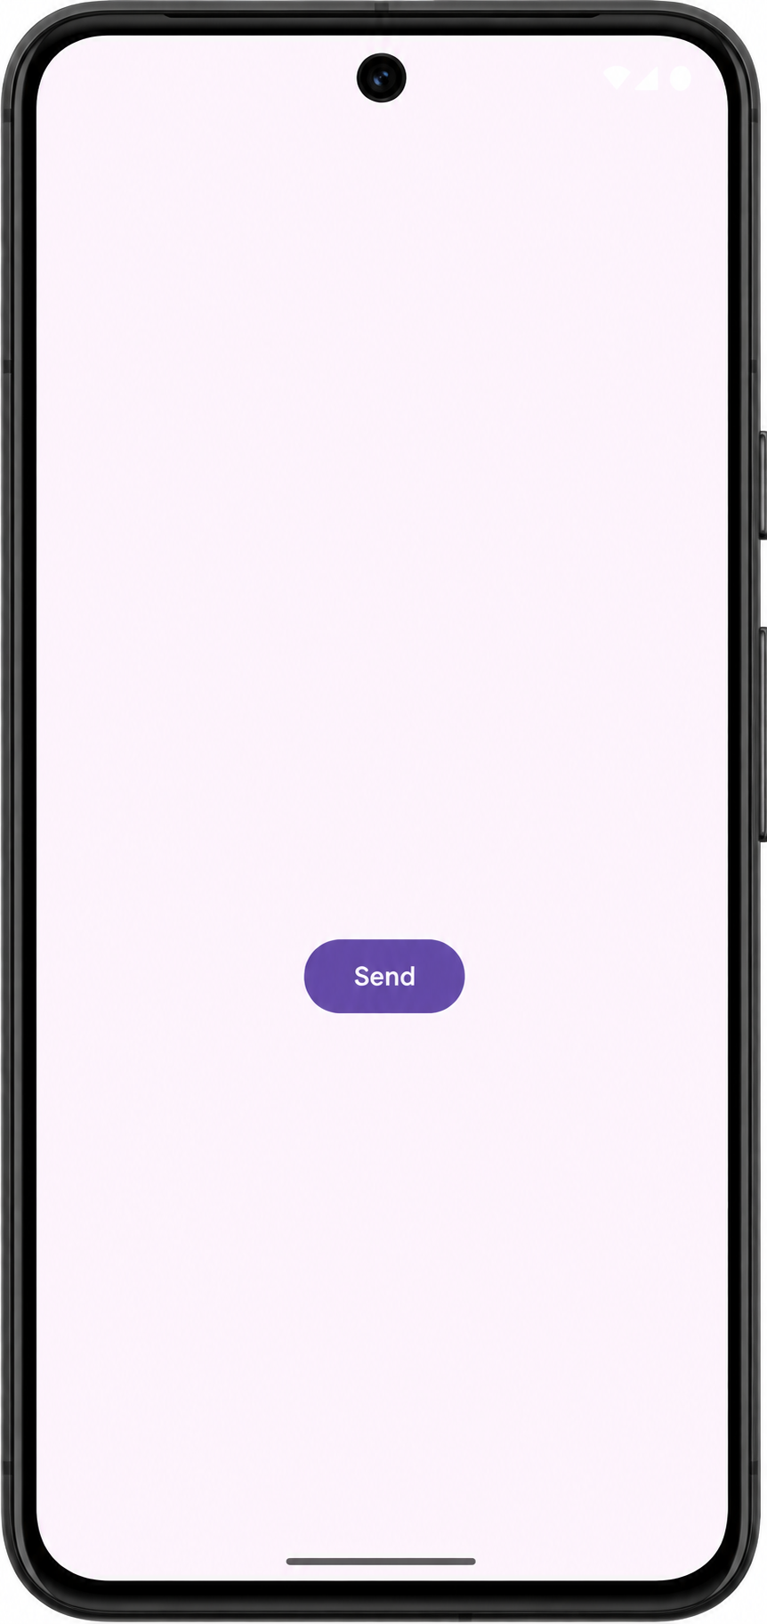 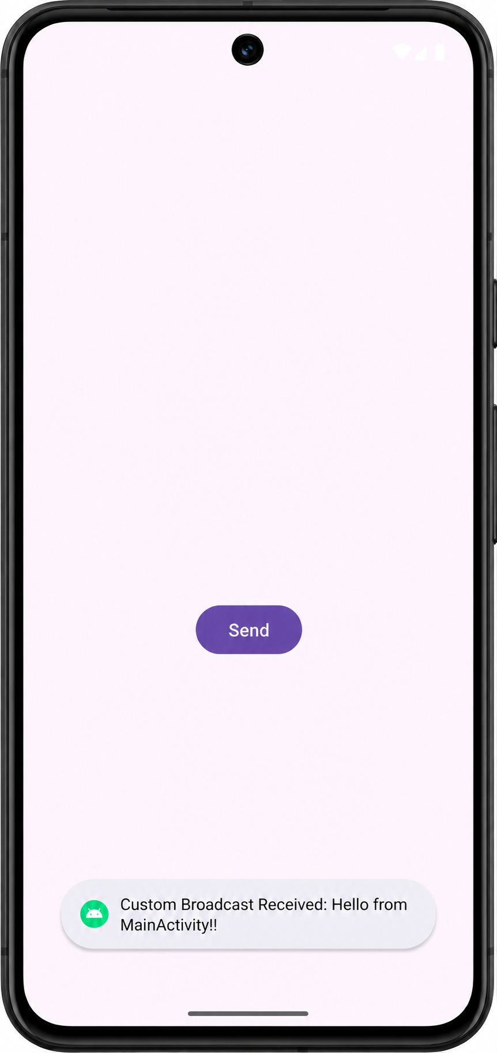

Program No: 19 | Date: 29/06/2026
Program Title: Create an app to broadcast a system intent (AIRPLANE MODE CHANGED).
MainActivity.java:
package com.example.pg19_airplanemode;
import android.content.Intent;
import android.content.IntentFilter;
import android.os.Bundle;
import androidx.appcompat.app.AppCompatActivity;
public class MainActivity extends AppCompatActivity {
private final AirplaneModeReceiver receiver = new AirplaneModeReceiver();
@Override
protected void onCreate(Bundle savedInstanceState) {
super.onCreate(savedInstanceState);
setContentView(R.layout.activity_main);
IntentFilter filter =
new IntentFilter(Intent.ACTION_AIRPLANE_MODE_CHANGED);
registerReceiver(receiver, filter);
}
@Override
protected void onDestroy() {
super.onDestroy();
unregisterReceiver(receiver);
}
}
AirplaneModeReceiver.java:
package com.example.pg19_airplanemode;
import android.content.BroadcastReceiver;
import android.content.Context;
import android.content.Intent;
import android.widget.Toast;
public class AirplaneModeReceiver extends BroadcastReceiver {
@Override
public void onReceive(Context context, Intent intent) {
if (intent.ACTION_AIRPLANE_MODE_CHANGED.equals(
intent.getAction())) {
boolean isOn = intent.getBooleanExtra("state", false);
String msg = isOn ? "Airplane Mode turned ON"
: "Airplane Mode turned OFF";
Toast.makeText(context, msg, Toast.LENGTH_SHORT).show();
}
}
}
activity_main.xml:
<?xml version="1.0" encoding="utf-8"?>
<androidx.constraintlayout.widget.ConstraintLayout
xmlns:android="http://schemas.android.com/apk/res/android"
xmlns:app="http://schemas.android.com/apk/res-auto"
xmlns:tools="http://schemas.android.com/tools"
android:id="@+id/main"
android:layout_width="match_parent"
android:layout_height="match_parent"
tools:context=".MainActivity" />
AndroidManifest.xml:
<receiver
android:name=".AirplaneModeReceiver"
android:enabled="true"
android:exported="true">
</receiver>
Output:
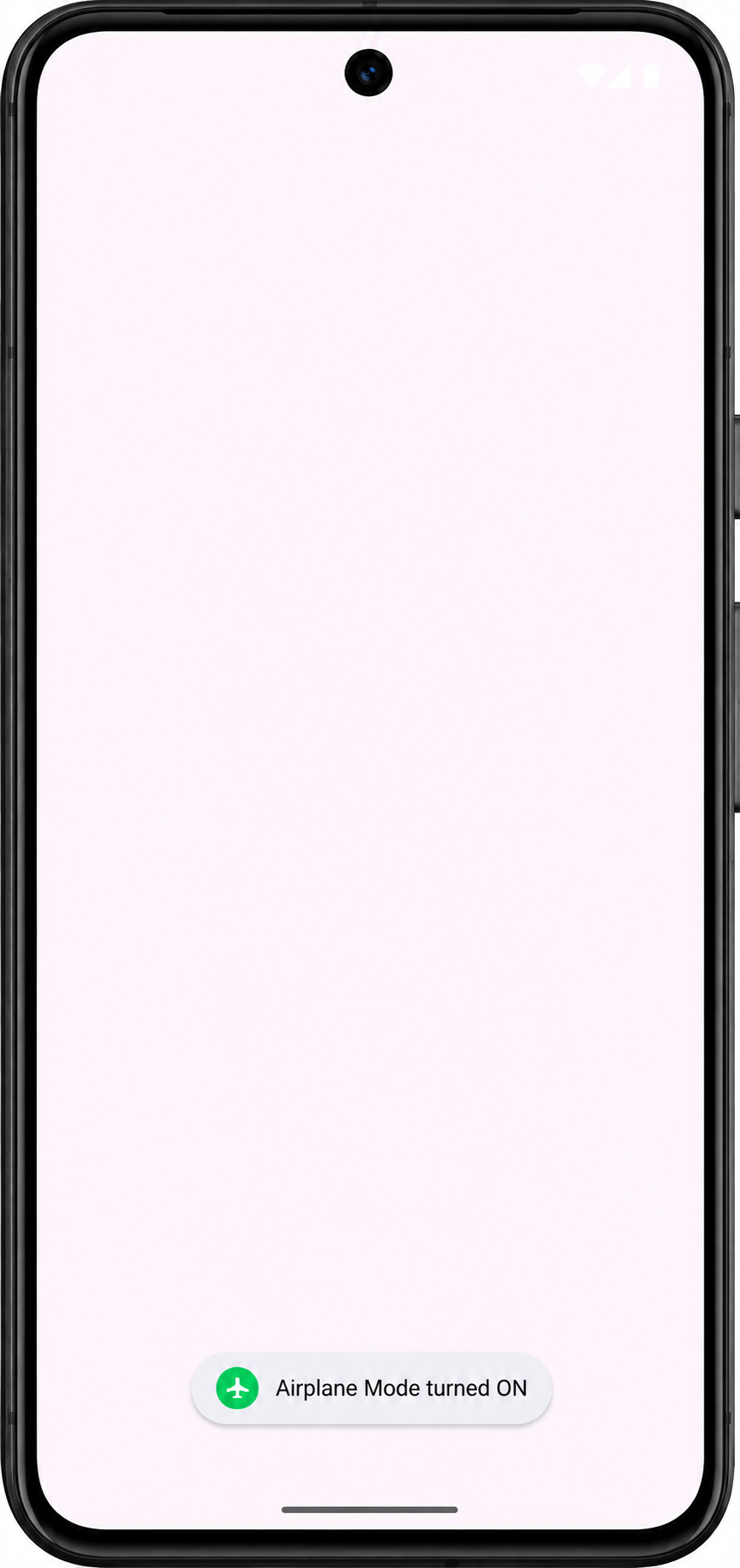

Program No: 20 | Date: 29/06/2026
Program Title: Create an app that launches a new activity on a button click.
MainActivity.java:
package com.example.batterylow;
import android.content.Intent;
import android.content.IntentFilter;
import android.os.Bundle;
import androidx.appcompat.app.AppCompatActivity;
public class MainActivity extends AppCompatActivity {
PowerReceiver receiver = new PowerReceiver();
@Override
protected void onCreate(Bundle savedInstanceState) {
super.onCreate(savedInstanceState);
setContentView(R.layout.activity_main);
IntentFilter filter =
new IntentFilter(Intent.ACTION_BATTERY_CHANGED);
registerReceiver(receiver, filter);
}
@Override
protected void onDestroy() {
super.onDestroy();
unregisterReceiver(receiver);
}
}
PowerReceiver.java:
package com.example.batterylow;
import android.content.BroadcastReceiver;
import android.content.Context;
import android.content.Intent;
import android.os.BatteryManager;
import android.widget.Toast;
public class PowerReceiver extends BroadcastReceiver {
@Override
public void onReceive(Context context, Intent intent) {
int level = intent.getIntExtra(BatteryManager.EXTRA_LEVEL, 0);
int scale = intent.getIntExtra(BatteryManager.EXTRA_SCALE, 100);
int percent = level * 100 / scale;
if (percent <= 15) {
Toast.makeText(context, "Battery Low: " + percent + "%",
Toast.LENGTH_SHORT).show();
}
}
}
activity_main.xml:
<?xml version="1.0" encoding="utf-8"?>
<androidx.constraintlayout.widget.ConstraintLayout
xmlns:android="http://schemas.android.com/apk/res/android"
xmlns:app="http://schemas.android.com/apk/res-auto"
xmlns:tools="http://schemas.android.com/tools"
android:id="@+id/main"
android:layout_width="match_parent"
android:layout_height="match_parent"
tools:context=".MainActivity" />
AndroidManifest.xml:
<receiver
android:name=".PowerReceiver"
android:enabled="true"
android:exported="true">
</receiver>
Output:
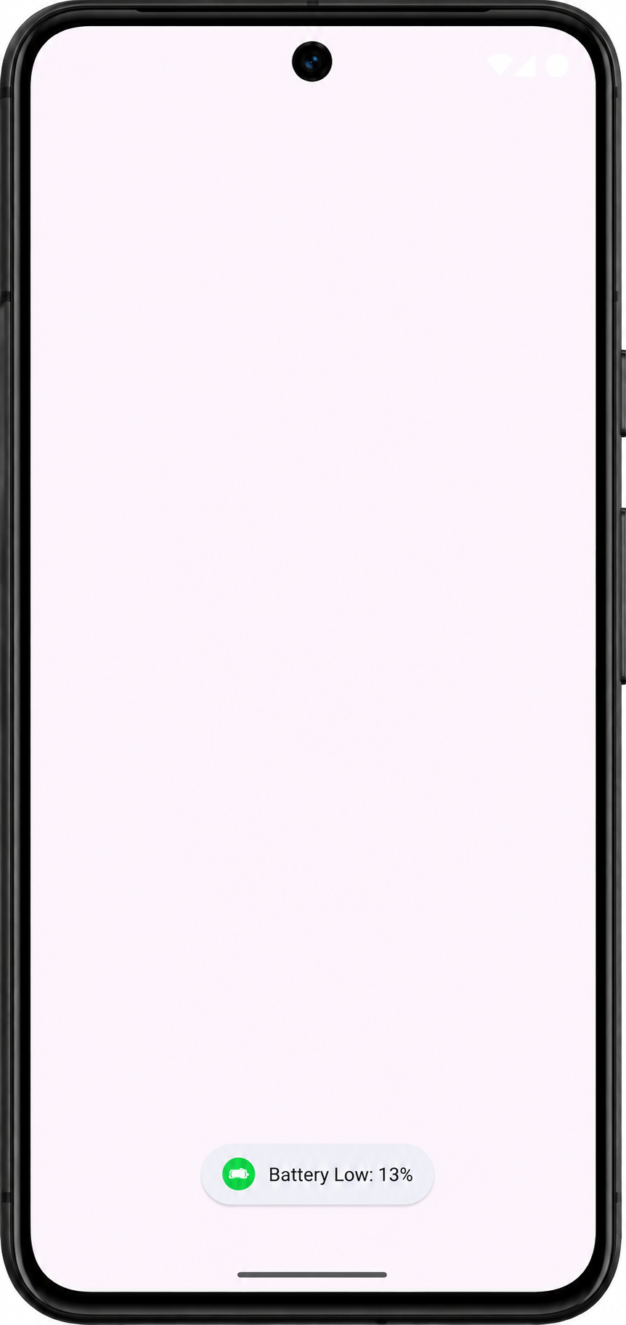

Program No: 21 | Date: 29/06/2026
Program Title: Create an alarm application.
MainActivity.java:
package com.example.pg20_alarmapp;
import android.app.AlarmManager;
import android.app.PendingIntent;
import android.content.Intent;
import android.os.Bundle;
import android.widget.Button;
import androidx.appcompat.app.AppCompatActivity;
public class MainActivity extends AppCompatActivity {
Button btnAlarm;
@Override
protected void onCreate(Bundle savedInstanceState) {
super.onCreate(savedInstanceState);
setContentView(R.layout.activity_main);
btnAlarm = findViewById(R.id.btnAlarm);
btnAlarm.setOnClickListener(v -> {
AlarmManager alarmManager = (AlarmManager)
getSystemService(ALARM_SERVICE);
Intent intent = new Intent(MainActivity.this,
AlarmReceiver.class);
PendingIntent pendingIntent = PendingIntent.getBroadcast(this, 0,
intent, PendingIntent.FLAG_IMMUTABLE);
long time = System.currentTimeMillis() + 10000; // 10 seconds
alarmManager.set(AlarmManager.RTC_WAKEUP, time, pendingIntent);
});
}
}
AlarmReceiver.java:
package com.example.pg20_alarmapp;
import android.content.BroadcastReceiver;
import android.content.Context;
import android.content.Intent;
import android.widget.Toast;
public class AlarmReceiver extends BroadcastReceiver {
@Override
public void onReceive(Context context, Intent intent) {
Toast.makeText(context, "Alarm Triggered!", Toast.LENGTH_LONG).show();
}
}
activity_main.xml:
<?xml version="1.0" encoding="utf-8"?>
<LinearLayout
xmlns:android="http://schemas.android.com/apk/res/android"
android:layout_width="match_parent"
android:layout_height="match_parent"
android:gravity="center"
android:orientation="vertical">
<Button
android:id="@+id/btnAlarm"
android:layout_width="wrap_content"
android:layout_height="wrap_content"
android:text="Set Alarm" />
</LinearLayout>
AndroidManifest.xml:
<receiver
android:name=".AlarmReceiver"
android:enabled="true"
android:exported="false" />
Output:
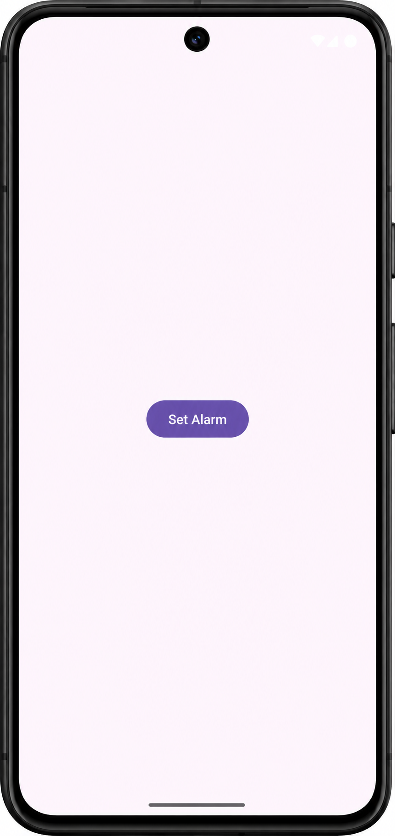 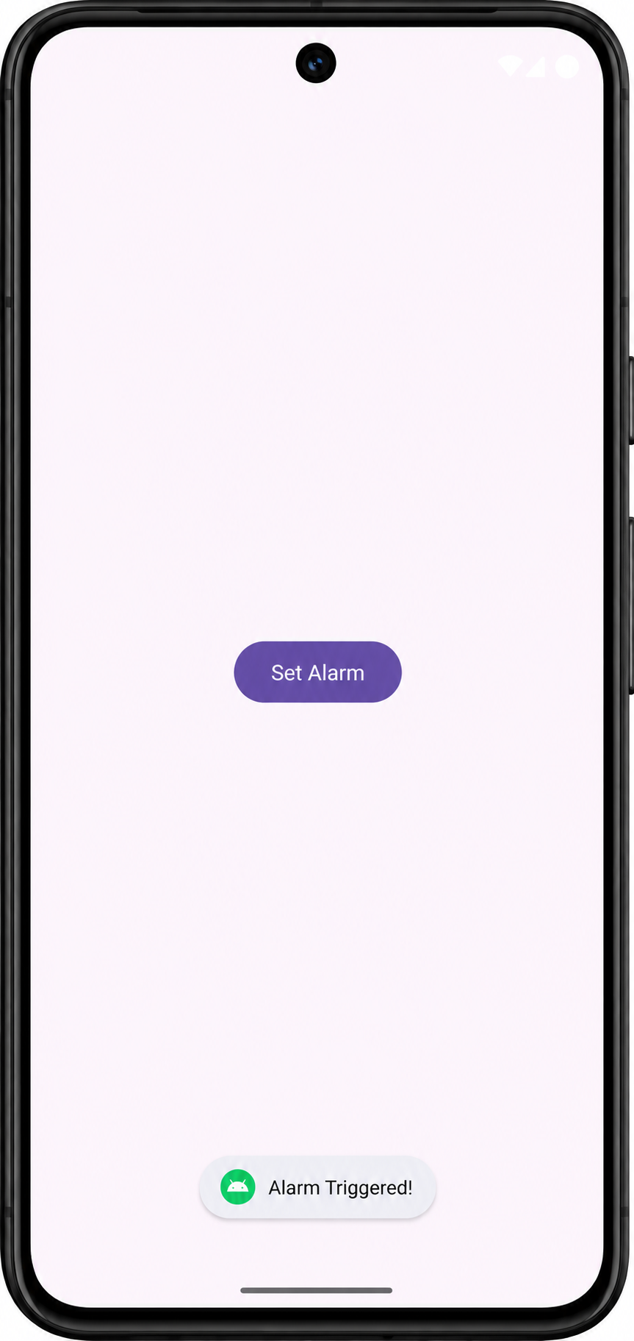

Program No: 22 | Date: 29/06/2026
Program Title: Create an app that displays a simple ListView. (Contacts list).
MainActivity.java:
package com.example.contactlist;
import android.os.Bundle;
import android.widget.ArrayAdapter;
import android.widget.ListView;
import androidx.appcompat.app.AppCompatActivity;
public class MainActivity extends AppCompatActivity {
@Override
protected void onCreate(Bundle savedInstanceState) {
super.onCreate(savedInstanceState);
setContentView(R.layout.activity_main);
String[] contacts = {
"Albin - 9876543210",
"Shyam - 9123456780",
"Jubin - 9988776655",
"Sharvin - 9876501234",
"Anandhu - 9012345678"
};
ListView listView = findViewById(R.id.listview);
ArrayAdapter<String> adapter = new ArrayAdapter<>(this,
android.R.layout.simple_list_item_1, contacts);
listView.setAdapter(adapter);
}
}
activity_main.xml:
<?xml version="1.0" encoding="utf-8"?>
<LinearLayout
xmlns:android="http://schemas.android.com/apk/res/android"
android:layout_width="match_parent"
android:layout_height="match_parent"
android:orientation="vertical"
android:padding="16dp">
<TextView
android:layout_width="wrap_content"
android:layout_height="wrap_content"
android:layout_gravity="center"
android:layout_marginTop="40dp"
android:text="Contact List"
android:textSize="24sp" />
<ListView
android:id="@+id/listview"
android:layout_width="match_parent"
android:layout_height="0dp"
android:layout_weight="1" />
</LinearLayout>
Output:
