Good Morning RenewTrak Team,

I have used these technologies:

1. Visual Studio 2019
2. .NET Core 3.1 API
3. Swagger for API testing
4. SOLID patterns, Repository pattern.
5. NUnit the unit testing. <WIP… due to time constraint. >
6. NLog for logging the exception in the text file.
7. Front end is developed using Angular 8, Bootstrap, Angular features – controller, services, pipe(for sorting) etc. are used.

I have completed the below tasks.

1. PartA.sln 🡪 Write a function to reverse the words in a string, for example “cat and dog” becomes “tac dna god”.
2. PartB.sln 🡪 Glossary
   1. Run API project. This opens the Glosaary.API project using the Swagger. It may take little time in first load as the local DB migration scripts with two seed data runs.
   2. Run Angular ClientApp from the folder—ClientApp
      1. Open Node.js command prompt and CD to ClientApp folder.
      2. Run
         1. npm install
         2. ng build

(for production we will use [ng build --prod] and update environment.prod.ts file.)

* + - 1. The angular project should build without any errors.
      2. ng serve
      3. open the ClientApp on <http://localhost:4200>
      4. Test the below features:
         1. Two added record during the API project setup should display on the browser.
         2. Sort the records by clicking the column header
         3. Add New Glossary Term
         4. Edit the existing Glossary item
         5. Delete the glossary item

1. I have documented below test case as a result.
   1. PartA – puzzle.
      1. 



* 1. ParB – Glossary Task test result.

First time lauch the UI looks like:

API

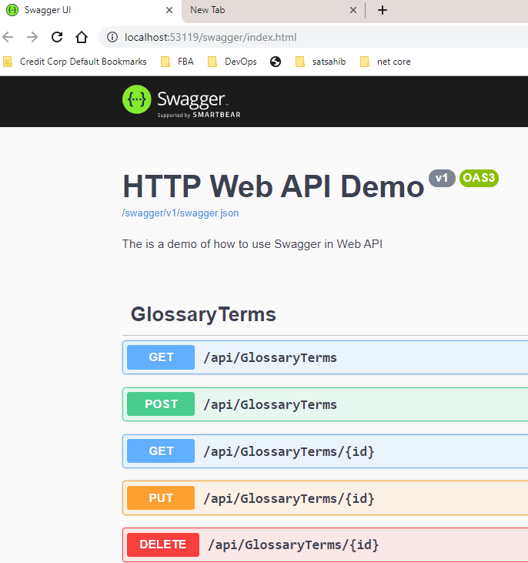

Front end:

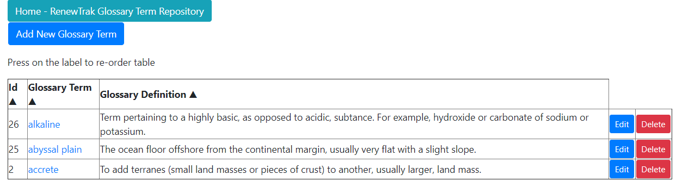

Click on any column lable to sort again:

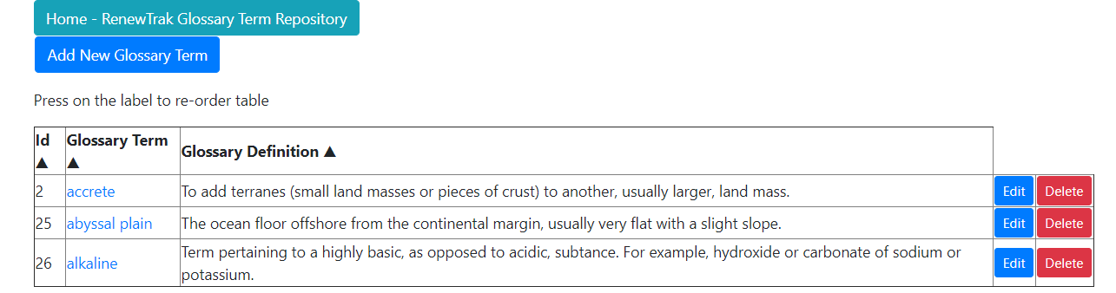

Add New item

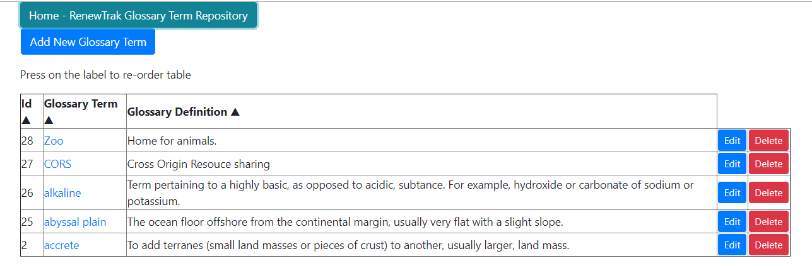

Add/Edit/Delete or view item details.

View item details:

