Self-Adaptive Agentic AI for Autonomous Intrusion Detection in Smart Healthcare IoT Ecosystems
Shyam Makadia – 24BAI1556 Kumar Aditya – 24BAI1580

Abstract
Smart healthcare ecosystems increasingly depend on connected sensors, medical devices, and industrial IoT infrastructure, making reliable detection of evolving network attacks important for protecting confidentiality, integrity, and availability. This study investigates a self-adaptive intrusion-detection framework motivated by healthcare IoT requirements while evaluating on the general Edge-IIoTset IoT/IIoT cybersecurity benchmark rather than hospital traffic. Six classifiers Logistic Regression, Decision Tree, Random Forest, XGBoost, LightGBM, and Multi-Layer Perceptron are compared using a scenario-aware split in which SQL injection, TCP-based distributed denial-of-service (DDoS), and man-in-the-middle (MITM) categories are withheld from training. XGBoost is selected because it obtains the highest validation ROC-AUC (99.83%), although LightGBM has a marginally higher validation F1-score. The selected detector uses 12 numeric network- and transport-level features, a validation-calibrated gradual threshold updated over sequential batches, and a deterministic rule-based decision-and-response layer that distinguishes Normal, Suspicious, and Attack states and prioritizes alerts. On 24,604 test samples, the reported evaluation achieves 99.35% accuracy, 99.24% precision, 100% recall, and 99.62% F1-score; each of the three held-out categories reaches 100% recall on this benchmark. These findings indicate benchmark-level potential for combining adaptive operating thresholds with differentiated alert triage, not validated healthcare deployment or universal zero-day detection. Limitations include the single benchmark, offline batch replay, exploratory status of the holdout evaluation, possible dataset-specific bias, and the absence of external-dataset or live-traffic validation.

Index Terms—Intrusion Detection System, Internet of Things, Industrial Internet of Things, Edge-IIoTset, XGBoost, Adaptive Thresholding, Agentic AI, Smart Healthcare, Unseen Attack Detection

I. Introduction
The Internet of Things (IoT) connects physical devices, sensors, actuators, and communication networks so that they can support continuous monitoring and automated services. A typical deployment has three layers. Devices at the perception layer collect data, a network layer carries it through gateways using protocols such as TCP, UDP, and DNS, and an application layer turns it into decisions. In smart healthcare, this includes connected medical equipment, remote-monitoring devices, building-management systems, and the gateways that link them. Industrial IoT (IIoT) follows the same structure in factories and control systems, usually with stricter requirements for uptime and safety. These systems improve coordination and patient support, but they also widen the attack surface. Many devices have limited memory and processing power, run old firmware, and cannot support heavy security software. They are often deployed for years without updates, and a single compromised device or communication channel can expose sensitive information, disrupt a service, or alter operational data.
Security is usually described by three properties: confidentiality, integrity, and availability. Confidentiality means that only authorized parties can read the data. Integrity means that data and commands have not been changed in the way. Availability means that the service keeps working when it is needed. Different attacks target different properties. A man-in-the-middle (MITM) attack places the attacker between two communicating parties, so it threatens confidentiality and integrity. SQL injection inserts malicious database commands through an input field and threatens the data behind a web interface. A distributed denial-of-service (DDoS) attack floods a target with traffic from many sources until legitimate requests can no longer be served, so it targets availability. In a healthcare setting, losing availability can be as serious as losing data, because a monitoring device that stops reporting can affect patient care. An intrusion detection system (IDS) is therefore an important defensive layer. It observes network behavior and raises an alert when it sees activity that may threaten one of these properties.
Intrusion detection methods are commonly divided into signature-based and anomaly-based approaches. A signature-based system compares traffic with a database of known attack patterns. It is accurate for attacks it already knows, but it cannot recognize a new variant until someone writes a signature for it. An anomaly-based system learns what normal behavior looks like and flags deviations, which lets it catch unfamiliar activity at the cost of more false alarms. The difficulty is made worse by attacks that have never been seen before, often called zero-day attacks, which no signature can cover. As IoT and IIoT deployments become more varied and more connected, traffic changes quickly and new attack variants keep appearing, so purely signature-based monitoring is no longer enough.
Machine learning has become a common answer to this problem. A supervised classifier learns a mapping from traffic features, such as TCP flags, port numbers, packet lengths, and timing, to an attack or normal label. It outputs a probability that a record is an attack, and a threshold turns that probability into a decision. Tree-based models are popular for this task because network features are a mix of flags, counters, and lengths on very different scales, and trees handle such data without needing normalization. This study compares six classifiers: Logistic Regression, Decision Tree, Random Forest, XGBoost, LightGBM, and a Multi-Layer Perceptron. Reported performance, however, depends heavily on how the data are partitioned, how the traffic is represented, how imbalanced the classes are, and which threshold is used. Class imbalance matters because attack records often outnumber normal ones in benchmark data, so a high accuracy can hide a weak detector, and measures such as precision, recall, the false-positive rate, and ROC-AUC give a fuller picture. Partitioning matters even more. In a random split, records from the same attack family land in both the training and the test set. Because the records of one attack are very similar to each other, the model is partly tested on patterns it has already seen. This is a form of data leakage, and it makes the detector look better than it would be against an attack it has never met, which is the situation that matters most in practice.
Two further issues limit many existing detectors. The first is the threshold. Most systems fix a single probability cutoff, often 0.5, even though the distribution of predicted probabilities can change from one batch of traffic to the next. A cutoff tuned once may become unsuitable as conditions change. The choice of cutoff is also a trade-off between two errors with different costs. A low threshold catches more attacks but raises more false alarms, and a high threshold does the opposite. In security the two errors are not equal: a missed attack can mean a compromised device, while a false alarm costs analyst time. The second issue is the output. A binary attack-or-normal decision treats borderline traffic and high-confidence attacks in the same way, although an operator would handle them differently. Healthcare adds a third concern. Missed attacks and excessive alerts both carry real costs, since too many false alarms lead to alert fatigue and genuine warnings get ignored. Many studies motivated by healthcare are also evaluated on data that are not clinical, so their claims can end up stronger than the evidence allows.
This paper addresses these issues with a self-adaptive intrusion detection framework. It is motivated by smart-healthcare security requirements but evaluated on the public Edge-IIoTset benchmark, a general IoT/IIoT dataset built from a purpose-made testbed that contains normal traffic and several families of attack. It is not hospital-specific and contains no real patient-care traffic, so healthcare is the target application context and not the source of the data. The framework uses a scenario-aware partition that keeps whole attack categories apart. SQL injection, TCP-based DDoS, and MITM are withheld from training, which tests how the models handle attack categories they have not seen. XGBoost has been selected as the primary detector because it has the highest validation ROC-AUC. Its probabilities are then processed in sequential batches using a threshold that moves in small steps within fixed bounds and is calibrated on validation traffic. Small steps stop one unusual batch from pushing the detector to an extreme setting, and the bounds keep it from drifting to a point where it flags everything or nothing. A deterministic rule-based layer then separates traffic into Normal, Suspicious, and Attack states and maps each state to an alert, so that monitoring and high-priority responses are kept apart. In this paper, the word “agentic” refers to this explicit rule-based coordination. No large language model or generative-AI component is used, and every decision can be traced back to a stated rule.
The main contributions of this work are as follows. We benchmark six models on a common 12-feature representation, and we build a scenario-aware partition that keeps three attack categories out of training. We design a bounded adaptive-threshold mechanism and a deterministic triage layer that together produce differentiated alerts. Finally, we report the benchmark results openly and state the limits of the evaluation, including the single dataset, the offline batch replay, the exploratory status of the held-out test set, possible dataset-specific bias in the features, and the absence of live-traffic validation. The results should be read as benchmark evidence for combining adaptive thresholds with alert triage, and not as validated healthcare deployment or universal zero-day detection.
The rest of the paper is organized as follows. Section II reviews related work on machine-learning-based IoT and IIoT intrusion detection, benchmark datasets, and adaptive and healthcare-oriented approaches. Section III describes the proposed architecture and methodology, including the dataset, features, split, models, adaptive threshold, and decision layer. Section IV reports the experimental results and the ablation study. Section V discusses the findings, practical relevance, and limitations. Section VI concludes the paper and outlines future work.
Benchmark datasets play a central role in this research, and the choice of dataset shapes every conclusion that follows. Early intrusion detection studies relied on older corpora that were collected from conventional enterprise networks and do not reflect the protocols, devices, and attack types found in IoT and IIoT environments. Newer benchmarks were built to close this gap. Edge-IIoTset, used in this study, was generated from a purpose-built testbed with many types of IoT and IIoT devices and sensors, and it contains normal traffic together with several families of attack, including denial-of-service, information gathering, man-in-the-middle, injection, and malware attacks. It is widely used because it is public, covers many attack categories, and supports both centralized and federated learning studies. Even so, a testbed is not a real deployment. The traffic is produced under controlled conditions, so some fields may reflect how the testbed was configured and not how attacks behave in practice. Destination ports and certain flag patterns are examples. For this reason, the paper keeps the feature set to a small group of network- and transport-level behavioral fields, and it states openly that this selection cannot fully remove dataset-specific bias.
Evaluating a detector also requires more than a single score. Accuracy is the share of records classified correctly, but when attacks make up most of a dataset, a model that labels every record as an attack already reaches a high accuracy without detecting anything useful. Precision shows how many of the alerts raised are real attacks, and recall shows how many real attacks were caught. The F1-score combines the two, and the false-positive rate shows how much normal traffic is wrongly flagged, which translates directly into analyst workload. ROC-AUC summarizes how well the model separates attacks from normal traffic across every possible threshold, so it does not depend on the cutoff that was chosen. Reading these measures together is especially important in this study, because the operating threshold is deliberately set low to favor recall, which raises the false-positive rate. Results must also be interpreted considering how they were produced. A test set that has been looked at during development no longer gives an unbiased estimate, and scores from different studies are not directly comparable when the dataset version, duplicate handling, feature subset, or split strategy differs. For these reasons, this paper reports a full set of metrics, describes its split in detail, and labels its held-out results as exploratory.

II. Literature Survey

A. Traditional and Machine-Learning-Based IoT and IIoT Intrusion Detection
Traditional intrusion detection research established the value of monitoring network behavior against signatures, statistical profiles, and supervised classifiers. In the IoT and IIoT setting, however, heterogeneous devices, constrained resources, protocol diversity, and changing traffic make a single detection strategy difficult to generalize. Zolanvari et al. studied machine-learning-based vulnerability analysis for IIoT networks, while Kasongo investigated genetic-algorithm feature selection with tree-based detection [2], [3]. These studies motivate compact feature representations and ensemble learners, but their results remain dependent on the selected dataset, labels, and partition protocol.

B. Deep Learning and Ensemble-Based Intrusion Detection
Injadat et al. proposed a multi-stage optimized machine-learning framework for network intrusion detection, illustrating how feature processing and model selection can be coordinated rather than treated as isolated steps [4]. Khammassi and Krichen similarly formulated feature selection as an NSGA-II/logistic-regression wrapper problem [5]. Eid et al. examined machine-learning intrusion detection for IIoT networks [6], and Khan et al. presented a robust attack-detection model for industrial-control-system environments [7]. Collectively, this work supports the use of supervised and tree-based models for resource-aware detection, but the cited studies do not, by themselves, establish robustness to attack categories withheld from training or a validated operational response loop.

C. IoT/IIoT Benchmarks and Edge-IIoTset
Deep models extend this foundation by learning nonlinear or temporal representations. Median et al. introduced N-BaIoT, using deep autoencoders for network-based IoT botnet detection and demonstrating the relevance of learned traffic profiles to previously unseen botnet behavior [8]. Alshehri et al. developed a self-attention-based deep convolutional model for IIoT intrusion detection [9]. CNN-based and hybrid CNN–LSTM approaches have also been applied to Edge-IIoTset and IoMT traffic, respectively [10], [11]. These methods can capture complex patterns, but they may require greater computation and careful leakage control; high scores from different binary, multiclass, or randomly partitioned evaluations are not directly comparable.

D. Adaptive, Agent-Based, and Response-Oriented Detection
Dataset design is therefore central to interpreting IDS results. Ferrag et al. introduced Edge-IIoTset as a realistic IoT/IIoT cybersecurity benchmark supporting centralized and federated-learning studies [1]. Moustafa introduced the Network TON_IoT datasets and a distributed architecture for evaluating AI-based security systems at the edge [12]. Thereza and Ramli evaluated IoT intrusion-detection models using CICIoT2023 [13]. More recent comparative work evaluates lightweight methods across TON_IoT, WUSTL-IIOT-2021, and Edge-IIoTset [14]. Singh and Chauhan reported a CNN-based study using Edge-IIoTset [10], while Javeed et al. evaluated an edge-oriented IDS for smart agriculture with Edge-IIoTset among its datasets [16]. These studies demonstrate the breadth of benchmark-based evaluation, but dataset choice, duplicate handling, feature subset, label definition, and split strategy can materially change conclusions.

E. Smart Healthcare IoT Security
Beyond classification, autonomous-security research considers how alerts should be interpreted and acted upon. Memon et al. added explainability to IoMT intrusion detection using feature selection, multiple classifiers, and LIME explanations [18]. Faruqui et al. proposed the SafetyMed CNN–LSTM hybrid for IoMT intrusion detection [11]. Kumar et al. investigated an LSTM-based cyberattack identification method for Internet of Healthcare Things networks [19]. These contributions improve detection, interpretability, or reproducibility, but the accessible records do not establish a common, experimentally validated policy layer for graded alerting, safe containment, or clinical escalation. Work that uses language models for security reasoning is conceptually distinct from this paper: the present framework uses deterministic rules and does not claim generative-AI reasoning.
Smart healthcare IoT adds requirements that are not captured by accuracy alone. A detector may observe medical, building-management, or gateway traffic whose disruption affects availability and safety, while excessive alerts can burden operators. Yet the studies reviewed here generally rely on public benchmarks or controlled testbeds rather than hospital-wide, continuously collected clinical traffic. Edge-IIoTset is particularly useful for general IoT/IIoT experimentation, but it is not hospital-specific; healthcare is therefore the motivation and intended context of this study, not the provenance of its evaluation data.

S. No. | Dataset | Methodology | Application | Advantages
1 | Edge-IIoTset | Benchmark construction; centralized/federated IDS evaluation | IoT/IIoT | Broad, reusable benchmark
2 | WUSTL-IIoT | Machine-learning vulnerability analysis | IIoT | Targets industrial vulnerabilities
3 | IIoT benchmark (paper record) | GA feature selection; tree algorithms | IIoT | Combines selection and detection
4 | Network IDS benchmark | Multi-stage optimized ML | Network IDS | Explicit staged optimization
5 | Network IDS benchmark | NSGA-II/LR wrapper selection | Network IDS | Multiobjective feature reduction
6 | IIoT network data | ML classifiers | IIoT | Direct IIoT focus
7 | Industrial-control data | Robust attack-detection model | IIoT/ICS | Industrial-control relevance
8 | IoT device traffic | Deep autoencoders | IoT botnets | Learns traffic profiles
9 | IIoT data | Self-attention deep CNN | IIoT | Models feature relationships
10 | Edge-IIoTset | CNN with image representation | IoT | Direct Edge-IIoTset study
11 | IoMT/CIC-IDS2017-derived data | CNN–LSTM hybrid | IoMT | Combines spatial and temporal learning
12 | TON_IoT | Distributed edge evaluation architecture | IoT/IIoT edge | Supports edge benchmarking
13 | CICIoT2023 | ML IDS models | IoT | Using recent IoT benchmark
14 | TON_IoT, WUSTL-IIOT-2021, EdgeIIoTset | Lightweight ML comparison | IoT/IIoT | Cross-dataset comparison
15 | Includes Edge-IIoTset | Edge-oriented IDS | Smart agriculture IoT | Edge-application focus
16 | IoT drift streams | Online deep learning | IoT | Addresses data/concept drift
17 | MQTT-IoT-IDS2020 | PSO selection; classifiers; LIME | IoMT | Adds post-hoc explanations
18 | IoHT attack traffic | Improved LSTM | IoHT | Healthcare-IoT focus

Adaptive IDS research addresses the possibility that a detector calibrated on one traffic distribution will become less suitable as conditions change. Lu et al. studied IoT intrusion detection under data and concept drift using an online deep-learning approach [17]. This line of work treats adaptation as a response to evolving data distributions rather than merely a one-time hyperparameter search. The present study adopts a narrower and auditable form of adaptation: a validation-calibrated threshold is adjusted gradually and within fixed bounds as sequential batch-level predicted
probabilities change. This threshold mechanism is paired with a deterministic response layer rather than an unrestricted automated remediation policy.

III. Proposed System Architecture and Methodology
- Overall System Architecture

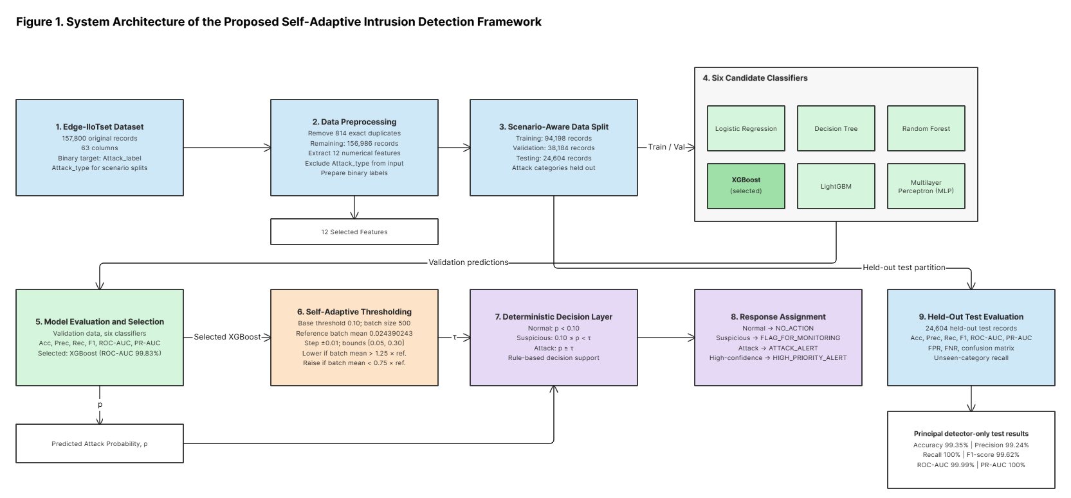
The proposed framework, titled Self-Adaptive Agentic AI for Autonomous Intrusion Detection in Smart Healthcare IoT Ecosystems, is an offline experimental pipeline built on the Edge-IIoTset cybersecurity benchmark. It covers dataset preprocessing, feature selection, scenario-aware splitting, comparison of machine-learning models, adaptive thresholding, and deterministic agentic decision-making.
The pipeline first removes duplicate records and keeps 12 network/transport-level behavioral features. Six classifiers are trained and evaluated, and XGBoost is chosen as the primary detector because it has the best validation ROC-AUC. Its predicted attack probabilities are then processed in sequential batches using a bounded adaptive threshold. Finally, deterministic rules label traffic as normal, suspicious, or attack and produce the matching alert.
The overall workflow is
D_raw → D_clean → D_split → M_selected → T_adaptive → A_decision
where D_raw is the original dataset, D_clean is the deduplicated dataset, D_split is the set of scenario-aware partitions, M_selected is the chosen XGBoost detector, T_adaptive is the adaptive threshold mechanism, and A_decision is the deterministic decision and response layer.
The framework is evaluated offline. It does not collect traffic from a hospital network, run live monitoring, or automatically blocks or remediate devices.
The implemented workflow is an offline experimental pipeline, not a deployed real-time hospital system. Edge-IIoTset records are deduplicated, represented by 12 retained network features, and split by attack category. Six classifiers are trained and compared; XGBoost is selected by validation ROC-AUC. Its probabilities are processed in sequential batches using a bounded gradual threshold, then mapped by deterministic rules to states and alert outputs.

Dataset Description and Preprocessing

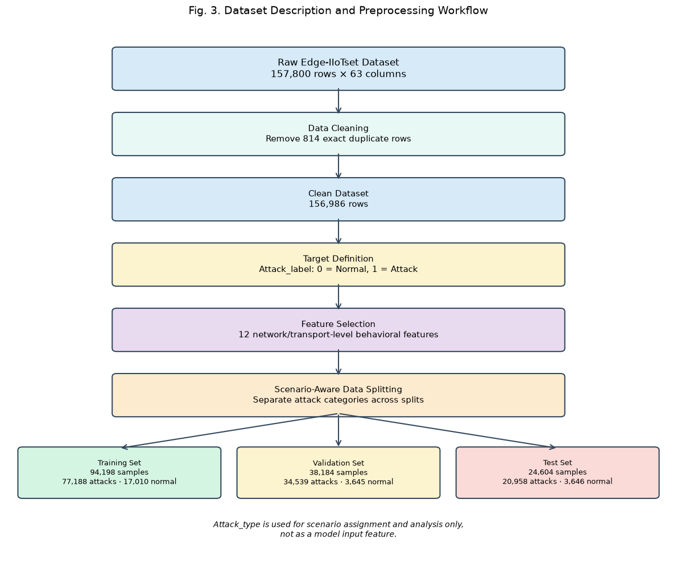

Edge-IIoTset is a general Internet of Things (IoT) and Industrial Internet of Things (IIoT) cybersecurity benchmark, not a dataset collected from hospitals [1]. It contains 157,800 records and 63 columns. After removing 814 exact duplicates, 156,986 records remain:
N_clean = N_raw − N_duplicate = 157,800 − 814 = 156,986
where N_raw is the original record count, N_duplicate is the number of removed duplicates, and N_clean is the resulting dataset size.
The binary target is Attack_label, where 0 is normal traffic and 1 is attack traffic. Attack_type is used only to build scenarios and analyze attack categories, and it is not a model input.
The classification objective is
$$f: R^{12}→ \left[0, 1\right]$$
where f(xᵢ) is the predicted probability that traffic sample xᵢ is an attack.
No claim is made about missing-value imputation, categorical encoding, normalization, or resampling unless the experimental implementation supports it.

Feature Selection
Edge-IIoTset is a general IoT/IIoT cybersecurity benchmark, not hospital-specific [1]. The documented file contained 157,800 rows and 63 columns; 814 exact duplicate rows were removed, leaving 156,986 records. Attack_label is the binary target (0 normal, 1 attack). Attack_type is reserved for scenario construction and analysis and is not an input feature. No unsupported claim is made about missing-value handling, normalization, encoding, or resampling.
Feature group Retained features
TCP tcp.ack, tcp.connection.fin, tcp.connection.rst, tcp.connection.syn, tcp.connection.synack, tcp.dstport, tcp.flags, tcp.flags.ack, tcp.len
UDP/DNS udp.port, udp.time_delta, dns.qry.qu
The feature vector for sample i is
xᵢ = [xᵢ₁, xᵢ₂, …, xᵢ₁₂]
where xᵢₖ is the value of the k-th retained feature for sample i. The target yᵢ is 0 for normal traffic and 1 for attack traffic.
Attack_type is not used as a model feature. The selected features capture useful traffic behavior, but choosing them does not establish protocol independence or rule out dataset-specific bias.

D. Scenario-Aware Dataset Splitting

Feature group | Features
TCP | tcp.ack; tcp.connection.fin; tcp.connection.rst; tcp.connection.syn; tcp.connection.synack; tcp.dstport; tcp.flags; tcp.flags.ack; tcp.len
UDP/DNS | udp.port; udp.time_delta; dns.qry.qu

Table I. Scenario-aware dataset partitioning

The dataset is split into training, validation, and test partitions by attack category. Each attack category goes to exactly one partition, so the models are tested on attack categories they never saw in training.
Partition Attack categories Attack samples Normal samples Total
Training Ransomware, Uploading, Backdoor, Vulnerability_scanner, Fingerprinting, Port_Scanning, DDoS_ICMP, DDoS_HTTP 77,188 17,010 94,198
Validation XSS, DDoS_UDP, Password 34,539 3,645 38,184
Test SQL_injection, DDoS_TCP, MITM 20,958 3,646 24,604
The separation condition is
$$A_{train}∩ A_{val}= A_{train}∩ A_{test}= A_{val}∩ A_{test}= ∅$$
where A_train, A_val, and A_test are the sets of attack categories assigned to each partition.
Training data fit the models. Validation data are used for model selection and threshold configuration. Test data are replayed offline to measure performance on held-out attack categories.
The test set was looked at before later refinements, so it is treated as an exploratory held-out benchmark, not a fully untouched confirmatory test. Category-level generalization on this benchmark does not prove universal zero-day detection.

E. Machine-Learning Model Development

Partition | Attack categories | Attack | Normal | Total
Training | Ransomware, Uploading, Backdoor, Vulnerability_scanner, Fingerprinting, Port_Scanning, DDoS_ICMP, DDoS_HTTP | 77,188 | 17,010 | 94,198
Validation | XSS, DDoS_UDP, Password | 34,539 | 3,645 | 38,184
Test | SQL_injection, DDoS_TCP, MITM | 20,958 | 3,646 | 24,604

Six classifiers are evaluated on the same 12 features and the same scenario-aware split:
Logistic Regression (LR) Decision Tree (DT) Random Forest (RF)
Extreme Gradient Boosting (XGBoost) Light Gradient Boosting Machine (LightGBM) Multi-Layer Perceptron (MLP)
A. Logistic Regression
Logistic Regression estimates the attack probability with the sigmoid function:
$$\hat{p}ᵢ = σ\left(wᵀxᵢ + b\right)= \frac{1}{\left(1 + e^{-\left(wᵀxᵢ + b\right)}\right)}$$
where w is the coefficient vector, b is the bias, and p̂ᵢ is the predicted attack probability.
B. Decision Tree
The Gini impurity of a node S is
$$G\left(S\right)= 1 - Σ \left(k = 0 to 1\right)pₖ^{2}$$
where pₖ is the proportion of samples in class k. Each split is chosen to reduce this impurity in the child nodes.
C. Random Forest
Random Forest combines the predictions of many decision trees. For a forest of B trees, the averaged attack probability is
$$\hat{p}\left(x\right)= \left(\frac{1}{B}\right)· Σ \left(b = 1 to B\right){\hat{p}}_{b\left(x\right)}$$
where p̂_b(x) is the probability predicted by tree b. The configuration uses 200 trees and has a maximum depth of 12.
D. XGBoost
XGBoost builds an additive ensemble of decision trees:
$$F_{K\left(x\right)}= Σ \left(k = 1 to K\right)f_{k\left(x\right)}$$
The binary attack probability is
$$\hat{p}ᵢ = \frac{1}{\left(1 + e^{-F_{K\left(xᵢ\right)}}\right)}$$
The regularized boosting objective is
$$L = Σ \left(i = 1 to N\right)l\left(yᵢ, \hat{p}ᵢ\right)+ Σ \left(k = 1 to K\right)Ω\left(f_{k}\right)$$
where ℓ is the classification loss and Ω(f_k) is a tree-complexity penalty.
The configuration uses n_estimators=200, max_depth=6, learning_rate=0.1, subsample=0.8, colsample_bytree=0.8, random_state=42, and eval_metric="logloss".
E. LightGBM
LightGBM is also a gradient-boosted decision tree model. It builds an additive ensemble in the same way as XGBoost, starting from an initial score and adding one tree per iteration scaled by the learning rate, and it converts the final score to an attack probability with the sigmoid function.
F. Multi-Layer Perceptron
The MLP passes its inputs through successive layers:
$$a^{(}ˡ^{)}= φ\left(W^{(}ˡ^{)}· a^{(}ˡ^{-1)}+ b^{(}ˡ^{)}\right)$$
where W⁽ˡ⁾ and b⁽ˡ⁾ are the weights and biases of layer l, and φ is the activation function. The output layer uses a sigmoid to give the attack probability.
G. Model Selection
XGBoost is chosen as the primary detector because it has the highest validation ROC-AUC, 99.83%. LightGBM has a slightly higher validation F1-score (98.91% versus 98.90% for XGBoost). The choice therefore rests on ROC-AUC and on how well XGBoost fits into the adaptive-threshold and decision framework, and it does not claim that XGBoost leads on every metric.
- Self-Adaptive Thresholding Mechanism
The adaptive-threshold mechanism changes the classification threshold during sequential offline evaluation. A validation search over thresholds from 0.10 to 0.90 in steps of 0.05 gives an initial threshold of t₀ = 0.10.
For a batch B_j with n_j samples, the mean predicted attack probability is
$${\bar{p}}_{j}= \left(\frac{1}{n_{j}}\right)· Σ \left(i ∈ B_{j}\right)pᵢ$$
where pᵢ is the predicted attack probability for sample i.The reference probability comes from the first sequential validation batch:
p_ref = p̄₁ = 0.024390243
Let t_j be the current threshold, δ = 0.01 the adjustment step, and t_min = 0.05 and t_max = 0.30 the bounds. The update rule is
$$t_{j+1}=\max\left(t_{min}, t_{j}- δ\right), if {\bar{p}}_{j}> 1.25 · p_{ref} \\ t_{j+1}=\min\left(t_{max}, t_{j}+ δ\right), if {\bar{p}}_{j}< 0.75 · p_{ref}$$$t_{j+1}= t_{j}$, otherwise
So the threshold goes down when the batch mean rises above the upper reference boundary, goes up when the mean falls below the lower boundary, and stays put otherwise. It never leaves the bounds.
The binary classification rule is
$$ŷᵢ = 1, if pᵢ ≥ t_{j} \\ ŷᵢ = 0, if pᵢ < t_{j}$$
The test replay uses 50 batches. This is offline adaptation, not live streaming or deployment. The mean predicted probability can also shift because of benign traffic composition or manipulation, so threshold changes should not be read as proof-of-concept drift or a guarantee of better security.
The six compared models are Logistic Regression, Decision Tree, Random Forest, XGBoost, LightGBM, and MLP using the same 12 features and split. XGBoost is selected for the highest validation ROC-AUC (99.83%); LightGBM has slightly higher validation F1 (98.91%) than XGBoost (98.90%). XGBoost configuration: n_estimators=200, max_depth=6, learning_rate=0.1, subsample=0.8, colsample_bytree=0.8, random_state=42, eval_metric="logloss".

G. Deterministic Agentic Decision and Response Layer

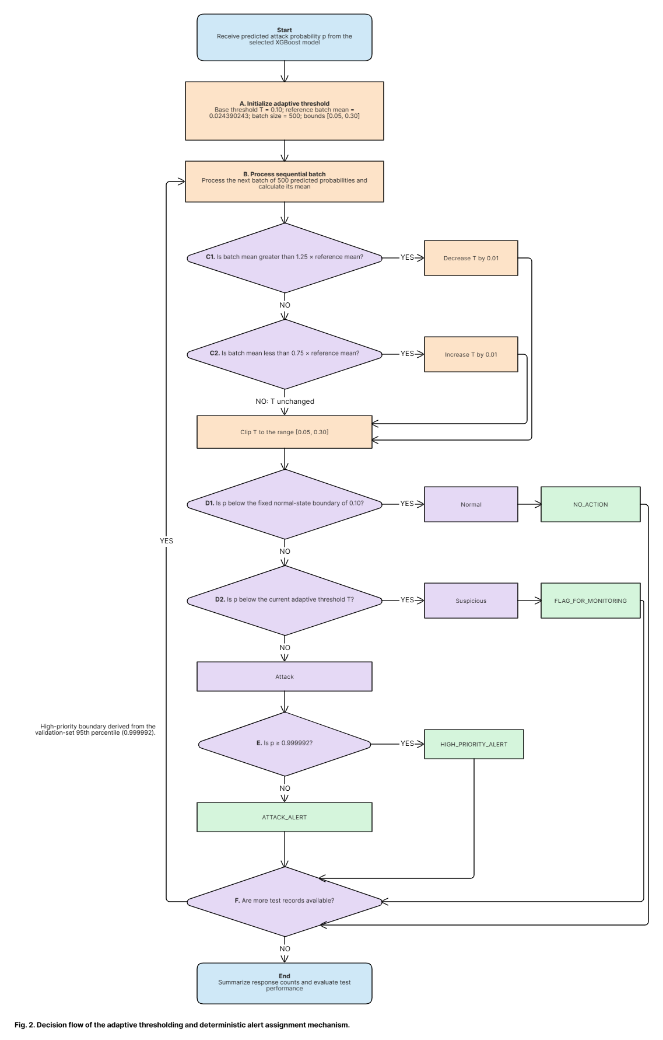

A validation search over 0.10–0.90 in steps of 0.05 selects base threshold =0.10. Batches contain 500 samples. The first validation batch supplies _ref=0.024390243. If a batch exceeds 1.25_ref, lower by 0.01; if below 0.75_ref, raise by 0.01; otherwise leave it unchanged. Bound to [0.05,0.30]. Test replay uses 50 sequential batches. This is offline replay, not live streaming; mean probability alone may react to benign composition changes or manipulation.
The agentic layer is a lightweight rule-based mechanism, not a large language model or generative-AI system. It maps the predicted attack probability and the current threshold to a traffic state and then maps that state to an alert.
A. Traffic-state assignment
Let pᵢ be the predicted attack probability and t_j the current threshold. The three-state rule is
$$Sᵢ = Normal, if pᵢ <\frac{t_{j}}{2} \\ Sᵢ = Suspicious, if\frac{t_{j}}{2}≤ pᵢ < t_{j} \\ Sᵢ = Attack, if pᵢ ≥ t_{j}$$
The suspicious band is defined relative to the current threshold, not as a fixed probability of 0.5.
B. High-priority alert boundary
The high-priority boundary is the 95th percentile of validation attack probabilities:
$$t_{HP}= Q_{0}._{95}\left(P_{val}\right)≈ 0.999992$$
where Q₀.₉₅ is the 95th percentile of the relevant validation probability distribution. It should be interpreted according to the exact probability array used in the notebook.
C. Response mapping
The response function is
Rᵢ = NO_ACTION, if Sᵢ = Normal
Rᵢ = FLAG_FOR_MONITORING, if Sᵢ = Suspicious
Rᵢ = ATTACK_ALERT, if Sᵢ = Attack and pᵢ < t_HP
Rᵢ = HIGH_PRIORITY_ALERT, if Sᵢ = Attack and pᵢ ≥ t_HP
These outputs are for offline triage and prioritization. They do not block traffic, remediate devices, or take security actions in a hospital environment.

H. Evaluation Metrics

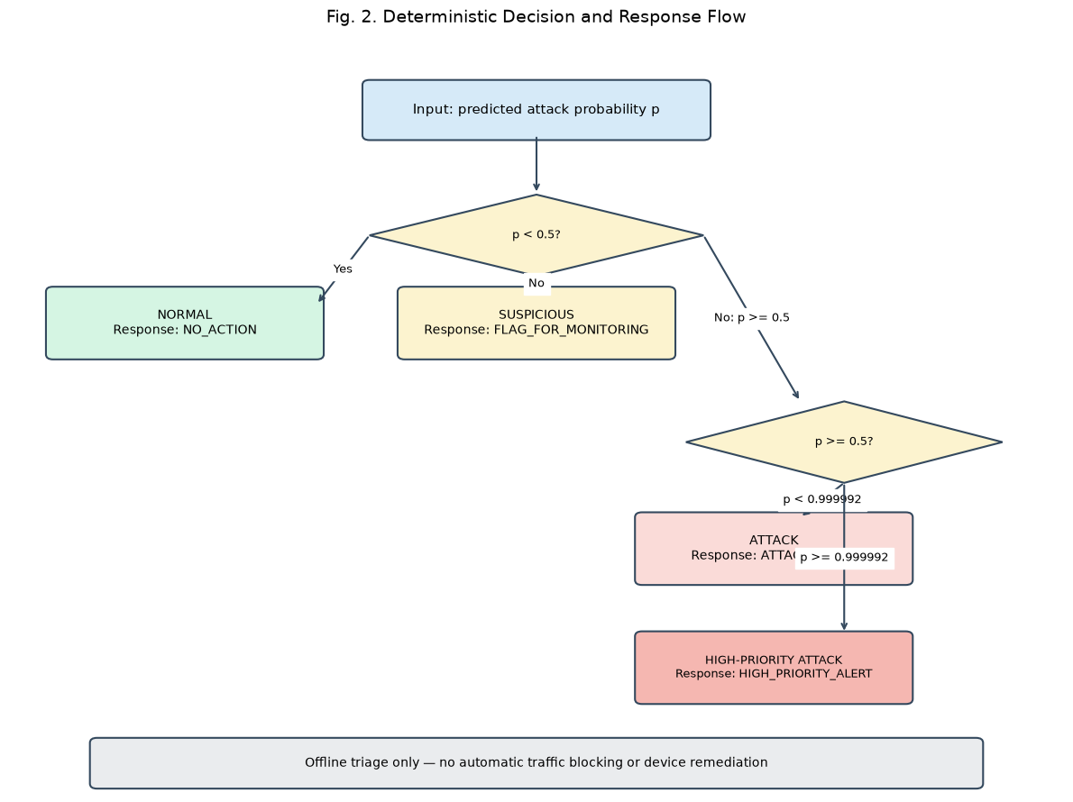
The framework is evaluated with Accuracy, Precision, Recall, F1-score, False Positive Rate (FPR), False Negative Rate (FNR), ROC-AUC, and PR-AUC. MCC and ECE can be added only if they are computed from experimental predictions.
Let TP, TN, FP, and FN be the true positives, true negatives, false positives, and false negatives.
A. Accuracy
Accuracy is the proportion of correctly classified samples:
$$Accuracy =\frac{\left(TP + TN\right)}{\left(TP + TN + FP + FN\right)}× 100$$
B. Precision
Precision is the proportion of predicted attacks that are real attacks:
$$Precision = \frac{TP}{\left(TP + FP\right)}× 100$$
C. Recall
Recall is the proportion of real attacks that were detected:
$$Recall = \frac{TP}{\left(TP + FN\right)}× 100$$
D. F1-score
F1 is the harmonic mean of precision and recall:
$$F1 = 2 ×\frac{\left(Precision × Recall\right)}{\left(Precision + Recall\right)}$$
E. False Positive Rate
FPR is the proportion of normal samples wrongly flagged as attacks:
$$FPR = \frac{FP}{\left(FP + TN\right)}$$
F. Other metrics
FNR is the proportion of attacks the detector missed, FN / (FN + TP). ROC-AUC is the area under the curve of true positive rate against false positive rate across thresholds, and it shows how well the model separates attack from normal traffic. PR-AUC summarizes the precision–recall trade-off, and its reported value depends on the average-precision convention the implementation uses. MCC gives a balanced single-number summary and ranges from −1 to +1. ECE measures the gap between predicted confidence and observed accuracy across confidence bins. MCC and ECE should be reported only if they were computed, with the binning strategy stated for ECE.
Metrics for the six classifiers, the adaptive detector, and the agentic decision layer should be reported separately, according to the predictions each one evaluates.

The agentic layer is deterministic rule logic, not an LLM or generative-AI system. Normal: p<0.5. Suspicious: 0.5p<. Attack: p. Normal maps to NO_ACTION; Suspicious to FLAG_FOR_MONITORING; Attack below the validation 95th-percentile boundary (~0.999992) to ATTACK_ALERT; Attack at or above it to HIGH_PRIORITY_ALERT. Outputs are triage labels only and do not block traffic or remediate devices.

IX. Ablation Study of the XGBoost Detector
The ablation study measures how much selected features and feature groups contribute. Each configuration is trained on the training partition and evaluated on the validation partition, with the XGBoost hyperparameters held constant.
Let F be the full set of 12 features and Rᵢ the features removed in configuration i. The retained set is
$$Fᵢ =\frac{ F }{Rᵢ}$$
For each configuration the model is retrained, and predictions and attack probabilities are obtained for the validation samples. Accuracy, Precision, Recall, F1-score, ROC-AUC, and Average Precision (AP) are calculated. The change in a metric M relative to the full model is
$$ΔMᵢ = M\left(F\right)- M\left(Fᵢ\right)$$
For the F1-score this gives ΔF1ᵢ = F1(F) − F1(Fᵢ). A positive value means removing those features lowered the metric, and a negative value means the reduced model scored higher.
Algorithm 1: Calibrated, Drift-Aware Adaptive Intrusion Detection Framework
Input:
D_raw: raw Edge-IIoTset records
F: 12 selected features
A_train, A_val, A_test: disjoint attack-category sets
M = {LR, DT, RF, XGB, LGBM, MLP} candidate classifiers
Θ = {0.10, 0.15, ..., 0.90} candidate thresholds
c = C_FN / C_FP: cost ratio; α: target FPR
S: set of random seeds
J = 50 batches; δ = 0.01; t_min = 0.05; t_max = 0.30
λ: smoothing factor; k: cooldown length
Ω = {abrupt, gradual, recurring}: drift scenarios
Output:
Threshold trace {t_j}, states {S_i}, responses {R_i}, metrics with 95% CIs, baseline comparison
--- Phase 1: Preprocessing and scenario-aware split ---
1. D_clean ← remove exact and near-duplicate records from D_raw
2. Assign each normal record to train/val/test by a stratified random split (or by device/session ID if available)
3. Build D_train, D_val, D_test from A_train, A_val, A_test plus their normal share
4. Assert A_train, A_val, A_test are pairwise disjoint, and no row hash appears in two partitions
5. Fit imputers, scalers and encoders on D_train only, then apply them to D_val and D_test
--- Phase 2: Model development and selection ---
6. For each model m in M and each seed s in S: tune on D_train with attack-family-grouped CV (leave-one-family-out inside A_train), fit, and score D_val
7. Record Precision, Recall, F1, MCC, ROC-AUC, PR-AUC and Recall FPR=α as mean ± std over seeds
8. m* ← argmax over m of PR-AUC (ties broken by Recall FPR=α, then inference latency)
9. Calibrate m* on D_val with isotonic or Platt scaling, then check ECE and Brier score on a held-out slice of D_val
--- Phase 3: Threshold and alert calibration ---
10. t_0 ← argmin over Θ of (C_FN·FN + C_FP·FP) on D_val, subject to FPR ≤ α. Report which criterion was used
11. t_0 ← clip (t_0, t_min, t_max)
12. t_HP ← 95th percentile of calibrated probabilities over validation attack records
13. P_ref ← calibrated scores of validations normal traffic (the whole set, not just the first batch)
--- Phase 4: Sequential adaptive replay on the test set ---
14. For each scenario ω in Ω: order D_test into J batches B_1, ..., B_J according to ω
15. t ← t_0; z ← 0; cool ← 0
16. For j = 1 to J:
17. p_i ← calibrated m*(x_i) for every i in B_j
18. For each i in B_j:
19. ŷ_i ← 1 if p_i ≥ t, else 0
20. If p_i < t/2: S_i ← Normal, R_i ← NO_ACTION
21. Else if p_i < t: S_i ← Suspicious, R_i ← FLAG_FOR_MONITORING
22. Else if p_i < t_HP: S_i ← Attack, R_i ← ATTACK_ALERT
23. Else: S_i ← Attack, R_i ← HIGH_PRIORITY_ALERT
24. d_j ← PSI (or KS distance) between scores in B_j with p_i < t and P_ref
25. z ← λ·d_j + (1 − λ)·z
26 If cool = 0 and z exceeds the drift limit:
27. Move t by δ in the direction that keeps the alert rate inside the target band
28. t ← clip (t, t_min, t_max); cool ← k
29. Else: cool ← max (0, cool − 1)
30. If analyst feedback is available for B_j: re-estimate FPR and lower t_(j+1) if FPR > α
31. Store t as t_(j+1)
32. Repeat steps 15 to 31 with a fixed threshold t_0 and with a periodic-retraining baseline
--- Phase 5: Evaluation ---
33.Compute Accuracy, Precision, Recall, F1, FPR, FNR, MCC, ROC-AUC and PR-AUC per batch and for the full test set (report ECE only if calculated)
34.Report recall and detection delay (batches until first alert) per attack category
35.Report alerts per 1,000 flows, precision of HIGH_PRIORITY_ALERT, and inference time per batch
36. Compute bootstrap 95% CIs over batches and seeds; compare adaptive vs fixed threshold with a paired test
37. Return {t_j}, {S_i}, {R_i}, metrics, baselines
Algorithm 2: Feature-Group Ablation with Significance Testing
Input:
D_train, D_val, D_test (unseen attack families)
Full feature set F (12 features)
Groups G = {tcp.dstport, tcp.ack, tcp.flags, tcp.len, TCP connection flags, UDP features, DNS feature}
XGBoost hyperparameters H (fixed)
Seeds S = {s_1, ..., s_K}; grouped-CV folds K_f; significance level α_sig
Output:
Ablation table (mean ± std, paired ΔF1, 95% CI, adjusted p-value), group ranking, robustness verdict
1. For each fold f and seed s: train XGBoost (H, s) on D_train using F with attack-family-grouped splits
2. Tune the decision threshold on training folds only
3. Evaluate on D_val and D_test: F1, MCC, ROC-AUC, PR-AUC, Recall FPR=α; store per-run values
4. M(F) ← mean of each metric over runs
5. For each group R_i in G:
6. F_i ← F \ R_i
7. Repeat steps 1 to 3 with the same folds and seeds, re-tuning the threshold for the ablated model
8. Δ_i,run ← M(F)_run − M(F_i)_run (paired by fold and seed)
9. Compute mean ΔF1_i, std of the paired differences σ_i, and a bootstrap 95% CI
10. Run a Wilcoxon signed-rank test on the paired Δ values
11.Train on R_i alone (keep-only ablation) and record the same metrics
12. Apply Holm correction to the p-values across all groups
13. Run backward elimination: repeatedly drop the least useful group and track F1 and PR-AUC; keep the smallest set within one std of the full model
14. Compute permutation importance and SHAP values on D_test as a cross-check
15. Mark group R_i influential if adjusted p < α_sig, the CI for ΔF1_i excludes 0, and the effect also holds on unseen attack families
16. Rank groups by ΔF1_i in descending order (ties broken by ΔPR-AUC)
17. Flag any group whose removal hurts only one attack family
18. Flag shortcut risk if tcp.dstport alone (keep-only) reaches near full-model F1
19. Export the table to CSV
20. Return the table and ranking
The ablation results are compared with the full 12-feature baseline to see what each feature and feature group contributes. Numerical findings should be reported only after the experiment has been run and the metrics checked.

IV. Experimental Results

A. Model Comparison
Why ROC-AUC and PR-AUC disagree for Logistic Regression?
Logistic Regression has the lowest ROC-AUC (73.17%) but a PR-AUC of 96.74%. That gap comes from class balance. About 90.5% of the validation records are attacks, so even a weak model gets a high PR-AUC. ROC-AUC does not depend on class balance in the same way, which is why it was used to select the primary detector.
The tree models are very close. XGBoost and LightGBM differ by 0.02 percentage points in accuracy and 0.01 in F1. Each model was run once with a fixed seed (random_state=42), so differences this small should not be read as a real ranking. Running several seeds and reporting mean ± standard deviation would settle it.

Why does the MLP trail the tree models?
The MLP scores below the three ensembles (94.66% accuracy). Neural networks are sensitive to feature scale, and the paper makes no normalization claim. Check whether the inputs were scaled, and if they weren’t, say that as a possible reason.

TABLE IV. Comparison of Machine Learning Models (Validation Set)

Model | Accuracy | Precision | Recall | F1-score | ROC-AUC | PR-AUC
Logistic Regression | 84.84% | 90.81% | 92.61% | 91.70% | 73.17% | 96.74%
Decision Tree | 97.91% | 99.87% | 97.81% | 98.83% | 99.66% | 99.94%
Random Forest | 97.72% | 99.86% | 97.62% | 98.73% | 99.80% | 99.97%
XGBoost | 98.03% | 99.86% | 97.96% | 98.90% | 99.83% | 99.97%
LightGBM | 98.05% | 99.85% | 97.99% | 98.91% | 99.82% | 99.97%
MLP | 94.66% | 98.91% | 95.14% | 96.99% | 98.34% | 99.80%

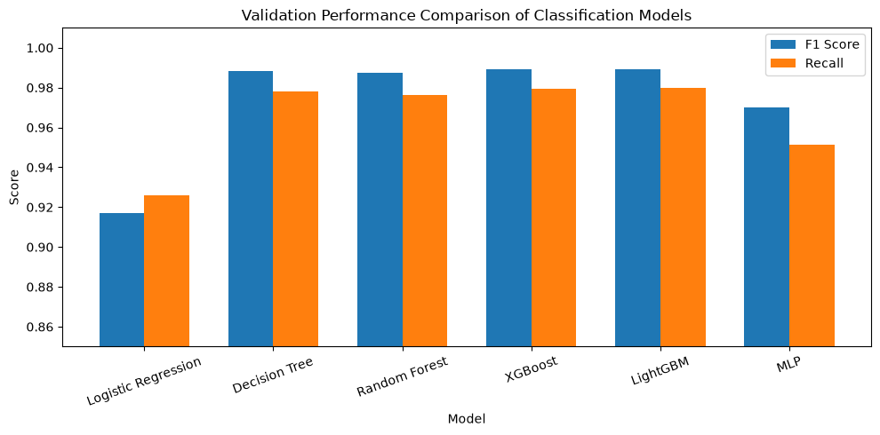

Fig. 4. Comparison of validation F1-score and recall across the six benchmarked models.
Logistic Regression trails the remaining models substantially, reflecting the limits of a linear decision boundary on this feature representation. The four tree/ensemble-based models (Decision Tree, Random Forest, XGBoost, LightGBM) cluster tightly together, all exceeding 97.7% accuracy and 98.7% F1-score, with LightGBM and XGBoost essentially tied at the top on F1-score and ROC-AUC respectively. As noted in Section III-F, LightGBM's validation F1-score (98.91%) is marginally higher than XGBoost's (98.90%),

B. XGBoost Feature Importance
Table III below and Figure 5 report the gain-based feature importance of the final XGBoost detector across the 12 selected features.

TABLE III. XGBoost Feature Importance

Feature | Importance
cp.dstport | 0.286025
tcp.ack | 0.218176
tcp.flags | 0.164111
tcp.len | 0.127149
tcp.connection.syn | 0.061080
udp.time_delta | 0.040683
udp.port | 0.037479
dns.qry.qu | 0.033829
tcp.connection.rst | 0.021140
tcp.connection.synack | 0.004970
tcp.connection.fin | 0.003861
tcp.flags.ack | 0.001497

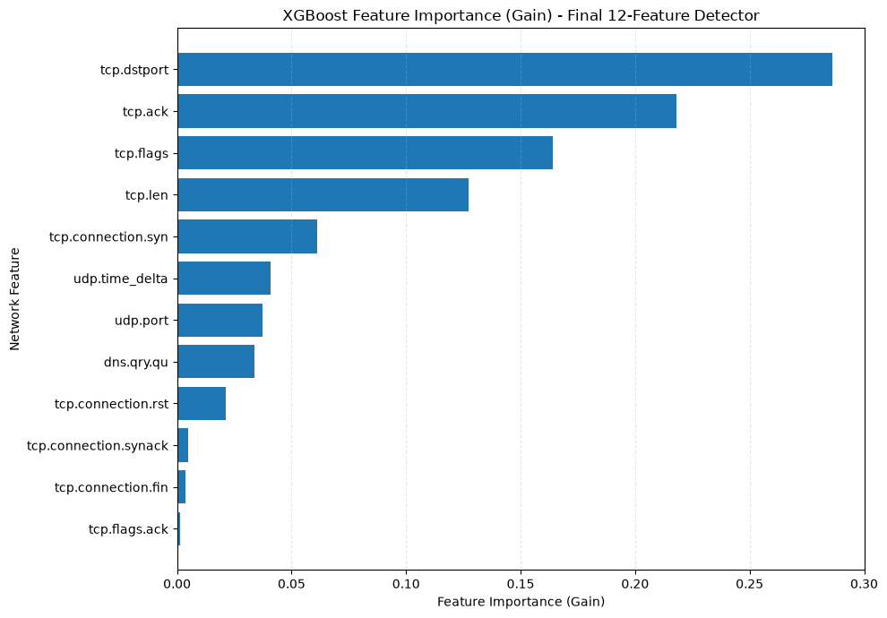
Fig. 5. XGBoost feature importance (gain) for the final 12-feature detector.
You can finish the unfinished sentence under Table III with these figures:
- The top three features (tcp.dstport, tcp.ack, tcp.flags) account for 66.8% of total gain, and the top four (adding tcp.len) account for 79.5%.
- TCP features together carry 88.8% of importance, and the three UDP/DNS features share the remaining 11.2%.
- tcp.flags.ack (0.0015) and tcp.connection.fin (0.0039) contribute almost nothing and are the first candidates for removal in the ablation.

Two cautions are worth adding. First, tcp.dstport is the strongest feature, and destination ports depend on how the testbed generated each attack. That ties directly to your limitation about dataset-specific bias. Second, gain importance describes how the model uses features, not how much each one causally matters. Correlated features such as tcp.ack, tcp.flags, and tcp.flags.ack share credit, so their individual scores can be misleading.

C. Threshold Adaptation
Table V compares the fixed-threshold baseline, an earlier non-gradual adaptive rule explored during development, and the final gradual adaptive rule, all measured on the validation set.
TABLE V. Self-Adaptive Threshold Performance (Validation Set)

Method | Accuracy | Precision | Recall | F1-score | FPR | FNR | TN | FP | FN | TP
Fixed threshold (0.10) | 99.10% | 99.54% | 99.47% | 99.50% | 4.33% | — | 3,487 | 158 | 184 | 34,355
Earlier non-gradual adaptive rule | 99.20% | 99.59% | 99.53% | 99.56% | 3.90% | — | 3,503 | 142 | 163 | 34,376
Final gradual adaptive rule | 99.18% | 99.56% | 99.53% | 99.54% | 4.17% | 0.47% | 3,493 | 152 | 163 | 34,376

The gradual adaptive rule improves modestly over the fixed 0.10 threshold on every reported metric (accuracy, precision, recall, F1-score, and false-positive rate) while making only small, bounded per-batch adjustments. An earlier, non-gradual adaptive rule explored during development achieved a marginally better validation score than the final gradual rule; the gradual rule was nonetheless selected as the final approach because its incremental adjustment behavior is smoother and less prone to abrupt operation
Counts tell more than percentages. Moving from the fixed threshold to the gradual rule cut false negatives from 184 to 163 and false positives from 158 to 152. That is 21 fewer missed attacks and 6 fewer false alarms.
Gradual vs. non-gradual. Both adaptive rules miss exactly 163 attacks, so their recall is identical (99.53%). The earlier rule’s edge comes only from 10 fewer false positives (142 vs. 152). This helps justify keeping the gradual rule: you give up very little.
All differences are small. The gaps are a few hundredths of a percentage point on a single validation sequence, and no significance test was done. Present them as consistent with a small benefit, not as proof.
Add a threshold trace figure. Plot t_j against batch number for the 50 test batches. It would show how often and in which direction the threshold moved, and whether it hit the 0.05 or 0.30 bounds. Without it, the reader cannot see what the adaptation did.
Batch arithmetic. With 500-record batches, 24,604 test records give 49 full batches and a last batch of 104. State this so the reader knows the final batch is smaller.

D. Agentic Decision and Response Layer
The test partition was replayed in 50 sequential batches. The resulting state and response counts are summarized in Tables VIII-A and VIII-B.
TABLE VIII. Agentic Decision and Response Distribution (Test Set, N = 24,604)
*Detection

Decision | Count
Attack | 21,118
Suspicious | 28
Normal | 3,458

*Response

Response | Count
ATTACK_ALERT | 16,519
HIGH_PRIORITY_ALERT | 4,599
FLAG_FOR_MONITORING | 28
NO_ACTION | 3,458

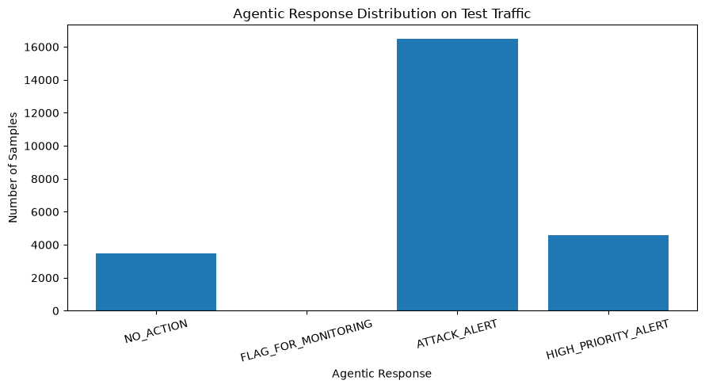

Fig. 6. Distribution of agentic response outputs (NO_ACTION, FLAG_FOR_MONITORING, ATTACK_ALERT, HIGH_PRIORITY_ALERT) on the test set.
The great majority of test traffic (21,118 of 24,604 records) is routed to the Attack state, consistent with the attack-heavy composition of the scenario-aware test partition described in Table I. Only 28 records fall into the Suspicious band, indicating that the adaptive threshold and the 0.5$\tau_t$ Suspicious boundary produce a narrow zone of borderline traffic on this benchmark, rather than a large volume of ambiguous cases requiring manual review.
Response breakdown. Of the 21,118 records in the Attack state, 20,958 are true attacks and 160 are false positives. HIGH_PRIORITY_ALERT covers 4,599 records (21.8% of the Attack state) and ATTACK_ALERT covers 16,519 (78.2%). So, the priority split separates a smaller high-confidence group from the bulk of alerts. Suspicious traffic is only 28 records (0.11% of the test set), so the review queue stays small.
The Suspicious state caught no attacks here. Between the detector and the agentic layer, FN stays at 0 while FP goes from 160 to 188 and TN drops from 3,486 to 3,458. That means all 28 Suspicious records were normal traffic. Because no attacks were missed, the Suspicious band had nothing to catch on this test set. Its value is only visible when the detector misses attacks, so it cannot be demonstrated on this benchmark. Say this openly, since a reviewer will notice it.
Suggested extra table. Break the four response categories down by true label and by attack category. It would show, for example, whether any false positives received a HIGH_PRIORITY_ALERT, which is the cost that matters most for analysts.

E. Generalization
Table VII reports detection recall for each of the three attack categories withheld entirely from model training.
TABLE VII. Unseen Attack-Type Generalization (Gradual Adaptive Detector, Test Set)

Held-Out Attack Type | Samples | Detected | Missed | Recall
DDoS_TCP | 10,247 | 10,247 | 0 | 100.00%
MITM | 400 | 400 | 0 | 100.00%
SQL_injection | 10,311 | 10,311 | 0 | 100.00%

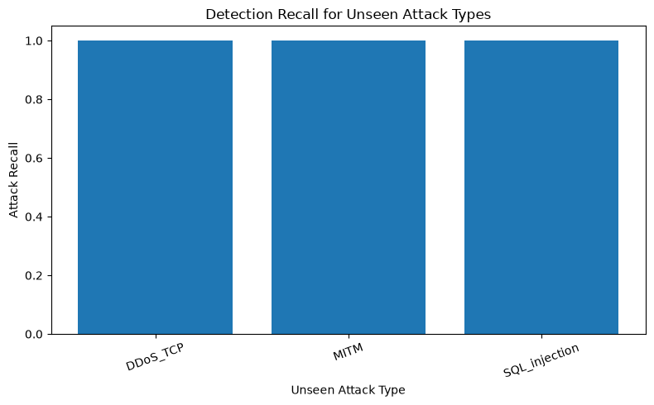

Fig. 7. Recall for each held-out (unseen) attack category on the scenario-aware test set.
All three attack categories withheld from trainingDDoS_TCP, MITM, and SQL_injectionare detected with 100% recall on this benchmark. This supports detection of the specific represented records under this scenario-aware split; it does not establish universal zero-day detection or generalization to other attack families. Because the test benchmark was examined earlier during the experimental process, this result is exploratory held-out evidence rather than a final estimate from an untouched confirmatory test.
- Category sizes are uneven. DDoS_TCP and SQL_injection make up about 98.1% of the test attacks, and MITM has only 400 samples (1.9%). The overall recall is therefore driven by two categories.
- Small sample for MITM. Zero misses in 400 samples support high recall, but a standard rule of thumb puts the 95% upper bound on the true miss rate near 3/400 ≈ 0.75%. A confidence interval makes the claim more honest.
- “Unseen” does not mean “unrelated”. DDoS_TCP may share traffic patterns with DDoS_HTTP and DDoS_ICMP in training, and SQL injection travels over HTTP/TCP like other training categories. The held-out categories are unseen as labels, but they may not be unseen in behavior. Mention this when you discuss the 100% result.
- Per-category false positives can’t be reported. Normal records are shared across all categories, so FP is only meaningful for the test set as a whole.

F. Overall Performance Analysis
Table VI-A reports exploration held-out detector-only performance and Table VI-B reports the corresponding confusion matrices. The detector-only result is 99.35% accuracy, 99.24% precision, 100% recall, 99.62% F1-score, and 4.39% false-positive rate. These values are internally consistent with TN=3,486, FP=160, FN=0, and TP=20,958 over 24,604 records; they should not be interpreted as clinical or live-network validation.
TABLE VI-A. Final Gradual Adaptive Test Performance

System | Accuracy | Precision | Recall | F1-score | ROC-AUC | PR-AUC | FPR | FNR
Gradual adaptive detector | 99.35% | 99.24% | 100.00% | 99.62% | 99.99% | 100.00% | 4.39% | 0.00%
Gradual adaptive agentic operational layer | 99.24% | 99.11% | 100.00% | 99.55% | — | — | 5.16% | 0.00%

TABLE VI-B. Confusion Matrices (Test Set, N = 24,604)

Evaluation | TN | FP | FN | TP
Gradual adaptive detector | 3,486 | 160 | 0 | 20,958
Agentic operational layer | 3,458 | 188 | 0 | 20,958

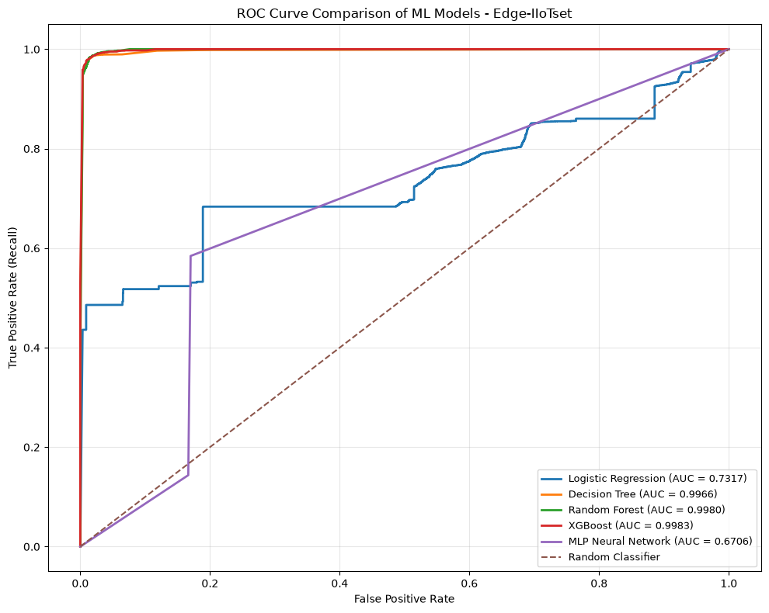
Fig. 8. Receiver operating characteristic (ROC) curve for the final gradual adaptive detector on the test set.

[
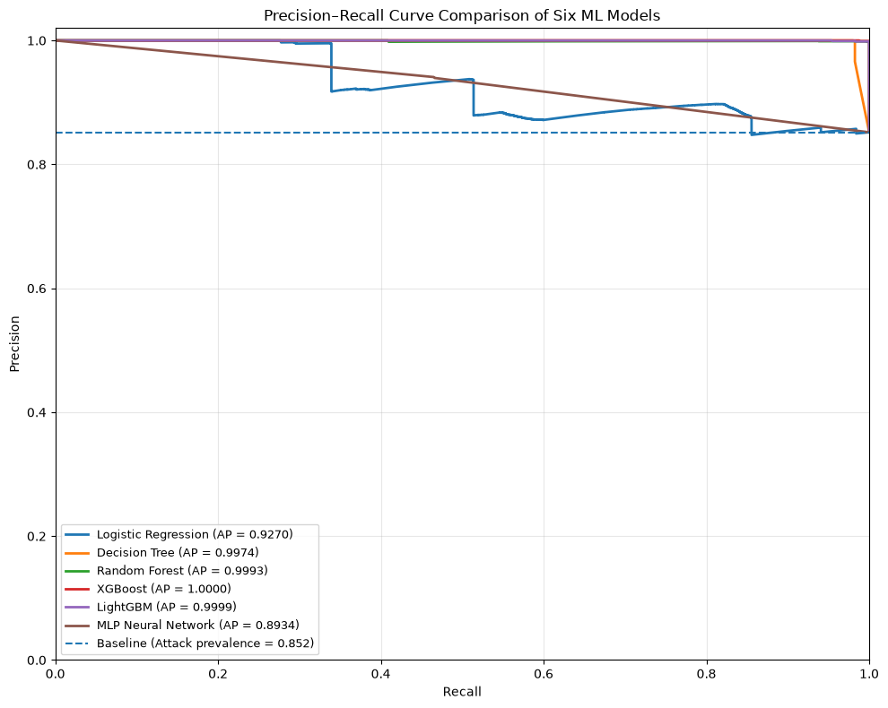

Fig. 9. Precision–recall curve for the final gradual adaptive detector on the test set.

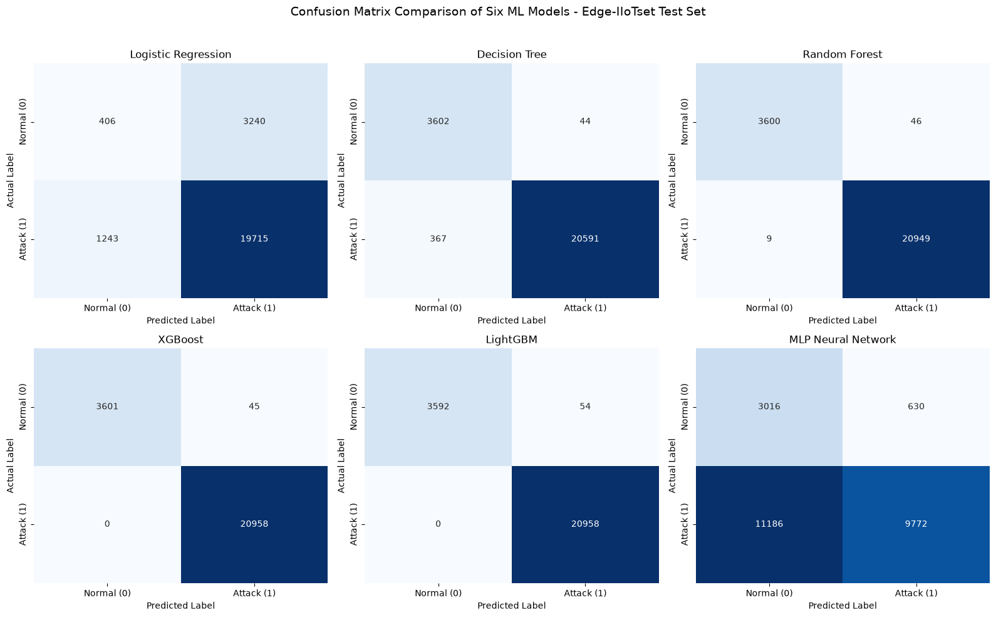
Fig. 10. Final confusion matrix for the gradual adaptive detector on the test set.

Add a trivial baseline. About 85.2% of the test records are attacks (20,958 of 24,604). A classifier that labels everything as an attack would already get 85.2% accuracy, 85.2% precision, and 100% recall. Reporting this baseline shows that the detector’s 99.35% accuracy is a real improvement and not just the effect of class imbalance. It also makes the false-positive rate the more informative number.
Test scores are higher than validation scores. Test ROC-AUC (99.99%) and recall (100%) are above the validation values (99.83% and about 99.5%). The likely explanation is that the held-out test categories are easier to separate with these 12 features, not that the model generalizes better. Say that and tie it to the limitation about dataset artifacts.
False-alarm cost in context. The detector flags 160 of 3,646 normal records (4.39%), and the agentic layer 188 (5.16%). A low threshold of 0.10 buys the 100% recall at this price. For a hospital setting, scale this to several alerts per day and discuss analyst workload.
Comparison with literature. You mention XGBoost studies reporting up to 99.98%. Add one sentence that those figures usually come from random splits where attack categories appear in both training and test data, so they measure a different and easier task.

G. Experimental Setup
Everything below comes from your paper except the items in [brackets], which you need to fill in from your notebook. I left them blank because I don’t want to invent hardware or library versions.
All experiments were run offline in Python on [CPU model, RAM, operating system], with no GPU. The models were built with scikit-learn [version], XGBoost [version], and LightGBM [version]. The dataset is the public Edge-IIoTset file (157,800 records, 63 columns), which was reduced to 156,986 records after 814 exact duplicates were removed. Each record is represented by 12 numeric network- and transport-level features, and the binary label is Attack_label. Attack_type was used only to build the splits.
The data were split by attack category into 94,198 training records, 38,184 validation records, and 24,604 test records (Table II). No attack category appears in more than one partition. All six models were trained on the training partition and compared on the validation partition. The test partition was used only for the sequential replay. A fixed random seed of 42 was used wherever a model accepts one.

Table. Hyperparameters of the benchmarked models

Model | Settings
Logistic Regression | [solver, max_iter, regularization, class_weight]
Decision Tree | [max_depth, criterion = gini, min_samples_split]
Random Forest | n_estimators = 200, max_depth = 12
XGBoost | n_estimators = 200, max_depth = 6, learning_rate = 0.1, subsample = 0.8, colsample_bytree = 0.8, eval_metric = logloss
LightGBM | [n_estimators, learning_rate, num_leaves, max_depth]
MLP | [hidden layer sizes, activation, optimizer, max_iter, whether inputs were scaled]

For the adaptive threshold, the base value was t₀ = 0.10, chosen by a validation search from 0.10 to 0.90 in steps of 0.05. The adjustment step was δ = 0.01, the bounds were 0.05 and 0.30, and the reference probability was taken from the first validation batch (0.024390243). Batches held 500 records, and the test replay used 50 sequential batches. Test labels were never used to update the threshold. The high-priority boundary was the 95th percentile of validation attack probabilities (about 0.999992).
Two things a reviewer will look for here. First, say whether the MLP and Logistic Regression inputs were scaled, because it affects how fairly they are compared with the three models. Second, say whether the replay used the original record order or a shuffled order, since the adaptive result depends on ordering.

V. Ablation Study
A. Purpose and Scope
The framework has three parts layered on top of the XGBoost detector: a validation-selected base threshold, a bounded batch-wise threshold update, and a deterministic response layer. The ablation study asks what each part adds. Each part is added one step at a time, so a change in behavior can be linked to the component that caused it. Because the response layer does not alter the detector’s predictions, it is judged by alert counts and workload, not by classification accuracy.
B. Ablation Configurations
- Configuration A: XGBoost baseline. The selected classifier with a fixed threshold of 0.10, chosen on validation data only. This is the reference point.
- Configuration B: XGBoost with adaptive thresholding. The baseline plus the batch-based update rule (step δ = 0.01, bounds 0.05 to 0.30). It shows whether adapting the threshold changes recall, precision, false positives, and F1.
- Configuration C: XGBoost with deterministic response assignment. The baseline plus the Normal, Suspicious, and Attack states and the four response labels. The predictions are the same as in A, so this configuration is assessed by how alerts are distributed.
- Configuration D: complete framework. XGBoost, adaptive thresholding, and the response layer together.
C. Effect of Adaptive Thresholding (Validation Set)

Table V gives the validation results for the fixed threshold, the earlier non-gradual rule, and the final gradual rule. Table V reports count as well as percentages, and the counts show more than the percentages alone.

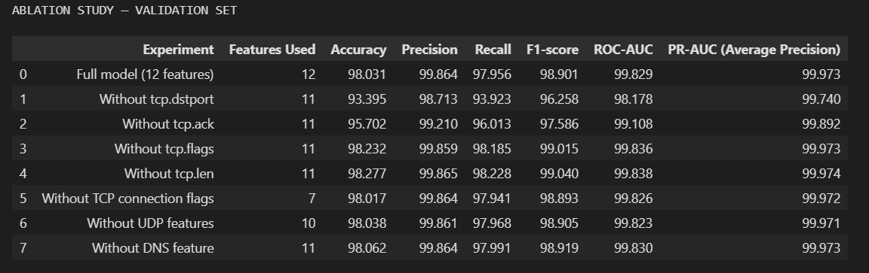

Compared with the fixed threshold, the gradual rule raised accuracy by 0.08 percentage points, recall by 0.06, precision by 0.02, and F1 by 0.04. In counts, it missed 21 fewer attacks (184 to 163) and raised 6 fewer false alarms (158 to 152). The false-positive rate fell from 4.33% to 4.17%. Every reported metric moved in the favorable direction, but only by a few hundredths of a percentage point.
The earlier non-gradual rule scored slightly higher still. Both adaptive rules missed exactly 163 attacks, so their recall is identical, and the earlier rule’s advantage comes entirely from 10 fewer false positives (142 versus 152). The gradual rule was kept for its design properties. It changes the threshold by at most 0.01 per batch and never leaves [0.05, 0.30], so the detector’s sensitivity cannot swing sharply because of one unusual batch, and every adjustment can be traced. The cost of this benchmark is small.
These comparisons come from a single validation sequence, with no repeated runs and no significance test. They are consistent with a small benefit from adaptation, and they should not be read as proof of one.

Ablation configurations

Configuration A — XGBoost baseline: Uses the selected XGBoost classifier with a fixed decision threshold. This establishes baseline detection performance.

Configuration B — XGBoost with adaptive thresholding: Adds the batch-based threshold update mechanism to assess its effect on recall, precision, false-positive rate, and F1-score.

Configuration C — XGBoost with deterministic response assignment: Adds the rule-based response categories to examine alert distribution and prioritization. Since response assignment does not necessarily change the underlying predictions, its contribution should be assessed using response-level measures rather than assuming an improvement in classifier accuracy.

Configuration D — Complete proposed framework: Combines XGBoost, adaptive thresholding, and deterministic response assignment. This configuration represents the complete system.
For a fair comparison, all configurations should use the same exploratory test partition and sample ordering. The fixed-threshold baseline should use a threshold selected exclusively from validation data. Adaptive thresholding should use predicted probabilities without accessing test labels during threshold updates. The evaluation should report accuracy, precision, recall, F1-score, ROC-AUC where applicable, false-positive rate, and false-negative rate. For the response layer, the number of alerts in each response category and the resulting analyst workload should also be reported.

The reported complete-framework results provide a reference point of 99.35% accuracy, 99.24% precision, 100% recall, and 99.62% F1-score. However, these results alone do not establish the incremental contribution of each component. The ablation configurations must be executed before quantitative claims can be made. Furthermore, because the test partition was examined during development, the resulting comparison should be interpreted as exploratory rather than as an unbiased confirmatory evaluation.

Limitations of This Ablation
The 99.35% accuracy and 100% recall of the complete framework are a reference point, not proof that each component helps. They do not show how much each part contributed until Configurations A to Dare ran side by side. The test partition was also examined during development, so any comparison on it is exploratory and not a confirmatory estimate. Two further limits apply. The validation comparison is a single run, so seed-to-seed variation is unknown. The adaptive result also depends on batch size and record order, and neither was varied. Repeating the comparison with several seeds, batch sizes, and orderings, and on rotated held-out categories, would show whether the small gains survive.

VI. Discussion

A. Interpretation of Results
The scenario-aware evaluation protocol used in this study is deliberately more demanding than a conventional random split, because it requires the detector to generalize to attack categories it has never seen during training. Under this protocol, the gradual adaptive XGBoost detector achieves 100% recall and a 99.62% F1-score on the test set, with all three withheld attack categories (SQL_injection, DDoS_TCP, and MITM) detected at 100% recall. This suggests that the 12 selected network- and transport-layers
The gradual self-adaptive threshold mechanism produced only a small quantitative improvement over the simpler fixed-threshold baseline (Table V), and an even simpler non-gradual adaptive rule performed marginally better still on the validation set. The practical value of the gradual mechanism lies less in a large accuracy gain and more in its incremental, bounded behavior: because the threshold moves by only 0.01 per batch and is constrained to [0.05, 0.30], the detector's sensitivity cannot swing abruptly
The detector-only test evaluation reports accuracy 99.35%, precision 99.24%, recall 100.00%, F1-score 99.62%, and false-positive rate 4.39% (160 false positives among 3,646 normal records). When the 28 Suspicious decisions are included as requiring attention, the agentic operational layer reports accuracy 99.24%, precision 99.11%, recall 100.00%, F1-score 99.55%, and false-positive rate 5.16% (188 normal records flagged). Thus, differentiated triage preserves recall on this exploratory split but increases false-positive burden; operational acceptability requires future workload and alert-fatigue evaluation.

B. Practical Relevance
For smart healthcare IoT ecosystems, the combination of a scenario-aware evaluation protocol, an adaptive threshold, and a graded response layer is directly relevant because (i) new attack variants targeting medical and building-management IoT devices continue to emerge, so a detector's ability to generalize beyond its training attack categories is operationally important; (ii) traffic patterns in a clinical network can shift over the course of a day or across departments, making a single fixed threshold po

C. Limitations
Several limitations of this study should be stated explicitly:
1. Edge-IIoTset is a benchmark dataset generated from a purpose-built testbed, not real hospital or clinical network traffic. The smart-healthcare framing adopted in this paper is a target deployment motivation, not a claim about the source of the evaluated data.
2. The proposed agentic layer is a lightweight, deterministic, rule-based decision-and-response mechanism. It is not a large-language-model-based or generative-AI-based autonomous cybersecurity agent, and it should not be characterized as such.
3. The sequential monitoring and threshold-adaptation experiments are offline simulations using ordered validation and test arrays in fixed-size batches. Test labels were not used to update the threshold, but batch-level test predicted probabilities were used to change it. The test metrics therefore evaluate an order-dependent replay policy rather than a completely fixed classifier at an independent operating point. Record-order provenance, batch composition, and sensitivity to alternative batch sizes or orderings were not established; this is not live-stream validation.
4. As noted in Section IV-F, the test benchmark was examined earlier in the experimental process, before later refinements to the model comparison and adaptation
5. The reported results are specific to the Edge-IIoTset benchmark, its
6. The 12 retained features were selected by screening out fields identified as more likely to be dataset-construction artifacts, but this screening does not guarantee that the retained features are entirely free of dataset-specific bias; the framework's generalization has not been confirmed on an external dataset.
7. Real-world deployment would require live traffic streaming and capture infrastructure, continuous monitoring, drift detection beyond the batch-mean heuristic used here, safe and auditable model-update procedures, and integration with existing healthcare security infrastructure and incident-response workflows.

D. Generalizability and Deployment Considerations
Deploying this framework, or a system inspired by it, in an actual healthcare IoT environment would require, at minimum: (i) validation on network traffic representative of the target clinical environment, ideally including a genuinely held-out external dataset; (ii) a governance process for updating the underlying XGBoost model as new attack data becomes available, including safeguards against adversarial poisoned retraining data; (iii) integration of the HIGH_PRIORITY_ALERT and ATTACK_ALERT outputs with

E. Ethical and Security Considerations
Because the proposed framework targets environments in which false negatives (missed attacks against medical or building-management IoT devices) and false positives (unnecessary alerts that contribute to operator alert fatigue) both carry meaningful operational costs, any deployment should retain human oversight over high-impact automated responses rather than allowing fully automated remediation. No real patient data was used in this study; all experiments were conducted on the publicly available Edge-IIoT
F. Comparison with Existing Intrusion Detection Approaches
The proposed framework was compared with existing intrusion detection approaches based on machine learning and ensemble methods evaluated on IoT and Industrial IoT datasets. Previous studies using Edge-IIoTset have demonstrated strong classification performance through conventional classifiers, deep learning, and optimized ensemble techniques, with some XGBoost-based approaches reporting accuracy as high as 99.98%. In comparison, the proposed framework achieved an exploratory test accuracy of 99.35%, precision of 99.24%, recall of 100%, and F1-score of 99.62%. Although these results demonstrate promising detection performance, direct comparisons must be interpreted cautiously because studies may differ in dataset versions, feature selection, preprocessing, and data partitioning. The primary contribution of this work is the integration of XGBoost with batch-based adaptive thresholding and deterministic response assignment, extending the focus beyond classification alone to adaptive detection and structured alert prioritization. Further evaluation using independently held-out datasets and consistent experimental protocols is required to establish its generalizability and comparative effectiveness.
VII. CONCLUSION
This study presented a self-adaptive intrusion detection framework for smart healthcare Internet of Things (IoT) environments using machine learning, batch-based adaptive thresholding, and a deterministic response-assignment mechanism. The proposed framework was evaluated using the Edge-IIoTset dataset, with scenario-aware partitioning to separate attack categories across training, validation, and exploratory testing. Six classification algorithms were compared, and XGBoost was selected based on its validation ROC-AUC of 99.83%. The selected model was integrated with an adaptive threshold mechanism that adjusts the detection threshold according to changes in batch-level predicted attack probabilities while maintaining the threshold within predefined bounds.
In the exploratory test evaluation, the detector achieved an accuracy of 99.35%, precision of 99.24%, recall of 100%, and F1-score of 99.62%. The reported results indicate that the framework identified all attack instances in the evaluated test partition, although false-positive predictions remained. The deterministic response layer further mapped detection outcomes to four response categories: NO_ACTION, FLAG_FOR_MONITORING, ATTACK_ALERT, and HIGH_PRIORITY_ALERT. This separation between probabilistic detection and rule-based response assignment improves the interpretability of the framework and provides a structured basis for prioritizing potential security events.
Despite these promising results, the framework remains an offline experimental prototype rather than a validated clinical deployment system. The test partition was examined during development; therefore, the reported performance should be interpreted as exploratory rather than as an unbiased estimate of generalization to completely unseen data. Moreover, batch-based threshold adaptation was evaluated using predicted probabilities in sequential replay, not through continuous monitoring of live healthcare network traffic.
Overall, this work provides a foundation for further investigation into adaptive, interpretable, and response-oriented intrusion detection for smart healthcare IoT ecosystems. Additional evaluation on independent datasets, realistic traffic streams, and operational healthcare environments is necessary to establish the framework's generalizability, reliability, and practical security value.
VIII. FUTURE WORK
Several directions can extend the proposed framework and address the limitations of the current evaluation.
1. Independent and Cross-Dataset Evaluation: Future experiments should evaluate the framework on an untouched test set and additional IoT or healthcare-network security datasets. Cross-dataset testing would help determine whether the learned patterns generalize beyond the traffic distribution represented in Edge-IIoTset. Dataset versions, preprocessing procedures, and partitioning rules should be documented to support reproducibility.
2. Real-Time Streaming Evaluation: The current adaptive threshold mechanism operates through offline sequential replay. Future work should implement and evaluate it on streaming network traffic, measuring detection latency, throughput, memory consumption, and the effect of batch size and traffic ordering. The threshold-update procedure should also be compared against fixed-threshold baselines under consistent evaluation conditions.
3. Improved Detection of Unseen Attacks: Further research could investigate anomaly detection, one-class classification, and open-set recognition to identify traffic patterns that differ from known training scenarios. Experiments should explicitly distinguish attacks withheld during training from genuinely novel attacks and report per-category detection rates, false-positive rates, and confidence intervals.
4. Explainability and Alert Prioritization: Feature attribution techniques, such as SHAP, could be incorporated to explain individual predictions and identify the network characteristics contributing to high-priority alerts. The response layer could also be evaluated for alert quality, prioritization consistency, and the workload imposed on security analysts. Any additional response rules should be assessed against clearly defined operational criteria.
5. Robustness and Adversarial Evaluation: Future studies should examine the framework's resilience to noisy traffic, class imbalance, data drift, adversarial manipulation, and changes in network protocols. Sensitivity analyses should investigate how the reference batch means, adjustment step, threshold bounds, and batch size affect detection performance and false alarms.

References
[1] M. A. Ferrag, O. Friha, D. Hamouda, L. Maglaras, and H. Janicke, “Edge-IIoTset: A New Comprehensive Realistic Cyber Security Dataset of IoT and IIoT Applications for Centralized and Federated Learning,” IEEE Access, vol. 10, pp. 40281–40306, 2022, doi: 10.1109/ACCESS.2022.3165809.
[2] M. Zolanvari, M. A. Teixeira, L. Gupta, K. M. Khan, and R. Jain, “Machine Learning-Based Network Vulnerability Analysis of Industrial Internet of Things,” IEEE Internet of Things Journal, vol. 6, no. 4, pp. 6822–6834, 2019, doi: 10.1109/JIOT.2019.2912022.
[3] S. M. Kasongo, “An Advanced Intrusion Detection System for IIoT Based on GA and Tree Based Algorithms,” IEEE Access, vol. 9, pp. 113199–113212, 2021, doi: 10.1109/ACCESS.2021.3104113.
[4] M. Injadat, A. Moubayed, A. B. Nassif, and A. Shami, “Multi-Stage Optimized Machine Learning Framework for Network Intrusion Detection,” IEEE Transactions on Network and Service Management, vol. 18, no. 2, pp. 1803–1816, 2021, doi: 10.1109/TNSM.2020.3014929.
[5] C. Khammassi and S. Krichen, “A NSGA2-LR Wrapper Approach for Feature Selection in Network Intrusion Detection,” Computer Networks, vol. 172, art. 107183, 2020, doi: 10.1016/j.comnet.2020.107183.
[6] A. M. Eid, A. B. Nassif, B. Soudan, and M. N. Injadat, “IIoT Network Intrusion Detection Using Machine Learning,” in Proc. 2023 6th Int. Conf. Intelligent Robotics and Control Engineering, pp. 196–201, 2023, doi: 10.1109/IRCE59430.2023.10255088.
[7] I. A. Khan, M. Keshk, D. Pi, N. Khan, Y. Hussain, and H. Soliman, “Enhancing IIoT Networks Protection: A Robust Security Model for Attack Detection in Internet Industrial Control Systems,” Ad Hoc Networks, vol. 134, art. 102930, 2022, doi: 10.1016/j.adhoc.2022.102930.
[8] Y. Meidan, M. Bohadana, Y. Mathov, Y. Mirsky, D. Breitenbach, A. Shabtai, and Y. Elovici, “N-BaIoT—Network-Based Detection of IoT Botnet Attacks Using Deep Autoencoders,” IEEE Pervasive Computing, vol. 17, no. 3, pp. 12–22, 2018, doi: 10.1109/MPRV.2018.03367731.
[9] M. S. Alshehri, O. Saidani, F. S. Alrayes, S. F. Abbasi, and J. Ahmad, “A Self-Attention-Based Deep Convolutional Neural Networks for IIoT Networks Intrusion Detection,” IEEE Access, vol. 12, pp. 45762–45772, 2024, doi: 10.1109/ACCESS.2024.3380816.
[10] M. Singh and N. Chauhan, “Convolutional Neural Network Based IoT Intrusion Detection System Using Edge-IIoTset,” in Proc. 2024 Int. Conf. Integrated Circuits, Communication, and Computing Systems, pp. 1–4, 2024, doi: 10.1109/ICIC3S61846.2024.10603309.
[11] N. Faruqui, M. A. Yousuf, M. Whaiduzzaman, A. K. M. Azad, S. A. Alyami, P. Li, M. A. Kabir, and M. A. Moni, “SafetyMed: A Novel IoMT Intrusion Detection System Using CNN–LSTM Hybridization,” Electronics, vol. 12, no. 17, art. 3541, 2023, doi: 10.3390/electronics12173541.
[12] N. Moustafa, “A New Distributed Architecture for Evaluating AI-Based Security Systems at the Edge: Network TON_IoT Datasets,” Sustainable Cities and Society, vol. 72, art. 102994, 2021, doi: 10.1016/j.scs.2021.102994.
[13] N. Thereza and K. Ramli, “Development of Intrusion Detection Models for IoT Networks Utilizing CICIoT2023 Dataset,” in Proc. 2023 3rd Int. Conf. Smart Cities, Automation & Intelligent Computing Systems, pp. 66–72, 2023, doi: 10.1109/ICON-SONICS59898.2023.10435006.
[14] S. S. Ismail, S. Dandan, and A. Qushou, “Intrusion Detection in IoT and IIoT: Comparing Lightweight Machine Learning Techniques Using TON_IoT, WUSTL-IIOT-2021, and EdgeIIoTset Datasets,” IEEE Access, vol. 13, pp. 73468–73485, 2025, doi: 10.1109/ACCESS.2025.3554083.
[15] R. Lu et al., Intrusion Detection in the IoT Under Data and Concept Drifts: Online Deep Learning Approach, IEEE Internet of Things Journal, 2022, IEEE Xplore Document 9755949, https://ieeexplore.ieee.org/document/9755949.
[16] S. Memon, U. Kock Wiil, and M. Shaikh, “Explainable Intrusion Detection for Internet of Medical Things,” in Proc. 15th Int. Joint Conf. Knowledge Discovery, Knowledge Engineering and Knowledge Management, pp. 40–51, 2023, doi: 10.5220/0012210300003598.
[17] D. Javeed, T. Gao, M. S. Saeed, and P. Kumar, An Intrusion Detection System for Edge-Envisioned Smart Agriculture in Extreme Environment, IEEE Internet of Things Journal, vol. 11, pp. 26866–26876, 2024, doi: 10.1109/JIOT.2023.3288544.
[18] M. Kumar, C. Kim, Y. Son, S. K. Singh, and S. Kim, Empowering Cyberattack Identification in IoHT Networks With Neighborhood-Component-Based Improvised Long Short-Term Memory, IEEE Internet of Things Journal, vol. 11, pp. 16638–16646, 2024, doi: 10.1109/JIOT.2024.3354988.

Dataset link- https://www.kaggle.com/datasets/mohamedamineferrag/edgeiiotset-cyber-security-dataset-of-iot
Github link-

