**Department of Computer Science & Engineering, SISTec ,BHOPAL**

Library Management System

(SRS Report)

# Library Management System

## 1. INTRODUCTION

With the increase in the number of readers, better management of libraries system is required. The Library management system focuses on improving the management of libraries records in college library. “What If librarian can check whether a book is available in the library through his system instead of doing it manually?” or “what if instead of having different library cards for different libraries you can just have to give your name only?” . The Integrated Library Management system provides the ease of issuing, renewing the books by just telling your name and the book to the librarian.

The Integrated Library Management system is developed in the python language and will run on system console which basically focuses on saving the time in issuing the books from the library.

**1.1** **PURPOSE**

The purpose of the project is to maintain the details of books ,student details, faculty details.

The main purpose of this project is to maintain a easy circulation system between students, faculties and the librarian, to issue books and to maintain details about the students and faculties.

* **1.2 SCOPE**
* Automatically updating the library system which will run on system console so that the librarian can know the details of the book available and maximum limit of borrowing for any individual .
* The pickle file will store the information like details of the books, insertion of new books, availability of books, number of books issued, fine of each individual if they have not reissued from the given date.

## 2. OVERALL DESCRIPTION

**2.1 PRODUCT PRESPECTIVE**

The proposed Library Management System will take care of the current book detail at any point of time. The book issue, book return can be easily updated automatically during each and every book issue and return .

**2.2.1 FUNCTIONAL REQUIREMENT**

* **R.1:Register**
* Description : first the student or the faculty has to give their details to the librarian.
* faculty/student : The student or the faculty has to provide details about his/her and if anyone is new there or have visited for the first time, then he/she has to enroll their details .
* The library manager/head : The manager have to provide details about the book for what the student or faculty is asking for .

* **R.2.1 : Books issued.**

▪ Description : List of books will be displaced along with data of return.

* **R.2.2 : Search** 
  + Input : Enter the name of author's or the title of the book or the isbn no. Of the book.
  + Output : List of books related to the number of copies.

* **R.2.3 : Issues book** 
  + State : Searched the book student/librarian wants to issue.
  + Input : click the book..
  + Output : book issued.
  + Processing : if selected book is available then book will be issued else error will be displayed.

* **R.2.5 : Return** 
  + Input ; Return the book to the library.
  + Output : The issued list will be updated and the returned book will be listed out.

* **R.2.6 Fine** 
  + Input : check for the fines.
  + Output : Details about fines on different books issued by the user.
  + Processing : The fine will be calculated, if it crossed the date of return and the user did not renewed if then fine will be applied .

* **R.2.7 Add books** 
  + Input : Enter the details of the books such as names ,author ,book no.
  + Output : confirmation of addition.

**2.5 USER CHARACTERSTICS**

We have 1 level of user :

* + - librarian

• book module : In the book module, librarian will check the availability of the books.

* + - * + Issue book
        + Book list
        + Search book
        + Return book
        + Fine details of students only !

• main module:

The following are the functionalities :

* + - * + Register users
        + Add new Books
        + Maintain Books
        + Book issue
        + Calculate fine
* Use Case Diagram

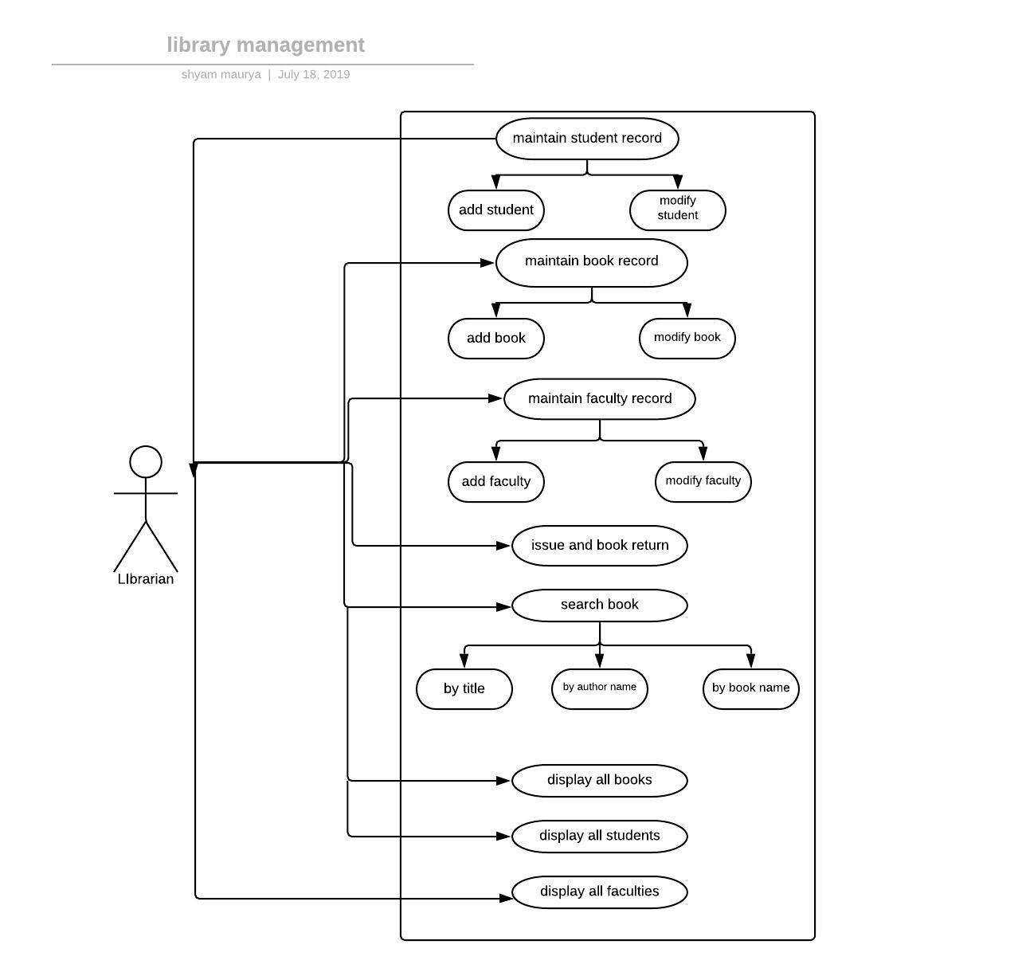

**Some samples(example) of my project :** how it looks on the console screen and its operations .

* Menu:

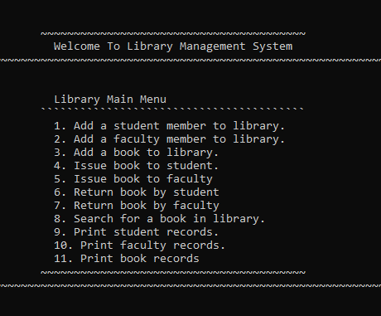

* Print student records :

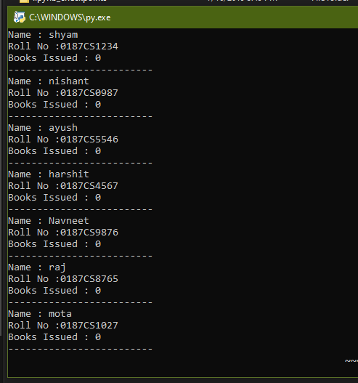

* Print faculty records:

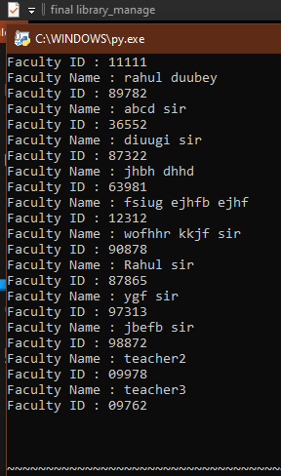

* Print book records :

