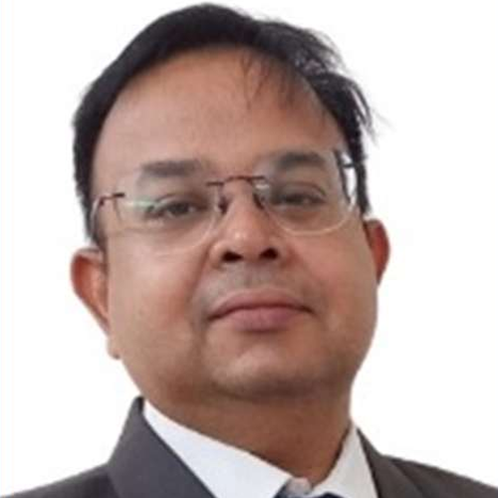 | Shyam Premkumar Shrivastava  Firmware Engineering Leader  Pune, Maharashtra · +91 9158212310 · shyam.nexus@gmail.com  linkedin.com/in/shyamshrivastava · shyamshrivastava.com

PROFESSIONAL SUMMARY
Firmware engineering leader with 19+ years taking connected products from architecture to release. At Honeywell in Pune, leads a 12-member cross-functional team across surveillance, fire safety, and wearable platforms: firmware roadmap, design reviews, Scrum delivery, secure boot and OTA, and STQC/BIS certification. Hands-on in Embedded C/C++, FreeRTOS, ARM Cortex-M/A, device drivers, bootloaders, and UART, SPI, I2C, CAN, USB, Ethernet, BLE, Wi-Fi, MQTT, and TCP/IP.
Roadmap and architecture · Multi-program delivery · Team of 12
Hardware, cloud, QA, manufacturing · DFMEA, cybersecurity, STQC/BIS
TECHNICAL EXPERTISE
Languages. Embedded C, Embedded C++
RTOS and platforms. FreeRTOS, CMSIS-RTOS (RTX), Embedded Linux (Yocto, Buildroot), ESP-IDF
Processors. ARM Cortex-M (STM32, LPC1788), ARM Cortex-A (i.MX 8), ESP32 and ESP32-S3
Protocols. UART, SPI, I2C, RS-485, CAN, USB, Ethernet, BLE, Wi-Fi, MQTT, TCP/IP, HTTP, UDP, Modbus
Firmware. Architecture, device drivers, middleware, bootloaders, secure boot, OTA/FOTA, connectivity stacks
Hardware. Schematic review, board bring-up, sensor integration, manufacturing diagnostics and test
Engineering systems. Git, GitHub Enterprise, GitLab, Jira, Confluence, Keil, IAR, STM32CubeMX, VS Code, SonarQube, Black Duck, threat modeling
EXPERIENCE
Project Lead / Sr. Advanced Engineer Feb 2024 – Present
Honeywell Technologies (HIIPL), Pune
People, project, delivery, and technical management for connected firmware programs: architecture and solution design, hardware and firmware reviews, Scrum planning, and weekly progress reporting.
▸ Lead a 12-member cross-functional engineering team. Own performance reviews for 6 engineers and mentor subsystem leads across firmware, Linux BSP, and validation.
▸ Define firmware architecture for a multi-variant AI IP camera platform so board differences stay behind a hardware abstraction layer and variants share one baseline: Buildroot/Yocto, H.264/H.265, ONVIF/RTSP, edge AI, secure boot, TPM, and authenticated OTA.
▸ Set design-review and release discipline with Dev-to-QA entry criteria, checklist-driven validation, and tighter control of what qualifies as a build. Vulnerability remediation cycle time fell by about 35%, with schedule adherence above 95%.
▸ Own STQC and BIS certification for the security-camera portfolio, including secure-boot evidence and vulnerability closure, with zero critical audit rejections.
▸ Led the cost-optimized fire-alarm panel on an STM32 MCU running an RTOS. DFMEA plus schematic and firmware review kept alarm, supervision, watchdog, and manufacturing diagnostics intact while reducing BOM cost by about 10–15% and improving early defect detection by about 25%.
▸ Guide the wearable smart-patch firmware on ESP32-S3 and ESP-IDF, covering ECG, SpO2, and temperature, BLE and Wi-Fi, MQTT/TCP-IP sync, local store-and-forward, and power budgets that improved efficiency by about 20%.
▸ Partner with hardware, cloud, QA, security, certification labs, and manufacturing on production readiness, and lead system-level debug across boot, video, connectivity, and power.
Technical Manager Apr 2016 – Jan 2024
Sai Agrotel, Pune · progressed from Senior Firmware Engineer
Led firmware, hardware, and cloud engineers on industrial and connected products, from statement of work through post-release support for global customers.
▸ Led a team of 7 software, electrical, and mechanical engineers through stage-gate new-product development, using Design for Six Sigma from concept to product release.
▸ Defined the division technology roadmap and an industrial IoT platform: local control on embedded controllers, a Linux edge gateway, Modbus and field-protocol adapters, MQTT, buffered telemetry, fleet diagnostics, and OTA for intermittent sites.
▸ Ran requirements, WBS, and Gantt planning across concurrent programs. Presented monthly technical reviews and quarterly executive updates on budget, schedule variance, and requirements compliance.
▸ Mentored firmware and hardware engineers, stood up a dedicated product-stability effort, tracked defects in a bug-tracking system, and allocated merit increases from performance reviews.
▸ Delivered connected products for Cardinal Detecto (USA) and Haven Lighting on FreeRTOS (STM32), ESP32 bootloaders and FOTA, USB, RS-232, Ethernet, BLE/Wi-Fi, graphical HMI, and Azure IoT Hub.
▸ Representative releases: Navigator legal-for-trade scale (STM32, FreeRTOS, ESP32 FOTA, graphical LCD); medical cart (ATSAM7 with ESP32 coprocessor, deep sleep, secure record sync); Haven lighting controller (STM32/ESP32, secure Azure IoT and embedded web server); plant-connect module and belt-scale integrator (LPC1788, CMSIS-RTOS, Modbus, Ethernet, MQTT, USB, PID and PLC interface).
Head of Research and Development Aug 2012 – Apr 2016
Precise Technology, Pune
▸ Designed Embedded C firmware and electronics for automobile durability and structural-test data acquisition: signal conditioning, synchronized ADC sampling, CAN acquisition, calibration metadata, and recoverable logging.
▸ Separated time-critical sampling from storage and the user interface so long test runs survived power loss, storage limits, and transient faults.
▸ Owned prototyping, calibration, field validation, and customer delivery, and fed field failures back into firmware revisions.
Senior R&D Engineer May 2008 – Jul 2012
NESD Labs / Nexus Embedded, Pune
▸ Designed purpose-built electronics and firmware for startup and industrial clients, taking concepts through working prototypes and hardware-software integration.
R&D Engineer Mar 2007 – Apr 2008
Transworld Compressor Technologies, Pune
▸ Developed embedded electronics and firmware for compressor products, building the foundation in product design and hardware-firmware integration.
EDUCATION
Bachelor of Engineering, Electronics and Telecommunication · RITEE, Raipur, 2005
Languages. English, Hindi

