Exercise

2.1

Table : BOOK

Functional Dependencies:

TitleNr → ISBN

ISBN → Title, Author, PublYear

Author → AuthorNat

Table is in 1NF (domain of each attribute contains only atomic values, and the value of each attribute contains only a single value from that domain), there is a partial dependency of attribute AuthorNat on part of the primary key attribute Author, so the table is not in 2NF form.

Table : CUSTOMER

Functional Dependencies:

CustomerNr → PersonNr

PersonNr → Name, Address, Tel, NrBooks

Table Customer is in 2NF (does not have any non-prime attribute that is dependent on any proper subset of any candidate key of the relation)

CustomerNr → PersonNr and PersonNr → Name, Address, Tel, NrBooks

There is a transitive dependency between CustomerNr → Name, Address, Tel, NrBooks, So the table is not in 3NF.

Table : LOAN

Functional Dependencies:

TiltleNr, CopyNr → CustomerNr

CustomerNr → BorrowerName

Table LOAN is in 2NF (does not have any non-prime attribute that is dependent on any proper subset of any candidate key of the relation),

TiltleNr, CopyNr → CustomerNr and CutomerNr → BorrowerName so there is a transitive dependency between TiltleNr, CopyNr → BorrowerName

Therefore, the table is not in 3NF.

2.2

All three tables Book, Customer, Loan does not fulfill BCNF requirements.

Table : Book

Following are the problems/issues due to the table not being in BCNF normalization.

Update Anomaly

One Author might have written multiple books, so there will be multiple rows for the same author. If someone updates the Author nationality in one row and does not update in other rows for the same author. The database will be inconsistent.

Delete Anomaly

Since multiple records are stored for the same title/author due to different copy numbers. While deleting a title/author if they don’t delete for all the copy number, the database will be inconsistent.

Insert Anomaly

Suppose a new book is ordered, and author’s Nationality is unknown then we would not be able to insert the data into the table if AuthorNat field doesn’t allow nulls.

For each new ISBN number being added to the table, if there are multiple copies of that book, multiple rows of the same information have to be inserted into the table.

For eg: if ISBN 1111, has 10 copies then 10 rows will be inserted. Lot of redundant information.

Table : Loan, Customer

Update Anomaly

If a customer name changes both Loan and Customer table has to be updated. If accidentally one table is updated and not the other then the database will become inconsistent.

2.3

Entity Diagram

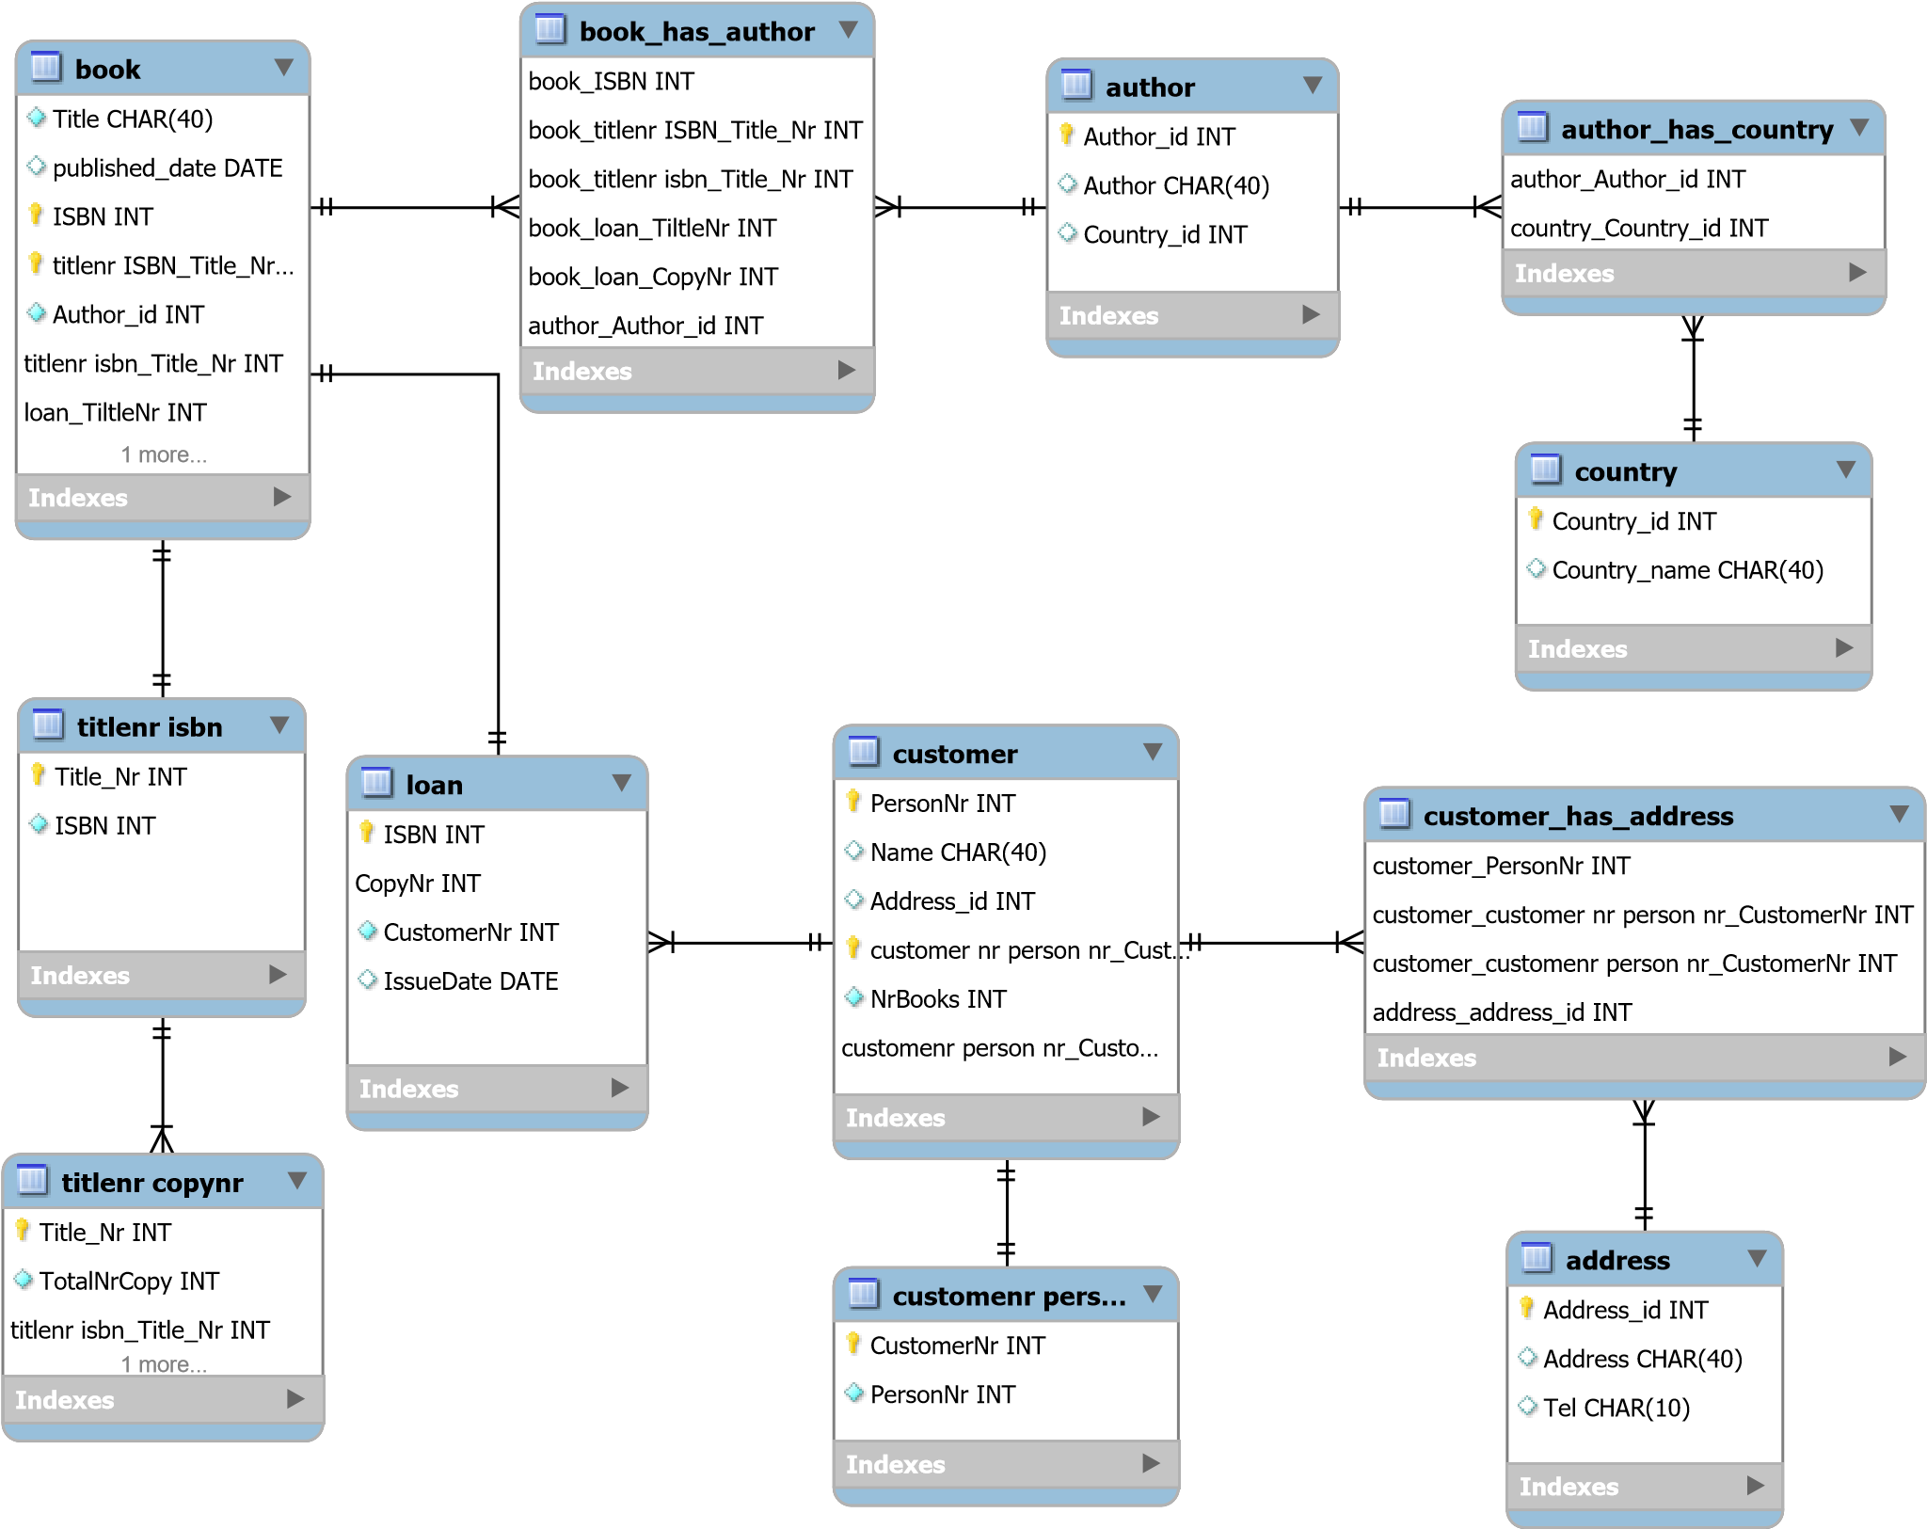

Tables for new library system

Titlenr isbn( TiltleNr, ISBN)

FD TitleNr → ISBN

Tiltlecopynr(TitleNr,TotalNrCopy,TotalNrCopyIssued)

FD TitleNr → CopyNr

Book(ISBN,Title,Author_id)

FD ISBN → Title, Author

Author(Author_id,Author,Country_id)

FD Author_id → Author, Country_id

Country(Country_id,Country_name)

FD Country_id → Country_name

CustomernrPersonnr(CustomerNr,PersonNr)

FD CustomerNr → PersonNr

Customer(PersonNr,Name,Nrbooks,Address_id)

FD PersonNr → name,Nrbooks,Address_id

Address(Address_id,Address,Tel)

FD Address_id → Address. Tel

Loan(ISBN,CopyNr,CostomerNr,IssueDate)

FD ISBN , CopyNr → CustomerNr, IssueDate

Each attribute in the right-hand side of all the above functional dependencies represent a fact about the whole key, so all the tables are in BCNF form.