

[**Directed Independent Study**](http://digitalcommons.unf.edu)

[UNF School of Computing](http://digitalcommons.unf.edu/etd) [Fall 2019](http://digitalcommons.unf.edu/student_scholars)

Leadership Hours Tracking

User Guide

© 2019 All Rights Reserved

LEADERSHIP HOURS TRACKING

School of Computing

Guidance:

Professor Sherif Elfayoumy

Professor Larry Snedden

Professor Schuller Walt

UNIVERSITY OF NORTH FLORIDA

SCHOOL OF COMPUTING

December 2019

**INTRODUCTION**

At present, the hours spent by students participating in various events and activities are manually maintained by various faculties. It has been time consuming task and difficult to access and compile information and to report on timely fashion. “Leadership hours Tracking” is a web based application developed to automate the data capture and reporting.

The hardware and software specifications are listed below. “Leadership Hours Tracking” application is developed and tested on this platform.

Hardware:

Windows 2016 Virtual Machine: CICSVM-SOCHONORS

CPU: Intel Xeon E5-26700 2600MHz, 2 cores

Memory: 6GB

**Software**:

|  |  |  |  |
| --- | --- | --- | --- |
| **Serial No.** | **Software/Tool** | **Version** | **User for:** |
| 1 | Microsoft SQL Server Management Studio | 18.3.1 | To design database model/diagram and to draw entity diagram to show relationship between tables/views |
| 2 | Microsoft SQL Server 2016 | 13.0.4259.0 | Database to persist and to enforce referential and data integrity |
| 3 | Microsoft Visual Studio 2017 | 15.9.17 | IDE to develop ASP.NET web application |
| 4 | .NET Framework | 4.7.0.3062 | Version 4.7.2, MVC Architecture style/model |
| 5 | Microsoft IIS |  | Runtime for ASP.NET web application |
| 6 | Active Directory |  | Used for authentication |

**Database Design**:

This application has following four SQL Server database tables

* Student

To store student’s N# and related attributes.

* ActivityItem

To capture information related to each event that the student participated.

* Semester

A lookup table to capture terms such as Fall 2019, Summer 2019 etc. This table is preloaded with all terms.

* Majors

A lookup table to keep majors/subjects which is also preloaded.

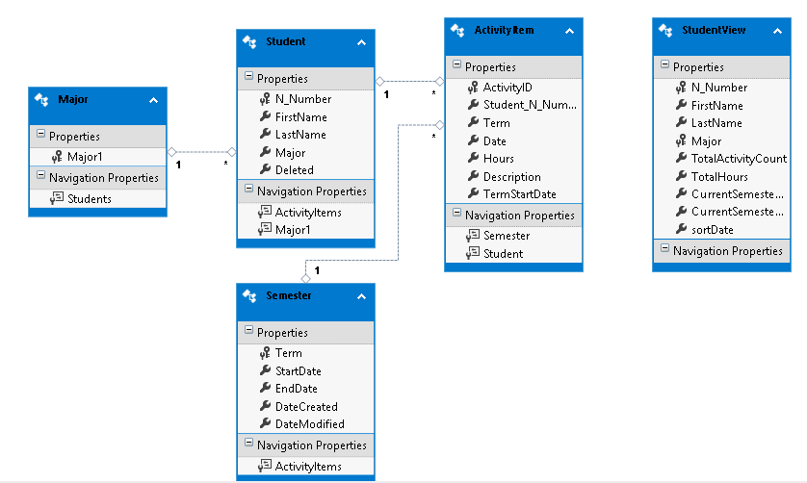

**Entity-Relationship diagram**

**Assumption**: “Current Semester” is determined by the semester with the latest StartDate in Semester table.

**WALKTHRU**

“Leadership Hours Tracking” Application can be launched by

Option 1: Express IIS in visual studio

Option 2 : <http://CISVM-SOCHONORS> in the browser as it is published to the IIS default site at “c:\inetpub\wwwroot” as Target location.

**Landing page**:  
The landing page lists all students and their hours for the current semester, activity count, and their total hours.

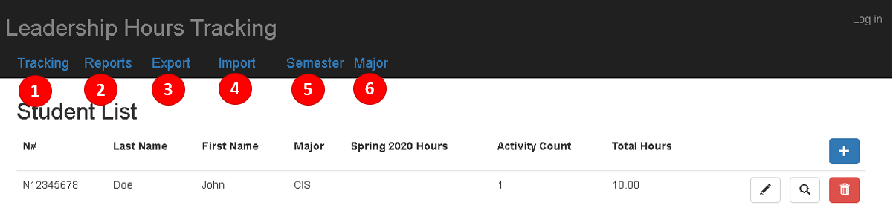

1. Tracking

Tracking is the landing page.

1. Reports

To list all the activities for a given search criteria using filters.

1. Export

To export activities into the Excel file based on a given search criteria using filters.

1. Import

To import activities from an Excel file into the ActivityItem table.

1. Semester

To manage terms

1. Major

To manage majors.

**Majors:**

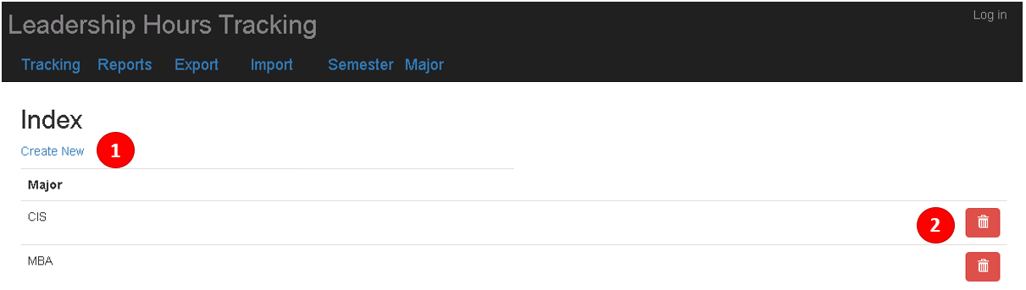

Major view lists all the majors.

1. Create New: To add new major

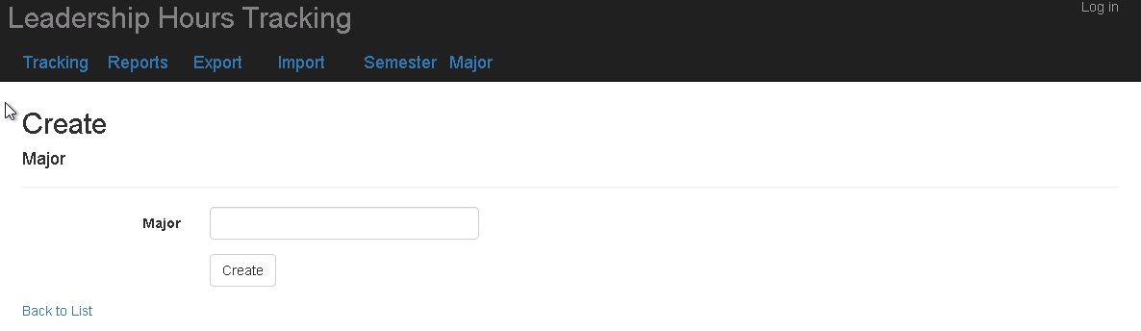

Enter major and click on create. “Back to List” takes you back to the list view.

1. Delete: To delete a major

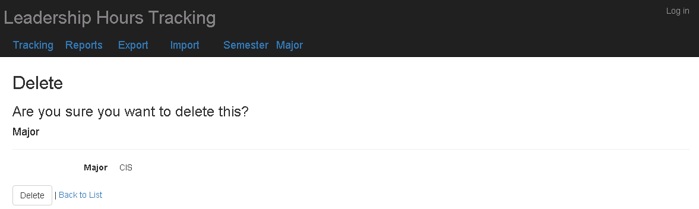

Click on “Delete” to delete the major. It cannot be deleted if there are students registered with this major.

**Semester:**

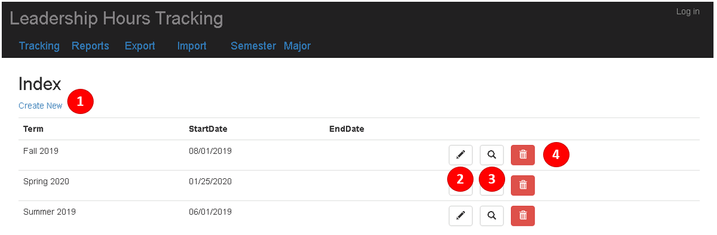

1. Create New: To add new semester/term

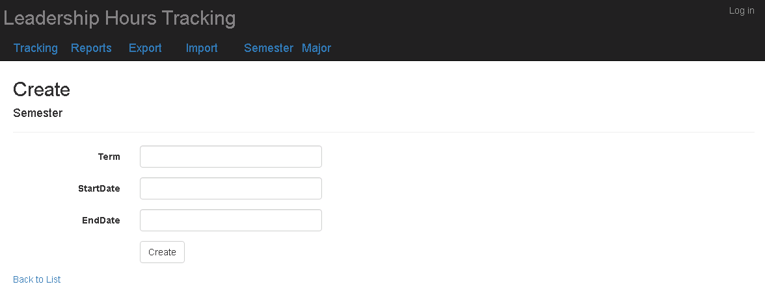

Enter Term and start/end date and click on create. Start Date is a required field, an accurate Start Date must be entered in order for the “Current Semester Hours” to be displayed properly. “Back to List” takes you back to the list view.

1. Edit: To edit/update a Term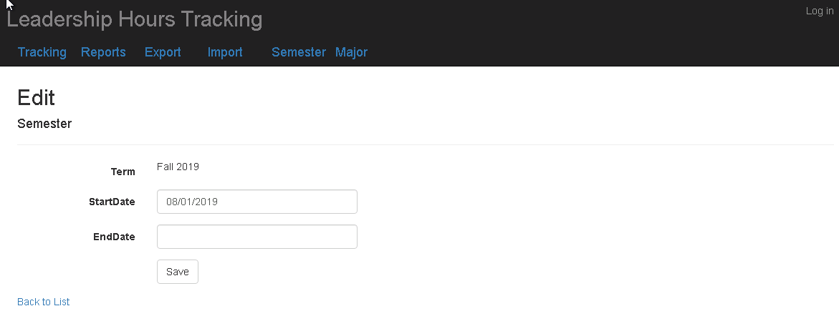

Click on “Save” to save changes.

1. Edit: To query a Term

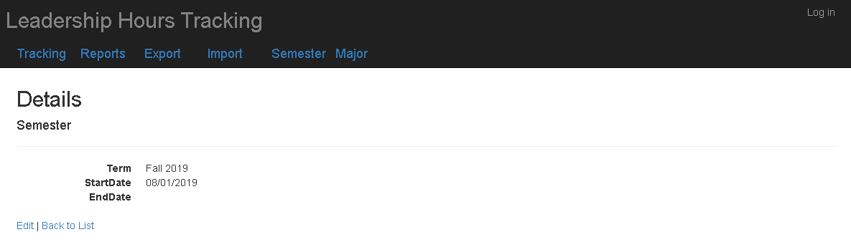

1. Delete: To delete a Term

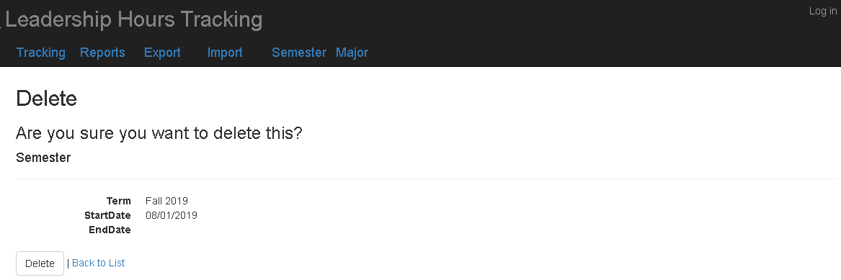

Click on “Delete” to delete the Term. It cannot be deleted if there are activities for this term.

**Tracking:**

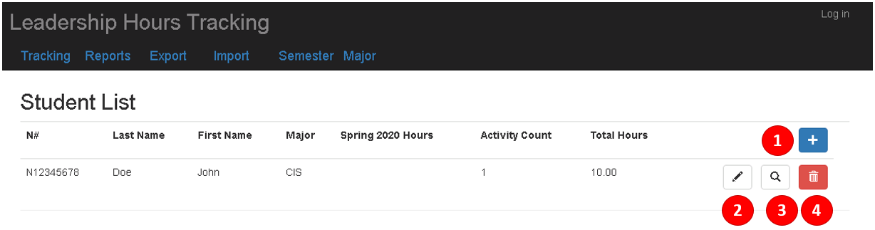

1. Create New (+): To register a new student.

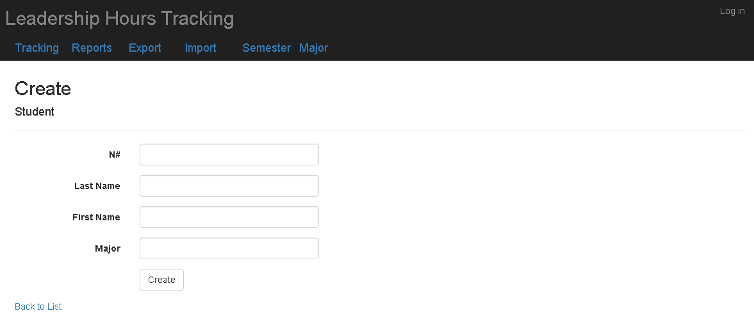

Enter student information and click on “Create”. N# and Major are required fields. “Back to List” takes you back to the list view.

1. Edit: To edit/update student information.

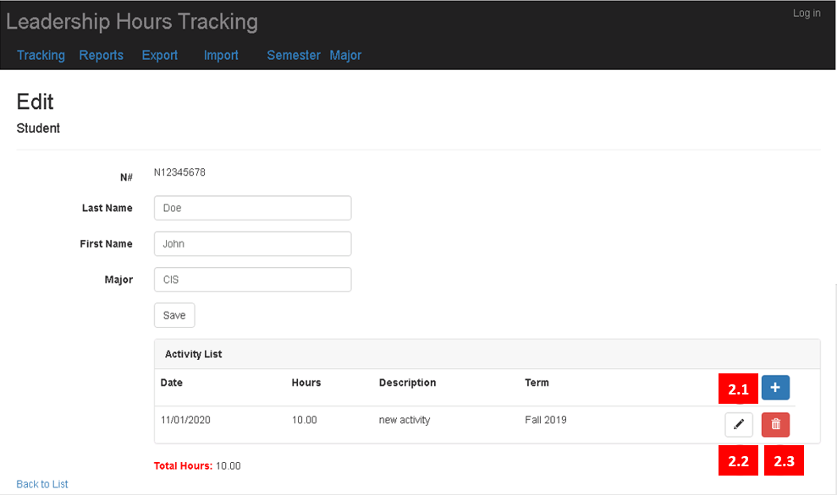

Change/Update student information and click on “Save”.

* 1. To add new activity to the student, click on 

This will bring up a pop-up window

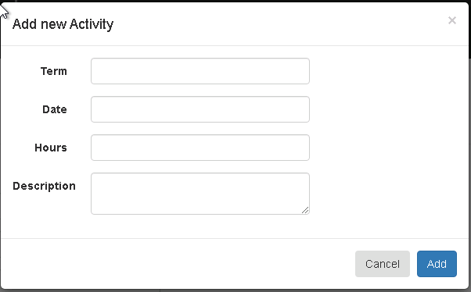

Enter Activity information and click on “Add”. Term and Hours are required fields.

* 1. To edit an activity, click on 

Change/Update activity information on the pop-up window, click on “Save”

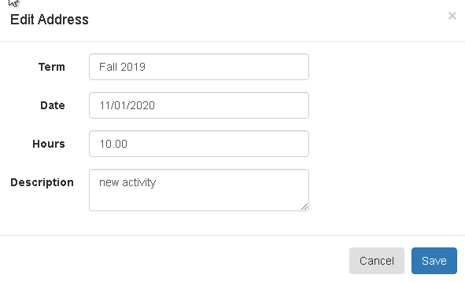

* 1. To delete an activity, click on 

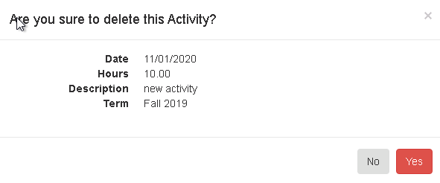

Click on “Yes” to confirm.

1. To query student information.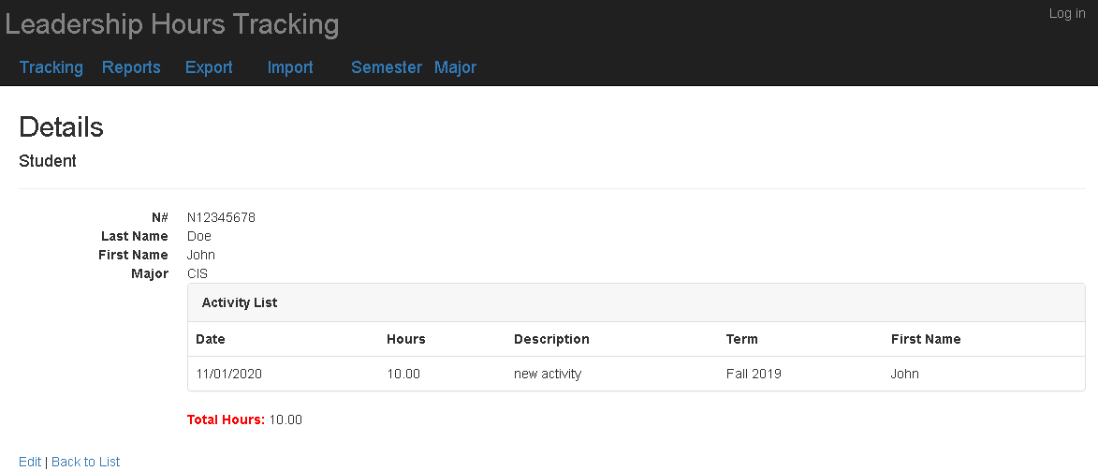
2. To delete/unregister a student.

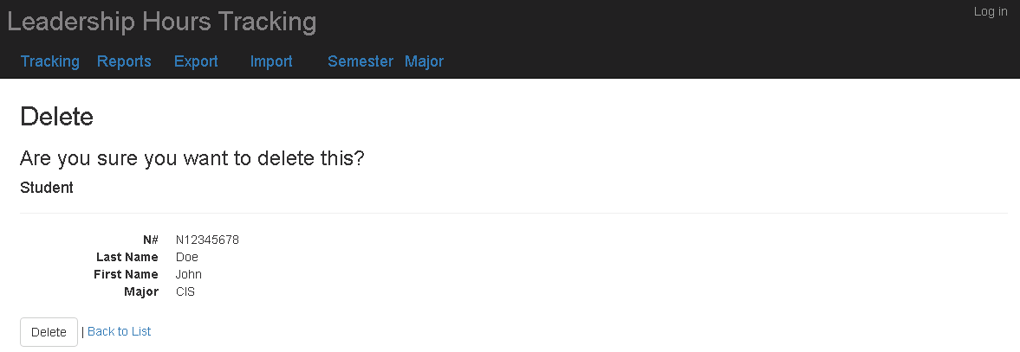

Click on “Delete” to do the “soft” delete on student. The “Deleted” column will be updated to “1” and the student will be unlisted from any changes. In order to add the Student once again, the database must be manually updated by changing the “Deleted” column for that student back to “NULL”.

**Reports:**

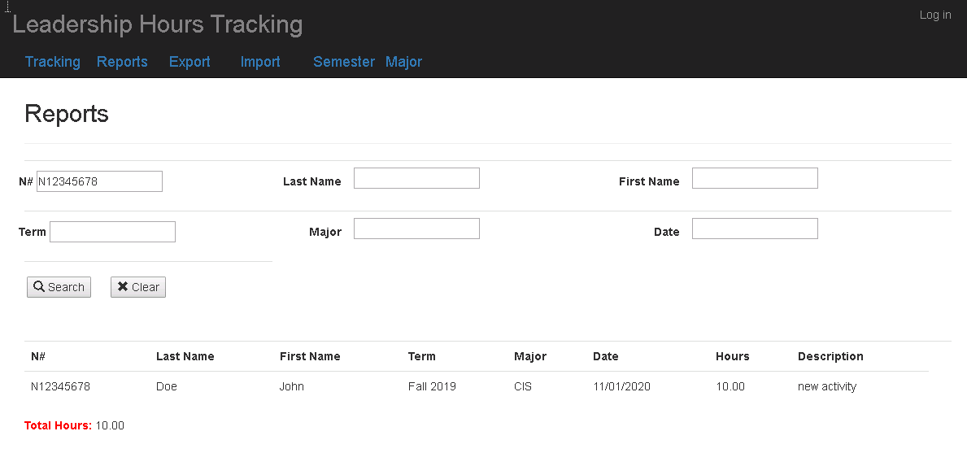

By default, it displays activities of all students. Enter filter conditions to narrow the list and click on “Search”. To clear the search criteria/filters, click on “Clear”.

**Export:**

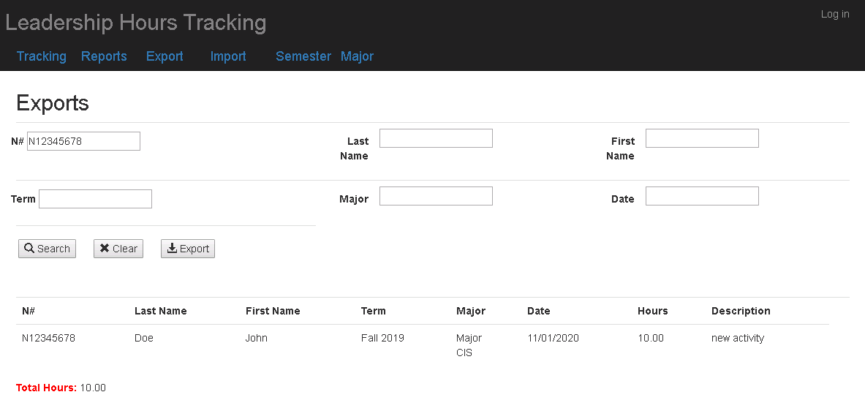

By default, it displays activities of all students. Enter filter conditions to narrow the list and click on “Search”. To clear the search criteria/filters, click on “Clear”. To export the data into Excel file, click on “Export”. The exported file name will be displayed at the top of the page as well as selected activities.

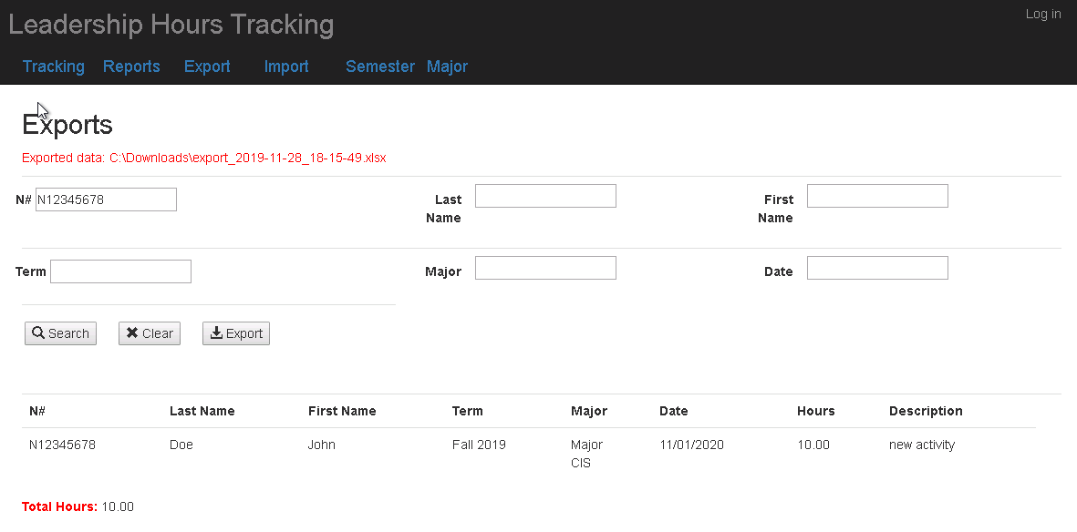

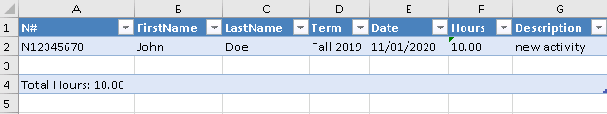

**Import:**

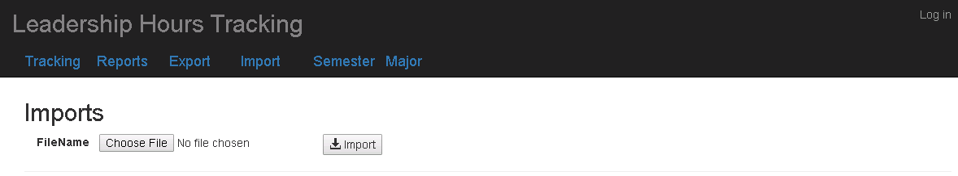

Click on “Choose File” to select the Excel file that contains activity data.



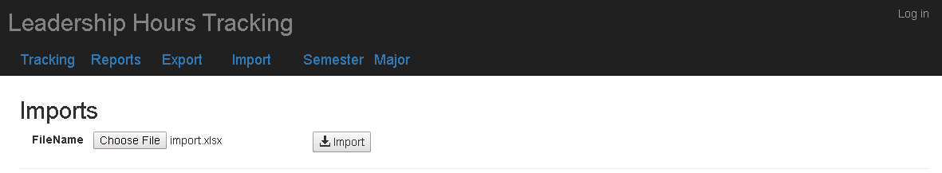

Click on “Import”

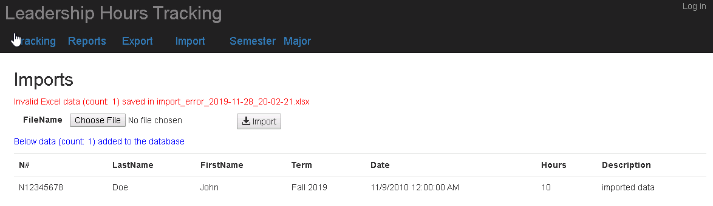

It will display the number of imported rows as well as the imported data. Invalid data will be written into another excel file for users to correct and reimport.

**APPENDIX A**: DATABASE SCHEMA

CREATE TABLE [UNFCSD\<database>].[ActivityItem](

[ActivityID] [int] IDENTITY(1,1) NOT NULL,

[Student_N_Number] [nchar](9) NOT NULL,

[Term] [nvarchar](20) NOT NULL,

[Date] [date] NULL,

[Hours] [decimal](4, 2) NULL,

[Description] [nvarchar](250) NULL,

[TermStartDate] [date] NULL,

CONSTRAINT [PK_ActivityItem] PRIMARY KEY CLUSTERED

(

[ActivityID] ASC

)WITH (PAD_INDEX = OFF, STATISTICS_NORECOMPUTE = OFF, IGNORE_DUP_KEY = OFF, ALLOW_ROW_LOCKS = ON, ALLOW_PAGE_LOCKS = ON) ON [PRIMARY]

) ON [PRIMARY]

CREATE TABLE [UNFCSD\<database>].[Semester](

[Term] [nvarchar](20) NOT NULL,

[StartDate] [date] NOT NULL,

[EndDate] [date] NULL,

[DateCreated] [datetime] NULL,

[DateModified] [datetime] NULL,

CONSTRAINT [PK_Semester] PRIMARY KEY CLUSTERED

(

[Term] ASC

)WITH (PAD_INDEX = OFF, STATISTICS_NORECOMPUTE = OFF, IGNORE_DUP_KEY = OFF, ALLOW_ROW_LOCKS = ON, ALLOW_PAGE_LOCKS = ON) ON [PRIMARY]

) ON [PRIMARY]

CREATE TABLE [UNFCSD\<database>].[Student](

[N_Number] [nchar](9) NOT NULL,

[FirstName] [nvarchar](50) NULL,

[LastName] [nvarchar](50) NULL,

[Subject] [nvarchar](50) NOT NULL,

[Deleted] [nchar](1) NULL,

CONSTRAINT [PK_Student] PRIMARY KEY CLUSTERED

(

[N_Number] ASC

)WITH (PAD_INDEX = OFF, STATISTICS_NORECOMPUTE = OFF, IGNORE_DUP_KEY = OFF, ALLOW_ROW_LOCKS = ON, ALLOW_PAGE_LOCKS = ON) ON [PRIMARY]

) ON [PRIMARY]

CREATE VIEW [UNFCSD\<database>].[StudentView]

AS

SELECT Student.N_Number, Student.FirstName, Student.LastName, Student.Subject, TotalActivityCount, TotalHours, CurrentSemesterActivityCount, CurrentSemesterHours, sortDate

FROM Student

OUTER APPLY

(

SELECT SUM(ActivityItem.Hours) as TotalHours, count(*) as TotalActivityCount

FROM ActivityItem

WHERE ActivityItem.Student_N_Number = Student.N_Number

) AS T1

OUTER APPLY

(

SELECT SUM(ActivityItem.Hours) as CurrentSemesterHours, count(*) as CurrentSemesterActivityCount

FROM ActivityItem

WHERE ActivityItem.Student_N_Number = Student.N_Number and

ActivityItem.Term = (SELECT TOP 1 term FROM Semester ORDER BY StartDate DESC)

) AS T2

OUTER APPLY

(

SELECT TOP 1 ActivityItem.TermStartDate as sortDate

FROM ActivityItem

WHERE ActivityItem.Student_N_Number = Student.N_Number

ORDER BY ActivityItem.TermStartDate DESC

) AS T3

WHERE Student.Deleted IS NULL

CREATE TABLE [UNFCSD\<database>].[Majors](

[Subject] [nvarchar](50) NOT NULL,

CONSTRAINT [PK_Majors] PRIMARY KEY CLUSTERED

(

[Subject] ASC

)WITH (PAD_INDEX = OFF, STATISTICS_NORECOMPUTE = OFF, IGNORE_DUP_KEY = OFF, ALLOW_ROW_LOCKS = ON, ALLOW_PAGE_LOCKS = ON) ON [PRIMARY]

) ON [PRIMARY]

ALTER TABLE [UNFCSD\<database>].[ActivityItem] WITH CHECK ADD CONSTRAINT [FK_ActivityItem_Semester] FOREIGN KEY([Term])

REFERENCES [UNFCSD\<database>].[Semester] ([Term])

ALTER TABLE [UNFCSD\<database>].[ActivityItem] CHECK CONSTRAINT [FK_ActivityItem_Semester]

ALTER TABLE [UNFCSD\<database>].[ActivityItem] WITH CHECK ADD CONSTRAINT [FK_ActivityItem_Student] FOREIGN KEY([Student_N_Number])

REFERENCES [UNFCSD\<database>].[Student] ([N_Number])

ALTER TABLE [UNFCSD\<database>].[ActivityItem] CHECK CONSTRAINT [FK_ActivityItem_Student]

ALTER TABLE [UNFCSD\<database>].[Student] WITH CHECK ADD CONSTRAINT [FK_Student_Majors] FOREIGN KEY([Subject])

REFERENCES [UNFCSD\<database>].[Majors] ([Subject])

ALTER TABLE [UNFCSD\<database>].[Student] CHECK CONSTRAINT [FK_Student_Majors]

**REFERENCES**

ASP.NET MVC

<https://dotnet.microsoft.com/apps/aspnet/mvc>

<https://docs.microsoft.com/en-us/aspnet/mvc/overview/getting-started/introduction/getting-started>

<https://sensibledev.com/mvc-bootstrap-form-example/>

<https://www.tutorialspoint.com/asp.net_mvc/asp.net_mvc_overview.htm>

C#

<https://docs.microsoft.com/en-us/dotnet/csharp/>

<https://www.tutorialspoint.com/csharp/index.htm>

<https://www.c-sharpcorner.com/>

Authentication:  
<http://www.codedigest.com/posts/4/forms-authentication-using-active-directory-users-in-aspnet-mvc>

<https://stackoverflow.com/questions/10279140/configure-asp-net-mvc-for-authentication-against-ad>

Excel – ClosedXML:

<https://github.com/ClosedXML/ClosedXML>

Glyphicons:

<https://getbootstrap.com/docs/3.3/components/>

ADO.NET:

<https://docs.microsoft.com/en-us/dotnet/framework/data/adonet/ado-net-overview>

IIS:

<https://www.iis.net/>

<https://www.youtube.com/watch?v=nrlayNIFd8s>

SQL Server Management Studio:

<https://www.codeproject.com/Articles/1185300/Creating-A-SQL-Server-Database-From-Visual-Studio>