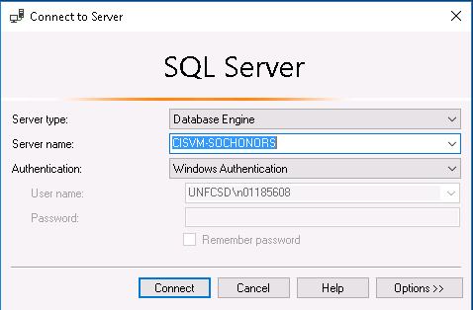

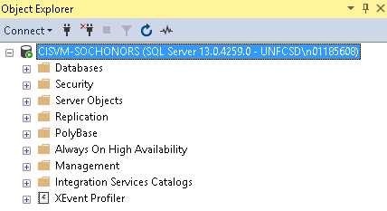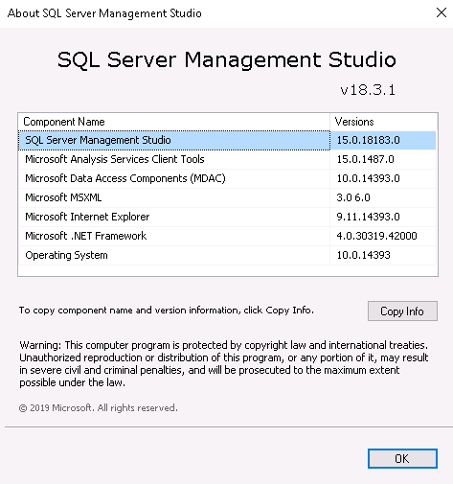

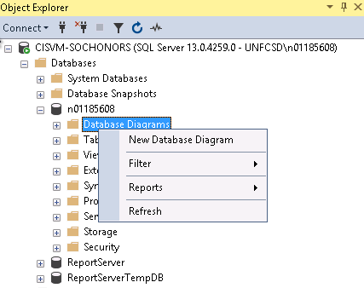

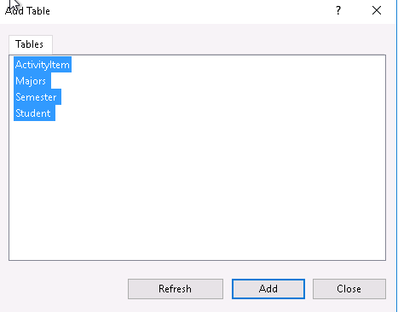

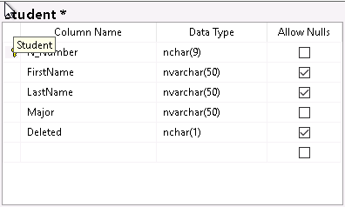

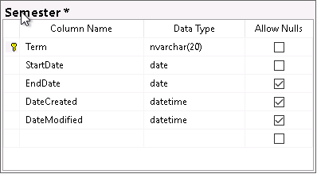

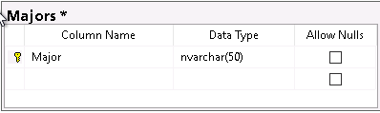

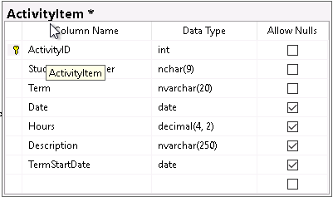

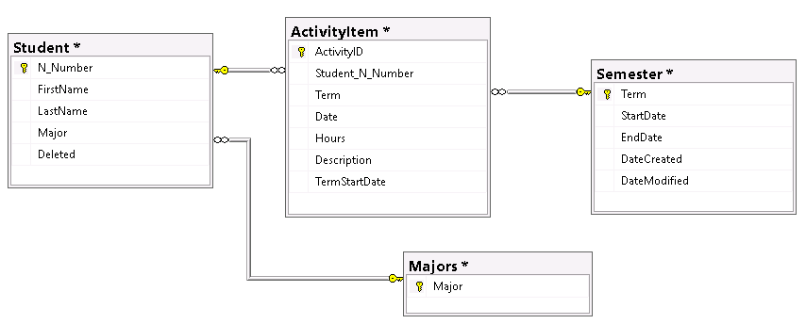

CREATE TRIGGER insert_DateCreated  
ON dbo.Semester  
FOR INSERT  
AS  
UPDATE  
SET DateCreated = GETDATE()

CREATE TRIGGER insert_DateCreated  
ON dbo.Semester  
FOR INSERT  
AS  
UPDATE  
SET DateCreated = GETDATE()

CREATE TRIGGER insert_DateCreated  
ON dbo.Semester  
FOR INSERT  
AS  
UPDATE  
SET DateCreated = GETDATE()

CREATE VIEW StudentView

AS

SELECT Student.N_Number, Student.FirstName, Student.LastName, Student.Major, TotalActivityCount, TotalHours, CurrentSemesterActivityCount, CurrentSemesterHours, sortDate

FROM Student

CROSS APPLY

(

SELECT SUM(ActivityItem.Hours) as TotalHours, count(*) as TotalActivityCount

FROM ActivityItem

WHERE ActivityItem.Student_N_Number = Student.N_Number

) AS T1

CROSS APPLY

(

SELECT SUM(ActivityItem.Hours) as CurrentSemesterHours, count(*) as CurrentSemesterActivityCount

FROM ActivityItem

WHERE ActivityItem.Student_N_Number = Student.N_Number and

ActivityItem.Term = (SELECT TOP 1 term FROM Semester ORDER BY DateCreated DESC)

) AS T2

CROSS APPLY

(

SELECT TOP 1 ActivityItem.TermStartDate as sortDate

FROM ActivityItem

WHERE ActivityItem.Student_N_Number = Student.N_Number

ORDER BY ActivityItem.TermStartDate DESC

) AS T3

WHERE Student.Deleted IS NULL

