SHYAM

1NT20IS413

Exercise:1

Create database

use shyam

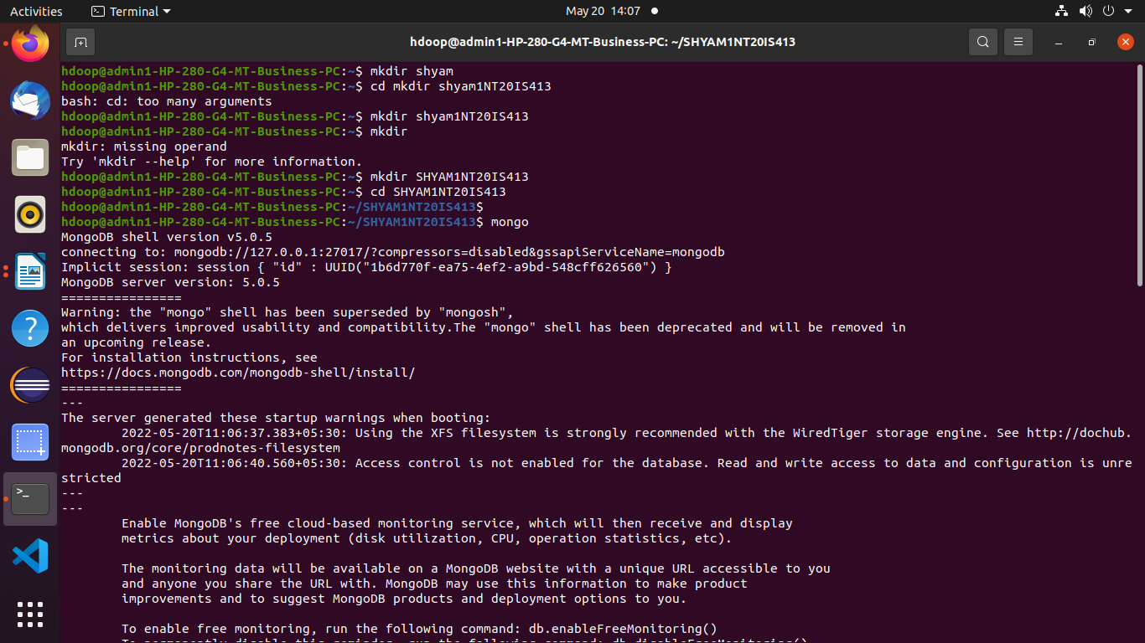**to check the current database**

>show dbs

**to insert one record**

> db.shyam.insertOne({name:"shyam",dept:"ise"})

{

"acknowledged" : true,

"insertedId" : ObjectId("62875110515c8b59ab4f9294")

}

**to insert many data.**

> db.shyam.insertMany([{name:antman",dept:"marvel"},{name:"batman",dept:"DC"},{name:shyam,dept:ISE}])

{

"acknowledged" : true,

"insertedIds" : [

ObjectId("6287529f515c8b59ab4f9295"),

ObjectId("6287529f515c8b59ab4f9296")

]

}

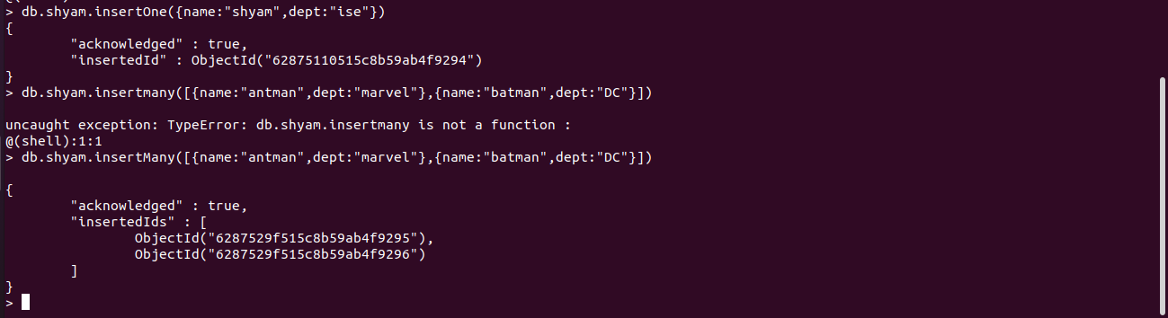



> db.shyam.find()

{ "_id" : ObjectId("62875110515c8b59ab4f9294"), "name" : "shyam", "dept" : "ise" }

{ "_id" : ObjectId("6287529f515c8b59ab4f9295"), "name" : "antman", "dept" : "marvel" }

{ "_id" : ObjectId("6287529f515c8b59ab4f9296"), "name" : "batman", "dept" : "DC" }

db.shyam.find().pretty();

{

"_id" : ObjectId("62875110515c8b59ab4f9294"),

"name" : "shyam",

"dept" : "ise"

}

{

"_id" : ObjectId("6287529f515c8b59ab4f9295"),

"name" : "antman",

"dept" : "marvel"

}

{

"_id" : ObjectId("6287529f515c8b59ab4f9296"),

"name" : "batman",

"dept" : "DC"

}

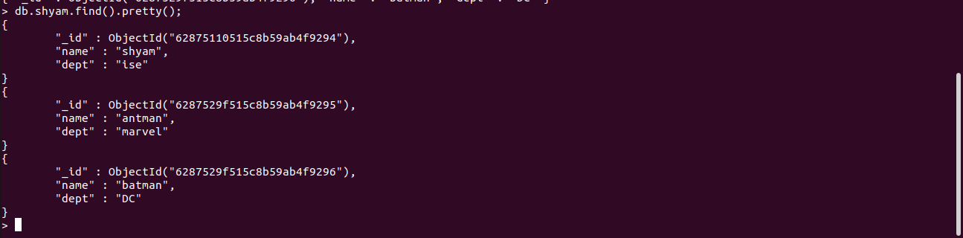

Update in MongoDB

to update one record using $set

db.shyam.updateOne({"name":"shyam"},{$set:{"dept":"cse"}})

{ "acknowledged" : true, "matchedCount" : 1, "modifiedCount" : 1 }

>



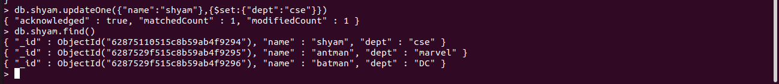

db.shyam.updateOne({"name":"shyam"},{$unset:{"dept":""}})

{ "acknowledged" : true, "matchedCount" : 1, "modifiedCount" : 1 }

> db.shyam.find().pretty();

{ "_id" : ObjectId("62875110515c8b59ab4f9294"), "name" : "shyam" }

{

"_id" : ObjectId("6287529f515c8b59ab4f9295"),

"name" : "antman",

"dept" : "marvel"

}

{

"_id" : ObjectId("6287529f515c8b59ab4f9296"),

"name" : "batman",

"dept" : "DC"

}

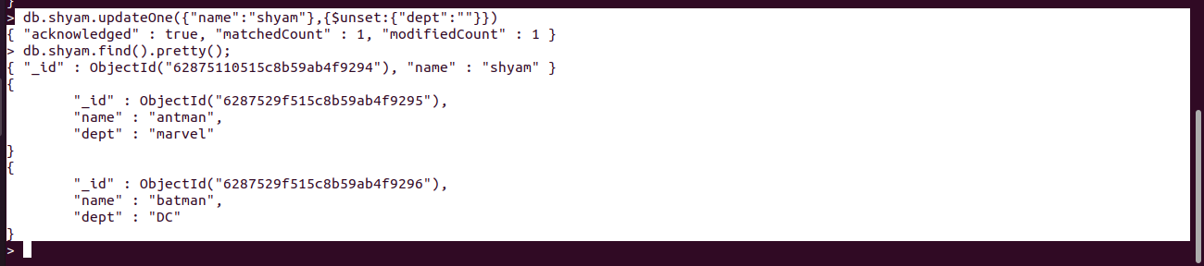

To delete One record

> db.shyam.deleteOne({name:"antman"})

{ "acknowledged" : true, "deletedCount" : 1 }

> db.shyam.find().pretty();

{ "_id" : ObjectId("62875110515c8b59ab4f9294"), "name" : "shyam" }

{

"_id" : ObjectId("6287529f515c8b59ab4f9296"),

"name" : "batman",

"dept" : "DC"

}

>

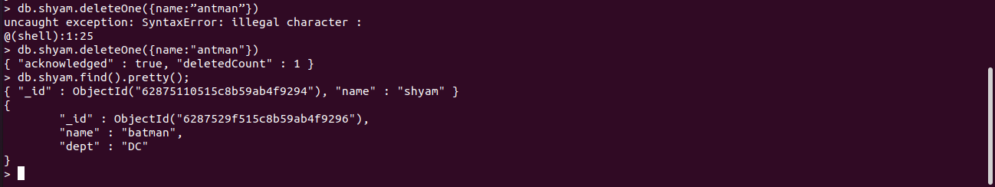

OR operation

db.shyam.find({$or:[{"dept":"marvel"},{"dept":"DC"}]}).pretty()

> db.shyam.insertMany([{name:"natasha",dept:"marvel"},{name:"aquaman",dept:"DC"},{name:"queen",dept:"ISE"}])

{

"acknowledged" : true,

"insertedIds" : [

ObjectId("62875df351a9651656254c80"),

ObjectId("62875df351a9651656254c81"),

ObjectId("62875df351a9651656254c82")

]

}

> db.shyam.find({$or:[{"dept":"marvel"},{"dept":"DC"}]}).pretty()

{

"_id" : ObjectId("6287529f515c8b59ab4f9296"),

"name" : "batman",

"dept" : "DC"

}

{

"_id" : ObjectId("628759b6515c8b59ab4f9297"),

"name" : "antman",

"dept" : "marvel"

}

{

"_id" : ObjectId("628759b6515c8b59ab4f9298"),

"name" : "batman",

"dept" : "DC"

}

{

"_id" : ObjectId("62875df351a9651656254c80"),

"name" : "natasha",

"dept" : "marvel"

}

{

"_id" : ObjectId("62875df351a9651656254c81"),

"name" : "aquaman",

"dept" : "DC"

}

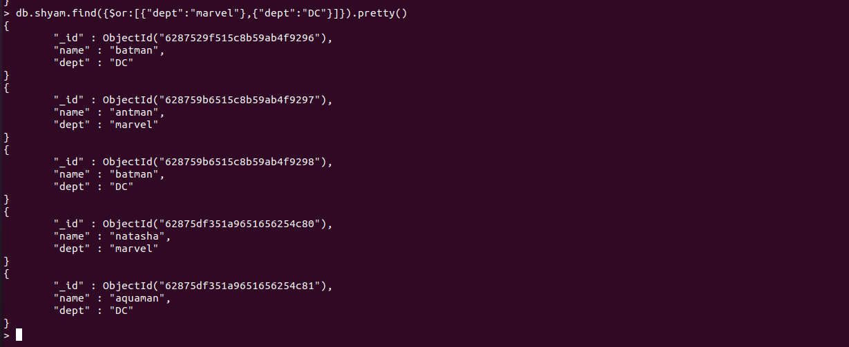

**AND OPERATION**

> db.shyam.find({$and:[{"dept":"DC"}]}).pretty()

{

"_id" : ObjectId("6287529f515c8b59ab4f9296"),

"name" : "batman",

"dept" : "DC"

}

{

"_id" : ObjectId("628759b6515c8b59ab4f9298"),

"name" : "batman",

"dept" : "DC"

}

{

"_id" : ObjectId("62875df351a9651656254c81"),

"name" : "aquaman",

"dept" : "DC"

}

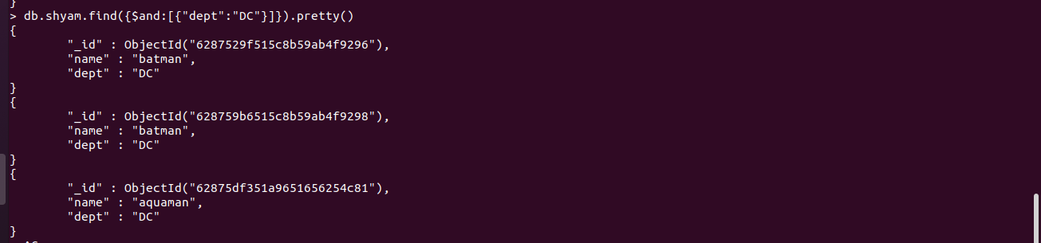

PIPELINE:

db.shyam.aggregate([

{ $match: {dept : “DC” } }

])

db.shyam.aggregate([

{ $match: { "name": "shyam" } },

{ $sort: { "dept": 1 } }

])

Exercise:2