SHYAM
1NT20IS413

Exercise:1
Create database
use shyam

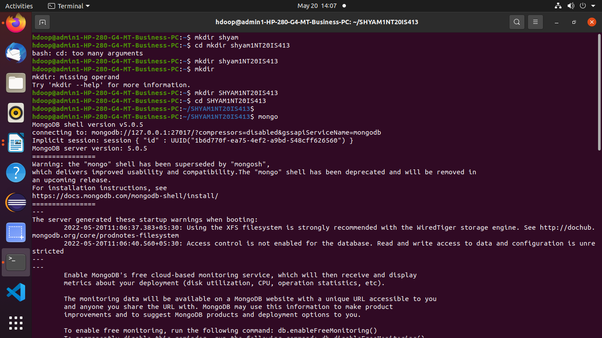
to check the current database

>show dbs

to insert one record

> db.shyam.insertOne({name:"shyam",dept:"ise"})
{
"acknowledged" : true,
"insertedId" : ObjectId("62875110515c8b59ab4f9294")
}
to insert many data.

> db.shyam.insertMany([{name:antman",dept:"marvel"},{name:"batman",dept:"DC"},{name:shyam,dept:ISE}])

{
"acknowledged" : true,
"insertedIds" : [
ObjectId("6287529f515c8b59ab4f9295"),
ObjectId("6287529f515c8b59ab4f9296")
]
}

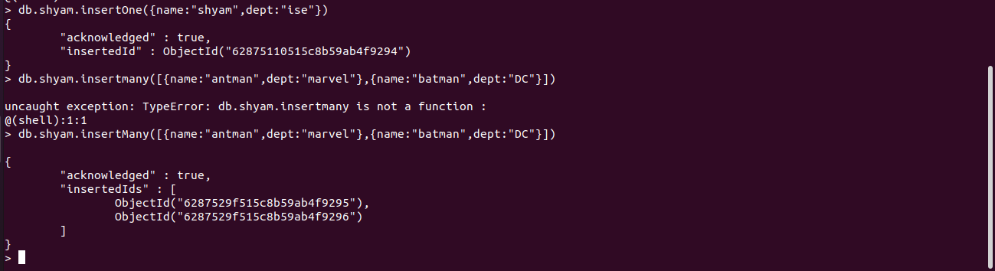
> db.shyam.find()
{ "_id" : ObjectId("62875110515c8b59ab4f9294"), "name" : "shyam", "dept" : "ise" }
{ "_id" : ObjectId("6287529f515c8b59ab4f9295"), "name" : "antman", "dept" : "marvel" }
{ "_id" : ObjectId("6287529f515c8b59ab4f9296"), "name" : "batman", "dept" : "DC" }

db.shyam.find().pretty();
{
"_id" : ObjectId("62875110515c8b59ab4f9294"),
"name" : "shyam",
"dept" : "ise"
}
{
"_id" : ObjectId("6287529f515c8b59ab4f9295"),
"name" : "antman",
"dept" : "marvel"
}
{
"_id" : ObjectId("6287529f515c8b59ab4f9296"),
"name" : "batman",
"dept" : "DC"
}

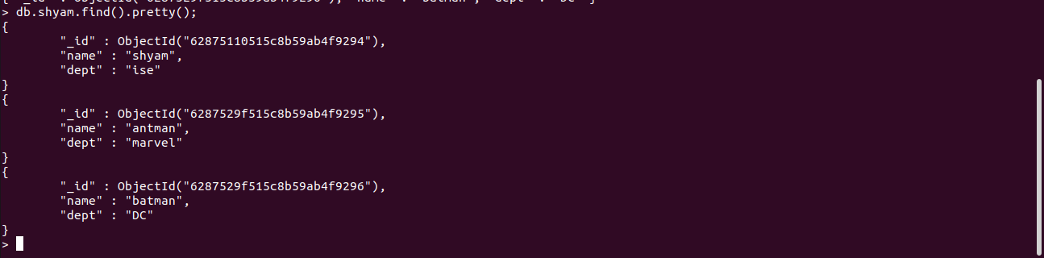
Update in MongoDB

to update one record using $set

db.shyam.updateOne({"name":"shyam"},{$set:{"dept":"cse"}})
{ "acknowledged" : true, "matchedCount" : 1, "modifiedCount" : 1 }
>
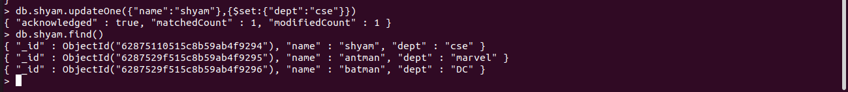
db.shyam.updateOne({"name":"shyam"},{$unset:{"dept":""}})
{ "acknowledged" : true, "matchedCount" : 1, "modifiedCount" : 1 }
> db.shyam.find().pretty();
{ "_id" : ObjectId("62875110515c8b59ab4f9294"), "name" : "shyam" }
{
"_id" : ObjectId("6287529f515c8b59ab4f9295"),
"name" : "antman",
"dept" : "marvel"
}
{
"_id" : ObjectId("6287529f515c8b59ab4f9296"),
"name" : "batman",
"dept" : "DC"
}

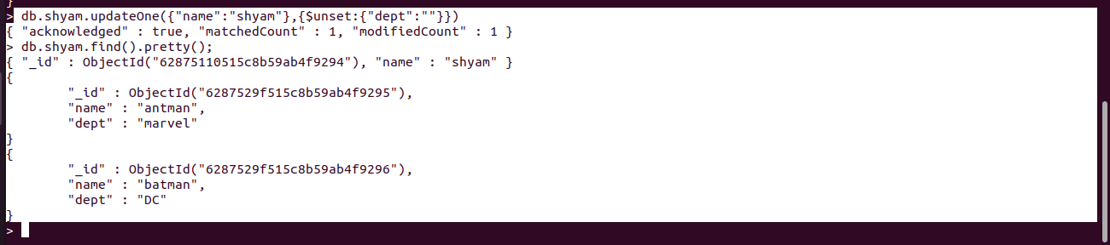
To delete One record

> db.shyam.deleteOne({name:"antman"})
{ "acknowledged" : true, "deletedCount" : 1 }
> db.shyam.find().pretty();
{ "_id" : ObjectId("62875110515c8b59ab4f9294"), "name" : "shyam" }
{
"_id" : ObjectId("6287529f515c8b59ab4f9296"),
"name" : "batman",
"dept" : "DC"
}
>

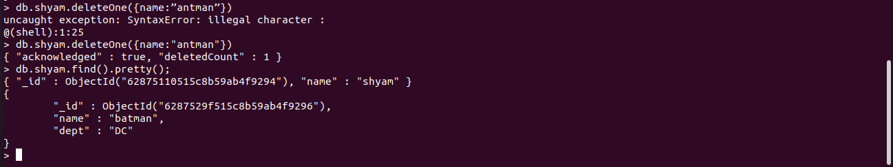
OR operation
db.shyam.find({$or:[{"dept":"marvel"},{"dept":"DC"}]}).pretty()
> db.shyam.insertMany([{name:"natasha",dept:"marvel"},{name:"aquaman",dept:"DC"},{name:"queen",dept:"ISE"}])
{
"acknowledged" : true,
"insertedIds" : [
ObjectId("62875df351a9651656254c80"),
ObjectId("62875df351a9651656254c81"),
ObjectId("62875df351a9651656254c82")
]
}
> db.shyam.find({$or:[{"dept":"marvel"},{"dept":"DC"}]}).pretty()
{
"_id" : ObjectId("6287529f515c8b59ab4f9296"),
"name" : "batman",
"dept" : "DC"
}
{
"_id" : ObjectId("628759b6515c8b59ab4f9297"),
"name" : "antman",
"dept" : "marvel"
}
{
"_id" : ObjectId("628759b6515c8b59ab4f9298"),
"name" : "batman",
"dept" : "DC"
}
{
"_id" : ObjectId("62875df351a9651656254c80"),
"name" : "natasha",
"dept" : "marvel"
}
{
"_id" : ObjectId("62875df351a9651656254c81"),
"name" : "aquaman",
"dept" : "DC"
}
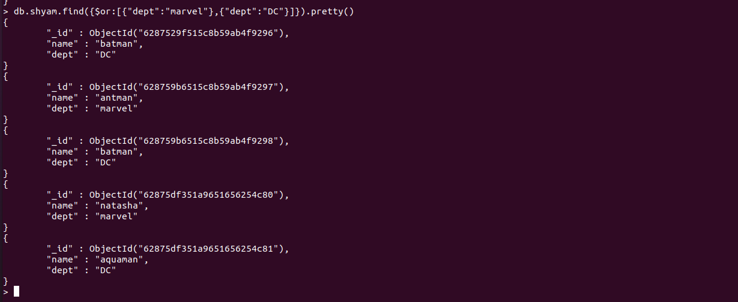
AND OPERATION

> db.shyam.find({$and:[{"dept":"DC"}]}).pretty()
{
"_id" : ObjectId("6287529f515c8b59ab4f9296"),
"name" : "batman",
"dept" : "DC"
}
{
"_id" : ObjectId("628759b6515c8b59ab4f9298"),
"name" : "batman",
"dept" : "DC"
}
{
"_id" : ObjectId("62875df351a9651656254c81"),
"name" : "aquaman",
"dept" : "DC"
}
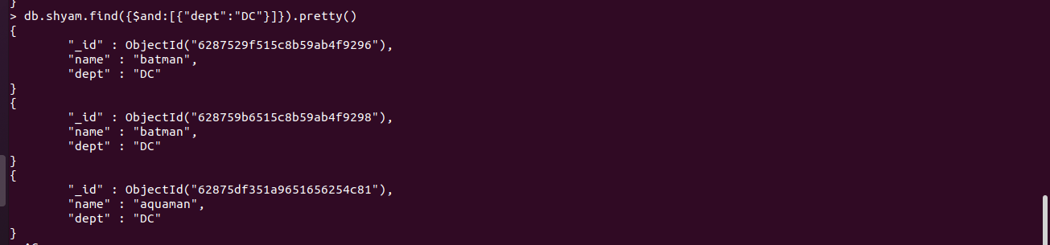

Exercise:2

