SIMATS ENGINEERING

ASSESSMENT TOOL 2

COURSE NAME: Cryptography and Network Security

COURSE CODE: CSA5111

COURSE OUTCOME COVERED

CO1: Apply classical encryption techniques using symmetric and asymmetric ciphers to encrypt and decrypt data for the ensuring data security. (BL3, BL4)

Assessment Tool Weightage: 20%

QUESTIONS: 5 Total Marks:50

Annexure A

CONCEPT MAPPING

Code of Conduct:

I (Name / Reg No) certify that this submission is my original work and that I have adhered to the guidelines specified for this assessment.

I understand that any violation of academic integrity

SIGNATURE OF THE STUDENT:

Question 1: Security Attacks, Threats, Risks and Security Goals

Key definitions
- Attack: A deliberate action that attempts to compromise the security of information or a system (passive or active).
- Threat: A potential danger that an attack can realise, i.e. what could go wrong (disclosure, alteration, disruption).
- Risk: The likelihood of a threat succeeding multiplied by its impact on the organisation (financial loss, loss of privacy, reputation damage).
- Security goals (CIA triad): Confidentiality, Integrity and Availability, the controls that reduce threats and risks.

Concept map
Figure 1: Concept map linking attacks, threats, risks and security goals (diagram below).
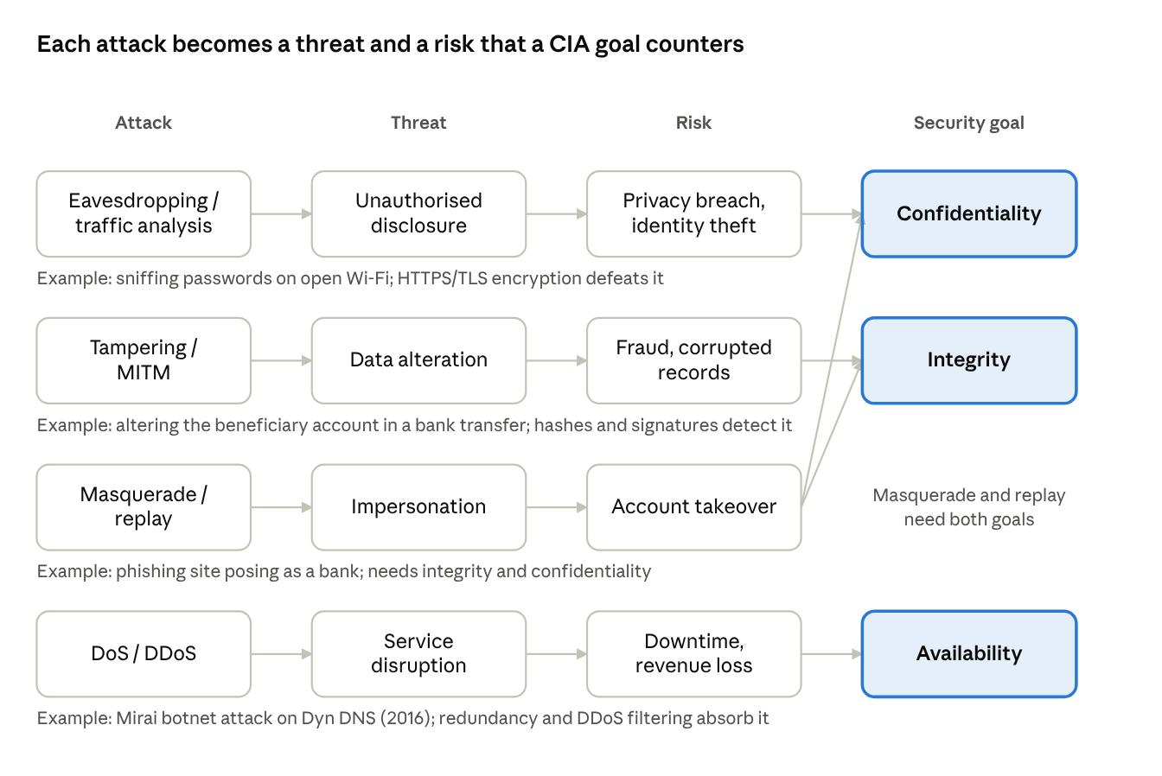
attacks to threats, risks and CIA goals · 4 chains
Read each row left to right: the attack creates a threat, the threat carries a risk, and the goal on the right is the control that counters it.

a. How each attack leads to specific threats and risks
Attack | Type | Threat created | Resulting risk | Real-world example
Eavesdropping / sniffing, traffic analysis | Passive | Unauthorised disclosure of data | Privacy breach, identity theft, legal penalties | Sniffing unencrypted traffic on an open public Wi-Fi hotspot to capture passwords
Message modification, man-in-the-middle tampering | Active | Unauthorised alteration of data | Fraud, corrupted records, loss of trust | Altering the beneficiary account number in an online bank transfer; the SolarWinds supply-chain compromise (2020) modified trusted software updates
Masquerade, replay | Active | Impersonation, unauthorised access | Account takeover, unauthorised transactions | Phishing site impersonating a bank to steal credentials; replaying a captured payment request
Denial of Service (DoS / DDoS) | Active | Loss of service availability | Downtime, revenue loss, reputational damage | Mirai botnet attack on Dyn DNS (2016) that took down major websites
Data breach through exploited vulnerability | Active | Mass disclosure of confidential records | Regulatory fines, lawsuits, identity fraud | Equifax breach (2017) exposing personal data of about 147 million people

b. How security goals mitigate them
Security goal | Attacks/threats mitigated | Mechanisms | Real-world example
Confidentiality | Eavesdropping, traffic analysis, data breach | Symmetric/asymmetric encryption, access control, VPN, TLS | HTTPS (TLS) encrypts web traffic so a Wi-Fi sniffer sees only ciphertext
Integrity | Modification, MITM tampering, replay | Hash functions, MACs, digital signatures, sequence numbers | Software vendors publish SHA-256 checksums and sign updates so tampering is detected
Availability | DoS/DDoS, ransomware | Redundancy, load balancing, firewalls, rate limiting, backups, CDN | Content delivery networks absorb DDoS traffic to keep sites online
Link summary (attack → threat → risk → goal): Eavesdropping → disclosure → privacy loss → Confidentiality; Tampering → alteration → fraud → Integrity; DoS → disruption → downtime → Availability. Masquerade and replay are countered by combining integrity (signatures, MACs) with confidentiality (protected credentials).

Question 2: Comparison of Substitution Techniques

Concept map
Figure 2: Concept map comparing Caesar, Monoalphabetic, Vigenère and Hill ciphers by key usage, complexity and security strength (diagram below).
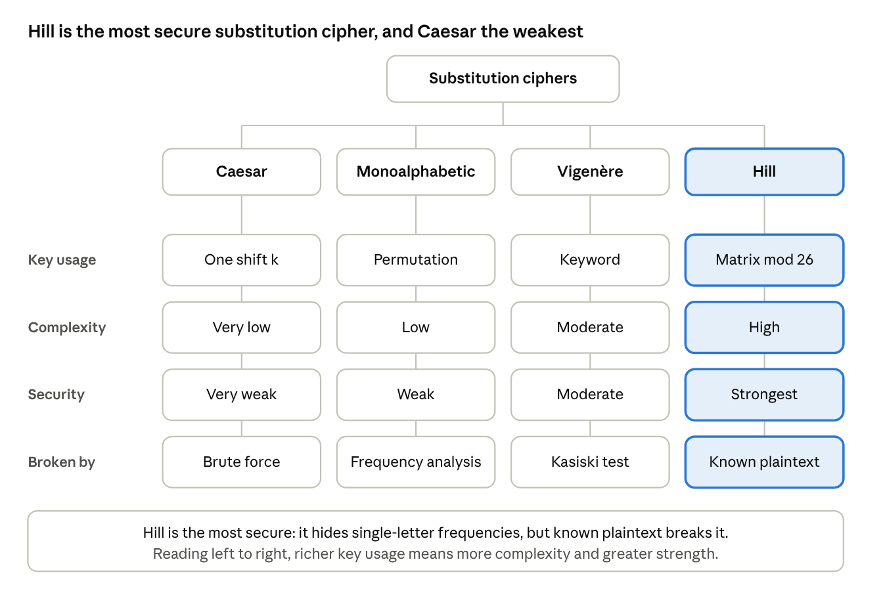
four substitution ciphers compared · 4 attributes
Each column follows one cipher from its key down to the attack that breaks it; the highlighted Hill column is the strongest on every row.

Comparison table
Aspect | Caesar | Monoalphabetic | Vigenère | Hill
Type | Monoalphabetic, shift | Monoalphabetic, arbitrary permutation | Polyalphabetic | Polygraphic (block of m letters)
Key usage | Single integer shift k (0–25), same for every letter | A permutation of the 26 letters used for every letter | Keyword; each key letter gives a different Caesar shift, repeated cyclically | An m×m matrix K, invertible modulo 26; blocks encrypted as C = K·P mod 26
Key space | 25 useful keys | 26! ≈ 4×10²⁶ keys | 26ⁿ for a keyword of length n | Number of invertible m×m matrices mod 26 (very large for m ≥ 3)
Complexity | Very low (one addition mod 26) | Low–moderate (table lookup, key must be stored/shared) | Moderate (key stream alignment) | High (matrix multiplication, modular inverse for decryption)
Main weakness | Brute force in at most 25 tries | Letter-frequency analysis | Kasiski examination and index of coincidence reveal key length, then each column is a Caesar cipher | Known-plaintext attack: with m plaintext/ciphertext blocks the key is solved by linear algebra
Security strength | Very weak | Weak (large key space but statistical pattern preserved) | Moderate | Strongest of the four against ciphertext-only attacks

Worked mini-examples
- Caesar (k = 3): HELLO → KHOOR.
- Vigenère (key = KEY): the shifts are K=10, E=4, Y=24, repeated along the message, so identical plaintext letters can map to different ciphertext letters.
- Hill (m = 2, K = [[3,3],[2,5]]): the pair HE is the vector (7,4); K·(7,4) mod 26 = (33, 34) mod 26 = (7, 8) giving HI. Decryption uses K⁻¹ mod 26.

Connections made in the map
- Key usage → complexity: the more the key changes the substitution (one shift, one permutation, a rotating keyword, a matrix over blocks), the greater the computation and key-management effort.
- Complexity → security strength: Caesar and Monoalphabetic keep a one-to-one letter mapping so frequencies survive; Vigenère flattens frequencies; Hill hides single-letter and, for larger m, digraph statistics.

Analysis: which technique is most secure and why
Hill cipher is the most secure of the four against ciphertext-only attacks. It encrypts several letters at once, so a single letter does not map to a single fixed ciphertext letter and simple frequency analysis fails. Its security grows with the matrix size m, since the frequency distribution of m-letter groups is far harder to analyse. Its drawback is that it is linear, so it falls quickly to a known-plaintext attack. Vigenère is next, being polyalphabetic but breakable once the key length is found; Monoalphabetic follows, with a huge key space that frequency analysis bypasses; Caesar is weakest. In practice none of these is secure by modern standards, and they are the foundation for modern block ciphers such as AES.

Question 3: Classical Encryption Schemes – Substitution vs Transposition

Concept map
Figure 3: Concept map of classical encryption schemes showing differences, similarities, effect on data structure and security level (diagram below).
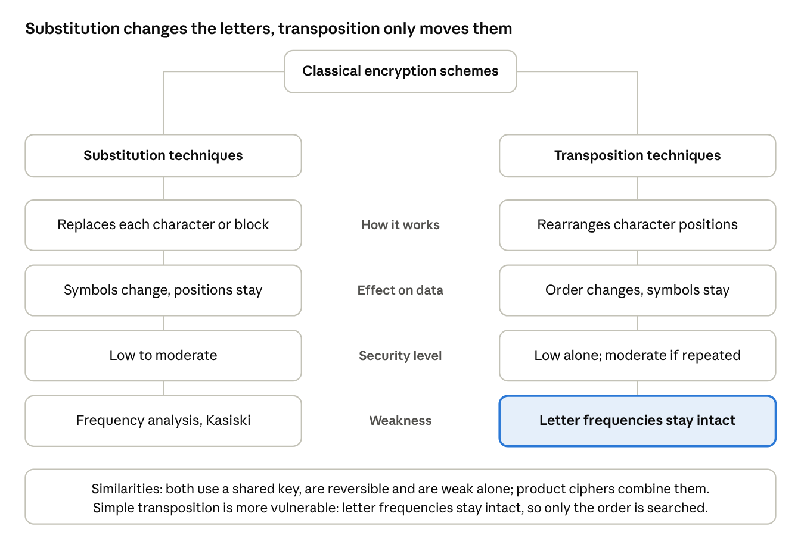
substitution vs transposition · 4 comparisons
The map compares the two schemes row by row; the highlighted box marks the weakness that makes simple transposition easier to attack.

Overview
- Substitution techniques replace each plaintext letter (or block) with another symbol, changing the identity of characters while keeping their positions (Caesar, Monoalphabetic, Vigenère, Playfair, Hill).
- Transposition techniques rearrange the positions of plaintext letters according to a rule or key while keeping the letters themselves unchanged (Rail Fence, Columnar Transposition).

a. Differences and similarities
Aspect | Substitution | Transposition
Principle | Replace characters | Permute positions
What changes | Character values | Character order
What is preserved | Position of each character | Identity and frequency of each character
Typical key | Shift, permutation, keyword, matrix | Number of rails, column order keyword
Technique for breaking | Frequency analysis, Kasiski, known plaintext | Anagramming, trying column counts, frequency check (letters match language)
Example | HELLO → KHOOR (Caesar) | HELLO (rail fence, 2 rails) → HLOEL
Similarities: both are classical symmetric (shared-key) schemes; both are reversible with the key; both operate on plaintext letters/blocks; both aim at the Shannon properties of confusion (substitution) and diffusion (transposition); and both are weak on their own but are combined in product ciphers (e.g. DES and AES rounds use substitution and permutation steps).

i. Effect on data structure and security level
- Substitution: the message length and character positions remain the same, but the symbol set changes. Simple (monoalphabetic) forms leave the statistical structure intact (low security); polyalphabetic and polygraphic forms disturb the structure and raise security to low–moderate.
- Transposition: the symbol set and frequency distribution are unchanged, but the sequence structure is scrambled. Security is low for single-pass schemes, because the ciphertext still looks like language letter frequencies; applying double transposition raises it to moderate.

ii. Which is more vulnerable and why
A simple transposition cipher is more vulnerable in practice. The ciphertext has exactly the same letter frequencies as normal language, which immediately signals that it is a transposition; an attacker then only has to recover the permutation by testing possible rail or column counts and anagramming common words, a search space that is small for short keys. Simple monoalphabetic substitution is also weak because of frequency analysis, but polyalphabetic and polygraphic substitution hide letter frequencies and are more resistant. Neither is secure alone; combining them (product cipher) gives much stronger security through confusion plus diffusion.

Question 4: Steganography – Data Hiding, Watermarking and Survivability

Concept map
Figure 4: Concept map relating data hiding, watermarking and survivability in steganography (diagram below).

Concepts
- Steganography: hiding the very existence of a message inside a cover medium (image, audio, video, text), whereas cryptography hides the meaning of a message.
- Data hiding: embedding secret data into a cover object so that it is imperceptible, typically with high capacity (e.g. least-significant-bit replacement in image pixels). The priority is invisibility and capacity.
- Watermarking: embedding an identifying mark (owner ID, serial number, signature) into content to prove ownership or trace copies. The priority is robustness rather than capacity, and the mark may be visible or invisible.
- Survivability: the ability of the hidden data or watermark to remain recoverable after processing or attacks such as compression, cropping, noise, resizing, format conversion or re-recording.

a. Relationships between the concepts
- Data hiding is the parent technique; watermarking is a specialised data-hiding application aimed at protecting content rather than carrying a private message.
- Survivability is the quality that watermarking depends on most: a watermark that is removed by simple JPEG compression is worthless. Data hiding also needs some survivability if the stego-object travels over lossy channels.
- The three properties trade off against each other: capacity (data hiding), imperceptibility and robustness (survivability). Raising one usually lowers another.

b. Contribution to secure communication
Concept | Contribution to secure communication
Data hiding | Gives covert communication: an eavesdropper does not even know a message exists, adding a layer beyond encryption (hide, then encrypt)
Watermarking | Provides authenticity, ownership proof and integrity checking, and allows leaked copies to be traced
Survivability | Ensures that the hidden message or watermark persists through noisy or lossy channels and deliberate attacks, so the protection is reliable

c. Real-world applications
Concept | Application
Data hiding | Covert transfer of a message inside an image using LSB embedding, used by journalists and activists under censorship; malware command channels hidden in images have also been observed
Watermarking | Stock-photo and film studios embed invisible watermarks to prove copyright; banknotes carry watermarks to prevent counterfeiting
Survivability | Robust audio/video watermarks (e.g. in streaming and broadcast monitoring) that survive compression and re-encoding so pirated copies can still be traced

Conclusion
Concept maps show that security attacks lead to threats and risks that the CIA goals counter; that substitution ciphers grow stronger from Caesar to Hill as key usage and complexity rise; that substitution and transposition are complementary building blocks of modern product ciphers; and that steganography adds hidden, robust and traceable protection that complements encryption.

