1.2

Case where Greedy less nodes than ASTAR
TYPE | A* | GREEDY BEST
Nodes Expanded | 412 | 85
Path Cost | 80 | 80

%%%%%%%%%%%%%%%%%%%%%%%%%%%%%%%%%%%%
% P%
% %% %% %%% %% %%%% %%%%%%%% %
% %% % % %% %
% %% % % % % %%%% % %% %%%% %% %%%%%
% %% % % % % %% %% %
% %% % % % % % % % %%% %%%%%% %
% % % % % % %% %%%%%%%% %
% %% % % %% %% %%%%%
% %% % %% %% %%% %% %
% %%%%%% % %% %% %%%%%% %
%%%%%% % %%%% %% % %
% % %% %%%%% % %% %% %%%%%
% %%%%%% % %%%%% %% %
% %%%%%% %%% %%% %% %% %
% % %%%% %%% % %% %% %%%%%
% %%%%%% % %%%%% %% %
% %%%%%% %%%%%%%%%%% %% %% %
% %% % % % % % %%%% %%% %%%%%% %
% % % % % % %% %%%%%%%% %
% %% % % %%%%%%%% %% %% %%%%%
%%%%%%%%%% %% %%%%%
%. %%%%%%%%%%%%%%%% %
%%%%%%%%%%%%%%%%%%%%%%%%%%%%%%%%%%%%

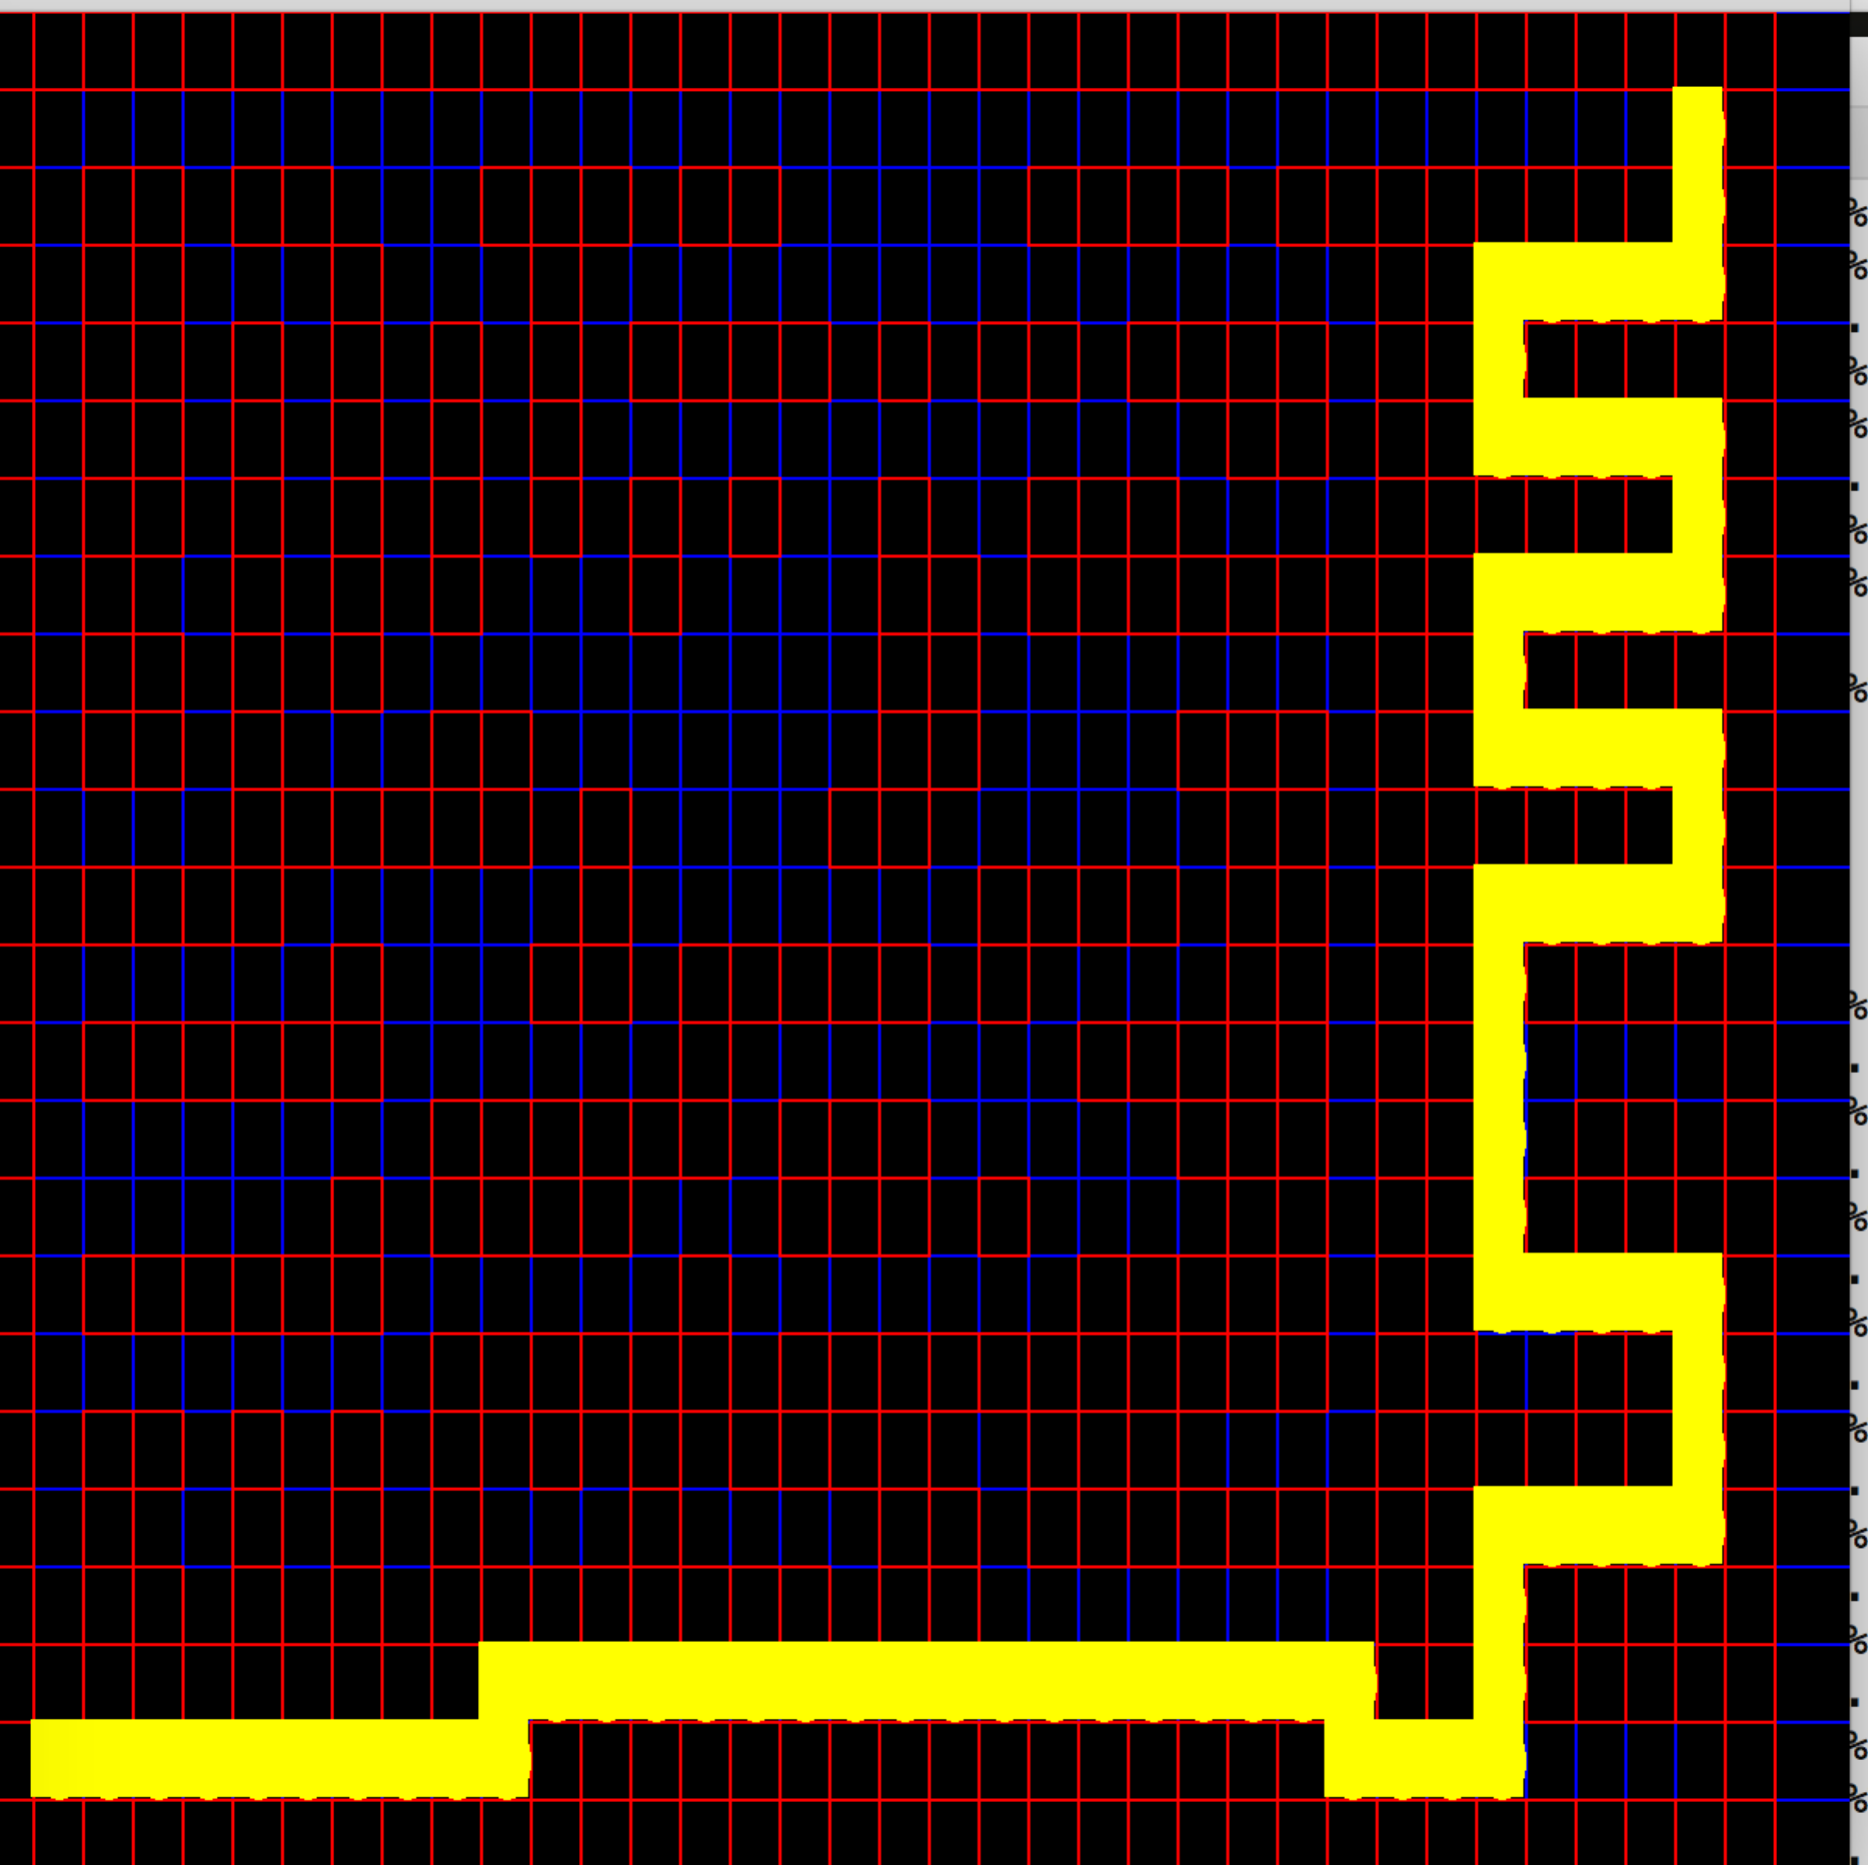  Greedy Expanding less nodes | 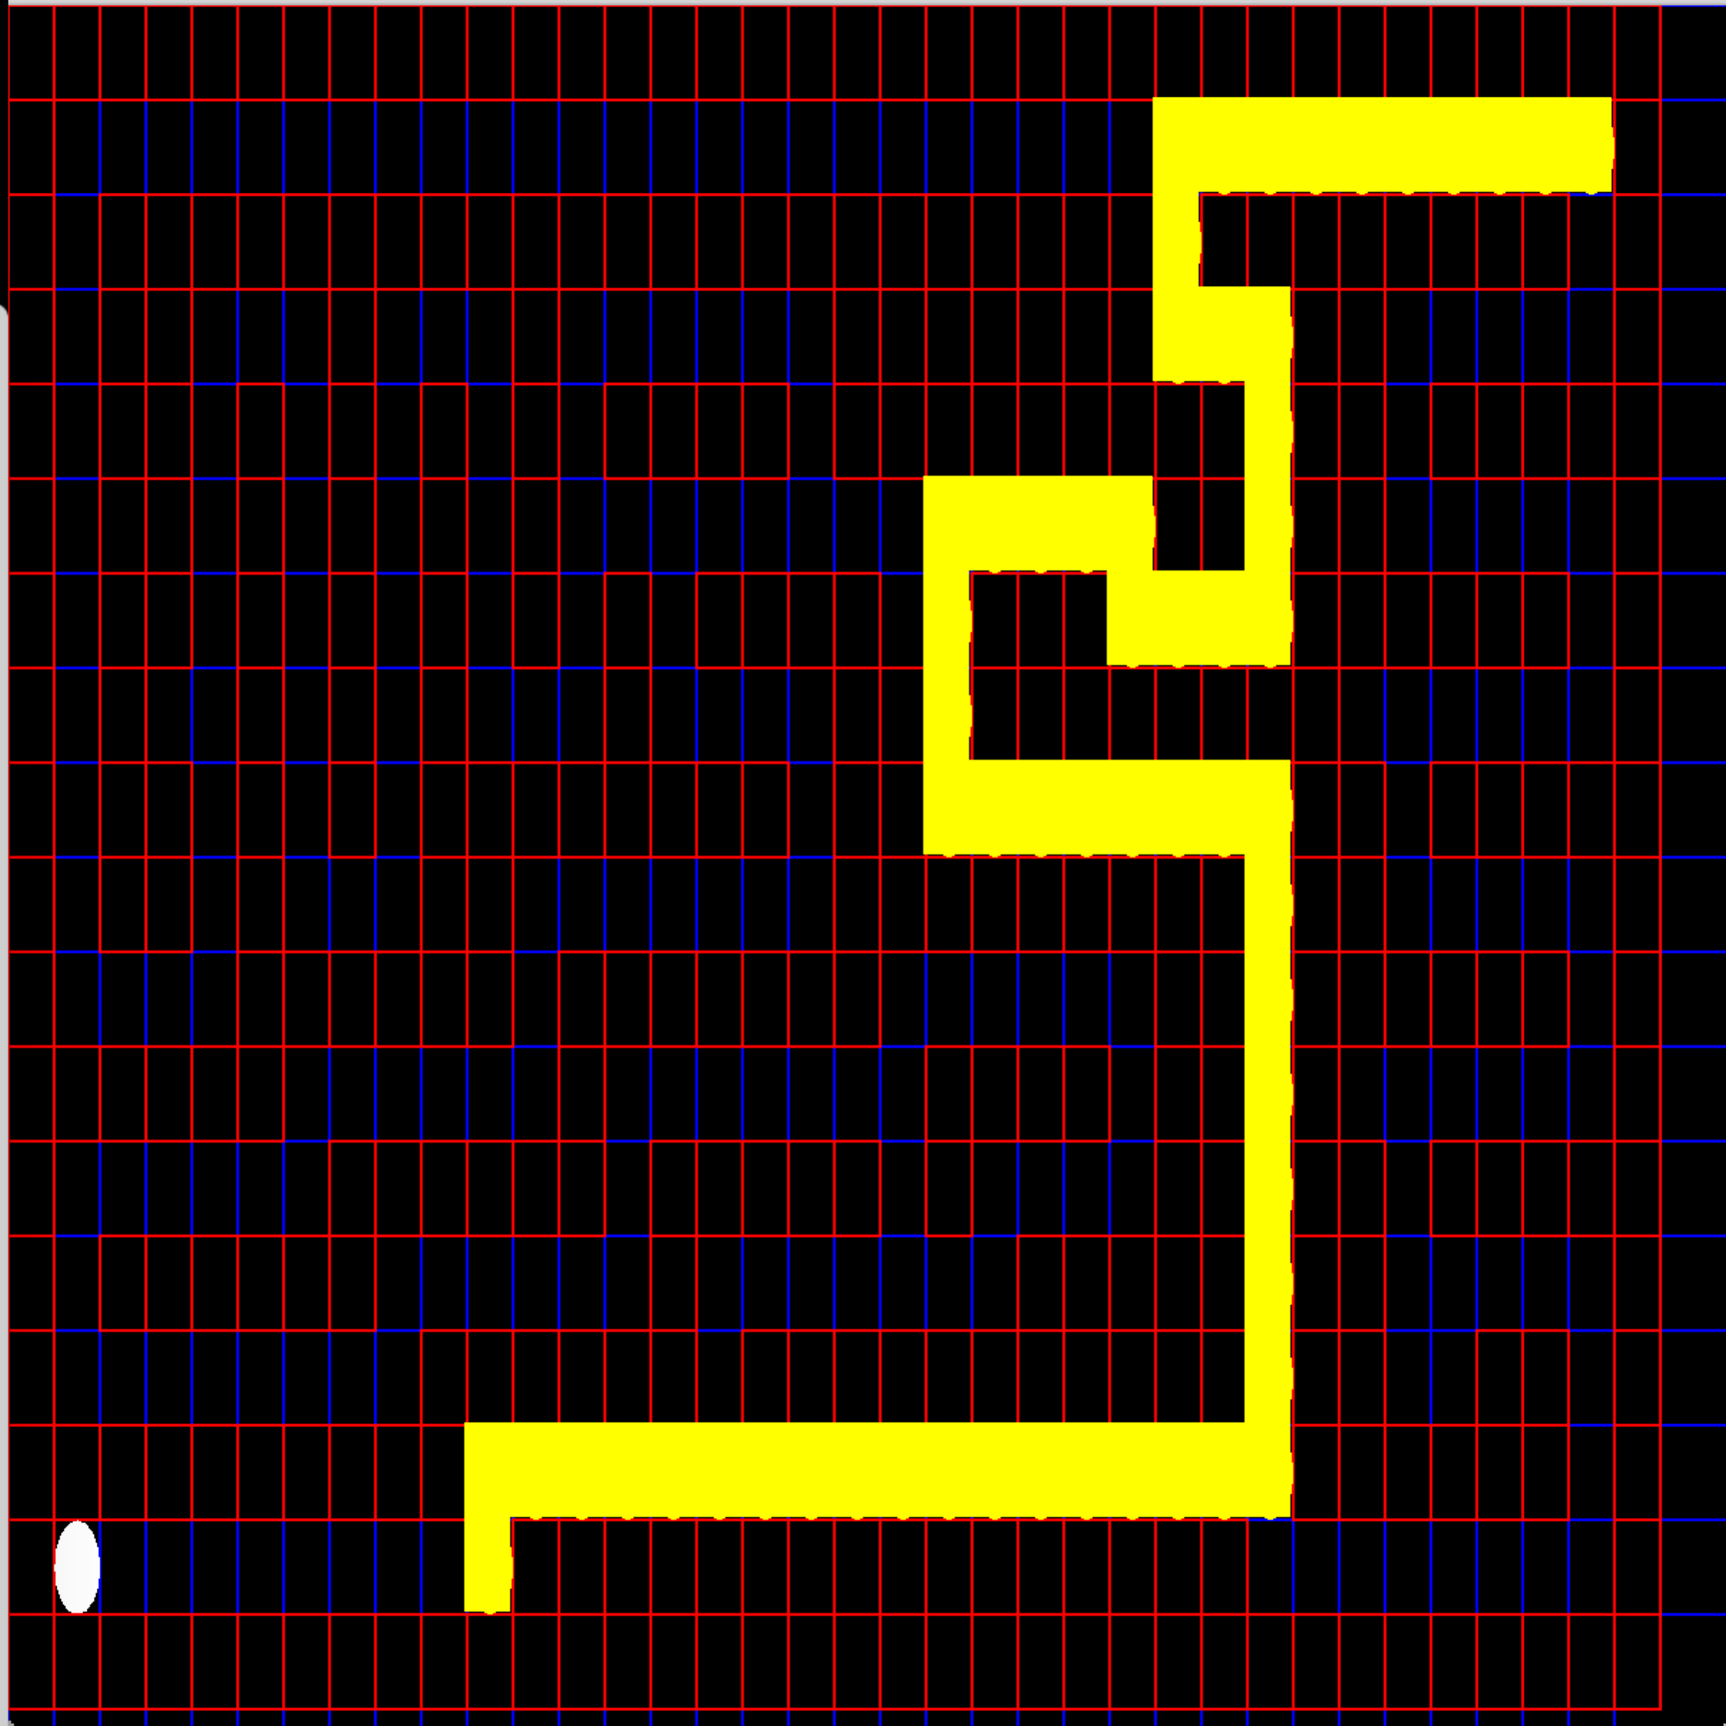  A STAR expanding more nodes

Case where ASTAR expands less nodes than Greedy
TYPE | A* | GREEDY BEST
Nodes Expanded | 78 | 228
Path Cost | 46 | 228

%%%%%%%%%%%%%%%%%%%%%%%%%%%%%%%%%%
%P %
% %%%%%%%%%%%%%%%%%%%%%%%%%%%%% %
% % % % % % % % % %
% % % % % % % % % % % % % % % % %
% % % % % % % % % % % % % % % % %
% % % % % % % % % % % % % % % % %
% % % % % % % % % % % % % % % % %
% % % % % % % % % % % % % % % % %
% % % % % % % % % % % % % % % % %
% % % % % % % % % % % % % % % % %
% % % % % % % % % % % % % % % % %
% % % % % % % % % % % % % % % % %
% % % % % % % % % % % % % % % % %
% % % % % % % % % % % % % % % % %
% % % % % % % % % % % % % % % % %
% % % % % % % % .%
%%%%%%%%%%%%%%%%%%%%%%%%%%%%%%%%%%

Greedy Expanding More Nodes  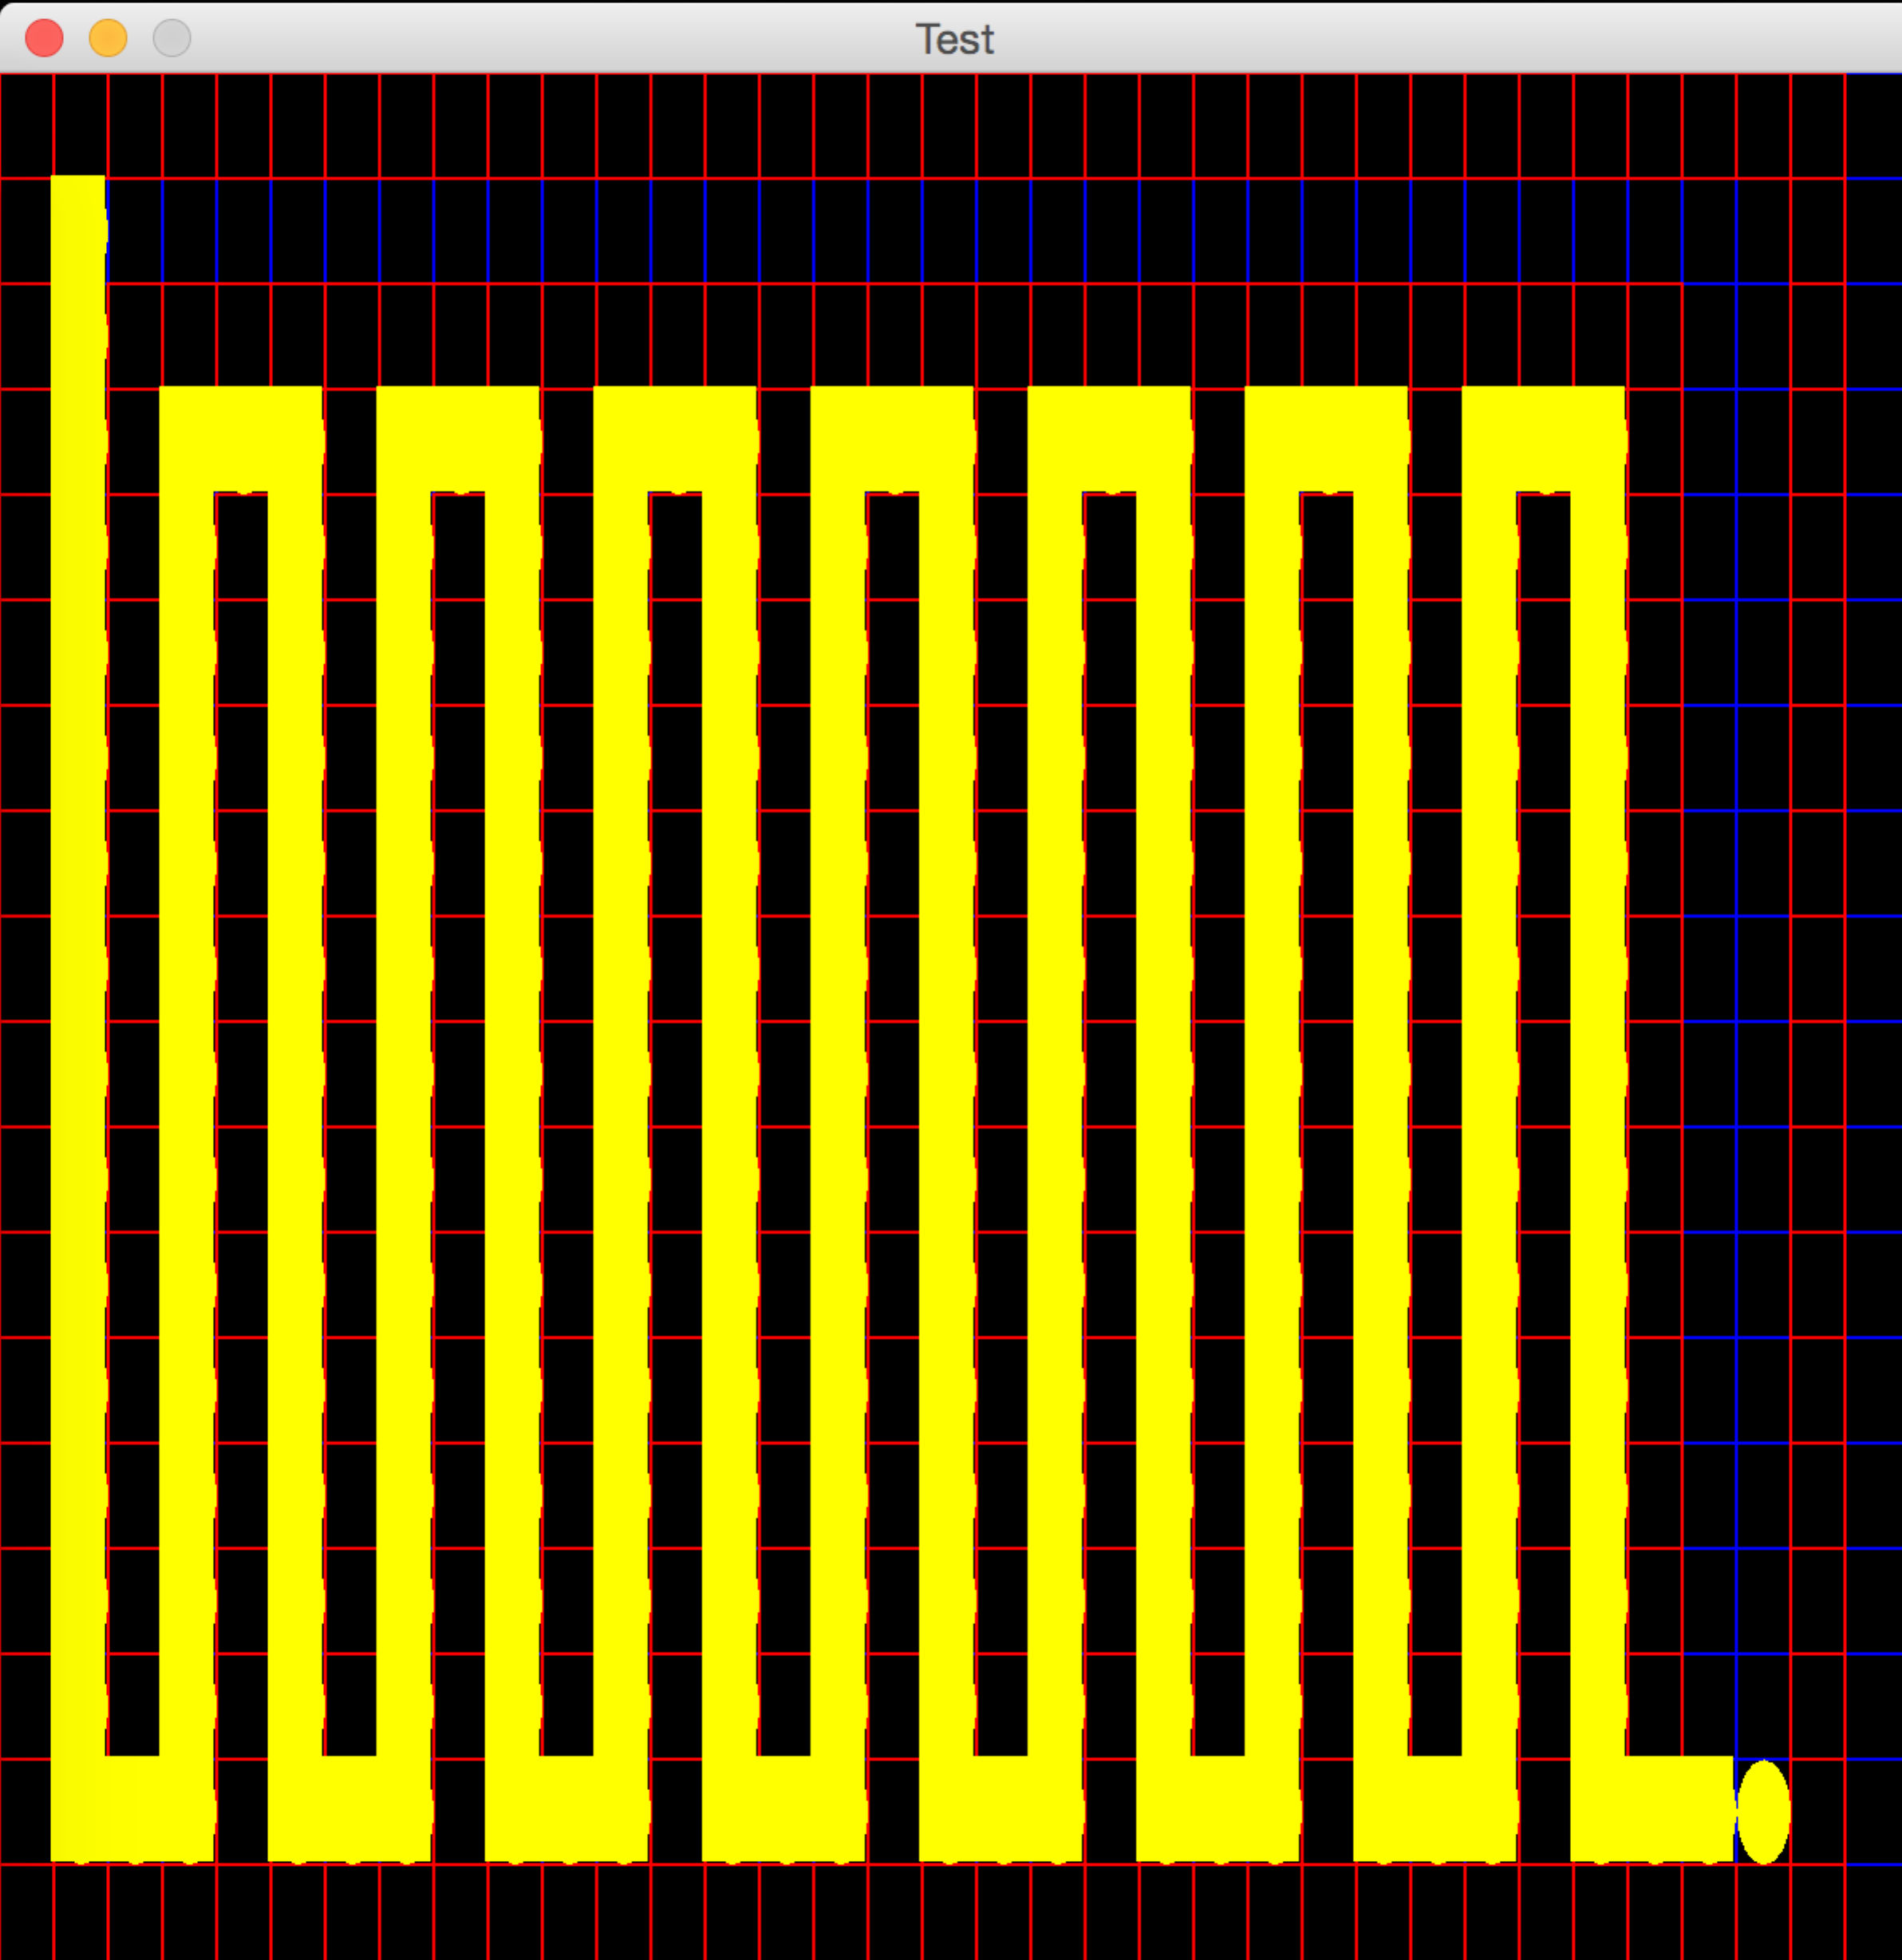 | 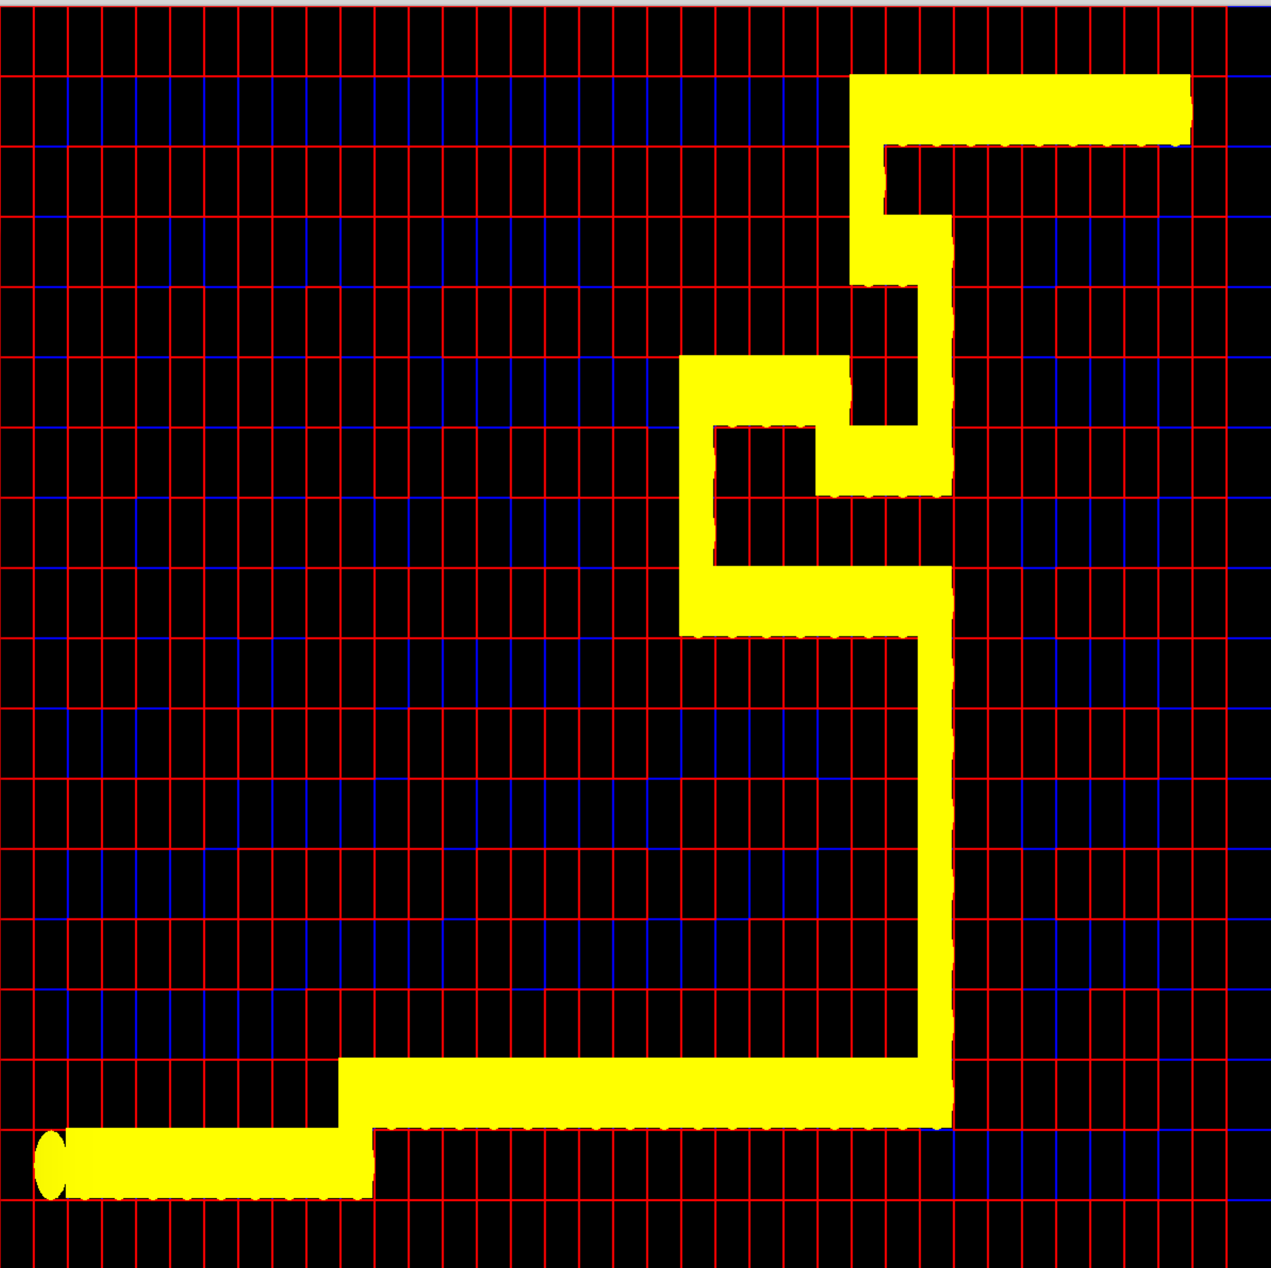  A* expanding less nodes

Case 1 : Greedy expanded lesser nodes
This happens when the heuristic calculated from the start location is close to the total path cost and also there is an actual path leading in that direction. So, in this type of case greedy will follow that path that leads to the goal as heuristic is decreasing in that direction, while on the other hand Astar will also look for other possibilities in other direction. So, it will also expand nodes that are closer to starting point even if they don’t lead to goal via closest path.

Case 2 : Astar expanded lesser nodes
This happens when we fool greedy into thinking that there is a goal in the direction in which it is exploring but actually it is blocked ahead. So, it will have to backtrack and then look in another direction, which might lead to goal that can again be blocked. But on the other hand, Astar also look at the distance of goal from the starting point, so, it is harder to fool. It will also consider expanding those nodes whose distance is closest from the starting point but heuristic might be more than other neighbors.

1.3 Eating Multiple Dots

Heuristic for multiple goal search

1.3.1 (Optimal for small & tricky search)

Using MST(Minimum Spanning Tree) heuristic :- The problem to eat all the dots in minimum number of hops starting from the initial location is very closely but not exactly related to the problem of travelling salesman problem(TSP). The only difference in the given problem from TSP is that we need not come back to the start location after visiting each goal location.

Since, TSP is NP-Hard there are several approximation and heuristic based algorithms that are used to solve it.
One way to solve the TSP problem is by using Astar search with MST heuristic.

a) Below is the pseudo code for solving TSP problem using Astar
Initial State: Agent in the starting location and has not visited any goal.

Goal State: Agent has visited all the goals.

Successor Function: Generates all the goals that have not yet visited.

Edge-cost: distance between the goals represented by the nodes, use this cost to calculate g(n).

h(n): distance to the nearest unvisited goal from the current state(start or goal) + estimated distance to travel all the unvisited cities (MST heuristic used here)

Reducing Given Problem To TSP (Bonus Points)

We represent the initial co-ordinates of the pacman as the starting location and all other dots as the goals or cities to be visited using the minimum path. We precompute the distance b/w goal-goal and goal-start pairs using point-to-point astar and save their cost and minimum path in a 2D lookup table.
Now, we give this pre-computed distances to TSP program which gives the ordered list of goals to be visited so that distance travelled in whole tour is minimum.
Correction of path received from TSP program to Pacman Problem → The TSP program that we implemented is modeled as a graph of only goal nodes as vertices and edges as their distances, to keep it general. The program is not aware of the pacman maze constraints that are not seen in general TSP problem.

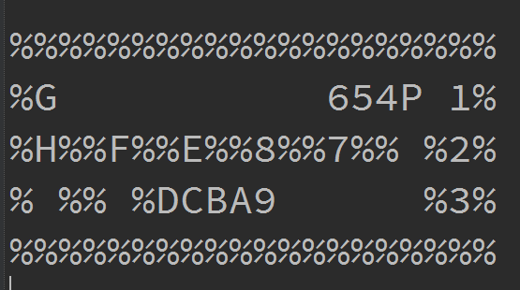

Actual Optimal Path → (1, 18) → 1, (2, 18) → 2, (3, 18) → 3, (1, 15) → 4 …..................
TSP path o/p → (2, 18) → 2, (3, 18) → 3, (1, 18) → 1, (1, 15) → 4 …..................

As you can see, the path of general TSP algorithm is not exactly the same as optimal path as it proposes the path of 2, 3, 1... instead of 1, 2, 3... This happens often because TSP program is not aware of the fact that to reach 3 pacman will automatically eat 1 first and there is no other way to reach 3, it thinks of each point as node and is devoid of the knowledge of constraints of maze. But as you can see this doesn't change the cost because the path is still same just the order of eating dots in the corridor has changed.
So, to correct this we implemented the following path correction algorithm →
1. Initialize the final_path list
2. Loop over goals in tsp_path.
3. If the current goal is already in the final_path ignore it.
4. Else {append this current goal in the final_path.
find the astar_path taken from current goal to the next available goal in the TSP path which is not yet included in the final_path.
In that astar_path, look at each node and check if it exists as one of the goal in tsp_path that has not been put in the final_path and append all such goals in order in final_path
}
5. Now, final_path will contain the paths that satisfy the maze constraints and is still optimal.
Minimum Spanning Tree (MST) : A spanning tree of a graph is a subgraph that contains all the vertices of the graph and is a tree. A graph may have many spanning trees; and the minimum spanning tree is the one with the minimum sum of the edge costs of the tree. We used Kruskal Algorithm based on Disjoint Set to find the MST span cost.

b) Kruskal Algorithm :
1. sort the edges of Graph in increasing order of edge weights
2. keep a subgraph S of G, initially empty
3. for each edge e in sorted order
4. if the endpoints of e are disconnected in S i.e. does not form a cycle
5. add e to S
6. return S
Kruskal’s algorithm executes in O(|E|log|E|) complexity, where |E| is the number if edges in the graph.

1.3.2 (Suboptimal for medium and big search)

Since, the approach discussed above takes too much time for solving mediumSearch and bigSearch, we used sub optimal algorithm where we concentrated on one closest goal ignoring all others.

Algorithm

1. We precompute the distance b/w goal-goal and goal-start pairs using point-to-point astar(manhattan heuristic) and save their cost and minimum path in a 2D lookup table.
2. Maintain a list of goals that are visited.
3. Initialize current location as start location.
4. Visit the closest goal from the current location that is not already visited.
5. Insert that goal location in the goals that are visited.
6. Make this goal as the current location.
7. Repeat 3-5 till all goals are visited.

This algorithm is not optimal as it ignores the global views for all other goals while moving to a single goal. So, it doesn't consider that moving to a closest goal might not lead to overall shortest tour.
The algorithm is not optimal but computes the path very fast.

Stats

Maze Layout | Nodes Expanded | Path cost
trickySearch.txt (Optimal) | 2972(Precomputation) + 85(TSP) = 3057 | 60
smallSearch.txt (Optimal) | 1846(Precomputation) + 122(TSP) = 1968 | 34
mediumSearch.txt (SubOptimal) | 181509 | 166
bigSearch.txt (SubOptimal) | 1470795 | 325

SmallSearch.txt Optimal Path by MST heuristic | TrickySearch.txt Optimal Path by MST heuristic
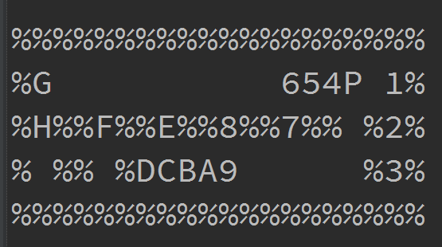 | 