
ff
Identity and Security for the AI Agent Platform

Prepared for
Optum
4/22/2026
Version 3 Final

Prepared by
Microsoft team

Revision and Signoff Sheet
Change Record
Date | Author | Version | Change Reference
3/31/2026 | Microsoft Team | 1 | IAM and Security document initial release
4/8/2026 | Microsoft Team | 2 | Updates based on feedback
4/10/2026 | Microsoft Team | 3 | Updates based on initial review with Optum team

Table of Contents
1 Overview 5
1.1 Inbound Calls: Two Personas and Required Identities 5
1.2 Outbound Connections Required for All Platform Elements 7
1.3 Separate Option: New Agent-Based Identities from Microsoft Entra ID (Entra Agent ID) 8
2 Security Mechanisms for Scanning Skills and MCP Servers (Including Microsoft Defender for AI) 14
3 Personas - Flow 20

- Overview
This analysis elaborates on the required identity types, authentication flows, authorization models, and security controls for the Unified AI Platform (UAP) architecture. It is derived directly from the draft architecture which describes the UAP, Unified AI Services (UAIS) middleware, Unified Data Platform (UDP) with Mongo DB, Microsoft Agent Framework (MAF) Execution Engine, LLM Gateway, MCP (Model Context Protocol) Gateway Proxy, A2A (Agent-to-Agent) registries, Policy Engine, Security Scanner, Azure Container Apps (ACA), Azure AI Foundry, Azure OpenAI, Key Vault, and related components.
This requires a catalog of agent personas (roles, responsibilities, behaviors, primary/secondary use cases, goals/triggers/outcomes, and high-level access/permissions/scope/data visibility to the AI Provider Platform). The relevant user/agent personas in Layer 1 (e.g., Data Scientist/ML Engineer, Agent Modeler/User (MCP), MCP Manager/Analyst, Publisher/Contributor, etc.). For this analysis, there is focus on the two inbound caller personas specified for calls into the agent (i.e., requests reaching the LLM Gateway → Execution Engine → orchestrated agents/tools/models). I also cover outbound connections from all platform elements (gateways, engine, registries, agents).
All identities must align with zero-trust principles, least-privilege access, and the platform’s dual-enforcement governance (publish-time + execute-time scanning/policy checks). Microsoft best-practice guidance prioritizes workload identities (managed identities and service principals) over interactive/user accounts for automation and agentic scenarios, with Entra Agent ID (preview features) as the emerging standard for AI agents.
  - Inbound Calls: Two Personas and Required Identities
Inbound calls enter via the LLM Gateway (Entra-authenticated entry point) or the API/Registry Layer (FastAPI on ACA), then route through governance pre-flight (Policy Engine + Entra claims), intent classification (Azure AI Foundry /classify), plan selection (AI Search + Registries), and Execution Engine dispatch.
Persona 1: Internal Enterprise Calls (within the tenant)
- Description: Enterprise users/agents (e.g., Data Scientist, MCP Manager, internal workflows) calling the platform for orchestration, tool invocation, or agent execution. Triggers: internal apps, IDE integrations (VS Code/Cursor exporting mcp.json), or domain-specific orchestrators. Goals: secure, governed execution with full audit/provenance. Success: traceable, compliant outcomes with HITL (Human-in-the-Loop) where required.
- Identity Type:
  - Primary: Microsoft Entra ID user identity (interactive or delegated) or Entra ID service principal / application registration (for app-to-app calls).
  - Best practice: Prefer delegated permissions via OAuth 2.0 Authorization Code or On-Behalf-Of (OBO) flow for user-context calls; use application permissions only for daemon/app-only scenarios.
- RBAC/ABAC Requirements:
  - RBAC (Entra ID + Azure RBAC): Enforce at platform level via roles (e.g., "Agent Executor", "Publisher", "Admin") for view/submit/approve/execute access. Assigned at subscription/resource-group scope for ACA, Mongo DB (tenantId-partitioned), and registries.
  - ABAC (Attribute-Based Access Control via Policy Engine): Dynamic evaluation per invocation using claims + context (e.g., budget, risk rating, HITL rules). Purpose: enforce least-privilege envelopes (Delegation Envelope feature) and context-aware perms.
- Policies Required:
  - Conditional Access (CA) policies in Entra ID: Require MFA, compliant device, location/IP restrictions, sign-in risk.
  - Microsoft Entra ID Governance + Privileged Identity Management (PIM): JIT (just-in-time) elevation for high-privilege roles.
  - Outbound from this identity: None directly; the gateway proxies using its own identity (see outbound section).
- Microsoft Best Practice & Restrictions: Entra ID is the standard for internal enterprise auth. Restrictions: Interactive users require MFA; service principals cannot be used for interactive sign-in (by design). Avoid user-based service accounts (migrate to workload identities per Entra best practices).
Persona 2: External Calls (from users outside their tenant)
- Description: Non-tenant users/partners/vendors calling agents (e.g., federated discovery, cross-tenant A2A, or marketplace consumers). Triggers: external apps or third-party integrations. Goals: secure access without tenant trust. Success: audited.
- Constraint: Cannot rely on Entra ID or Entra External ID (B2B/B2C) options.
- Identity Type:
  - Signed JWT (JSON Web Token) from trusted external IdP
    - Type: OAuth2 client credentials or custom JWT bearer flow (external IdP issues JWT; gateway validates signature/audience/claims).
    - Implementation: Register external issuer in gateway config; validate with JWKS endpoint. Map to internal synthetic principal.
    - RBAC/ABAC: ABAC using JWT claims (e.g., partner ID, allowed MCP tools). Purpose: fine-grained, revocable access.
    - Policies: APIM JWT validation policy + Policy Engine for claims-based gating (budget, PHI class).
    - Microsoft Best Practice: Recommended when mTLS is operationally heavy; aligns with OpenID Connect patterns. Restriction: Relies on external IdP security hygiene.
  - Outbound Connections Required for All Platform Elements
Outbound flows occur from: LLM Gateway → UAIS → MCP GW Proxy / A2A Registry → Azure AI services / external MCP servers / tools / models. Also: Execution Engine → Redis (short-term memory), Mongo DB (episodic), ADLS Gen 2 (long-term), Event Hubs, Key Vault, etc. Agents themselves initiate tool calls or A2A delegation.
- Identity Type (Best Practice):
  - System-assigned or user-assigned Managed Identity (MI) on ACA, Functions, Execution Engine pods, and LLM Gateway. (Microsoft recommendation: Prefer user-assigned MI for shared components like the gateway/engine to enable easy rotation and auditing.)
  - For agent-to-agent (A2A) or MCP tool calls: JWT Token Vending — agent presents Entra creds → JWT → GW Proxy.
  - Service Principal only as fallback (e.g., legacy MCP servers that do not support MI).
- RBAC/ABAC Requirements:
  - RBAC: Azure RBAC roles (e.g., "Cognitive Services OpenAI User", "Key Vault Secrets User") assigned to the MI at resource scope. Purpose: control access to Foundry, OpenAI endpoints, registries, and storage. Reader capabilities into Mongo DB,
  - ABAC: Policy Engine evaluates dynamic claims (e.g., agent persona, context, risk rating) before outbound call. Purpose: enforce Delegation Envelope (least-privilege) and post-flight checks (compliance).
- Policies Required:
  - Managed Identity best-practice policies: Enable only required permissions; use PIM for MI role assignments; enable diagnostic logs to Azure Monitor.
  - Key Vault access policies: MI-only access with "Get/Secret" permissions; soft-delete + purge protection enabled.
  - Azure Policy + Defender for Cloud: Enforce "Managed Identity" usage; block public endpoints; require private endpoints/VNet integration for outbound to MCP/Foundry.
  - Content Safety + Policy Engine: Post-flight compliance checks on all outbound responses.
- Microsoft Best Practice & Restrictions: Managed Identities are the official best practice for Azure-to-Azure outbound (no credential management, automatic rotation, tied to resource lifecycle). Restrictions: MI works only for Azure AD-authenticated resources (not all external MCP servers — fall back to JWT vending). Service principals require secret/certificate management (avoid where possible). Interactive identities are prohibited for outbound automation.
  - Separate Option: New Agent-Based Identities from Microsoft Entra ID (Entra Agent ID)
Microsoft Entra Agent ID (still in Public Preview as of April 2026) is a purpose-built identity type specifically designed for AI agents. It is not a managed identity, service principal, or user account. Instead, it introduces a new class of identity in Microsoft Entra ID that treats agents as first-class, governable entities — similar to how human users are managed but optimized for autonomous AI workloads.
This option is the recommended alternative in the UAP AI Platform for any agent persona (Domain Agents, A2A Agents, etc.) because it provides enterprise-grade identity lifecycle management, accountability, and policy enforcement that traditional workload identities cannot fully deliver.
Detailed Benefits Compared to Managed Identities
Aspect | Managed Identity (User-assigned or System-assigned) | Entra Agent ID (Preview)
Identity Type | Tied to an Azure resource (ACA, Function, VM, etc.) | Standalone “agent” subtype service principal + optional agent user
Lifecycle Management | Tied to resource lifecycle; deletion = identity deletion | Independent lifecycle; can survive resource changes
Human Accountability | None (no owner/sponsor) | Required human sponsor + optional owner
Governance & Approval | Basic Azure RBAC only | Full Entitlement Management, Access Packages, JIT access
Auditing & Provenance | Standard resource logs | Agent-specific audit events + “Agent type” filter in Entra logs
Credential Management | Automatic (no secrets) | Federated credentials issued by Agent Identity Blueprint (no secrets exposed to agent code)
Scalability | One identity per resource | One blueprint → many agent identities (1:N relationship)

Key advantage: Managed Identities are excellent for Azure resource-to-Azure resource authentication (zero secrets, automatic rotation). Entra Agent ID is superior for autonomous, multi-resource, cross-protocol, or long-lived agent workloads because it decouples the agent’s identity from any single Azure resource.
Capabilities Unique to Entra Agent ID (Not Available with Managed Identities)
- Agent Identity Blueprint — A template (like an app registration) that defines common security policies, permissions, and creation rules. One blueprint can spawn hundreds of agent identities with consistent governance.
- Human Sponsor Model — Every agent identity must have a designated human sponsor (accountable person). This satisfies compliance requirements (e.g., SOX, HIPAA, GDPR) that demand human oversight of autonomous agents.
- Agent User (optional) — Creates a companion user object that can be used for delegated scenarios or when the agent needs to “act as” a user.
- First-class Conditional Access (CA) for Agents — Apply CA policies directly to agent identities (location, risk, device compliance, etc.) with agent-specific logic.
- Identity Governance & Access Packages — Agents can request (or be granted) time-bound, reviewed access via Entitlement Management — exactly like users.
- Identity Protection & Risk Detection — Leverages the same risk signals (anomalous token requests, unusual tool calls) as human accounts.
- Dedicated Audit & Sign-in Logs — All agent actions are logged with an “Agent type” attribute, making forensics straightforward.
- Blueprint-based Delegation — The blueprint principal can impersonate/create tokens for child agent identities without exposing credentials.
These capabilities make Entra Agent ID the only identity type that gives agents a true digital identity with full enterprise controls, which aligns with the design spike requirements for agent personas, roles, responsibilities, and access patterns.
Licensing Requirements & Capabilities Enabled
Microsoft Entra Agent ID is not a standalone product or SKU. It is the agent identity and access management capability delivered through Microsoft Agent 365, which serves as the control plane for AI agents. All licensing for Entra Agent ID flows through Agent 365.
1. Current Preview Access (April 2026)
During preview, Agent 365 and Entra Agent ID are available exclusively through the Microsoft 365 Copilot Frontier program.
Requirements
Microsoft 365 Copilot
- License level: Per-user
- Who must be licensed:
Users who:
  - Create agents
  - Own or sponsor agents
  - Use agents that act on their behalf (delegated / OBO model)
- Scope: Assigned per user in Microsoft 365 admin center
- Purpose: Copilot licensing is the prerequisite for Frontier participation and early agent capabilities
Frontier program enablement
- Enablement level: Tenant configuration with user-scoped access
- How it works:
  - A Global or Billing Administrator enables Frontier in the Microsoft 365 admin center
  - Frontier can be enabled for specific users or groups, not automatically the entire tenant
2. General Availability (Starting May 1, 2026)
At GA, Agent 365 exits preview and becomes commercially available under two supported licensing paths.
Option A – Microsoft Agent 365 (Standalone)
License
- Product: Microsoft Agent 365
- Availability: GA May 1, 2026
Licensing model
- License level: Per-user
- Who must be licensed:
Users whose agents:
  - Act on their behalf (On-Behalf-Of / delegated agents)
  - Are sponsored or governed by them
Frontier program enablement (for autonomous agents)
- Enablement level: Tenant configuration with user-scoped access
What it includes
Agent 365 provides the full Entra Agent ID capability set (OBO agents), including:
- Agent identity blueprints
- Human sponsor and accountability model
- Conditional Access for agents
- Identity Protection for agents
- Identity governance, lifecycle controls, and auditing
- Integration with Microsoft Entra, Defender, and Purview
Option B – Microsoft 365 E7
License
- Product: Microsoft 365 E7
- Availability: GA May 1, 2026
What E7 bundles
- Microsoft 365 E7 includes:
- Microsoft 365 E5 (productivity, security, compliance)
- Microsoft 365 Copilot
- Microsoft Entra Suite (full identity & Zero Trust stack)
- Microsoft Agent 365 (including Entra Agent ID for OBO agents)
Licensing characteristics
- License level: Per-user
- Scope:
  - The Agent 365 service becomes available in the tenant
  - Capabilities apply only to licensed users
Frontier program enablement (for autonomous agents)
- Enablement level: Tenant configuration with user-scoped access
3. Critical Licensing Rules (Applies to All Options)
Per-user licensing (not per agent)
- All Agent 365 and Entra Agent ID licensing is per user
- There is no per-agent or per-tenant license
On-Behalf-Of (OBO) agents
- Agents acting under a user’s delegated permissions:
  - Do not consume an additional license
  - Are covered by the sponsoring user’s Agent 365 or E7 license
- One licensed user can govern any number of OBO agents
Autonomous (non-OBO) agents
- Fully autonomous agents with their own independent identity:
  - Remain in Frontier preview
  - Do not yet have a finalized GA licensing model
- Microsoft has stated no incremental charges until a commercial model is announced.

- Security Mechanisms for Scanning Skills and MCP Servers (Including Microsoft Defender for AI)
The architecture includes a built-in Security Scanner (static + runtime: risky patterns, missing metadata, dependency checks — Feature in Layer 2) that feeds the Policy Engine and Admin Dashboard.
- Enhanced Scanning Mechanisms:
  - Publish-time: Publisher API → Scanner → Policy Engine → Admin review queue → Catalog (dual enforcement).
  - Runtime: Execution Engine + MCP GW Proxy performs dynamic checks (health, schema, allowed tools list).
  - Microsoft Defender for AI / Defender for Cloud AI Threat Protection: Enable as a native option for comprehensive coverage. Defender for Cloud now discovers/monitors/governs MCP servers (Model Context Protocol endpoints) across Azure/multi-cloud, providing:
    - Real-time threat detection (prompt injection, jailbreak, data leakage, credential theft, tool misuse).
    - AI Security Posture Management (misconfigurations, vulnerabilities in agents using MCP).
    - Integration with Azure AI Content Safety Prompt Shields and threat intelligence.
    - Alerts for unauthorized MCP usage, shadow AI, and indirect prompt injection (requires human-in-the-loop for high-risk MCP tool actions).
    - Visibility into MCP servers hosted in containers (agentless scanning).
  - Additional Controls: OpenTelemetry tracing (per-episode), immutable Audit Log in Mongo DB (TTL), App Insights metrics, and Redis/Mongo DB memory flushing (summary-first, no raw PHI).
Recommendations for Implementation: Document the above in the personas catalog; capture dependencies (e.g., Entra Agent ID licensing); validate with stakeholders; and prioritize MI + Entra Agent ID for all new agent workloads to meet enterprise compliance (audit trails, RBAC/ABAC).
This design ensures the UAP platform is secure, compliant, and scalable while directly supporting the agent persona/access requirements in the design spike.
All the above details are summarized in the following diagram:
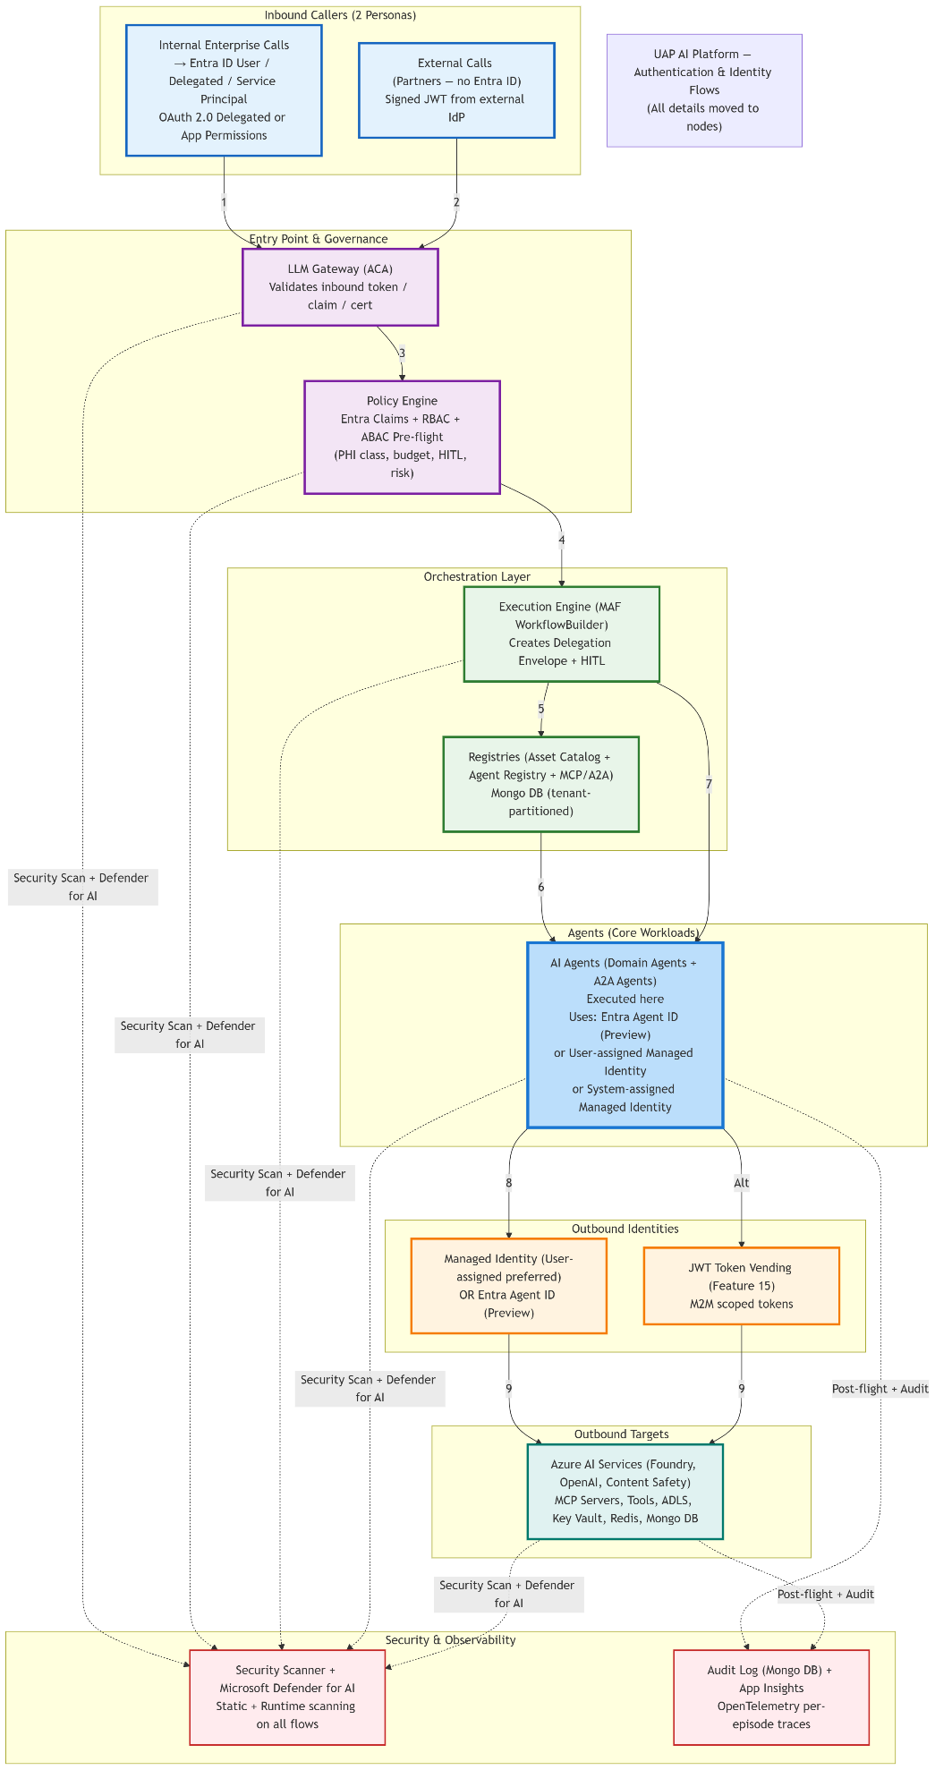
The following diagram expands on an agent-to-agent flow:
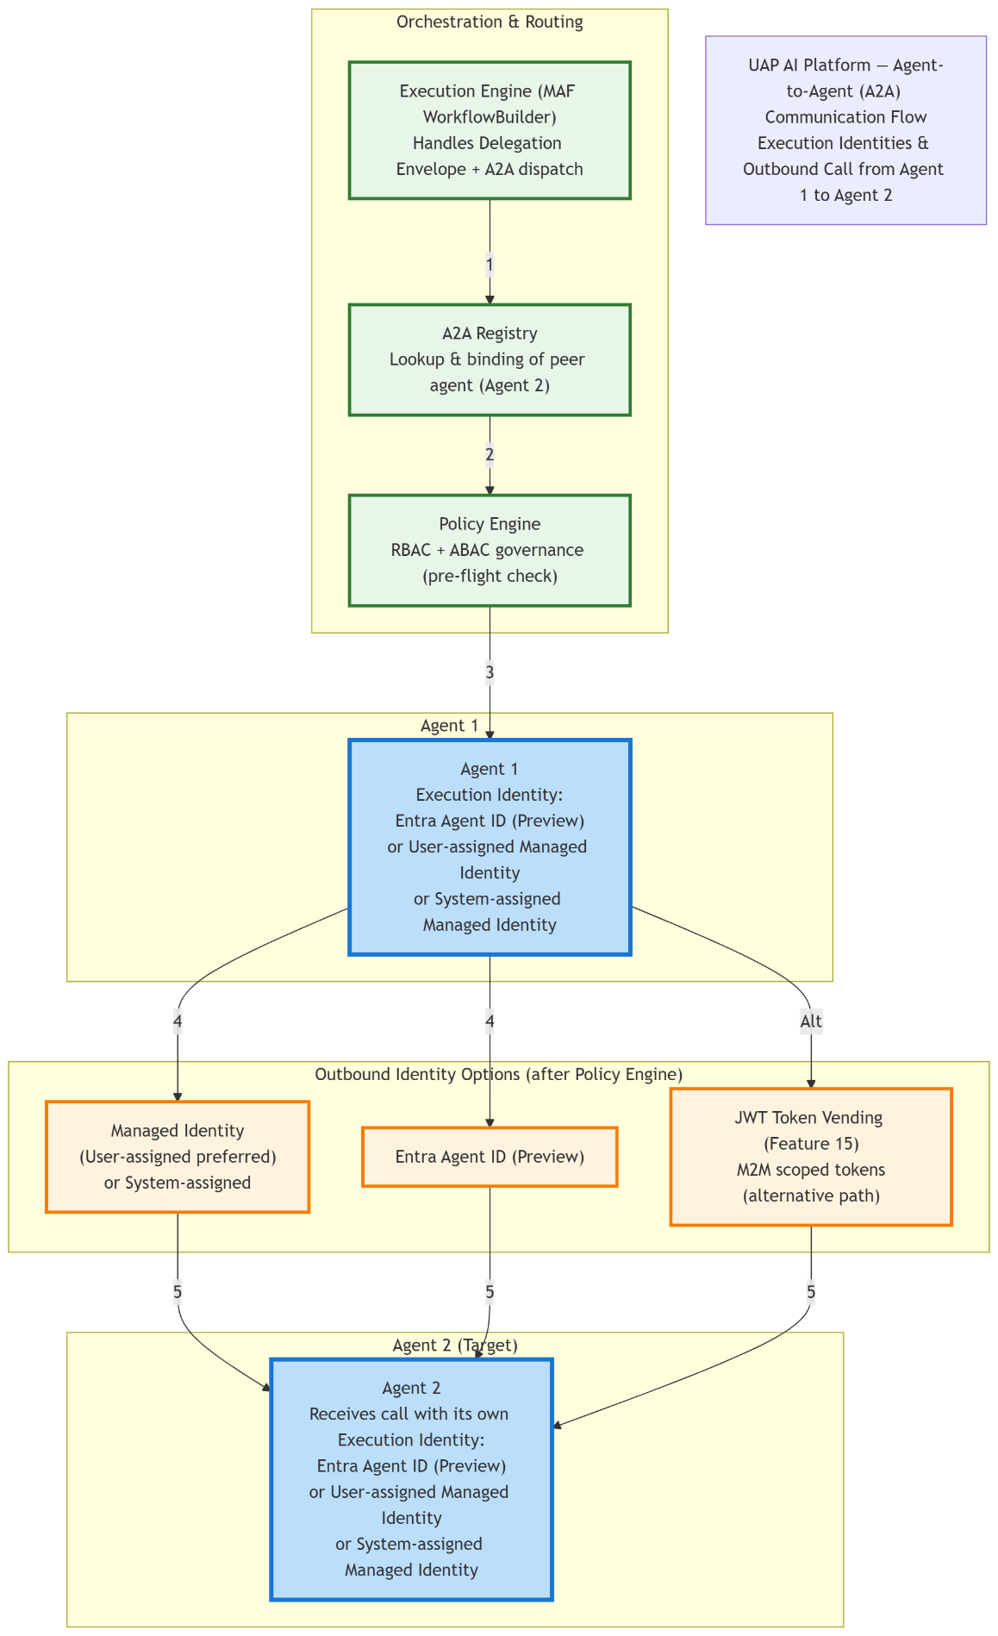
The following diagram covers the detailed flow between an agent and MCP:
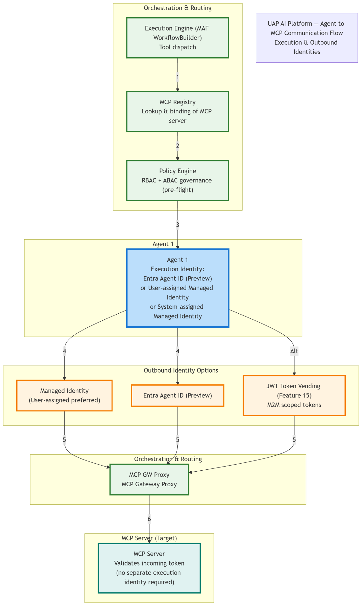

The following diagram expands the details related to the security scanning and Microsoft Defender for AI:
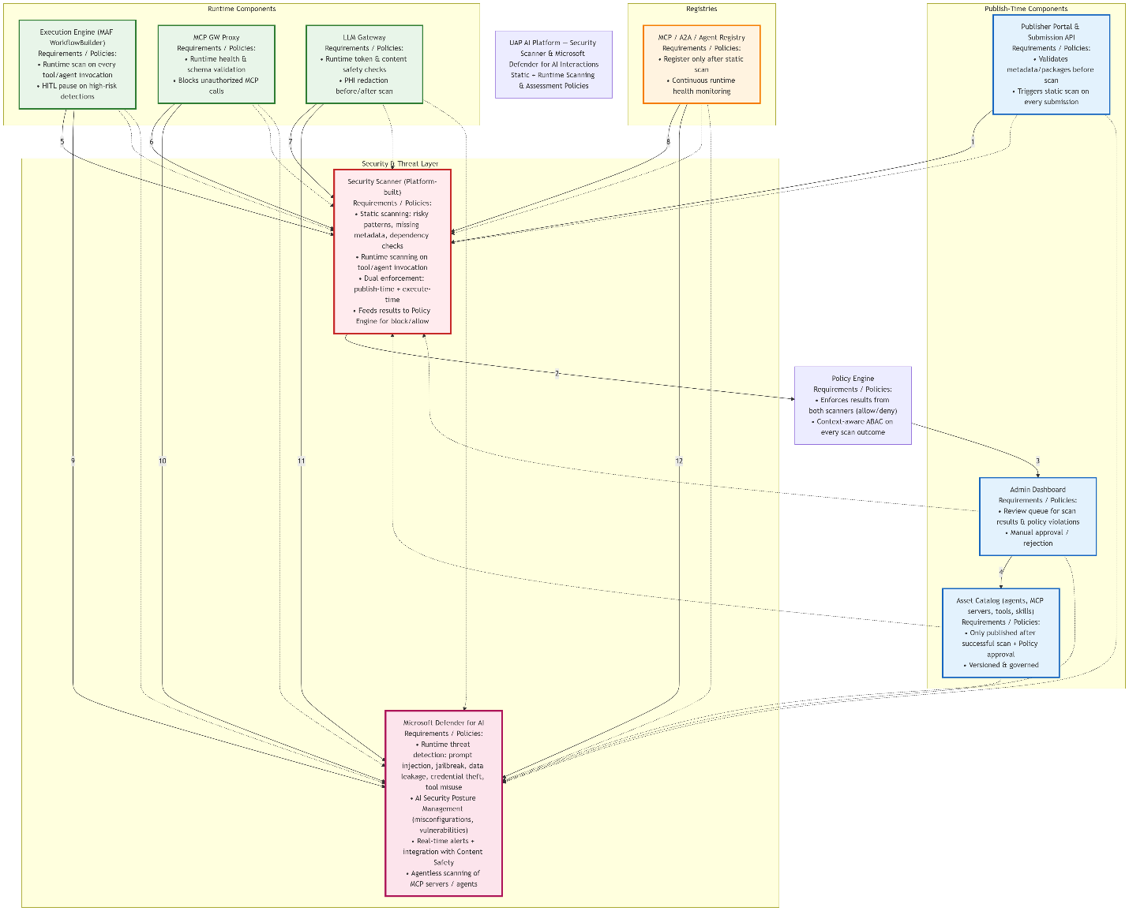

- Personas - Flow
Data Scientist / ML Engineer
This persona is responsible for end-to-end AI development: discovering assets, composing complex workflows (orchestration graphs), testing agents/tools in a sandbox, debugging prompts, running experiments, and analyzing execution history. Primary interactions include the Visual Orchestration Canvas (React Flow drag-and-drop), Playground (interactive testing), DevUI (Microsoft Agent Framework debugging), Asset Catalog (search/discovery), Execution Engine, and Execution History / Metrics.
Identity & Authorization Details
- Inbound Identity: Entra ID User (interactive or delegated OAuth 2.0 flow).
- RBAC Roles (all custom platform-defined roles in UAP; not built-in Azure/Entra roles):
  - “Workflow Designer” (custom) – full CRUD on personal/team workflows, read access to Asset Catalog and registries.
  - “Workflow Executor” (custom) – permission to trigger executions via the Execution Engine.
  - “Read-Only Analyst” (custom) – read-only access to Execution History and Metrics.
- Assignment / Mapping to Entra ID Group:
  - Create an Entra ID Security Group (e.g., UAP-Workflow-Designer, UAP-Workflow-Executor).
  - Add the Data Scientist user (or a Microsoft 365/Entra ID group) as a member via the Entra admin center or Microsoft Graph API.
  - On every inbound token validation (LLM Gateway), the platform queries Microsoft Graph (/me/memberOf) or reads group claims from the ID token, then maps the group Object ID to the custom UAP role stored in Mongo DB (tenant-partitioned). The Policy Engine then injects the resolved role into the session context.
  - For time-bound elevation, use Entra ID Privileged Identity Management (PIM) to assign the group membership as eligible (JIT activation).
- ABAC Rules (enforced by Policy Engine per invocation):
  - Context attributes evaluated: budget remaining, PHI/PII classification of inputs, risk rating of the workflow, team/workspace scoping, HITL flag.
  - Example policy: “If workflow estimated cost > $500 or contains PHI data, require Human-in-the-Loop approval before execution.”
- Specific Use-Case Scenarios:
  - Allowed: A Data Scientist drags nodes on the Canvas to build a multi-agent research workflow using discovered models and MCP tools. Custom RBAC “Workflow Designer” (mapped via Entra ID group) allows save/submit; ABAC confirms budget is sufficient and no PHI is detected → execution proceeds.
  - Blocked: Same user attempts to run a high-risk workflow that exceeds monthly budget. Policy Engine ABAC denies execution and forces HITL gate.
  - Allowed with escalation: User with custom “Workflow Executor” role can invoke a pre-approved template, but ABAC injects a dynamic scope limit based on their current team quota.

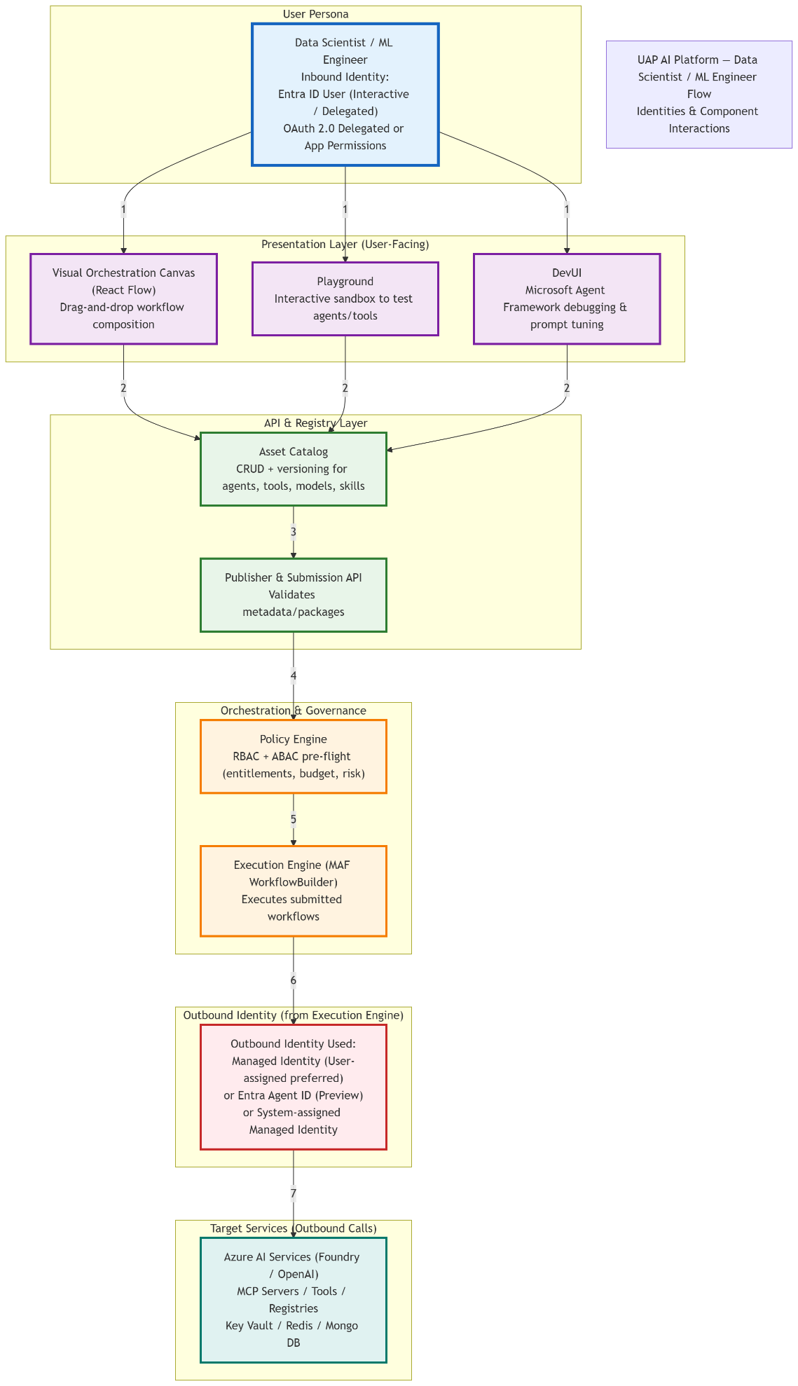

Agent Modeler / User (MCP)
This persona specializes in creating, versioning, configuring, and registering AI agents, MCP servers, tools, and skills. Key interactions: MCP Server & Tool Registry, Asset Catalog, Publisher & Submission API, Playground, Security Scanner, and DevUI.
Identity & Authorization Details
- Inbound Identity: Entra ID User (delegated).
- RBAC Roles (all custom platform-defined roles in UAP):
  - “Agent Modeler” (custom) – create/edit/register MCP endpoints and agent definitions.
  - “Tool Contributor” (custom) – submit tools and skills to the registry.
  - “MCP Tester” (custom) – run sandbox tests in Playground.
- Assignment / Mapping to Entra ID Group:
  - Create Entra ID Security Groups (e.g., UAP-Agent-Modeler, UAP-Tool-Contributor).
  - Add users (or nested groups) as members in Entra admin center.
  - LLM Gateway / Policy Engine resolves group membership at token validation time via Microsoft Graph or token claims, then maps the group ID to the internal UAP role record in Mongo DB. The mapping table (group Object ID → UAP role name) is maintained in the Asset Catalog for easy admin management.
  - PIM can be used for eligible group membership on sensitive modeling roles.
- ABAC Rules (Policy Engine):
  - Evaluates metadata completeness, security scan results, version compatibility, domain/team ownership, and dependency risk.
  - Example policy: “MCP server registration allowed only if static scan passes and the endpoint uses Entra-managed identity (no static secrets).”
- Specific Use-Case Scenarios:
  - Allowed: Modeler creates a new MCP server definition; custom RBAC “Agent Modeler” (via Entra group mapping) grants registration rights; ABAC confirms scan passed.
  - Blocked: Attempt to register an MCP endpoint with risky dependency → ABAC + Security Scanner rejects.

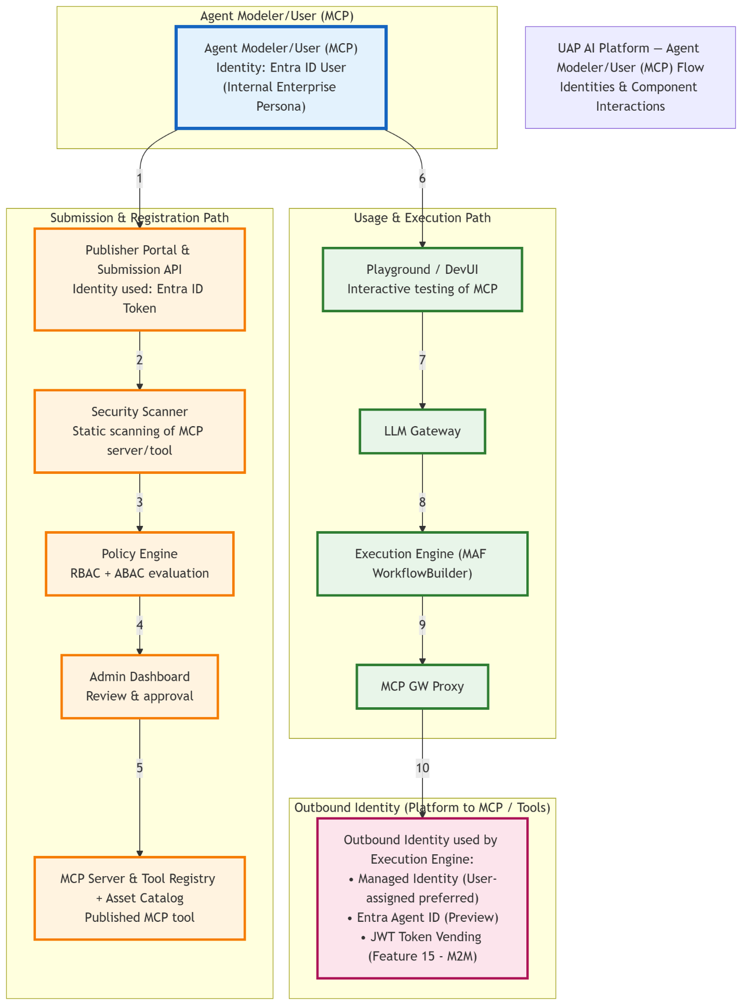

MCP Manager / Analyst
This operational role monitors, governs, troubleshoots, and reports on MCP servers, tools, and agents. Primary interactions: MCP/A2A/Agent Registry, Admin Dashboard, Metrics & OTLP, Execution History, Security Scanner results, and Audit Log.
Identity & Authorization Details
- Inbound Identity: Entra ID User with elevated “Manager” context.
- RBAC Roles (all custom platform-defined roles in UAP):
  - “MCP Manager” (custom) – full read/write on registry health, monitoring, and configuration.
  - “Security Analyst” (custom) – access to scan results and compliance reports.
  - “Observability Viewer” (custom) – read-only on metrics and execution history.
- Assignment / Mapping to Entra ID Group:
  - Create Entra ID Security Groups (e.g., UAP-MCP-Manager, UAP-Security-Analyst).
  - Users are added as members (or eligible via PIM for time-bound access).
  - On token validation, the platform performs a group membership lookup (Microsoft Graph) and maps the group Object ID to the custom UAP role in Mongo DB. Role resolution happens once per session and is cached for performance.
  - PIM is strongly recommended for “MCP Manager” to enforce just-in-time activation and approval workflows.
- ABAC Rules:
  - Dynamic scoping by domain, team, or tenant; risk-based visibility.
  - Example policy: “Managers can view runtime scan data only for MCP servers in their assigned domain.”
- Specific Use-Case Scenarios:
  - Allowed: Analyst views real-time health of MCP servers; custom RBAC “MCP Manager” (Entra group mapped) grants access; ABAC scopes to team.
  - Blocked: Attempt to delete an MCP server from another domain → ABAC denies.

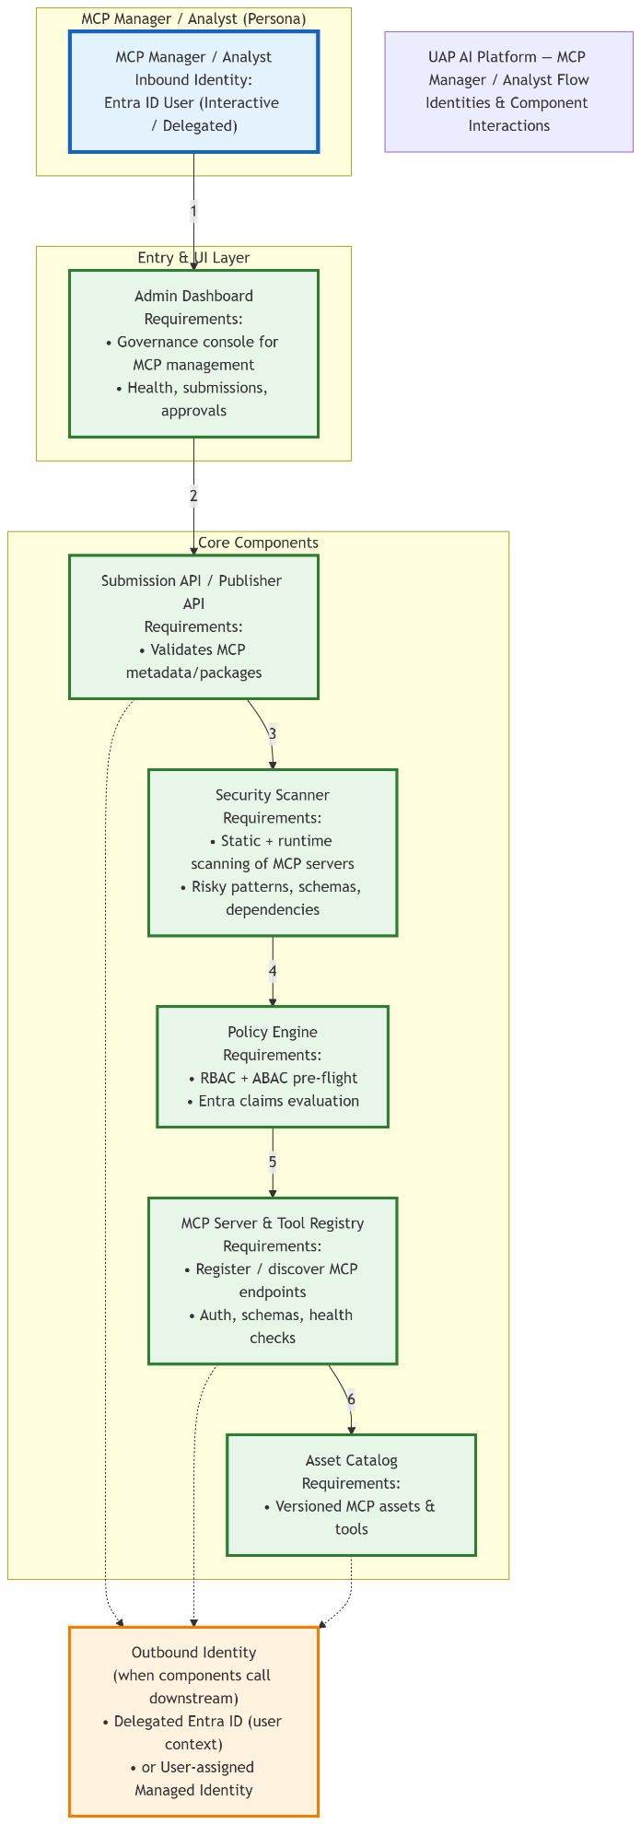

Publisher / Contributor
This persona develops and submits new AI assets to the marketplace. Key interactions: Publisher Portal, Submission API, Security Scanner, Admin review queue, Asset Catalog, and Policy Engine.
Identity & Authorization Details
- Inbound Identity: Entra ID User.
- RBAC Roles (all custom platform-defined roles in UAP):
  - “Publisher” (custom) – submit, version, and withdraw assets.
  - “Contributor” (custom) – draft and collaborate on assets.
  - “Reviewer” (custom, optional escalation) – approve/reject submissions.
- Assignment / Mapping to Entra ID Group:
  - Create Entra ID Security Groups (e.g., UAP-Publisher, UAP-Contributor, UAP-Reviewer).
  - Users are added directly or via nested groups in Entra admin center.
  - The LLM Gateway / Policy Engine resolves membership at authentication time via Microsoft Graph API or ID token claims, then looks up the group → custom UAP role mapping in the tenant-partitioned Mongo DB. This mapping is fully configurable via the Admin Dashboard.
  - PIM is used for “Reviewer” and “Publisher” roles to require approval for elevated submission rights.
- ABAC Rules (Policy Engine + Security Scanner):
  - Dual-enforcement: publish-time static scan + execute-time policy validation.
  - Example policy: “Asset can only be published if static scan passes and the publisher’s team has sufficient quota.”
- Specific Use-Case Scenarios:
  - Allowed: Contributor submits a new agent; custom RBAC “Publisher” (via Entra group) is resolved at login; ABAC confirms team scope and scan success.
  - Blocked: Submission with risky patterns → Scanner + ABAC rejects.

