Microsoft
Architecture Document
Unified AI Platform (UAP)
AI Marketplace & Global Agentic Orchestrator
Capabilities, Architecture and Developer Experience

Microsoft Agent Framework | Azure Container Apps | MongoDB | Azure OpenAI
Document Version 1.0 | Status: Draft | April 2026
Owner: Rajesh Singh, Senior Architect, Applied AI
Table of Contents

1. Document Control

1.1 Document Metadata
Field | Value
Document Title | Unified AI Platform (UAP) — Architecture
Document Version | 1.0
Status | Draft — For Review
Classification | Microsoft Internal
Author | Rajesh Singh, Senior Architect, Applied AI
Owner | Applied AI — Architecture
Reviewers | Architecture Review Board, Security, Responsible AI, Platform Engineering
Last Updated | April 2026
Next Review | Every 90 days or on material change

1.2 Revision History
Version | Date | Author | Change Summary
0.1 | Q1 2026 | Applied AI | Initial UAP AI Marketplace draft
0.5 | Q1 2026 | Applied AI | Global Agentic Orchestrator design consolidated
0.9 | Q1 2026 | Applied AI | Foundry and LLM Gateway feature matrices integrated
1.0 | Apr 2026 | R. Singh | First Microsoft-format consolidated architecture document

1.3 Distribution and Classification
This document is classified Microsoft Internal. Distribution is limited to the Architecture Review Board, Platform Engineering, Security, Responsible AI, Applied AI and designated RCM domain leads. External distribution requires explicit approval from the document owner.

2. Executive Summary
The Unified AI Platform (UAP) consolidates AI marketplace, orchestration, governance and developer experience capabilities onto a single, Azure-native, enterprise-grade platform. UAP unifies three tiers — UAP (experience), Unified AI Services (UAIS — middleware) and Unified Data Platform (UDP — persistence and observability) — to deliver a cohesive surface for enterprise teams to discover, publish, compose and operate AI assets at scale.
A Global Agentic Orchestrator sits above domain-specialized orchestrators to execute multi-step, multi-agent workflows — starting with Revenue Cycle Management (RCM). The platform is built on the Microsoft Agent Framework and LangGraph graph-execution engine, Azure Container Apps, MongoDB, Azure OpenAI via UAIS, MCP and A2A protocols, and a unified LLM / API Gateway fronted by Azure API Management.
The platform is designed to deliver measurable outcomes: onboarding new agents in hours rather than weeks, 40–50% agent reuse across projects, 20%+ productivity gains in claims processing and HIPAA-ready compliance by design. Scale targets include 100K+ daily encounters and billions of claims per year through auto-scaling Azure Container Apps, KEDA-driven Event Hub consumers and durable LangGraph checkpoints.

3. Business Context and Drivers

3.1 Problem Statement
- Administrative tasks in Revenue Cycle Management consume roughly 25% of total US healthcare spend — over $200B annually.
- A typical 45-minute procedure generates approximately 7 days of administrative paperwork.
- Initial claim denial rates sit near 12%, yet approximately 85% of those denials are preventable with the right information at submission.
- Manual coordination across eligibility, prior-authorization, billing, claims and denials workflows is slow, error-prone and difficult to audit.

3.2 Enterprise AI Investment
- UnitedHealth is investing $3B in AI, with 22,000 engineers (approximately 20,000 using AI in development) and 1,000+ AI applications in production.
- Optum Real pilot demonstrates measurable denial reduction and prior-authorization acceleration.
- The organization is scaling the largest AI initiative in healthcare; UAP is the unifying platform to make that investment composable, governable and safe.

3.3 Strategic Vision
UAP establishes an intelligent hub that coordinates specialized AI agents across RCM domains, promotes reuse across teams and aligns with top RCM automation priorities. The same platform pattern extends beyond RCM as additional domains adopt capability-based discovery, declarative plan templates and governed orchestration.

4. Goals and Non-Goals

4.1 Goals
- Provide a single, governed marketplace for AI assets: agents, MCP tools, models, skills and workflow templates.
- Deliver a Global Agentic Orchestrator that composes multi-agent workflows with durable state, HITL and full provenance.
- Normalize access to Azure AI Foundry, Azure OpenAI, MCP servers and A2A agents through a consistent UAIS contract.
- Enforce zero-trust security, HIPAA compliance and Responsible AI controls at publish time and at execute time.
- Enable automated onboarding, canary deployment, instant rollback and continuous evaluation.
- Scale to 100K+ daily encounters and billions of claims per year while absorbing burst traffic.

4.2 Non-Goals
- Replacing existing systems of record (claims engines, EHRs or billing platforms).
- Re-implementing Layer 5 Azure services — these are provisioned independently via Bicep IaC and referenced by the platform.
- Building bespoke foundation models — the platform consumes Azure OpenAI and Foundry-hosted models, including BYOM.
- Replacing the existing Web Dashboard, which already ships and remains in scope for Phase 1 only for continuity.

5. Architecture Principles
- Azure-native, not locked-in — open protocols (MCP, A2A) and optional Foundry enable federation across hosted, SaaS and on-premises endpoints.
- Zero-trust by default — Entra ID plus Managed Identity, VNet isolation, mTLS and least-privilege delegation envelopes across every hop.
- Governed at publish and execute — dual enforcement via Security Scanner at publish and Policy Engine at execute.
- Declarative over imperative — plan templates, AgentCards and AgentCard-carried policies express intent; the runtime binds dynamically.
- Durable by design — every workflow persisted in MongoDB with checkpoints; Redis accelerates hot reads; ADLS Gen 2 stores long-term evidence.
- Observable end-to-end — OpenTelemetry propagation, per-episode trace IDs, Arize Phoenix for LLM semantics, Azure Monitor for infrastructure.
- Multi-tenant by construction — tenantId partition keys, per-tenant quotas and cost attribution, per-tenant rate limits in the LLM Gateway.
- Human-in-the-Loop is first-class — HITL is a step type, not a bolt-on; decisions are audited and reversible via saga compensation.

6. Solution Overview
UAP is organized into three tiers that separate experience, services and data concerns while sharing a common identity, telemetry and governance fabric.
Tier | Purpose | Anchor Technologies
Unified AI Platform (UAP) | Overarching platform that unifies asset catalog, orchestration, governance and developer experience into a single surface for enterprise teams. | Next.js 15 UI, React Flow, Azure Container Apps, Azure Front Door
Unified AI Services (UAIS) | Middleware layer that normalizes access to Azure AI Foundry, Azure OpenAI, MCP servers and A2A agents with consistent auth, retries, circuit breakers and telemetry. | Entra ID, Managed Identity, APIM, LLM Gateway, MCP Gateway Proxy
Unified Data Platform (UDP) | Persistence and observability backbone: catalog metadata, workflow state, execution history and audit logs, plus real-time metrics, distributed traces and alerts. | MongoDB (tenantId partition), Application Insights, Azure Monitor, Redis, ADLS Gen 2

7. Logical Architecture

7.1 Five-Layer Model
Layer | Scope | Primary Components
Layer 1 — Presentation & UX | User experiences across end users, publishers and administrators. | Marketplace catalog, Visual Orchestration canvas (React Flow), Publisher Portal, Admin Dashboard, Playground, DevUI, Web Dashboard
Layer 2 — API & Registries | Stateless FastAPI services exposing catalog, registries and publisher workflows, fronted by APIM. | Asset Catalog, MCP Server & Tool Registry, A2A Agent Registry, Skills Registry, Publisher & Submission API, Security Scanner
Layer 3 — Orchestration & Governance | Graph execution, policy enforcement, human oversight and saga compensation for multi-step workflows. | Execution Engine (MAF / LangGraph), Workflow Templates, Policy Engine, Human-in-the-Loop Gate, IAM & RBAC, Compensation Logic
Layer 4 — Data & Observability | Durable state, evidence and telemetry for every run, with workspace and community signals. | MongoDB, Redis, ADLS Gen 2, Audit Log, OTLP / App Insights, Projects & Workspace, Ratings & Reviews, Execution History
Layer 5 — Azure Services | Managed Azure services provisioned independently via Bicep IaC (out of application scope). | Azure OpenAI, Azure AI Foundry, Azure AI Search, Event Hubs, Key Vault, Entra ID, Front Door, Content Safety
Data choice: MongoDB (Azure Cosmos DB for MongoDB vCore in-VNet, or MongoDB Atlas) is the strategic NoSQL store for UAP. Multi-tenant isolation is enforced via sharded collections with a compound shard key rooted on tenantId, and registry interfaces are abstracted so the same contracts back any compliant MongoDB deployment.

7.2 Data Flow Summary
- Discover (1) — Enterprise Users (Browser / Microsoft 365 Copilot) and Requestor workflows enter through Azure API Management acting as the front-door API Gateway and AI Gateway. APIM applies Entra ID validation, per-tenant rate limits and the LLM token-limit policy before routing to the Marketplace Portal, which calls the AI Asset, Models, Sandbox and Eval/OTel APIs over private endpoints inside the UAP VNet.
- Publish & Onboard (2–4) — Publishers push assets and CI/CD artifacts via APIM to the Publisher API and Ingestion API. The Publisher API hands off to the Onboarding Agent (3) which performs schema validation, signed SLSA-style provenance verification, security scanning and registry writes, then invokes the AI Asset MCP server and DB MCP server to materialize catalog entries and metadata into the AI Registry.
- Intent & Routing (5) — Runtime requests are dispatched by the LangGraph Orchestrator through the LLM Gateway (APIM AI gateway) to Azure OpenAI in Microsoft Foundry. The llm-content-safety APIM policy invokes Azure AI Content Safety — including Prompt Shields for jailbreak and indirect prompt-injection detection — on every inbound prompt before model execution; outputs are scanned again on egress.
- Policy & Governance (6) — Before each step the Orchestrator consults the Policy Registry for entitlements, risk ratings, data-category constraints and token/cost budgets. Denied or high-risk steps are routed to the HITL workflow; allowed steps are bound to the Orchestration Template Registry plan and dispatched.
- HITL Approvals (7.1) — Human approvers act on flagged steps through the HITL workflow; decisions are signed with the approver's Entra identity, audited and fed back to the Orchestrator to resume, compensate (saga rollback) or terminate the run.
- Domain Execution (8 — A2A) — Approved plans are dispatched over the Agent-to-Agent (A2A) protocol from the Orchestrator to Domain Agents in the Domain Subscription (Custom, Claims, Clinical, Denial). Domain Agents read RAG knowledge, short-term session memory and domain ontologies, call enterprise systems through MCP connectors, and emit results back over A2A; this aligns with the Foundry Agent Service A2A endpoint pattern.
- Persist — Every step is durably written to the Unified Data Platform (UDP): the AI Registry and Orchestration Run History in MongoDB (sharded with a compound shard key rooted on tenantId), Audit History in Azure SQL, Azure Databricks for analytics and lakehouse processing, Azure Cache for Redis for sub-millisecond session and cache reads, and ADLS Gen 2 for long-term blob and evidence storage.
- Observe — OpenTelemetry traces with the GenAI semantic conventions (per-episode trace IDs, model, token counts, tool calls) flow from UAIS to Arize Phoenix for LLM evaluation, drift and safety analytics, while infrastructure metrics, dependency telemetry and KQL-queryable logs land in Azure Monitor / Application Insights for SRE and audit.

8. AI Marketplace — Component Architecture

8.1 Presentation Layer
A Next.js 15 frontend served from Azure Container Apps delivers the Marketplace catalog, Visual Orchestration canvas (React Flow), Publisher Portal, Admin Dashboard and Playground. Azure Front Door provides edge caching and global routing.

8.2 API and Registry Layer
Azure Container Apps running Python / FastAPI expose RESTful APIs: Asset Catalog CRUD, MCP Server Registry, A2A Agent Registry, Skills Registry, Publisher Submission API and Security Scanner. Each registry stores data in MongoDB with a tenantId partition key.

8.3 Orchestration and Governance
The Execution Engine (MAF / LangGraph) interprets workflow graphs, dispatching calls to agents, tools and models. The Policy Engine enforces guardrails (entitlements, risk ratings, budgets). Human-in-the-Loop approval gates pause automation for manual review when risk is high.

8.4 Azure AI Services
Azure AI Foundry hosts model deployments and agent runtimes. Azure OpenAI provides GPT endpoints. Azure AI Search powers semantic discovery across the catalog. All services integrate via Managed Identity for zero-secret authentication.

8.5 Data and Observability
MongoDB (Azure Cosmos DB for MongoDB vCore, or MongoDB Atlas) is the single NoSQL store, sharded by tenantId for multi-tenant isolation. Application Insights plus Log Analytics capture distributed traces, custom metrics and KQL-queryable logs. Azure Cache for Redis accelerates hot reads such as sessions and lookup data. ADLS Gen 2 stores long-term episode records and evidence bundles.

9. Global Agentic Orchestrator

9.1 Two-Tier Orchestration
- Global Orchestrator (central brain) plus Domain Orchestrators (specialists).
- Global layer owns cross-domain workflows and policies; domain layer owns specialized task execution.

9.2 Three Logical Planes
- Model Plane — LLM access via UAIS (Azure OpenAI) with content filtering and cost-aware routing.
- Tool Plane — enterprise APIs exposed as MCP connectors over a standard interface.
- Agent Plane — domain and platform agents in containers communicating via A2A through the orchestrator.

9.3 Unified Memory
- Redis for sub-millisecond working memory and session context.
- MongoDB for persistent state, AgentCards and episodic memory.
- Vector index (MongoDB vector or Azure AI Search) for RAG and semantic lookups.

9.4 General Orchestrator Workflow
# | Step | Component | Description
1 | Client Request | LLM Gateway | Request enters via domain LLM Gateway with Entra authentication.
2 | Classify Intent | Azure Foundry /classify | Determine intent, phase and domain routing.
3 | Governance Pre-flight | Policy Engine + Entra | Check entitlements, PHI class, budgets and HITL rules.
4 | Select Domain + Plan | AI Search + Registries | Query plan registry and domain orchestrator registry.
5 | Resolve + Bind Tools | MCP / A2A Registries | Bind agents via A2A and tools via MCP from registries.
6 | Delegation Envelope | Orchestration API | Create least-privilege envelope with plan and constraints.
7 | Domain Execution | Event Hubs + Engine | Fan-out via Event Hubs; step loop in the Execution Engine.
8 | Memory + Evidence | Redis + MongoDB | Short-term state in Redis; episodic memory in MongoDB.
9 | Post-flight Checks | Content Safety + Policy | PHI redaction, compliance and channel HITL enforcement.
10 | Normalize + Respond | LLM Gateway | Standard schema with provenance and trace_id returned to caller.

9.5 Global Orchestrator Pattern — Nested Workflows
Workflows compose hierarchically: a domain workflow executes as a step in a parent workflow. The MAF pattern wraps a sub-workflow as an executor via .as_executor(), which supports kwargs propagation, request interception and checkpointing. Use-cases include reusable modules (e.g., a claim-check sub-workflow), team-owned composites, isolated testable sub-units, recursive workflows and cross-service composition via A2A.

10. Orchestration Framework — LangGraph vs MAF
The Global Orchestrator engine requires mature graph orchestration, durable execution, first-class human-in-the-loop and enterprise observability. LangGraph and Microsoft Agent Framework (MAF) were evaluated side-by-side. LangGraph was selected for flexibility and maturity; MAF strengths are rebuilt as platform capabilities so that Azure-native observability, identity and compliance hooks are not sacrificed.

10.1 Capability Comparison
Dimension | LangGraph | MAF (v1.0) | Decision
Maturity | Mature, MIT-licensed, production-proven | New v1.0; improving rapidly | LangGraph
Control Granularity | Custom graph: nodes, branches, parallel | WorkflowBuilder DAG | LangGraph
Durable Execution | Built-in checkpointing and recovery | Workflow checkpoints | Comparable
Human-in-the-Loop | Native interrupts and state edits | First-class support | Comparable
Enterprise Observability | Requires LangSmith or custom | Native OTel + Azure Monitor | MAF
Managed Identity / RBAC | Manual integration | Native, platform-level | MAF
A2A Interoperability | Framework-agnostic open protocols | Best with MS agents (v1.0) | LangGraph
Foundry Hosting | Runs natively alongside MAF | Native Foundry support | Both
Compliance Logging | Custom audit trail | Native workflow hooks | MAF
Multi-Agent Flexibility | Low friction for complex scenarios | More boilerplate in v1.0 | LangGraph

10.2 Compliance Posture
MAF offers native Entra ID, Managed Identity, workflow-level audit hooks and Azure Monitor integration, while LangGraph requires custom built equivalents. The UAP platform compensates by providing those capabilities as shared services (managed identity injection, OTel exporters, audit log fan-out, RBAC at platform level) so that LangGraph inherits Azure-native compliance posture.

11. Communication Patterns

11.1 Default — Direct Orchestrator-to-Orchestrator Calls
- Global Orchestrator packages a delegation envelope and invokes a Domain endpoint over a synchronous API.
- LangGraph's durable execution pauses the global workflow while the domain runs — no CPU consumed during wait.
- State checkpointed to MongoDB; the orchestrator can scale down during waits of hours or days (e.g., human approvals).
- Errors propagate synchronously, simplifying retry, fallback and escalation.

11.2 Optional — Azure Event Hub for Bursty Workloads
- Event Hub buffers domain task events durably during surges; domain orchestrators pull at their own pace.
- Scalable fan-out via partitions — millions of events per second; KEDA-scaled consumers.
- Fire-and-forget loose coupling: global does not need domain addresses or availability.
- At-least-once delivery requires idempotent domain handlers; slightly higher latency.

11.3 Decision Matrix
Dimension | Direct Calls (Default) | Event Hub (Optional)
Latency | Low; no queuing overhead | Slightly higher; publish / consume cycle
Throughput | 100K+/day via async I/O and scaling | Unbounded via partitions (millions/sec)
Error Handling | Synchronous, immediate feedback | Event-driven with dead-letter and timeout logic
Ordering | Fully controlled by orchestrator | Per-partition only; cross-partition unordered
Coupling | Orchestrator knows domain endpoints | Fire-and-forget; loose coupling
Complexity | Simpler; fewer moving parts | Higher; idempotency, correlation, DLQ
Burst Absorption | Scale-out domain instances | Hub buffers spikes; KEDA auto-scales consumers
Fault Tolerance | Errors propagate immediately | Events queue during domain downtime
Decision rule: Start with direct calls — simpler, lower latency and sufficient for 100K+/day with auto-scaling instances. Add Event Hub only when traffic spikes exceed instant processing capacity or when massive parallel fan-out is required (see decision matrix in Table 6).

12. Platform AI Agents
Four specialized agents form the cross-cutting operating system of the platform. They sit around the developer's source-control and CI/CD boundary — never replacing it — and add value where deterministic pipelines fall short: scaffolding, policy judgment, supply-chain verification, governance curation and runtime safety. The developer continues to own commits and pushes; GitHub Actions continues to build, sign and emit SLSA-style provenance. The platform agents make sure what gets pushed is already compliant, then turn raw CI outputs into governance-ready, marketplace-ready artifacts. Agents drive — but do not implement — version promotion, canary rollout and rollback; those release-plane mechanics are described separately in §17.3 Lifecycle Management.
What we mean by an agent. Across this section, an "agent" is more than a workflow or REST service: each platform agent is goal-directed, perceives its environment via telemetry and registries, reasons with an LLM under uncertainty, autonomously chooses which tools and APIs to invoke, learns from prior episodes, and acts within explicit policy guardrails — escalating to humans only when its boundary is reached. The four subsections below state, for each agent, the goal it pursues, the decisions it owns without human input, where its reasoning surface lives, and the boundary at which it must hand off to HITL or policy.

12.1 Onboarding Agent
The Onboarding Agent automates the seven-stage publish-to-production pipeline that takes an Agent, MCP server or Tool from a developer submission to a live, governed endpoint in hours rather than weeks. It operates around the developer's source-control and CI/CD boundary in three explicit phases. Phase 1 — Pre-push (co-pilot): in the IDE / Publisher Portal the agent scaffolds the AgentCard / MCP manifest, infers capabilities and data sensitivity from source, lints against tenant policy, generates eval stubs and opens the initial PR with the right labels and CODEOWNERS. Phase 2 — Push and CI (developer-driven): the developer's push (or the resulting PR) is what triggers GitHub Actions; the agent does not invoke CI directly. The hardened builder performs the build, dependency audit and security / supply-chain scan, emits the SBOM (CycloneDX) and the SLSA-style provenance attestation (Sigstore-signed via OIDC), and runs the eval harness — publishing all outputs as workflow artifacts. Phase 3 — Post-push (verify, govern, deploy): the agent ingests those Actions outputs via webhook / Event Grid, cryptographically verifies the SLSA attestation against marketplace policy, registers the AgentCard in MongoDB with status=staging, assembles a human-actionable governance ticket (provenance summary, SBOM / CVE highlights, eval delta, suggested approver), drives Responsible AI / Security approval gates for sensitive or production-tier assets, coordinates infrastructure provisioning on Azure Container Apps with Managed Identity and APIM routing, and oversees the controlled canary rollout (5% → 25% → 50% → 100%). Once verified and approved, the agent hands off to the version-management process described in §17.3 Lifecycle Management, which executes the canary advancement and rollback mechanics on Azure Container Apps revisions.
- Inputs — package artifact and digest, AgentCard / MCP manifest, signed SLSA provenance attestation, SBOM (CycloneDX), CI scan and eval reports, deployment metadata.
- Gates — schema and policy lint (pre-push, by the agent); build, dependency audit, security scan, SBOM and SLSA attestation (in GitHub Actions); provenance verification, Responsible AI review, evaluation thresholds (post-push, by the agent).
- Outputs — verified provenance bundle, registered AgentCard in MongoDB, governance ticket with risk summary, provisioned ACA revision, APIM route, lifecycle event stream.
- Outcome — submission to production in hours; cryptographically verified provenance and audit trail captured for every release.
Agency.
- Goal — move a submission to safely-running production with minimum human time and zero unsafe regressions, without ever executing or replacing the developer's CI pipeline.
- Decisions it owns — whether a SLSA attestation satisfies marketplace policy (trusted builder, allowed repo, signed commit), whether scan / CVE findings are real risks or false positives, whether to auto-fix or request changes, which approval tier applies (auto / RAI / SecOps), and whether canary metrics warrant pause, advance or rollback.
- Reasoning surface — LLM scaffolds and enriches the AgentCard from source and README, infers capability / data-sensitivity tags, classifies scan findings, summarises provenance and SBOM evidence into a one-screen governance brief, drafts remediation diffs and reviewer summaries, and routes to the right approval gate based on risk tags.
- Boundary (HITL / policy) — does not push code, modify workflow files, or invoke GitHub Actions directly; cannot promote past 25% canary on production-tier assets without a signed Responsible AI approval; never bypasses Security Scanner verdicts or accepts an artifact whose provenance attestation fails verification.
Sequence flow:
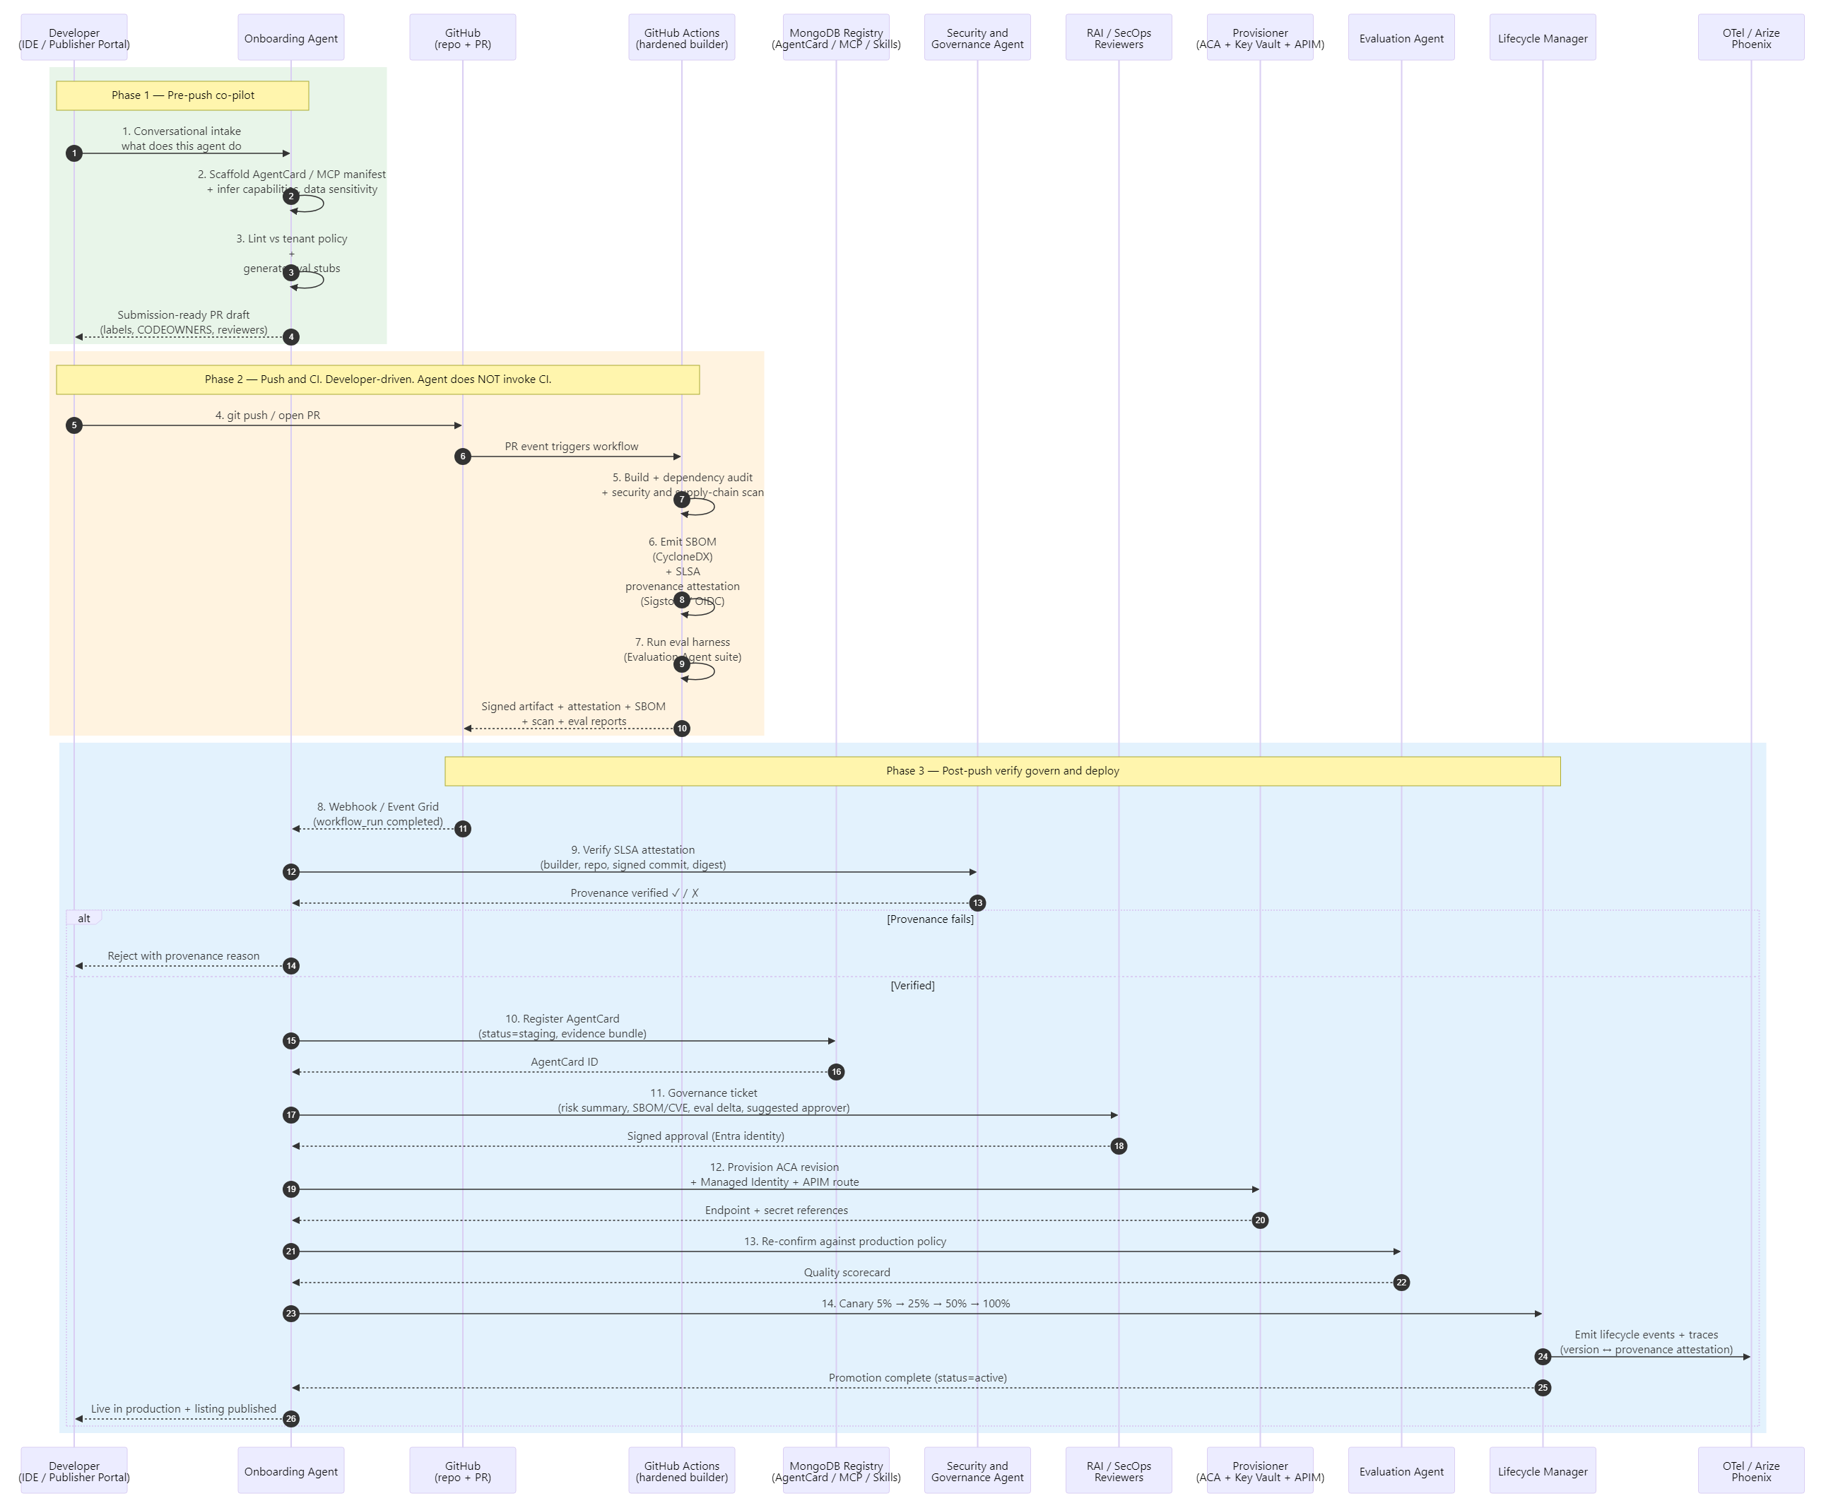
Figure 12.1 — Onboarding Agent sequence: three explicit phases — Phase 1 pre-push co-pilot (scaffold / lint / open PR), Phase 2 developer-driven push that triggers GitHub Actions (build, scan, SBOM, SLSA attestation, eval — agent does not invoke CI), Phase 3 post-push verify-govern-deploy (SLSA verification, registry, governance ticket, approval, provisioning, canary).

12.2 Evaluation Agent
The Evaluation Agent runs continuous quality assessment on every agent, prompt and model version using configurable golden datasets, adversarial probes and LLM-as-a-judge scoring. It is the quality gate that the Onboarding Agent and Lifecycle Manager call before any promotion or canary advancement, and it runs on a schedule for production drift monitoring. Telemetry is captured to a self-hosted Arize Phoenix deployment for HIPAA-aligned LLM observability and to Azure Monitor / Application Insights for infrastructure metrics.
- Quality measures — accuracy, relevance, toxicity, bias, clinical correctness; embedding-based drift vs baseline.
- Test sets — golden cases, synthetic edge cases, prompt-injection and jailbreak probes via Azure AI Content Safety.
- Judging — GPT-class LLM-as-a-judge invoked through the APIM AI Gateway with token / cost budgets enforced.
- Outputs — eval scorecard written to AgentCard, certification status, promote / rollback signals to Lifecycle Manager.
Agency.
- Goal — continuously establish and defend a measurable quality bar for every agent, prompt and model version.
- Decisions it owns — which eval suite to run for a given AgentCard (clinical accuracy vs. retrieval vs. safety), when to synthesize new adversarial cases, whether a metric delta is a real regression or noise, and whether to recommend promote, hold or rollback.
- Reasoning surface — LLM-as-a-judge scoring with structured rubrics, embedding-drift interpretation against baselines, and root-cause hypothesis generation when failures cluster across cases.
- Boundary (HITL / policy) — cannot mark an agent "production-certified" — only "eligible". Final certification remains a HITL or policy-gated decision.
Sequence flow:
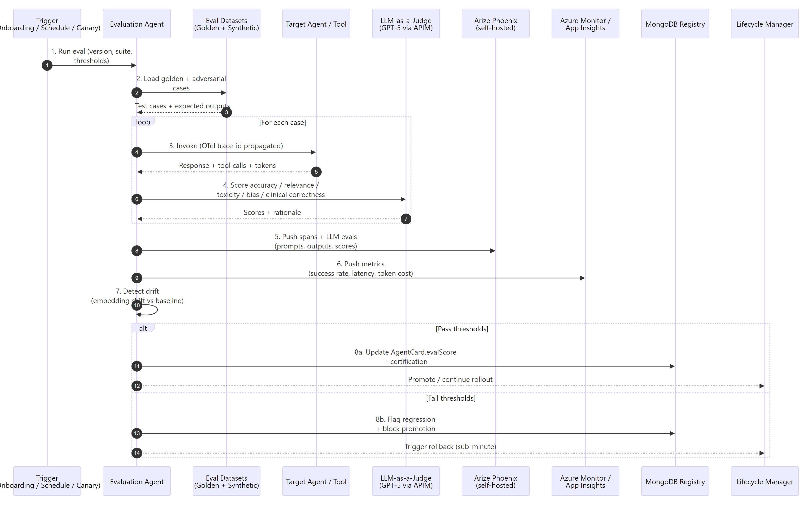
Figure 12.2 — Evaluation Agent sequence: load datasets → invoke target → LLM-as-judge → push to Phoenix and Azure Monitor → promote or rollback.

12.3 Discovery Agent
The Discovery Agent is the Dynamic Skill Resolver for the platform. It binds runtime intent — whether from the Global Orchestrator, the Marketplace Portal, or a workflow step — to the best available Agent, MCP tool or plan template via capability tag matching, vector-semantic similarity and confidence scoring. Results are filtered by tenant entitlements, Responsible AI tags and policy constraints before binding, ensuring cross-domain reuse without violating data-category or governance rules.
- Catalog — AgentCards and MCP manifests in MongoDB; capability embeddings in MongoDB vector index or Azure AI Search.
- Resolution — tag match + semantic similarity + eval score + cost / SLA → confidence-scored ranked list.
- Policy filter — Policy Registry filters candidates by tenant entitlements, data category and RAI tags.
- Authorization — Security & Governance Agent issues a zero-trust pre-bind authorization with audit ID.
- Outputs — bound endpoint plus AgentCard, declarative plan template hint when applicable, marketplace fallback otherwise.
Agency.
- Goal — bind a runtime intent to the best-fit, policy-compliant capability — even when the request is fuzzy or no exact match exists.
- Decisions it owns — how to decompose intent into capabilities, whether to bind a single agent or compose several, what to recommend when confidence is low, and when to fall back to marketplace search or propose a new submission.
- Reasoning surface — LLM parses intent into capability tags, ranks candidates with a blended score (tag + semantic + eval + cost + SLA), and produces an explanation for the selected binding.
- Boundary (HITL / policy) — cannot bind across data-category boundaries or tenant entitlement violations — the Policy Registry is a hard gate.
Sequence flow:
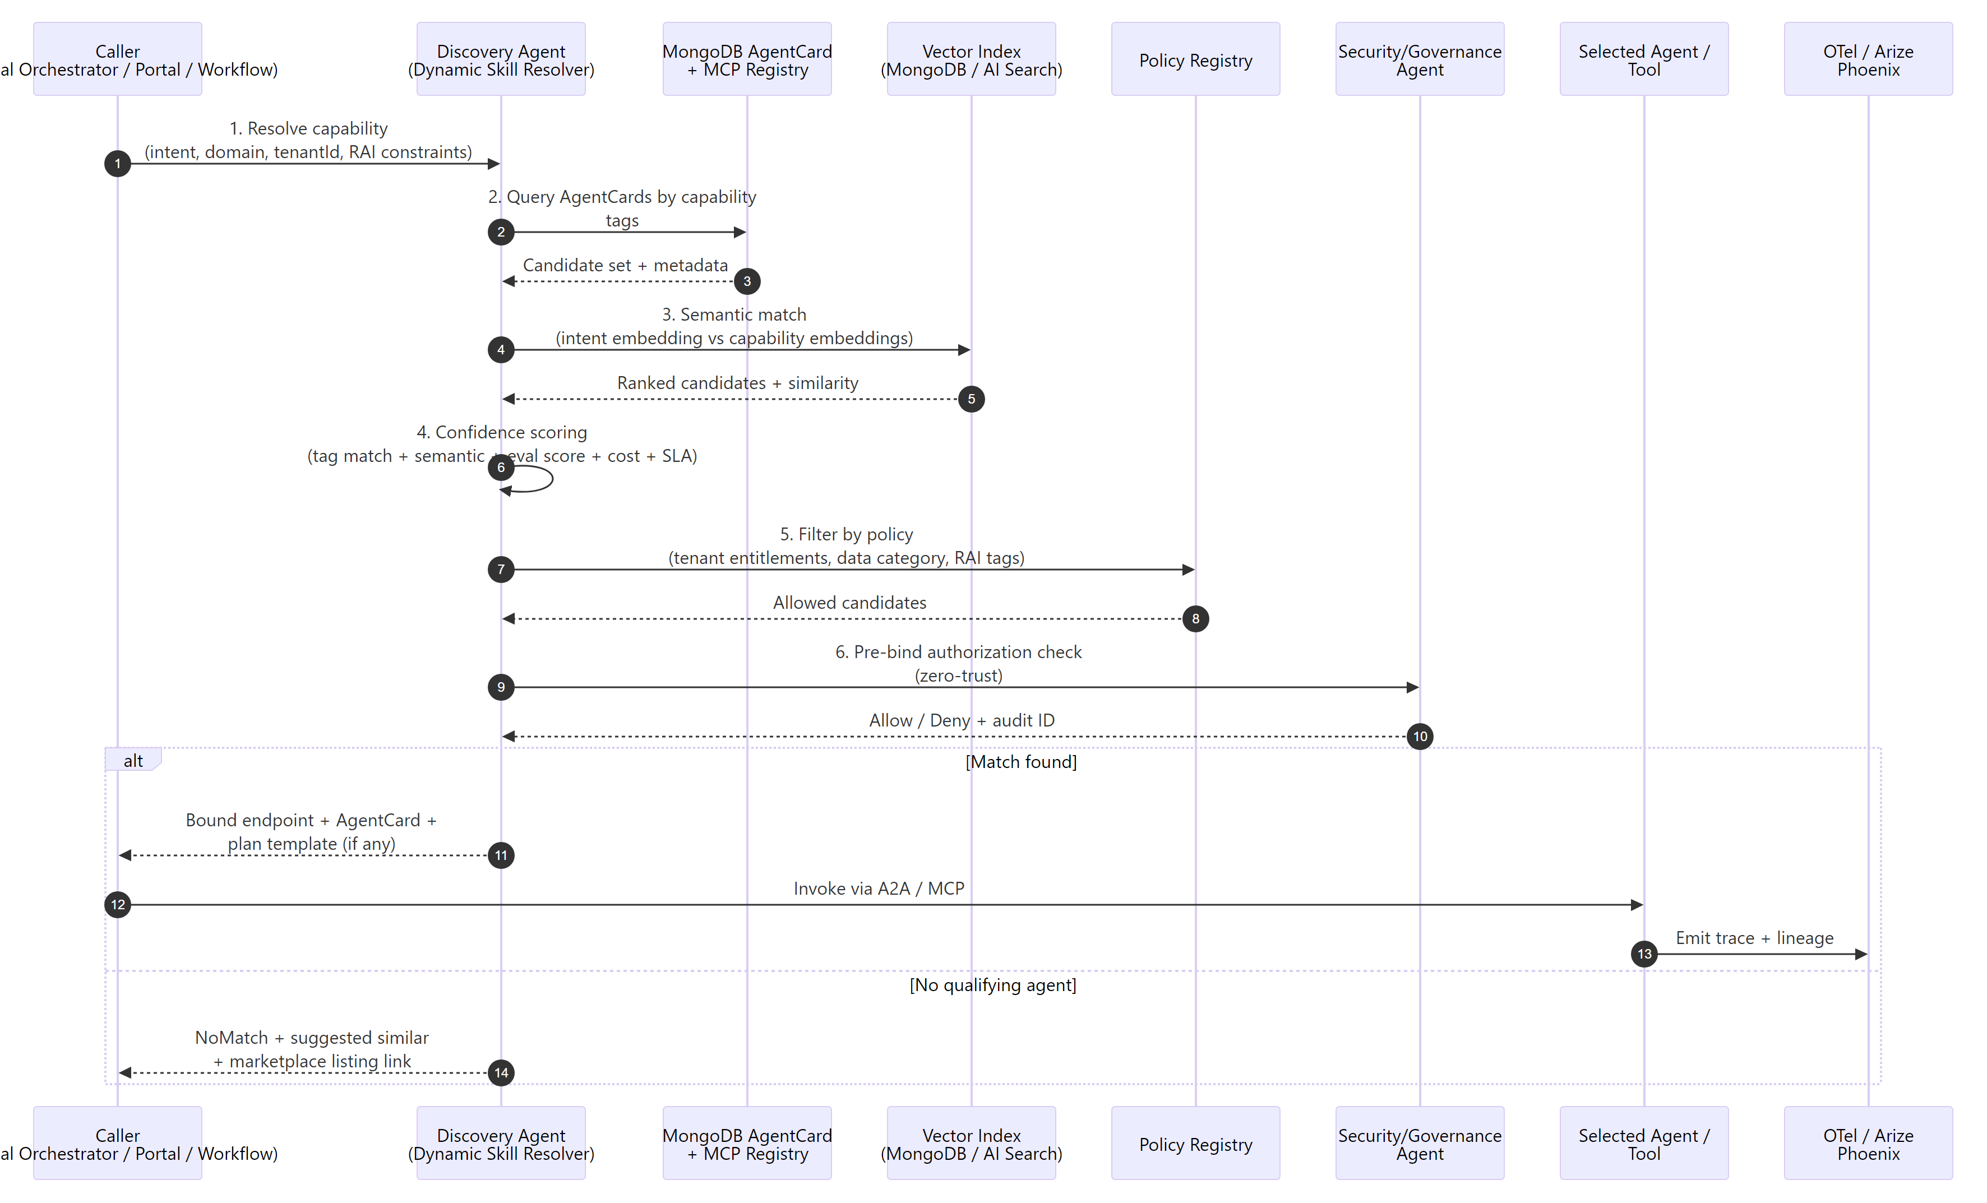
Figure 12.3 — Discovery Agent sequence: capability query → registry + vector match → policy and authorization filter → bind or fall back.

12.4 Observability, Security & Governance Agent
The Observability, Security & Governance Agent is a single cross-cutting agent with two complementary roles. As Security & Governance, it cryptographically verifies the SLSA provenance attestation of every published artifact (builder identity, source repo + commit, signature) before promotion, and performs pre-execution policy evaluation on every step — invoking Azure AI Content Safety Prompt Shields for jailbreak and indirect prompt-injection detection, redacting PHI / PII, checking entitlements and token / cost budgets against the Policy Registry, and issuing scoped Managed Identity credentials from Key Vault. As Observability, it continuously ingests OpenTelemetry GenAI semantic spans and Azure Monitor metrics, correlates production behavior with the agent version and its provenance attestation, detects anomalies and drift, and triggers automated remediation through the Lifecycle Manager (rollback, scale, circuit-break) with full audit trail in MongoDB. Remediation actions (rollback, scale, circuit-break) are dispatched to the version-management process defined in §17.3 Lifecycle Management.
- Pre-execution — SLSA provenance verification, Prompt Shields, PHI / PII redaction, policy evaluation, scoped credential issuance, allow / deny / HITL.
- Telemetry — OpenTelemetry GenAI conventions (model, tokens, tool calls) → Arize Phoenix; infra metrics → Azure Monitor.
- Detection — error spikes, latency anomalies, model and embedding drift, cost burn-rate, RAI score regressions.
- Response — raise incident, log to immutable audit (MongoDB TTL), trigger rollback or saga compensation via Lifecycle Manager.
- Compliance — every decision is signed with Entra identity and traceable end-to-end via OTel trace_id.
Agency.
- Goal — keep the running platform safe, performant and within policy without an operator in the loop for routine events.
- Decisions it owns — whether a SLSA attestation matches policy, whether a Prompt Shields trigger is a real attack or a softenable false positive, whether anomalous latency / drift warrants alert, scale, circuit-break or rollback, whether to redact-and-continue versus deny, and which incidents to escalate.
- Reasoning surface — LLM-driven provenance and anomaly explanation that correlates build-time attestation evidence with runtime Phoenix LLM signals and Azure Monitor infra signals, plus remediation proposal generation grounded in prior episode memory.
- Boundary (HITL / policy) — cannot disable a policy or change AgentCard certification; can quarantine, scale or rollback but never delete an asset.
Sequence flow:
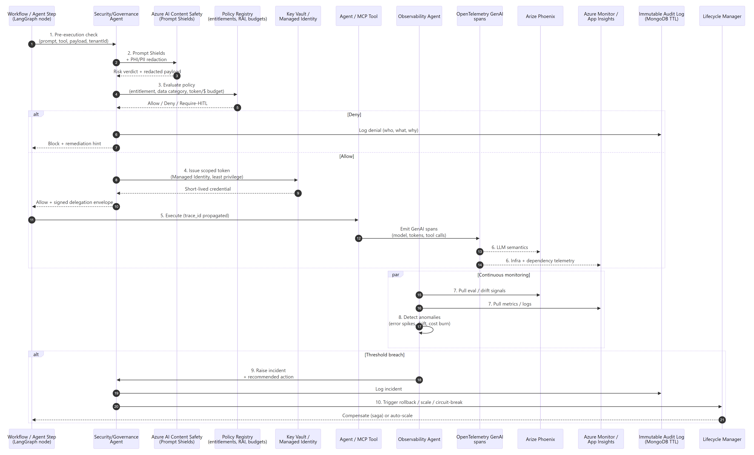
Figure 12.4 — Observability, Security & Governance Agent sequence: pre-execution gate → scoped credential → telemetry capture → anomaly detection → automated response.

13. LLM Gateway Capabilities
The LLM Gateway is built on Azure API Management and enforces a single policy surface for all LLM, agent, orchestrator and MCP traffic. It centralizes identity, rate limiting, content safety, cost governance and routing, and exposes a developer portal for self-service onboarding.
Capability Area | Representative Features | Azure Service
LLM Traffic Routing | Task-based model selection; PTU → PAYG fallback; multi-region routing; dynamic model selection | APIM + Azure OpenAI + custom policies
Load Balancing & Failover | Round-robin and weighted distribution; circuit breaker; retry with exponential backoff | APIM policies + Azure Front Door
Token-Based Rate Limiting | Azure OpenAI token limits; OSS model token limits; token metrics emission to Monitor | APIM token limit policies
Call-Rate Limiting | Requests per minute; per-tenant quota | APIM quota policies
Security | Entra ID / JWT validation; API key management; OAuth2 client credentials; mTLS; IP allowlist; RBAC | APIM + Entra ID + Key Vault
Content Safety | PHI / PII masking; prompt-injection and jailbreak detection; output content filtering | Azure AI Content Safety + custom policies
Observability | Distributed request tracing; request / response logging with redaction; real-time dashboards | App Insights + Log Analytics
Reliability | Timeout enforcement; health-aware routing; graceful degradation | APIM + custom policies
Orchestrator Traffic | Routing to orchestration engine; async long-running (202 + poll); request prioritization | APIM + ACA / Functions
Agent & MCP Traffic | Agent identity; capability-based discovery routing; JSON-RPC 2.0 proxy; SSE streaming; tool-discovery caching | APIM + MCP Gateway Proxy
Cost Management | Per-tenant token attribution; budget alerts and enforcement; cross-model cost normalization | APIM + Cost Management
Semantic & Exact Caching | Exact-match response caching for deterministic lookups | APIM cache + Redis
Protocol Support | SSE streaming passthrough; WebSocket support; JSON-RPC 2.0 validation | APIM WebSocket / SSE
Multi-Tenancy | Tenant-scoped routing; per-tenant rate limits and quotas; automated tenant onboarding | APIM subscriptions + Entra
Developer Experience | Developer portal with self-service API docs and key management | APIM Developer Portal
Policy Engine | Custom gateway policies; prompt-template enforcement; A/B prompt testing | APIM + policy fragments

14. Azure AI Foundry Capability Mapping
UAP capabilities map directly to Azure AI Foundry and supporting Azure services. The table below summarizes the current GA posture and mapping; the full feature matrix is maintained separately.
UAP Capability Area | Azure Foundry / Azure Service | GA Status | Notes
Model Marketplace — Central Repository | Azure AI Foundry Projects & Hub Workspace | GA (East US / East US 2) | Registers and manages models with metadata; model cards via evaluations workspace.
Model Marketplace — BYOM | Azure AI Foundry Model Catalog + BYOM onboarding | GA | 1800+ models (OpenAI, Meta, Mistral, DeepSeek); custom and partner models under same governance.
Model Marketplace — Approval Workflow | Foundry Governance + Publisher API | GA | Draft → Review → Approved pipeline with Responsible AI reviewers.
Model Marketplace — Drift Detection | Foundry Evaluations + Azure Monitor | GA | Performance drift and bias detection triggers retraining or rollback.
Model Marketplace — Champion/Challenger | Foundry Evaluations + APIM routing | GA | Compare new model versions via weighted traffic splits.
One-Click Deployment | Foundry Deployments + ACA / Functions | GA | Zero-downtime blue-green and canary rollout for models, agents and workflows.
RAG Integration | Azure AI Search + Foundry Knowledge | GA | Shared RAG module; vector + hybrid retrieval across marketplace assets.
IMDE — Secure Sandbox | Foundry Compute + VNet-integrated notebooks | GA | Safe experimentation environment connected to enterprise data sources.
IMDE — Multi-Modal Pre-loaded Tools | Foundry AI-ML / LLM / Multimodal / DL images | GA | Pre-loaded environments for classical ML, LLMs, multimodal and deep learning.
Dynamic Agent Orchestrator | MAF / LangGraph on ACA + Foundry Agent Service | GA | Typed Agent / MCP / Model / Tool / Control-Flow / HITL / Governance nodes.
Visual Agent Builder | Next.js + React Flow canvas | App | Drag-and-drop assembly with guardrails, versioning, approvals and rollback.
Cross-Cutting — Multi-Tenant Isolation | MongoDB tenantId partition + Entra | GA | Data and execution isolated per tenant; VNet-private traffic.
Cross-Cutting — HIPAA / SOC 2 | Azure HIPAA-covered services + policy controls | GA | PHI / PII protection, audit trail, covered-service usage.

15. Security, Compliance and Governance

15.1 Identity and Access
- Entra ID as the single identity authority for users, agents and services.
- Managed Identity for zero-secret service-to-service authentication.
- JWT token vending through the LLM Gateway issues machine-to-machine, scope-restricted tokens for autonomous agents.
- Context-aware permissions evaluated per invocation via Policy Engine claims and context.

15.2 Network and Secrets
- VNet isolation and subnet segmentation for all Azure Container Apps and Functions workloads.
- mTLS between APIM and backend LLM / agent / MCP endpoints.
- Azure Key Vault with Managed Identity access for all secrets and certificates — no secrets in configuration.

15.3 Data Protection and Compliance
- PHI / PII detection and masking in inbound prompts, plus output content filtering for harmful categories.
- HIPAA-covered Azure services only; SOC 2 posture aligned with enterprise baselines.
- AgentCards carry Responsible AI and data-category tags; Security Agent enforces declaratively at publish and execute.

15.4 Governance Controls
- Security Scanner (static and runtime) gates publication; Policy Engine gates execution.
- Immutable audit log in MongoDB with TTL — who did what, when, with what outcome.
- Human-in-the-Loop gate for sensitive actions — denials, high-value claims, elevated data categories.
- Responsible AI board reviews at onboarding and on material version changes.

16. Data and Observability

16.1 Three-Tier Memory
- Short-term — Redis session and working memory (sub-millisecond).
- Episodic — MongoDB for run state, AgentCards, audit records, workflow checkpoints.
- Long-term — ADLS Gen 2 for summary-first evidence bundles; raw PHI is never persisted at this tier.

16.2 Observability Stack
- OpenTelemetry trace_id propagation across gateway → orchestrator → agent → LLM → MCP hops.
- Application Insights and Azure Monitor for infrastructure metrics, KQL queries and alerts.
- Arize Phoenix for LLM-semantic traces, LLM-as-a-judge evaluations and drift detection.
- Real-time LLM Gateway dashboard — throughput, latency, error rates, token burn and per-tenant cost attribution.

17. Deployment and DevOps

17.1 Runtime Topology
- Azure Container Apps run stateless FastAPI registries, the orchestrator and domain agents, with KEDA-based scaling and scale-to-zero where appropriate.
- Azure Functions handle event-driven extensions and lightweight MCP servers.
- APIM fronts both the API surface and the LLM / MCP gateway; Azure Front Door provides global edge routing.

17.2 Developer Experience
- Agent Development Lifecycle: scaffold → code → test → register as a discoverable A2A agent.
- MCP tool development: build → test → publish to registry → agents discover.
- Visual workflow builder — select agents, wire edges, attach policies, save as a plan template.
- Local testing — MongoDB local container plus VS Code F5 debug with policy-decision inspection.
- CI/CD — azd up and GitHub Actions; Git push → build container → deploy to Container Apps → verify.
- Day-2 operations — monitor executions, review policy violations, update agents and version templates.

17.3 Lifecycle Management
Lifecycle Management is the platform's release-plane discipline for safely evolving Agents, MCP servers, Tools and prompts over time. It is not itself an agent — it is a set of automated mechanics on Azure Container Apps revisions and the AgentCard / MCP Registry that the Onboarding Agent and the Observability, Security & Governance Agent drive on behalf of the platform. The Lifecycle process owns versioning, promotion, rollback, deprecation and per-version provenance.
- Versioning — semantic versioning (MAJOR.MINOR.PATCH) for every Agent, MCP server, Tool and prompt; multiple versions run concurrently for backward compatibility.
- Promotion — canary releases with orchestrated traffic shifts 5% → 25% → 50% → 100%, evaluation-gated at each step by the Evaluation Agent (§12.2).
- Rollback — automated regression detection by the Observability, Security & Governance Agent (§12.4) triggers an Azure Container Apps revision swap with sub-minute revert.
- Deprecation — 90-day deprecation notices with auto-decommissioning of containers; consumers receive APIM-mediated notifications and are migrated to the successor version. The declarative plan-template library grows via contributions and validated deprecations.
- Provenance per version — every release is logged to MongoDB and Arize Phoenix and linked back to the SLSA-style attestation that promoted it, so any version in production is traceable to its build, scan, eval and approval evidence.

18. Key Architecture Features
Sixteen features anchor the UAP differentiation story, split into security and orchestration foundations (1–8) and scalability, extensibility and autonomy features (9–16). Each maps directly to components above.

18.1 Features 1–8 — Security and Orchestration Foundations
# | Feature | Components | Key Differentiator
1 | Enterprise Security | LLM GW, Entra ID, Key Vault, Security Scanner | Zero-trust, VNet isolation, PHI redaction, HIPAA-ready
2 | Plan-Based Orchestration | Execution Engine, Workflow Templates, Registries | Declarative plans, delegation envelope, step polymorphism
3 | Semantic Discovery | Azure AI Search, Asset Catalog, MCP/A2A Registries | Vector-indexed search, .well-known crawl, federation
4 | Human-in-the-Loop | HITL Gate, Execution Engine, Admin Dashboard | First-class step type with full audit provenance
5 | Three-Tier Memory | Redis, MongoDB, ADLS Gen 2 | Summary-first flush, episode records, no raw PHI
6 | Multi-Protocol Tools | MCP GW Proxy, MCP Registry, A2A Registry, Foundry | MCP + A2A + Foundry + SaaS in a single gateway
7 | Governance | Policy Engine, Publisher API, Scanner, Admin UI | Dual enforcement at publish and execute with full audit
8 | Observability | App Insights, Azure Monitor, ACA, Functions | OpenTelemetry end-to-end with per-episode trace IDs

18.2 Features 9–16 — Scale, Extensibility and Autonomy
# | Feature | Components | Key Differentiator
9 | Azure-Native, Not Locked | MCP GW Proxy, A2A Registry, Foundry, ACA | Open protocols, federation and optional Foundry
10 | Production Infrastructure | ACA, Functions, Event Hub, LLM Gateway, MongoDB | Subnet isolation, scale-to-zero, Bicep IaC
11 | Intelligent Tool Finder | Azure AI Search, MCP Registry, Azure OpenAI | MongoDB vector index / Azure AI Search semantic match; agents self-discover tools
12 | Dynamic Invocation | Execution Engine, MCP GW Proxy, AI Search | Discover, resolve and call in one turn with no pre-config
13 | Load Balancing | LLM Gateway, ACA, MCP GW Proxy | Health-aware routing across MCP server replicas
14 | IDE Integration | MCP Registry, Asset Catalog, LLM Gateway | One-click IDE setup from marketplace registry
15 | JWT Token Vending | Entra ID, Key Vault, LLM Gateway | Machine-to-machine scoped tokens for autonomous agents
16 | Context-Aware Permissions | Policy Engine, Entra ID, LLM Gateway | Dynamic per-invocation scope evaluation, not just RBAC

19. 180-Day Implementation Roadmap
Twenty-two capabilities across four layers are targeted for implementation in the next 180 days (Q2-Q3 2026), grouped into a Core Platform track and a Governance and Publisher track that run in parallel.

19.1 Group 1 — Core Platform
Layer | Capability
Presentation & UX | Web Portal / CLI Discovery (React Flow drag-drop)
Presentation & UX | Admin Dashboard (governance, health, approvals)
API & Registries | AI Asset Catalog (CRUD, versioning, search)
API & Registries | MCP Server & Tool Registry
Orchestration & Governance | Workflow Templates (reusable patterns)
Orchestration & Governance | Execution Engine (graph dispatch, retries, fan-out)
Data & Observability | Audit Log (immutable, TTL, MongoDB)
Data & Observability | Metrics & OTLP (OpenTelemetry → App Insights)

19.2 Group 2 — Governance and Publisher
Layer | Capability
Presentation & UX | Publisher Portal (submission lifecycle)
Presentation & UX | Playground (interactive agent / tool testing)
Presentation & UX | DevUI (MAF agent debugging surface)
API & Registries | Agent Skills Registry
API & Registries | Publisher & Submission API
API & Registries | Security Scanner (static + runtime validation)
Orchestration & Governance | Human-in-the-Loop Approval Gate
Orchestration & Governance | IAM & RBAC Access Control (Entra ID)
Orchestration & Governance | Compensation Logic / Saga (rollback coordination)
Data & Observability | Projects & Workspace (team-owned work areas)
Data & Observability | Ratings & Reviews (community feedback)
Data & Observability | Execution History (run outcomes, traces)
Out of scope: The existing Web Dashboard is already shipping. Layer 5 Azure services are provisioned independently via Bicep IaC and tracked outside the application backlog.

20. Key Design Decisions
Ten decisions define the Global Agentic Orchestrator for RCM and, by extension, the UAP reference architecture.
# | Decision | Rationale
01 | Two-Tier Orchestration | Central Global Orchestrator plus specialized Domain Orchestrators. Separates cross-domain policy from in-domain expertise.
02 | LangGraph over MAF (v1.0) | Mature graph engine with durable checkpoints and framework-agnostic A2A. MAF strengths rebuilt as platform capabilities.
03 | Direct A2A Calls (Default) | Synchronous API with async behavior via LangGraph durable pauses — lowest latency. Event Hub added only for bursty fan-out.
04 | Capability-Based Discovery | AgentCards in MongoDB registry plus a confidence-scored resolver enable cross-domain reuse without hardcoded endpoints.
05 | MCP for Enterprise Tools | Enterprise APIs (claims, EHR, billing) wrapped as MCP servers behind APIM — uniform tool surface with zero-trust via Entra ID.
06 | Three-Plane Architecture | Model Plane (UAIS / Azure OpenAI), Tool Plane (MCP), Agent Plane (containers), with unified memory (Redis + MongoDB + vector index).
07 | Automated 7-Stage Onboarding | Submission → Validation → Registration → Approval → Provisioning → Test → Canary, with human gates where required.
08 | Canary + Instant Rollback | Semantic versioning with 5% → 25% → 50% → 100% traffic shifts; ACA revisions enable sub-minute revert on regression.
09 | Arize Phoenix for LLM Ops | Self-hosted on Azure for HIPAA. OTel traces plus LLM-as-a-judge plus drift detection correlated with Azure Monitor infra metrics.
10 | Compliance by Declaration | AgentCards carry Responsible AI and data-category tags; Security Agent enforces. PHI / PII redaction and audit trail by design.

21. Expected Impact and Benefits
Benefit Area | Impact | Supporting Evidence
Faster Deployment | Agent onboarding: weeks → hours | Automated 7-stage pipeline replaces manual coordination.
Increased Reuse | 40–50% of new projects leverage existing agents | Shared registries plus plan templates create network effect.
Operational Efficiency | 20%+ productivity gains in claims processing | Optum pilot data; AI catches errors and denials upfront.
Denial Reduction | Significant reduction in avoidable denials | Approximately 85% of claim denials preventable with right info.
Quality Assurance | All agents vetted for fairness, bias and performance | Continuous evaluation via Arize Phoenix plus LLM-as-a-judge.
Compliance | Full audit trail; HIPAA-ready by design | Every action logged with provenance; Responsible AI board.
Developer Productivity | AI pair-programming for 20K+ engineers | Developer Productivity Agent plus platform templates.
Risk Mitigation | Canary releases + instant rollback | Lifecycle Agent monitors quality and auto-reverts on regression.
Net effect: Faster onboarding (weeks → hours) · 40–50% agent reuse · HIPAA-ready by default · scale to 100K+ encounters/day.

22. Glossary
Term | Definition
A2A | Agent-to-Agent protocol: HTTP-based, self-describing via Agent Cards, enabling capability discovery and invocation across agents.
ACA | Azure Container Apps — managed serverless container platform with KEDA-based auto-scaling and per-revision traffic splitting.
AgentCard | Declarative metadata describing an agent: identity, capabilities, owner, version, data categories and Responsible AI tags.
APIM | Azure API Management — fronts UAP registries and the LLM / MCP gateways with policies, auth, throttling and observability.
HITL | Human-in-the-Loop gate: first-class workflow step that pauses automation for manual review with full decision provenance.
LangGraph | Graph-based orchestration framework used as the UAP Execution Engine. StateGraph DAG with checkpointing and interrupts.
LLM Gateway | APIM-based entry point enforcing auth, rate limiting, content safety, cost governance and routing for LLM and agent traffic.
MAF | Microsoft Agent Framework — Microsoft's strongly typed workflow framework with native Azure observability and RBAC integration.
MCP | Model Context Protocol — JSON-RPC 2.0 standard for exposing tools, resources and prompts to agents.
PHI / PII | Protected Health Information / Personally Identifiable Information — data classes regulated under HIPAA and privacy law; UAP detects, redacts and audits handling of these classes via Azure AI Content Safety, Policy Engine tags and the Security & Governance Agent.
PTU | Provisioned Throughput Unit — reserved Azure OpenAI capacity with predictable latency; PAYG is the pay-as-you-go fallback.
RCM | Revenue Cycle Management — healthcare administrative workflows (eligibility, prior-auth, billing, claims, denials).
UAIS | Unified AI Services — middleware layer normalizing access to Foundry, OpenAI, MCP and A2A with consistent auth, retries and telemetry.
UAP | Unified AI Platform — the overarching platform described in this document.
UDP | Unified Data Platform — persistence and observability backbone (MongoDB, Redis, App Insights, Azure Monitor, ADLS Gen 2).

23. Appendix

23.1 Sequence Diagrams (Work in Progress)
Twelve sequence diagrams are authored to complement this document — six for Developer Experience flows and six for RCM Domain Orchestration flows. They will be published as a companion deck and linked from the Marketplace documentation site.

23.2 Reference Source Documents
- Draft — UAP AI Marketplace Architecture.
- Global Agentic Orchestrator Design v2 (with decisions).
- UAP — Azure Foundry feature matrix.
- UAP — LLM Gateway feature matrix.

23.3 Referenced Technologies
Microsoft Agent Framework, LangGraph, Azure Container Apps, Azure Functions, Azure API Management, Azure AI Foundry, Azure OpenAI, Azure AI Search, Azure AI Content Safety, MongoDB (Atlas or Azure Cosmos DB for MongoDB vCore), Azure Cache for Redis, ADLS Gen 2, Azure Event Hubs / Event Grid / Service Bus, Entra ID, Managed Identity, Key Vault, Application Insights, Azure Monitor, Log Analytics, Arize Phoenix, OpenTelemetry, MCP (Model Context Protocol), A2A (Agent-to-Agent) protocol, Next.js 15, React Flow, Azure Front Door, Bicep.

