Microsoft
Architecture Document
Unified AI Platform (UAP)
AI Marketplace & Global Agentic Orchestrator
Capabilities, Architecture and Developer Experience

Document Version 1.0 | Status: Draft | May 2026
Table of Contents
1. Document Control 5
1.1 Revision History 5
2. Executive Summary 6
3. Business Context and Drivers 7
3.1 Problem Statement 7
3.2 Business Value of an Enterprise AI Investment 7
3.3 Benefit of the UAP to Optum Real 8
4. Goals 10
4.1 Goals 10
5. Architecture Principles 11
6. Solution Overview 12
7. Logical Architecture 13
7.1 UAP Capability Architecture 13
7.2 Solution and Data Flow Architecture 17
8. Physical Architecture 20
8.1 Entry and Security Layer 20
8.2. UAP Container Apps Environment 21
8.3 Shared Platform Services within the UAP Subscription 21
8.4. External AI and Monitoring Services (UAIS and Enterprise Shared Services) 22
9. Global Agentic Orchestrator 25
9.1 Two-Tier Orchestration 25
9.2 Three Logical Planes 25
9.3 Unified Memory 25
9.4 General Orchestrator Workflow 25
9.5 Global Orchestrator Pattern — Nested Workflows 26
10. Orchestration Framework — LangGraph vs MAF 27
10.1 Capability Comparison 27
10.2 Compliance Posture 28
11. Communication Patterns 29
11.1 Default — Direct Orchestrator-to-Orchestrator Calls 29
11.2 Azure Event Hub for Bursty Workloads 29
11.3 Decision Matrix 29
12. Platform AI Agents 31
12.1 Onboarding Agent 31
12.2 Evaluation Agent 33
12.3 Discovery Agent 35
12.4 Observability, Security & Governance Agent 36
13. Azure AI Foundry Capability Mapping 39
14. Security, Compliance and Governance 41
14.1 Identity and Access 41
14.2 Network and Secrets 42
14.3 Data Protection 42
14.4 Governance Controls 42
15. Data and Observability 43
15.1 Three-Tier Memory 43
15.2 Observability Stack 43
16. Deployment and DevOps 44
16.1 Runtime Topology 44
16.2 Developer Experience 44
16.3 Lifecycle Management 44
17. Key Architecture Features 45
17.1 Features 1–8 — Security and Orchestration Foundations 45
17.2 Features 9–16 — Scale, Extensibility and Autonomy 46
18. Key Design Decisions 47
19. Decision Matrix for UAP 48
20. Risks 49
21. Technical Questions 50
22. Expected Impact and Benefits 51
23. Glossary 52
24. Appendix 53
24.1 Sequence Diagrams (Work in Progress) 53
24.2 Reference Source Documents 53
24.3 Referenced Technologies 53
24.4 180 Day Roadmap 53
24.4.1 Group 1 — Core Platform 53
24.4.2 Group 2 — Governance and Publisher 54

1. Document Control

1.1 Revision History
Version | Date | Author | Change Summary
0.1 | Q1 2026 | Applied AI | Initial UAP AI Marketplace draft
0.5 | Q1 2026 | Applied AI | Global Agentic Orchestrator design consolidated
0.9 | Q1 2026 | Applied AI | Foundry and LLM Gateway feature matrices integrated
1.0 | May 2026 | Rajesh, Antony, Monica and Agustin | First Microsoft-format consolidated architecture document

2. Executive Summary
The Unified AI Platform (UAP) consolidates AI marketplace, orchestration, governance and developer experience capabilities onto a single, Azure-native, enterprise-grade platform. UAP unifies three tiers — UAP (experience), Unified AI Services (UAIS — middleware) and Unified Data Platform (UDP — persistence and observability) — to deliver a cohesive surface for enterprise teams to discover, publish, compose and operate AI assets at scale.
A Global Agentic Orchestrator sits above domain-specialized orchestrators to execute multi-step, multi-agent workflows — starting with Revenue Cycle Management (RCM). The platform is built on the Microsoft Agent Framework and LangGraph graph-execution engine, Azure Container Apps, MongoDB, Azure OpenAI via UAIS, MCP and A2A protocols, and a unified LLM / API Gateway fronted by Azure API Management.
The platform is designed to deliver measurable outcomes: onboarding new agents in hours rather than weeks, 40–50% agent reuse across projects, 20%+ productivity gains in claims processing and HIPAA-ready compliance by design. Scale targets include 100K+ daily encounters and billions of claims per year through auto-scaling Azure Container Apps, KEDA-driven Event Hub consumers and durable LangGraph checkpoints.

3. Business Context and Drivers

3.1 Problem Statement
- Healthcare revenue cycle management (RCM) is under unprecedented strain from manual inefficiencies, rising administrative costs, and slow post-care reimbursement cycles. Providers are losing time and money due to these broken processes. For example, Optum estimates 85% of claim denials are preventable via predictive validation and two-thirds of health information professionals report persistent staffing shortages. At the same time, underpayments remain high (e.g. ~$130 billion of government underpayments in 2023), while the market for next-generation RCM solutions is booming ($156 billion TAM, ~15% CAGR). These forces create an urgent imperative to fundamentally reinvent RCM via integrated, AI-driven platforms that shift work from reactive, post-visit tasks to proactive, real-time processes at the point of care – a strategic move poised to reduce overhead, accelerate cash flow, and capture billions in value across the healthcare ecosystem.

3.2 Business Value of an Enterprise AI Investment
- Optum has evolved an enterprise-wide AI strategy built on mature, scalable platforms and a commitment to responsible use. Instead of isolated projects, Optum’s approach centers on a Unified AI Platform that integrates data, models, and governance across the business. With thousands of AI engineers and over a thousand AI solutions already in production, Optum’s AI initiatives operate at one of the largest scales in healthcare. This unified platform strategy ensures that AI is developed once and deployed broadly, with consistent oversight, strong security and compliance, and clear business value.

- Optum Real’s Unified AI Platform (UAP) embodies this strategy for provider-facing revenue cycle management. Optum Real UAP serves as a common AI foundation for real-time claims workflows – a modular, multi-layer platform that harmonizes clinical, claims, and operational data into a single source of truth. On top of this data foundation, orchestrated AI “agents” handle tasks like coverage prediction, medical coding, documentation and prior authorization in real time. Each AI component benefits from shared context and lifecycle management through the platform, allowing rapid iteration and continuous monitoring. Built-in governance and Responsible AI controls in UAP enforce standards on every model and decision, ensuring accuracy, fairness and traceability. By shifting manual processes into proactive, AI-driven workflows at the point of care, Optum Real reduces denials, administrative overhead, and delays – delivering a more transparent, efficient experience for patients, providers, and payers. Critically, this unified architecture creates reusable AI capabilities that can be extended across Optum’s business, accelerating innovation beyond just claims.

- Microsoft’s role as a strategic platform partner underpins these capabilities. Optum leverages Microsoft’s cloud infrastructure and AI services to power the UAP at scale, relying on Azure’s secure, compliant environment and advanced AI toolchain. Together, Microsoft and Optum have co-engineered core platform components – from unified data architecture to AI orchestration frameworks – aligning Optum Real’s vision with enterprise-grade security, compliance, and Responsible AI foundations. This partnership enables Optum to rapidly scale AI with confidence, focusing on transformative outcomes while trusting the platform’s robust technical underpinnings and governance.

3.3 Benefit of the UAP to Optum Real
- Specific to revenue cycle management (RCM), Optum Real’s modular UAP for providers will automate the process to reduce unnecessary overhead in processes like prior authorization, clinical coding, claims submissions, denials and appeals management, and billing. The unified data platform will enable secure clinical data integration, intelligent orchestration, natural language processing, specialized AI agents, and a semantic layer to perform pre-care, point of care, and post care RCM activities in real-time – otherwise shifting RCM activities “left” in the process so providers can be paid at the point of care, not 3+ months later. This platform architecture promotes reuse across teams and aligns with top RCM automation priorities. The same platform pattern extends beyond RCM as additional domains adopt capability-based discovery, declarative plan templates and governed orchestration.

- At a business level, Optum Real will resolve the mismatch of pre care estimates/inquiry claims and final claims to reduce or eliminate administrative denials processes and provide better price transparency to patients. To do so they will reinvent how the patient’s medical need/chart and insurance plan/benefits/eligibility, provider’s payor contract and services performed, and payor claim submission expectations connect proactively. They will unify the data required, capture it in real time (through the EHR and ambient clinical documentation), use intelligence to interpret inputs and produce outputs automatically (prior authorization, coding alignment, and claim submissions), and flag any potential errors or misalignments that lead to denials early in the process. There are 4 prioritized platform capabilities for the first phase of partnership: autonomous coding, chart intelligence, denials intelligence, and unified data platform.

4. Goals

- Provide a single, governed marketplace for AI assets: agents, MCP tools, models, skills and workflow templates.
- Deliver a Global Agentic Orchestrator that composes multi-agent workflows with durable state, HITL and full provenance.
- Normalize access to Azure AI Foundry, Azure OpenAI, MCP servers and A2A agents through a consistent UAIS contract.
- Enforce zero-trust security, HIPAA compliance and Responsible AI controls at publish time and at execute time.
- Enable automated onboarding, canary deployment, instant rollback and continuous evaluation.
- Scale to 100K+ daily encounters and billions of claims per year while absorbing burst traffic.

5. Architecture Principles
  - Azure-native, never locked-in — built on Azure managed services but composed over open agent protocols (MCP, A2A, OpenTelemetry GenAI) and pluggable model/framework adapters (Foundry, Semantic Kernel, LangGraph, Microsoft Agent Framework, BYOM), enabling federation across hosted, SaaS and on-premises endpoints without rewrites.
  - Zero-trust by default — Entra ID + Managed Identity for humans and Microsoft Entra Agent ID (with Workload Identity Federation / SPIFFE support where applicable) for every agent and tool, VNet isolation, mTLS, and least-privilege delegation envelopes across every hop;
  - Governed at publish and execute — dual enforcement via Security Scanner + signed SLSA-style provenance attestation at publish, and Policy Engine + token/cost/latency budgets at execute; every artifact (agent, MCP server, model, prompt) is verifiable end-to-end.
  - Declarative over imperative — plan templates, AgentCards and AgentCard-carried policies express intent and capabilities; the runtime binds dynamically via capability matching, enabling emergent multi-agent composition without hard-coded topologies.
  - Durable and replayable by design — every workflow and agent episode (prompts, tool calls, decisions) is persisted in MongoDB with checkpoints, accelerated by Redis for hot reads and archived to ADLS Gen 2 as long-term evidence, with deterministic replay against pinned model snapshots for debugging and audit.
  - Observable end-to-end — OpenTelemetry propagation with per-episode trace IDs, Arize Phoenix for LLM semantics, Splunk Monitor for infrastructure, and per-episode cost/token telemetry surfaced alongside latency.
  - Multi-tenant by construction — tenantId partition keys, per-tenant quotas, cost attribution, and rate limits in the LLM Gateway; isolation is a default, not a configuration.
  - Human-in-the-Loop is first-class — HITL is a step type, not a bolt-on; decisions are audited and reversible via saga compensation, and agent autonomy is graduated (observe → suggest → act-with-approval → autonomous) with promotion gated on eval evidence.
  - Developer experience — typed SDKs, OpenAPI/AsyncAPI contracts, scaffolded golden-path templates (azd init agent / MCP / workflow), local emulators (Azurite, Functions Core Tools, mock LLM Gateway) and a one-command dev up deliver time-to-first-agent ≤ 15 minutes;
  - Quality is gated — no agent, prompt, or model change ships without automated evals (golden datasets, LLM-as-judge, prompt-injection and jailbreak probes via Azure AI Content Safety + Foundry evaluators), backward-compatible API/AgentCard SemVer with N-2 support, and CI-validated documentation samples.

6. Solution Overview
UAP is organized into three tiers that separate experience, services and data concerns while sharing a common identity, telemetry and governance fabric.
Tier | Purpose | Anchor Technologies
Unified AI Platform (UAP) | Overarching platform that unifies asset catalog, orchestration, governance and developer experience into a single surface for enterprise teams. | Next.js 15 UI, React Flow, Azure Container Apps, Azure Front Door
Unified AI Services (UAIS) | Middleware layer that normalizes access to Azure AI Foundry, Azure OpenAI, MCP servers and A2A agents with consistent auth, retries, circuit breakers and telemetry. | Entra ID, Managed Identity, LLM Gateway, MCP Gateway Proxy
Unified Data Platform (UDP) | Persistence and observability backbone: catalog metadata, workflow state, execution history and audit logs, plus real-time metrics, distributed traces and alerts. | MongoDB, Splunk Monitor, Redis, ADLS Gen 2

7. Logical Architecture

7.1 UAP Capability Architecture
The Unified AI Provider Platform (UAP) capability delivers a governed, reusable, and scalable foundation for applying AI to the business of Revenue Cycle Management (RCM). UAP architecture defines a cohesive technical platform that unifies users, data, models, and workflows into a governed AI fabric for revenue cycle operations. It enables internal and external teams to build and improve models in a secure environment, register and evaluate them in a centralized asset library, compose them into multi-agent workflows via the Global Agent Orchestrator and Visual Agent Builder, and deploy them safely through one-click CI/CD. By aligning everything with strong governance, security, and a shared data foundation, the platform is designed to reduce time-to-market, maximize reuse, and support reliable, compliant AI automation across the provider's revenue cycle.
The platform is structured in layered fashion: user personas at the top, a presentation and access layer, core UAP capabilities, and a unified data and integration layer at the bottom. This layered design ensures that diverse users can interact with AI capabilities through role-appropriate interfaces while sharing common data, security, and governance services. The capability architecture and its detail are provided below:

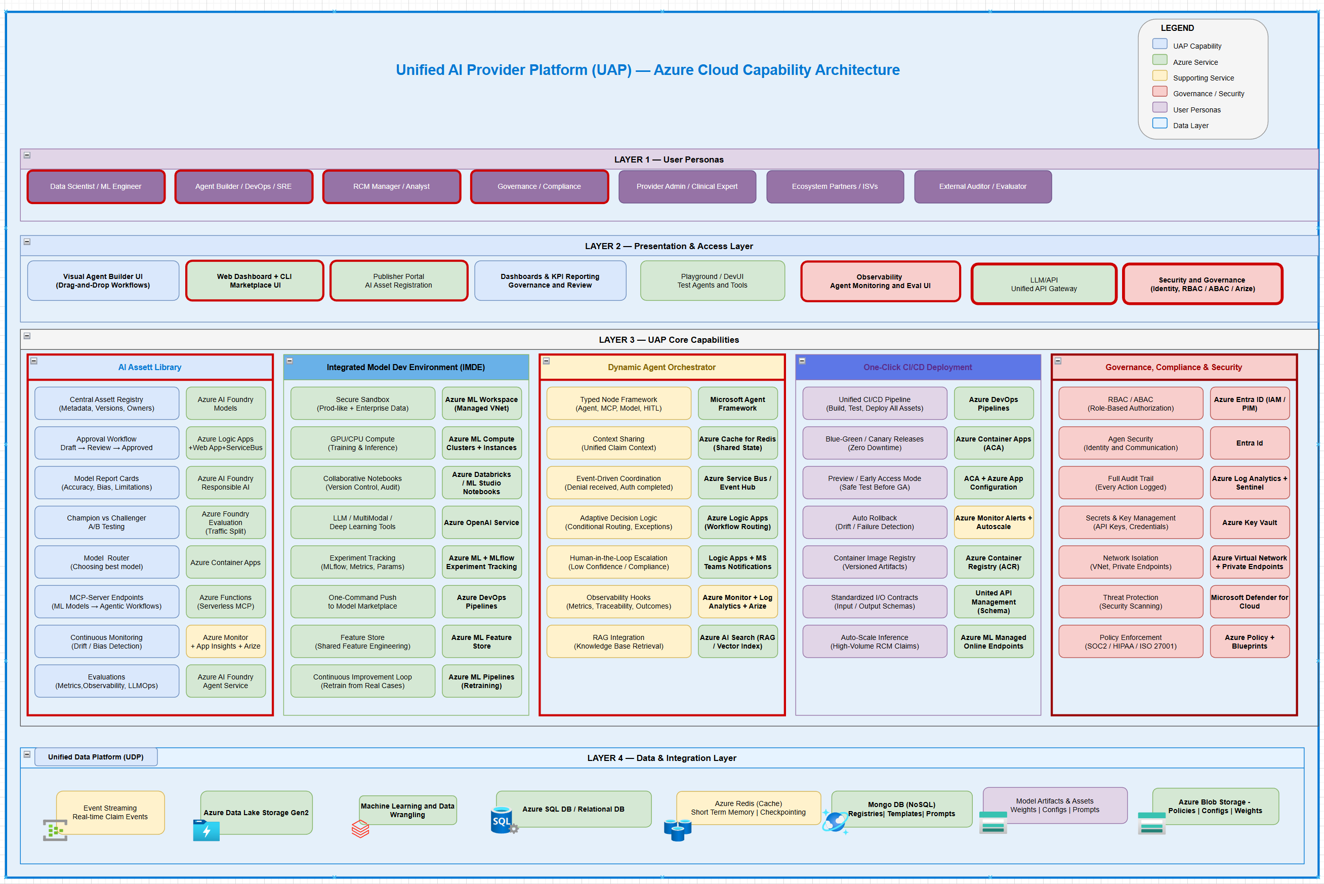
Layer 1 - User Personas
The user layer identifies the primary constituencies that consume or contribute to UAP. Internal technical teams include data scientists, ML engineers, platform engineers, data engineers, and DevOps/SRE, who build and operate the platform and its AI assets. Business and operations personas such as RCM managers, analysts, and agent builders design workflows, configure agents, and monitor performance. Governance and compliance teams oversee responsible AI, approvals, access control, and audits. Provider side personas include provider admins, operational staff, domain and clinical experts, and IT/security staff, who integrate UAP outputs into daily operations and validate clinical and business correctness. External participants such as ecosystem partners, ISVs, and external auditors connect via governed interfaces to contribute models or validate compliance.
Layer 2 - Presentation and Access Layer
The presentation and access layer provides the primary entry points into the platform. A Visual Agent Builder UI enables drag-and-drop composition of workflows using steps such as eligibility checks, ML model invocations, denial review, and human approval. This interface supports branching logic and routing rules without requiring code, allowing domain experts to design and adjust agentic workflows directly. A web dashboard and CLI marketplace allow users to discover, search, and manage AI assets (models, agents, prompts) and to inspect their metadata, versions, and status.
A publisher portal serves as the on-ramp for AI asset registration, enabling technical teams and partners to onboard new models and agents under governance. Dashboards and KPI reporting surfaces provide real-time visibility into deployment status, workflow performance, model quality, and revenue outcomes for operations, product, and governance stakeholders. A playground or dev/test area lets users safely experiment with agents and tools before they are wired into production workflows. Cross-cutting this layer are observability experiences for monitoring agents and evaluation results, a unified API gateway for consistent external access, and dedicated security/identity capabilities to enforce RBAC/ABAC, authentication, and authorization.
Layer 3 - Core Capabilities – AI Asset Library
Within the core platform layer, the AI Asset Library acts as the single source of truth for all AI assets. It maintains a central asset registry that stores metadata such as purpose, owner, lifecycle state, versions, and dependencies for models, prompts, and agents. Governance workflows enforce transitions such as draft, review, and approved before assets can be promoted to production. Model report cards summarize evaluation metrics, accuracy, bias checks, and known limitations to make model behavior transparent to users and reviewers.
The library supports champion–challenger testing so new models can be evaluated against existing baselines under controlled traffic before broad rollout. MCP-served models and tools are exposed in a standardized way so they can be invoked from agentic workflows without bespoke integration. Continuous monitoring capabilities track data drift, performance degradation, and operational metrics, triggering alerts and potential rollback or retraining workflows. Evaluation artifacts for ML and LLMs (e.g., metric suites, test sets, and observability results) are stored alongside models to provide an auditable history.
Layer 3 - Core Capabilities – Integrated Model Development Environment (IMDE)
The Integrated Model Dev Environment provides a secure, production-like sandbox where internal and partner data science teams build and improve models. It connects securely to enterprise and RCM data while respecting data governance controls, enabling rapid experimentation with supervised ML, LLMs, multimodal models, and deep learning workloads. Managed Azure ML workspaces, notebooks, GPU/CPU clusters, and experiment tracking tools are available to streamline experimentation and collaboration.
Version control, experiment tracking, and model registry integration ensure that experiments, artifacts, and code are traceable and reproducible. Domain experts such as billing or coding specialists can collaborate within IMDE to review model behavior, annotate edge cases, and refine features. Once a model meets quality and governance criteria, users can use a one-command publish path to promote it into the AI Asset Library, where it becomes available for orchestration and deployment. A continuous improvement loop pulls real production cases where models struggle back into IMDE for retraining and retuning.
Layer 3 - Core Capabilities – Global Agent Orchestrator
The Global Agent Orchestrator is the execution fabric for end-to-end agentic workflows across the revenue cycle. It uses a typed node framework to compose workflows from different node types: agents, MCP-served models, tools, control-flow constructs, human-in-the-loop steps, and explicit governance checkpoints. All nodes operate on a unified claim or workflow context, ensuring consistent data and decisions as work progresses from registration through coding, billing, appeals, and denials.
The orchestrator supports event-driven coordination, where business events such as “denial received” or “authorization confirmed” trigger downstream actions or agent chains. Adaptive decision logic allows conditional routing, exception handling, retries, and compensation logic, making workflows resilient to real-world variability. Human escalation nodes route cases to human reviewers when confidence is low, policy requires oversight, or exceptions occur. Governance and safety are embedded via PHI/PII policies, RBAC/ABAC enforcement, and structured audit logging of both human and agent actions. Observability hooks emit metrics, traces, and outcome data for every step, enabling performance tuning and compliance reporting. A retrieval capability (e.g., RAG) is integrated so agents can access structured and unstructured knowledge bases through standardized search and vector retrieval services.
Layer 3 - Core Capabilities – One-Click CI/CD Deployment
The one-click CI/CD deployment capability turns approved AI assets into production services with minimal friction. It orchestrates CI/CD pipelines, container build and registry services, and managed inference endpoints so that models, agents, and workflows can be deployed as scalable services. The pipelines implement strategies such as bulk deployments, blue-green releases, and canary rollouts, ensuring updates can be introduced without downtime for mission-critical RCM workloads.
Deployment automation enforces standardized input–output contracts so that any asset conforms to the schemas expected by orchestrated workflows and external integrations. Preview or early-access modes allow new models or agents to be exercised with limited traffic or sandboxed workflows before general availability. Continuous monitoring tracks latency, error rates, business KPIs, and safety metrics; anomalies can automatically trigger rollback to a previous stable version. Auto-scale capabilities ensure that inference capacity can grow with peak claim volumes and shrink during off-hours to control cost.
Layer 3 - Core Capabilities - Governance, Compliance, and Security
Governance, compliance, and security are implemented as first-class platform capabilities spanning all layers. The architecture enforces identity, authentication, and authorization through enterprise identity services and fine-grained RBAC/ABAC policies. Secrets, keys, and certificates are managed centrally, while network isolation, private endpoints, and firewalling limit exposure of sensitive services. Threat protection, logging, and security analytics provide continuous monitoring for anomalous or malicious activity.
On the AI side, the platform defines explicit governance workflows for model and agent approval, evaluation standards, and periodic reviews. Every deployment and configuration change is captured in audit logs. Agent and workflow executions are logged at a level that supports forensic analysis, root-cause investigations, and regulatory audits. Policy frameworks and blueprints encode compliance requirements (e.g., HIPAA, SOC2, internal risk controls) as enforceable configuration and deployment rules, preventing non-compliant assets from reaching production. Safety controls such as PHI masking, hallucination mitigation, content filters, and action guardrails can be configured at the agent level through the builder UI and enforced at runtime.
Layer 4 - Data and Integration Layer

The data and integration layer provides the unified data backbone on which UAP operates. A Unified Data Platform aggregates and organizes RCM data from source systems into governed stores, including event streams for real-time claim and workflow events, data lake storage for large-scale raw and curated data, and relational databases for transactional and reference data. Caching layers provide short-term memory for low-latency retrieval, while NoSQL stores manage unstructured content such as prompts, documents, and vector embeddings.
Model artifacts such as weights, configurations, prompts, and policies are stored in dedicated registries to support traceability and reproducibility. Standardized integration patterns (APIs, streaming, batch ingestion) connect UAP with upstream clinical and billing systems, payer connectivity, and downstream analytics platforms. Telemetry from agents, models, and workflows flows back into this layer to support monitoring, reporting, and feedback into IMDE for continuous learning.

7.2 Solution and Data Flow Architecture
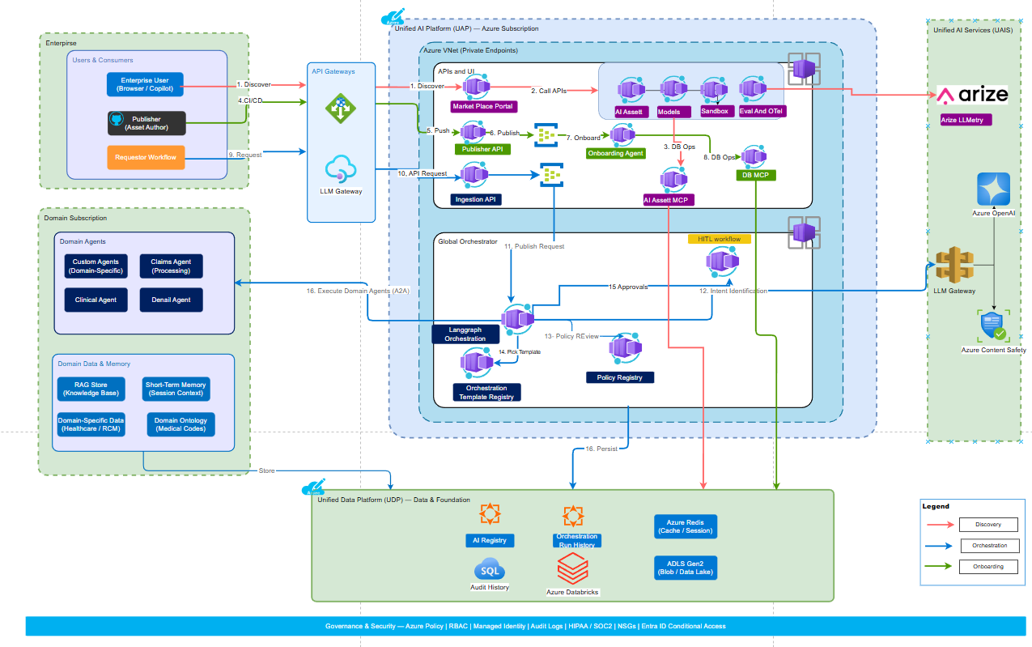

This diagram shows how Optum’s Unified AI Platform (UAP) on Azure moves requests from enterprise users through API gateways, orchestration, AI assets, and data platforms, while enforcing governance and monitoring across the whole flow.
The purpose of this diagram is to represents the end-to-end architecture of the Unified AI Platform (UAP) running in Azure, designed to support revenue cycle management (RCM) AI use cases. It connects enterprise users and domain agents to AI models, LangGraph orchestration, governance workflows, and unified data services in a single platform.

Main zones in the diagram
- Enterprise zone (left): Contains enterprise users, publishers (asset authors), and requester workflows that initiate and consume AI capabilities through App/API gateways.
- Domain subscription zone (lower left): Hosts domain agents such as custom, claims, clinical, and denial agents, along with domain data and memory including RAG stores, short-term memory, and domain ontologies.
- UAP Azure subscription (center): Contains APIs, ingestion, orchestration, model marketplace, AI assets, sandboxes, and governance components such as policy and workflow registries.
- Unified Data Platform (bottom): Provides shared services such as AI registry, SQL audit history, Databricks, ADLS Gen2, Azure Redis, and run history, which persist and serve platform data.
- Unified AI Services (right): Integrates with Azure OpenAI, Azure Content Safety, and Arize for LLM telemetry through an LLM gateway.

Data and request flow
1,2 and 3: Discovery and request: Enterprise users discover AI capabilities through a marketplace portal and send requests through API gateway. This helps to identify right AI asset and capabilities that can be utilized by AI Engineer or domain expert to build the solution.
4-8: Ingestion and AI asset management: Publishers onboard and publish existing AI assets through platform APIs that feed into ingestion services. The ingestion layer registers assets into managed platform components so that models, tools, and other AI assets can be onboarded, governed, and reused. The existing
9-12: Orchestration layer is invoked by requestor(provider) workflow that publish the request and picked up by Langraph based orchestrator to identify the inten
13-15. Orchestrator after identify intent, identify and apply policies on the request, pick orchestration template and execute the domain agents.
16. Domain agent execution: After policy checks, orchestrated workflows call domain agents such as claims, clinical, denial, or custom agents using domain-specific data and memory as context.

Observability
LLM and monitoring integration: LLM calls route through gateway services to Azure OpenAI and Azure Content Safety, while telemetry and monitoring support evaluation and continuous improvement.

Governance and lifecycle
The architecture emphasizes governance, approvals, and auditability before and during execution, which aligns with UAP’s stated focus on compliance, monitoring, and controlled deployment of models and workflows. It also reflects a lifecycle from asset onboarding and marketplace publication to orchestration, execution, storage, and feedback, supporting continuous improvement across AI models and agentic workflows.

8. Physical Architecture
This diagram describes the high-level architecture of the Unified AI Provider Platform (UAP) as deployed on Microsoft Azure using Azure Container Apps for the application layer. The focus is on how traffic enters the platform, how containerized services are organized inside the UAP subscription and virtual network, and how the platform connects to shared AI, monitoring, and data services.
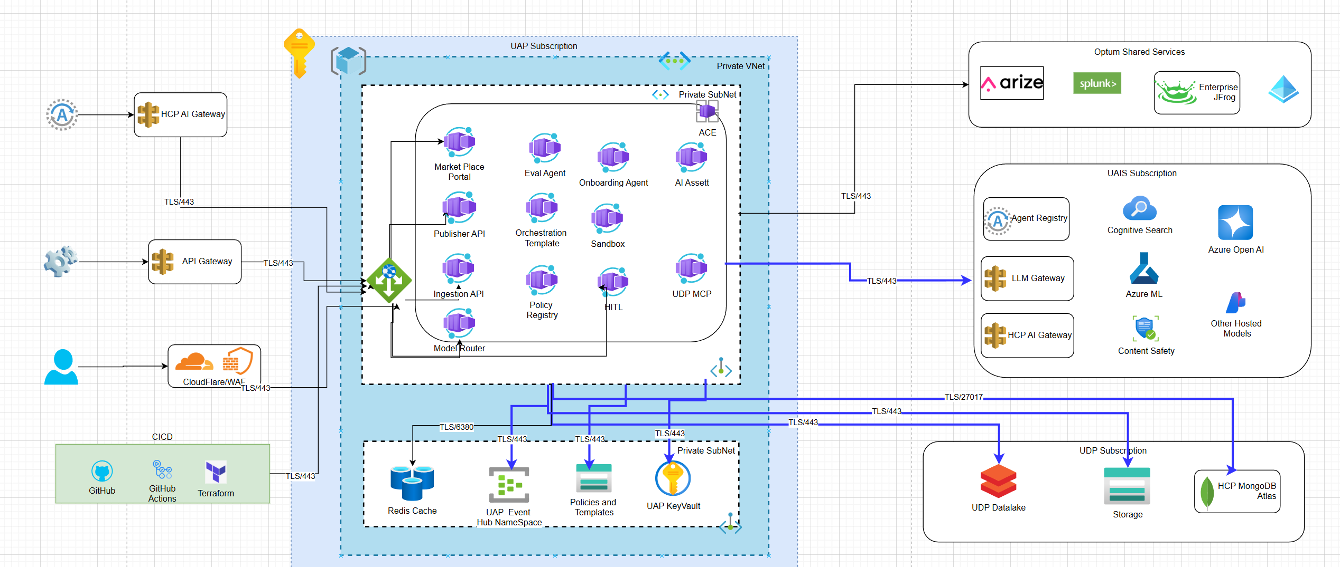

8.1 Entry and Security Layer
External access to UAP is controlled through a set of network and security components:
- Cloudflare / Web Application Firewall (WAF) serves as the primary public entry point for end-user and partner traffic, providing DDoS protection, TLS termination, and application-level security filtering.
- An internal API Gateway and an HCP AI Gateway handle system-to-system integrations and specialized healthcare partner traffic paths.
- All external connections use TLS over port 443, and only traffic that passes WAF and gateway policies is forwarded into Azure.
Once in Azure, requests are routed to an internal load balancer or Application Gateway in the UAP virtual network, which directs traffic to internal services based on path, host, and routing rules.

8.2. UAP Container Apps Environment
Inside the UAP subscription there is a dedicated Azure Container Apps environment deployed into a private subnet of the UAP virtual network:
- The environment is fully private; container apps have no public IP addresses.
- Ingress from the internal load balancer is configured so that only specific container apps accept HTTP traffic.
Within this environment, each logical capability of UAP is implemented as a separate Container App, allowing independent deployment and scaling:
- Marketplace Portal
- Eval Agent
- Onboarding Agent
- AI Asset service
- Publisher API
- Orchestration Template service
- Sandbox service
- Ingestion API
- Policy Registry
- Human-in-the-Loop (HITL) service
- UDP MCP adapter
- Model Router
Service-to-service communication between these container apps occurs over the internal VNet using secure calls and service discovery features of Container Apps. Each app scales automatically based on HTTP traffic, events, or custom metrics, aligning with the platform’s requirement for rapid, low-touch scaling.

8.3 Shared Platform Services within the UAP Subscription
In addition to Container Apps, the UAP subscription hosts shared platform services that support all microservices:
- Redis Cache for low-latency storage of ephemeral state, session information, or cached results.
- UAP Event Hub Namespace for asynchronous messaging, telemetry, and event-driven orchestration between agents and workflows.
- Policies and Templates store for reusable workflow and configuration assets referenced by container apps such as the Policy Registry and Orchestration Template service.
- UAP Key Vault in a private subnet for secure storage of secrets, keys, and certificates, accessed using managed identities from the container apps.
These shared services provide the “glue” that connects the various container apps into a coherent, governed platform, consistent with the governance and one-click deployment requirements in the UAP product definition.

8.4. External AI and Monitoring Services (UAIS and Enterprise Shared Services)
To execute AI workloads, UAP integrates with a separate UAIS subscription:
- LLM Gateway and HCP AI Gateway expose internal endpoints that unify access to multiple model backends.
- Azure OpenAI, Cognitive Search, Azure Machine Learning, Content Safety, and “other hosted models” run in this subscription, typically exposed through private endpoints or VNet-integrated services.
The UAP container apps call these services over TLS through the UAIS gateways, allowing agents and orchestrations to select and invoke different models while maintaining centralized governance and observability.
Above the UAIS subscription, an enterprise shared-services block provides:
- Arize for model performance and drift monitoring.
- Splunk for log and event aggregation.
- Enterprise JFrog (or similar) for artifact and container image management.
- An enterprise identity platform (such as Azure AD/Entra ID) for authentication and authorization.
UAP container apps and gateways emit telemetry, logs, and metrics into these shared services to support monitoring, auditing, and lifecycle management.

8.5. Data Layer (UDP Subscription)
Persistent data is hosted in a dedicated UDP subscription that holds:
- UDP Datalake implemented using Azure Data Lake Storage for large-scale analytical and historical data.
- General Storage accounts for operational artifacts, files, and intermediate outputs.
- HCP MongoDB Atlas or similar document database for configuration, metadata, or operational datasets.
The UAP container apps access these data stores over secure, VNet-integrated endpoints. This separation of concerns (application, AI services, and data) helps enforce security and governance boundaries, especially for PHI/PII and regulatory requirements.

8.6. CI/CD and Lifecycle Management
On the left side of the architecture, a CI/CD toolchain drives continuous delivery for all container-based services:
- GitHub hosts application and infrastructure code.
- GitHub Actions pipelines build container images, run tests, and deploy changes.
- Terraform (and optionally Bicep or ARM) manages declarative infrastructure for Container Apps, networking, and platform services.
Pipelines publish images to an enterprise container registry (for example, JFrog or Azure Container Registry) and then update the respective Container Apps in the UAP environment, enabling rapid, governed release of new agents, APIs, and workflows.

8.7. End-to-End Request Flow
End-to-end, a typical request flows as follows:
- A user or external system sends a request to UAP through Cloudflare/WAF or an API Gateway over HTTPS.
- After security checks, the request is forwarded into Azure and routed by the internal load balancer/Application Gateway to the appropriate entry Container App (often mediated by the Model Router).
- The Model Router determines which downstream agents or services to invoke, calling other container apps (Eval Agent, Onboarding Agent, HITL, etc.) and referencing policies and templates as needed.
- These services, in turn, call AI models and tools via the UAIS LLM Gateway, retrieve or persist data in the UDP datalake and other storage, and emit logs and metrics to shared observability tools.
- The response is assembled and returned back through the gateway and WAF to the caller, with all hops secured via TLS and governed by platform policies.

9. Global Agentic Orchestrator

9.1 Two-Tier Orchestration
- Global Orchestrator (central brain) plus Domain Orchestrators (specialists).
- Global layer owns cross-domain workflows and policies; domain layer owns specialized task execution.

9.2 Three Logical Planes
- Model Plane — LLM access via UAIS (Azure OpenAI) with content filtering and cost-aware routing.
- Tool Plane — enterprise APIs exposed as MCP connectors over a standard interface.
- Agent Plane — domain and platform agents in containers communicating via A2A through the orchestrator.

9.3 Unified Memory
- Redis for sub-millisecond working memory and session context.
- MongoDB for persistent state, AgentCards and episodic memory.
- Vector index (MongoDB vector or Azure AI Search) for RAG and semantic lookups.

9.4 General Orchestrator Workflow
# | Step | Component | Description
1 | Client Request | LLM Gateway | Request enters via domain LLM Gateway with Entra authentication.
2 | Classify Intent | Azure Foundry /classify | Determine intent, phase and domain routing.
3 | Governance Pre-flight | Policy Engine + Entra | Check entitlements, PHI class, budgets and HITL rules.
4 | Select Domain + Plan | AI Search + Registries | Query plan registry and domain orchestrator registry.
5 | Resolve + Bind Tools | MCP / A2A Registries | Bind agents via A2A and tools via MCP from registries.
6 | Delegation Envelope | Orchestration API | Create least-privilege envelope with plan and constraints.
7 | Domain Execution | Event Hubs + Engine | Fan-out via Event Hubs; step loop in the Execution Engine.
8 | Memory + Evidence | Redis + Mongo DB | Short-term state in Redis; episodic memory in Mongo DB.
9 | Post-flight Checks | Content Safety + Policy | PHI redaction, compliance and channel HITL enforcement.
10 | Normalize + Respond | LLM Gateway | Standard schema with provenance and trace_id returned to caller.

9.5 Global Orchestrator Pattern — Nested Workflows
Workflows compose hierarchically: a domain workflow executes as a step in a parent workflow. The MAF pattern wraps a sub-workflow as an executor via .as_executor(), which supports kwargs propagation, request interception and checkpointing. Use-cases include reusable modules (e.g., a claim-check sub-workflow), team-owned composites, isolated testable sub-units, recursive workflows and cross-service composition via A2A.

10. Orchestration Framework — LangGraph vs MAF
The Global Orchestrator engine requires mature graph orchestration, durable execution, first-class human-in-the-loop and enterprise observability. LangGraph and Microsoft Agent Framework (MAF) were evaluated side-by-side. LangGraph was selected for flexibility and maturity and this ; MAF strengths are rebuilt as platform capabilities so that Azure-native observability, identity and compliance hooks are not sacrificed.

10.1 Capability Comparison
Dimension | LangGraph | MAF (v1.0) | Decision
Maturity | Mature, MIT-licensed, production-proven | New v1.0; improving rapidly | LangGraph
Control Granularity | Custom graph: nodes, branches, parallel | WorkflowBuilder DAG | LangGraph
Durable Execution | Built-in checkpointing and recovery | Workflow checkpoints | Comparable
Human-in-the-Loop | Native interrupts and state edits | First-class support | Comparable
Enterprise Observability | Requires LangSmith or custom | Native OTel + Splunk Monitor | MAF
Managed Identity / RBAC | Manual integration | Native, platform-level | MAF
A2A Interoperability | Framework-agnostic open protocols | Best with MS agents (v1.0) | LangGraph
Foundry Hosting | Runs natively alongside MAF | Native Foundry support | Both
Compliance Logging | Custom audit trail | Native workflow hooks | MAF
Multi-Agent Flexibility | Low friction for complex scenarios | More boilerplate in v1.0 | LangGraph

10.2 Compliance Posture
MAF offers native Entra ID, Managed Identity, workflow-level audit hooks and Splunk Monitor integration, while LangGraph requires custom built equivalents. The UAP platform compensates by providing those capabilities as shared services (managed identity injection, OTel exporters, audit log fan-out, RBAC at platform level) so that LangGraph inherits Azure-native compliance posture.

11. Communication Patterns

11.1 Default — Direct Orchestrator-to-Orchestrator Calls
- Global Orchestrator packages a delegation envelope and invokes a Domain endpoint over asynchronous API.
- LangGraph's durable execution pauses the global workflow while the domain runs — no CPU consumed during wait. LangGraph supports orchestrators that call other agents (or sub-graphs) asynchronously, including running them in parallel.
- LangGraph is built around StateGraph / graph nodes, not a single “agent” abstraction, so any node in your orchestrator graph can:
- Call tools, models, or other services using async functions.
- Spawn or route into other graphs (worker agents) when you use orchestrator-worker patterns (via the Send API and dynamic worker nodes).

- State checkpointed to MongoDB; the orchestrator can scale down during waits of hours or days (e.g., human approvals).
- Errors propagate synchronously, simplifying retry, fallback and escalation.

11.2 Azure Event Hub for Bursty Workloads
- Event Hub buffers domain task events durably during surges; domain orchestrators pull at their own pace.
- Scalable fan-out via partitions — millions of events per second; KEDA-scaled consumers.
- Fire-and-forget loose coupling: global does not need domain addresses or availability.
- At-least-once delivery requires idempotent domain handlers; slightly higher latency.

11.3 Decision Matrix
Dimension | Direct Calls | Event Hub
Latency | Low; no queuing overhead | Slightly higher; publish / consume cycle
Throughput | 10K+/day via async I/O and scaling | Unbounded via partitions (millions/sec)
Error Handling | Synchronous, immediate feedback | Event-driven with dead-letter and timeout logic
Ordering | Fully controlled by orchestrator | Per-partition only; cross-partition unordered
Coupling | Orchestrator knows domain endpoints | Fire-and-forget; loose coupling
Complexity | Simpler; fewer moving parts | Higher; idempotency, correlation, DLQ
Burst Absorption | Scale-out domain instances | Hub buffers spikes; KEDA auto-scales consumers
Fault Tolerance | Errors propagate immediately | Events queue during domain downtime
Recommendation: Use Event Hub to manage scalability and traffic spikes for instant processing capacity and support massive parallel fan-out for any future update.

12. Platform AI Agents
Four specialized agents form the cross-cutting operating system of the platform. They sit around the developer's source-control and CI/CD boundary — never replacing it — and add value where deterministic pipelines fall short: scaffolding, policy judgment, supply-chain verification, governance curation and runtime safety. The developer continues to own commits and pushes; GitHub Actions continues to build, sign and emit SLSA-style provenance. The platform agents make sure what gets pushed is already compliant, then turn raw CI outputs into governance-ready, marketplace-ready artifacts. Agents drive — but do not implement — version promotion, canary rollout and rollback; those release-plane mechanics are described separately in §17.3 Lifecycle Management.
What we mean by an agent. Across this section, an "agent" is more than a workflow or REST service: each platform agent is goal-directed, perceives its environment via telemetry and registries, reasons with an LLM under uncertainty, autonomously chooses which tools and APIs to invoke, learns from prior episodes, and acts within explicit policy guardrails — escalating to humans only when its boundary is reached. The four subsections below state, for each agent, the goal it pursues, the decisions it owns without human input, where its reasoning surface lives, and the boundary at which it must hand off to HITL or policy.

12.1 Onboarding Agent
The Onboarding Agent automates the seven-stage publish-to-production pipeline that takes an Agent, MCP server or Tool from a developer submission to a live, governed endpoint in hours rather than weeks. It operates around the developer's source-control and CI/CD boundary in three explicit phases. Phase 1 — Pre-push (co-pilot): in the IDE / Publisher Portal the agent scaffolds the AgentCard / MCP manifest, infers capabilities and data sensitivity from source, lints against tenant policy, generates eval stubs and opens the initial PR with the right labels and CODEOWNERS. Phase 2 — Push and CI (developer-driven): the developer's push (or the resulting PR) is what triggers GitHub Actions; the agent does not invoke CI directly. The hardened builder performs the build, dependency audit and security / supply-chain scan, emits the SBOM (CycloneDX) and the SLSA-style provenance attestation (Sigstore-signed via OIDC), and runs the eval harness — publishing all outputs as workflow artifacts. Phase 3 — Post-push (verify, govern, deploy): the agent ingests those Actions outputs via webhook / Event Grid, cryptographically verifies the SLSA attestation against marketplace policy, registers the AgentCard in MongoDB with status=staging, assembles a human-actionable governance ticket (provenance summary, SBOM / CVE highlights, eval delta, suggested approver), drives Responsible AI / Security approval gates for sensitive or production-tier assets, coordinates infrastructure provisioning on Azure Container Apps with Managed Identity and APIM routing, and oversees the controlled canary rollout (5% → 25% → 50% → 100%). Once verified and approved, the agent hands off to the version-management process described in §17.3 Lifecycle Management, which executes the canary advancement and rollback mechanics on Azure Container Apps revisions.
- Inputs — package artifact and digest, AgentCard / MCP manifest, signed SLSA provenance attestation, SBOM (CycloneDX), CI scan and eval reports, deployment metadata.
- Gates — schema and policy lint (pre-push, by the agent); build, dependency audit, security scan, SBOM and SLSA attestation (in GitHub Actions); provenance verification, Responsible AI review, evaluation thresholds (post-push, by the agent).
- Outputs — verified provenance bundle, registered AgentCard in MongoDB, governance ticket with risk summary, provisioned ACA revision, APIM route, lifecycle event stream.
- Outcome — submission to production in hours; cryptographically verified provenance and audit trail captured for every release.
Agency
:
- Goal - move submission to safely running production with minimum human time and zero unsafe regressions, without ever executing or replacing the developer's CI pipeline.
- Decisions - whether a SLSA attestation satisfies marketplace policy (trusted builder, allowed repo, signed commit), whether scan / CVE findings are real risks or false positives, whether to auto-fix or request changes, which approval tier applies (auto / RAI / SecOps), and whether canary metrics warrant pause, advance or rollback.
- Reasoning surface — LLM scaffolds and enriches the AgentCard from source and README, infers capability / data-sensitivity tags, classifies scan findings, summarises provenance and SBOM evidence into a one-screen governance brief, drafts remediation diffs and reviewer summaries, and routes to the right approval gate based on risk tags.
- Boundary – HITL/policy does not push code, modify workflow files, or invoke GitHub Actions directly; cannot promote past 25% canary on production-tier assets without a signed Responsible AI approval; never bypasses Security Scanner verdicts or accepts an artifact whose provenance attestation fails verification.

Sequence flow:
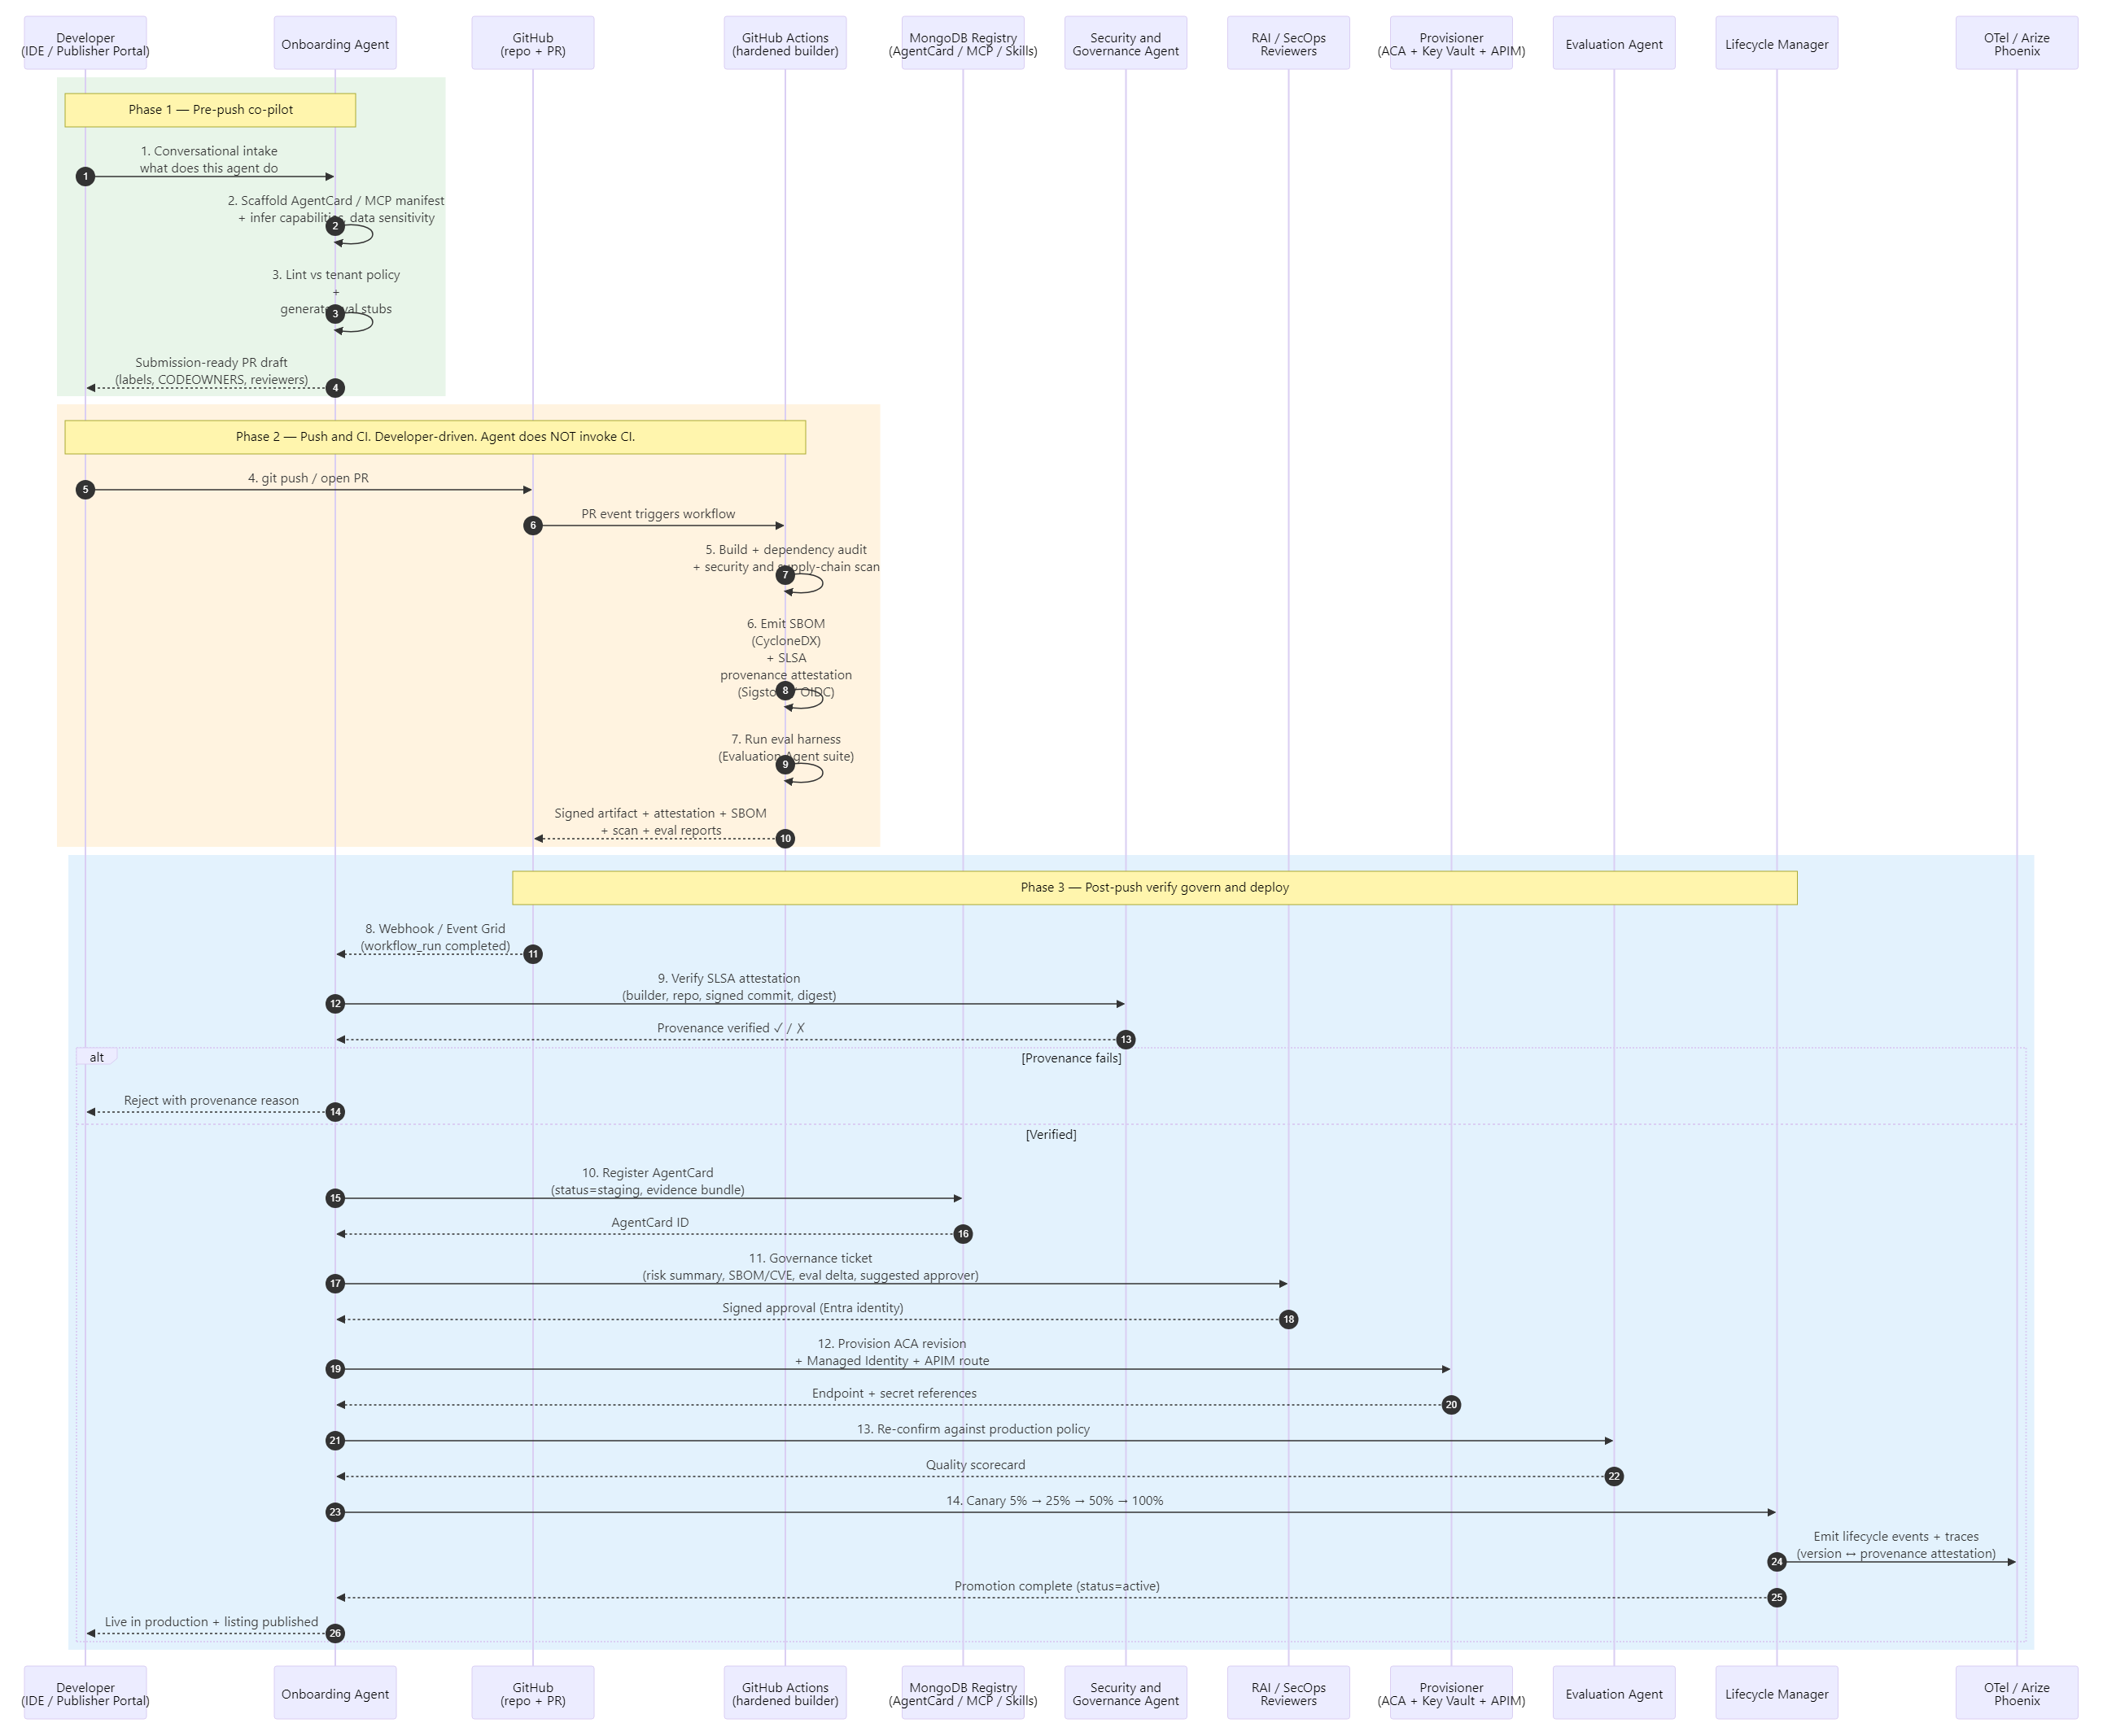
Figure 12.1 — Onboarding Agent sequence: three explicit phases — Phase 1 pre-push co-pilot (scaffold / lint / open PR), Phase 2 developer-driven push that triggers GitHub Actions (build, scan, SBOM, SLSA attestation, eval — agent does not invoke CI), Phase 3 post-push verify-govern-deploy (SLSA verification, registry, governance ticket, approval, provisioning, canary).

12.2 Evaluation Agent
The Evaluation Agent runs continuous quality assessment on every agent, prompt and model version using configurable golden datasets, adversarial probes and LLM-as-a-judge scoring. It is the quality gate that the Onboarding Agent and Lifecycle Manager call before any promotion or canary advancement, and it runs on a schedule for production drift monitoring. Telemetry is captured to a self-hosted Arize Phoenix deployment for HIPAA-aligned LLM observability using Arize. Following metrics are covered by this agent:
- Quality measures — accuracy, relevance, toxicity, bias, clinical correctness; embedding-based drift vs baseline.
- Test sets — golden cases, synthetic edge cases, prompt-injection and jailbreak probes via Azure AI Content Safety.
- Judging — GPT-class LLM-as-a-judge invoked through the APIM AI Gateway with token / cost budgets enforced.
- Outputs — eval scorecard written to AgentCard, certification status, promote / rollback signals to Lifecycle Manager.
Agency:
- Goal — continuously establish and defend a measurable quality bar for every agent, prompt and model version.
- Decisions it owns — which eval suite to run for a given AgentCard (clinical accuracy vs. retrieval vs. safety), when to synthesize new adversarial cases, whether a metric delta is a real regression or noise, and whether to recommend promote, hold or rollback.
- Reasoning surface — LLM-as-a-judge scoring with structured rubrics, embedding-drift interpretation against baselines, and root-cause hypothesis generation when failures cluster across cases.
- Boundary (HITL / policy) cannot mark an agent "production-certified" — only "eligible". Final certification remains a HITL or policy-gated decision.
Sequence flow:
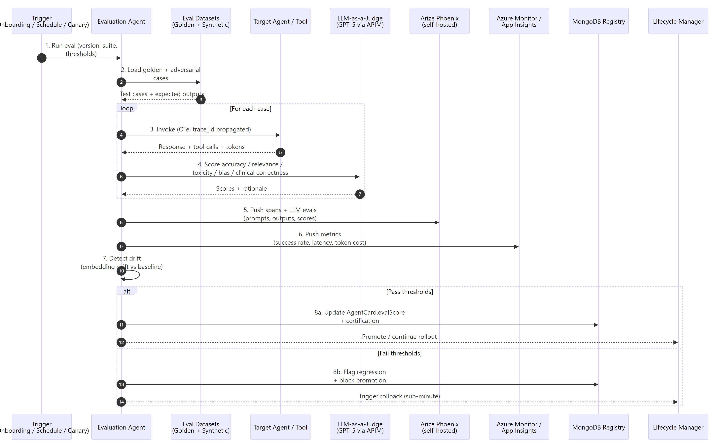
Figure 12.2 — Evaluation Agent sequence: load datasets → invoke target → LLM-as-judge → push to Phoenix and Splunk Monitor → promote or rollback.

12.3 Discovery Agent
The Discovery Agent is the Dynamic Skill Resolver for the platform. It binds runtime intent — whether from the Global Orchestrator, the Marketplace Portal, or a workflow step — to the best available Agent, MCP tool or plan template via capability tag matching, vector-semantic similarity and confidence scoring. Results are filtered by tenant entitlements, Responsible AI tags and policy constraints before binding, ensuring cross-domain reuse without violating data-category or governance rules.
- Catalog — AgentCards and MCP manifests in MongoDB; capability embeddings in MongoDB vector index or Azure AI Search.
- Resolution — tag match + semantic similarity + eval score + cost / SLA → confidence-scored ranked list.
- Policy filter — Policy Registry filters candidates by tenant entitlements, data category and RAI tags.
- Authorization — Security & Governance Agent issues a zero-trust pre-bind authorization with audit ID.
- Outputs — bound endpoint plus Agent Card, declarative plan template hint when applicable, marketplace fallback otherwise.
Agency.
- Goal — bind a runtime intent to the best-fit, policy-compliant capability — even when the request is fuzzy or no exact match exists.
- Decisions it owns — how to decompose intent into capabilities, whether to bind a single agent or compose several, what to recommend when confidence is low, and when to fall back to marketplace search or propose a new submission.
- Reasoning surface — LLM parses intent into capability tags, ranks candidates with a blended score (tag + semantic + eval + cost + SLA), and produces an explanation for the selected binding.
- Boundary (HITL / policy) — cannot bind across data-category boundaries or tenant entitlement violations — the Policy Registry is a hard gate.

Sequence flow:
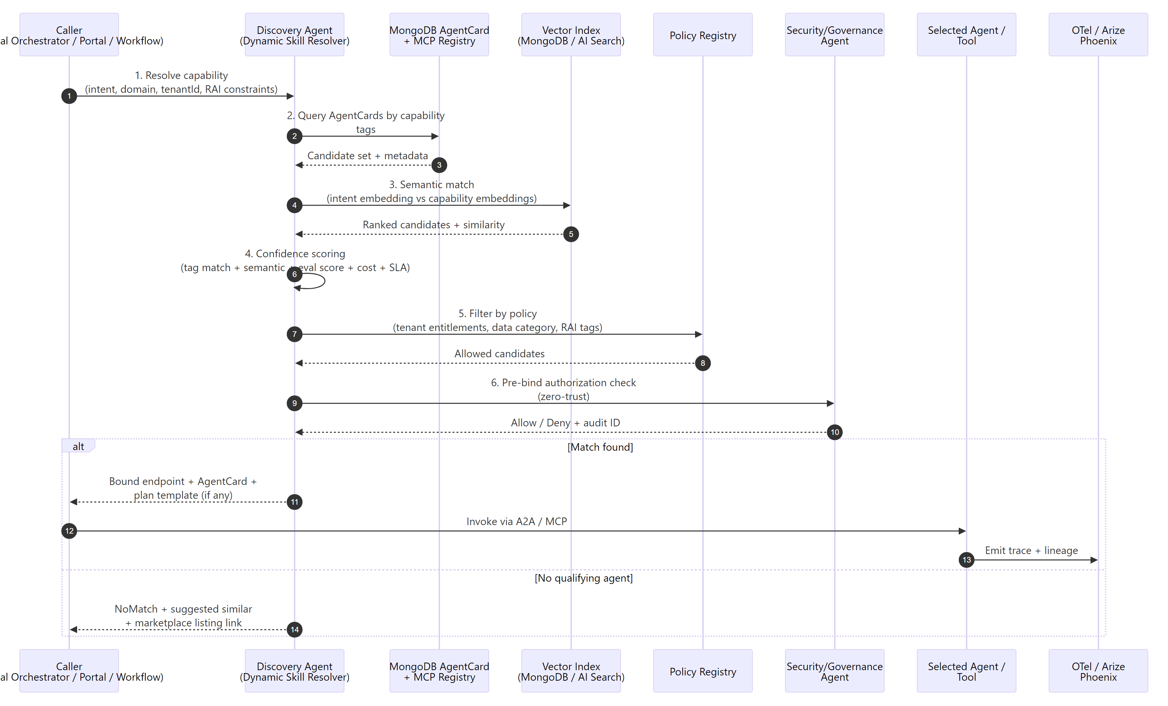
Figure 12.3 — Discovery Agent sequence: capability query → registry + vector match → policy and authorization filter → bind or fall back.

12.4 Observability, Security & Governance Agent
The Observability, Security & Governance Agent is a single cross-cutting agent with two complementary roles. As Security & Governance, it cryptographically verifies the SLSA provenance attestation of every published artifact (builder identity, source repo + commit, signature) before promotion, and performs pre-execution policy evaluation on every step — invoking Azure AI Content Safety Prompt Shields for jailbreak and indirect prompt-injection detection, redacting PHI / PII, checking entitlements and token / cost budgets against the Policy Registry, and issuing scoped Managed Identity credentials from Key Vault. As Observability, it continuously ingests OpenTelemetry GenAI semantic spans and Arize LLM metrics, correlates production behavior with the agent version and its provenance attestation, detects anomalies and drift, and triggers automated remediation through the Lifecycle Manager (rollback, scale, circuit-break) with full audit trail in MongoDB. Remediation actions (rollback, scale, circuit-break) are dispatched to the version-management process defined in §16.3 Lifecycle Management.
- Pre-execution — SLSA provenance verification, Prompt Shields, PHI / PII redaction, policy evaluation, scoped credential issuance, allow / deny / HITL.
- Telemetry — OpenTelemetry GenAI conventions (model, tokens, tool calls) → Arize Phoenix; infra metrics → Splunk.
- Detection — error spikes, latency anomalies, model and embedding drift, cost burn-rate, RAI score regressions.
- Response — raise incident, log to immutable audit (MongoDB TTL), trigger rollback or saga compensation via Lifecycle Manager.
- Compliance — every decision is signed with Entra identity and traceable end-to-end via OTel trace_id.
Agency.
- Goal — keep the running platform safe, performant and within policy without an operator in the loop for routine events.
- Decisions it owns — whether a SLSA attestation matches policy, whether a Prompt Shields trigger is a real attack or a softenable false positive, whether anomalous latency / drift warrants alert, scale, circuit-break or rollback, whether to redact-and-continue versus deny, and which incidents to escalate.
- Reasoning surface — LLM-driven provenance and anomaly explanation that correlates build-time attestation evidence with runtime Phoenix LLM signals and Splunk Monitor infra signals, plus remediation proposal generation grounded in prior episode memory.
- Boundary (HITL / policy) — cannot disable a policy or change AgentCard certification; can quarantine, scale or rollback but never delete an asset.
Sequence flow:
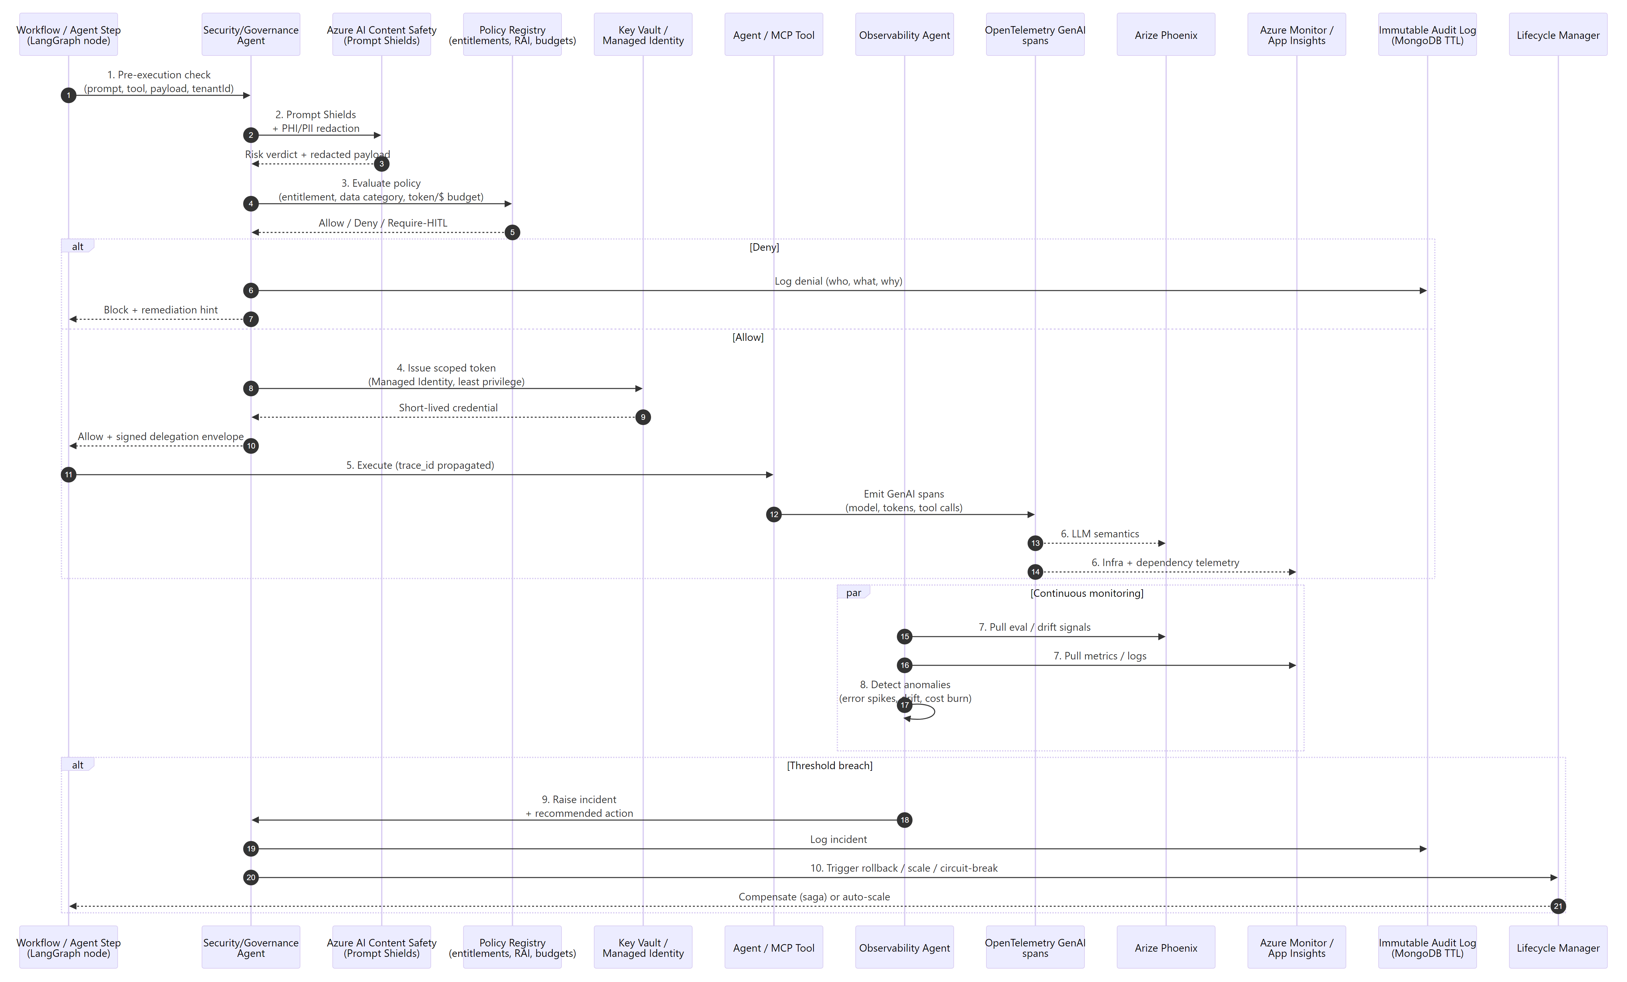
Figure 12.4 — Observability, Security & Governance Agent sequence: pre-execution gate → scoped credential → telemetry capture → anomaly detection → automated response.

13. Azure AI Foundry Capability Mapping
UAP capabilities map directly to Azure AI Foundry and supporting Azure services. The table below summarizes the current GA posture and mapping; the full feature matrix is maintained separately.
UAP Capability Area | Azure Foundry / Azure Service | GA Status | Notes
Model Marketplace — Central Repository | Azure AI Foundry Projects & Hub Workspace | GA (East US / East US 2) | Registers and manages models with metadata; model cards via evaluations workspace.
Model Marketplace — BYOM | Azure AI Foundry Model Catalog + BYOM onboarding | GA | 1800+ models (OpenAI, Meta, Mistral, DeepSeek); custom and partner models under same governance.
Model Marketplace — Approval Workflow | Foundry Governance + Publisher API | GA | Draft → Review → Approved pipeline with Responsible AI reviewers.
Model Marketplace — Drift Detection | Foundry Evaluations + Splunk Monitor | GA | Performance drift and bias detection triggers retraining or rollback.
Model Marketplace — Champion/Challenger | Foundry Evaluations + APIM routing | GA | Compare new model versions via weighted traffic splits.
One-Click Deployment | Foundry Deployments + ACA / Functions | GA | Zero-downtime blue-green and canary rollout for models, agents and workflows.
RAG Integration | Azure AI Search + Foundry Knowledge | GA | Shared RAG module; vector + hybrid retrieval across marketplace assets.
IMDE — Secure Sandbox | Foundry Compute + VNet-integrated notebooks | GA | Safe experimentation environment connected to enterprise data sources.
IMDE — Multi-Modal Pre-loaded Tools | Foundry AI-ML / LLM / Multimodal / DL images | GA | Pre-loaded environments for classical ML, LLMs, multimodal and deep learning.
Global Agent Orchestrator | MAF / LangGraph on ACA + Foundry Agent Service | GA | Typed Agent / MCP / Model / Tool / Control-Flow / HITL / Governance nodes.
Visual Agent Builder | Next.js + React Flow canvas | App | Drag-and-drop assembly with guardrails, versioning, approvals and rollback.
Cross-Cutting — Multi-Tenant Isolation | Mongo DB tenantId partition + Entra | GA | Data and execution isolated per tenant; VNet-private traffic.
Cross-Cutting — HIPAA / SOC 2 | Azure HIPAA-covered services + policy controls | GA | PHI / PII protection, audit trail, covered-service usage.

14. Security, Compliance and Governance

14.1 Identity and Access
Microsoft Entra ID is the single source of truth and authoritative identity provider for all human users, platform services, AI agents, and external workloads in the Unified AI Platform (UAP).
Identity Types and Assignment
- Human users & groups: Standard Entra ID user and security group objects with Conditional Access policies, MFA, and device compliance enforcement.
- Platform services & runtimes (ACA, Functions, APIM backends): User-assigned Managed Identities (zero-secret, Entra ID–backed).
- AI Agents & domain orchestrators: Microsoft Entra Agent ID (dedicated agent service principals). Each agent receives a unique, auditable identity in Entra ID that supports granular Conditional Access, audit logging, and lifecycle management separate from human or general workload identities.
- External CI/CD workloads (GitHub Actions): Entra ID Workload Identity Federation using OpenID Connect (OIDC). Federated credentials are configured on the target Entra ID application or Managed Identity, scoped to repository, environment, branch, and workflow. The azure/login@v2 action exchanges GitHub’s short-lived OIDC token for an Entra ID access token with no secrets stored in GitHub.
Core Design Patterns
- Zero-secret authentication everywhere: No client secrets, certificates, or static credentials are used or stored in code, configuration, or GitHub. All service-to-service calls rely on Managed Identities or federated OIDC tokens.
- Least-privilege delegation envelopes: The Global Orchestrator (via the LLM Gateway) issues short-lived, audience-restricted, scoped JWTs for agent-to-agent (A2A) and agent-to-tool (MCP) calls. Claims and context are evaluated by the Policy Engine at execution time.
- AgentCard metadata enforcement: Every AgentCard carries identity, data-category, and Responsible AI tags. The Security & Governance Agent and Policy Engine enforce these declaratively at both publish time (Security Scanner) and execute time.
- Multi-tenancy & isolation: All identities, tokens, and data are partitioned by tenantId. Per-tenant quotas, rate limits, and cost attribution are enforced at the LLM Gateway and Policy Engine.
Compliance & Observability
- Every identity action (token issuance, delegation, access) is logged immutably to the Audit Log (MongoDB) with full provenance.
- Microsoft Entra audit logs, Conditional Access signals, and risk detections feed into Azure Splunk and the Observability Agent.
- Human-in-the-Loop (HITL) and elevated actions require explicit reviewer sign-off with reversible saga compensation.
This model satisfies HIPAA, SOC 2, and Optum/UHG zero-trust standards while enabling the automated 7-stage onboarding pipeline and cross-domain agent reuse.

14.2 Network and Secrets
- VNet isolation and subnet segmentation for all Azure Container Apps and Functions workloads.
- mTLS between APIM and backend LLM / agent / MCP endpoints.
- Azure Key Vault with Managed Identity access for all secrets and certificates — no secrets in configuration.

14.3 Data Protection
- PHI / PII detection and masking in inbound prompts, plus output content filtering for harmful categories.
- AgentCards carry Responsible AI and data-category tags; Security Agent enforces declaratively at publish and execute.

14.4 Governance Controls
- Agent Security Scanner (static) gates publication; Policy Engine gates execution.
- Immutable audit log in MongoDB with TTL — who did what, when, with what outcome.
- Human-in-the-Loop gate for sensitive actions — denials, high-value claims, elevated data categories.
- Responsible AI board reviews at onboarding and on material version changes.

15. Data and Observability

15.1 Three-Tier Memory
- Short-term — Redis session and working memory (sub-millisecond).
- Episodic —Mongo DB for run state, AgentCards, audit records, workflow checkpoints.
- Long-term — ADLS Gen 2 for summary-first evidence bundles; raw PHI is never persisted at this tier.

15.2 Observability Stack
- OpenTelemetry trace_id propagation across gateway → orchestrator → agent → LLM → MCP hops.
- Splunk for infrastructure metrics, KQL queries and alerts.
- Arize Phoenix for LLM-semantic traces, LLM-as-a-judge evaluations and drift detection.
- Real-time LLM Gateway dashboard — throughput, latency, error rates, token burn and per-tenant cost attribution.

16. Deployment and DevOps

16.1 Runtime Topology
- Azure Container Apps run stateless FastAPI registries, MCP server, orchestrator and domain and platform agents, with KEDA-based scaling and scale-to-zero where appropriate.
- Azure App Gateway provide secure access to azure environment for user and github
- UAIS API Gateway fronts both the API surface and the LLM / MCP gateway; Cloud Flare provides global edge routing.

16.2 Developer Experience
- Agent Development Lifecycle: scaffold → code → test → register as a discoverable A2A agent.
- MCP tool development: build → test → publish to registry → agents discover.
- Visual workflow builder — select agents, wire edges, attach policies, save as a plan template.
- Local testing — DB emulator plus VS Code F5 debug with policy-decision inspection.
- CI/CD — azd up and GitHub Actions; Git push → build container → deploy to Container Apps → verify.
- Day-2 operations — monitor executions, review policy violations, update agents and version templates.

16.3 Lifecycle Management
Lifecycle Management is the platform's release-plane discipline for safely evolving Agents, MCP servers, Tools and prompts over time. It is not itself an agent — it is a set of automated mechanics on Azure Container Apps revisions and the AgentCard / MCP Registry that the Onboarding Agent and the Observability, Security & Governance Agent drive on behalf of the platform. The Lifecycle process owns versioning, promotion, rollback, deprecation and per-version provenance.
- Versioning — semantic versioning (MAJOR.MINOR.PATCH) for every Agent, MCP server, Tool and prompt; multiple versions run concurrently for backward compatibility.
- Promotion — canary releases with orchestrated traffic shifts 5% → 25% → 50% → 100%, evaluation-gated at each step by the Evaluation Agent (§12.2).
- Rollback — automated regression detection by the Observability, Security & Governance Agent (§12.3) triggers an Azure Container Apps revision swap with sub-minute revert.
- Deprecation — 90-day deprecation notices with auto-decommissioning of containers; consumers receive APIM-mediated notifications and are migrated to the successor version. The declarative plan-template library grows via contributions and validated deprecations.
- Provenance per version — every release is logged to MongoDB and Arize Phoenix and linked back to the SLSA-style attestation that promoted it, so any version in production is traceable to its build, scan, eval and approval evidence.

17. Key Architecture Features
Sixteen features anchor the UAP differentiation story, split into security and orchestration foundations (1–8) and scalability, extensibility and autonomy features (9–16). Each maps directly to components above.

17.1 Features 1–8 — Security and Orchestration Foundations
# | Feature | Components | Key Differentiator
1 | Enterprise Security | LLM GW, Entra ID, Key Vault, Security Scanner | Zero-trust, VNet isolation, PHI redaction, HIPAA-ready
2 | Plan-Based Orchestration | Execution Engine, Workflow Templates, Registries | Declarative plans, delegation envelope, step polymorphism
3 | Semantic Discovery | Azure AI Search, Asset Catalog, MCP/A2A Registries | Vector-indexed search, .well-known crawl, federation
4 | Human-in-the-Loop | HITL Gate, Execution Engine, Admin Dashboard | First-class step type with full audit provenance
5 | Three-Tier Memory | Redis, Mongo DB, ADLS Gen 2 | Summary-first flush, episode records, no raw PHI
6 | Multi-Protocol Tools | MCP GW Proxy, MCP Registry, A2A Registry, Foundry | MCP + A2A + Foundry + SaaS in a single gateway
7 | Governance | Policy Engine, Publisher API, Scanner, Admin UI | Dual enforcement at publish and execute with full audit
8 | Observability | Arize Phoenix, Splunk Monitor, ACA | OpenTelemetry end-to-end with per-episode trace IDs

17.2 Features 9–16 — Scale, Extensibility and Autonomy
# | Feature | Components | Key Differentiator
9 | Azure-Native, Not Locked | MCP GW Proxy, A2A Registry, Foundry, ACA | Open protocols, federation and optional Foundry
10 | Production Infrastructure | ACA, Functions, Event Hub, LLM Gateway, Mongo DB | Subnet isolation, scale-to-zero, Bicep IaC
11 | Intelligent Tool Finder | Azure AI Search, MCP Registry, Azure OpenAI | FAISS vector matching; agents self-discover tools
12 | Dynamic Invocation | Execution Engine, MCP GW Proxy, AI Search | Discover, resolve and call in one turn with no pre-config
13 | Load Balancing | LLM Gateway, ACA, MCP GW Proxy | Health-aware routing across MCP server replicas
14 | IDE Integration | MCP Registry, Asset Catalog, LLM Gateway | One-click IDE setup from marketplace registry
15 | JWT Token Vending | Entra ID, Key Vault, LLM Gateway | Machine-to-machine scoped tokens for autonomous agents
16 | Context-Aware Permissions | Policy Engine, Entra ID, LLM Gateway | Dynamic per-invocation scope evaluation, not just RBAC

18. Key Design Decisions
The following decisions define the Global Agentic Orchestrator for RCM and, by extension, the UAP reference architecture.
# | Decision | Rationale
01 | Two-Tier Orchestration | Central Global Orchestrator plus specialized Domain Orchestrators. Separates cross-domain policy from in-domain expertise.
02 | LangGraph over MAF (v1.0) | Mature graph engine with durable checkpoints and framework-agnostic A2A. MAF strengths rebuilt as platform capabilities.
03 | Direct A2A Calls (Default) | Synchronous API with async behavior via LangGraph durable pauses — lowest latency. Event Hub added only for bursty fan-out.
04 | Capability-Based Discovery | AgentCards in MongoDB registry plus a confidence-scored resolver enable cross-domain reuse without hardcoded endpoints.
05 | MCP for Enterprise Tools | Enterprise APIs (claims, EHR, billing) wrapped as MCP servers behind APIM — uniform tool surface with zero-trust via Entra ID.
06 | Three-Plane Architecture | Model Plane (UAIS / Azure OpenAI), Tool Plane (MCP), Agent Plane (containers), with unified memory (Redis + MongoDB + vector index).
07 | Automated 7-Stage Onboarding | Submission → Validation → Registration → Approval → Provisioning → Test → Canary, with human gates where required.
08 | Canary + Instant Rollback | Semantic versioning with 5% → 25% → 50% → 100% traffic shifts; ACA revisions enable sub-minute revert on regression.
09 | Arize Phoenix for LLM Ops | Self-hosted on Azure for HIPAA. OTel traces plus LLM-as-a-judge plus drift detection correlated with Splunk Monitor infra metrics.
10 | Managed identities vs Entra Agent ID | Microsoft’s recommendation is to leverage Entra Agent IDs where possible; however, due to implementation dependencies, managed identities may be used initially instead.

19. Decision Matrix for UAP
The following decisions apply to the UAP reference architecture.
# | Decision | Rationale
01 | Use of MCP for Data access | MCP tools will be used for Data access
02 | LLM gateways | UAIS platform will be leverage for LLM gateways
03 | Mongo DB | Episodic memory
04 | Redis | Fast state
05 | API gateways | OI gateway (External), HCP gateway (Internal) for mcp and a2a
06 | Observability | Arize, Splunk, NESS
07 | Graph-Based Execution Engine | LangGraph or Microsoft Agent Framework
08 | Azure Container Apps for Agent Runtime | With auto-scaling support
09 | Zero‑Trust + Entra ID Integration | Identity and access via Entra ID (Azure AD)
10 | Security Scanning | Sonar,JFrog

20. Risks
The following risks have been identified for the UAP platform.
# | Risk | Rationale
01 | Feature Maturity Risk | Some of the AI Foundry features may be in private preview that can prevent Optum from leveraging those features
02 | Dependency on UAIS / Middleware | UAIS APIs may not expose all required functionality
03 | Platform Capability Gaps | Foundry and UAIS does not natively provide some workflow features (e.g., orchestration UX, approval pipelines). Need for custom engineering
04 | Fragmentation & Integration Risk | Agents are not fully integrated into shared context will result in inconsistent decisions across claims lifecycle
05 | Adoption Risk | Governance circumvention by Domain and applicatin teams will result in inefficient workflows and AI assets sprawl
06 | Multi-Agent Coordination Complexity | UAP orchestrates multiple agents + humans in workflows. Possible failures include Partial execution failures and Inconsistent decision outcomes
07 | Human-in-the-Loop Risk | Platform includes human escalation workflows. Bottlenecks due to manual approvals
08 | Observability & Debugging Risk | Platform requires end-to-end tracing and monitoring. Includes agents,tools and external systems
09 | Throughput / Latency Risk | Orchestrator can become a bottleneck
10 | Resiliency Risk | Central orchestrator or MCP gateway failure. It may cascade failures across workflows

21. Technical Questions
Open Questions for UAIS platform
1.Does UAIS natively provide model report cards with- evaluation summaries (accuracy, bias, limitations)?
2. Does UAIS support controlled model comparison (champion vs challenger) natively?
3. Does UAIS provide a true “one-click deployment” experience for models, agents, prompts and workflows
4. What APIs exist in UAIS for registering assets, promoting to production, triggering deployment?
5. Does UAIS enforce standardized input/output schemas across: agents and tools (MCP)
6. Does UAIS support environment isolation such as preview / staging deployments
7. Does UAIS provide pre-configured environments
8. Does UAIS support reusable workflows or templates as first-class entities?

22. Expected Impact and Benefits
Benefit Area | Impact | Supporting Evidence
Faster Deployment | Agent onboarding: weeks → hours | Automated 7-stage pipeline replaces manual coordination.
Increased Reuse | 40–50% of new projects leverage existing agents | Shared registries plus plan templates create network effect.
Operational Efficiency | 20%+ productivity gains in claims processing | Optum pilot data; AI catches errors and denials upfront.
Denial Reduction | Significant reduction in avoidable denials | Approximately 85% of claim denials preventable with right info.
Quality Assurance | All agents vetted for fairness, bias and performance | Continuous evaluation via Arize Phoenix plus LLM-as-a-judge.
Compliance | Full audit trail; HIPAA-ready by design | Every action logged with provenance; Responsible AI board.
Developer Productivity | AI pair-programming for 20K+ engineers | Developer Productivity Agent plus platform templates.
Risk Mitigation | Canary releases + instant rollback | Lifecycle Agent monitors quality and auto-reverts on regression.
Net effect: Faster onboarding (weeks → hours) · 40–50% agent reuse · HIPAA-ready by default · scale to 100K+ encounters/day.

23. Glossary
Term | Definition
A2A | Agent-to-Agent protocol: HTTP-based, self-describing via Agent Cards, enabling capability discovery and invocation across agents.
ACA | Azure Container Apps — managed serverless container platform with KEDA-based auto-scaling and per-revision traffic splitting.
APIM | Azure API Management — fronts UAP registries and the LLM / MCP gateways with policies, auth, throttling and observability.
HITL | Human-in-the-Loop gate: first-class workflow step that pauses automation for manual review with full decision provenance.
MAF | Microsoft Agent Framework — Microsoft's strongly typed workflow framework with native Azure observability and RBAC integration.
MCP | Model Context Protocol — JSON-RPC 2.0 standard for exposing tools, resources and prompts to agents.
PTU | Provisioned Throughput Unit — reserved Azure OpenAI capacity with predictable latency; PAYG is the pay-as-you-go fallback.
RCM | Revenue Cycle Management — healthcare administrative workflows (eligibility, prior-auth, billing, claims, denials).
UAIS | Unified AI Services — middleware layer normalizing access to Foundry, OpenAI, MCP and A2A with consistent auth, retries and telemetry.
UAP | Unified AI Platform — the overarching platform described in this document.
UDP | Unified Data Platform — persistence and observability backbone (MongoDB, Redis, Arize Phoenix, Splunk Monitor, ADLS Gen 2).

24. Appendix

24.1 Sequence Diagrams (Work in Progress)
Twelve sequence diagrams are authored to complement this document — six for Developer Experience flows and six for RCM Domain Orchestration flows. They will be published as a companion deck and linked from the Marketplace documentation site.

24.2 Reference Source Documents
- Draft — UAP AI Marketplace Architecture.
- Global Agentic Orchestrator Design v2 (with decisions).
- UAP — Azure Foundry feature matrix.
- UAP — LLM Gateway feature matrix.

24.3 Referenced Technologies
Microsoft Agent Framework, LangGraph, Azure Container Apps, Azure Functions, Azure API Management, Azure AI Foundry, Azure OpenAI, Azure AI Search, Azure AI Content Safety, MongoDB (Atlas / Mongo API), Azure Cache for Redis, ADLS Gen 2, Azure Event Hubs / Event Grid / Service Bus, Entra ID, Managed Identity, Key Vault, Splunk Monitor and Analytics, Arize Phoenix, OpenTelemetry, MCP (Model Context Protocol), A2A (Agent-to-Agent) protocol, Next.js 15, React Flow, Azure Front Door, Bicep.

24.4 180 Day Roadmap

24.4.1 Group 1 — Core Platform
Layer | Capability
Presentation & UX | Web Portal / CLI Discovery (React Flow drag-drop)
Presentation & UX | Admin Dashboard (governance, health, approvals)
API & Registries | AI Asset Catalog (CRUD, versioning, search)
API & Registries | MCP Server & Tool Registry
Orchestration & Governance | Workflow Templates (reusable patterns)
Orchestration & Governance | Execution Engine (graph dispatch, retries, fan-out)
Data & Observability | Audit Log (immutable, TTL, Mongo DB)
Data & Observability | Metrics & OTLP (OpenTelemetry → Splunk)

24.4.2 Group 2 — Governance and Publisher
Layer | Capability
Presentation & UX | Publisher Portal (submission lifecycle)
Presentation & UX | Playground (interactive agent / tool testing)
Presentation & UX | DevUI (MAF agent debugging surface)
API & Registries | Agent Skills Registry
API & Registries | Publisher & Submission API
API & Registries | Security Scanner (static + runtime validation)
Orchestration & Governance | Human-in-the-Loop Approval Gate
Orchestration & Governance | IAM & RBAC Access Control (Entra ID)
Orchestration & Governance | Compensation Logic / Saga (rollback coordination)
Data & Observability | Projects & Workspace (team-owned work areas)
Data & Observability | Ratings & Reviews (community feedback)
Data & Observability | Execution History (run outcomes, traces)
Out of scope: The existing Web Dashboard is already shipping. Layer 5 Azure services are provisioned independently via Bicep IaC and tracked outside the application backlog.

