Week-01-overview of c ,constants , variables , data and types
Week 1 – 0
Coding-C-language features-optional.
REG NO.:241801268
NAME : SHYAM SUNDAR.K
Q1)
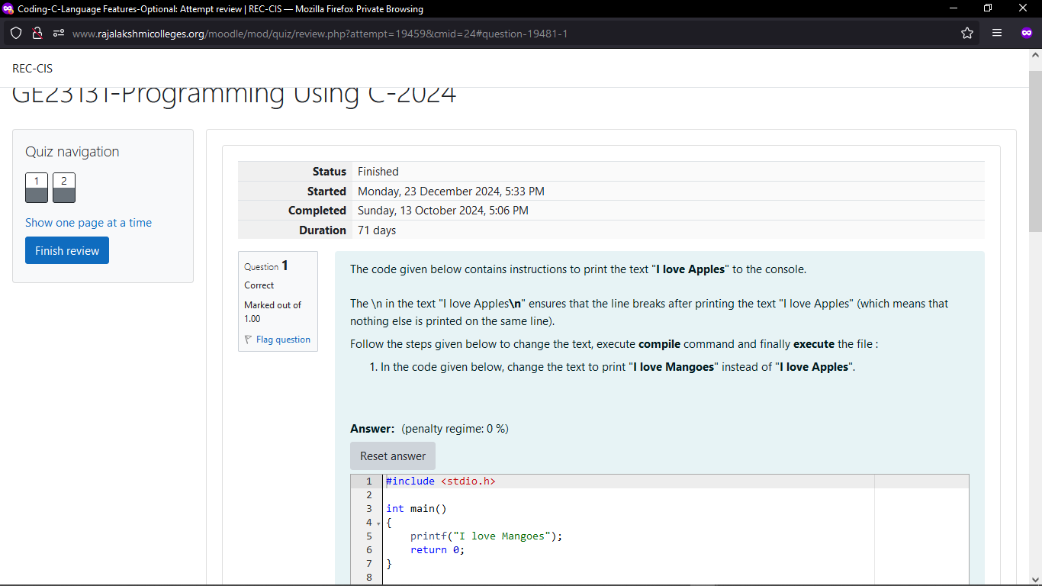
OUTPUT

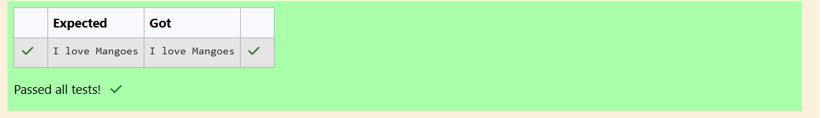

WEEK 1-0
CODING C LANGUAGE FEATURES OPTIONAL
REG NO.:241801268
NAME: SHYAM SUNDAR.K
Q2)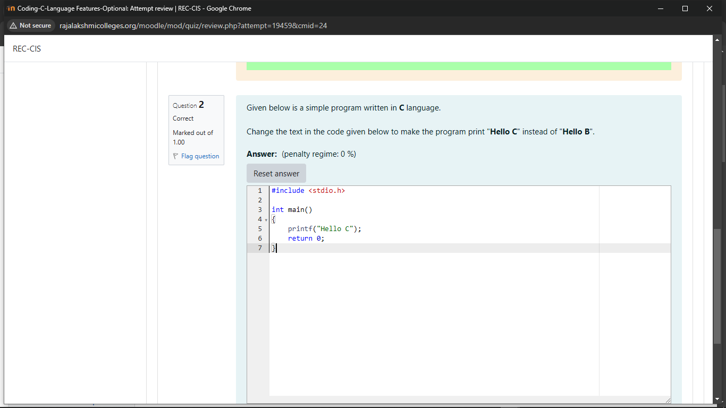
OUTPUT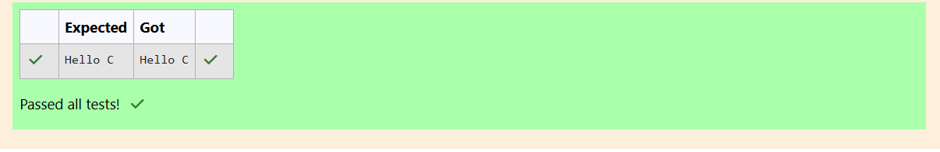

Week 01-01-practice session coding
Reg no : 241801268
Name : SHYAM SUNDAR.K
Q1)
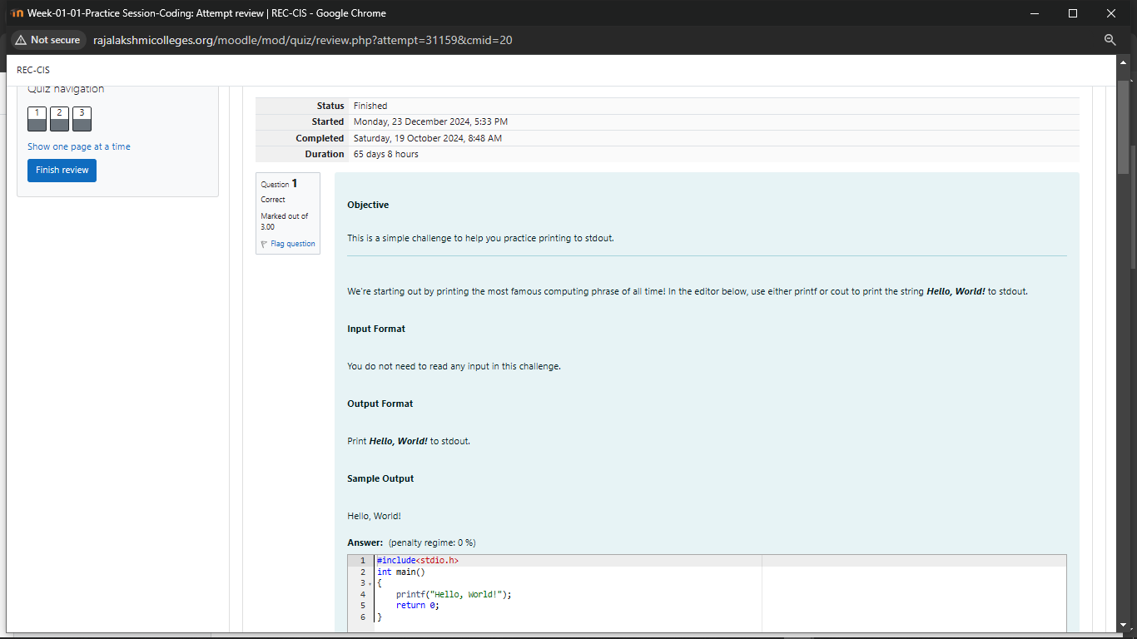
OUTPUT
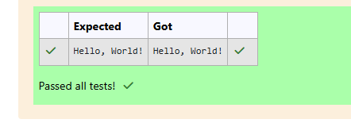
Week 01-01-practice session coding
Reg no : 241801268
Name : SHYAM SUNDAR.K
Q2)
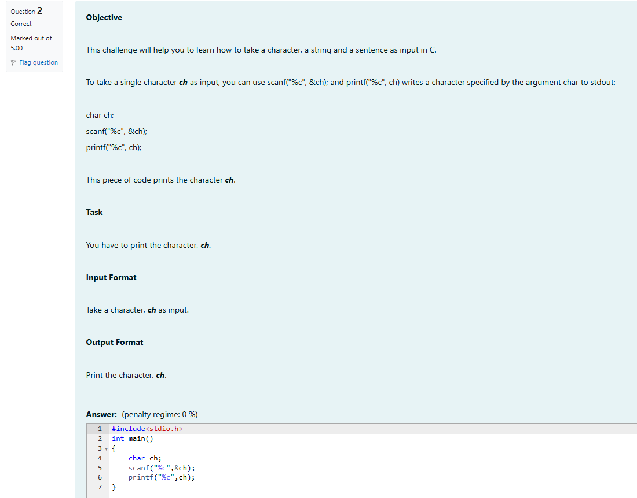

OUTPUT
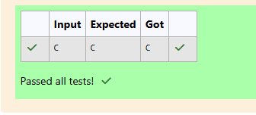
Week 01-01-practice session coding
Reg no : 241801268
Name : SHYAM SUNDAR.K
Q3) 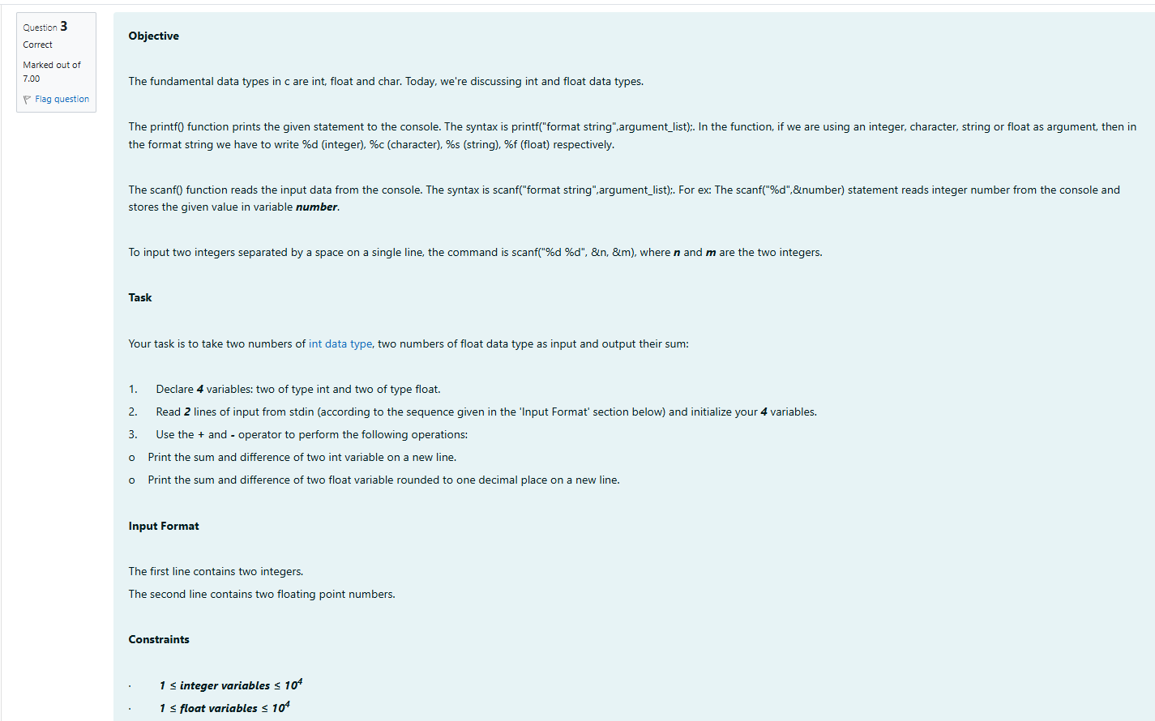
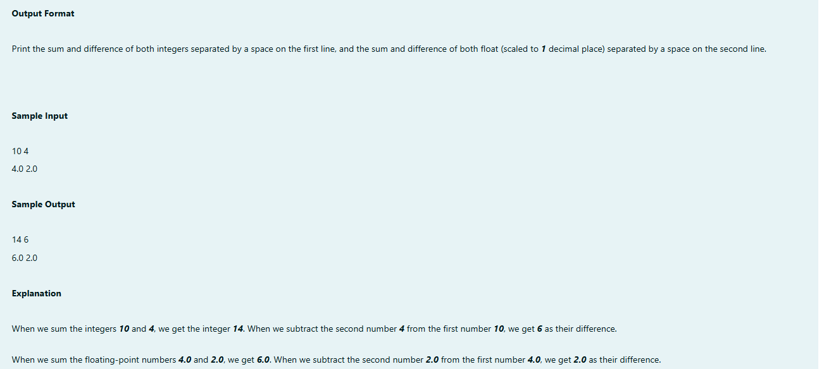

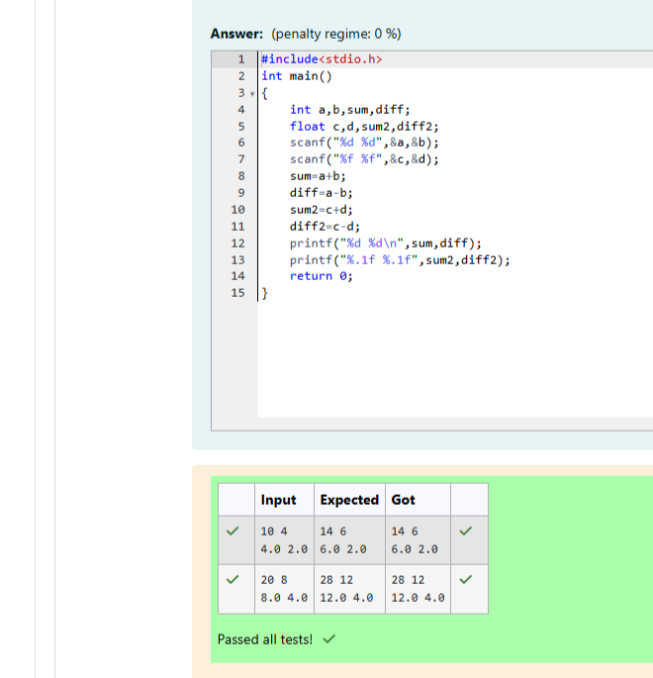

Week 01-02-practice session coding
Reg no : 241801268
Name : SHYAM SUNDAR.K
Q1)
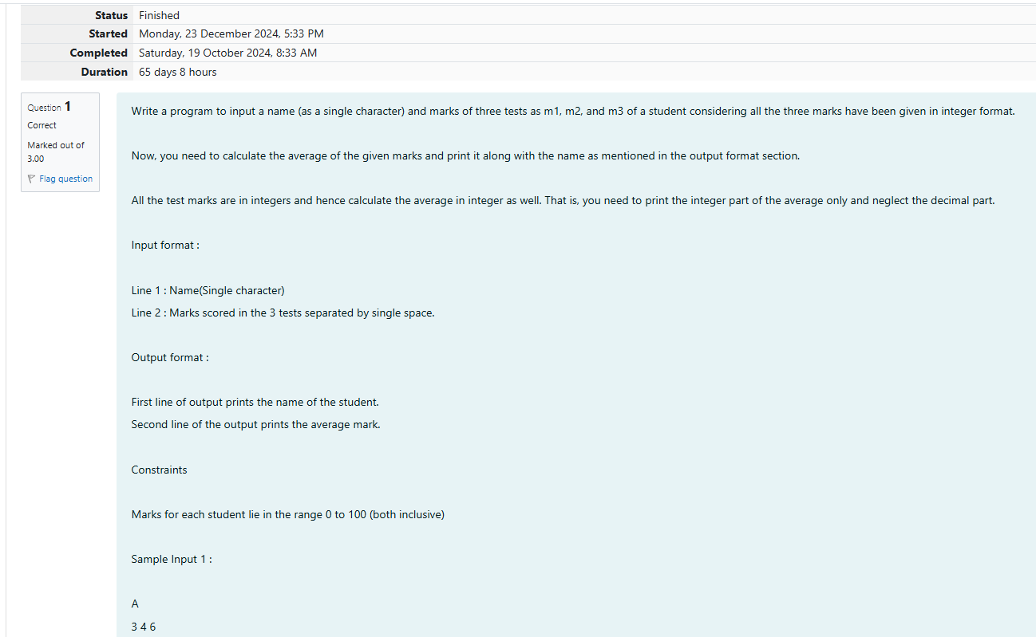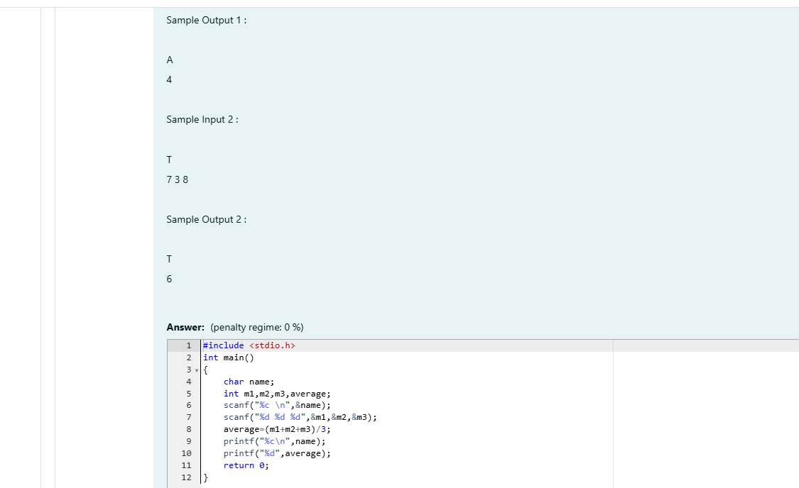
OUTPUT
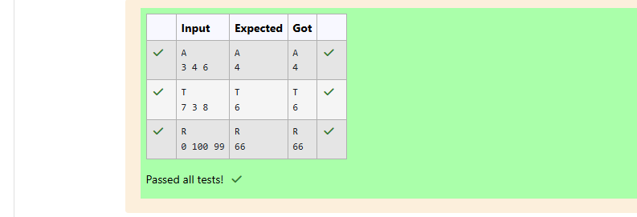

Week 01-02-practice session coding
Reg no : 241801268
Name : SHYAM SUNDAR.K
Q2)
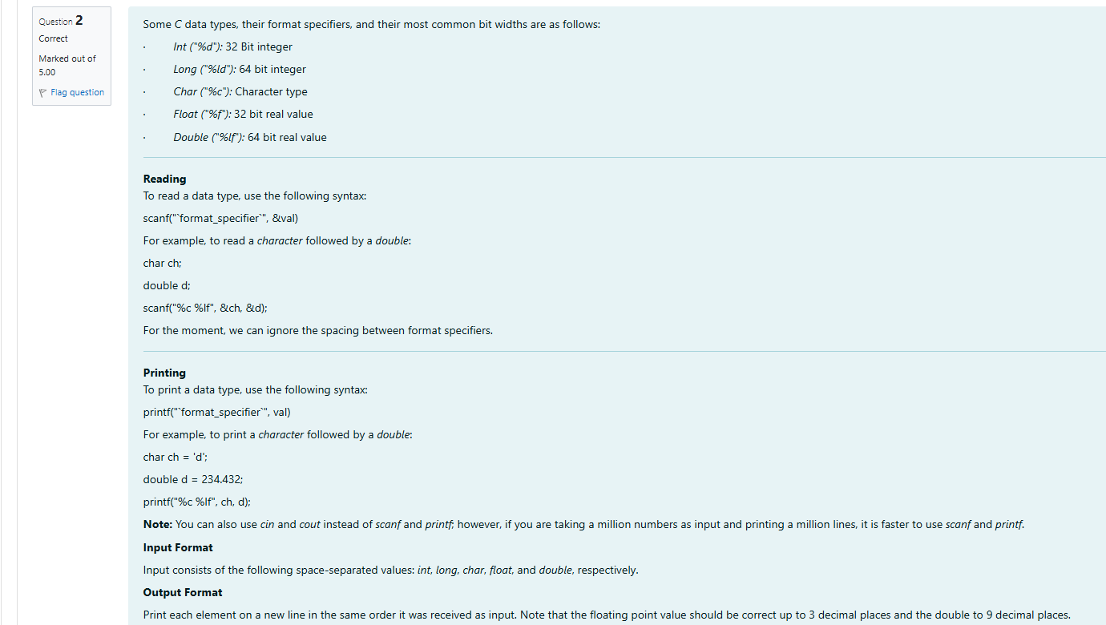
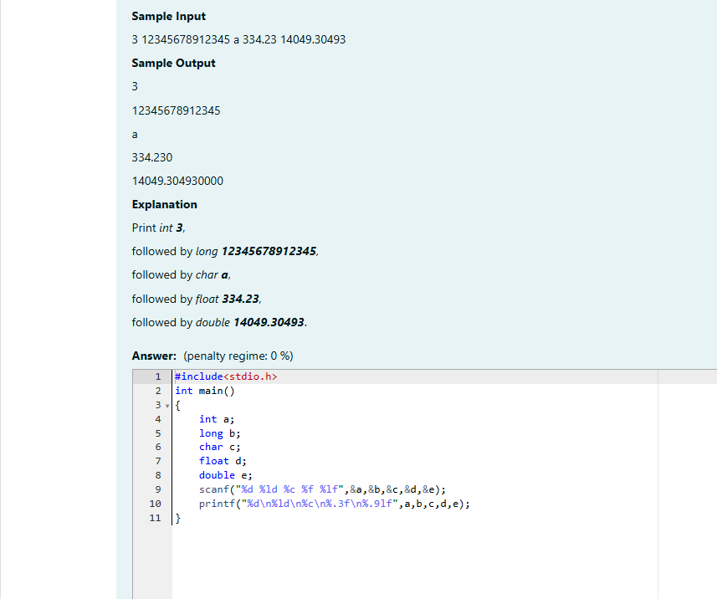
OUTPUT
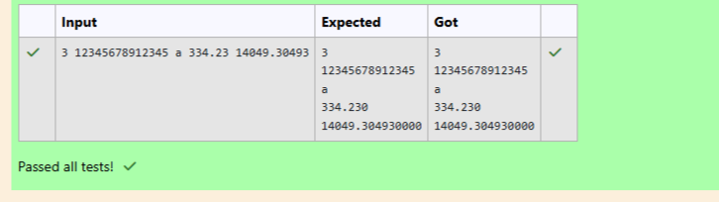

Week 01-02-practice session coding
Reg no : 241801268
Name : SHYAM SUNDAR.K
Q3)
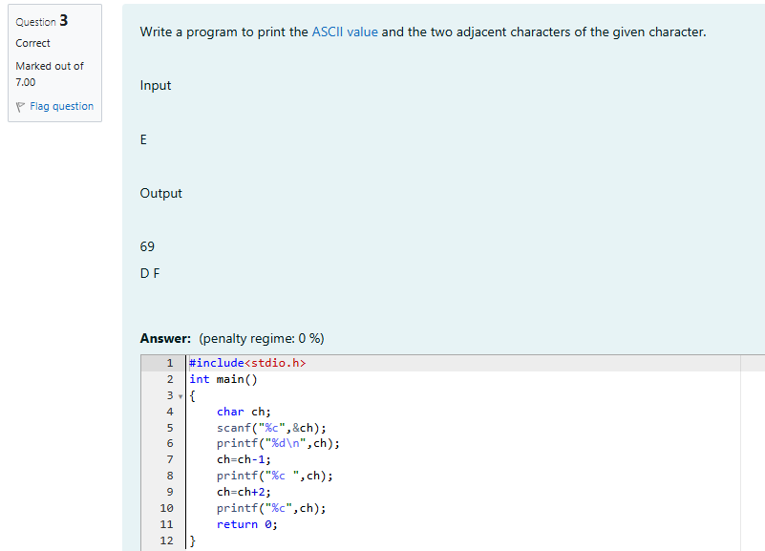
OUTPUT
