Week-02-Operators and Expressions, Managing Input and Output Operations
Week 02-01-practice session coding
Reg no : 241801268
Name : SHYAM SUNDAR.K
Q1)
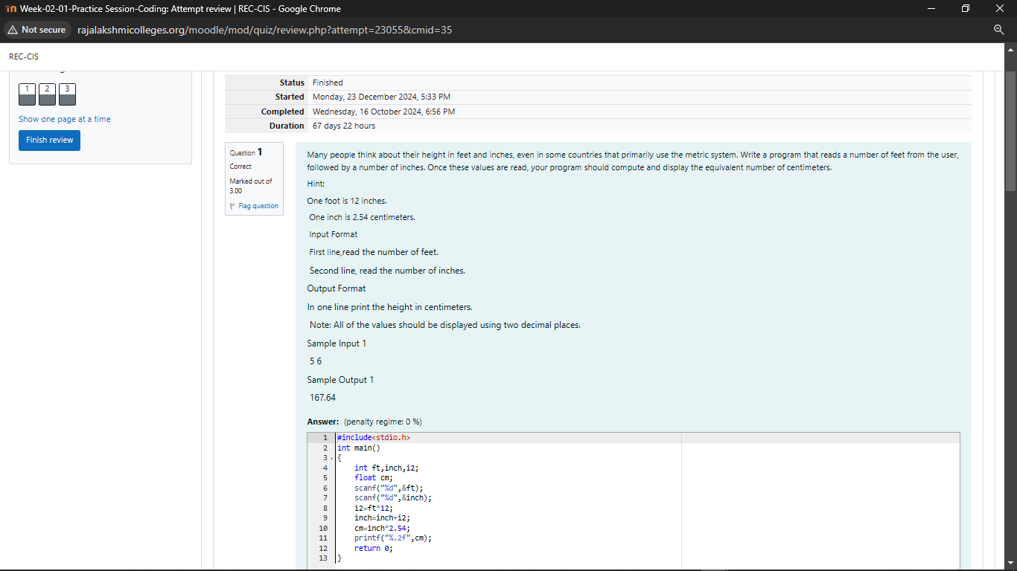
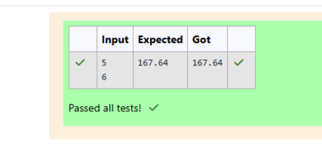

Week 02-01-practice session coding
Reg no : 241801268
Name : SHYAM SUNDAR.K
Q2)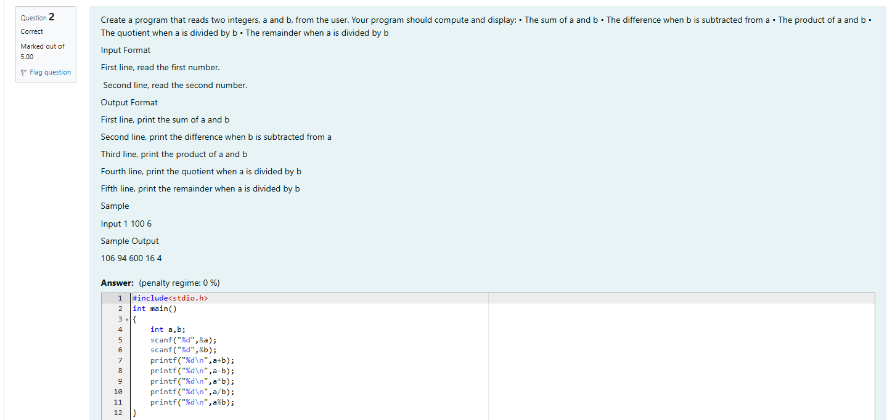
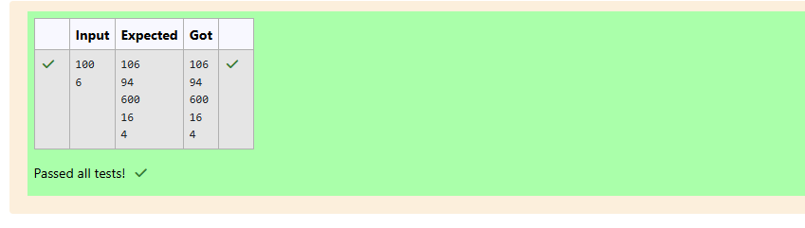

Week 02-01-practice session coding
Reg no : 241801268
Name : SHYAM SUNDAR.K
Q3)
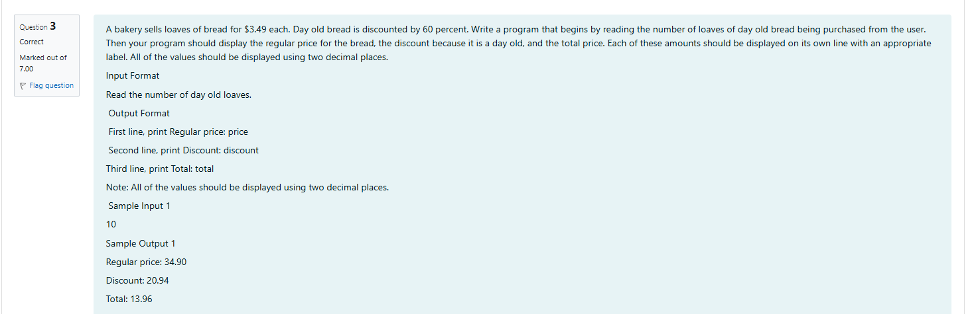
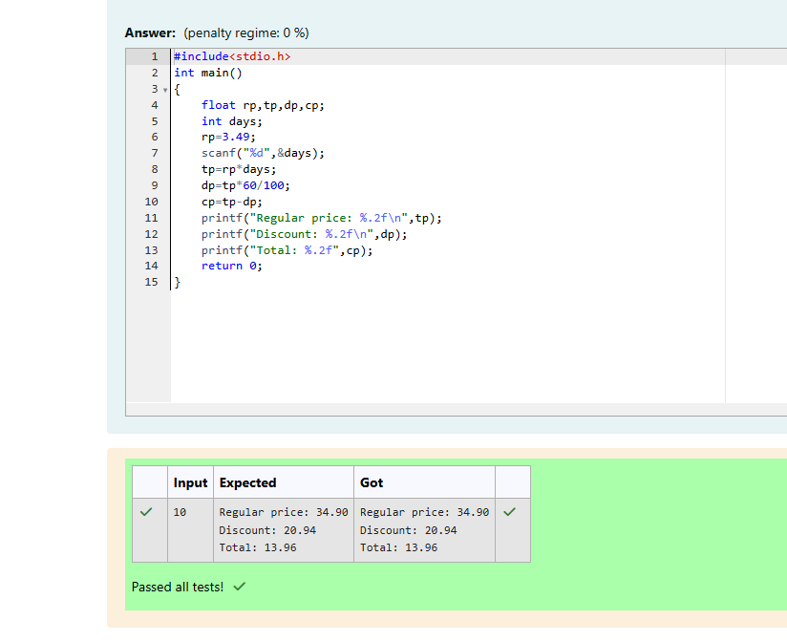

Week 02-02-practice session coding
Reg no : 241801268
Name : SHYAM SUNDAR.K
Q1) 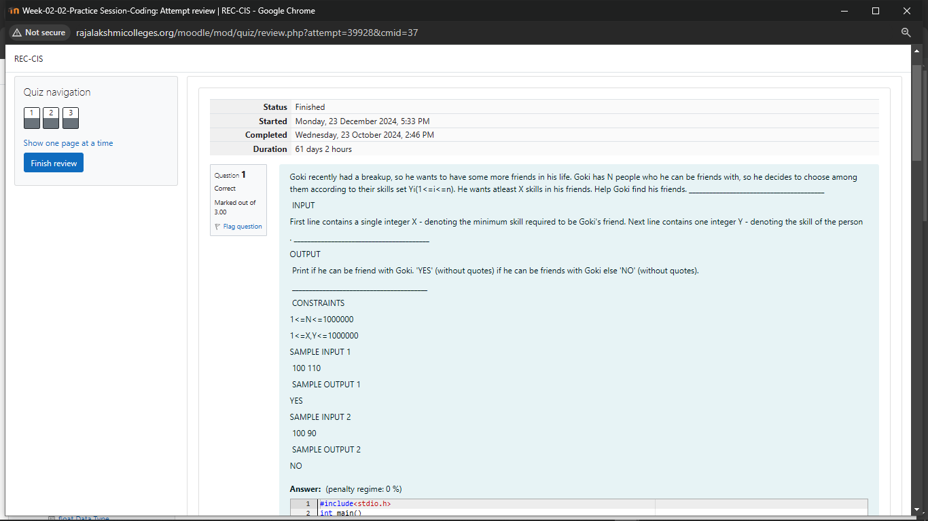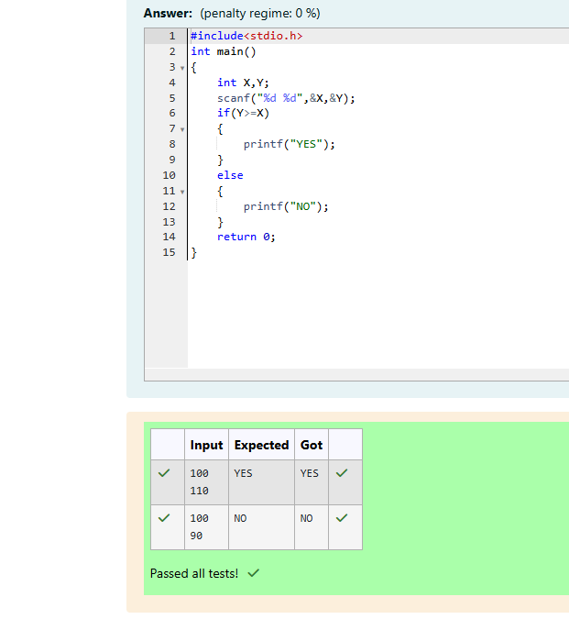

Week 02-02-practice session coding
Reg no : 241801268
Name : SHYAM SUNDAR.K
Q2) 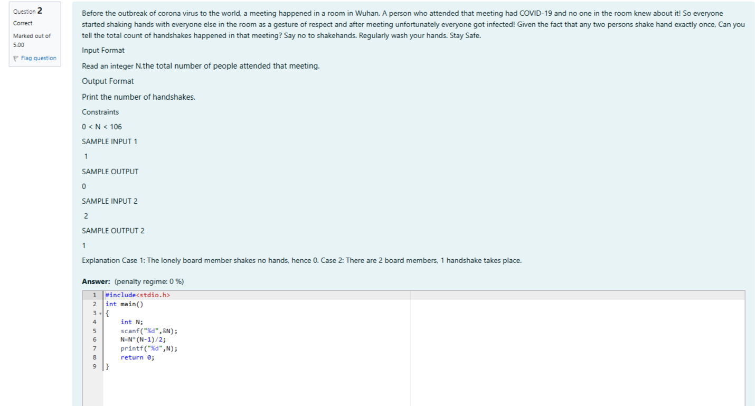
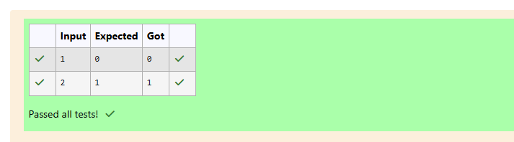
Week 02-02-practice session coding
Reg no : 241801268
Name : SHYAM SUNDAR.K
Q3)
