Week-03-Decision Making and Branching - if, if...else and nested if…else, if...else if and switch…case
Week 03-01-practice session coding
Reg no : 241801268
Name : SHYAM SUNDAR.K
Q1)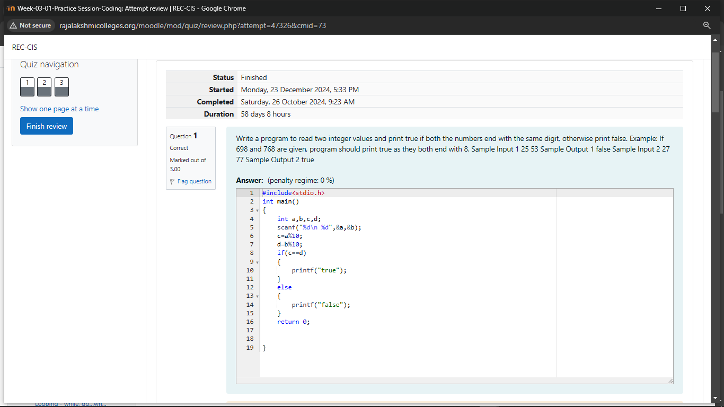

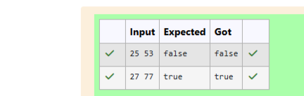

Week 03-01-practice session coding
Reg no : 241801268
Name : SHYAM SUNDAR.K
Q2)
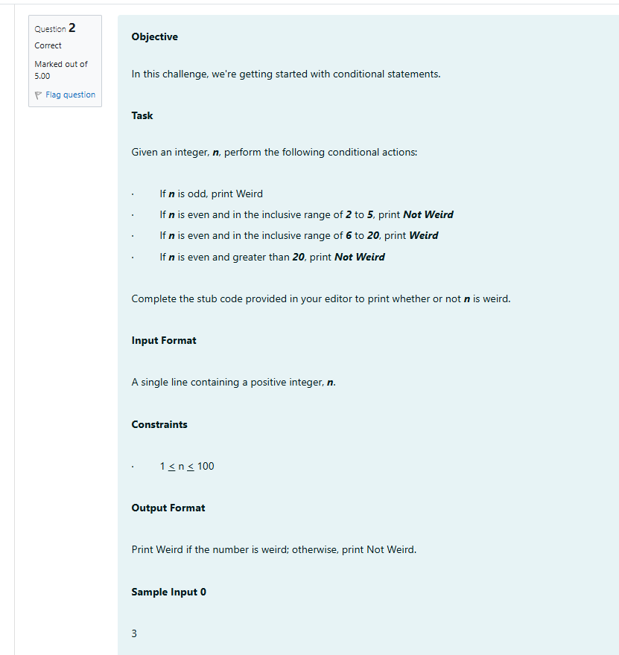

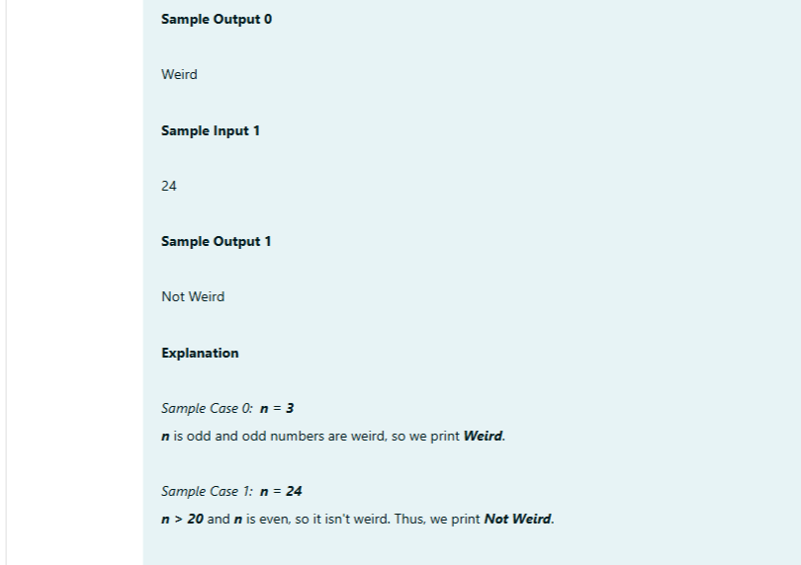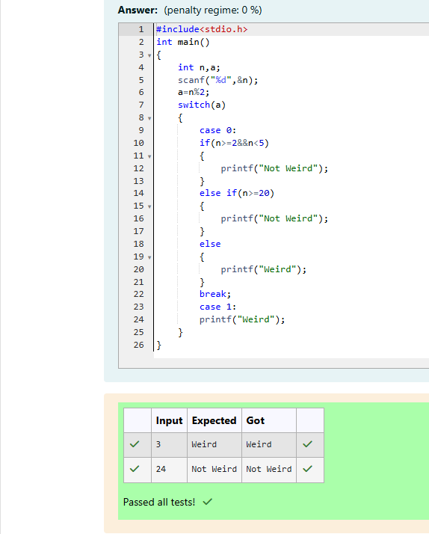
Week 03-01-practice session coding
Reg no : 241801268
Name : SHYAM SUNDAR.K
Q3)
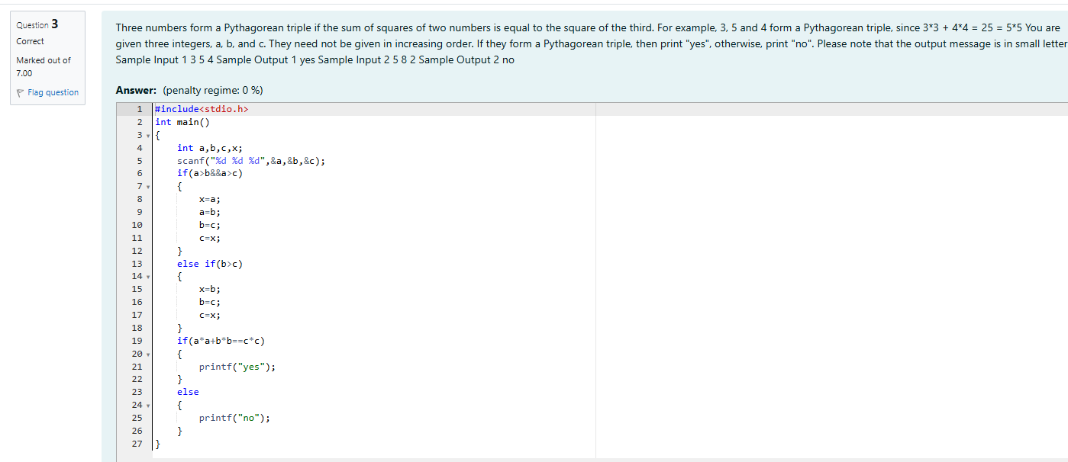
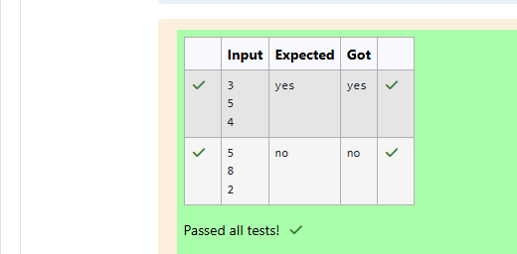

Week 03-02-practice session coding
Reg no : 241801268
Name : SHYAM SUNDAR.K
Q1)
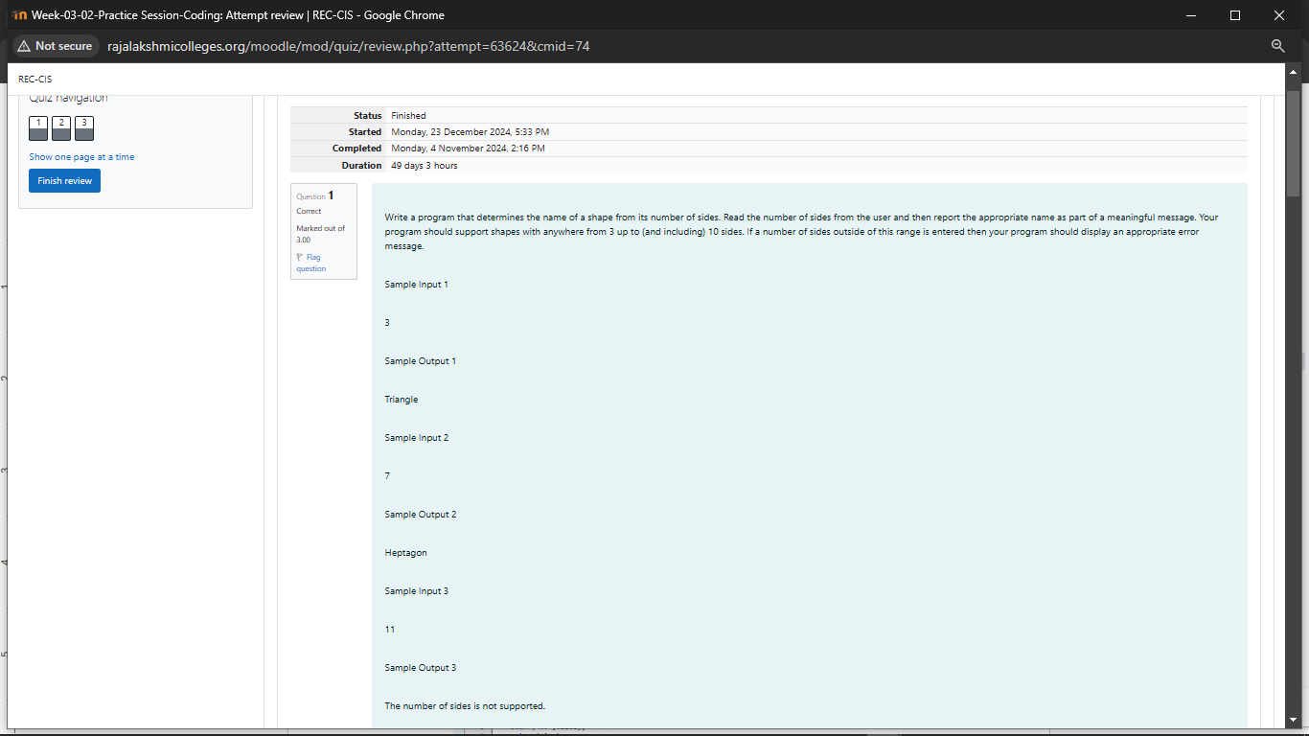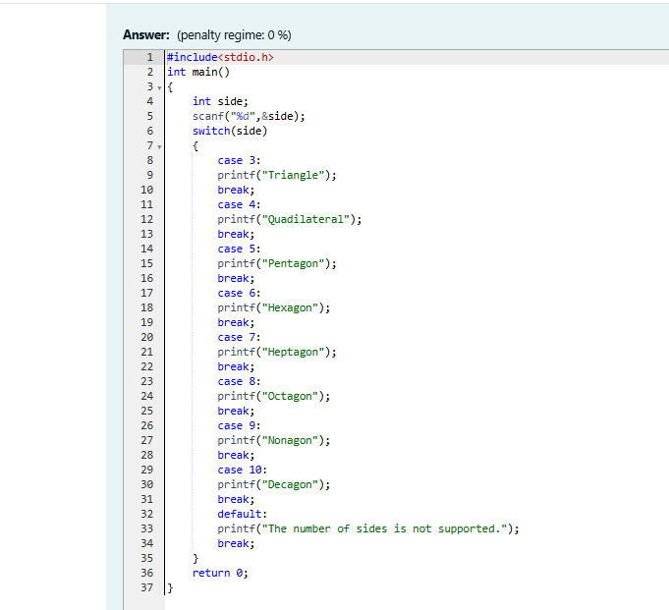
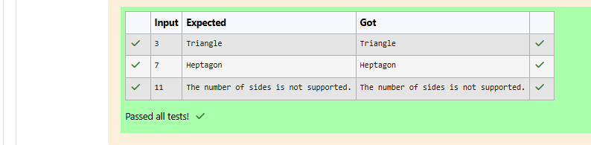

Week 03-02-practice session coding
Reg no : 241801268
Name : SHYAM SUNDAR.K
Q2)
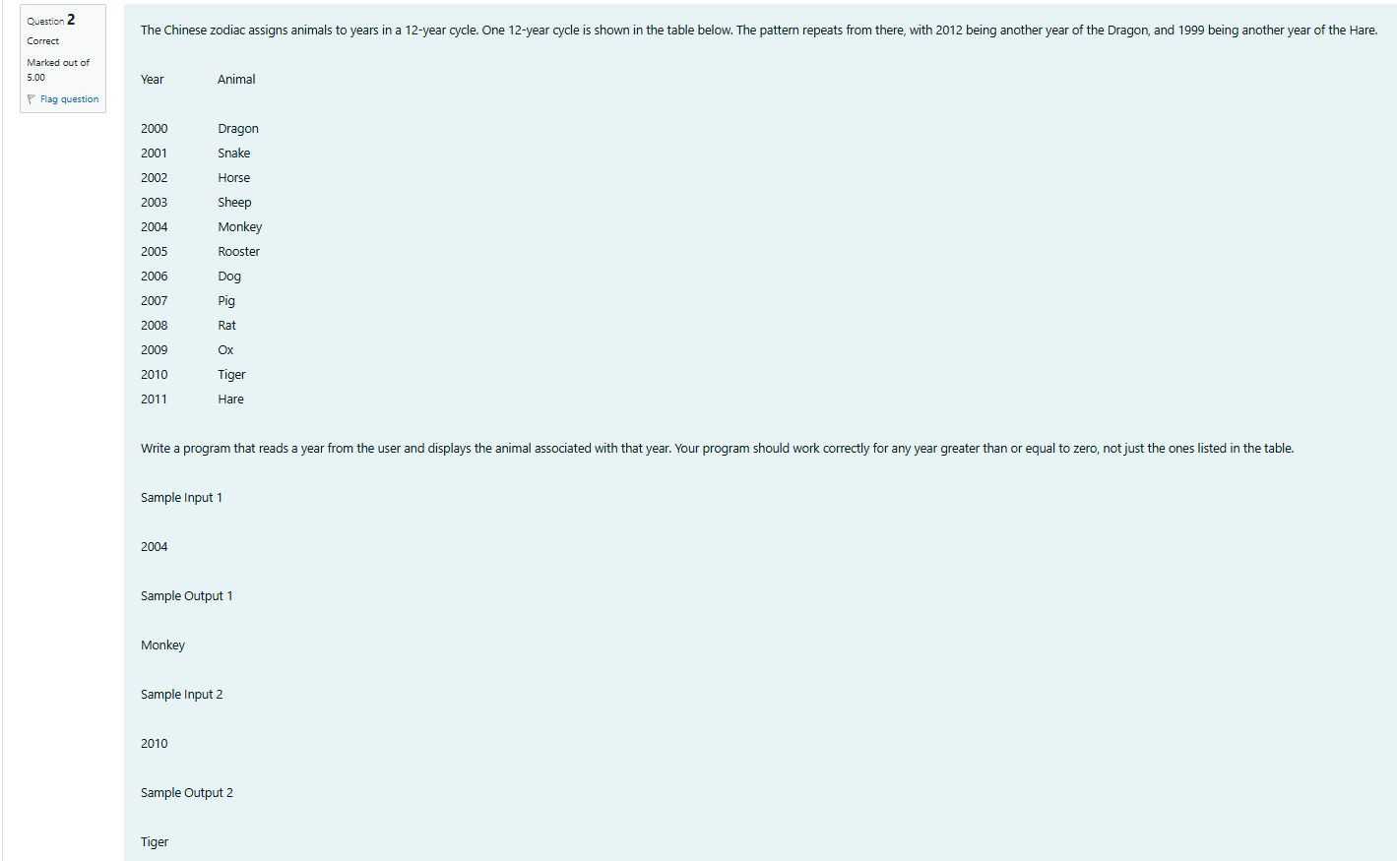
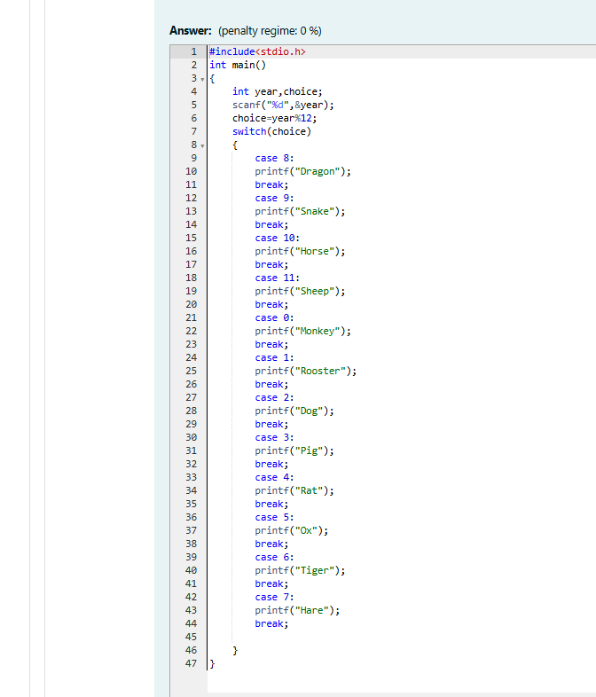

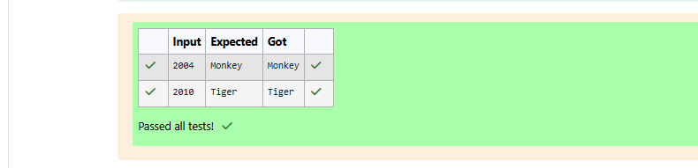

Week 03-02-practice session coding
Reg no : 241801268
Name : SHYAM SUNDAR.K
Q3)
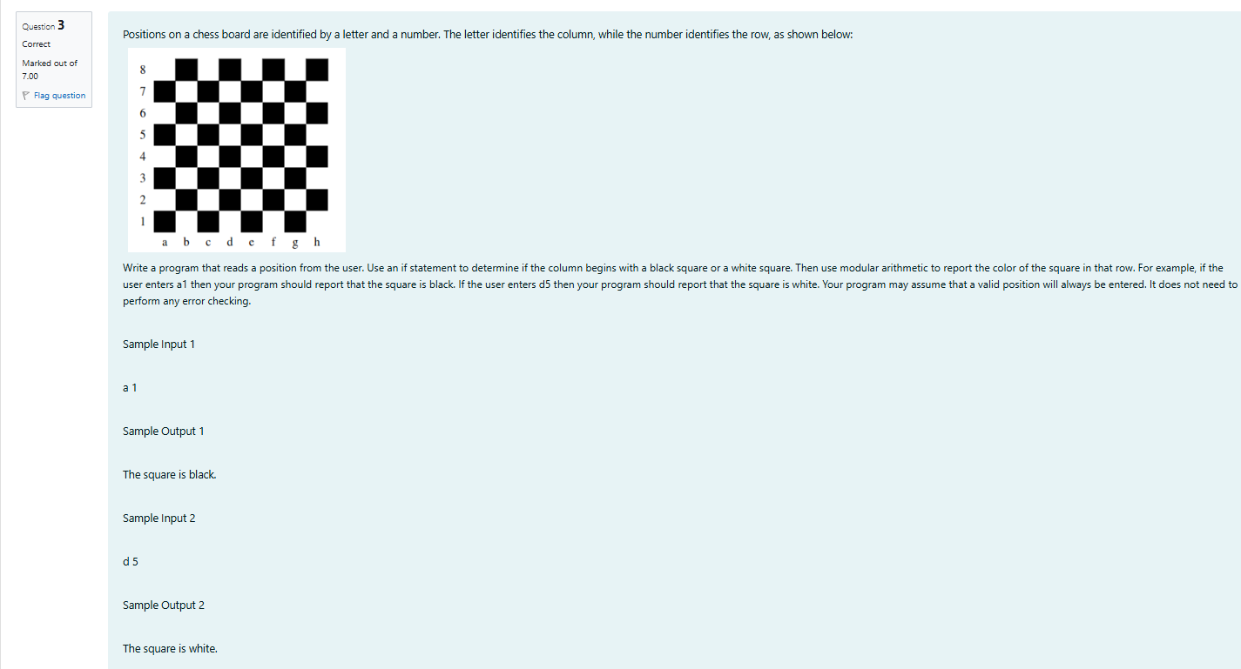
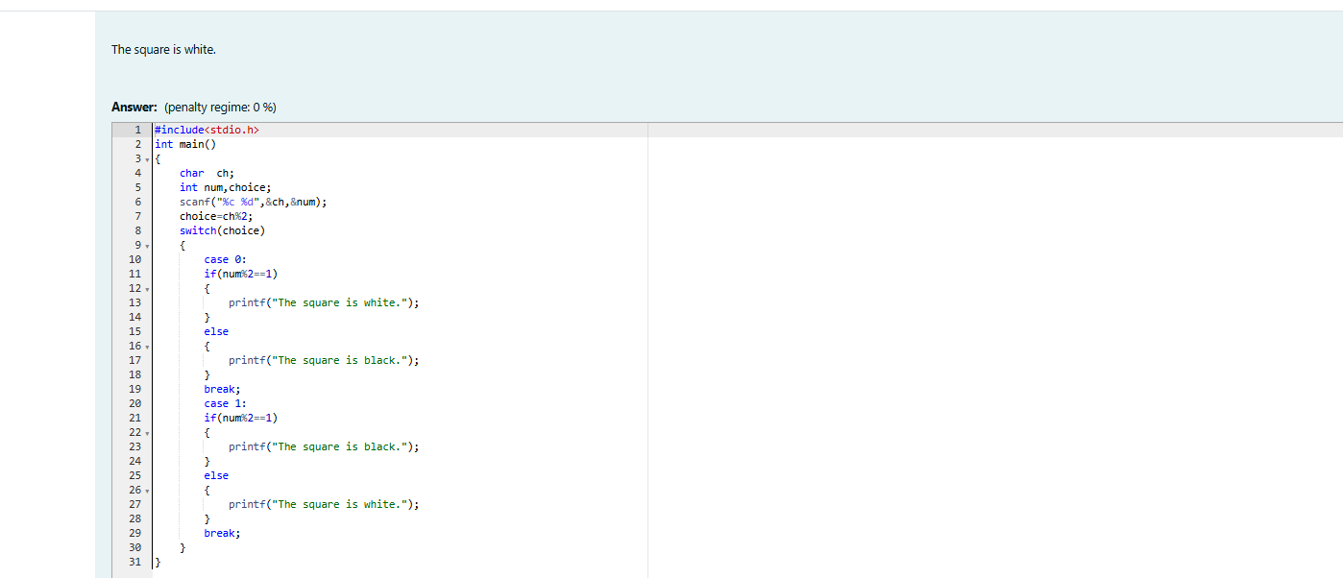
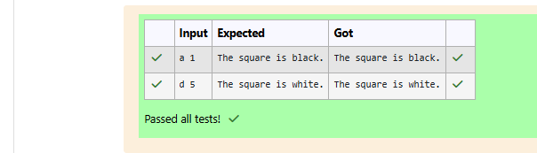

Week 03-03-practice session coding
Reg no : 241801268
Name : SHYAM SUNDAR.K
Q1)
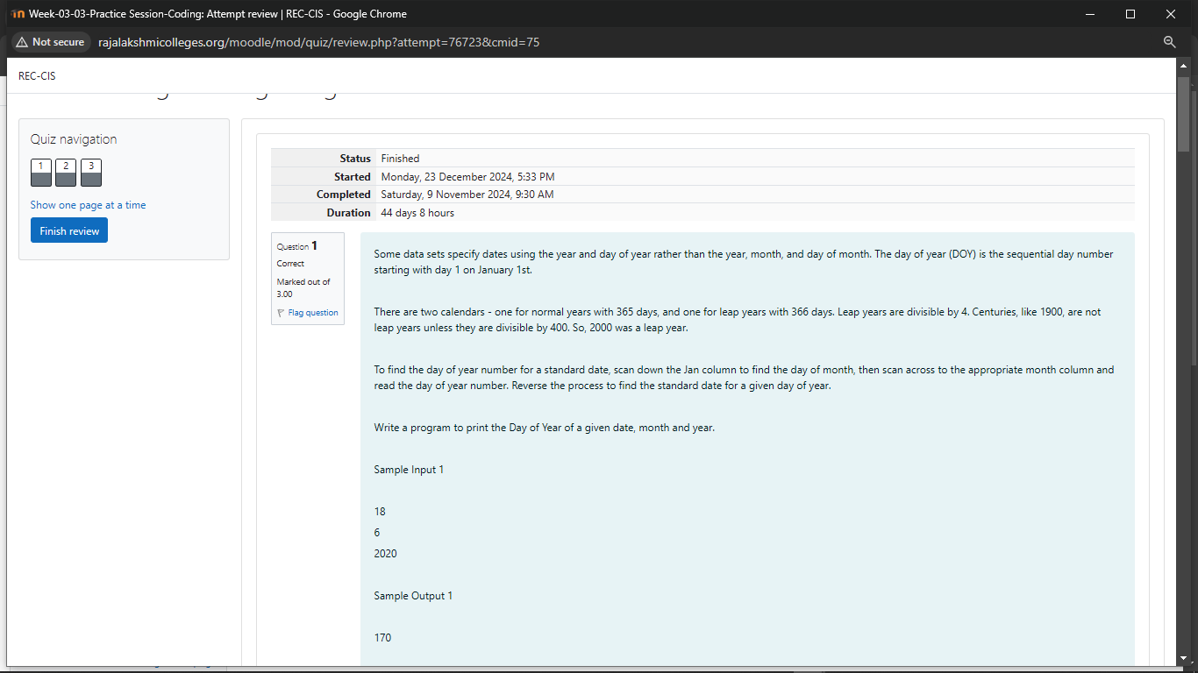
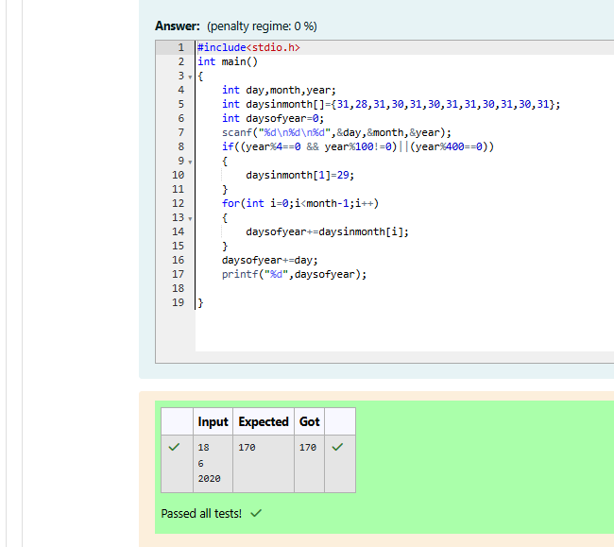
Week 03-03-practice session coding
Reg no : 241801268
Name : SHYAM SUNDAR.K
Q2)
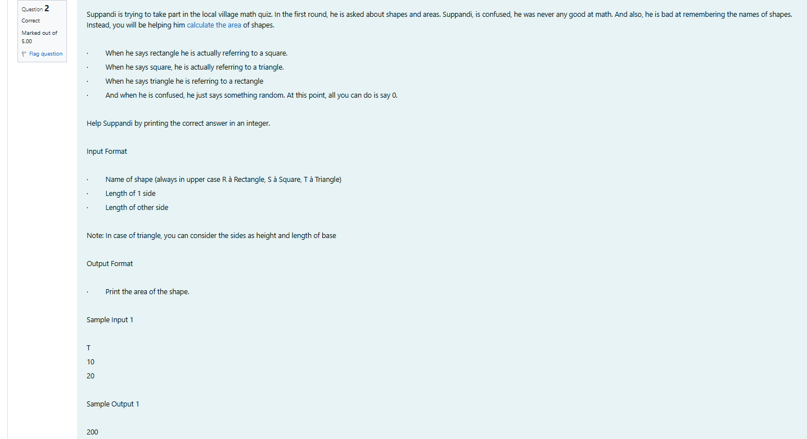
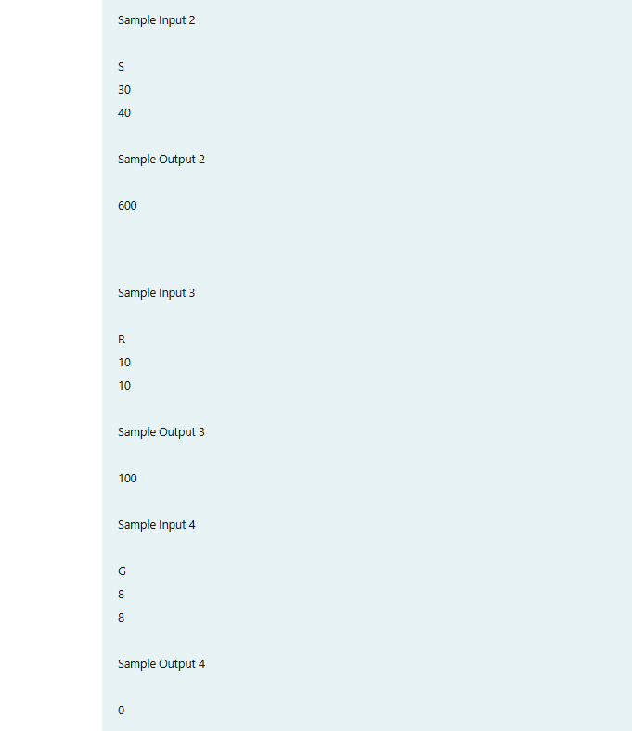
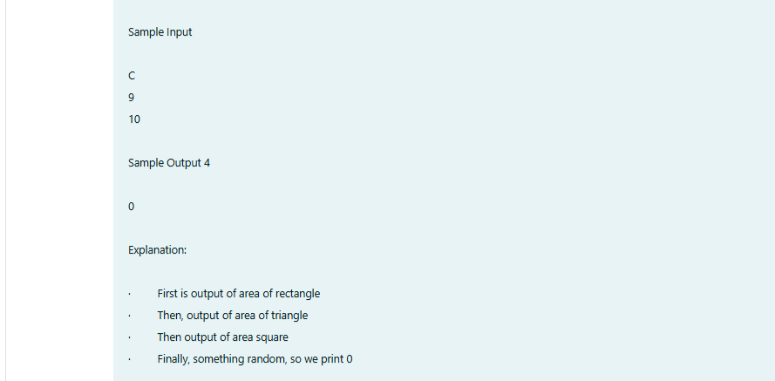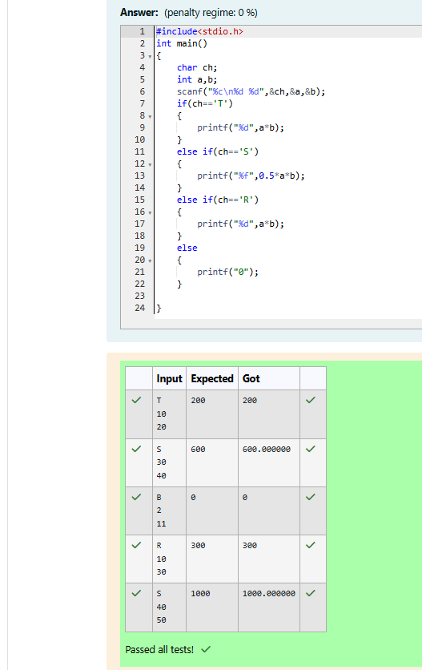
Week 03-03-practice session coding
Reg no : 241801268
Name : SHYAM SUNDAR.K
Q3)
