Week-04-Decision Making and Looping - while, do…while and for
Week 04-01-practice session coding
Reg no : 241801268
Name : SHYAM SUNDAR.K
Q1)
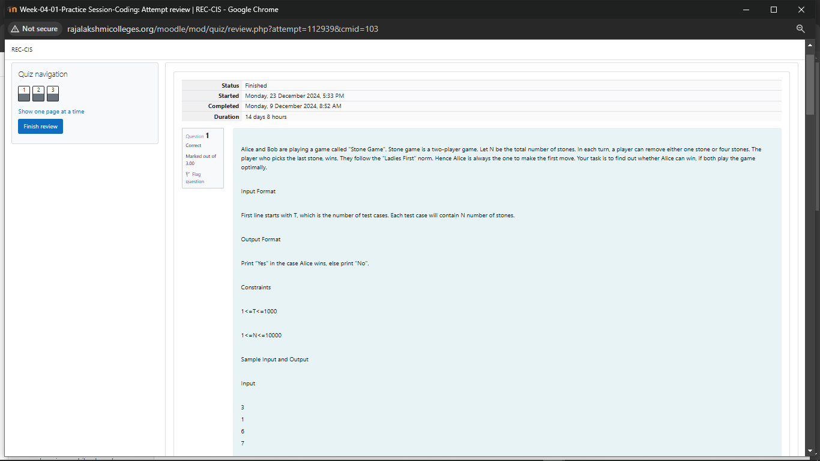
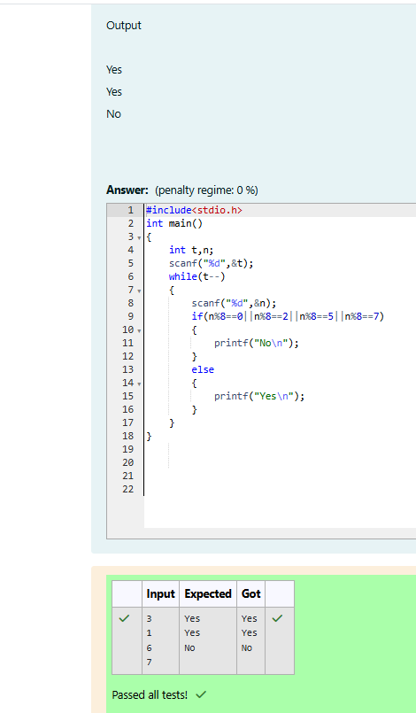

Week 04-01-practice session coding
Reg no : 241801268
Name : SHYAM SUNDAR.K
Q2)
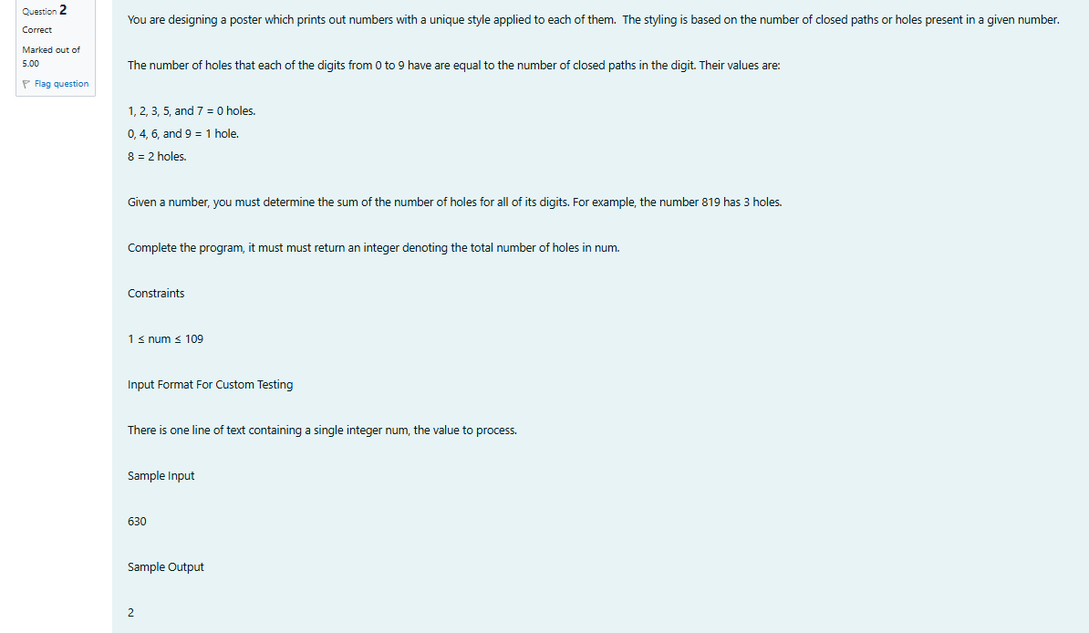

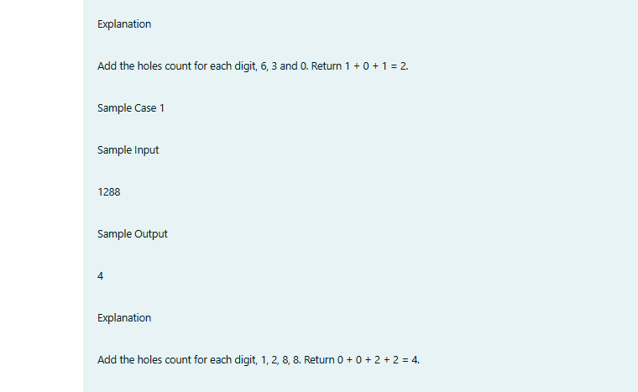

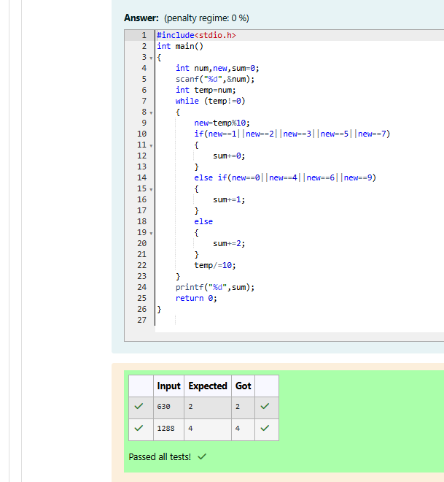

Week 04-01-practice session coding
Reg no : 241801268
Name : SHYAM SUNDAR.K
Q3)
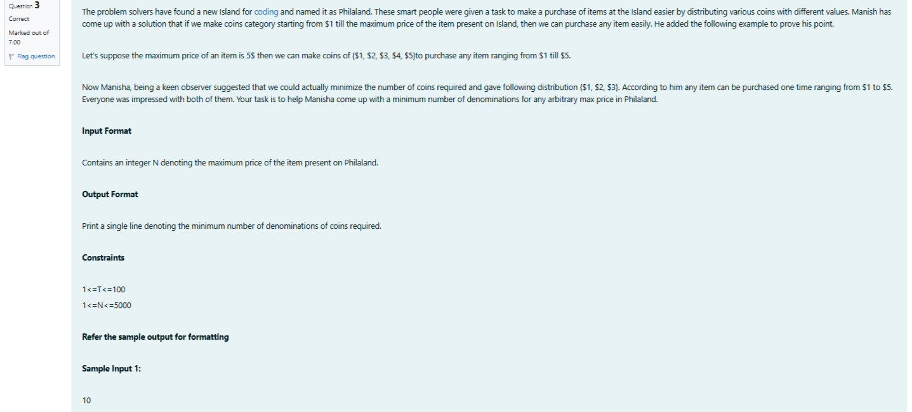
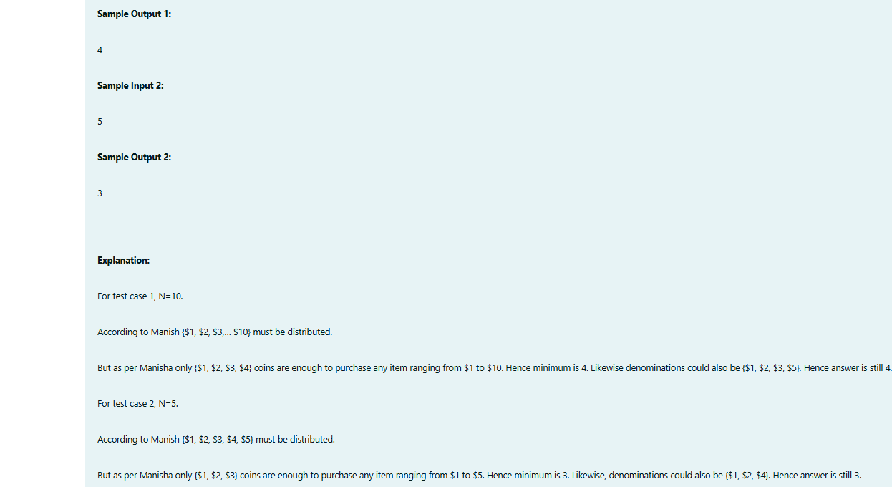

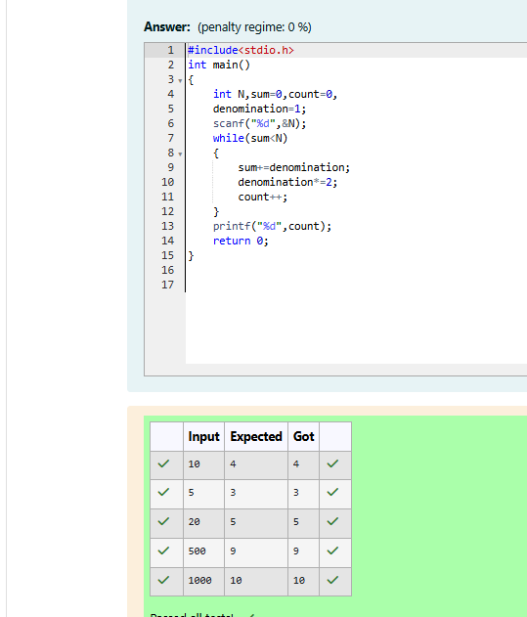

Week 04-02-practice session coding
Reg no : 241801268
Name : SHYAM SUNDAR.K
Q1)
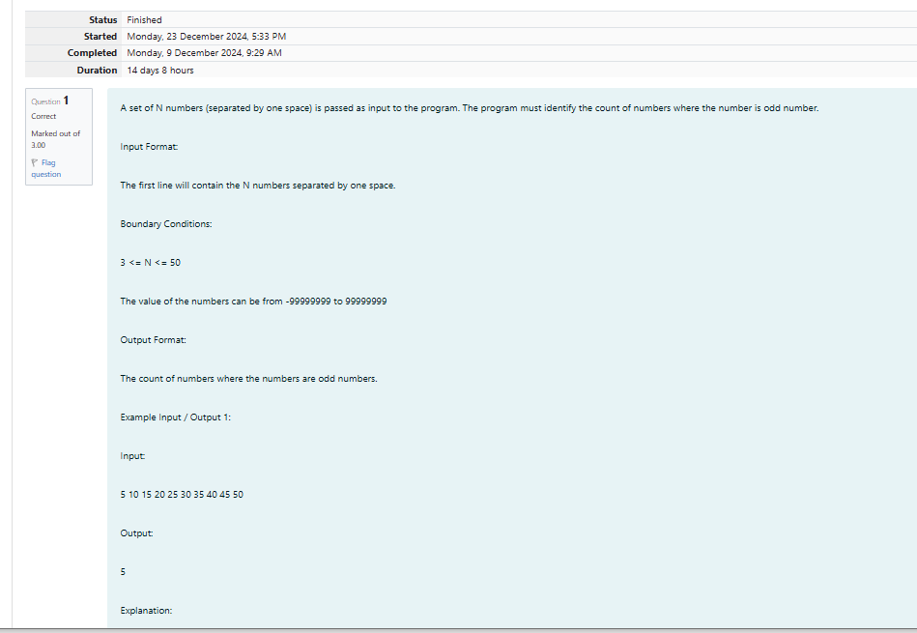
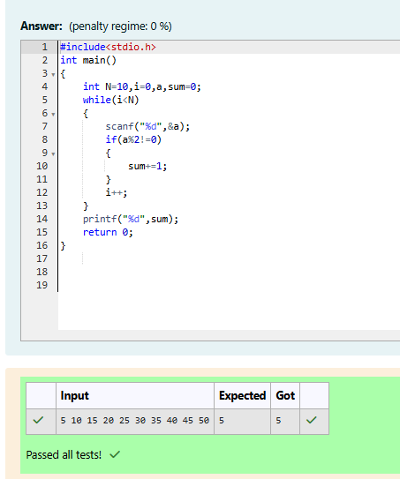

Week 04-02-practice session coding
Reg no : 241801268
Name : SHYAM SUNDAR.K
Q2)
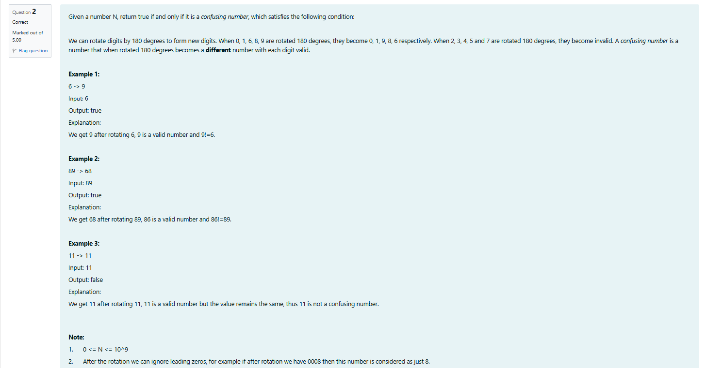
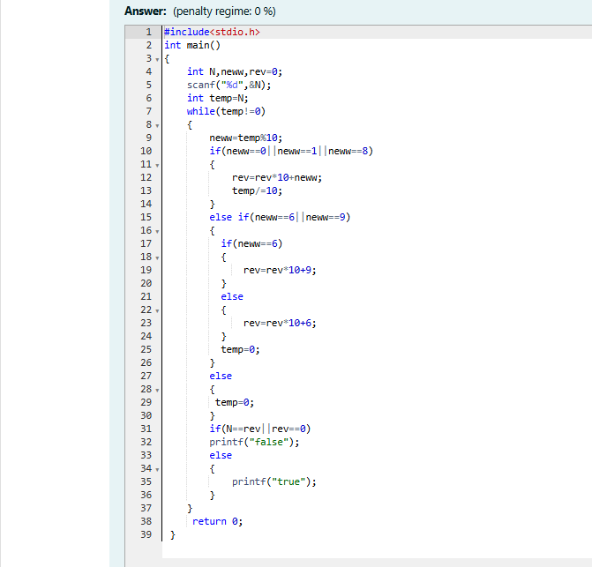
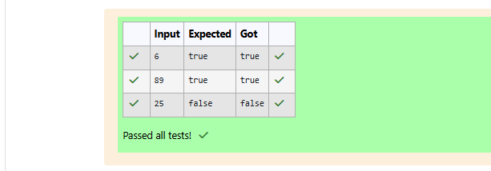

Week 04-02-practice session coding
Reg no : 241801268
Name : SHYAM SUNDAR.K
Q3)
