Week-05-Nested Loops - while and for, Jumps in Loops
Week 05-01-practice session coding
Reg no : 241801268
Name : SHYAM SUNDAR.K
Q1)
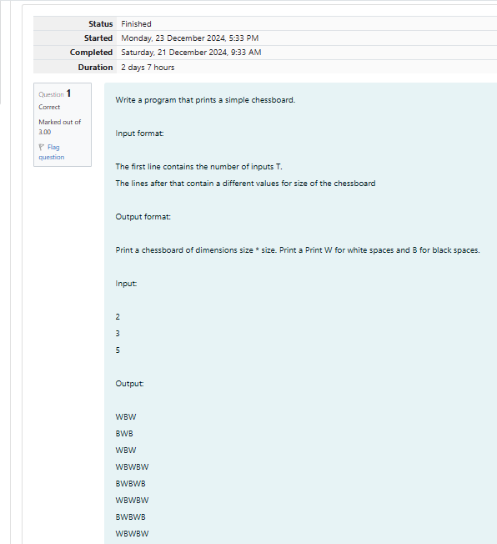

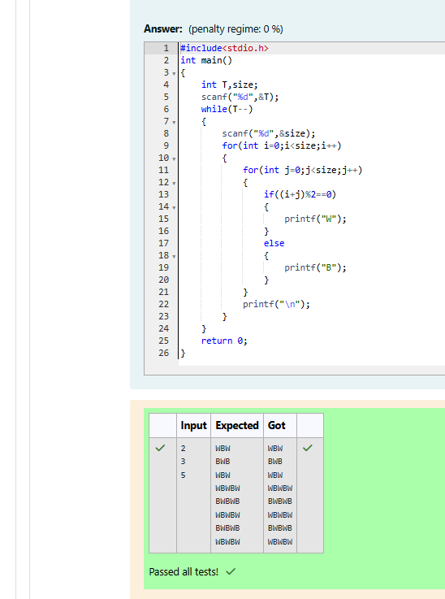

Week 05-01-practice session coding
Reg no : 241801268
Name : SHYAM SUNDAR.K
Q2)
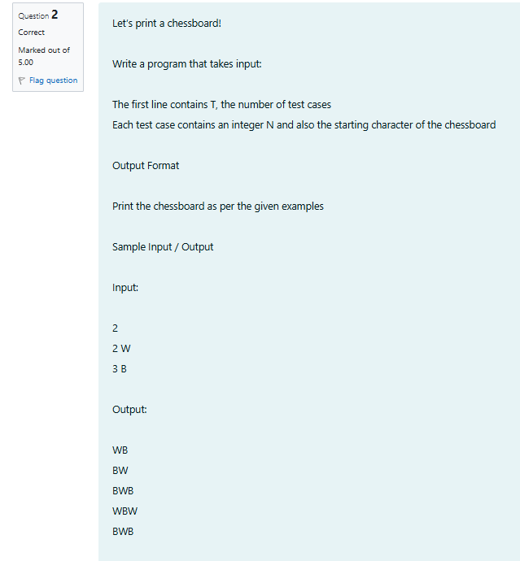

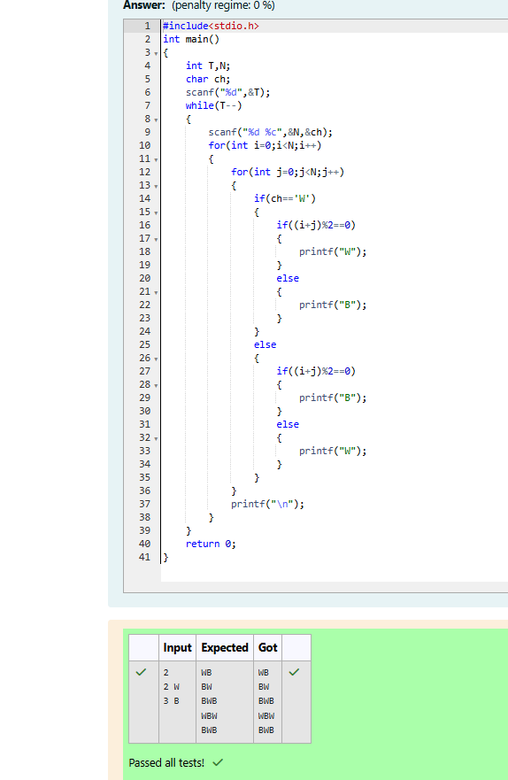

Week 05-01-practice session coding
Reg no : 241801268
Name : SHYAM SUNDAR.K
Q3)
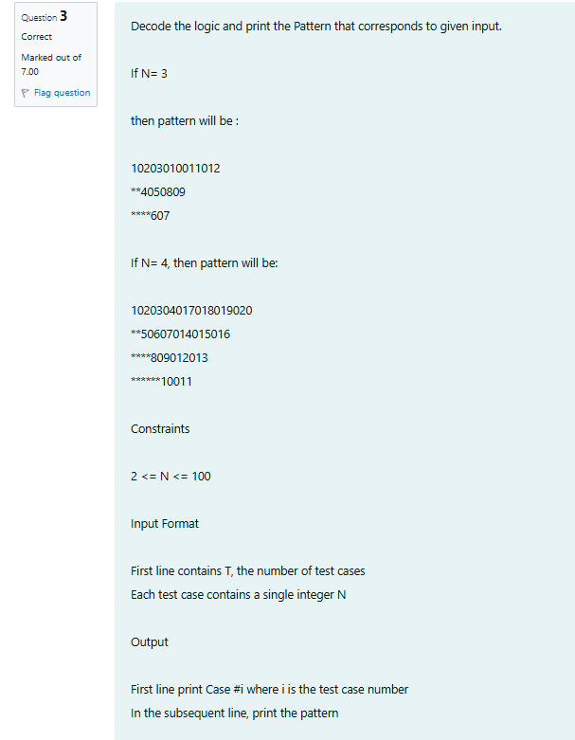
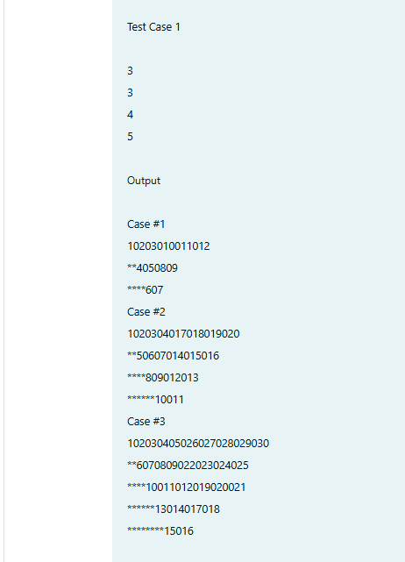
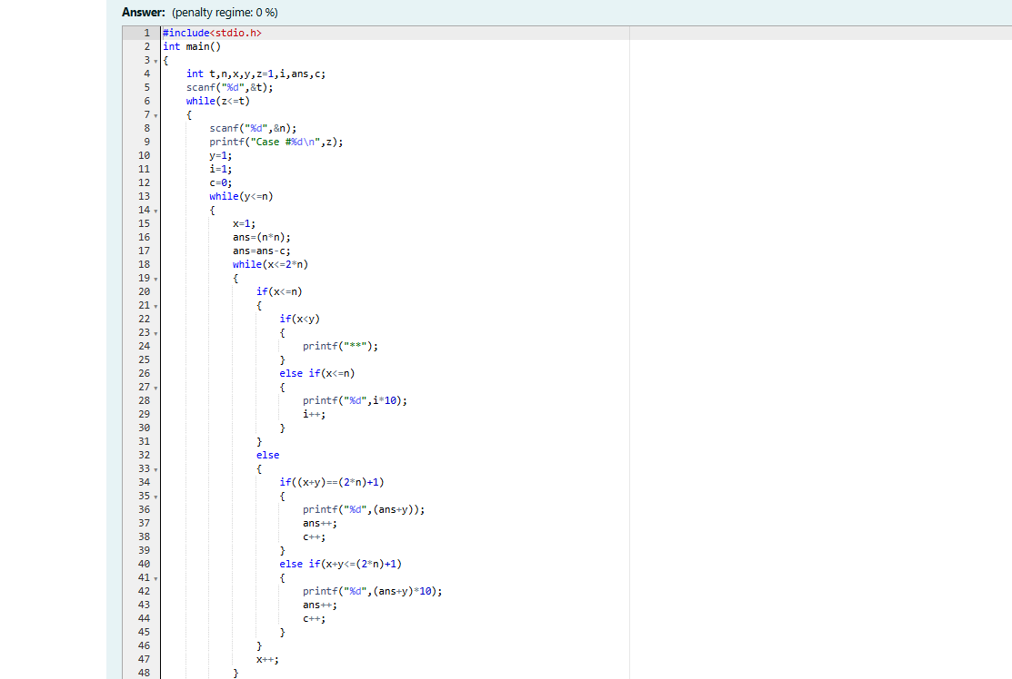
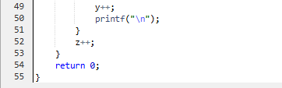

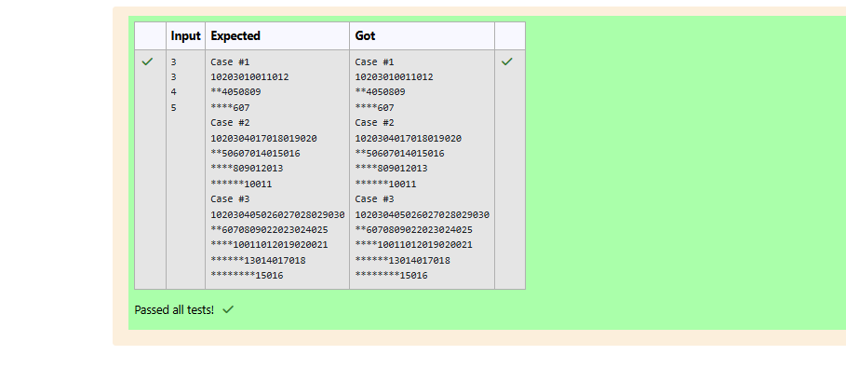

Week 05-02-practice session coding
Reg no : 241801268
Name : SHYAM SUNDAR.K
Q1)
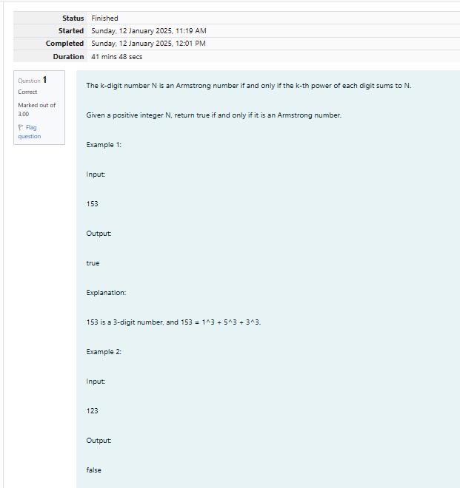
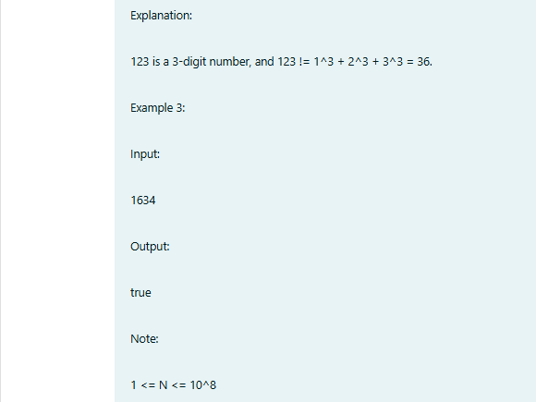
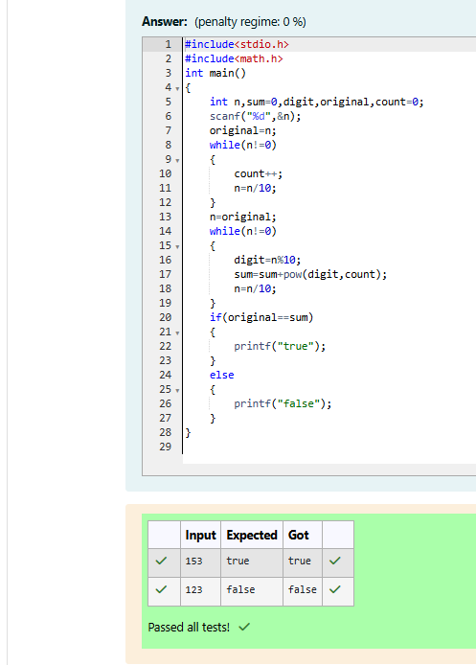

Week 05-02-practice session coding
Reg no : 241801268
Name : SHYAM SUNDAR.K
Q2)
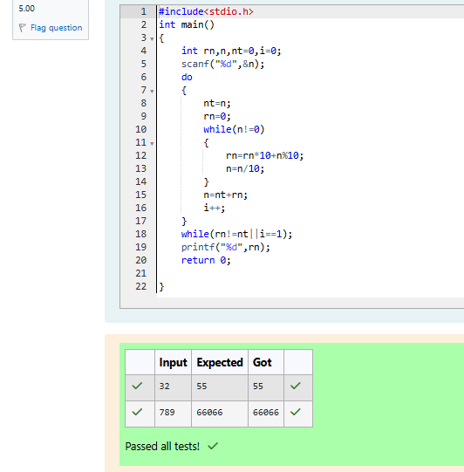

Week 05-02-practice session coding
Reg no : 241801268
Name : SHYAM SUNDAR.K
Q3)
