Week-08-Sorting Algorithms-Bubble and Selection
Week 08-01-practice session coding
Reg no : 241801268
Name : SHYAM SUNDAR.K
Q1)
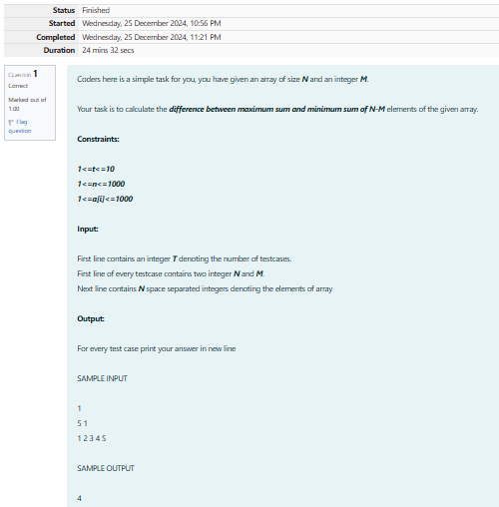

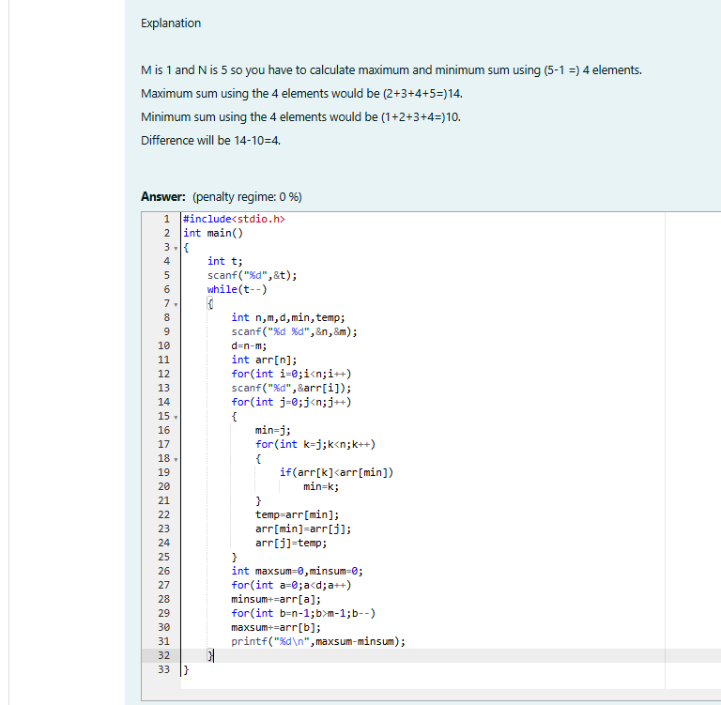

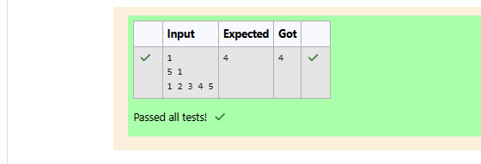

Week 08-01-practice session coding
Reg no : 241801268
Name : SHYAM SUNDAR.K
Q2)

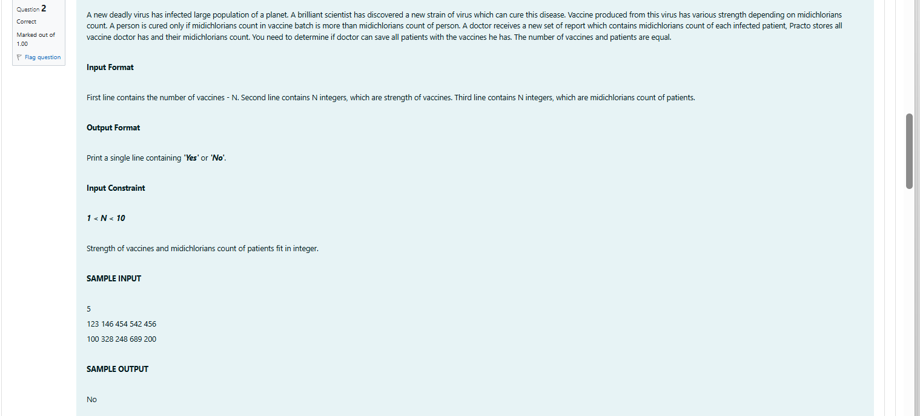
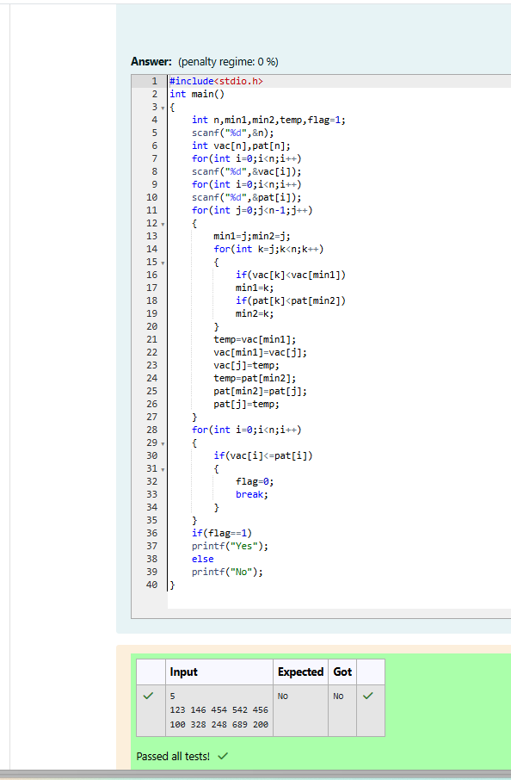
Week 08-01-practice session coding
Reg no : 241801268
Name : SHYAM SUNDAR.K
Q3)

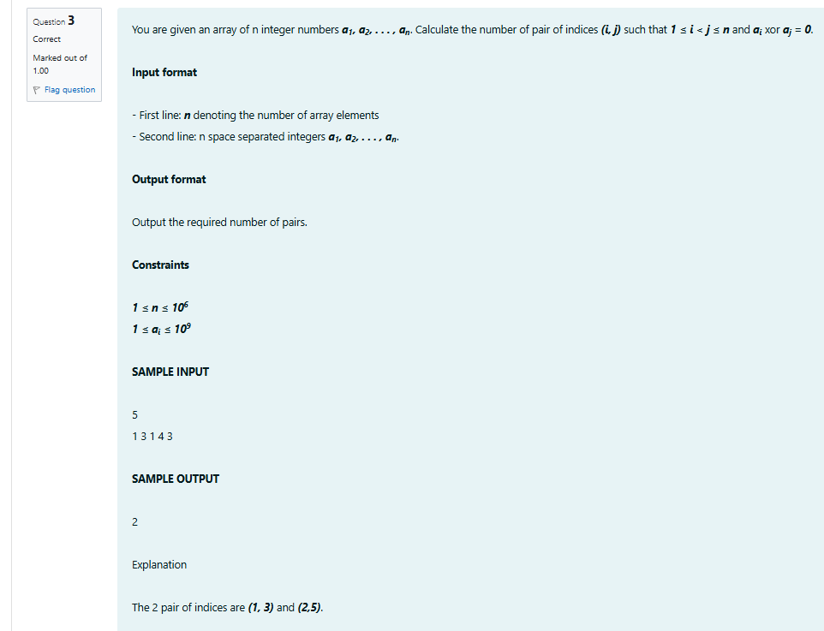

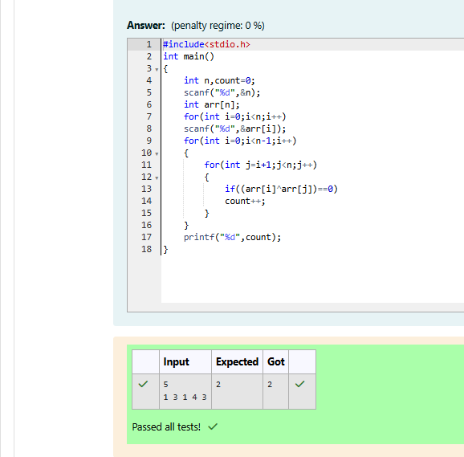

Week 08-01-practice session coding
Reg no : 241801268
Name : SHYAM SUNDAR.K
Q4)

