Week-14-Structures and Unions
Reg no : 241801268
Name : SHYAM SUNDAR.K
Q1)

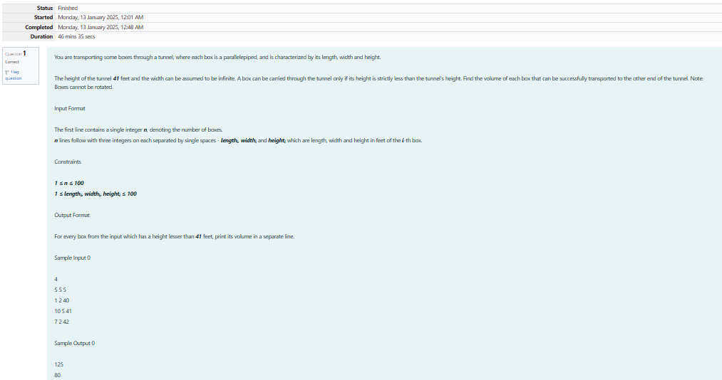

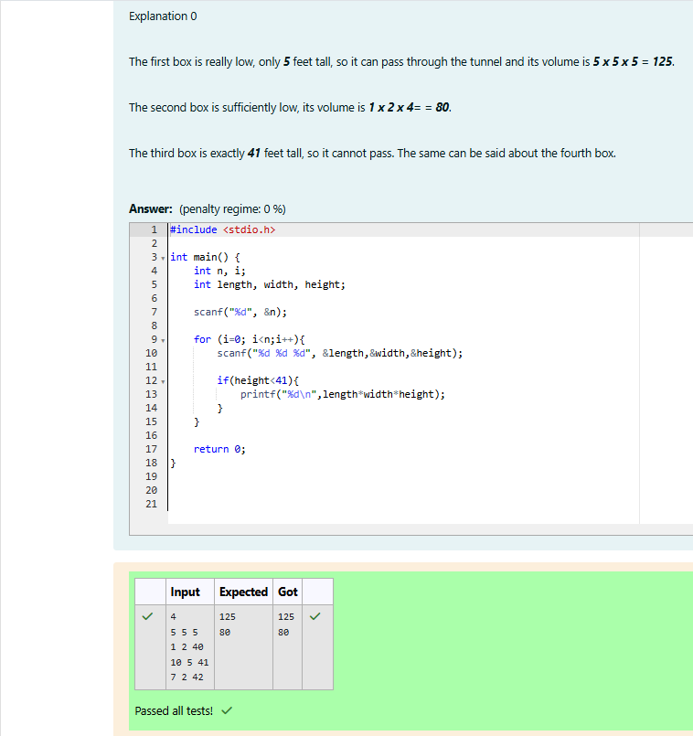

Reg no : 241801268
Name : SHYAM SUNDAR.K
Q2)

