RAJALAKSHMI ENGINEERING COLLEGE
RAJALAKSHMI NAGAR, THANDALAM 602 105



Laboratory Record Note Book
CS23331 - DESIGN AND ANALYSIS OF ALGORITHMS

NAME : | SHYAM SUNDAR A
YEAR / BRANCH / SECTION : | 2ND YEAR / IT / ‘A’ SECTION
UNIVERSITY REGISTER NO :
COLLEGE ROLL NO : | 2116251001510
SEMESTER : | 3RD SEMESTER
ACADAMIC YEAR : | 2026-2027

INDEX PAGE
Exp.No | Name of the Experiment | Date of Completion
1.a | Finding Complexity using Counter Method | 31 /07/2026
1.b | Finding Complexity using Counter Method | 31 /07/2026
1.c | Finding Complexity using Counter Method | 31 /07/2026
1.d | Finding Complexity using Counter Method | 07/08/2026
1.e | Finding Complexity using Counter Method | 07/08/2026
2.a | Coin Problem | 14/08/2026
2.b | Cookies Problem | 14/08/2026
2.c | Burger Problem | 14/08/2026
2.d | Array Sum max problem | 14/08/2026
2.e | Product of Array elements-Minimum | 21/08/2026
3.a | Number of Zeros in a Given Array | 21/08/2026
3.b | Majority Element | 21/08/2026
3.c | Finding Floor Value | 11/09/2026
3.d | Two Elements sum to x | 11/09/2026
3.e | Implementation of Quick Sort | 11/09/2026
4.a | DP-Playing with Numbers | 25/09/2026
4.b | DP-Playing with chessboard | 25/09/2026
4.c | Longest Common Subsequence | 25/09/2026
4.d | Longest non-decreasing Subsequence | 25/09/2026
5.a | Finding Duplicates-O(n^2) Time Complexity,O(1) Space Complexity | 05/10/2026
5.b | Finding Duplicates-O(n) Time Complexity,O(1) Space Complexity | 05/10/2026
5.c | Print Intersection of 2 sorted arrays-O(m*n)Time Complexity,O(1) Space Complexity | 05/10/2026
5.d | Print Intersection of 2 sorted arrays-O(m+n)Time Complexity,O(1) Space Complexity | 09/10/2026
5.e | Pair with Difference-O(n^2)Time Complexity,O(1) Space Complexity | 09/10/2026
5.f | Pair with Difference -O(n) Time Complexity,O(1) Space Complexity | 09/10/2026

1.a ) Finding Complexity using Counter Method
AIM:
To implement the given algorithm as a program and determine its time complexity using the counter method.
ALGORITHM:
- Start the program and initialize i = 1, s = 1, and count = 0.
- Read the value of n from the user.
- Check whether s <= n; if true, increment count and i.
- Add i to s and update the counter for each operation; repeat until the condition becomes false.
- Print the total counter value and stop.
PROGRAM:
#include <stdio.h>
int main()
{
int n;
int i = 1, s = 1, count = 0;
scanf("%d", &n);
count++;
count++;
while (s <= n)
{
count++;
i++;
count++;
s = s + i;
count++;
}
count++;
printf("%d", count);
return 0;
}

OUTPUT:

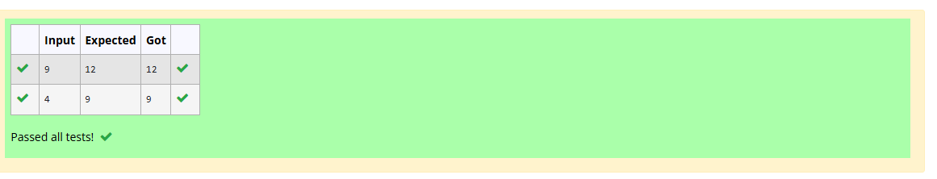

RESULT:
The given algorithm was implemented successfully using C programming, and its time complexity was analyzed using the counter method.
1.b ) Finding Complexity using Counter method
AIM:
To implement the given algorithm in C and determine its time complexity using the counter method.

ALGORITHM:
- Start the program and read the value of n.
- If n == 1, print *.
- Otherwise, execute the outer loop from 1 to n.
- Execute the inner loop, print **, and terminate the inner loop using break.
- Count the operations, display the result, and stop.
PROGRAM:

#include <stdio.h>
int main()
{
int n, count = 0;
scanf("%d", &n);
if (n == 1)
{
count++;
}
else
{
count++;
for (int i = 1; i <= n; i++)
{
count++;
for (int j = 1; j <= n; j++)
{
count++;
count++;
count++;
break;
}
count++;
}
count++;
}
printf("%d", count);
return 0;
}

OUTPUT:
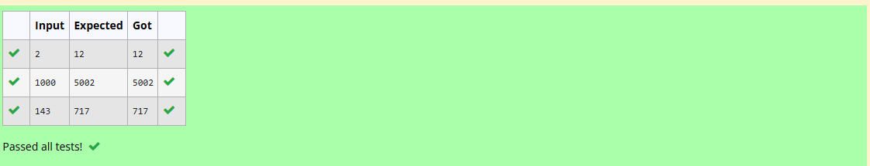

RESULT:
The given algorithm was implemented successfully in C, and its time complexity was determined using the counter method as \(O(n)\).
1.c ) Finding Complexity using Counter Method
AIM:
To write a C program to find and print all factors of a given positive integer and determine its time complexity using the counter method.

ALGORITHM:
- Start the program and read the positive integer num.
- Initialize the counter variable count = 0.
- Execute a for loop from i = 1 to num.
- Increment count and check whether num % i == 0. If true, print i.
- Print the counter value and stop the program.
PROGRAM:
#include <stdio.h>
int main()
{
int num, count = 0;
scanf("%d", &num);
for (int i = 1; i <= num; ++i)
{
count++;
count++;
if (num % i == 0)
{
count++;
}
}
count++;
printf("%d", count);
return 0;
}

OUTPUT:
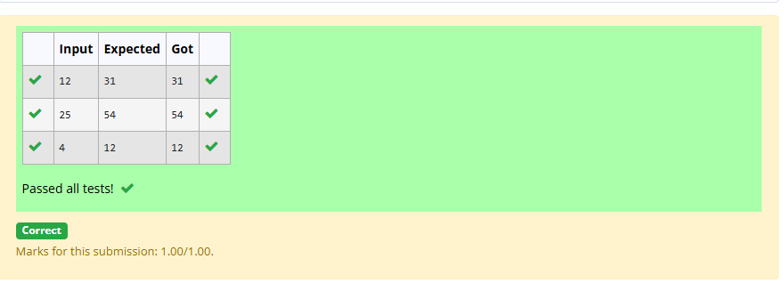

RESULT:
The C program was implemented successfully to find the factors of a positive integer. The time complexity was calculated using the counter method as \(O(n)\).

1.d) Finding Complexity using Counter Method
AIM:
To implement the given algorithm in C and determine its time complexity using the counter method.
ALGORITHM:
- Start the program and read the value of n.
- Initialize the counter variable c = 0.
- Execute the outer loop from n/2 to n-1.
- Execute the inner loops by doubling j and k in each iteration, and increment c.
- Print the counter value and stop the program.
PROGRAM:

#include <stdio.h>
int main()
{
int n, c = 0, count = 0;
scanf("%d", &n);
count++;
for (int i = n / 2; i < n; i++)
{
count++;
for (int j = 1; j < n; j = 2 * j)
{
count++;
for (int k = 1; k < n; k = k * 2)
{
count++;
c++;
count++;
}
count++;
}

count++;
}
count++;
printf("%d", count);
return 0;
}

OUTPUT:
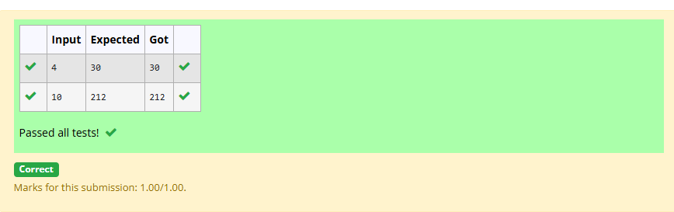

RESULT:
The given algorithm was implemented successfully in C, and its time complexity was determined using the counter method as \(O(n\log^2 n)\).

1.e ) Finding Complexity using counter method

AIM:
To write a C program to reverse a given integer and determine its time complexity using the counter method.

ALGORITHM:
- Start the program and read the integer n.
- Initialize rev = 0 and declare remainder.
- Repeat while n != 0: calculate remainder = n % 10.
- Update rev = rev * 10 + remainder and divide n by 10.
- Print rev and the counter value, then stop.
PROGRAM:
#include <stdio.h>
int main()
{
int n, rev = 0, remainder, count = 0;
scanf("%d", &n);
count++;
while (n != 0)
{
count++;
remainder = n % 10;
count++;
rev = rev * 10 + remainder;
count++;
n /= 10;
count++;
}
count++;
count++;
printf("%d", count);
return 0;}

OUTPUT:
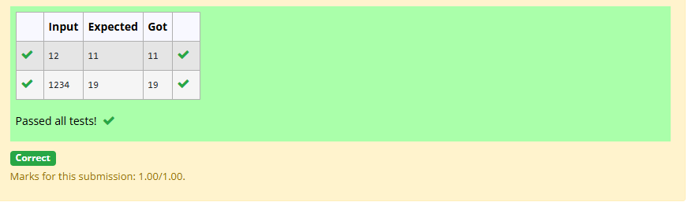

RESULT:
The C program was implemented successfully to reverse an integer. Using the counter method, its time complexity was determined as \(O(\log n)\), where \(n\) is the input number.

GREEDY ALGORITHMS
2.a ) 1-G-Coin Problem

AIM:
To write a C program to find the minimum number of Indian currency notes and coins required to make a given amount using the greedy algorithm.
ALGORITHM:
- Start the program and read the amount V.
- Initialize count = 0 and store the denominations in descending order.
- Select the largest denomination that is less than or equal to the remaining amount.
- Add V / denomination to count and update V using V % denomination.
- Repeat for all denominations, print count, and stop.
PROGRAM:

#include <stdio.h>
int main()
{
int V, count = 0;
int coins[] = {1000, 500, 100, 50, 20, 10, 5, 2, 1};
int i;
scanf("%d", &V);
for (i = 0; i < 9; i++)
{
count += V / coins[i];
V = V % coins[i];
}
printf("%d", count);
return 0;
}

OUTPUT:
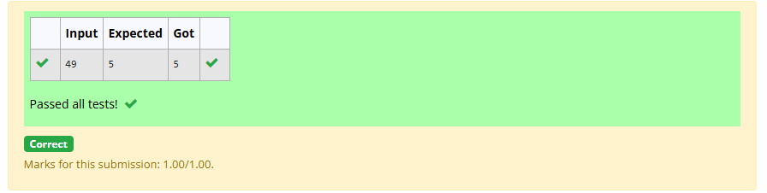

RESULT:
The program was implemented successfully to find the minimum number of Indian currency notes and coins required to make the given amount.
2.b ) 2-G-Cookies Problem
AIM:
To write a C program to assign cookies to children based on their greed factors and maximize the number of content children using the greedy algorithm.

ALGORITHM:
- Start the program and read the number of children and cookies.
- Read the greed factors of the children and the sizes of the cookies.
- Sort both arrays in ascending order.
- Compare each child's greed factor with the cookie size and assign a cookie if its size is sufficient.
- Count and print the maximum number of content children, then stop.
PROGRAM:

#include <stdio.h>
#include <stdlib.h>
int compare(const void *a, const void *b)
{
return (*(int *)a - *(int *)b);
}
int main()
{
int n, m, i, j = 0, count = 0;
scanf("%d", &n);
int g[n];
for (i = 0; i < n; i++)
scanf("%d", &g[i]);
scanf("%d", &m);
int s[m];
for (i = 0; i < m; i++)
scanf("%d", &s[i]);
qsort(g, n, sizeof(int), compare);
qsort(s, m, sizeof(int), compare);
i = 0;
while (i < n && j < m)
{
if (s[j] >= g[i])
{
count++;
i++;
}
j++;
}
printf("%d", count);
return 0;
}
OUTPUT:
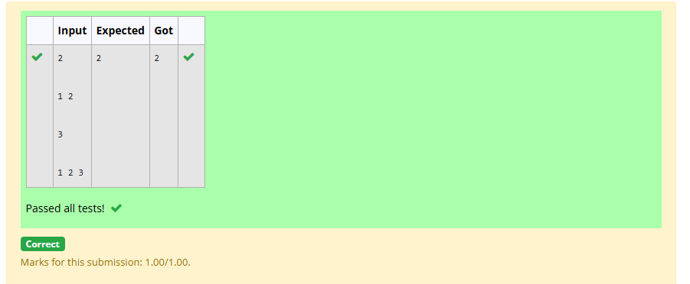

RESULT:
Thus the program was implemented successfully to maximize the number of content children using the greedy algorithm.
2.c ) 3-G-Burger Problem
AIM:
To write a C program to determine the minimum distance a person needs to run after eating burgers using the greedy approach and an efficient sorting algorithm.

ALGORITHM:
- Start the program and read the number of burgers n.
- Read the calorie values of all burgers into an array.
- Sort the calorie values in descending order using an efficient sorting algorithm.
- Calculate the total distance by adding each calorie value multiplied by \(3^i\), where i starts from 0.
- Print the minimum running distance and stop.
PROGRAM:

#include <stdio.h>
#include <stdlib.h>
int cmp(const void *a, const void *b)
{
long long x = *(const long long *)a;
long long y = *(const long long *)b;
if (x < y) return 1;
if (x > y) return -1;
return 0;
}
int main()
{
int n;
scanf("%d", &n);
long long *c = (long long *)malloc((n > 0 ? n : 1) * sizeof(long long));
for (int i = 0; i < n; i++)
scanf("%lld", &c[i]);
qsort(c, n, sizeof(long long), cmp);
long long total = 0, mult = 1;
for (int i = 0; i < n; i++)
{
total += mult * c[i];
mult *= n;
}
printf("%lld", total);
free(c);
return 0;
}

OUTPUT:
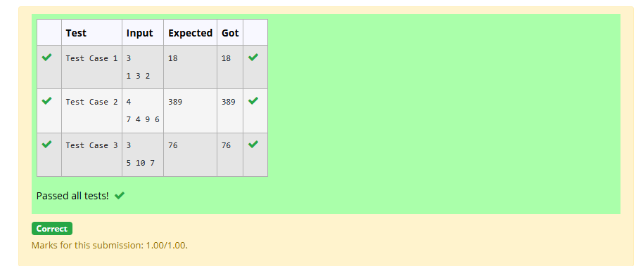

RESULT:
Thus the program was designed to determine the minimum running distance using the greedy approach by eating burgers in descending order of calorie values.
2.d ) 4-G-Array Sum max problem
AIM:
To write a program using the greedy technique to maximize the sum of arr[i] * i by arranging the array elements optimally in $O\left(n\log{n}\right)$time.

ALGORITHM:
- Start the program and read the number of elements n.
- Read the n array elements.
- Sort the array in ascending order using an efficient sorting algorithm.
- Calculate the sum of arr[i] * i for all indices from 0 to n-1.
- Print the maximum array sum and stop.
PROGRAM:

#include <stdio.h>
#include <stdlib.h>
int cmp(const void *a, const void *b)
{
long long x = *(const long long *)a;
long long y = *(const long long *)b;
if (x < y) return -1;
if (x > y) return 1;
return 0;
}
int main()
{
int n;
scanf("%d", &n);
long long *arr = (long long *)malloc((n > 0 ? n : 1) * sizeof(long long));
for (int i = 0; i < n; i++)
scanf("%lld", &arr[i]);
qsort(arr, n, sizeof(long long), cmp);
long long sum = 0;
for (int i = 0; i < n; i++)
sum += arr[i] * i;
printf("%lld", sum);
free(arr);
return 0;
}

OUTPUT:
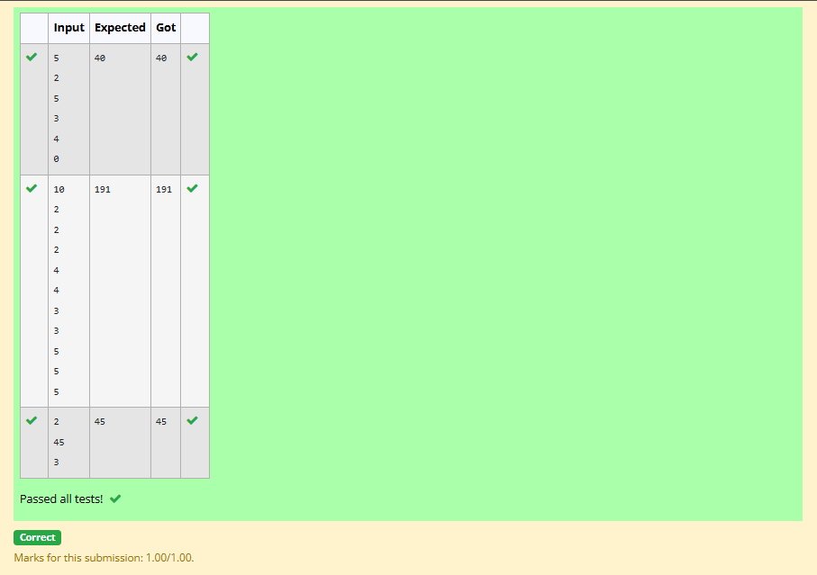

RESULT:
Thus the program was designed using the greedy technique to maximize the array sum. The time complexity is \(O(n\log n)\), dominated by sorting

2.e ) 5-G-Product of Array elements-Minimum
AIM:
To write a program using the greedy technique to rearrange two arrays of equal size such that the sum of the products of corresponding elements is minimized.
ALGORITHM:
- Start the program and read the size N of both arrays.
- Read the elements of array_One[] and array_Two[].
- Sort the first array in ascending order and the second array in descending order.
- Multiply the corresponding elements of both arrays and calculate their total sum.
- Print the minimum sum and stop.
PROGRAM:

#include <stdio.h>
#include <stdlib.h>
int asc(const void *a, const void *b)
{
long long x = *(const long long *)a;
long long y = *(const long long *)b;
if (x < y) return -1;
if (x > y) return 1;
return 0;
}
int desc(const void *a, const void *b)
{
return asc(b, a);
}
int main()
{
int n;
scanf("%d", &n);
long long *A = (long long *)malloc((n > 0 ? n : 1) * sizeof(long long));

long long *B = (long long *)malloc((n > 0 ? n : 1) * sizeof(long long));
for (int i = 0; i < n; i++)
scanf("%lld", &A[i]);
for (int i = 0; i < n; i++)
scanf("%lld", &B[i]);
qsort(A, n, sizeof(long long), asc);
qsort(B, n, sizeof(long long), desc);
long long sum = 0;
for (int i = 0; i < n; i++)
sum += A[i] * B[i];
printf("%lld", sum);
free(A);
free(B);
return 0;
}

OUTPUT:
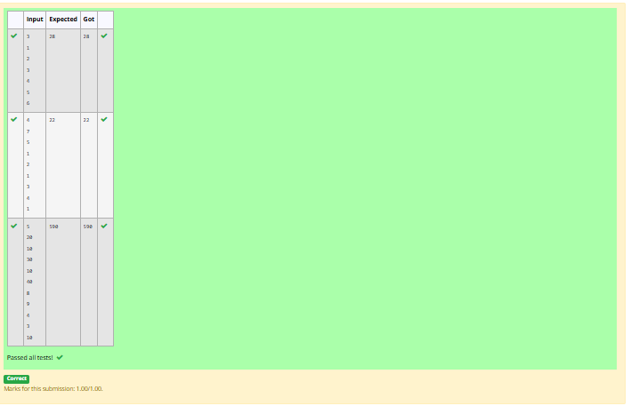

RESULT:
Thus the program was designed using the greedy technique to minimize the sum of products of corresponding array elements by sorting the arrays in opposite orders.
DIVIDE AND CONQUER
3.a ) Number of Zeros in a Given Array
AIM:
To write a C program using the Divide and Conquer technique to count the number of zeros in an array containing all 1s followed by all 0s.
ALGORITHM:
- Start the program and read the size n and array elements.
- Find the middle index of the array.
- If the middle element is 1, search the right half; otherwise, search the left half.
- Repeat the process using Divide and Conquer to locate the first zero.
- Count and print the number of zeros, then stop.
PROGRAM:

#include <stdio.h>
#include <stdlib.h>
int findFirstZero(int arr[], int low, int high)
{
if (low > high)
{
return -1;
}
if (arr[low] == 0)
{
return low;
}
if (arr[high] == 1)
{
return -1;
}

int mid = low + (high - low) / 2;
if (arr[mid] == 0)
{
return findFirstZero(arr, low, mid);
}
else
{
return findFirstZero(arr, mid + 1, high);
}}
int main()
{
int m;
scanf("%d", &m);
int *arr = (int *) malloc(m * sizeof(int));
int i;
for (i = 0; i < m; i++)
{
scanf("%d", &arr[i]);}
int firstZeroIndex = findFirstZero(arr, 0, m - 1);
int countOfZeroes;
if (firstZeroIndex == -1)
{countOfZeroes = 0;
}
else
{ countOfZeroes = m - firstZeroIndex; }
printf("%d\n", countOfZeroes);
free(arr);
return 0;}

OUTPUT:
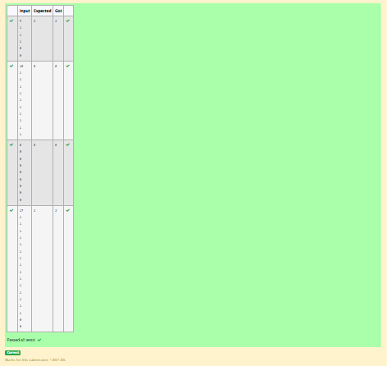

Result
Thus the program was designed using the Divide and Conquer technique to count the zeros in the given array efficiently.

3.b ) -Majority Element
AIM:
To write a C program to find the majority element in an array, which appears more than \(\lfloor n/2 \rfloor\) times, using an efficient algorithm.
ALGORITHM:
- Start the program and read the size n and array elements.
- Initialize a candidate element and a counter.
- Traverse the array using the Boyer–Moore Voting Algorithm.
- Update the candidate and counter based on the current element.
- Print the majority element and stop.
PROGRAM:
#include <stdio.h>
int main()
{
int n;
scanf("%d", &n);
int candidate = 0, count = 0;
for (int i = 0; i < n; i++)
{
int x;
scanf("%d", &x);
if (count == 0)
candidate = x;
if (x == candidate)
count++;
else
count--;
}
printf("%d", candidate);
return 0;}

OUTPUT:
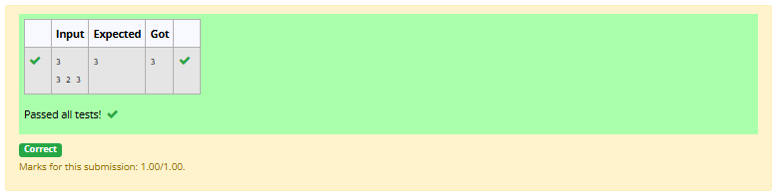

RESULT:
Thus the program was designed successfully to find the majority element using the Boyer–Moore Voting Algorithm with \(O(n)\) time complexity and \(O(1)\) extra space.
3.c ) -Finding Floor Value
AIM:
To write a program using the Divide and Conquer technique to find the floor of a given value x in a sorted array.
ALGORITHM:
- Start the program and read the sorted array and the value x.
- Find the middle element of the array.
- If the middle element is equal to x, return it.
- If it is smaller than x, search the right half; otherwise, search the left half.
- Print the largest element less than or equal to x, or report that no floor exists.
PROGRAM:

#include <stdio.h>
#include <stdlib.h>
int floorSearch(int arr[], int low, int high, int x)
{
if (low > high)
return -1;
int mid = low + (high - low) / 2;
if (arr[mid] == x)
return arr[mid];

if (arr[mid] < x)
{
int r = floorSearch(arr, mid + 1, high, x);
return (r != -1) ? r : arr[mid];
}
return floorSearch(arr, low, mid - 1, x);
}
int main()
{
int n, x;
scanf("%d", &n);
int *arr = (int *)malloc((n > 0 ? n : 1) * sizeof(int));
for (int i = 0; i < n; i++)
scanf("%d", &arr[i]);
scanf("%d", &x);
printf("%d", floorSearch(arr, 0, n - 1, x));
free(arr);
return 0;
}
OUTPUT:
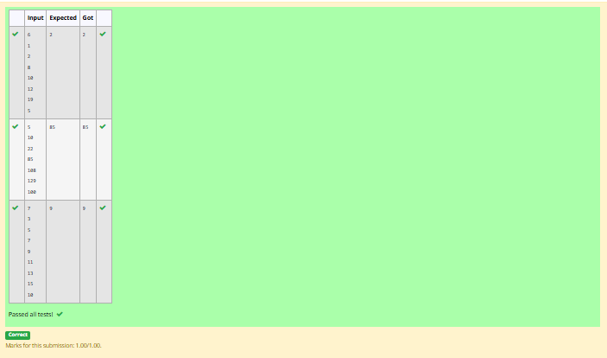

RESULT:
Thus the program was designed using the Divide and Conquer technique to find the floor of x in a sorted array with \(O(\log n)\) time complexity.
3.d ) Two Elements sum to x
AIM:
To write a recursive program using the Divide and Conquer technique to find two elements in a sorted array whose sum equals the given value x.
ALGORITHM:
- Start the program and read the sorted array, its size n, and the target value x.
- Initialize two pointers, left at the beginning and right at the end of the array.
- Calculate the sum of the elements at both pointers.
- If the sum equals x, print the two elements; if smaller, move left forward; otherwise, move right backward.
- Repeat recursively until a pair is found or the pointers meet; if no pair exists, print No.
PROGRAM:

#include <stdio.h>
#include <stdlib.h>
int search(int arr[], int low, int high, long long target)
{
if (low > high)
return 0;
int mid = low + (high - low) / 2;
if (arr[mid] == target)
return 1;
if (arr[mid] < target)
return search(arr, mid + 1, high, target);
return search(arr, low, mid - 1, target);
}
int main()
{
int n, x;
scanf("%d", &n);
int *arr = (int *)malloc((n > 0 ? n : 1) * sizeof(int));
for (int i = 0; i < n; i++)

scanf("%d", &arr[i]);
scanf("%d", &x)
for (int i = 0; i < n - 1; i++)
{
long long target = (long long)x - arr[i];
if (search(arr, i + 1, n - 1, target))
{
printf("%d\n%d", arr[i], (int)target);
free(arr);
return 0;
}
}
printf("No");
free(arr);
return 0;
}

OUTPUT:
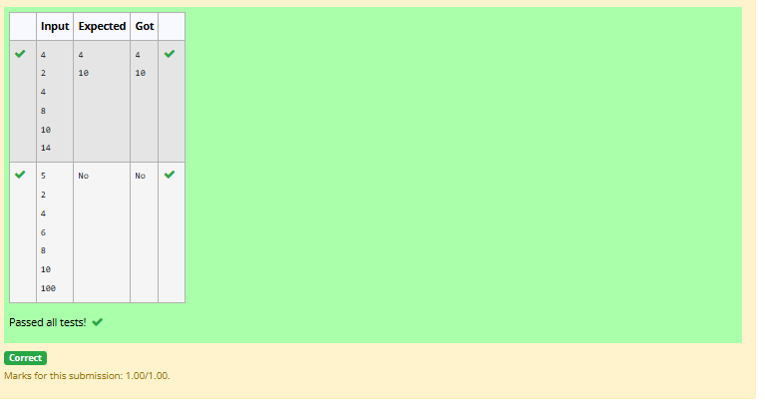

RESULT:
Thus the program was designed to check whether two elements in a sorted array have a sum equal to x using a recursive approach, with \(O(n)\) time complexity.

3.e ) Implementation of Quick Sort
AIM:
To write a C program to implement the Quick Sort algorithm to sort a list of elements in ascending order.
ALGORITHM:
- Start the program and read the number of elements n and the array elements.
- Select a pivot element from the array.
- Partition the array so that elements smaller than the pivot are placed before it and larger elements after it.
- Recursively apply Quick Sort to the left and right partitions.
- Print the sorted array and stop the program.
PROGRAM:

#include <stdio.h>
#include <stdlib.h>
void swap(int *a, int *b)
{
int t = *a;
*a = *b;
*b = t;
}
int partition(int arr[], int low, int high)
{
int pivot = arr[high];
int i = low - 1;
for (int j = low; j < high; j++)
{
if (arr[j] <= pivot)
{
i++;
swap(&arr[i], &arr[j]);}}

swap(&arr[i + 1], &arr[high]);
return i + 1;
}
void quickSort(int arr[], int low, int high)
{
if (low < high)
{
int p = partition(arr, low, high);
quickSort(arr, low, p - 1);
quickSort(arr, p + 1, high);
}
}
int main()
{
int n;
scanf("%d", &n);
int *arr = (int *)malloc((n > 0 ? n : 1) * sizeof(int));
for (int i = 0; i < n; i++)
scanf("%d", &arr[i]);
quickSort(arr, 0, n - 1);
for (int i = 0; i < n; i++)
{
if (i > 0)
printf(" ");
printf("%d", arr[i]);}
free(arr);
return 0;}

OUTPUT:
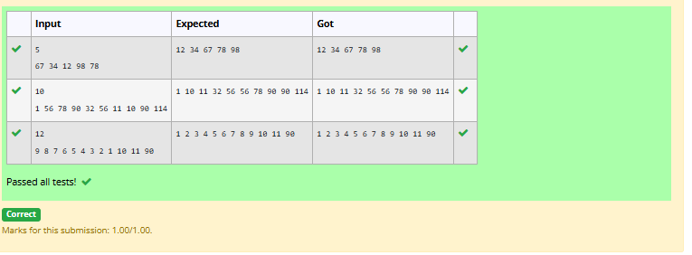

RESULT:
The Quick Sort algorithm was implemented successfully to sort the given list of elements in ascending order.

DYNAMIC PROGRAMMING
4.a ) DP-Playing with Numbers
AIM:
To write an efficient C program to find the number of possible ways to represent a positive integer n using the numbers 1 and 3.
ALGORITHM:
- Start the program and read the positive integer n.
- Initialize dp[0] = 1 and dp[1] = 1.
- For each value i from 2 to n, calculate dp[i] = dp[i-1] + dp[i-3] if i >= 3; otherwise, set dp[i] = dp[i-1].
- Repeat until dp[n] is calculated.
- Print dp[n] and stop the program.
PROGRAM:
#include <stdio.h>

int main
{
int n;
scanf("%d", &n);

long long f[n + 4];
f[0] = 1;
f[1] = 1;
f[2] = 1;

for (int i = 3; i <= n; i++)
f[i] = f[i - 1] + f[i - 3];

printf("%lld", f[n]);

return 0

OUTPUT: 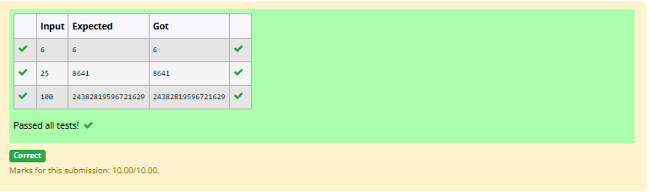

RESULT:
The algorithm was designed successfully to calculate the number of possible representations of n using 1 and 3 through dynamic programming
4.b ) DP-Playing with chessboard
AIM:
To develop an efficient Dynamic Programming (DP) algorithm to find the maximum monetary value path from the top-left cell \((0,0)\) to the bottom-right cell \((n-1,n-1)\) of an \(n \times n\) chessboard, moving only right or down.
ALGORITHM:
- Start the program and read the size n and the monetary values of the chessboard.
- Initialize a DP table to store the maximum monetary sum for each cell.
- Set dp[0][0] equal to the value of the starting cell.
- For each cell, calculate the maximum sum from the top or left cell and add the current cell's value.
- Print dp[n-1][n-1] as the maximum monetary path sum and stop.
PROGRAM:

#include <stdio.h>
#include <stdlib.h>
int main()
{
int n;
scanf("%d", &n);
long long **dp = (long long **)malloc(n * sizeof(long long *));
for (int i = 0; i < n; i++)
{
dp[i] = (long long *)malloc(n * sizeof(long long));
for (int j = 0; j < n; j++)
scanf("%lld", &dp[i][j]);
}
for (int i = 0; i < n; i++)
{
for (int j = 0; j < n; j++)
{
if (i == 0 && j == 0)

continue;
long long best;
if (i == 0)
best = dp[i][j - 1];
else if (j == 0)
best = dp[i - 1][j];
else
best = dp[i - 1][j] > dp[i][j - 1] ? dp[i - 1][j] : dp[i][j - 1];
dp[i][j] += best;
}
}
printf("%lld", dp[n - 1][n - 1]);
for (int i = 0; i < n; i++)
free(dp[i]);
free(dp);
return 0;
}

OUTPUT:
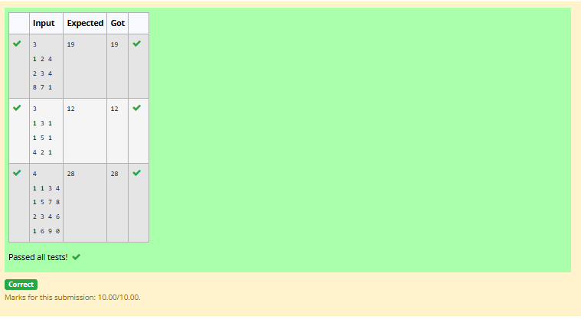

RESULT:
The Dynamic Programming algorithm was designed successfully to find the maximum monetary value path from the top-left to the bottom-right cell, with a time complexity of \(O(n^2)\).
4.c ) DP-Longest Common Subsequence
AIM:
To write a program using Dynamic Programming to find the length of the Longest Common Subsequence (LCS) between two strings, where the characters need not be contiguous.
ALGORITHM:
- Start the program and read the two strings s1 and s2.
- Create a DP table of size \((m+1)\times(n+1)\) and initialize the first row and column to zero.
- If the characters match, set dp[i][j] = dp[i-1][j-1] + 1.
- Otherwise, set dp[i][j] to the maximum of dp[i-1][j] and dp[i][j-1].
- Print dp[m][n] as the length of the Longest Common Subsequence and stop.
PROGRAM:
#include <stdio.h>
#include <string.h>
#include <stdlib.h>

int main()
{
char s1[5005], s2[5005];
scanf("%5000s", s1);
scanf("%5000s", s2);

int n = strlen(s1);
int m = strlen(s2);

int **dp = (int **)malloc((n + 1) * sizeof(int *));
for (int i = 0; i <= n; i++)
dp[i] = (int *)calloc(m + 1, sizeof(int));

for (int i = 1; i <= n; i++)
{
for (int j = 1; j <= m; j++)

{
if (s1[i - 1] == s2[j - 1])
dp[i][j] = dp[i - 1][j - 1] + 1;
else
dp[i][j] = dp[i - 1][j] > dp[i][j - 1] ? dp[i - 1][j] : dp[i][j - 1];
}
}

printf("%d", dp[n][m]);

for (int i = 0; i <= n; i++)
free(dp[i]);
free(dp);
return 0;
}

OUTPUT:
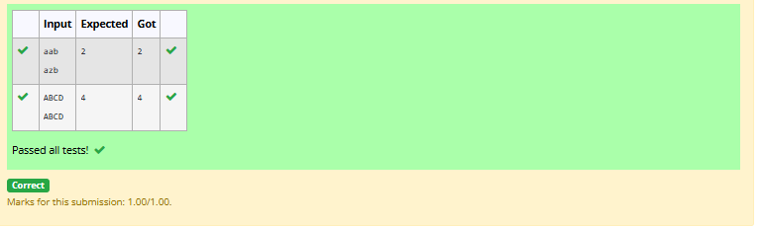

RESULT:
The Dynamic Programming algorithm was designed successfully to find the length of the Longest Common Subsequence. For the given strings ggtabe and tgatasb, the LCS length is 4.

4.d ) DP-Longest non-decreasing Subsequence
AIM:
To write a C program to find the length of the Longest Non-decreasing Subsequence (LNDS) in a given sequence using Dynamic Programming.
ALGORITHM:
- Start the program and read the number of elements n and the sequence.
- Initialize a DP array with 1 for every element.
- Compare each element with the previous elements in the sequence.
- If arr[i] >= arr[j], update dp[i] = max(dp[i], dp[j] + 1).
- Print the maximum value in the DP array and stop.
PROGRAM:
#include <stdio.h>
#include <stdlib.h>

int main()
{
int n;
scanf("%d", &n);

int *arr = (int *)malloc((n > 0 ? n : 1) * sizeof(int));
int *dp = (int *)malloc((n > 0 ? n : 1) * sizeof(int));

for (int i = 0; i < n; i++)
scanf("%d", &arr[i]);

int best = 0;
for (int i = 0; i < n; i++)
{
dp[i] = 1;
for (int j = 0; j < i; j++)

{
if (arr[j] <= arr[i] && dp[j] + 1 > dp[i])
dp[i] = dp[j] + 1;
}
if (dp[i] > best)
best = dp[i];
}

printf("%d", best);

free(arr);
free(dp);
return 0;
}

OUTPUT:
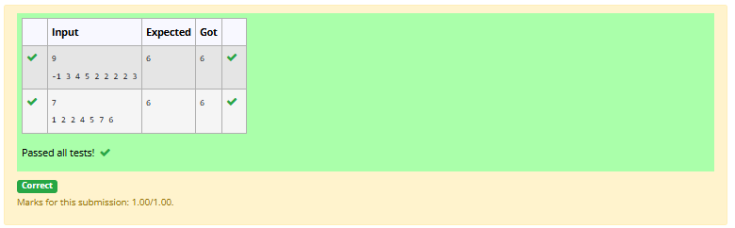

RESULT:
The program was designed to find the length of the Longest Non-decreasing Subsequence using Dynamic Programming.

COMPETITIVE PROGRAMMING
5.a ) Finding Duplicates-O(n^2) Time Complexity,O(1) Space Complexity
AIM:
To write a C program to find a duplicate element in a read-only array containing n integers between 1 and n.
ALGORITHM:
- Start the program and read the number of elements n.
- Read the n array elements.
- Compare each element with the remaining elements in the array.
- If two elements are equal, identify the repeated element.
- Print the duplicate element and stop the program.
PROGRAM:
#include <stdio.h>
#include <stdlib.h>

int main() {
int n;
scanf("%d", &n);

int *a = (int *)malloc(n * sizeof(int));
for (int i = 0; i < n; i++) {
scanf("%d", &a[i]);
}

int lo = 1, hi = n;
while (lo < hi) {
int mid = lo + (hi - lo) / 2;
int count = 0;
for (int i = 0; i < n; i++) {
if (a[i] <= mid) count++;
}
if (count > mid)
hi = mid;
else
lo = mid + 1;
}

printf("%d\n", lo);
free(a);
return 0;
}

OUTPUT:
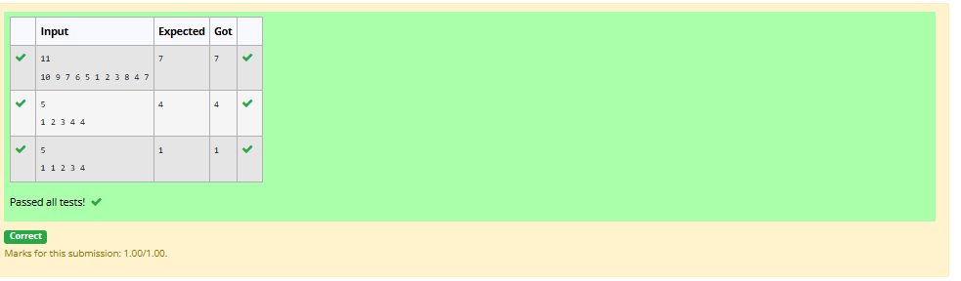

RESULT:
The program was designed successfully to identify and print a repeated element in the given array.

5.b ) Finding Duplicates-O(n) Time Complexity,O(1) Space Complexity
AIM:
To write a C program to find one repeated number in a read-only array containing n integers between 1 and n
ALGORITHM:
- Start the program and read the number of elements n.
- Read the n elements into an array.
- Compare each element with the remaining elements in the array.
- If two elements are equal, identify the duplicate number.
- Print the repeated element and stop the program.
PROGRAM:

#include <stdio.h>
#include <stdlib.h>

int main() {
int n;
scanf("%d", &n);

int *seen = (int *)calloc(n + 1, sizeof(int));
int ans = -1;

for (int i = 0; i < n; i++) {
int x;
scanf("%d", &x);
if (ans == -1 && x >= 1 && x <= n) {
if (seen[x]) ans = x;
else seen[x] = 1;
}
}

printf("%d\n", ans);
free(seen);
return 0;
}

OUTPUT:
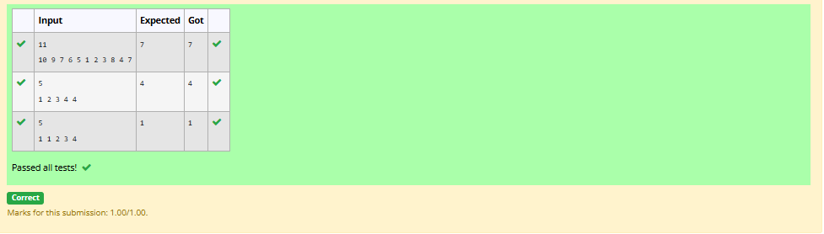

RESULT:
The algorithm was designed successfully to find and print one duplicate element in the given array.
5.c ) Print Intersection of 2 sorted arrays-O(m*n)Time Complexity,O(1) Space Complexity
AIM:
To write a C program to find the intersection of two sorted arrays by identifying the elements common to both arrays.
ALGORITHM:
- Start the program and read the number of test cases T.
- For each test case, read the sizes and elements of both sorted arrays.
- Initialize two pointers, i = 0 and j = 0.
- If both elements are equal, print the element and increment both pointers; if the first is smaller, increment i, otherwise increment j.
- Repeat until either array ends, then proceed to the next test case and stop.
PROGRAM:
#include <stdio.h>
#include <stdlib.h>

int main() {
int t;
scanf("%d", &t);

while (t--) {
int n1, n2;

scanf("%d", &n1);
int *a = (int *)malloc(n1 * sizeof(int));
for (int i = 0; i < n1; i++) scanf("%d", &a[i]);

scanf("%d", &n2);
int *b = (int *)malloc(n2 * sizeof(int));
for (int i = 0; i < n2; i++) scanf("%d", &b[i]);

int i = 0, j = 0, first = 1;
while (i < n1 && j < n2) {
if (a[i] < b[j]) {
i++;
} else if (a[i] > b[j]) {
j++;
} else {
if (!first) printf(" ");
printf("%d", a[i]);
first = 0;
int v = a[i];
while (i < n1 && a[i] == v) i++;
while (j < n2 && b[j] == v) j++;
}
}
printf("\n");

free(a);
free(b);
}
return 0;
}

OUTPUT:
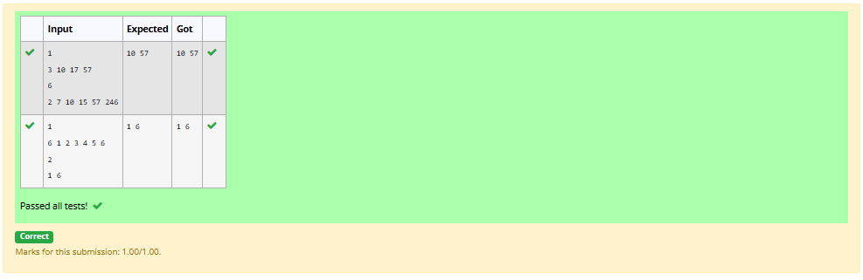

RESULT:
The program was designed successfully to find the common elements of two sorted arrays using the two-pointer technique.
5.d ) Print Intersection of 2 sorted arrays-O(m+n)Time Complexity,O(1) Space Complexity
AIM:
To write a C program to find the intersection of two sorted arrays by identifying all elements that are common to both arrays.
ALGORITHM:
- Start the program and read the number of test cases T.
- For each test case, read the sizes and elements of both sorted arrays.
- Initialize two pointers, i = 0 and j = 0.
- If both elements are equal, print the element and increment both pointers. If the first element is smaller, increment i; otherwise, increment j.
- Repeat until either array ends, process the remaining test cases, and stop.
PROGRAM:
#include <stdio.h>

int main() {
int t;
scanf("%d", &t);
while (t--) {
int n1, n2, i, j, first = 1;
static int a[100000], b[100000];

scanf("%d", &n1);
for (i = 0; i < n1; i++) scanf("%d", &a[i]);
scanf("%d", &n2);
for (j = 0; j < n2; j++) scanf("%d", &b[j]);

i = 0;
j = 0;
while (i < n1 && j < n2) {
if (a[i] < b[j]) i++;
else if (a[i] > b[j]) j++;
else {
if (!first) printf(" ");
printf("%d", a[i]);
first = 0;
i++;
j++;
}
}
printf("\n");
}
return 0;
}

OUTPUT:
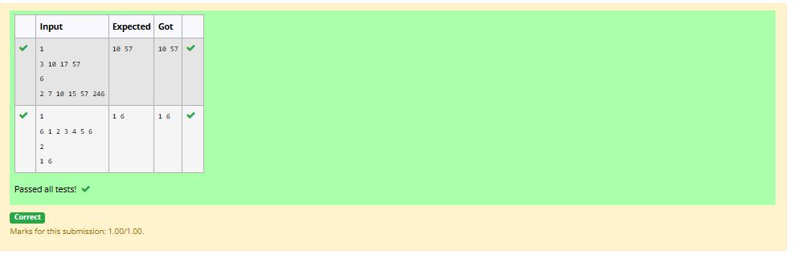

RESULT:
The program was designed successfully to find the common elements in two sorted arrays using the two-pointer technique

5.e ) -Pair with Difference-O(n^2)Time Complexity,O(1) Space Complexity
AIM:
To write a C program to check whether two distinct indices in a sorted array exist such that the difference between their elements equals a given non-negative integer k
ALGORITHM:
- Start the program and read the number of elements n and the sorted array.
- Read the non-negative integer k.
- Initialize two pointers, i = 0 and j = 1.
- If A[j] - A[i] == k, return 1; if the difference is less than k, increment j; otherwise, increment i.
- Repeat until a valid pair is found or the array ends. Print 1 if a pair exists; otherwise, print 0.
PROGRAM:
#include <stdio.h>

int main() {
int n, k, i = 0, j = 1, found = 0;
static int a[100000];

scanf("%d", &n);
for (int x = 0; x < n; x++) scanf("%d", &a[x]);
scanf("%d", &k);

while (i < n && j < n) {
int d = a[j] - a[i];
if (i != j && d == k) {
found = 1;
break;
}
if (d < k || i == j) j++;
else i++;
}

printf("%d\n", found);
return 0;}

OUTPUT:
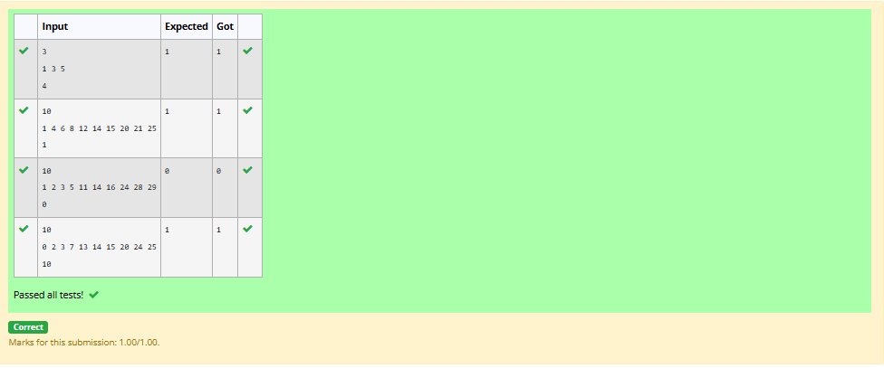

RESULT:
The program was designed successfully to determine whether a pair of elements has the required difference using the two-pointer technique.
5.f ) Pair with Difference -O(n) Time Complexity,O(1) Space Complexity
AIM:
To write a C program to check whether two distinct elements in a sorted array have a difference equal to a given non-negative integer k.
ALGORITHM:
- Start the program and read the number of elements n.
- Read the sorted array elements and the value of k.
- Initialize two pointers, i = 0 and j = 1.
- Compare A[j] - A[i] with k; if equal, print 1. If smaller, increment j; otherwise, increment i.
- Continue until a pair is found or the array ends. Print 0 if no pair exists.
PROGRAM:
#include <stdio.h>
#include <stdlib.h>

int main() {
int n, k, i = 0, j = 1, found = 0;
scanf("%d", &n);
int *a = (int *)malloc(n * sizeof(int));
for (int x = 0; x < n; x++) scanf("%d", &a[x]);
scanf("%d", &k);
while (i < n && j < n) {
long long d = (long long)a[j] - a[i];
if (i != j && d == k) {
found = 1;
break;
}
if (d < k || i == j) j++;
else i++;
}
printf("%d\n", found);
free(a);
return 0;
}

OUTPUT:
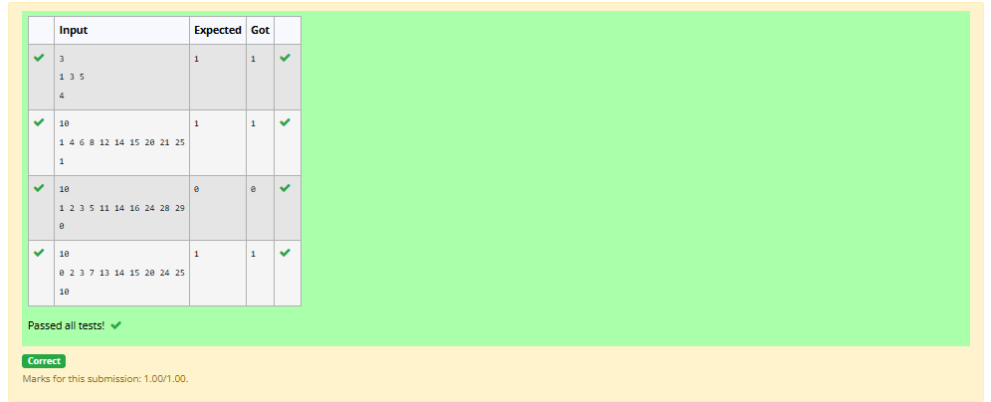

RESULT:
The program was designed successfully to check whether a pair with the required difference exists using the two-pointer technique, with \(O(n)\) time complexity

